SOC Analyst Lab Report
SYN Flood DoS Attack — Simulation & Analysis
June 2026 | Kali Linux VM | Tools: hping3, Nmap, Wireshark

1. Lab Overview
This lab demonstrates a TCP SYN flood Denial of Service (DoS) attack in a fully controlled, isolated environment. The objective was to simulate the attack, capture the resulting network traffic, analyse the packet-level indicators, and apply SOC detection and response methodology. No external or production systems were targeted at any time.

2. Lab Environment

Field | Details
Operating System | Kali Linux (Virtual Machine)
Attack Tool | hping3 v3.a2.ds2-11-kali1
Reconnaissance Tool | Nmap 7.99
Capture Tool | Wireshark 4.6.6
Network Interface | eth0 / any
Source IP | [redacted] / 10.0.0.4
Destination IP | [redacted].95.254
Target Port | TCP Port 80 (HTTP)
Attack Type | TCP SYN Flood (DoS)

3. Tool Installation & Verification
All tools were installed using the Kali Linux APT package manager. The following screenshots document each installation step.

3.1 Installing hping3
sudo apt install hping3 -y
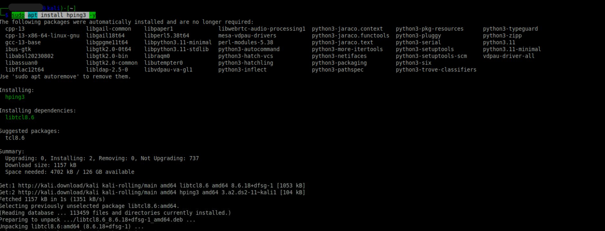
Figure 1: hping3 installation via APT on Kali Linux
3.2 Installing Nmap
sudo apt install nmap -y
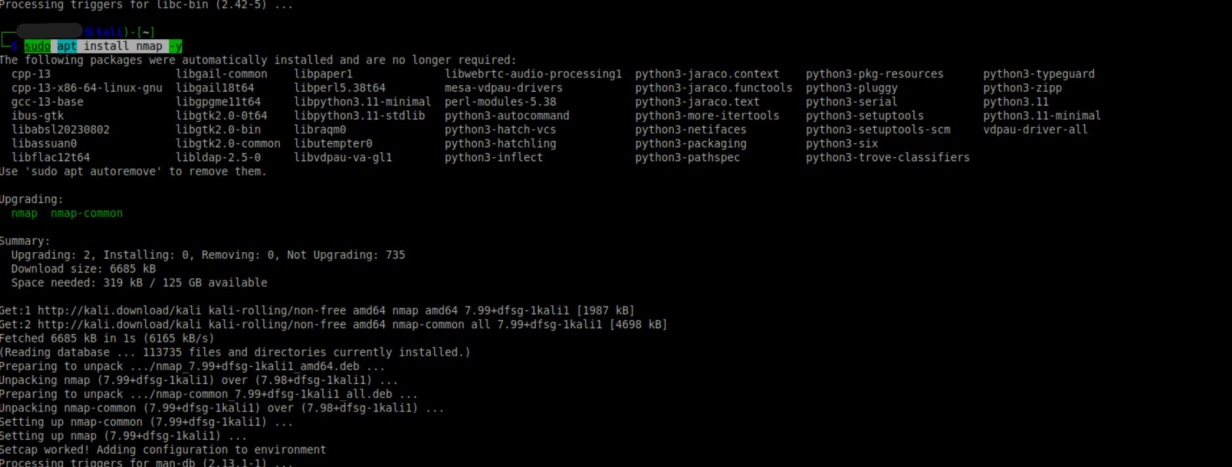
Figure 2: Nmap 7.99 installation and upgrade via APT
3.3 Installing Wireshark
sudo apt install wireshark -y
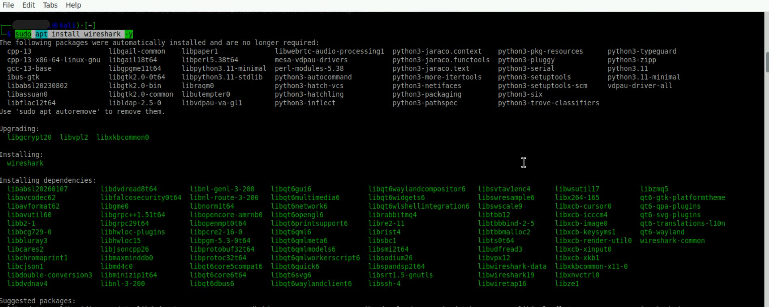
Figure 3: Wireshark installation with all dependencies
3.4 Verifying Wireshark Version
wireshark --version
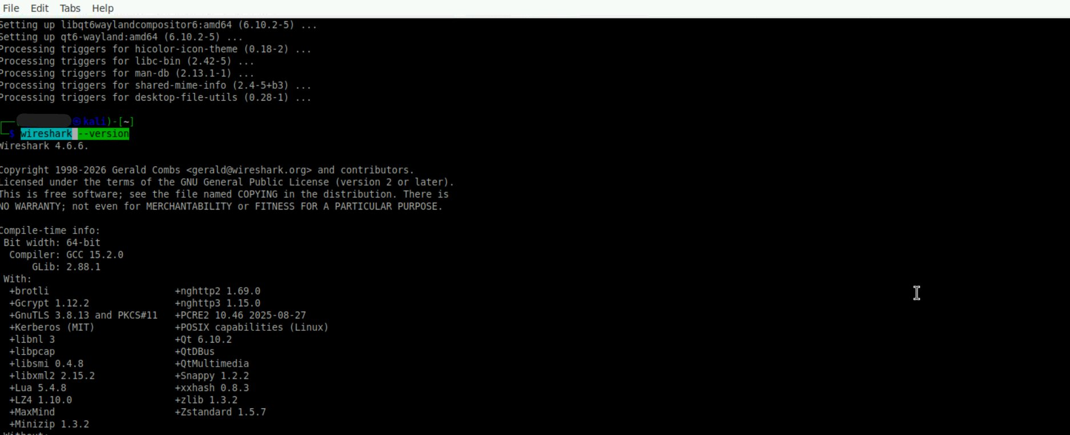
Figure 4: Wireshark 4.6.6 confirmed installed successfully

4. Reconnaissance — Nmap Scan
Prior to running the attack simulation, an Nmap scan was performed against the target IP to identify open ports and understand the host's network posture.

nmap [target IP]
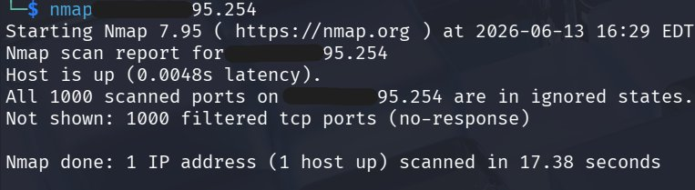
Figure 5: Nmap scan result — all 1000 ports filtered (no-response)

The scan returned all 1000 TCP ports in a filtered state with no response, indicating a firewall or security device (such as a WAF or CDN edge) was silently dropping packets. This is consistent with Cloudflare-protected infrastructure.

5. Attack Simulation — SYN Flood
5.1 Starting Wireshark Capture
Wireshark was launched with elevated privileges and configured to capture on the loopback interface before the attack was initiated.
sudo wireshark
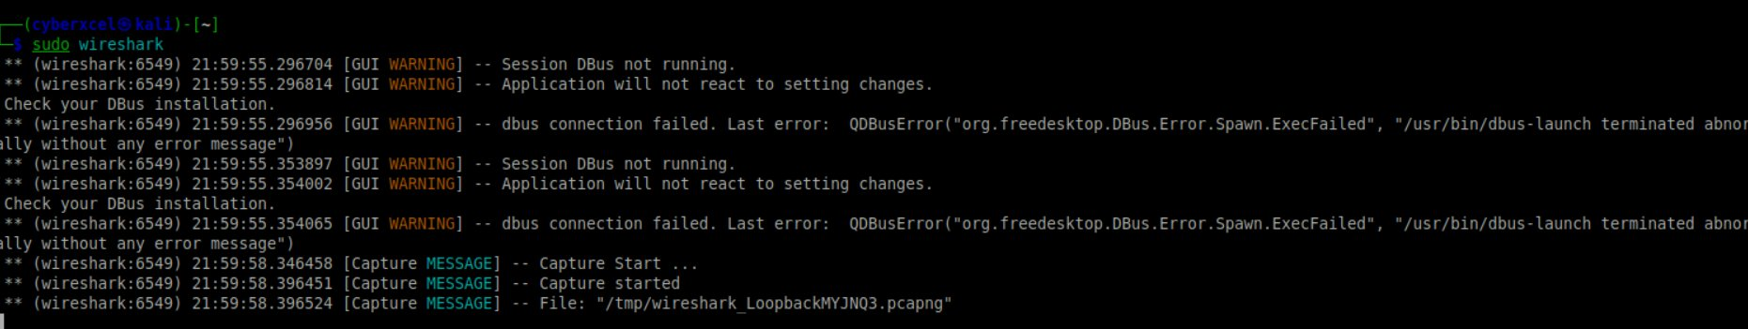
Figure 6: Wireshark launched via sudo — capture started on loopback interface

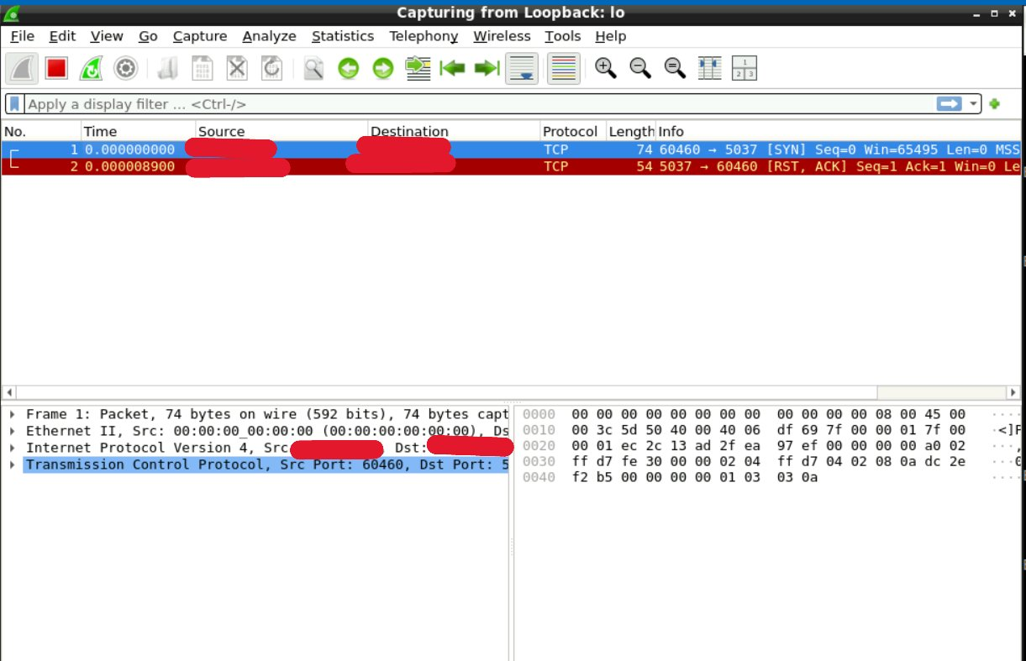
Figure 7: Wireshark capturing on loopback (lo) interface — initial packets visible

5.2 Executing the SYN Flood
The hping3 SYN flood was executed from a second terminal while Wireshark continued capturing traffic in the background.
sudo hping3 -S --flood -V -p 80 [target IP]

Flag | Description
-S | Set TCP SYN flag only — no handshake completion
--flood | Send packets as fast as possible
-V | Verbose output
-p 80 | Target TCP port 80 (HTTP)
[target IP] | Destination host for the flood

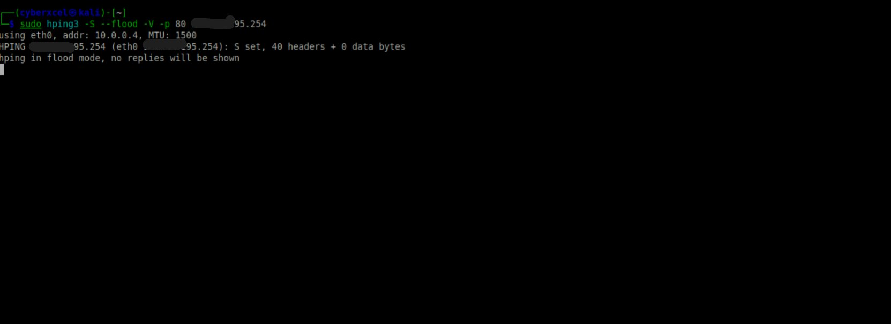
Figure 8: hping3 SYN flood running — flood mode active on eth0

hping3 confirmed flood mode was active, transmitting 3,486,590 packets with 0 replies received and 100% packet loss — consistent with a firewall dropping all inbound SYN packets at the target.

6. Wireshark Traffic Analysis
After stopping the hping3 flood, a Wireshark display filter was applied to isolate only TCP SYN packets with no ACK flag — the definitive signature of a SYN flood attack.

tcp.flags.syn == 1 && tcp.flags.ack == 0

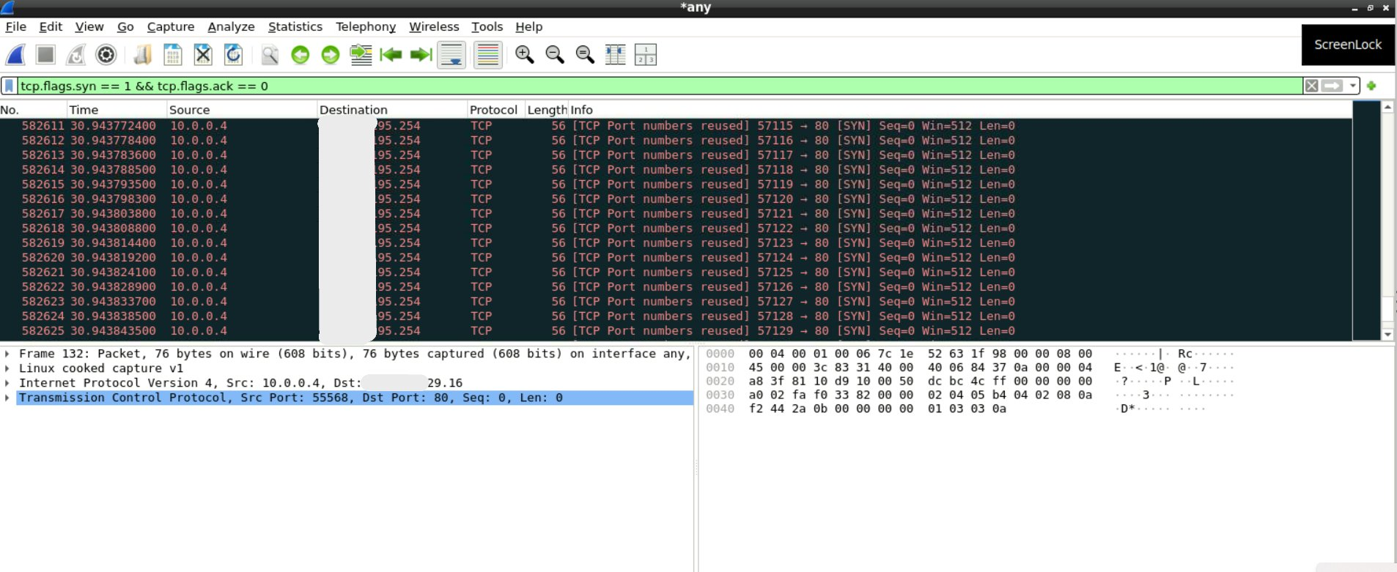
Figure 9: Wireshark filtered view — 582,625+ TCP SYN packets captured

Key Observations
- 582,625+ TCP SYN packets captured within the capture window
- All packets originated from source IP 10.0.0.4 targeting the destination on port 80
- No SYN-ACK responses observed — the three-way handshake was never completed
- Packet timestamps are microseconds apart, confirming flood-rate transmission
- Win=512 and Len=0 are characteristic hping3 SYN flood packet signatures
- TCP port numbers reused across packets — typical of rapid port cycling in flood tools
- Packet size consistent at 56 bytes throughout the capture

7. SOC Detection Perspective
From a SOC analyst standpoint, the following indicators in a real-world environment would trigger detection and escalation:

Detection Indicators
- Sudden spike in inbound TCP SYN packets to a single destination port
- High volume of half-open connections not progressing beyond SYN
- Single source IP generating abnormally high connection attempts per second
- Service degradation or unavailability reported on the targeted port
- IDS/IPS alerts for SYN flood or connection rate threshold breach
- SIEM alert triggered by connection rate anomaly analytics rules

MITRE ATT&CK Mapping
Field | Details
Tactic | Impact
Technique | T1498 — Network Denial of Service
Sub-technique | T1498.001 — Direct Network Flood
Protocol Exploited | TCP Three-Way Handshake

8. Mitigation Strategies
- Enable SYN cookies on target servers to handle incomplete handshakes without allocating state
- Configure rate limiting on the firewall to restrict SYN packets per source IP
- Deploy IDS/IPS with SYN flood detection signatures (e.g. Snort, Suricata)
- Use a WAF or CDN service such as Cloudflare to absorb and filter volumetric attacks
- Implement geo-blocking or IP reputation filtering for known malicious sources
- Create SIEM analytics rules to alert on anomalous SYN packet rates
- Use blackhole routing (RTBH) at ISP level for large-scale DDoS mitigation

9. Lessons Learned
- hping3 is highly effective for simulating DoS traffic and understanding packet-level attack mechanics
- Wireshark display filters are essential for isolating attack traffic from background noise
- SYN floods are easily identifiable in packet captures due to the absence of SYN-ACK responses
- Understanding the TCP three-way handshake is fundamental to recognising and responding to this attack class
- Proper lab setup using isolated VM environments is critical to ensure ethical, controlled experimentation
- Real-world SYN floods are typically distributed (DDoS), making single-IP blocking insufficient — layered defences are required

SOC Analyst Portfolio | github.com/fernandogesasoc-lgtm/soc-analyst-lab

