INCIDENT REPORT

Fernando Gesa

June 2026

Lumma Stealer — Suspected Host Compromise
Traffic Analysis Exercise
Incident Date: | 2026-01-27
Incident Time: | 23:05 UTC (alert triggered)
Exercise Source: | malware-traffic-analysis.net/2026/01/31/index.html
Analysis Tool: | Wireshark (MySOC profile)
PCAP File: | 2026-01-31-traffic-analysis-exercise.pcap
Classification: | Lab Exercise — Educational Purposes Only

ALERT SOURCE: ET MALWARE Lumma Stealer Victim Fingerprinting Activity — traffic from 153.92.1.49 over TCP port 80.

1. Executive Summary
On 2026-01-27 at 23:05 UTC, a SIEM alert fired for ET MALWARE Lumma Stealer Victim Fingerprinting Activity, identifying outbound traffic from an internal host directed at 153.92.1.49 over TCP port 80. Lumma Stealer is an information-stealing malware-as-a-service (MaaS) capable of harvesting browser credentials, cookies, cryptocurrency wallets, and other sensitive data from infected Windows systems.
Analysis of the retrieved packet capture confirmed a single infected Windows workstation was responsible. The host was identified through HTTP traffic analysis, Ethernet frame inspection, and Kerberos authentication records. The C2 domain associated with the Lumma Stealer activity was identified as whitepepper.su.
TLDR: One internal Windows host (10.1.21.58 — DESKTOP-ES9F3ML) was infected with Lumma Stealer and communicating with C2 domain whitepepper.su via 153.92.1.49:80. The logged-on user was gwyatt.

2. Environment Details
The following network environment context was provided for this exercise:

Parameter | Value
LAN Segment | 10.1.21.0/24 (10.1.21.0 – 10.1.21.255)
Domain | win11office.com
AD Environment | WIN11OFFICE
Domain Controller | 10.1.21.2 — WIN-LU4L24X3UB7
Gateway | 10.1.21.1
Broadcast | 10.1.21.255
Threat Actor C2 IP | 153.92.1.49 (TCP 80)
Threat Actor C2 Domain | whitepepper.su

3. Findings — Infected Host Details
The following details were extracted from the pcap and are confirmed as the infected Windows client:

Field | Value | How Identified
IP Address | 10.1.21.58 | Source IP of all HTTP requests to 153.92.1.49:80
MAC Address | 00:21:5d:c8:0e:f2 | Ethernet II source in frames from 10.1.21.58 (Intel NIC)
Hostname | DESKTOP-ES9F3ML | NBNS registration broadcasts / Kerberos realm field
User Account | gwyatt | Kerberos AS-REQ CNameString (filter: kerberos.CNameString)
C2 Domain | whitepepper.su | HTTP Host header in GET/POST requests to 153.92.1.49:80

4. Analysis

4.1 Lumma Stealer C2 Traffic — whitepepper.su
Applying the Wireshark display filter for HTTP and TLS traffic to 153.92.1.49 revealed outbound connections from 10.1.21.58 to the C2 server on both TCP port 80 (HTTP) and TCP port 443 (TLS). The HTTP Host header in frames on port 80 clearly identified the C2 domain as whitepepper.su. The malware communicated via GET and POST requests to the path /api/set_agent, which is consistent with Lumma Stealer's victim fingerprinting behaviour — the malware reports back system information to the C2 server to register the newly infected victim.

Filter: (http.request or tls.handshake.type eq 1) and !(ssdp) and ip.addr eq 153.92.1.49
GET /api/set_agent?id=3BF67EC053... HTTP/1.1
POST /api/set_agent?id=3BF67EC053... HTTP/1.1
Host: whitepepper.su

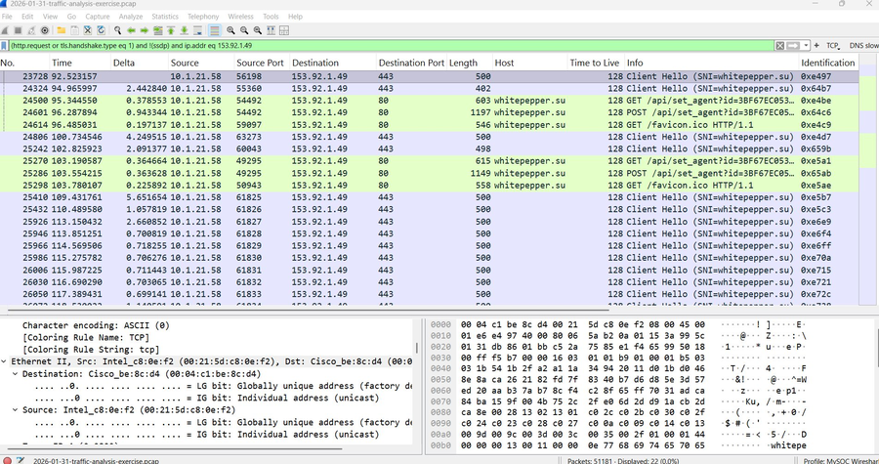
Figure 1 — HTTP and TLS traffic from 10.1.21.58 to 153.92.1.49, Host header showing whitepepper.su and /api/set_agent fingerprinting calls

4.2 MAC Address & IP Identification
Selecting any frame originating from 10.1.21.58 and expanding the Ethernet II layer confirmed the source MAC address as 00:21:5d:c8:0e:f2, identified as an Intel NIC. The IPv4 layer confirmed the source IP as 10.1.21.58 communicating with the C2 server at 153.92.1.49.

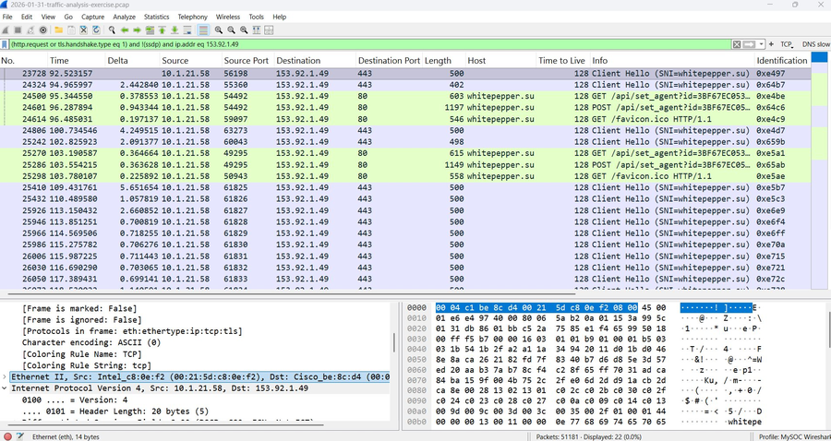
Figure 2 — Ethernet II layer showing source MAC 00:21:5d:c8:0e:f2 (Intel NIC) from infected host 10.1.21.58

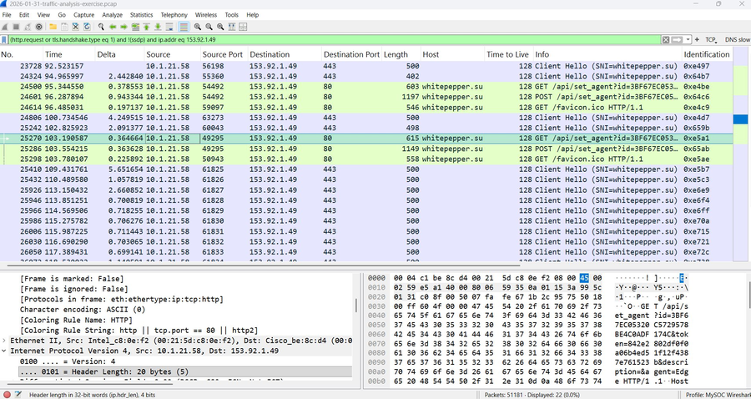
Figure 3 — IPv4 layer and HTTP protocol confirming source IP 10.1.21.58 in GET request to whitepepper.su

4.3 User Account via Kerberos
Filtering for Kerberos traffic using the display filter 'kerberos.CNameString' revealed AS-REQ packets from 10.1.21.58 to the domain controller at 10.1.21.2 on port 88. The CNameString field in the Kerberos AS-REQ body identified the authenticating user as gwyatt within the WIN11OFFICE domain, confirming this was the active user session on the infected host at the time of the infection.

Filter: kerberos.CNameString
Frame 214 — AS-REQ from 10.1.21.58 to 10.1.21.2:88
CNameString: gwyatt
Realm: WIN11OFFICE

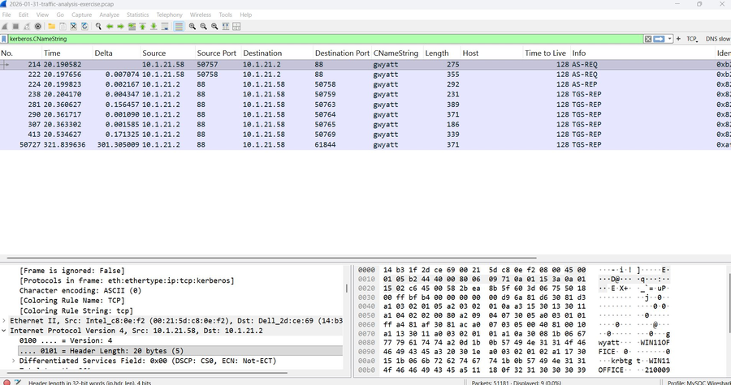
Figure 4 — Kerberos AS-REQ filtered by CNameString, confirming user account 'gwyatt' authenticating to WIN11OFFICE domain controller

5. Indicators of Compromise (IOCs)

Type | Value | Notes
IP (C2) | 153.92.1.49 | Lumma Stealer C2 server
Domain (C2) | whitepepper.su | C2 domain in HTTP Host header
Port | TCP 80 / TCP 443 | HTTP and TLS C2 comms
URI Path | /api/set_agent?id=3BF67EC053... | Victim fingerprinting endpoint
User-Agent | Observed in HTTP GET/POST | Check proxy logs for matching UA

6. Recommended Actions
Based on the findings, the following immediate and follow-up actions are recommended:

- Isolate DESKTOP-ES9F3ML (10.1.21.58) from the network immediately to prevent further data exfiltration to whitepepper.su.
- Block outbound connections to 153.92.1.49 and DNS resolution of whitepepper.su at the perimeter firewall and DNS sinkholes.
- Treat all credentials and cookies stored on DESKTOP-ES9F3ML as compromised — force password resets for gwyatt across all services and revoke active sessions.
- Notify and interview user gwyatt to determine the initial infection vector (phishing email, malicious download, drive-by compromise, etc.).
- Perform full forensic imaging of DESKTOP-ES9F3ML before remediation to preserve evidence of exfiltrated data.
- Search SIEM and proxy logs for other internal hosts communicating with 153.92.1.49 or whitepepper.su to identify potential lateral spread.
- Create a SIEM detection rule for outbound HTTP requests containing /api/set_agent in the URI path.
- Review and harden email gateway controls to block archive attachments and executables — common Lumma Stealer delivery vectors.

7. Conclusion
Analysis of the provided pcap confirmed that Windows workstation DESKTOP-ES9F3ML (10.1.21.58, MAC 00:21:5d:c8:0e:f2) was infected with Lumma Stealer and actively communicating with the threat actor's C2 infrastructure at whitepepper.su (153.92.1.49) over TCP ports 80 and 443. The victim fingerprinting activity via the /api/set_agent endpoint confirms the malware successfully registered the infected host with its C2 server. The active user session belonged to domain account gwyatt in the WIN11OFFICE environment. The alert was first triggered at 2026-01-27 23:05 UTC.
The host and user credentials should be treated as fully compromised. Immediate isolation, credential rotation across all services, and forensic investigation are required before the device is returned to service.

Traffic Analysis Exercise — malware-traffic-analysis.net/2026/01/31/index.html | Lab report produced for educational and portfolio purposes.

