ETHICAL HACKING LAB REPORT

Fernando Gesa

May 2026

-

Social Engineering & Credential Harvesting
Using the Social-Engineer Toolkit (SET) v8.0.3

DISCLAIMER: This report documents a lab exercise performed in a fully isolated virtual machine environment. All activities were conducted for educational purposes only. Performing these techniques against real systems without explicit written authorisation is illegal and unethical

1. Objective
The objective of this lab exercise was to gain hands-on experience with social engineering attack techniques using the Social-Engineer Toolkit (SET). Specifically, the exercise focused on understanding how credential harvesting attacks work by cloning a web login page in and observing how form submissions are intercepted.
This type of exercise is relevant to security professionals because it demonstrates the attack surface that end users face, helping organisations build better phishing awareness training and technical defences.

2. Lab Environment
The following environment was used for this exercise:
Component | Details
Attacker Machine | Kali Linux (VM)
Target Machine | Local VM / loopback (isolated network)
Tool | Social-Engineer Toolkit (SET) v8.0.3 'Maverick'
Network | Host-only / NAT adapter — no external connectivity
Cloned Page (lab replica) | Local copy of a login form (index.html)
Listener IP | 10.0.2.15 (internal VM address only)

3. Methodology
The attack chain followed during this lab exercise consisted of five stages:

Step 1 — Launch SET
The Social-Engineer Toolkit was launched from the Kali Linux terminal using the 'setoolkit' command. The main menu was presented with options including Social-Engineering Attacks, Penetration Testing, and configuration options.

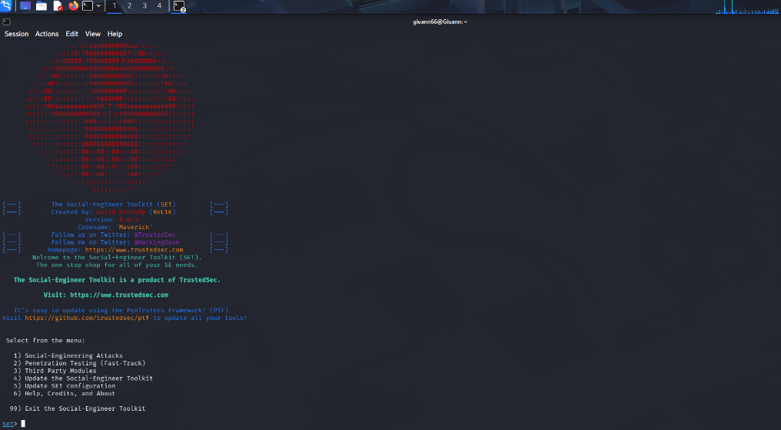
Figure 1 — Launching SET from the Kali terminal

Step 2 — Select Social-Engineering Attacks
Option 1 (Social-Engineering Attacks) was selected from the main menu, presenting a sub-menu of attack vectors including Spear-Phishing, Website Attack Vectors, Infectious Media, Mass Mailer, and others.

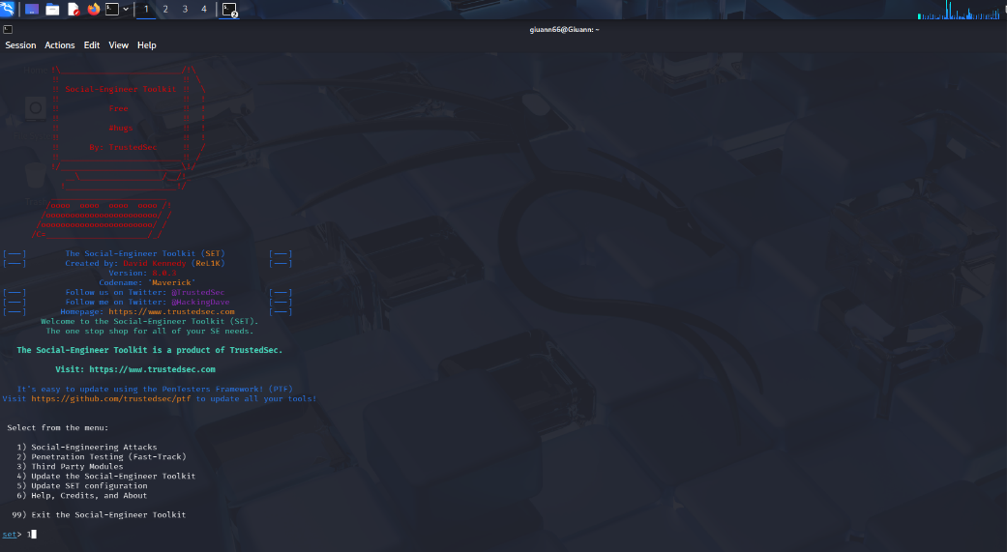
Figure 2 — Selecting Social-Engineering Attacks

Step 3 — Website Attack Vectors
Option 2 (Website Attack Vectors) was selected. SET presented descriptions of available web-based attack methods including the Credential Harvester, Java Applet Attack, Tabnabbing, Web-Jacking, Multi-Attack, and HTA Attack.

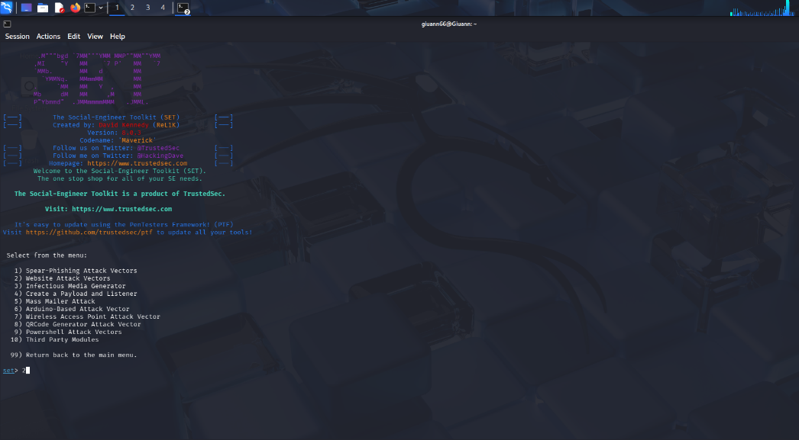
Figure 3 — Selecting Website Attack Vectors

Step 4 — Credential Harvester via Site Cloner
Option 3 (Credential Harvester Attack Method) was chosen, followed by Option 2 (Site Cloner). SET prompted for the listener IP address (10.0.2.15) and the URL of the page to clone. A local replica of a login form was used as the cloning target in the lab environment.

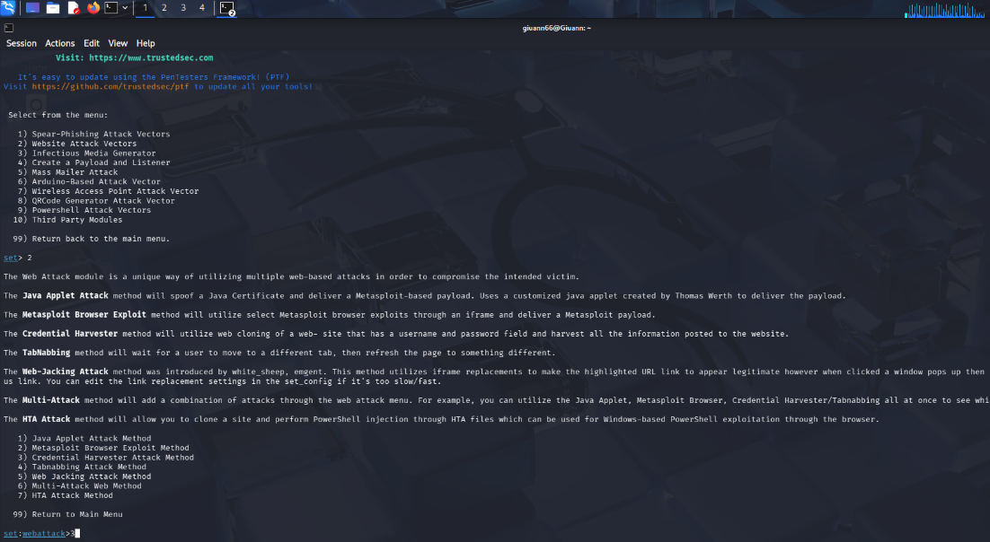
Figure 4 — Selecting Credential Harvester Attack Method

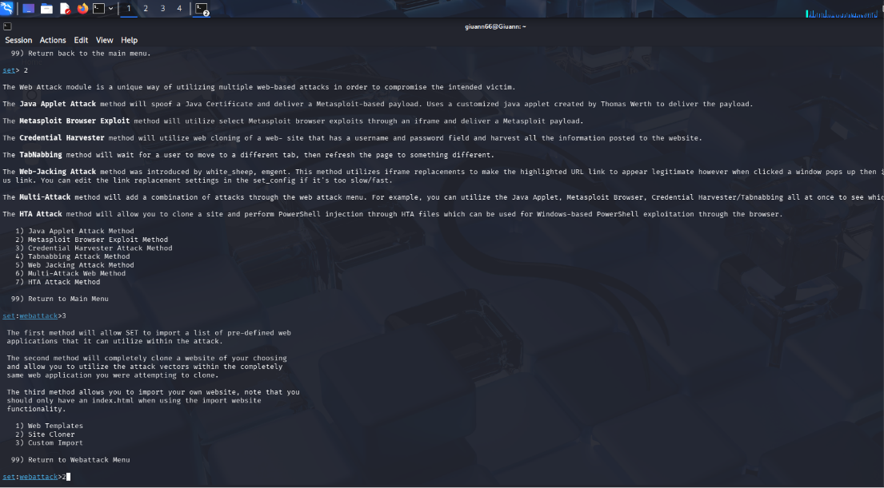
Figure 5 — Selecting Site Cloner

Step 5 — Capture & Observe
SET cloned the target login page and began listening on port 80. When a test form submission was made in the isolated browser, SET intercepted the POST request and printed the submitted form parameters to the terminal, demonstrating how credential harvesting works.

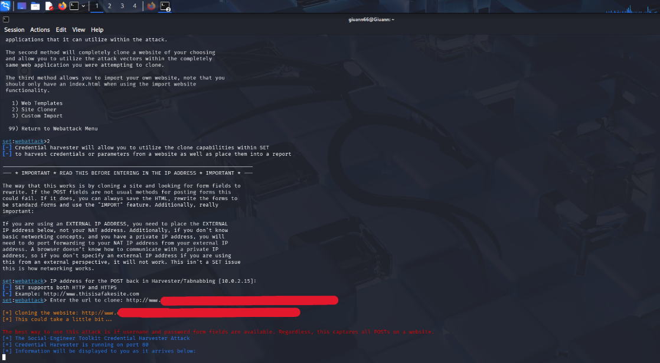
Figure 6 — Entering the url to clone

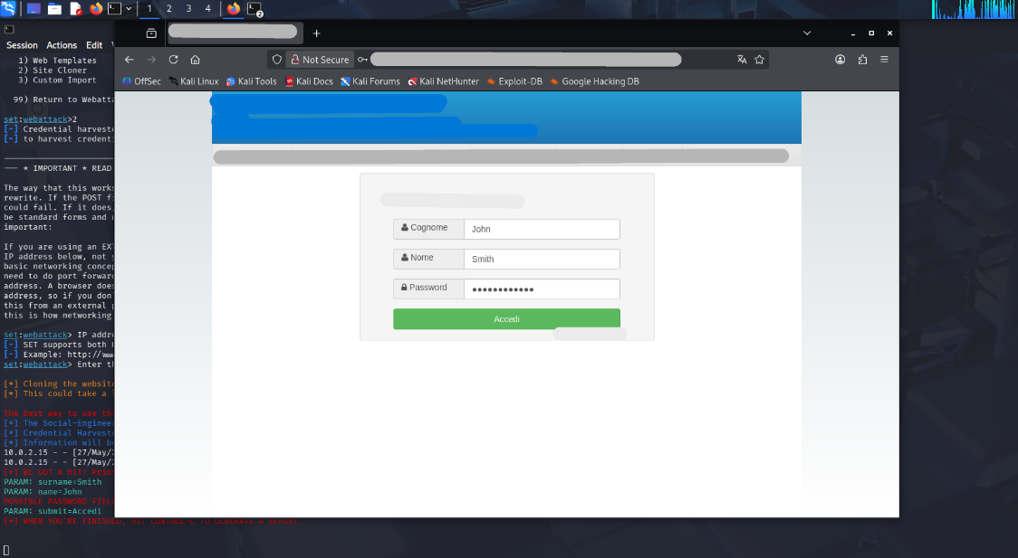
Figure 7 — Entering Login credential

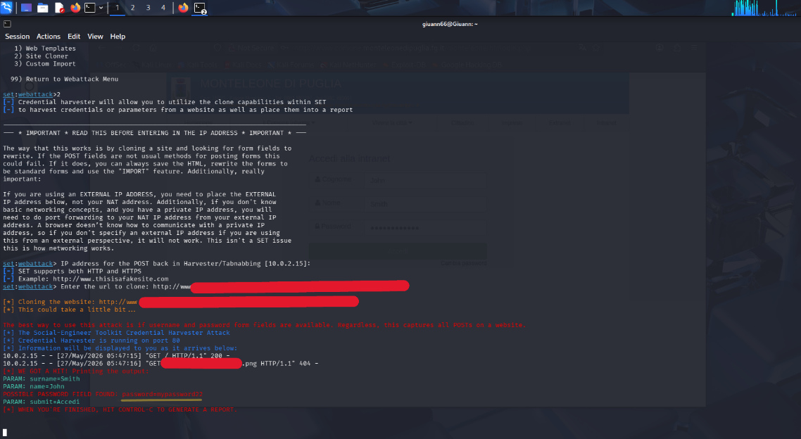
Figure 8 — Intercepted Credentials

4. Key Commands & Navigation
The following SET menu navigation path was used:

$ sudo setoolkit
set> 1 # Social-Engineering Attacks
set> 2 # Website Attack Vectors
set:webattack> 3 # Credential Harvester Attack Method
set:webattack> 2 # Site Cloner
IP for POST back: 10.0.2.15
URL to clone: [local lab login page]

5. Findings
Upon submitting the test login form in the isolated lab browser, SET successfully intercepted the POST request and displayed all submitted form parameters. The output confirmed that the Credential Harvester captured form fields including username, surname, and password fields.

Example of intercepted output (lab test data only):
[*] WE GOT A HIT! Printing the output:
PARAM: surname=Smith
PARAM: name=John
POSSIBLE PASSWORD FIELD FOUND: password=mypassword22
PARAM: submit=Accedi
[*] WHEN YOU'RE FINISHED, HIT CONTROL-C TO GENERATE A REPORT.

6. Defensive Recommendations
This exercise highlights several important defensive controls that organisations should implement:
- Multi-Factor Authentication (MFA): Even if credentials are harvested, MFA prevents account compromise by requiring a second factor that the attacker cannot intercept via a cloned page.
- Security Awareness Training: Regular phishing simulation exercises help users identify spoofed login pages by checking URLs, SSL certificates, and visual discrepancies.
- HSTS & Certificate Pinning: HTTP Strict Transport Security (HSTS) and certificate pinning make it harder to serve convincing clones over HTTP, as modern browsers will warn users.
- Email Filtering & URL Scanning: Gateway-level filtering can block links to known phishing domains before users ever receive them.
- Endpoint Detection & Response (EDR): EDR tools can detect unusual POST submissions and flag connections to suspicious or newly registered domains.

7. Conclusion
This lab exercise successfully demonstrated the ease with which the Social-Engineer Toolkit can be used to clone login pages and harvest submitted credentials in a controlled environment. The exercise reinforced the importance of user education, strong authentication mechanisms, and network-level controls as layered defences against social engineering attacks.
Understanding how these attacks work from an attacker's perspective is a core competency for penetration testers and security professionals, enabling them to better advise organisations on realistic threat scenarios and proportionate controls.

This report was produced for educational and portfolio purposes. All testing was performed in an isolated virtual lab environment.

