INCIDENT REPORT

Fernando Gesa

June 2026

-

NetSupport Manager RAT — Suspected Host Compromise Traffic Analysis Exercise

Report Date: | 02 June 2026
Incident Date: | 2026-02-28
Incident Time: | 19:55 UTC (activity start)
Exercise Source: | malware-traffic-analysis.net/2026/02/28/index.html
Analysis Tool: | Wireshark (MySOC profile)
PCAP File: | 2026-02-28-traffic-analysis-exercise.pcap
Classification: | Lab Exercise — Educational Purposes Only
Author: | Fernando Gesa

ALERT SOURCE: SIEM signature hits for NetSupport Manager RAT from 45.131.214.85 over TCP port 443.

- SIEM signature hits means the traffic matched a known bad pattern from the pre-written detection rule on the SIEM
- NetSupport Manager RAT is a legitimate remote desktop/IT support tool. However, threat actors abuse it as a Remote Access Trojan (RAT)
- 45.131.214.85 is the attacker's Command & Control (C2) server
- TCP port 443 is normally used for HTTPS (encrypted web traffic). The attacker deliberately chose this port because most firewalls and proxies allow outbound traffic on 443 without inspecting it closely. However, if you look at the pcap, the traffic is actually plain HTTP, not real HTTPS. It's just using port 443 to avoid being blocked. This is a common evasion technique

1. Executive Summary
On 2026-02-28 at 19:55 UTC, SIEM alerts identified NetSupport Manager RAT communication originating from an internal host on the easyas123.tech domain. The malicious traffic was directed at external IP 45.131.214.85 over TCP port 443, mimicking HTTPS traffic. Analysis of the packet capture confirmed a single infected Windows workstation was responsible for the activity.
The infected host was identified, and the associated user account was determined through a combination of HTTP POST traffic analysis, NetBIOS Name Service (NBNS) broadcasts, and Kerberos authentication records visible in the pcap.
TLDR: One internal Windows host (10.2.28.88 — DESKTOP-TEYQ2NR) was infected with NetSupport Manager RAT and beaconing to 45.131.214.85:443. The logged-on user was brolf.

2. Environment Details
The following network environment context was provided for this exercise:

Parameter | Value
LAN Segment | 10.2.28.0/24 (10.2.28.0 – 10.2.28.255)
Domain | easyas123.tech
AD Environment | EASYAS123
Domain Controller | 10.2.28.2 — EASYAS123-DC
Gateway | 10.2.28.1
Broadcast | 10.2.28.255
Threat Actor C2 | 45.131.214.85 (TCP 443)

3. Findings — Infected Host Details
The following details were extracted from the pcap and are confirmed as the infected Windows client:

Field | Value | How Identified
IP Address | 10.2.28.88 | Source IP of all HTTP POST requests to 45.131.214.85:443
MAC Address | 00:19:d1:b2:4d:ad | Ethernet II source in NBNS broadcast frames from 10.2.28.88
Hostname | DESKTOP-TEYQ2NR | NBNS registration broadcasts from the host (filter: nbns)
User Account | brolf | Kerberos AS-REQ CNameString (filter: kerberos.CNameString)

4. Analysis

4.1 NetSupport Manager RAT — C2 Beaconing
Applying the Wireshark display filter for HTTP POST requests to 45.131.214.85 revealed a high volume of regular outbound HTTP POST connections from 10.2.28.88 on source port 51912. The User-Agent string visible in the raw packet bytes confirmed the presence of NetSupport Manager:

Filter: (http.request or tls.handshake.type eq 1) and !(ssdp) and ip.addr eq 45.131.214.85
User-Agent: NetSupport Manager/1.3
POST fakeurl.htm HTTP/1.1
Host: 45.131.214.85
Content-Type: application/x-www-form-urlencoded

The beaconing began at frame 2638 (45.048 seconds into the capture, corresponding to 2026-02-28 19:55:51 UTC) and continued at regular approximately 60-second intervals throughout the capture, consistent with NetSupport Manager RAT's default polling behaviour.

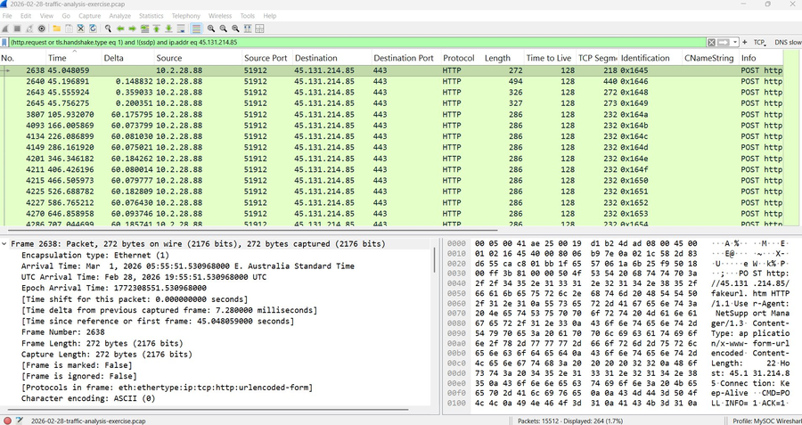
Figure 1 — HTTP POST beaconing from 10.2.28.88 to 45.131.214.85:443 with NetSupport Manager User-Agent visible in packet bytes

4.2 MAC Address & IP Identification via NBNS
Filtering for NBNS (NetBIOS Name Service) traffic using the display filter 'nbns' revealed broadcast registration packets from 10.2.28.88 to the subnet broadcast address 10.2.28.255. Expanding the Ethernet II layer in frame 135 confirmed the source MAC address of the infected host as 00:19:d1:b2:4d:ad (Intel NIC).

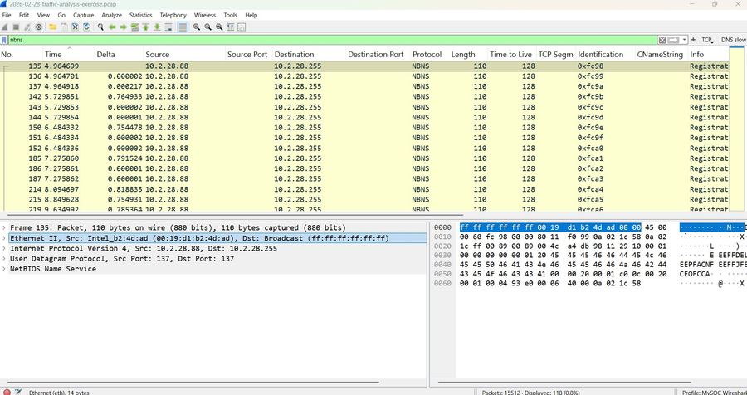
Figure 2 — NBNS broadcast from 10.2.28.88, Ethernet II layer showing MAC address 00:19:d1:b2:4d:ad
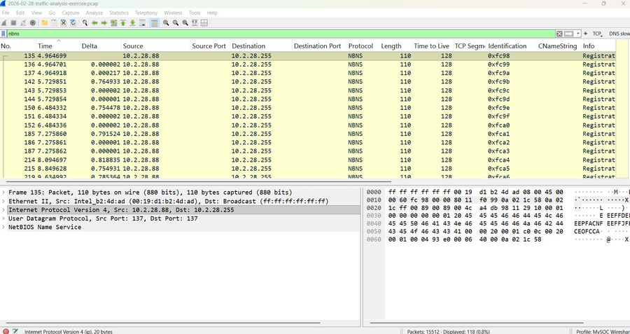
Figure 3 — IPv4 layer confirming source IP 10.2.28.88 and broadcast destination 10.2.28.255

4.3 Hostname Identification via NBNS
The NBNS registration packets in the same frame set contained the NetBIOS name being registered by the host. Decoding the NBNS payload confirmed the hostname as DESKTOP-TEYQ2NR, consistent with a default Windows 10/11 machine name format.

4.4 User Account via Kerberos
Filtering for Kerberos traffic using the display filter 'kerberos.CNameString' revealed AS-REQ (Authentication Service Request) packets from 10.2.28.88 to the domain controller at 10.2.28.2 on port 88. The CNameString field in the Kerberos AS-REQ body identified the authenticating user as brolf, confirming this was the active user session on the infected host at the time of compromise.
Filter: kerberos.CNameString
Frame 243 — AS-REQ from 10.2.28.88 to 10.2.28.2:88
CNameString: brolf
Realm: EASYAS123

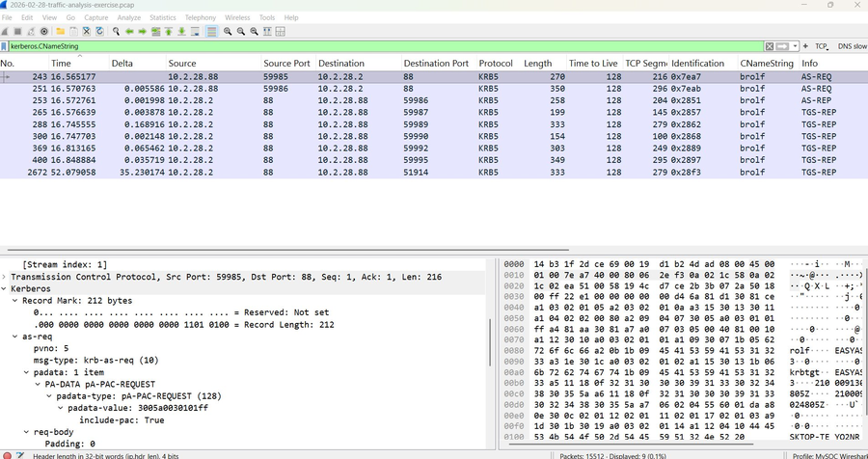
Figure 4 — Kerberos AS-REQ packets filtered by CNameString, showing user 'brolf' authenticating to EASYAS123-DC
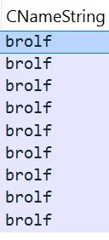
Figure 5 — CNameString column confirming all Kerberos requests associated with user account 'brolf'

5. Indicators of Compromise (IOCs)

Type | Value | Notes
IP (C2) | 45.131.214.85 | NetSupport RAT C2 server
Port | TCP 443 | HTTP over non-HTTPS port 443
User-Agent | NetSupport Manager/1.3 | Visible in HTTP POST packets
URL | POST /fakeurl.htm HTTP/1.1 | Consistent across all beacons

6. Recommended Actions
Based on the findings, the following immediate and follow-up actions are recommended:

- Isolate DESKTOP-TEYQ2NR (10.2.28.88) from the network immediately to prevent further C2 communication.
- Block outbound connections to 45.131.214.85 at the perimeter firewall.
- Notify and interview user brolf to determine how the infection occurred (phishing link, malicious download, etc.).
- Perform full forensic imaging of DESKTOP-TEYQ2NR before remediation.
- Rotate credentials for brolf and audit for lateral movement or privilege escalation within the EASYAS123 domain.
- Review SIEM rules to add the NetSupport Manager User-Agent string and fakeurl.htm POST pattern as high-confidence detection signatures.

7. Conclusion
Analysis of the provided pcap confirmed that Windows workstation DESKTOP-TEYQ2NR (10.2.28.88, MAC 00:19:d1:b2:4d:ad) was infected with NetSupport Manager RAT and actively beaconing to the threat actor's C2 server at 45.131.214.85 over TCP 443. The active user session belonged to domain account brolf in the EASYAS123 environment. The infection was first observed at 2026-02-28 19:55 UTC and continued at regular 60-second intervals throughout the captured traffic window.
The host should be treated as fully compromised. Immediate isolation, credential rotation, and forensic investigation are required before the device is returned to service.

Traffic Analysis Exercise — malware-traffic-analysis.net/2026/02/28/index.html | Lab report produced for educational and portfolio purposes.

