Senior Data Scientist
Risk Modeling Challenge

Origination Classification Model

EDA • Feature Engineering • Multi-Model Comparison • Hyperparameter Tuning • Deployment

May 2026

Exploratory Data Analysis

Dataset Overview
The dataset contains 1,000 company-level observations with 28 predictor variables and a binary target. Features come from two sources: SERPRO (7 variables on corporate structure and governance) and BACEN (21 variables on credit behavior and delinquency). The target is imbalanced: 854 good (85.4%) versus 146 bad (14.6%). This ~15% bad rate is typical for SME origination portfolios and shapes everything from metric selection to class weighting.
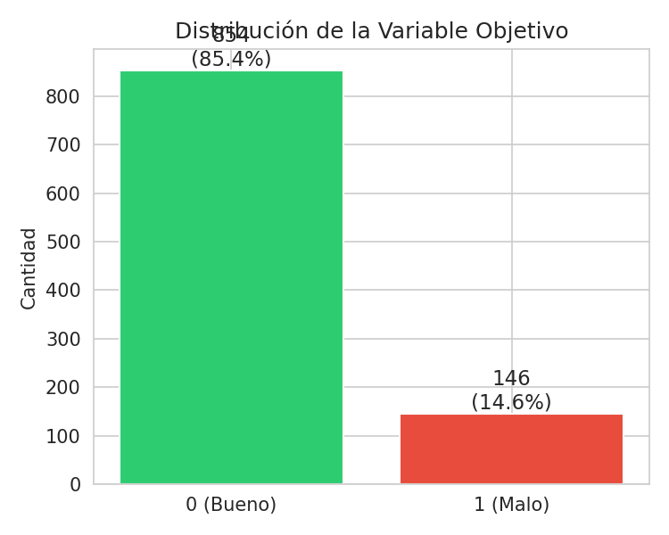

Missing Values
The missing pattern is informative rather than random. Credit card variables (_cc_ suffix) have 38.3% nulls, while general BACEN variables sit around 28–32%. This reflects companies without active credit products — itself a risk signal. SERPRO variables are complete. Rather than naively imputing, we leverage this pattern in feature engineering by creating explicit absence indicators.
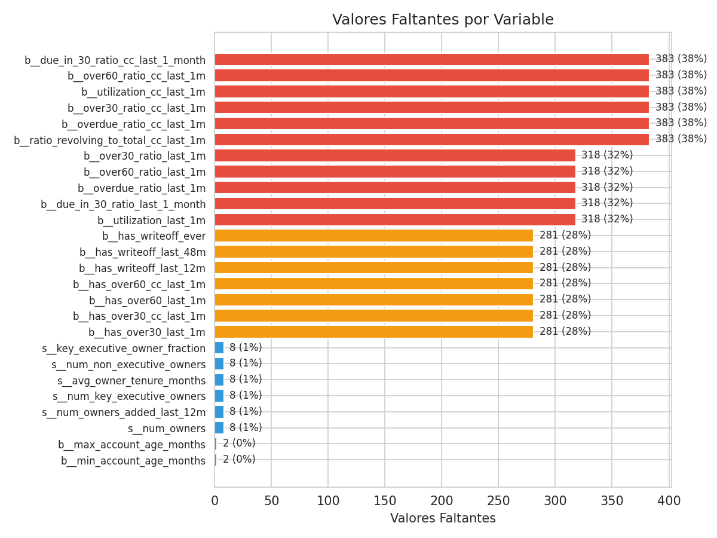

Distributions by Risk Class
Bad companies tend toward younger financial accounts, higher credit utilization, and elevated delinquency ratios. The separation is visible but not dramatic, which is expected — if these features cleanly separated good from bad, there wouldn't be much modeling to do.
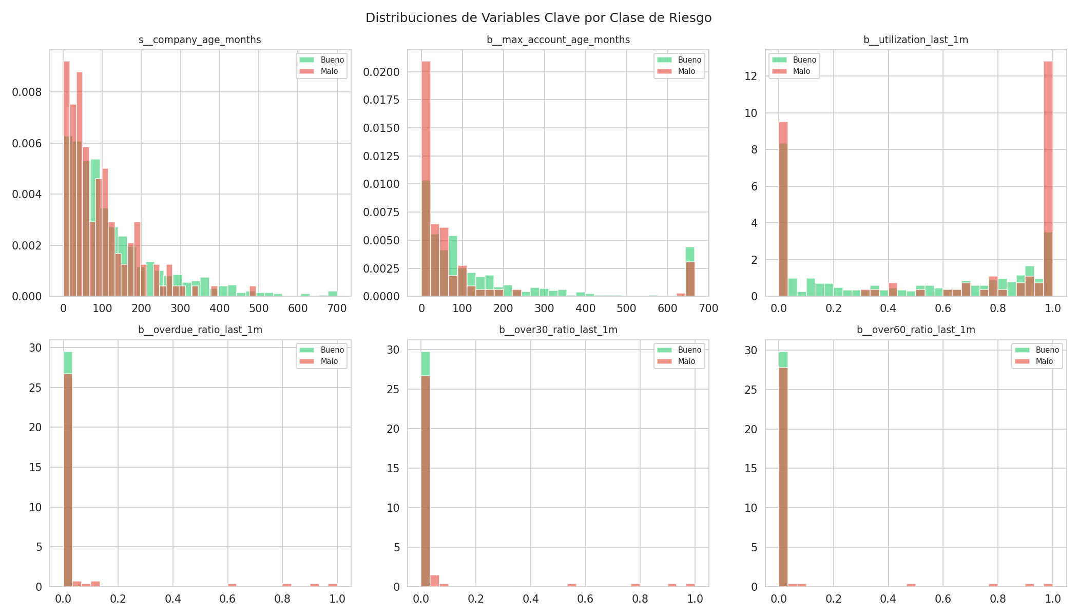

Bad Rate by Delinquency Flags
Binary delinquency indicators show clear discriminating power. Companies with any write-off history in the last 48 months carry substantially higher default rates. The presence of 30+ or 60+ day past-due balances in the last month also elevates risk meaningfully.
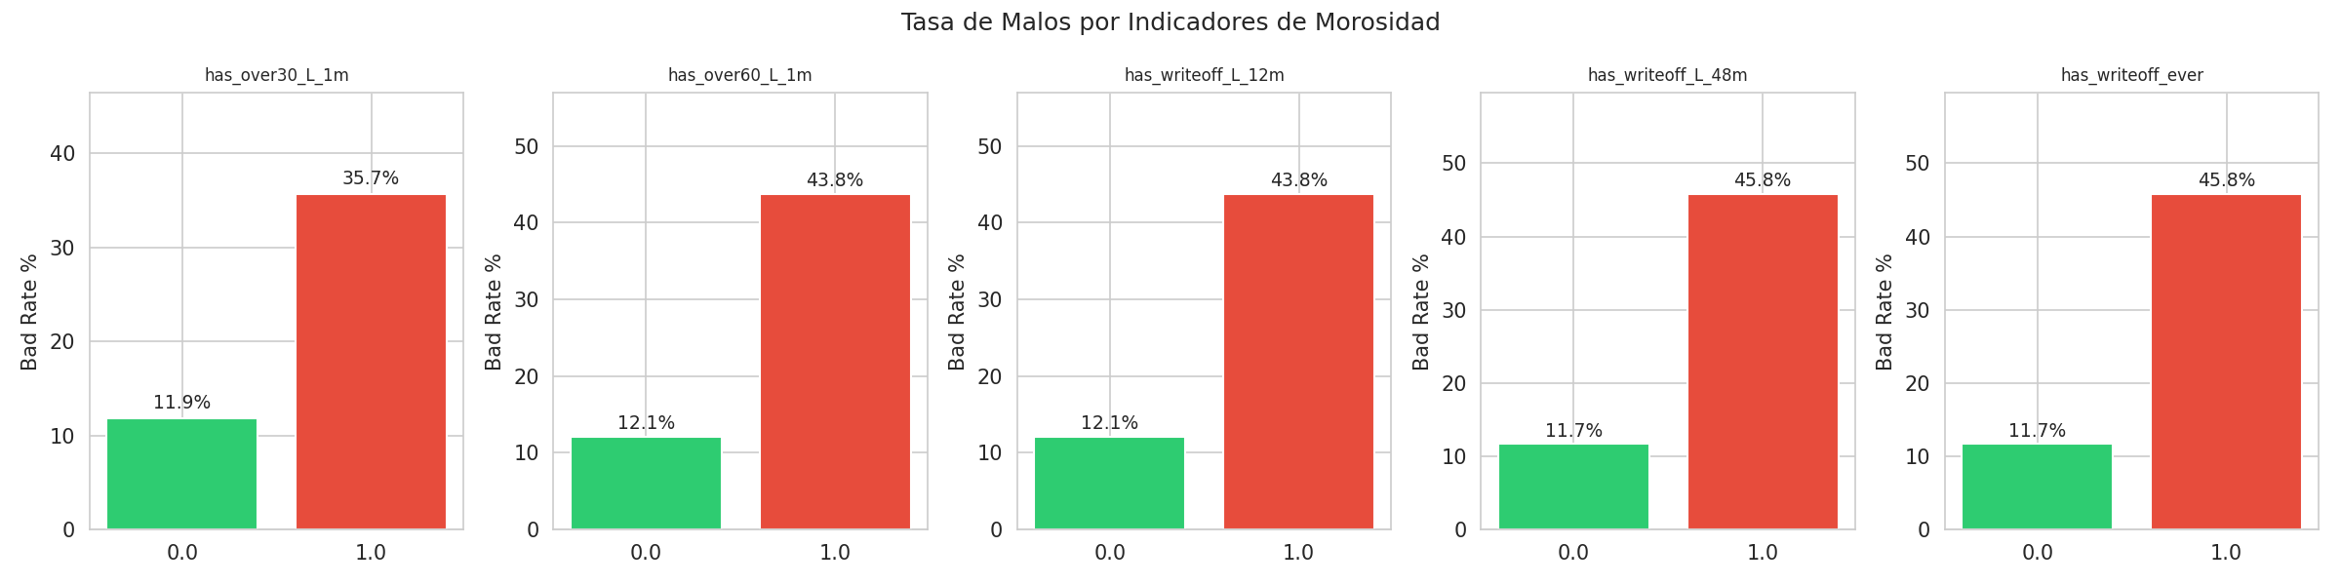

Correlation with Target
Spearman correlation reveals two predictive clusters. Corporate structure variables (number of owners at ρ=−0.287, executive owners at ρ=−0.230) carry negative correlation — more owners means lower risk, likely because these are more mature firms with diversified governance. Credit history variables (write-off flags, delinquency ratios) carry positive correlation with default.
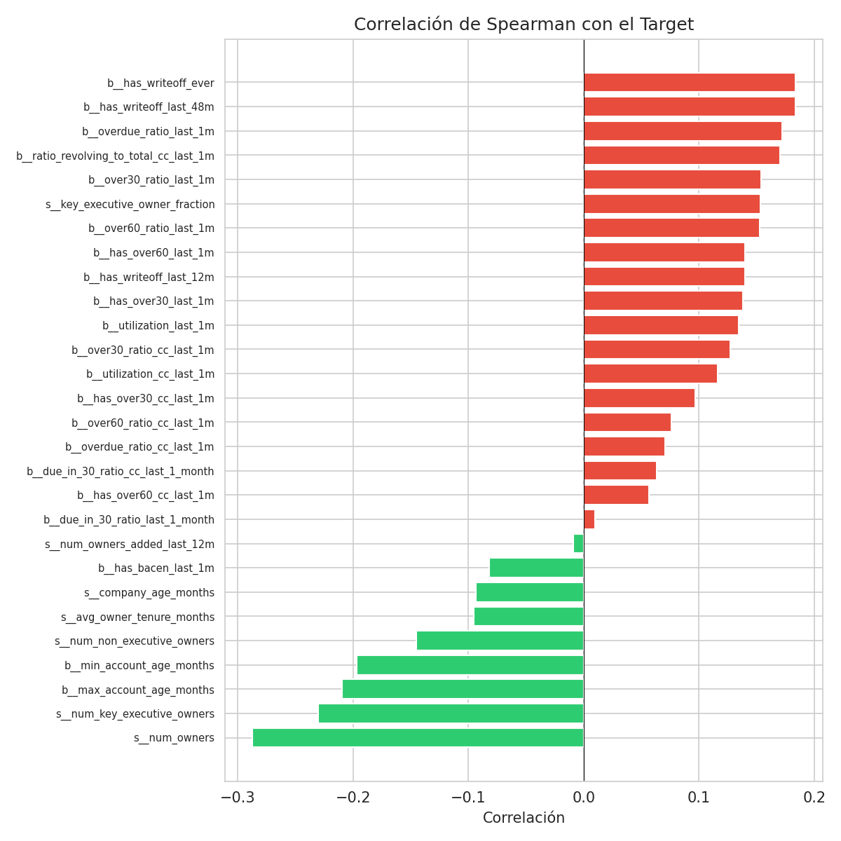

Statistical Tests
Mann-Whitney U tests confirm that 22 out of 28 features differ significantly between good and bad companies (p < 0.05). The five strongest discriminators are shown below. Chi-squared tests on binary BACEN flags validate the association, with has_writeoff_ever leading at χ²=28.42 (p=6.75e−07).
Variable | p-value | Med. Good | Med. Bad
serpro__num_owners | 1.44e-19 | 2.000 | 1.000
serpro__num_key_exec_owners | 4.42e-13 | 1.000 | 1.000
bacen__max_account_age | 3.62e-11 | 74.484 | 29.065
bacen__min_account_age | 5.02e-10 | 48.758 | 11.952
bacen__has_writeoff_48m | 8.48e-07 | 0.000 | 0.000

Feature Engineering
We created 33 new variables (28 → 61 total features) organized into seven domain-driven categories. Each feature is grounded in credit risk fundamentals rather than blind transformation.

Missing-as-Feature
Absence of BACEN data isn't random — it signals companies without active credit products, which represents a distinct risk profile. Three binary indicators were created: has_no_bacen_data, missing_cc_data, and missing_bacen_ratios.

Age and Maturity
Six variables capture company maturity and financial track record: company_age_years, is_young_company (<24 months), is_very_young_company (<6 months), account_age_range (spread between oldest and newest accounts), company_vs_max_account_age (how long before the company got credit), and account_to_company_age_ratio (proportion of company life with financial products).

Corporate Governance
Five variables capture ownership structure. Notably, is_sole_owner turned out to be the single most predictive feature (ρ=0.287), outperforming every original variable. Additional features include owners_added_ratio, all_owners_are_new, owner_tenure_vs_company_age, and has_non_executive_owners.

Composite Credit Stress
Rather than treating each delinquency flag independently, we built four composite scores: any_delinquency (binary, any 30+ or 60+ DPD), severe_delinquency (60+ DPD or recent write-off), delinquency_score (weighted: over30=1, over60=2, writeoff_12m=3, writeoff_48m=2, writeoff_ever=1), and writeoff_escalation (temporal write-off sub-score).

Utilization and Payment Behavior
Five variables capturing financial stress: high_utilization (>80%), very_high_utilization (>95%), cc_utilization_excess (credit card vs. total utilization ratio), overdue_intensity (sum of delinquency ratios), and overdue_intensity_cc (credit card equivalent).

Domain Interactions
Four interaction terms that capture compound risk profiles individual variables miss: young_company × delinquency, sole_owner × young, high_utilization × delinquency, and no_bacen_data × young. A young sole-owner company with active delinquency is a fundamentally different risk than each factor alone.

Log Transforms
Log(1+x) applied to the four age variables (company_age, max/min_account_age, avg_owner_tenure) to reduce skewness and capture diminishing marginal returns of tenure on risk reduction.
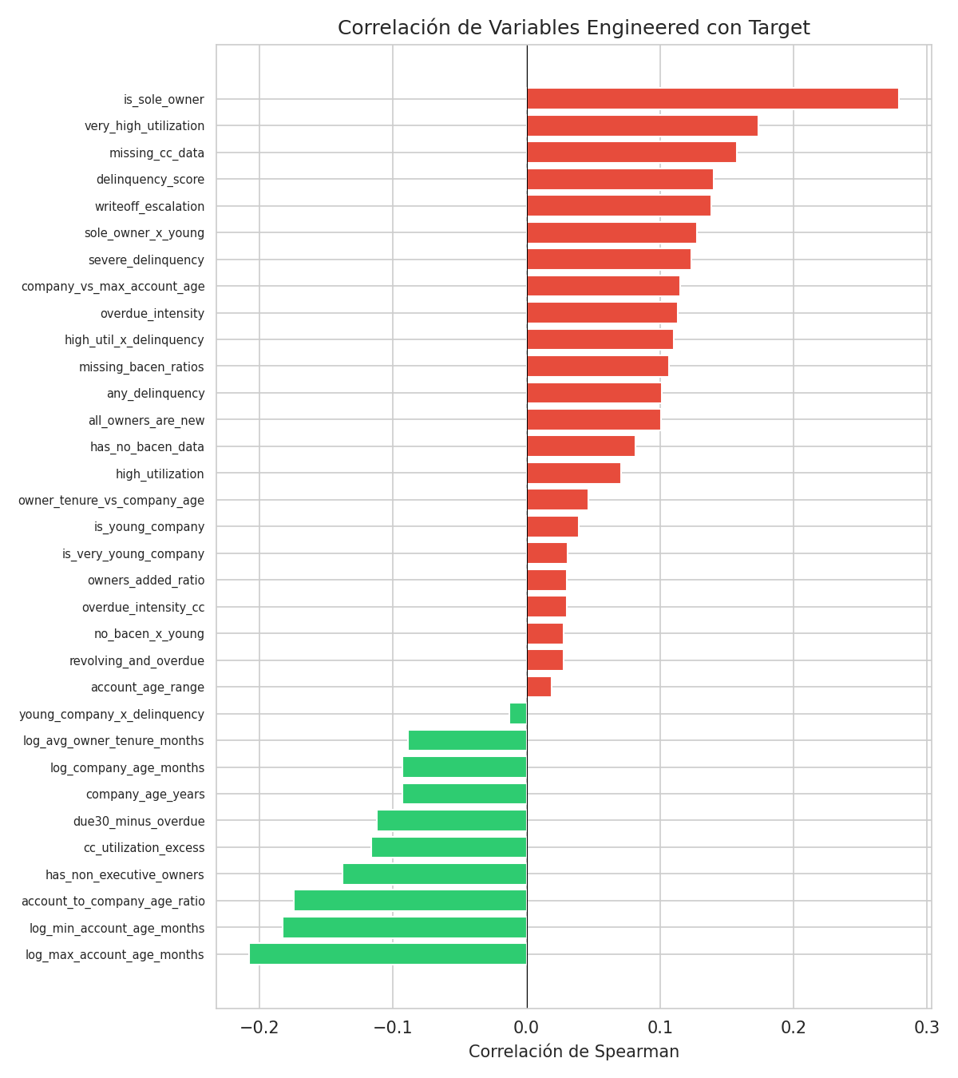

Model Development and Hyperparameter Tuning

Approach
Six models were trained, each with RandomizedSearchCV (15 iterations, 3-fold inner CV optimizing AUC-ROC) followed by 5-fold stratified outer CV for unbiased evaluation. Class imbalance was handled via scale_pos_weight or class_weight='balanced' depending on the model. All random seeds were fixed for reproducibility.

Models and Search Spaces
- LightGBM: Gradient boosting optimized for speed, handles NaN natively. Grid: n_estimators, learning_rate, max_depth, num_leaves, min_child_samples, subsample, colsample_bytree, reg_alpha, reg_lambda.
- XGBoost: Gradient boosting with L1/L2 regularization. Grid adds gamma and min_child_weight.
- CatBoost: Ordered boosting to reduce overfitting. Grid: iterations, learning_rate, depth, l2_leaf_reg, min_data_in_leaf, bagging_temperature, random_strength.
- Random Forest: Bagged tree ensemble. Grid: n_estimators, max_depth, min_samples_leaf, min_samples_split, max_features.
- Extra Trees: Random Forest variant with random splits. Same grid as Random Forest.
- Logistic Regression: Interpretable baseline via pipeline (median imputation + standardization). Grid: C, solver, imputer strategy.

Results: Before vs After HPO
Model | AUC Pre | AUC Post | Δ AUC | Gini | KS | AP
XGBoost | 0.7734 | 0.7937 | +0.0203 | 0.5874 | 0.4673 | 0.3460
CatBoost | 0.7823 | 0.7920 | +0.0097 | 0.5840 | 0.4624 | 0.3519
LightGBM | 0.7844 | 0.7918 | +0.0075 | 0.5837 | 0.4576 | 0.3466
Random Forest | 0.7589 | 0.7787 | +0.0199 | 0.5575 | 0.4452 | 0.3190
Log. Regression | 0.7740 | 0.7675 | -0.0065 | 0.5350 | 0.4342 | 0.3369
Extra Trees | 0.7357 | 0.7659 | +0.0301 | 0.5317 | 0.4339 | 0.3316

The three gradient boosting models converge to very similar performance after tuning (AUC 0.792–0.794), separated by less than 0.002. XGBoost leads with AUC=0.7937 and Gini=0.5874. The largest HPO benefit goes to Extra Trees (+4.1%), followed by XGBoost and Random Forest (+2.6%). Logistic Regression slightly degrades with HPO, suggesting its original hyperparameters were already near-optimal.
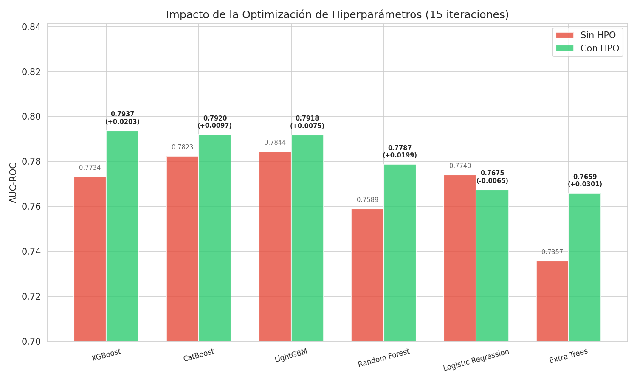

Optimal Hyperparameters (Top 3)
XGBoost landed on n_estimators=200, learning_rate=0.03, max_depth=6, min_child_weight=5, subsample=0.8, colsample_bytree=0.7, reg_alpha=0.1, reg_lambda=0.1, gamma=1.0. The higher depth (6 vs default 4) paired with a lower learning rate suggests the model benefits from more expressive trees with slower convergence. The gamma=1.0 provides additional leaf-level regularization to compensate.
CatBoost settled on iterations=100, learning_rate=0.05, depth=6, l2_leaf_reg=3, min_data_in_leaf=10, bagging_temperature=0.5. Fewer iterations with moderate regularization and depth.
LightGBM chose n_estimators=100, learning_rate=0.1, max_depth=4, num_leaves=15, min_child_samples=50. More conservative — fewer trees, higher learning rate, and high minimum samples per leaf.
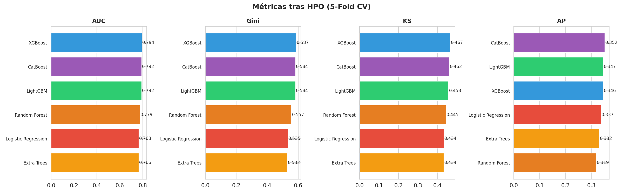

Model Evaluation

ROC and Precision-Recall Curves
XGBoost dominates in the low-FPR region (0.0–0.3), which is the operationally relevant zone for origination — where we want to maximize bad detection without rejecting too many good applicants. In the Precision-Recall space, CatBoost shows the highest Average Precision (0.352), suggesting it may be preferable at conservative decision thresholds.
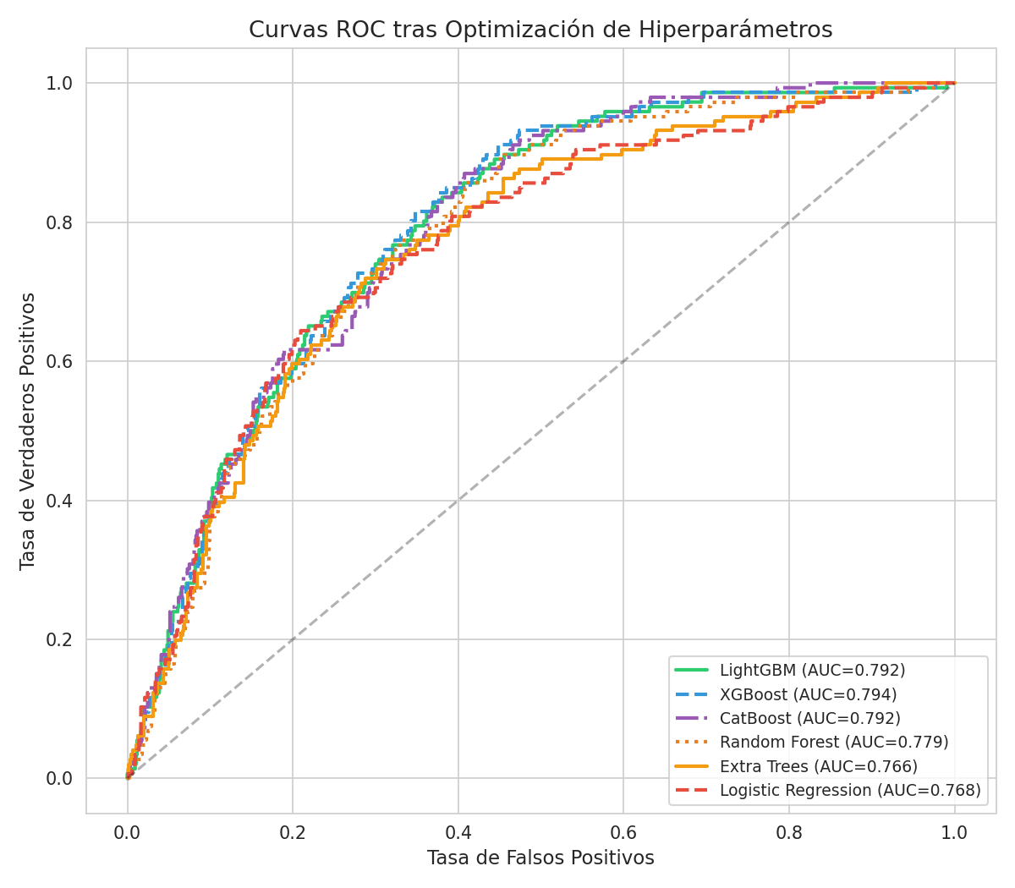
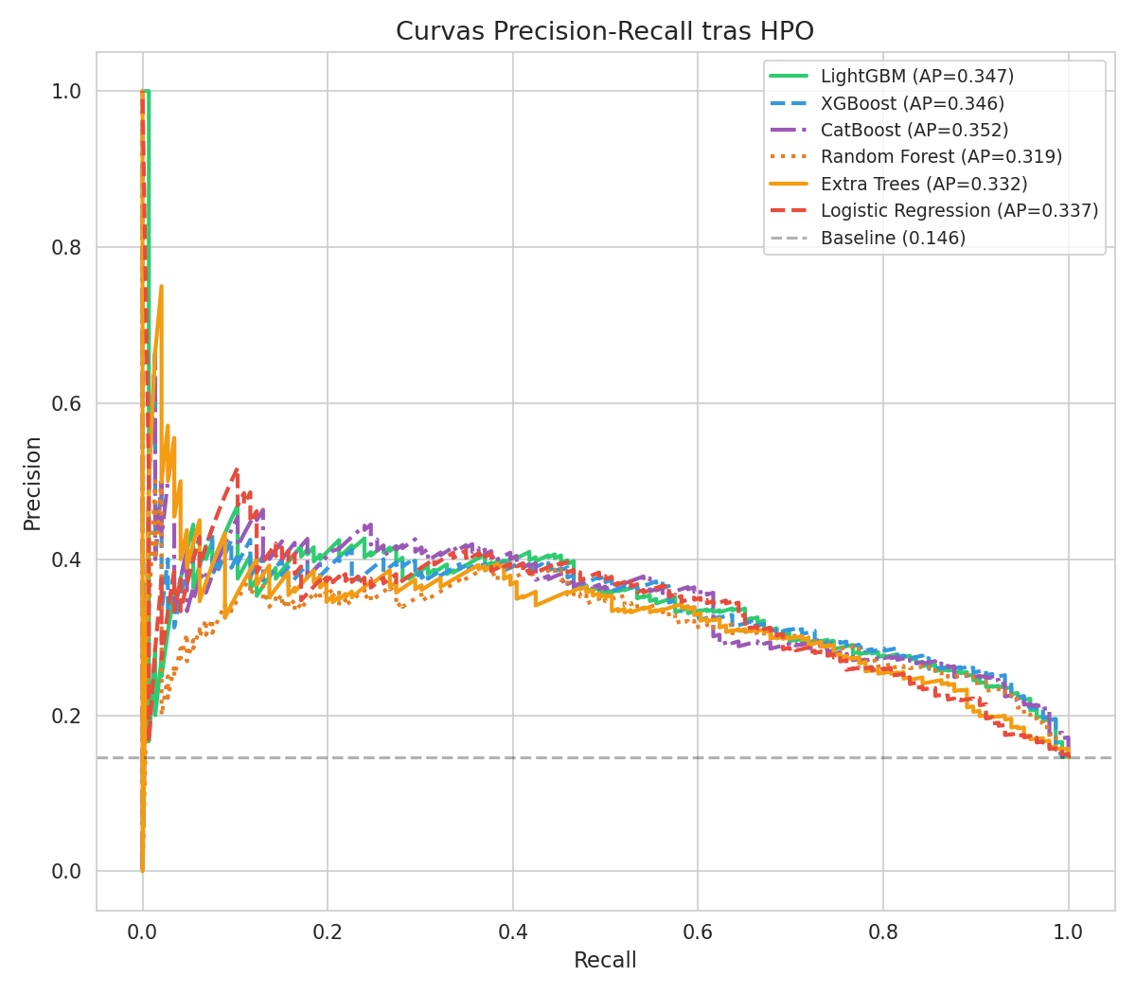

KS Curve
The KS statistic of 0.467 indicates strong separation between the cumulative distributions of good and bad scores. In the industry, KS > 0.40 is considered "good" for origination scoring. The optimal threshold sits at approximately 0.174.
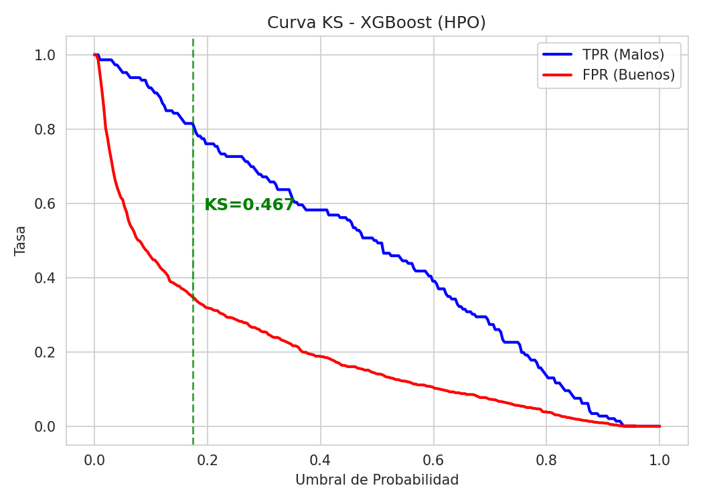

Decile Analysis
The model achieves perfectly monotonic risk ordering. Deciles 1–3 contain only 2.7% of all defaults (bad rates 0–2%), while decile 10 concentrates 26.7% of defaults with a 39% bad rate. Rejecting the bottom two deciles (20% of applications) would catch over 50% of all future defaults.
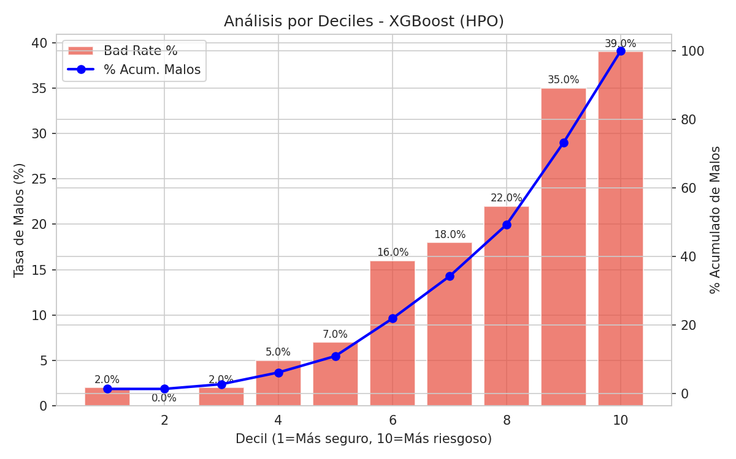
Decile | Count | Bads | Bad Rate | Avg Prob | Cum Bad %
1 | 100 | 2 | 2.0% | 0.010 | 1.4%
2 | 100 | 0 | 0.0% | 0.019 | 1.4%
3 | 100 | 2 | 2.0% | 0.031 | 2.7%
4 | 100 | 5 | 5.0% | 0.051 | 6.2%
5 | 100 | 7 | 7.0% | 0.087 | 11.0%
6 | 100 | 16 | 16.0% | 0.146 | 21.9%
7 | 100 | 18 | 18.0% | 0.251 | 34.2%
8 | 100 | 22 | 22.0% | 0.395 | 49.3%
9 | 100 | 35 | 35.0% | 0.591 | 73.3%
10 | 100 | 39 | 39.0% | 0.811 | 100.0%

Confusion Matrix and Trade-offs
At the KS-optimal threshold (0.174), the model captures 81.5% of bad companies (recall) at a precision of 28.6%. Put differently, for every 3.5 rejections, one is a true default. In origination, where the cost of approving a bad customer is typically 5–10x the margin on a good one, this trade-off is economically favorable.
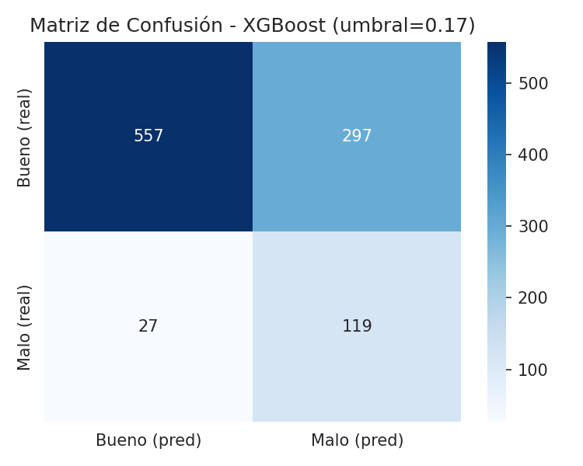

Feature Importance
The top features mix original and engineered variables: serpro__num_owners leads, followed by fe__is_sole_owner, serpro__num_key_executive_owners, and bacen__has_over30_last_1m. Six of the top 15 are engineered features, confirming the feature engineering added genuine predictive signal rather than noise.
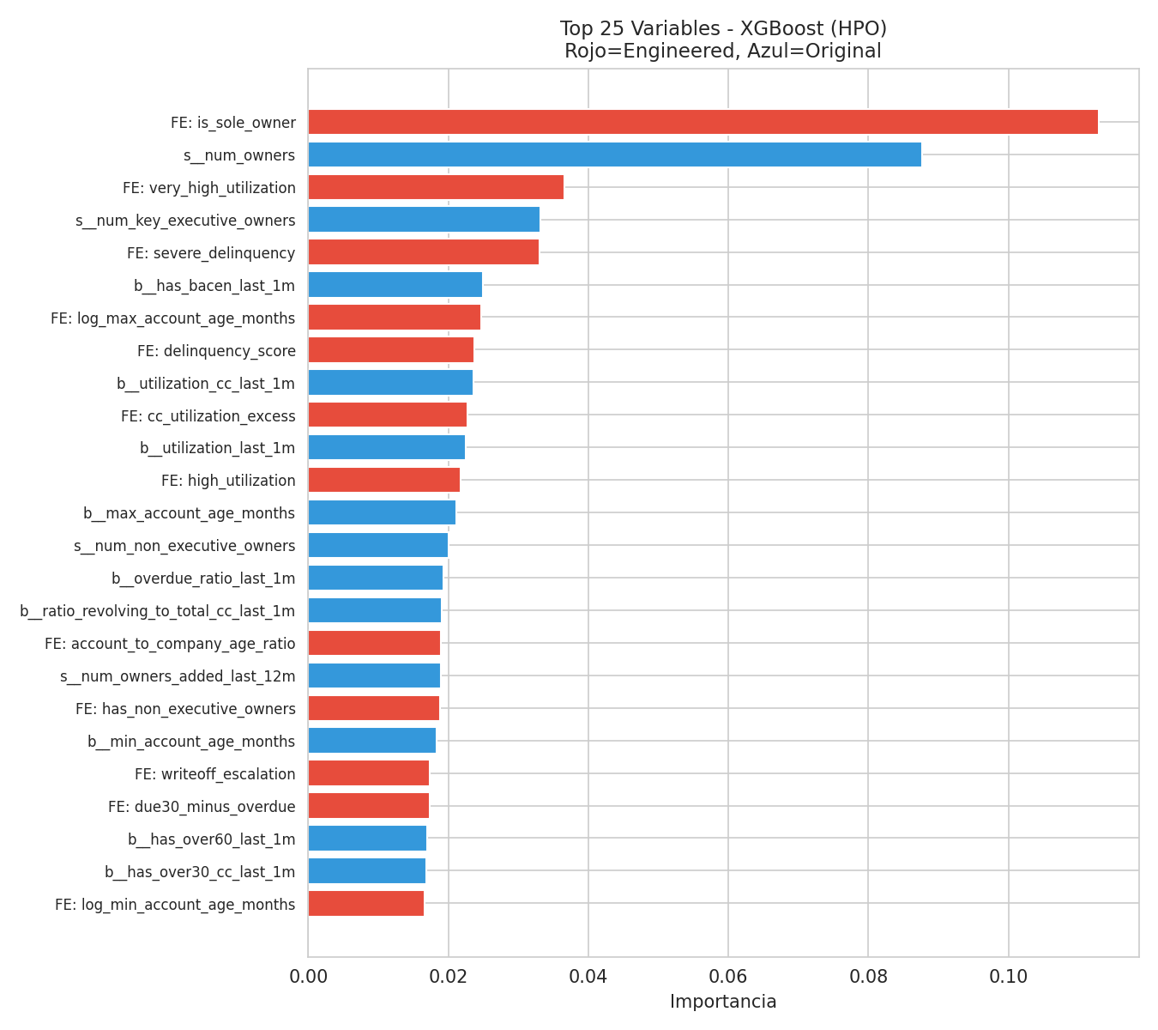

Why These Metrics
In origination, AUC and Gini measure global ranking ability — whether higher-scored applicants are genuinely safer. The KS statistic identifies the point of maximum separation, which typically aligns with the operational cutoff. Average Precision is more informative than accuracy on imbalanced datasets (a model predicting "good" for everyone would achieve 85.4% accuracy while detecting zero defaults). We deliberately avoid accuracy as a primary metric.

Deployment Architecture
- Ingestion layer: API Gateway receives origination requests and orchestrates real-time queries to SERPRO and BACEN. The feature engineering pipeline (33 derived variables) runs as a deterministic transformation within the same service. Caching with configurable TTL reduces latency.
- Scoring layer: Serialized XGBoost model inside a FastAPI microservice (Docker container) returning default probability, risk decile, and recommended decision. Target latency < 200ms. Champion/challenger framework for safe model rollouts.
- Monitoring layer: PSI and CSI tracking over 30-day rolling windows for drift detection. Gini and KS monitored against realized outcomes (6–12 month lag). Alerts if PSI > 0.25 or Gini drops > 10% from baseline.
- Infrastructure: Kubernetes orchestration, centralized logging (ELK), MLflow for model versioning, CI/CD with metric validation before promotion. Full traceability: data hash, hyperparameters, metrics, and feature set for every model version.

Limitations and Next Steps

Key Limitations
The dataset of 1,000 observations with only 146 positive events yields an events-per-variable ratio of approximately 2.4, well below the recommended 10–20 for reliable classification models. This limits stability and generalization confidence despite aggressive regularization and cross-validation. The dataset lacks key variables for business credit assessment: revenue, cash flow, industry sector, geography, and macroeconomic indicators. High multicollinearity among delinquency ratios may cause instability in feature importance across retraining cycles. The model assumes stationarity — performance may degrade under shifting macroeconomic conditions.

Selection Bias
Origination data inherently suffers from selection bias: we only observe outcomes for approved applications. Rejected applicants are absent from the dataset, biasing default probability estimates downward. Reject inference techniques (parceling, extrapolation, or augmentation methods) should be applied before production deployment to correct for this.

Proposed Improvements
- Data enrichment: Alternative bureau data, electronic invoicing records, and sectoral macroeconomic indicators.
- Advanced modeling: Survival analysis to model time-to-default, ensemble stacking combining XGBoost with WoE logistic regression, and temporal features with rolling windows.
- Calibration: Platt scaling or isotonic regression to align predicted probabilities with observed default rates.
- Segmentation: Specialized models for new vs. established companies, or companies with vs. without credit history.
- Fairness: Implement fairness metrics to detect and mitigate discriminatory bias in model decisions.
- Validation: Periodic backtesting against realized outcomes and out-of-time validation on future cohorts.

