Fernando Contreras
Assignment 5.1 – Movies: Setup
April 19, 2026

Step 1: Running the SQL Script
The db_init_2022.sql script was run from the MySQL command line using the following commands:
USE movies;
source <path>/db_init_2022.sql;
The script created the movies_user, set up the studio, genre, and film tables, and inserted the initial records. The screenshot below shows the output after running the script.

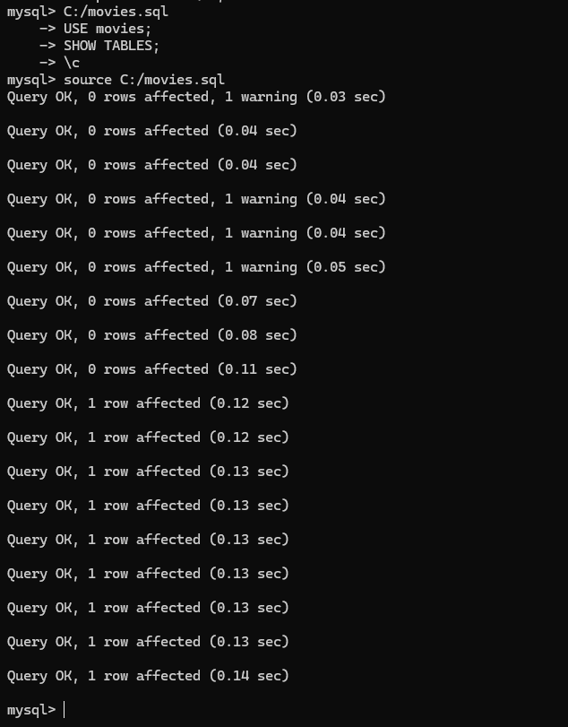

Step 2: Show Tables
After running the script, the following command was used to confirm the tables were created successfully:
USE movies;
SHOW TABLES;
The screenshot below shows the output of the SHOW TABLES command, confirming that the studio, genre, and film tables were created.
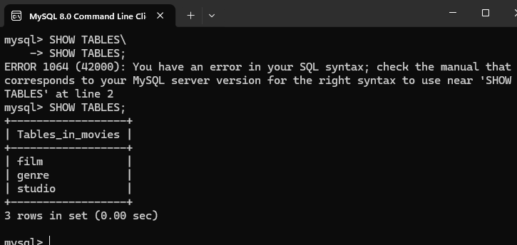

Step 3: Python Connector – mysql_test.py
The mysql-connector-python and python-dotenv packages were installed using pip:
pip install mysql-connector-python
pip install python-dotenv
A .env file was created in the module-5 directory to securely store the database login credentials. This file is listed in .gitignore so it is not pushed to GitHub.
The mysql_test.py script was then run to verify the Python-to-MySQL connection. The screenshot below shows the successful connection output.

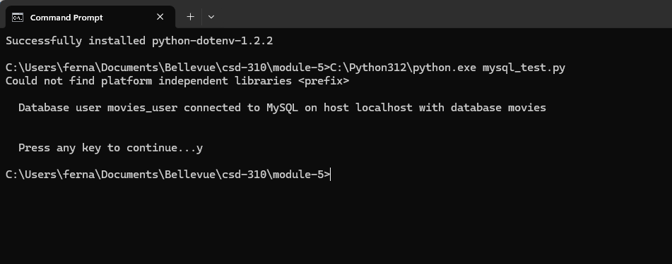

GitHub Repository: https://github.com/fernandojosecc/CSD-310

