Fernando Contreras
Assignment 4.3 – Movies ERD
April 19, 2026

Business Rules
The following business rules were used to design the Entity Relationship Diagram (ERD):
- One STUDIO can produce many FILMs
- One FILM can be described using one GENRE

Assumptions
The following assumptions were made when designing the ERD:
- Each FILM is produced by exactly one STUDIO (mandatory, one-to-many relationship)
- Each FILM belongs to exactly one GENRE (one-to-one relationship)
- A STUDIO may have zero or more FILMs associated with it
- studio_id and genre_id in the FILM table serve as foreign keys linking to their respective parent tables

Entity Relationship Diagram (ERD)
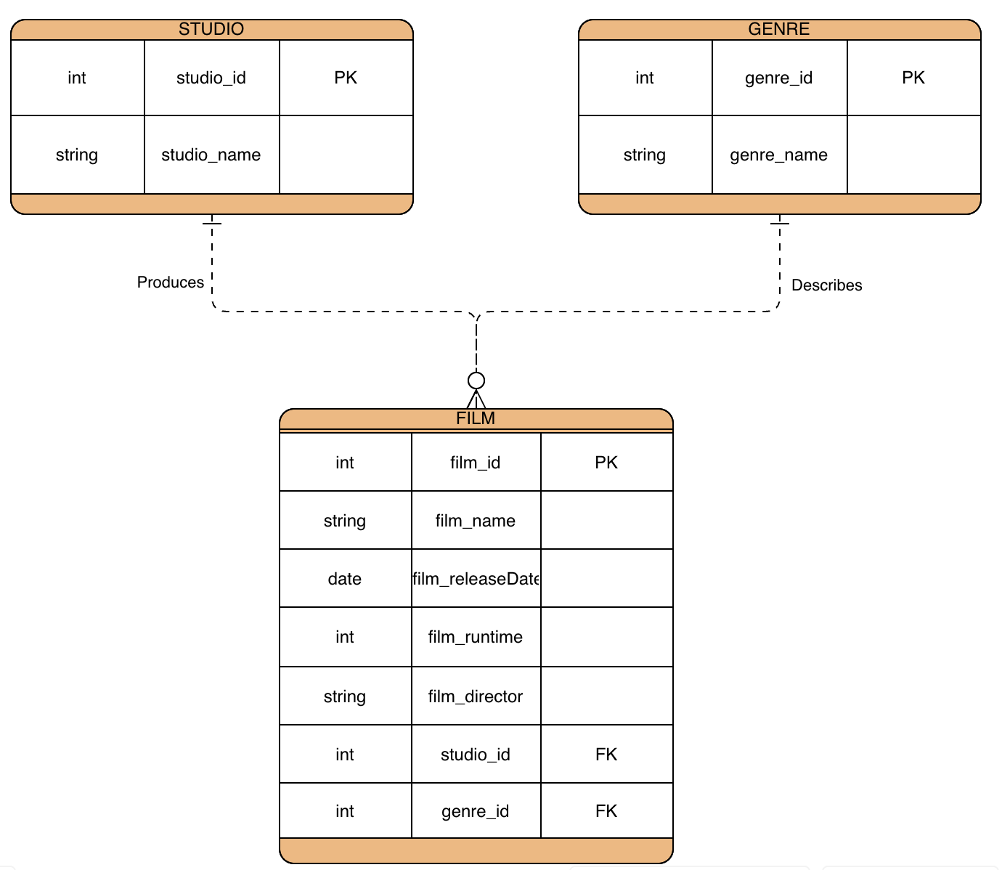

Entity Descriptions

STUDIO
Stores information about the studios that produce films.
studio_id — Primary Key. Unique identifier for each studio.
studio_name — The name of the studio.

GENRE
Stores the genre categories used to describe films.
genre_id — Primary Key. Unique identifier for each genre.
genre_name — The name of the genre (e.g., Action, Drama, Comedy).

FILM
Stores information about each film. Links to both STUDIO and GENRE via foreign keys.
film_id — Primary Key. Unique identifier for each film.
film_name — The title of the film.
film_releaseDate — The date the film was released.
film_runtime — The runtime of the film in minutes.
film_director — The name of the film's director.
studio_id — Foreign Key referencing STUDIO(studio_id).
genre_id — Foreign Key referencing GENRE(genre_id).

