Fernando Contreras
Assignment 7.2: Unit Testing Assignment
May 1, 2026

a) Write a function that accepts two parameters: a city name and a country name. The function should return a single string of the form City, Country, such as Santiago, Chile. Store the function in a file named city_functions.py. In the same file, call the function at least three times using a City, Country values. Execute city_functions.py and take a screenshot of the result. Paste that screenshot into your Word document.
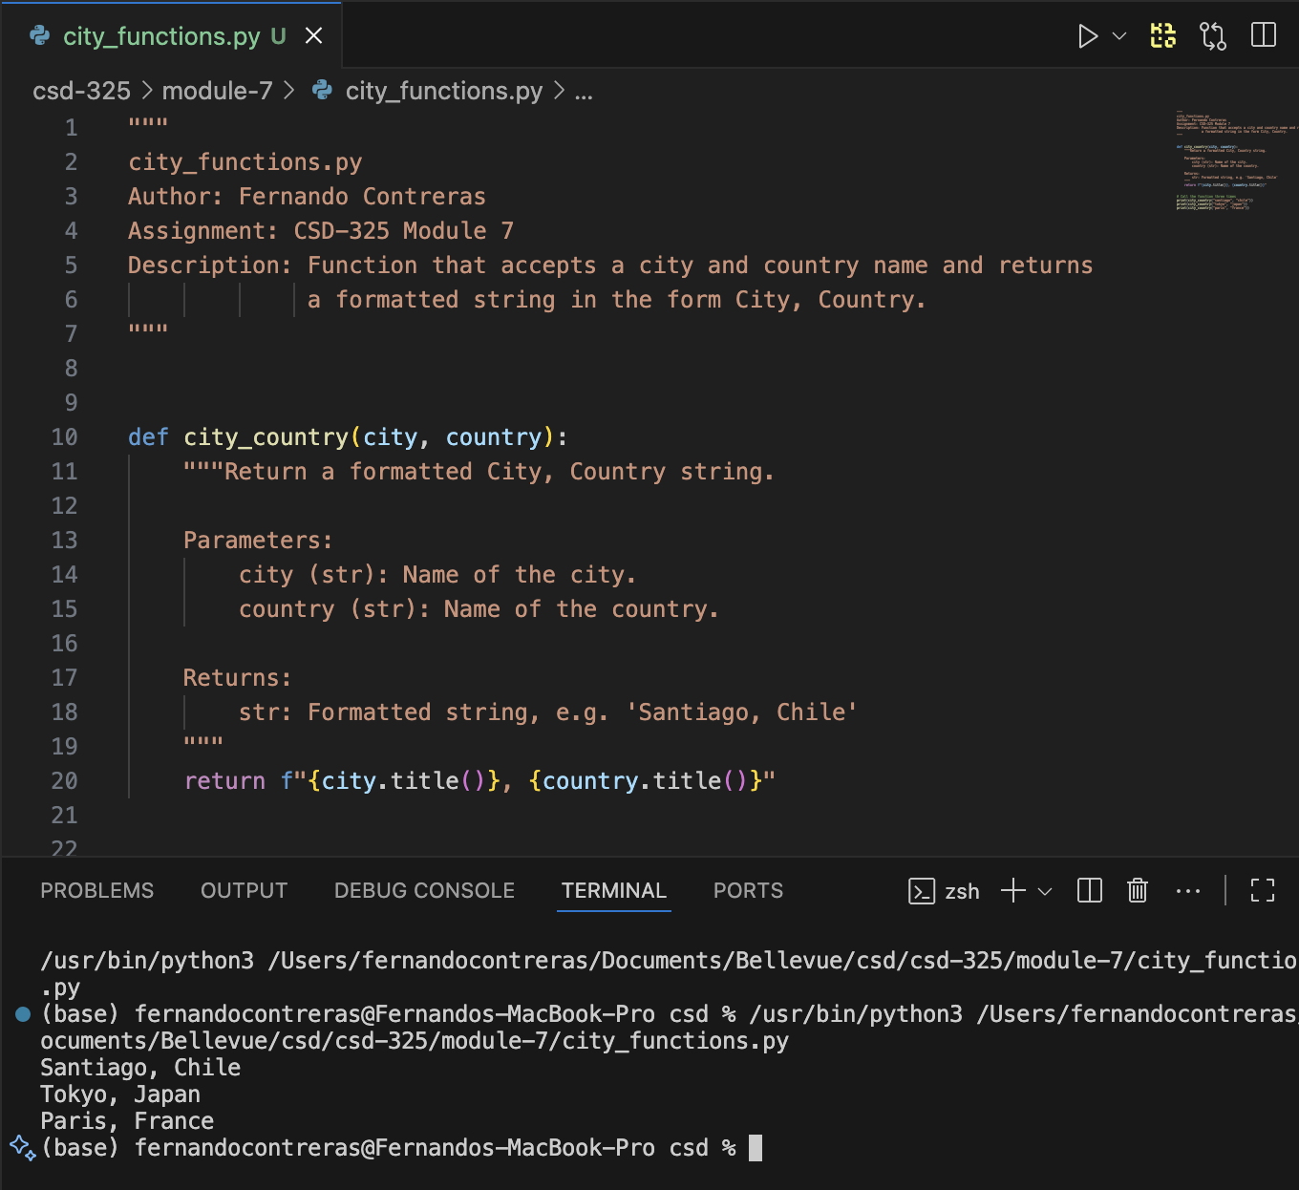

b) Create a file called test_cities.py that tests the function you just wrote (remember that you need to import unittest and the function you want to test). Write a method called test_city_country() to verify that calling your function with values such as Santiago and Chile results in the correct string. Run test_cities.py, and make sure test_city_country() passes. When it passes, take a screenshot of the result and paste in into your Word document.
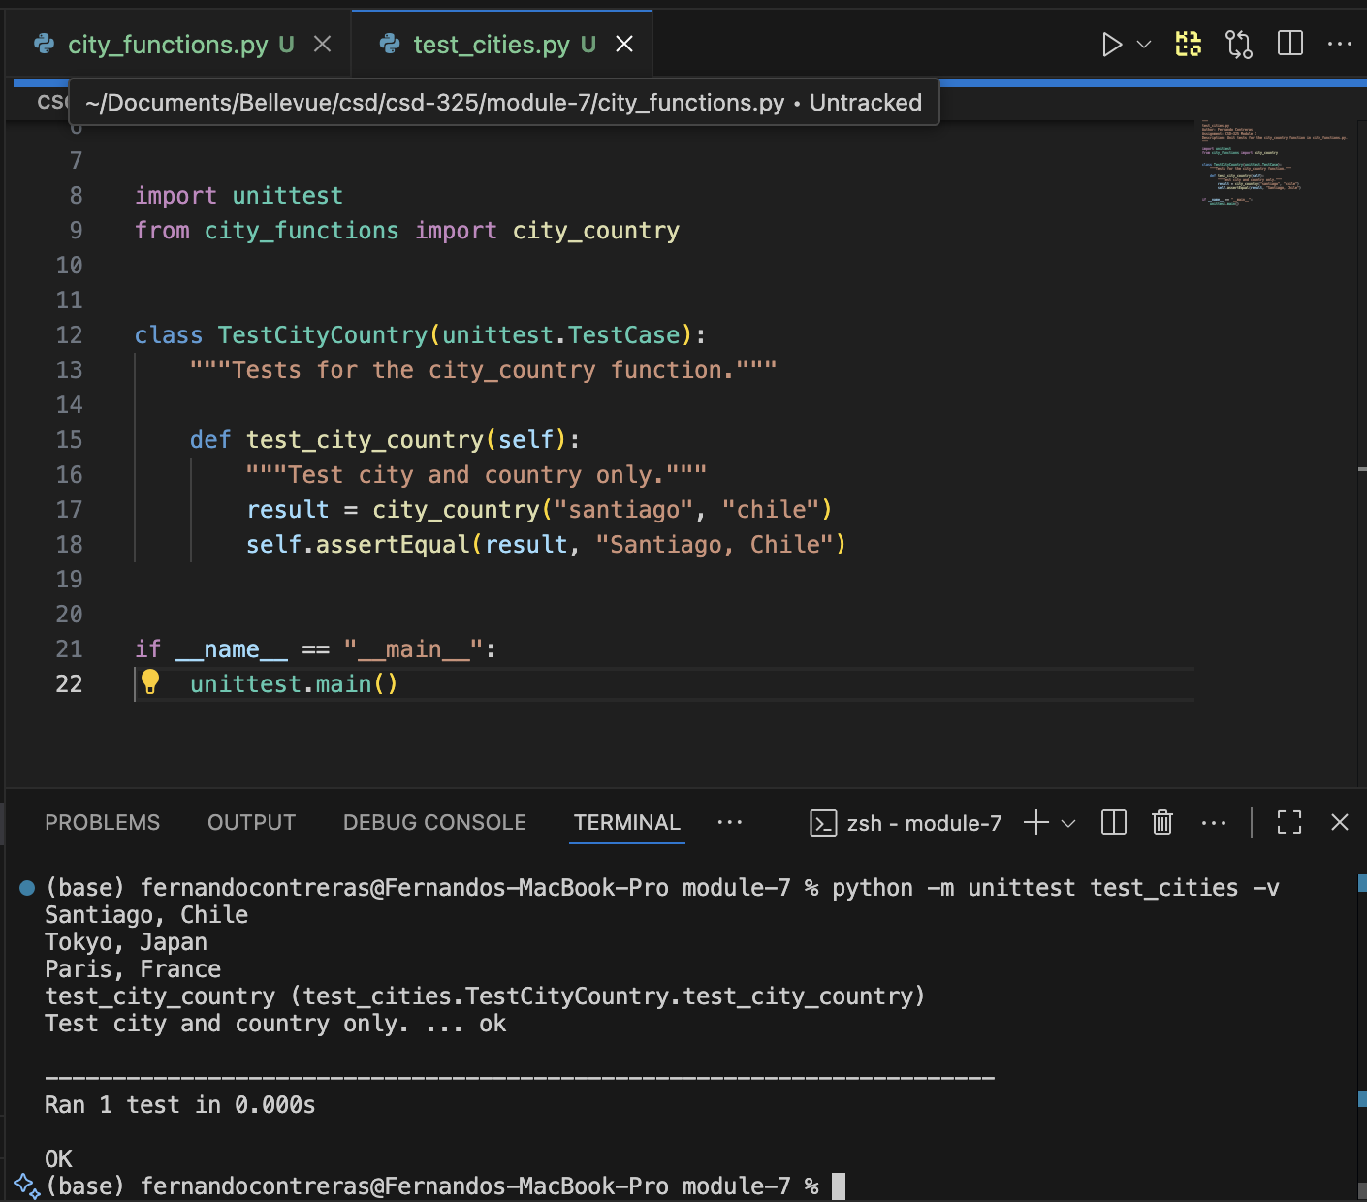

c) Modify your city_country function in city_functions.py so it requires a third parameter, population. It should now return a single string of the form City, Country - population xxx, such as Santiago, Chile - population 5000000.
d) Run test_cities.py again. It should fail. Take a screenshot of the result and paste into your Word document.
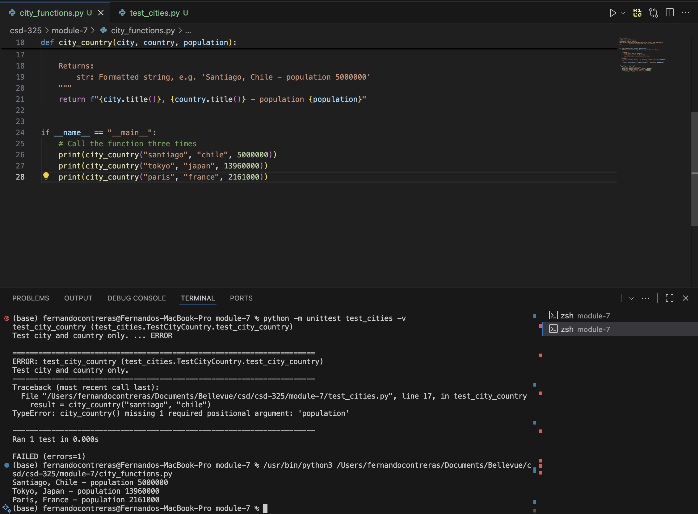

e) Now modify your city_country function in city_functions.py so that the population parameter is optional.
f) Run test_cities.py again. It should pass. Take a screenshot of the result and paste into your Word document.
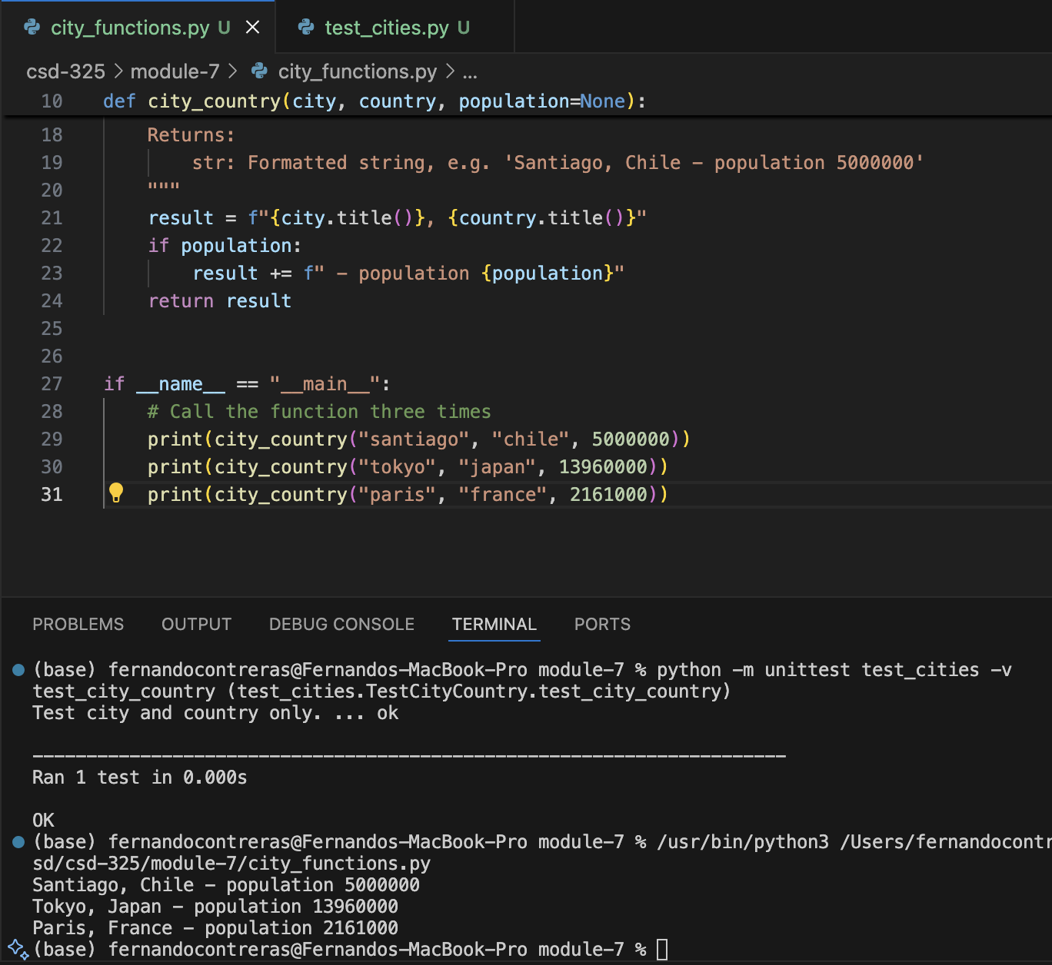

g) Modify your city_country function in city_functions.py so it requires a fourth parameter, language. It should now return a single string of the form City, Country - population xxx, Language, such as Santiago, Chile - population 5000000, Spanish.
h) Run test_cities.py again. It should fail. Take a screenshot of the result and paste into your Word document.
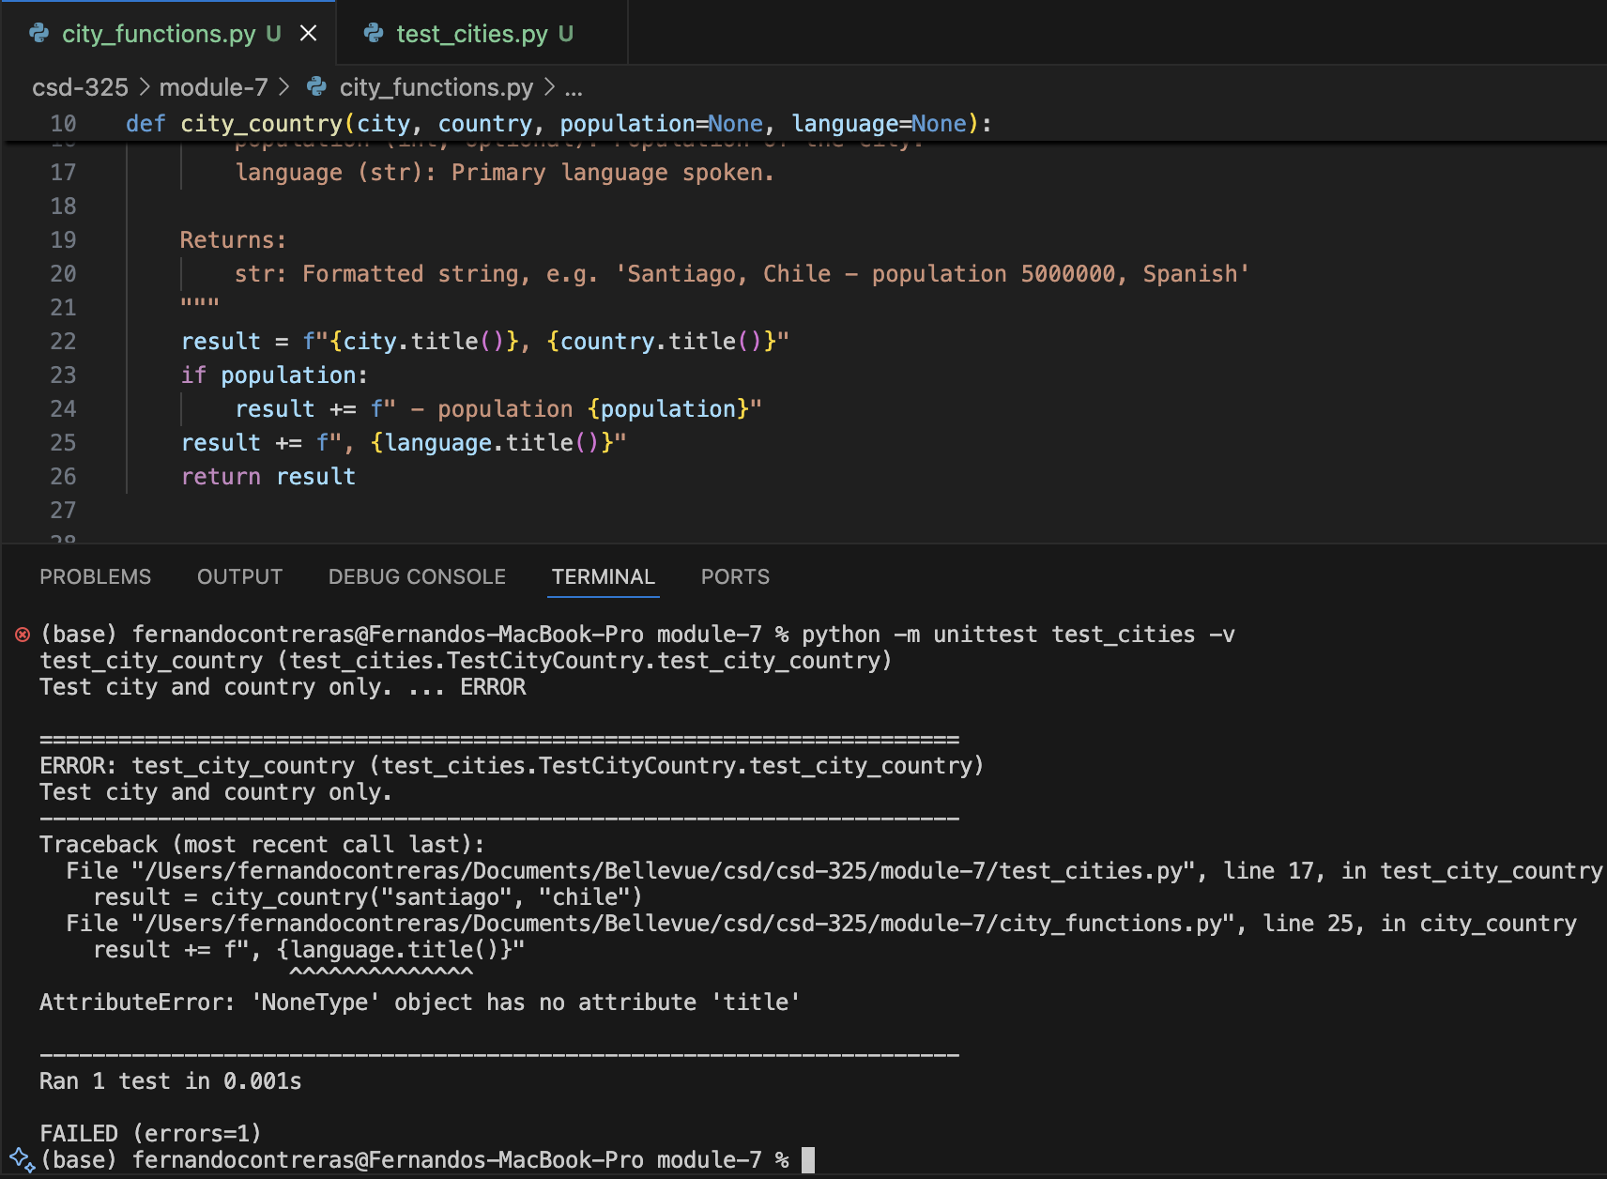

i) Now modify your city_country function in city_functions.py so that the language argument is optional.
j) Run test_cities.py again. It should pass. Take a screenshot of the result and paste into your Word document.
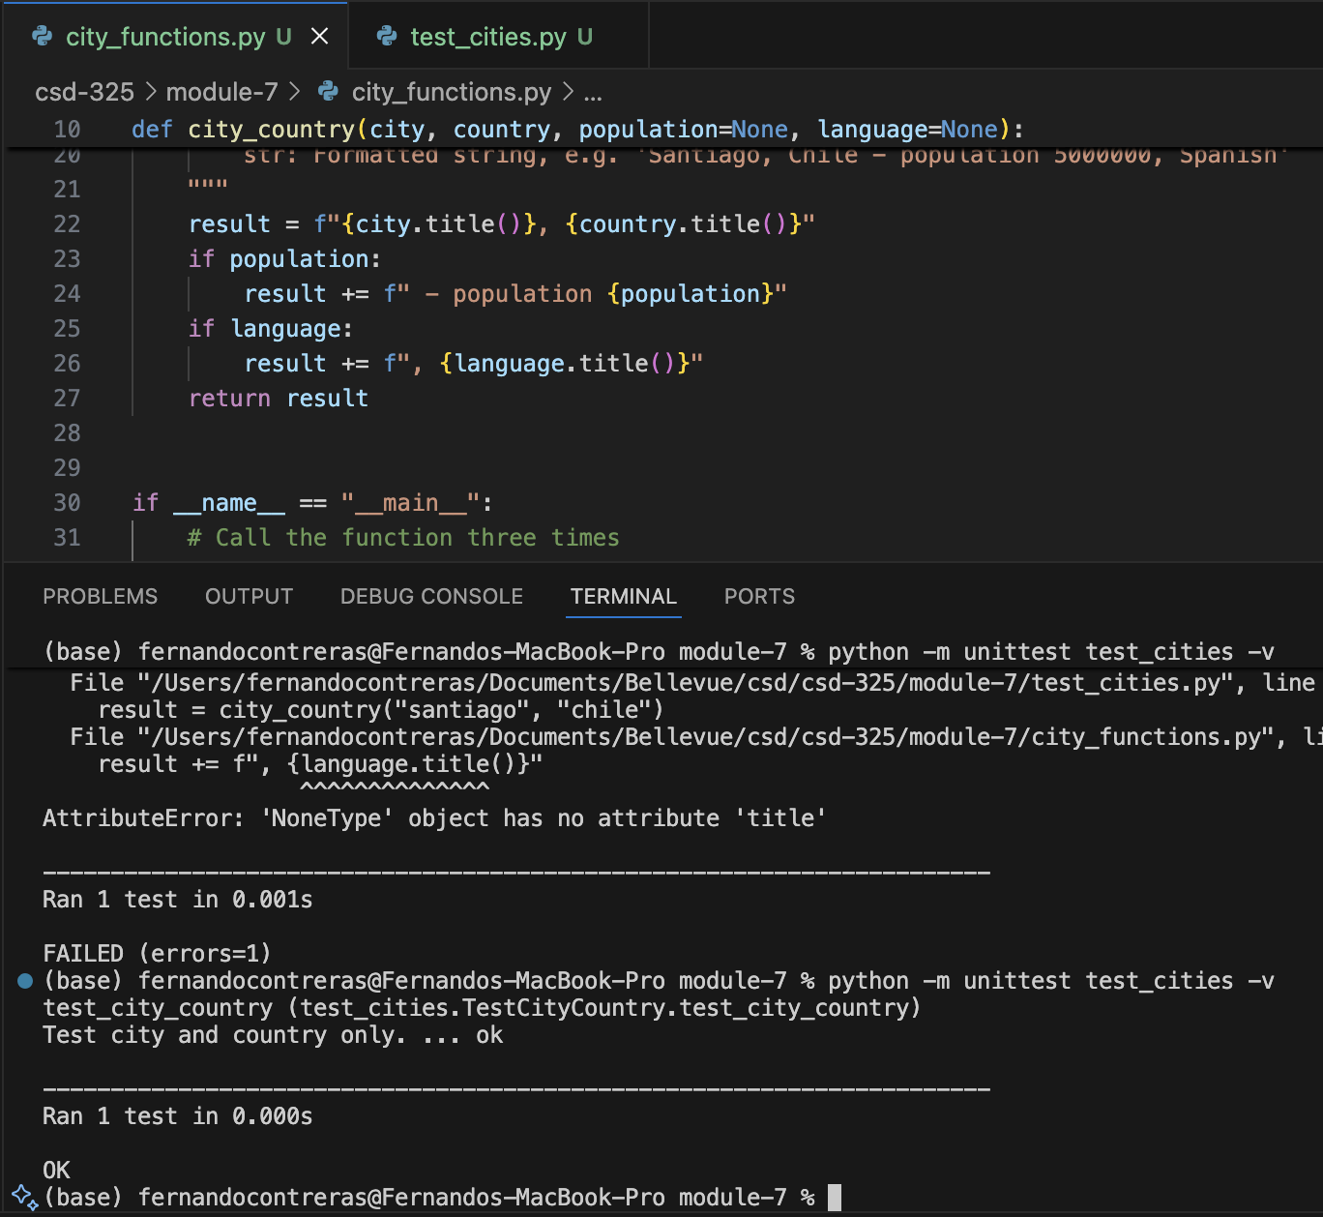

k) Run city_functions.py. Call the function at least three times using a City, Country for one, City, Country, Population for the next and City, Country, Population, Language for the last. Execute city_functions.py and take a screenshot of the result. Paste that screenshot into your Word document.
