Fernando Contreras
Assignment 8.2: JSON Practice Assignment
May 1, 2026
Flowchart: student_json_fc.py
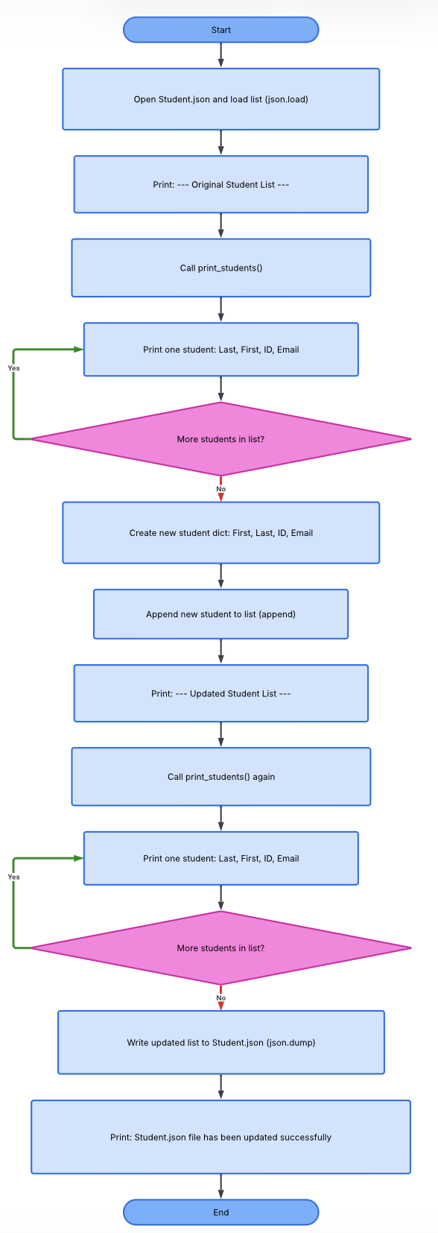

Run the program and take a screenshot of the results. Paste that screenshot into your Word document.
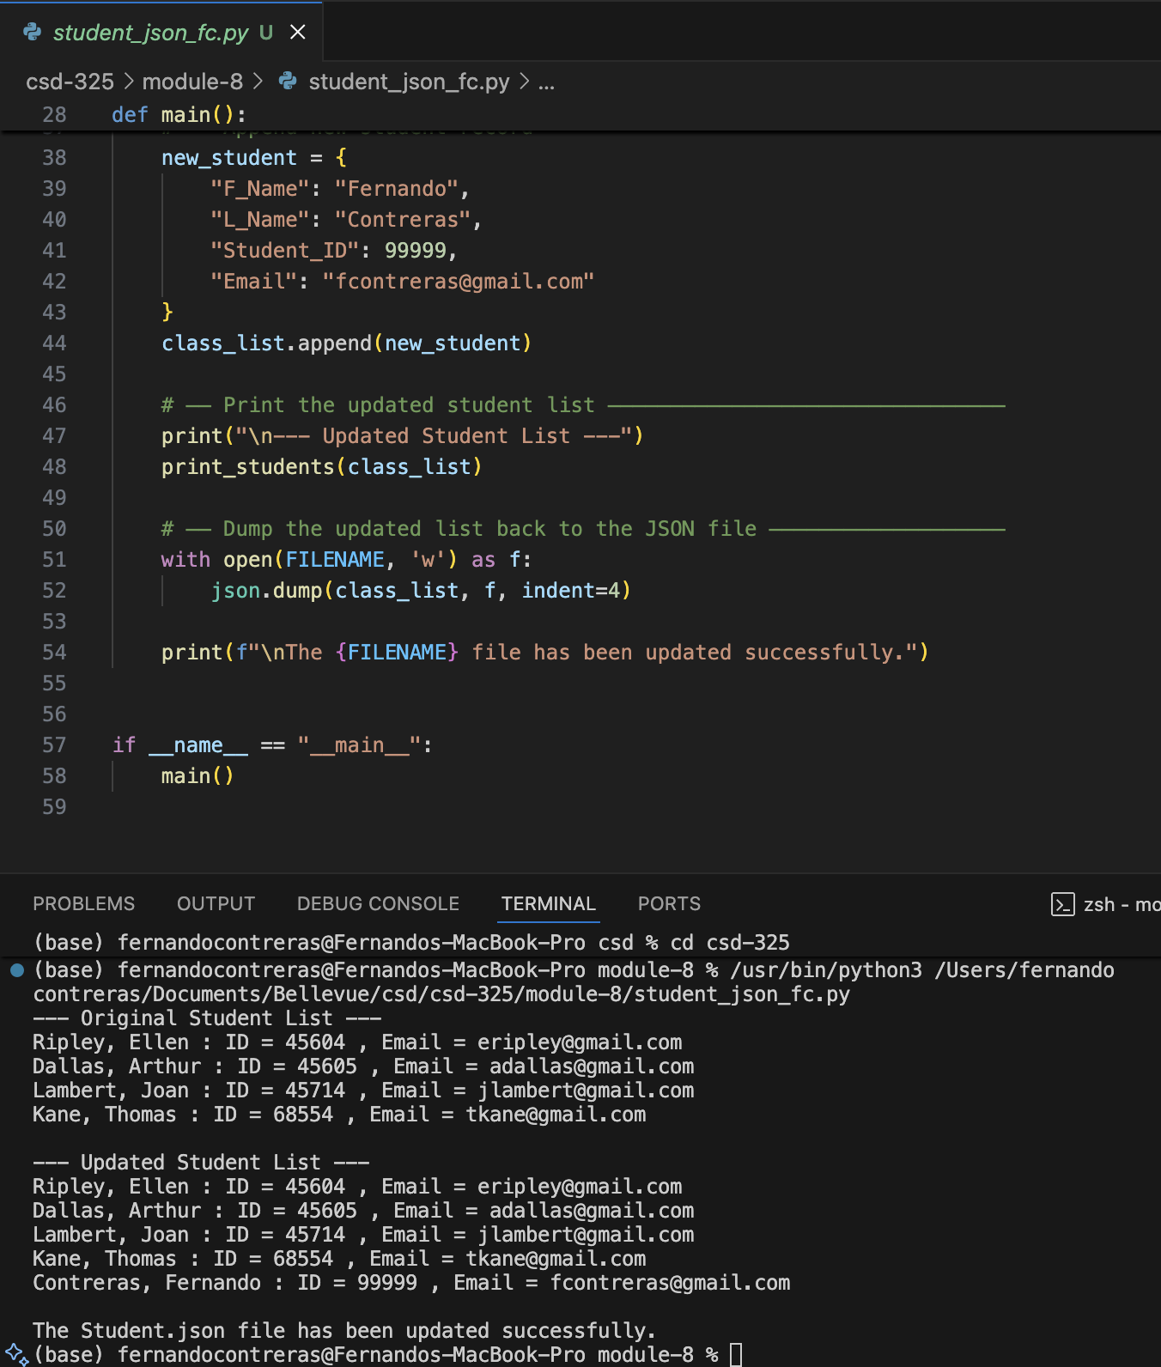

Student.json File Change Notification — Screenshot
The file change notification did not appear automatically on macOS. This is because macOS file watchers behave differently than Windows in some editors. As an alternative, the updated Student.json file was opened manually to confirm the changes were saved successfully. The updated contents are shown below.
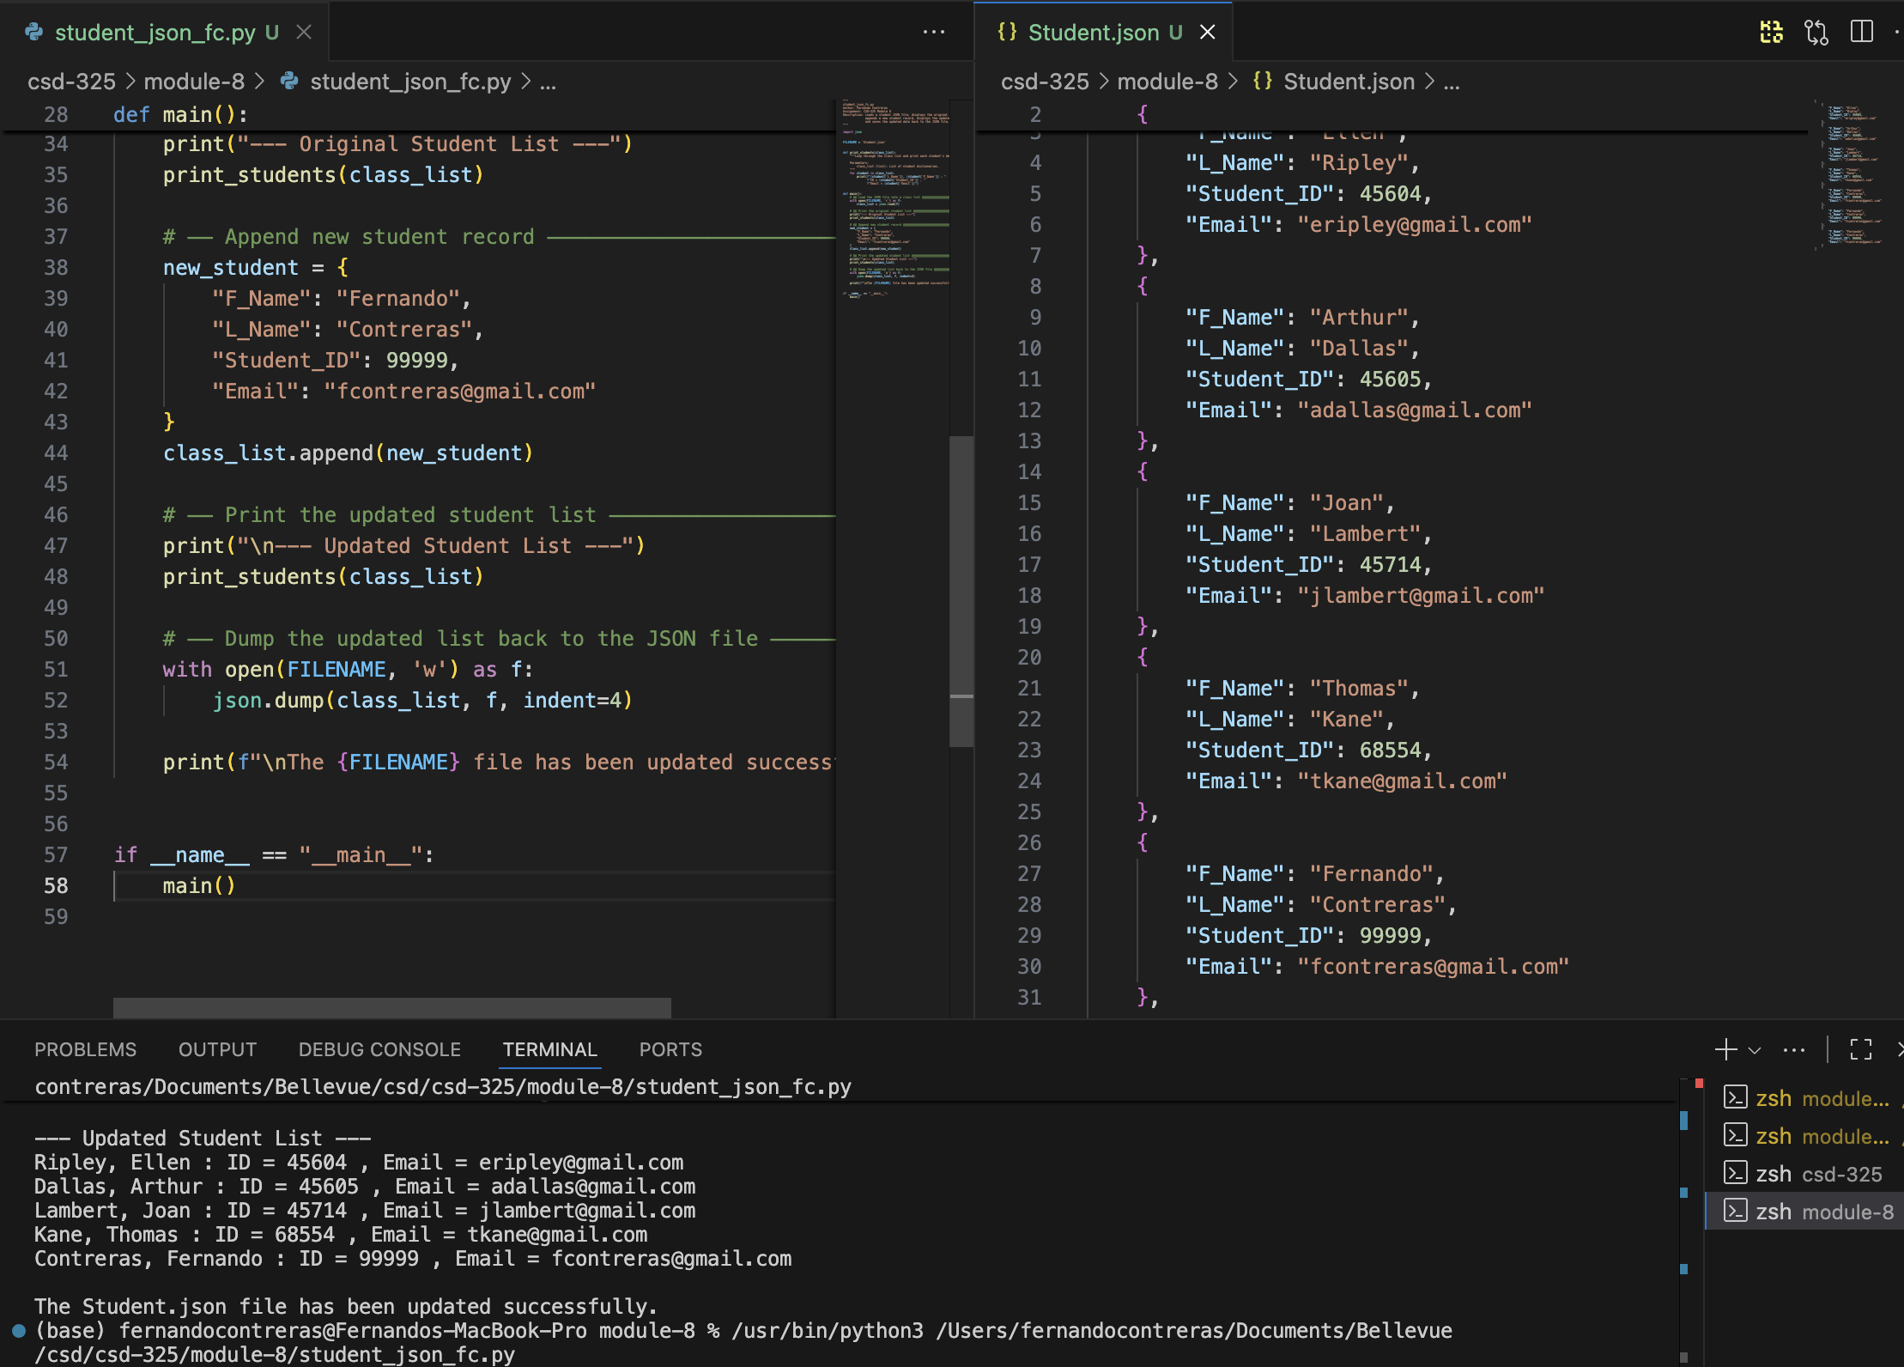 Open the .json file and copy the contents, then paste that into your Word document.
[
{
"F_Name": "Ellen",
"L_Name": "Ripley",
"Student_ID": 45604,
"Email": "eripley@gmail.com"
},
{
"F_Name": "Arthur",
"L_Name": "Dallas",
"Student_ID": 45605,
"Email": "adallas@gmail.com"
},
{
"F_Name": "Joan",
"L_Name": "Lambert",
"Student_ID": 45714,
"Email": "jlambert@gmail.com"
},
{
"F_Name": "Thomas",
"L_Name": "Kane",
"Student_ID": 68554,
"Email": "tkane@gmail.com"
},
{
"F_Name": "Fernando",
"L_Name": "Contreras",
"Student_ID": 99999,
"Email": "fcontreras@gmail.com"
}
]

