Fernando Contreras
October 22, 2026
CSD 430 Server-Side Development
Assignment 1.3: Java, Tomcat, and IDE Installation
1. Java Installation
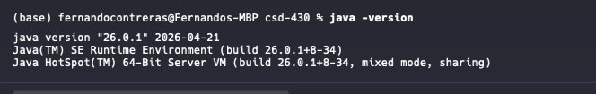
2. Tomcat Installation
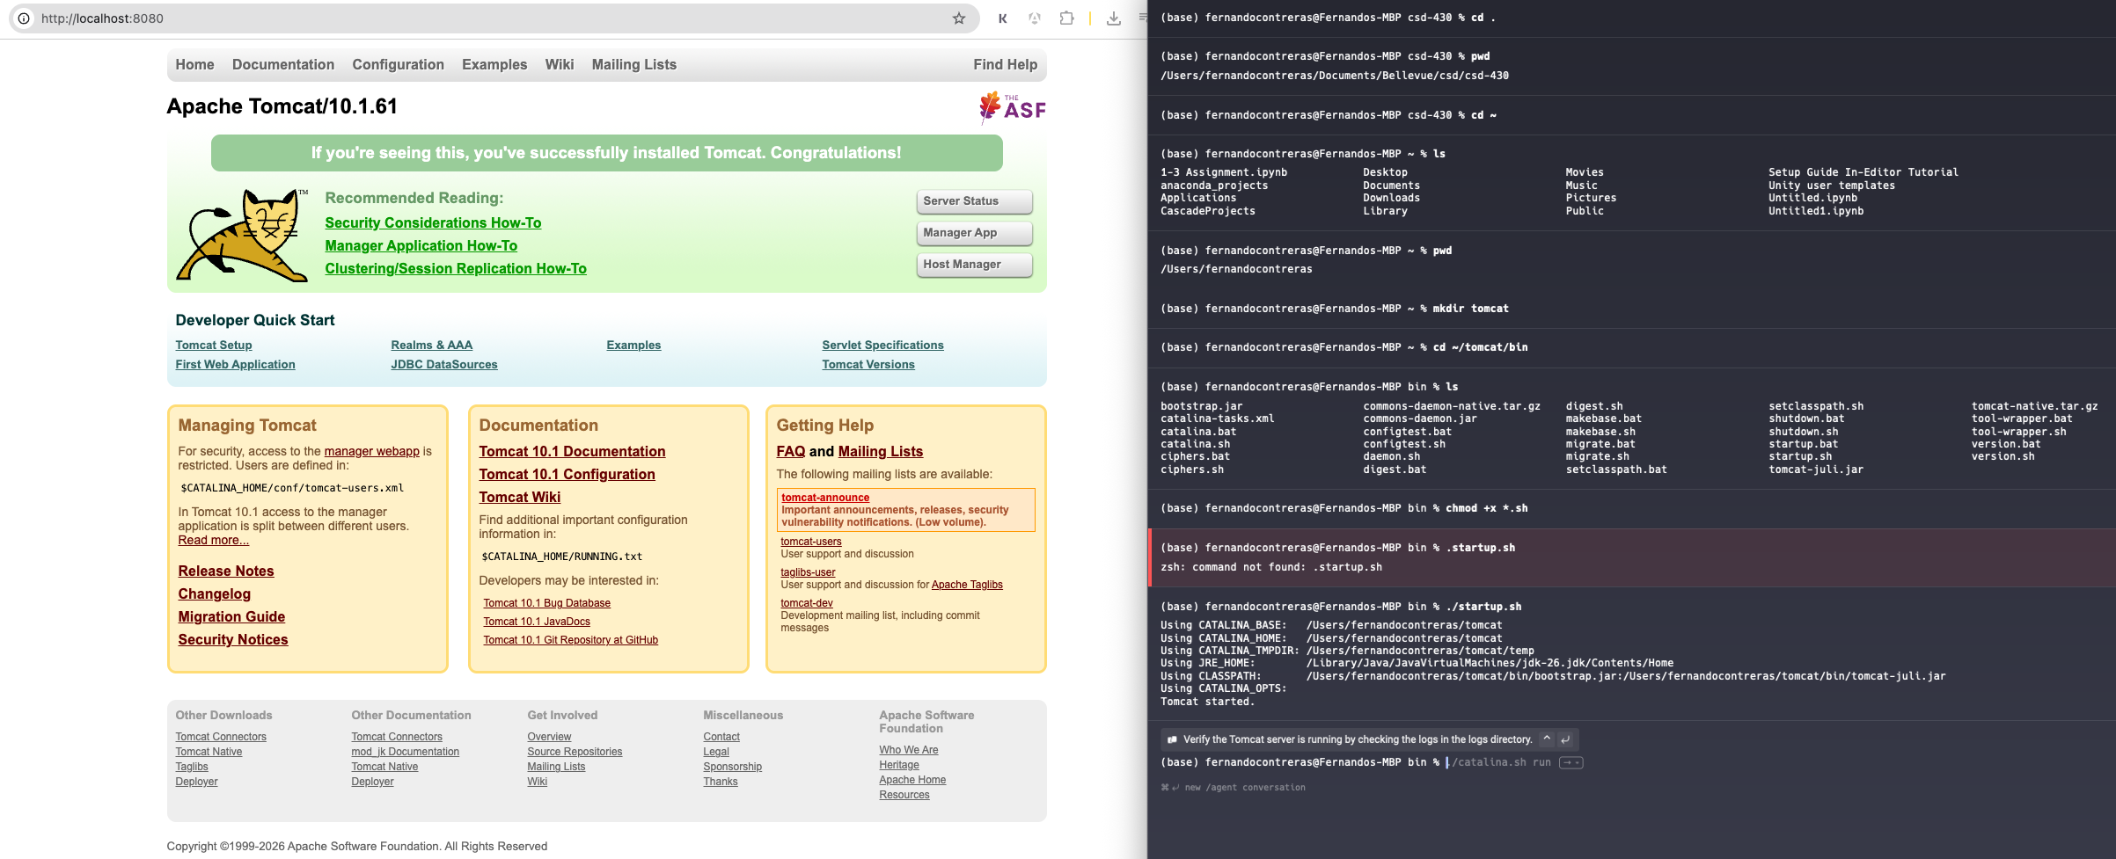
3. IDE Installation (Eclipse) and server started
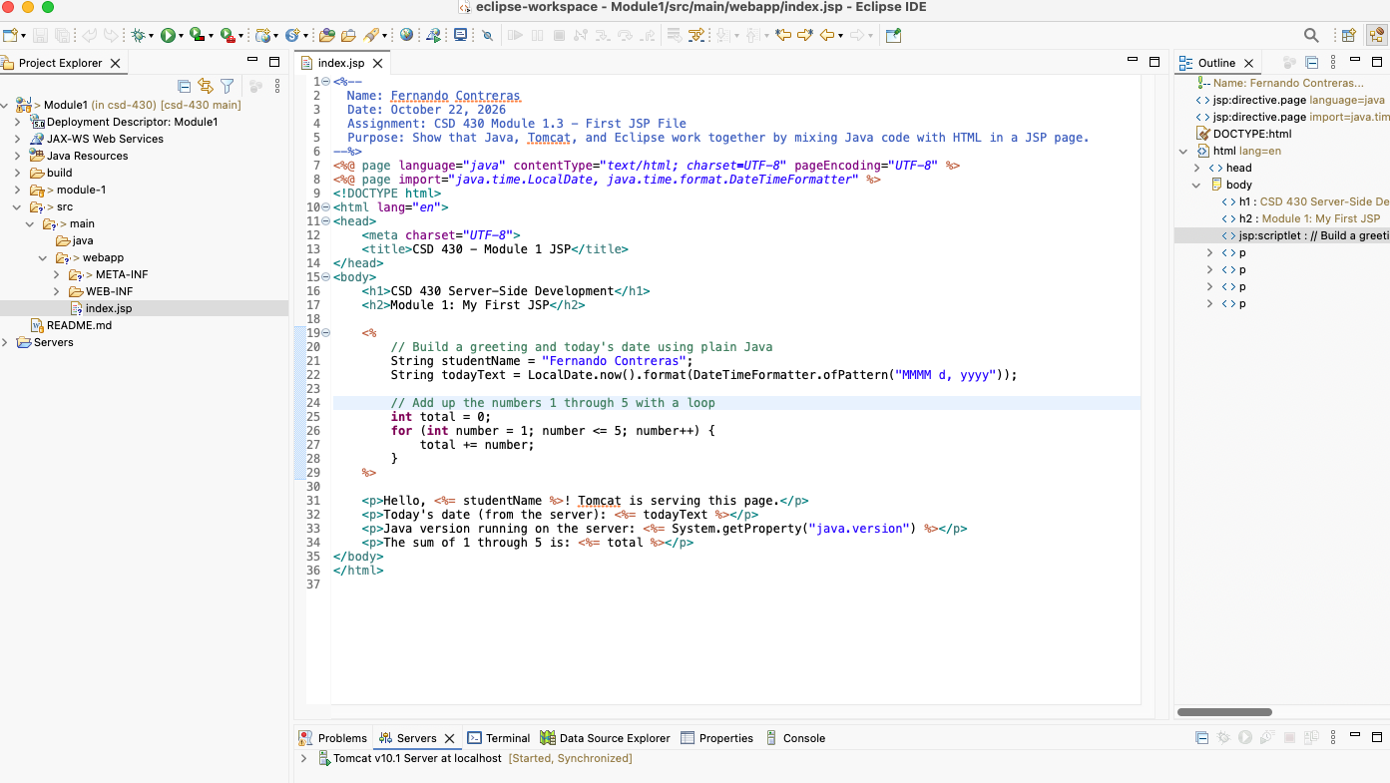

4. JSP Source Code
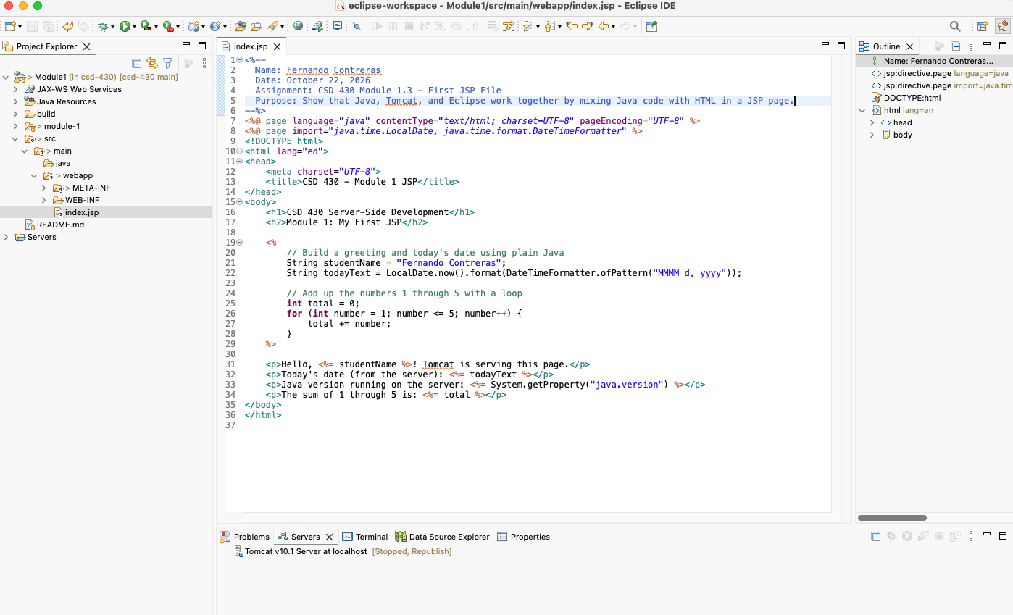

5. JSP Running in the Browser
