Fernando Contreras
October 28, 2026
CSD 430 Server-Side Development
Assignment 2.2: Dynamic JSP Page with Scriptlets and CSS
1. JSP Source Code (edinburgh.jsp)
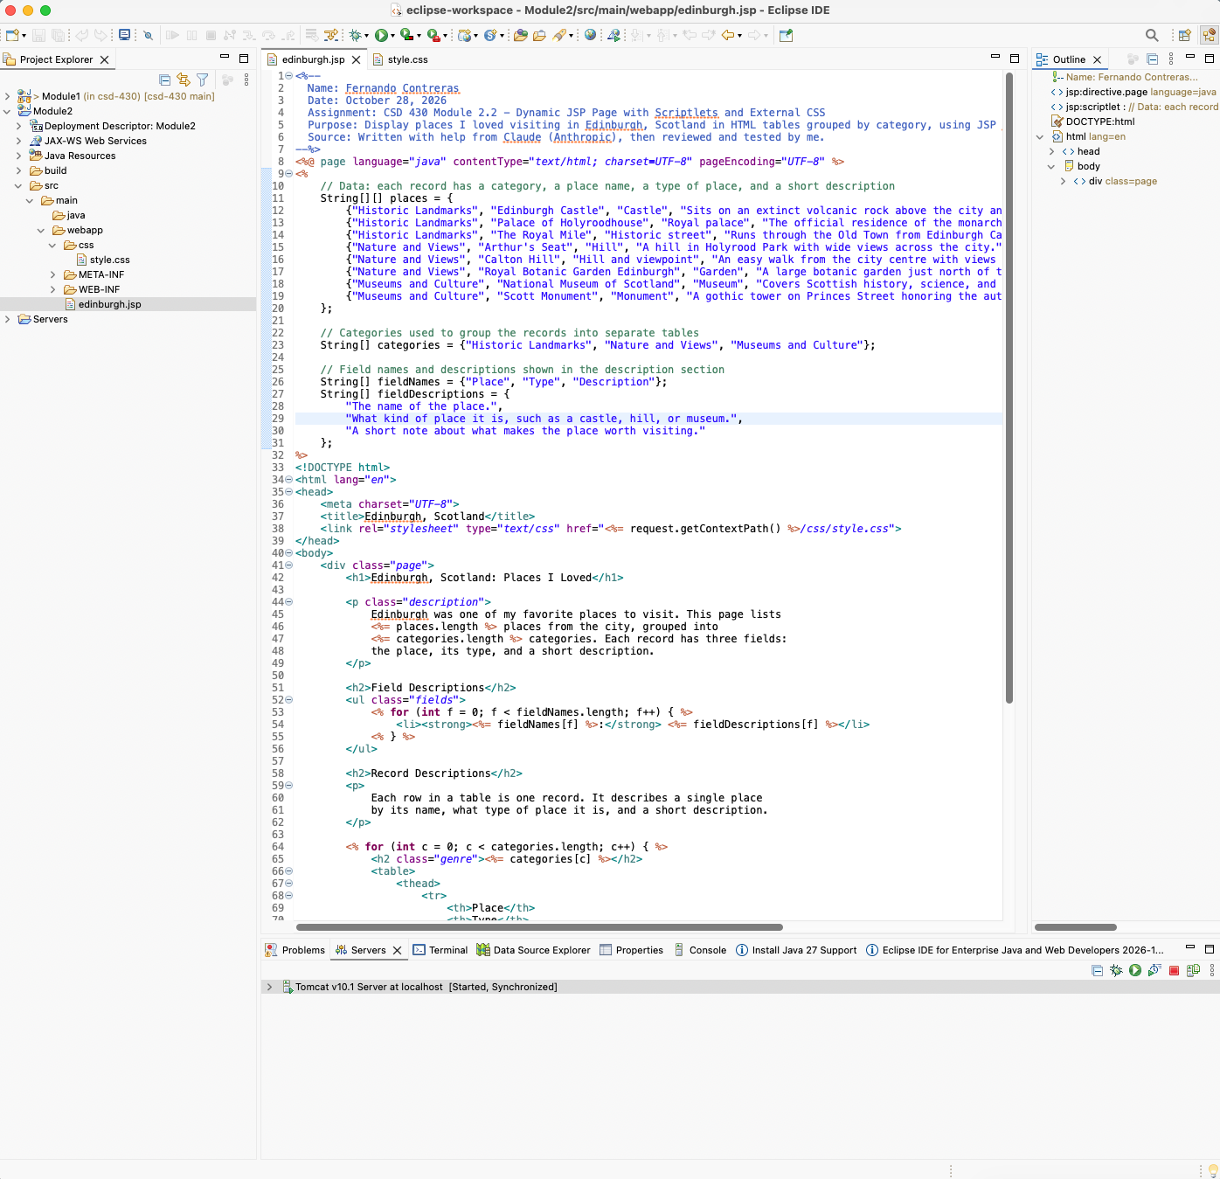

2. CSS Source Code (style.css)
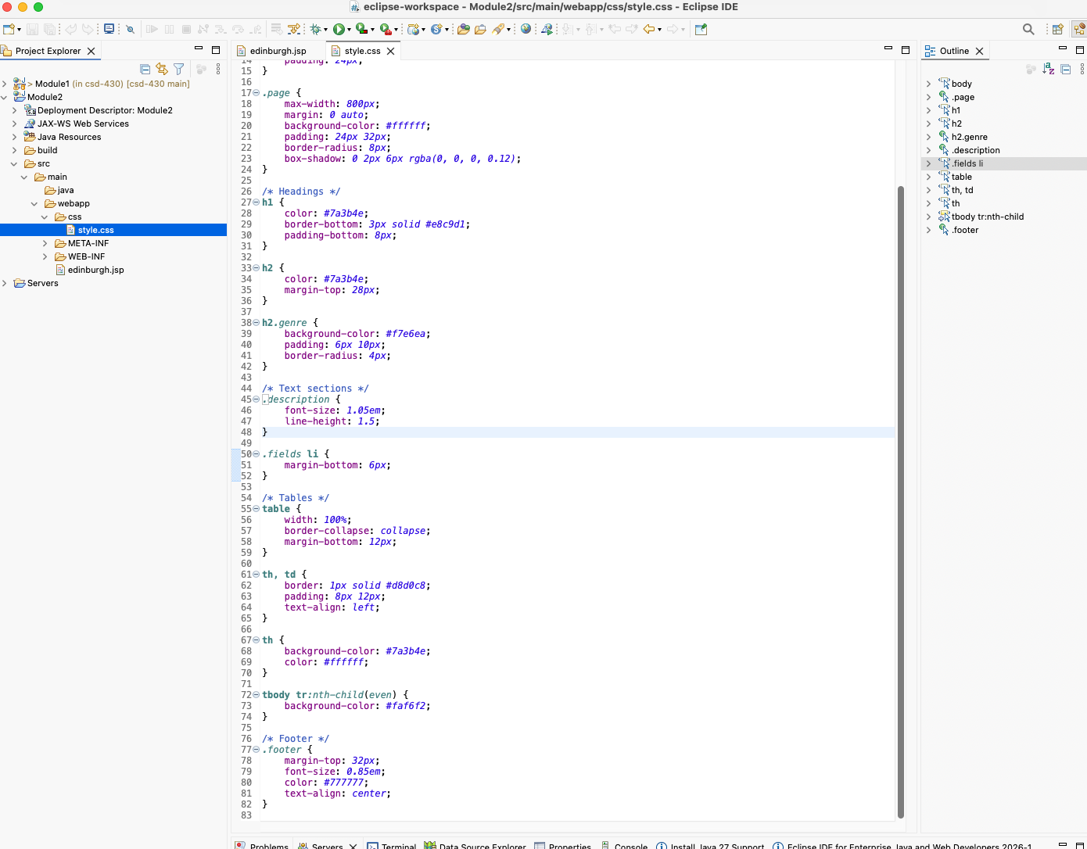

3. Project Structure
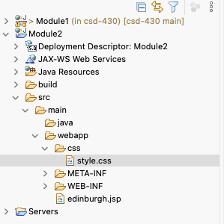

4. Page Running in the Browser
