Susliks in Miroslav July 2019

Fernando Mateos-Gonzalez

This report analises data from capture-recapture sessions during 15-19 July 2019. The aim is to estimate population characteristics (mainly density) in Miroslav airport, to be able to extrapolate and apply to other areas of the Czech Republic.

We will follow the protocols described here <https://www.otago.ac.nz/density/>

Useful links: Example analysis <https://www.otago.ac.nz/density/pdfs/secr-tutorial.pdf>

The following boxes include all the code and results to run the analyses in R. To install and run models in secr, you must download the package and load it. In the next box, we install and load the package secr, to do our analyses, and the package “here”, to find files.

library(secr)

## This is secr 3.2.1. For overview type ?secr

library(here)

## here() starts at D:/FPI/2019/CZ/SOUSLIK/susliks_july_2019

Now we create the capthist, the file combining our captures with the trap locations:

july <- read.capthist(here("data", "captures.txt"), here("data", "traps.txt"), detector = "proximity")

## Session miroslav   
## More than one detection per detector per occasion at binary detector(s)

summary(july)

## Object class capthist   
## Detector type proximity   
## Detector number 20   
## Average spacing 13.57938 m   
## x-range -623778.5 -623653.2 m   
## y-range -1187164 -1187091 m   
##   
## Counts by occasion   
## 1 2 3 4 5 Total  
## n 23 27 16 19 8 93  
## u 23 22 12 11 5 73  
## f 58 10 5 0 0 73  
## M(t+1) 23 45 57 68 73 73  
## losses 0 0 0 0 0 0  
## detections 24 27 17 21 8 97  
## detectors visited 14 12 12 15 8 61  
## detectors used 20 20 20 20 20 100

n number of distinct individuals detected on each occasion t u number of individuals detected for the first time on each occasion t f number of individuals detected on exactly t occasions M(t+1) cumulative number of detected individuals on each occasion t

Now we use the plot method, which for capthist objects has additional arguments; we set tracks = TRUE to join consecutive captures of each individual. (use arguments gridl and gridsp to suppress the grid or vary its spacing, and border to “zoom” in the area where the traps are).

par(mar = c(1,1,1,1)) # reduce margins  
plot (july, tracks = TRUE, gridsp = 5,border = 10)

## Warning in plot.capthist(july, tracks = TRUE, gridsp = 5, border = 10):  
## track for repeat detections on same occasion joins points in arbitrary  
## sequence

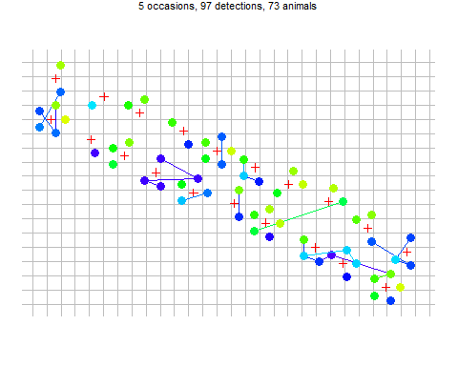

The most important insight from this figure is that individuals tend to be recaptured near their site of first capture. This is expected when the individuals of a species occupy home ranges. In SECR models the tendency for detections to be localised is reflected in the spatial scale parameter σ. Good estimation of σ and density D requires spatial recaptures (i.e. captures at sites other than the site of first capture).

Successive trap-revealed movements can be extracted with the moves function and summarised with hist:

m <- unlist(moves(july))  
par(mar = c(3.2,4,1,1), mgp = c(2.1,0.6,0)) # reduce margins  
hist(m, breaks = seq(0/2, 30,2), xlab = "Movement m", main = "")

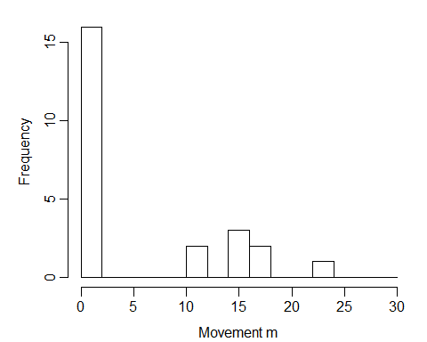

The function RPSV with option CC = TRUE provides a biased estimate of the spatial scale σ, ignoring the problem that movements are truncated by the edge of the grid:

initialsigma <- RPSV(july, CC = TRUE)  
cat("Quick and biased estimate of sigma =", initialsigma, "m\n")

## Quick and biased estimate of sigma = 5.116154 m

This estimate will be useful when we come to fit a model.

Next we fit the simplest possible SECR model with function secr.fit. Setting trace = FALSE suppresses printing of intermediate likelihood evaluations; it doesn’t hurt to leave it out. We save the fitted model with the name ‘fit’.

To examine model output or extract particular results you should use one of the functions defined for the purpose. Technically, these are S3 methods for the class ‘secr’. The key methods are print, plot, AIC, coef, vcov and predict. Append ‘.secr’ when seeking help e.g. ?print.secr. Typing the name of the fitted model at the R prompt invokes the print method for secr objects and displays a more useful report.

fit <- secr.fit (july, buffer = 4 * initialsigma, trace = FALSE,biasLimit = NA, verify = FALSE)  
  
detector(traps(july)) <- "proximity"  
  
fit

##   
## secr.fit(capthist = july, buffer = 4 * initialsigma, verify = FALSE,   
## biasLimit = NA, trace = FALSE)  
## secr 3.2.1, 12:30:02 22 Jul 2019  
##   
## Detector type proximity   
## Detector number 20   
## Average spacing 13.57938 m   
## x-range -623778.5 -623653.2 m   
## y-range -1187164 -1187091 m   
##   
## N animals : 73   
## N detections : 97   
## N occasions : 5   
## Mask area : 0.9380393 ha   
##   
## Model : D~1 g0~1 sigma~1   
## Fixed (real) : none   
## Detection fn : halfnormal  
## Distribution : poisson   
## N parameters : 3   
## Log likelihood : -198.4705   
## AIC : 402.9409   
## AICc : 403.2888   
##   
## Beta parameters (coefficients)   
## beta SE.beta lcl ucl  
## D 5.560902 0.1998768 5.169151 5.952653  
## g0 -1.705310 0.2997306 -2.292771 -1.117848  
## sigma 1.825563 0.1107729 1.608452 2.042674  
##   
## Variance-covariance matrix of beta parameters   
## D g0 sigma  
## D 0.039950730 -0.02430277 -0.007066589  
## g0 -0.024302768 0.08983844 -0.019885733  
## sigma -0.007066589 -0.01988573 0.012270644  
##   
## Fitted (real) parameters evaluated at base levels of covariates   
## link estimate SE.estimate lcl ucl  
## D log 260.0573343 52.50292539 175.76551739 384.7729528  
## g0 logit 0.1537731 0.03900302 0.09172345 0.2464106  
## sigma log 6.2062857 0.68960289 4.99507103 7.7111981

The report comprises these sections that you should identify: • function call and time stamp • summary of the data • description of the model, including the maximized log likelihood, Akaike’s Information Criterion AIC • estimates of model coefficients (beta parameters) • estimates of variance-covariance matrix of the coefficients • estimates of the ‘real’ parameters

The last three items are generated by the coef, vcov and predict methods respectively. The final table of estimates is the most interesting, but it is derived from the other two. For our simple model there is one beta parameter for each real parameter (We can get from beta parameter estimates to real parameter estimates by applying the inverse of the link function e.g.: Dˆ = exp(βˆD), and similarly for confidence limits; standard errors require a delta-method approximation (Lebreton et al. 1992).)

. The estimated density is 260 susliks per hectare, 95% confidence interval 175-384 susliks per hectare . The other two real parameters jointly determine the detection function that you can easily plot with 95% confidence limits

par(mar = c(4,4,1,1)) # reduce margins  
plot(fit, limits = TRUE)

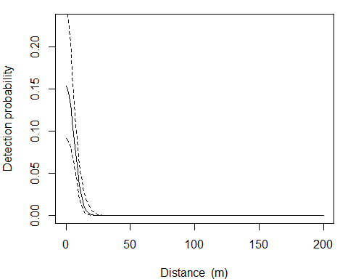

The theory of SECR tells us that buffer width is not critical as long as it is wide enough that animals at the edge have effectively zero chance of appearing in our sample. The 4 suggestion is based on experience with half-normal detection models7. We check that for the present model with the function esa.plot. The estimated density8 has easily reached a plateau at the chosen buffer width (dashed red line):

esa.plot(fit)  
abline(v = 4 * initialsigma, lty = 2, col = 'red')

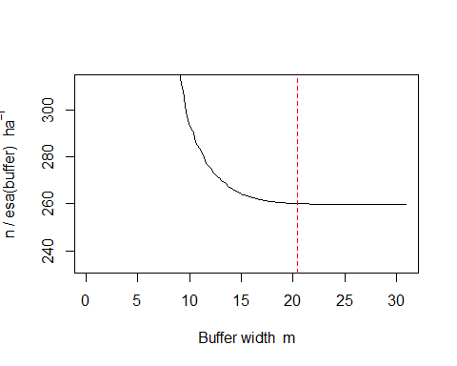

## Choosing a detection function

• detection probability declines with distance according to a half-normal curve

We can try alternative shapes for the detection function (the decline in detection probability with distance). secr offers several different shapes of detection function (see the list at ?detectfn). We need to sort these out. All except ANN and HAN decline monotonically with distance. Three are only used for acoustic data (BSS, SS, SSS). The simplest UN is not available for maximum likelihood model fitting, and several are frankly exotic and almost never used (CHN, WEX, CLN, CG), as are ANN and HAN.

That leaves the half-normal, negative exponential, and hazard rate functions (HN, EX, HR) These differ primarily in the length of their tails i.e. the probability they assign to very distant detections. The half-normal makes distant detections very improbable, the negative exponential less so; The ‘hazard-rate’ function requires a third parameter and potentially has a very long tail indeed. Fit each of these and assess the effect. We use a wider buffer to allow for longer tails

fit.HN <- secr.fit (july, buffer = 6 * initialsigma, detectfn = 'HN', trace = FALSE, biasLimit = NA,verify = FALSE)  
fit.EX <- secr.fit (july, buffer = 6 * initialsigma, detectfn = 'EX', trace = FALSE, biasLimit = NA,verify = FALSE)  
fit.HR <- secr.fit (july, buffer = 6 * initialsigma, detectfn = 'HR', trace = FALSE, biasLimit = NA,verify = FALSE)  
  
fits <- secrlist(HN = fit.HN, EX = fit.EX, HR = fit.HR)  
predict(fits)

## $HN  
## link estimate SE.estimate lcl ucl  
## D log 259.0852694 52.63608474 174.68561864 384.2627534  
## g0 logit 0.1534672 0.03899831 0.09145389 0.2461386  
## sigma log 6.2218492 0.70141023 4.99187192 7.7548879  
##   
## $EX  
## link estimate SE.estimate lcl ucl  
## D log 283.4497526 65.34724111 181.4566525 442.7711033  
## g0 logit 0.3537689 0.09537981 0.1946272 0.5535914  
## sigma log 3.9093954 0.55930681 2.9576501 5.1674038  
##   
## $HR  
## link estimate SE.estimate lcl ucl  
## D log 274.5514265 66.89727330 171.47582926 439.5866525  
## g0 logit 0.1805899 0.08336762 0.06807998 0.3993562  
## sigma log 5.4087425 2.46704016 2.30695740 12.6809866  
## z log 3.3653269 1.09322307 1.80892529 6.2608583

When everything is done, we upload it to github following <https://happygitwithr.com/existing-github-first.html>