|  |  |
| --- | --- |
| **SEM 01 – ANDROID – 2TDSS**  **2017** | |
| Nome: |  |
| RM: |  |

Cole aqui o print da tela de seu app

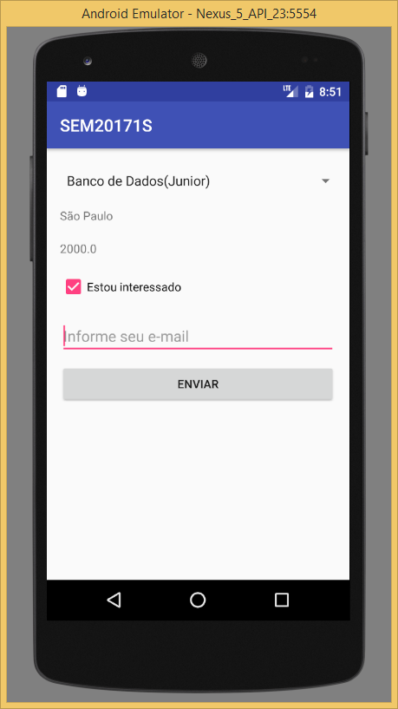

Cole aqui o código fonte da sua Activity

**package** com.example.logonrm.ps;  
  
**import** android.support.v7.app.AppCompatActivity;  
**import** android.os.Bundle;  
**import** android.view.View;  
**import** android.widget.AdapterView;  
**import** android.widget.ArrayAdapter;  
**import** android.widget.Button;  
**import** android.widget.CheckBox;  
**import** android.widget.EditText;  
**import** android.widget.Spinner;  
**import** android.widget.TextView;  
  
**import** org.json.JSONArray;  
**import** org.json.JSONException;  
**import** org.json.JSONObject;  
  
**import** java.util.ArrayList;  
**import** java.util.List;  
  
**public class** MainActivity **extends** AppCompatActivity **implements** AdapterView.OnItemSelectedListener {  
  
 **private** Spinner **spArea**;  
 **private** TextView **lblCidade**;  
 **private** TextView **lblSalario**;  
 **private** CheckBox **chkInteressado**;  
 **private** EditText **edtEmail**;  
 **private** Button **btnEnviar**;  
  
 **private** List<VagaBean> **vagas**;  
 **private** ArrayAdapter<VagaBean> **adpVaga**;  
 **private** VagaBean **selected**;  
 @Override  
 **protected void** onCreate(Bundle savedInstanceState) {  
 **super**.onCreate(savedInstanceState);  
 setContentView(R.layout.***activity_main***);  
  
 **spArea** = (Spinner) findViewById(R.id.***spArea***);  
 **lblCidade** = (TextView) findViewById(R.id.***lblCidade***);  
 **lblSalario** = (TextView) findViewById(R.id.***lblSalario***);  
 **chkInteressado** = (CheckBox) findViewById(R.id.***chkInteressado***);  
 **edtEmail** = (EditText) findViewById(R.id.***txtEmail***);  
 **btnEnviar** = (Button) findViewById(R.id.***btnEnviar***);  
 **edtEmail**.setVisibility(View.***INVISIBLE***);  
 **btnEnviar**.setVisibility(View.***INVISIBLE***);  
 **spArea**.setOnItemSelectedListener(**this**);  
 **chkInteressado**.setChecked(**false**);  
 criarAreas();  
 carregarAreas();  
 }  
  
 **private void** carregarAreas() {  
 **adpVaga** = **new** ArrayAdapter<VagaBean>(**this**,android.R.layout.***simple_spinner_item***,**this**.**vagas**);  
 **spArea**.setAdapter(**adpVaga**);  
 }  
  
 **private void** criarAreas() {  
 JSONArray array = **null**;  
 **try** {  
 array = **new** JSONArray(SemestralServer.*getAreas*());  
 } **catch** (JSONException e) {  
 e.printStackTrace();  
 }  
 **vagas** = **new** ArrayList<VagaBean>();  
  
 **for** (**int** i =0; i<array.length(); i++) {  
 **try** {  
 JSONObject obj = array.getJSONObject(i);  
 **int** id = obj.getInt(**"id"**);  
 String area = obj.getString(**"area"**);  
 String nivel = obj.getString(**"nivel"**);  
 **vagas**.add(**new** VagaBean(id, area, nivel));  
 } **catch** (JSONException e) {  
 e.printStackTrace();  
 }  
 }  
 }  
  
 **public void** interessado(View v) {  
 **if**(**chkInteressado**.isChecked()) {  
 **edtEmail**.setVisibility(v.***VISIBLE***);  
 **btnEnviar**.setVisibility(v.***VISIBLE***);  
 } **else** {  
 **edtEmail**.setVisibility(v.***INVISIBLE***);  
 **btnEnviar**.setVisibility(v.***INVISIBLE***);  
 }  
  
 }  
  
 **public void** enviar(View v) {  
 **adpVaga**.remove(**this**.**selected**);  
 **chkInteressado**.setChecked(**false**);  
 **edtEmail**.setText(**""**);  
 **edtEmail**.setVisibility(v.***INVISIBLE***);  
 **btnEnviar**.setVisibility(v.***INVISIBLE***);  
 }  
  
 @Override  
 **public void** onItemSelected(AdapterView<?> parent, View view, **int** position, **long** id) {  
 VagaBean vaga = (VagaBean) parent.getItemAtPosition(position);  
 **this**.**selected** = vaga;  
  
 **try** {  
  
 JSONObject obj = **new** JSONObject(SemestralServer.*getDetalhes*(vaga.getId()));  
 String cidade = obj.getString(**"cidade"**);  
 **double** salario = obj.getDouble(**"salario"**);  
 **lblCidade**.setText(cidade);  
 **lblSalario**.setText(String.*valueOf*(salario));  
 } **catch** (JSONException e) {  
 e.printStackTrace();  
 }  
 }  
  
 @Override  
 **public void** onNothingSelected(AdapterView<?> parent) {  
 VagaBean vaga = (VagaBean) parent.getSelectedItem();  
 **this**.**selected** = vaga;  
 }  
}