SERVO SETUP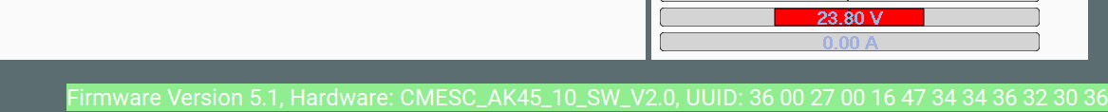
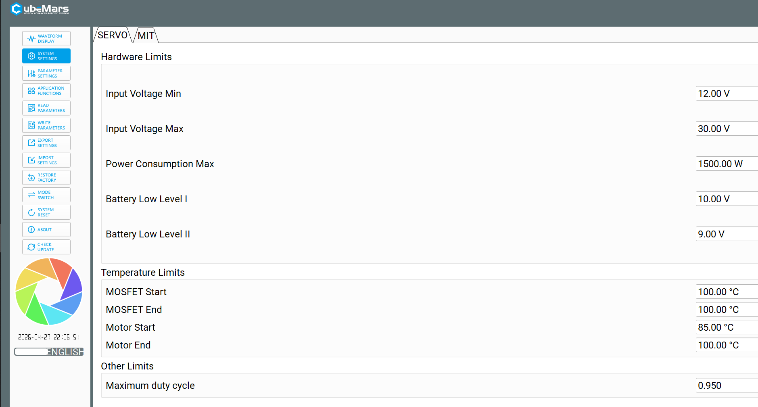
- Set Current limits
- Detect encoder→Update
- Measure R/L →Lambda→Update
- Might have to tune velocity controller

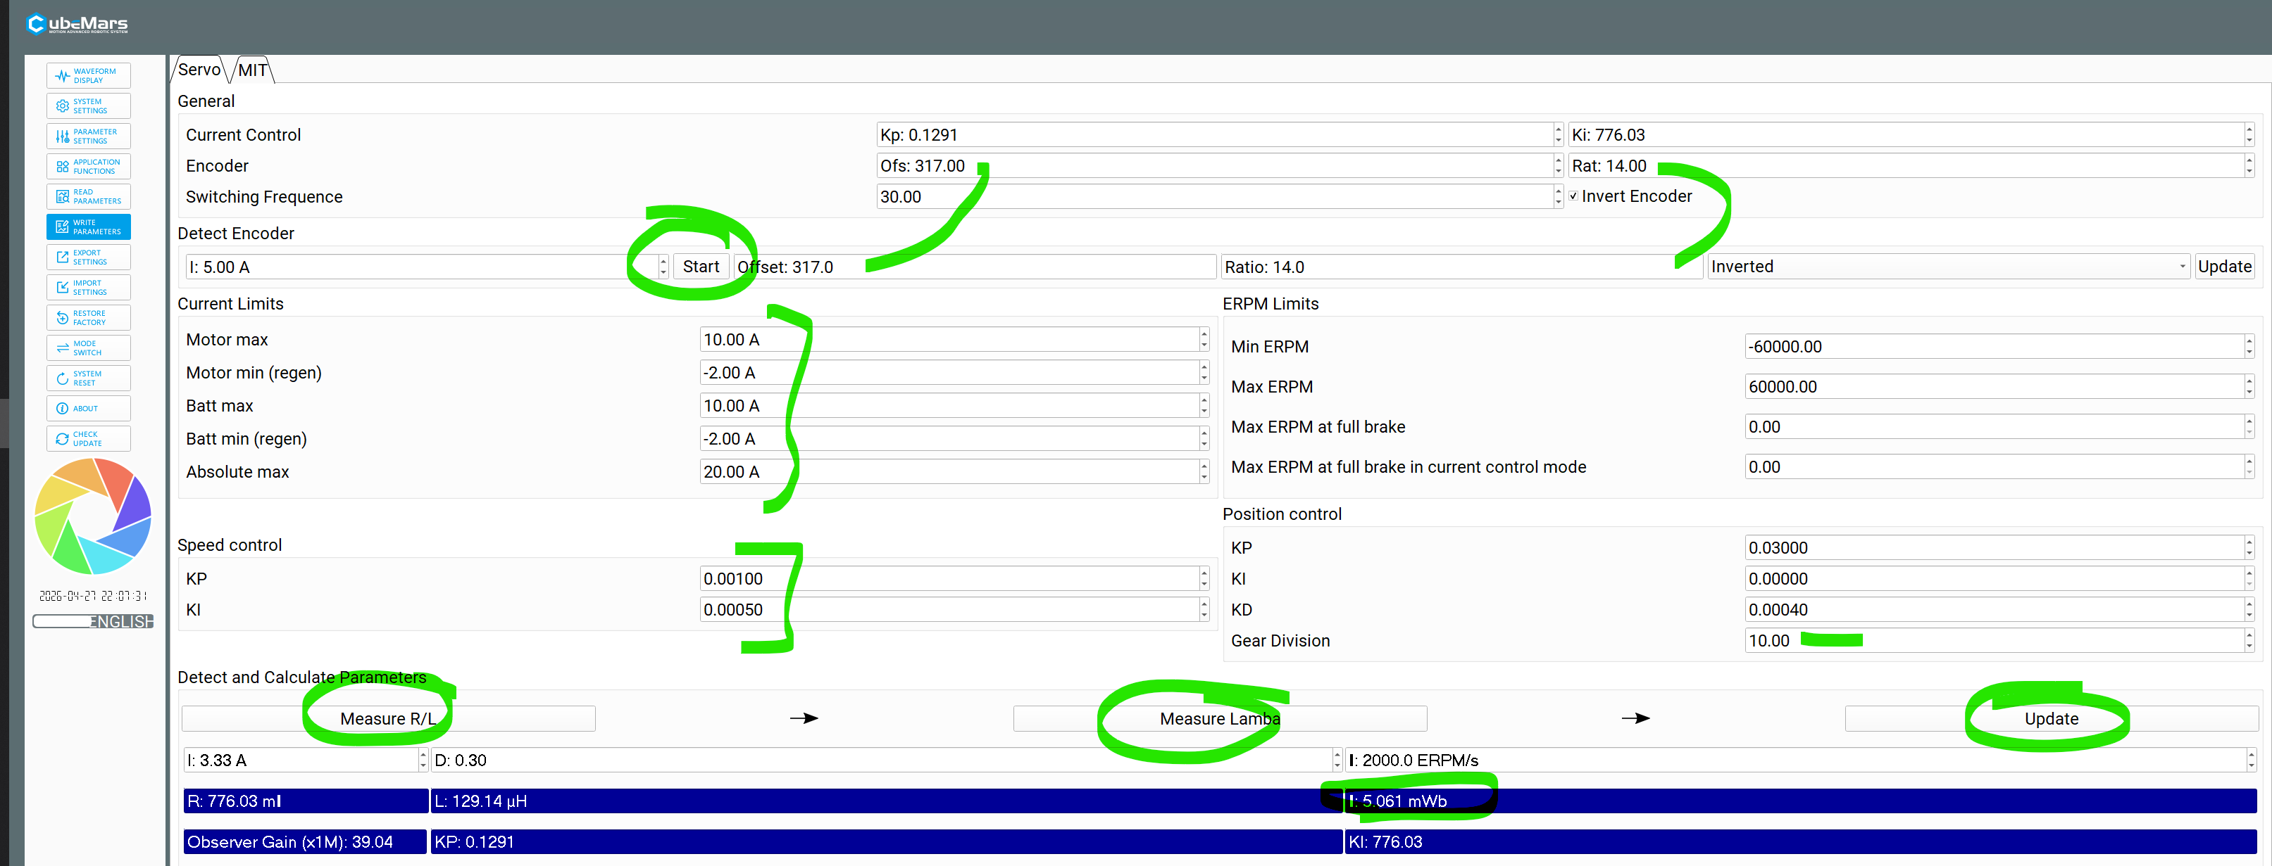


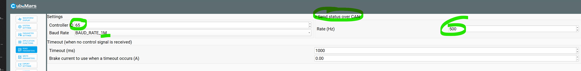

CAN MODE
https://www.youtube.com/watch?v=5KYqYAnAdCM
Setup CAN mode→ Debug
