Title: **Assignment Reset Tool**

Type: **Block**

Moodle version required: **2.4**

Git Repository: <https://github.com/fernandooliveira/moodlefn-assignment_reset>

Support and Feedback: [www.moodlefn.knet.ca](http://www.moodlefn.knet.ca)

Contents of this document:

1. Installation Instructions
2. Overview of Assignment Reset Tool
3. Screenshots
4. **Installation Instructions:**
5. Click on the following link to download the files for this plug-in: <https://github.com/fernandooliveira/moodlefn-assignment_reset/archive/master.zip>
6. Unzip the downloaded file and rename top directory to **fn_assignment_reset**
7. Copy the **fn_assignment_reset** directory to **yourmoodlesite/blocks/**

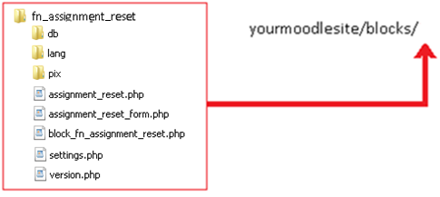

1. **Overview of My Progress Block**

The ***Assignment Reset Tool (ART)*** block was created as a quick and easy way to reset the setting for all assignments in a course. Note that it does not set defaults that are applied when creating new assignments but rather it only resets the setting for existing assignments.

Apart from the standard settings that are available via the assignment settings screen, this block also includes the ability to set the “grade-to-pass” value, which is otherwise accessible via the advanced grading settings. Moreover, with this block, the grade-to-pass value can be set as a percentage (see screenshot on the next page).

1. **Screenshot:**

|  |  |
| --- | --- |
|  |  |