Title: **My Menu**

Type: **Block**

Moodle version required: **2.3**

Git Repository: <https://github.com/fernandooliveira/moodlefn-mymenu>

Support and Feedback: [www.moodlefn.knet.ca](http://www.moodlefn.knet.ca)

Contents of this document:

1. Installation Instructions
2. Overview of My Progress Block
3. Suggestions
4. Screenshots
5. **Installation Instructions:**
6. Click on the following link to download the files for this plug-in: <https://github.com/fernandooliveira/moodlefn-mymenu/archive/master.zip>
7. Unzip the downloaded file and rename top directory to **fn_my_menu**
8. Copy the **fn_my_menu** directory to **yourmoodlesite/blocks/**

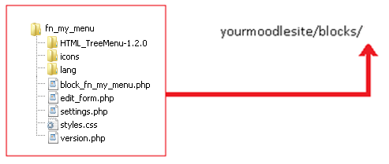

1. **Overview of My Progress Block**

The ***FN My Menu*** block was created as an alternative to the default [Moodle Navigation block](http://docs.moodle.org/21/en/Navigation_block) that was introduced in Moodle2. Note that this block is meant to simplify the navigation process for STUDENTS. The Moodle Navigation block will still be required for teachers, course managers and other roles that require the administrative functions that are contained within the Navigation block.

1. **Suggestions:**

* After installing the My Menu block, you will want to prevent students from seeing the Navigation block. To do this, click on the "Assign Roles" icon located in the Navigation block header, select "Permissions", as shown here: <http://screencast.com/t/5ZGjZhS9Tl2>. Then remove Student, Authenticated User, Guest and any other role that you want to prevent from viewing the default Navigation block.
* Keep the My Menu block in the same location across all courses by setting the same location setting in all courses (and even the front page), as shown here: <http://screencast.com/t/zmKO93jKp>

1. **Screenshots:**

|  |  |
| --- | --- |
|  |  |