Title: **My Progress**

Type: **Block**

Moodle version required: **2.5**

Git Repository: <https://github.com/fernandooliveira/moodlefn-myprogress25>

Support and Feedback: [www.moodlefn.knet.ca](http://www.moodlefn.knet.ca)

Note: The *My Progress*  block was originally created to work with the Tabs Course Format ( ). Both these plug-ins are part of the MoodleFN plug-in series for Moodle 2.x, which can be found on [www.moodlefn.knet.ca](http://www.moodlefn.knet.ca). Note however that the Tabs Course Format is not a required component of the My Progress block.

Contents of this document:

1. Installation Instructions
2. Overview of My Progress Block
3. **Installation Instructions:**
4. Click on the following link to download the files for this plug-in: [https://github.com/fernandooliveira/moodlefn-myprogress zipball/master/](https://github.com/fernandooliveira/moodlefn-myprogress%20zipball/master/)
5. Unzip the downloaded file and rename top directory to **fn_myprogress**
6. Copy the **fn_myprogress** directory to **yourmoodlesite/blocks/**

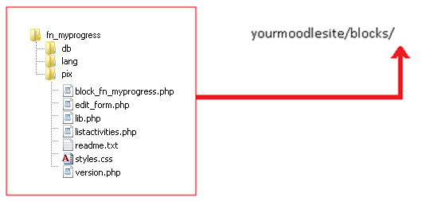

1. **Overview of My Progress Block**

The Progress Report block provides STUDENTS with an overview of their progress in regards to activities in a given course. This block is not shown to teachers. Each line also acts as a link which provides students with a list of the relevant activities (example: when a student clicks on ***X Incomplete*** activities, his/her incomplete activates will get listed).

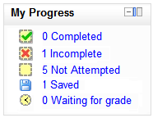

**Note 1:** This block relies on the Activity Completion feature that was released as part of Moodle 2.0 (more information about this feature can be found at <http://docs.moodle.org/20/en/Activity_completion>). Activities that do not have the “completion tracking” turned on will not be included in this block.

**Note 2:** If an activity has a “Require Grade” condition in the Activity Completion setting, then that activity will show as “complete” when it receives **any** grade.

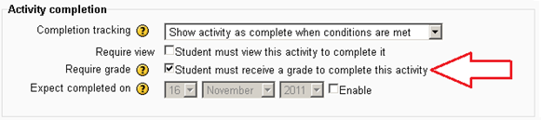

However, if the same activity also has the “[grade to pass](http://docs.moodle.org/20/en/Grade_items)” option enabled in the gradebook, the activity will show as “Incomplete” until it receives a grade that is equal or greater than the “grade to pass” value.

