Plugin: Group URL Swap (GURLS)

Type: Moodle Filter

Moodle versions: 2.7, 2.8, 2.9

Contact: [fernando.oliveira@rosedaleacademy.com](mailto:fernando.oliveira@rosedaleacademy.com)

**Summary:**

This plugin will dynamically replace a URL (example: [www.black.com](http://www.black.com)) with an alternative URL (example: [www.blue.com](http://www.blue.com)) based on front page group membership. Consider this example:

A Moodle site has a grouping named “SWAP” and this grouping contains two groups: Red Group and Blue Group. Using the GURLS filter, the admin creates a swap instance for the URL [www.black.com](http://www.black.com). Within this instance, the Red Group is associated with [www.red.com](http://www.red.com) and the Blue Group with [www.blue.com](http://www.blue.com).

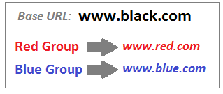

This means that when members of the Red Group come across any page that contains the URL [www.black.com](http://www.black.com), they will see their alternative URL [www.red.com](http://www.red.com). Accordingly, members of the blue group will see [www.blue.com](http://www.blue.com). This plugins can be used for different purposes, but it was originally created to serve large media files from a server that is closest to the user. In the example illustrated below, [www.red.com](http://www.red.com) could be a server in Brazil and [www.blue.com](http://www.blue.com) could be a server in China.

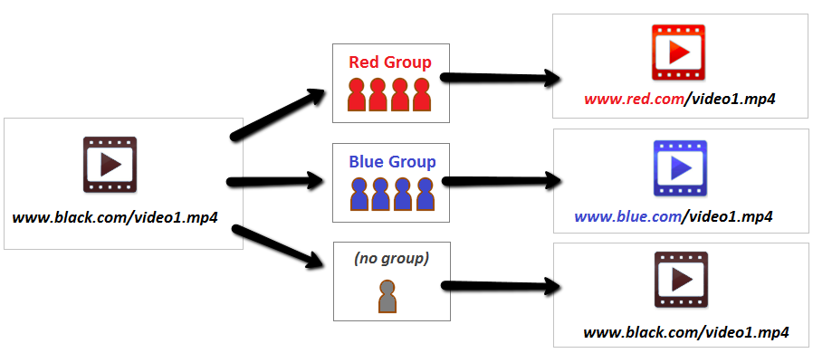

**Instructions:**

Install this plugin by following normal installation conventions (<https://docs.moodle.org/29/en/Installing_plugins>)

Part A: Create Groups

1. At the front page level, open the “Groups” page:

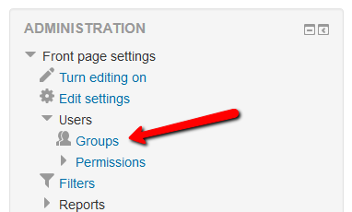

1. Within this page, create a grouping called “SWAP”
2. Create your groups and associate them with the SWAP grouping
3. You can return to this page in the future to add/remove groups

Part B: Create a SWAP instance

1. Go to Site Administartion > Plugins > Filters and activate the GURLS plugin
2. Click on the “Create new swap” button that is next the SWAP grouping
3. Enter the default URL. This is the URL that will be replaced by the filter.
4. Click on the pencil icon to associate groups, as shown here:

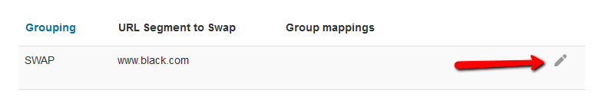

1. Add as many URLs as needed and associate groups. Here is how the interface works:

