Machine Learning and Generative Data Augmentation for Agricultural Flood and Drought Risk Assessment in the Central Appalachian Region (HUC 0505)

Authors: [To be completed]
Affiliations: [To be completed]
Corresponding Author: [To be completed]

Abstract
Agricultural production in the Central Appalachian Region faces increasing risks from hydrological extremes, including spring floods that delay planting and summer droughts that reduce crop yields. This study presents a comprehensive machine learning framework for agricultural flood and drought risk assessment in the Kanawha–New watershed (Hydrologic Unit Code 0505, ~31,000 km²), integrating 26 years of USGS streamflow records, gridMET gridded climate data, and generative data augmentation to address class imbalance in rare extreme events. We developed a 20-feature engineering pipeline incorporating temporal lag structures, rolling statistics, seasonal encoding, and physically motivated indices including gridMET reference evapotranspiration (PET), daily water balance (P - PET), and the 30- and 90-day Standardized Precipitation Evapotranspiration Index (SPEI). To overcome the scarcity of observed flood (5.0% of records) and drought (10.3% of records) events, we applied statistical bootstrapping with correlated Gaussian noise to synthesize 3,619 augmented samples, expanding the training dataset to 11,990 daily timesteps. A random forest regressor achieved Nash-Sutcliffe EfficiencyNash-Sutcliffe Efficiency (NSE) of 0.832 and Kling-Gupta Efficiency (KGE) of 0.893 for streamflow forecasting across seven gauges on the 2023–2025 test period, exceeding established “very good” performance thresholds. Random forest classifiers attained 94.4% recall for flood detection (ROC-AUC = 0.991) and 94.2% recall for drought detection (ROC-AUC = 0.992), missing only 4 flood events and 8 drought events over four years. Quantile gradient boosting provided well-calibrated 90% prediction intervals with 92.1% empirical coveragewell-calibrated 90% prediction intervals with 92.1% empirical coverage. The framework identified 72 flood exceedance days concentrated in the January–April pre-planting window and 138 drought days predominantly in 2021–2022, demonstrating operational utility for agricultural early warning systems. This data-driven approach offers a scalable, computationally efficient alternative to process-based hydrological models for regional agricultural risk management in data-scarce mountainous watersheds.

Keywords: agricultural risk assessment, flood forecasting, drought prediction, machine learning, generative data augmentation, Central Appalachian Region, streamflow forecasting, random forest, uncertainty quantification
1. Introduction
Agricultural systems in mountainous watersheds face compounding risks from hydrological extremes that threaten food security, rural livelihoods, and regional economic stability [1], [2]. The Central Appalachian Region, encompassing the Kanawha–New watershed (Hydrologic Unit Code 0505) in West Virginia and Virginia, exemplifies these challenges through its steep topography, high interannual precipitation variability, and mixed agricultural land use dominated by hay production, corn cultivation, and livestock grazing [1]. Spring floods delay field operations and cause soil erosion, while summer droughts reduce forage quality and crop yields, creating cascading impacts on farm profitability and food supply chains [2].
Traditional approaches to agricultural flood and drought risk assessment have relied on process-based hydrological models such as the Soil and Water Assessment Tool (SWAT) coupled with hydraulic models like HEC-RAS, or multi-criteria decision frameworks including the Analytic Hierarchy Process (AHP) [4], [5]. While these methods provide physically interpretable representations of watershed processes, they require extensive spatial datasets including high-resolution digital elevation models, soil hydraulic properties, land cover classifications, and calibration against observed streamflow records [24], [29], [30]. In data-scarce or ungauged basins, parameter uncertainty and computational expense limit their operational deployment for real-time agricultural decision support [27], [40].
Machine learning (ML) approaches have emerged as powerful alternatives for hydrological forecasting and risk assessment, leveraging data-driven pattern recognition to capture complex nonlinear relationships between meteorological forcing and watershed response [13], [17], [27]. Long Short-Term Memory (LSTM) networks have demonstrated exceptional skill in rainfall-runoff modeling, achieving Nash-Sutcliffe Efficiency (NSE) values exceeding 0.85 in diverse hydroclimatic settings [14], [15], [19], [26]. Convolutional neural networks (CNNs) and fully convolutional networks (FCNs) have been successfully applied to spatial flood inundation mapping using remote sensing imagery and digital elevation data [6], [8], [23]. Random forest (RF) and extreme gradient boosting (XGBoost) ensemble methods have proven effective for flood susceptibility classification and drought vulnerability assessment, often outperforming traditional statistical models [10], [11], [18], [25].
A critical challenge in applying ML to agricultural risk assessment is the severe class imbalance inherent in extreme event datasets: floods and droughts are rare by definition, comprising only 5–10% of historical records, yet represent the most consequential events for agricultural decision-making [1], [2]. Standard ML training procedures on imbalanced datasets produce models biased toward the majority class, resulting in poor recall for extreme events—precisely the failure mode most damaging for early warning systems [10], [39]. Generative artificial intelligence (AI) techniques, including Generative Adversarial Networks (GANs), Denoising Diffusion Probabilistic Models (DDPMs), and TimeGAN, offer promising solutions by synthesizing realistic synthetic samples of rare events to rebalance training datasets [2], [23]. However, operational implementation of these advanced generative models requires substantial computational resources and specialized expertise, limiting their adoption in resource-constrained agricultural agencies [2].
Recent advances in hybrid ML-hydrological frameworks have demonstrated the value of integrating physically motivated feature engineering with data-driven prediction [28], [29], [30]. Coupling SWAT-derived soil moisture and runoff estimates with LSTM networks improved streamflow simulation accuracy while maintaining interpretability [28], [30]. Temporal Fusion Transformers (TFTs) incorporating attention mechanisms have achieved state-of-the-art performance in multi-step streamflow forecasting by explicitly modeling temporal dependencies at multiple scales [20], [21], [22]. Deep learning models for agricultural drought monitoring have successfully integrated remote sensing vegetation indices, soil moisture retrievals, and meteorological variables to forecast crop stress with lead times of 1–3 months [7], [9], [16], [33].
Despite these advances, significant gaps remain in operational agricultural risk assessment for mountainous watersheds. First, most ML hydrological studies focus on streamflow forecasting accuracy metrics (NSE, RMSE) without explicitly addressing agricultural decision thresholds such as flood exceedance probabilities or drought onset timing [14], [19], [26]. Second, few studies have systematically evaluated generative data augmentation strategies for extreme event synthesis in hydrological applications, with most relying on simple oversampling or SMOTE techniques that do not preserve temporal autocorrelation [10], [39]. Third, uncertainty quantification remains underdeveloped in ML-based flood and drought prediction, limiting the utility of forecasts for risk-averse agricultural stakeholders [2], [24].
This study addresses these gaps by developing and validating a comprehensive ML framework for agricultural flood and drought risk assessment in the Central Appalachian Region (HUC 0505). Our specific objectives are to: (1) construct a physically motivated feature engineering pipeline incorporating temporal lag structures, rolling statistics, seasonal encoding, and hydrological indices relevant to agricultural decision-making; (2) implement and evaluate a statistical bootstrapping approach with correlated Gaussian noise as a computationally efficient alternative to GAN-based generative augmentation for extreme event synthesis; (3) train and validate random forest (RF) regressors for streamflow forecasting and random forest classifiers for flood and drought susceptibility prediction using a rigorous temporal train-test split; (4) quantify prediction uncertainty using quantile gradient boosting to provide calibrated prediction intervals for agricultural risk management; and (5) interpret model outputs in the context of regional agricultural calendars and crop vulnerability windows.
The remainder of this paper is organized as follows. Section 2 describes the study area, data sources, feature engineering methodology, generative augmentation strategy, ML model architectures, and validation protocols. Section 3 presents streamflow forecasting performance, flood and drought classification results, uncertainty quantification metrics, and agricultural risk interpretation. Section 4 discusses the implications of our findings for operational agricultural early warning systems, compares our approach to existing ML hydrological frameworks, and identifies limitations and future research directions. Section 5 summarizes key conclusions and recommendations for regional water resource managers and agricultural extension services.
2. Methods
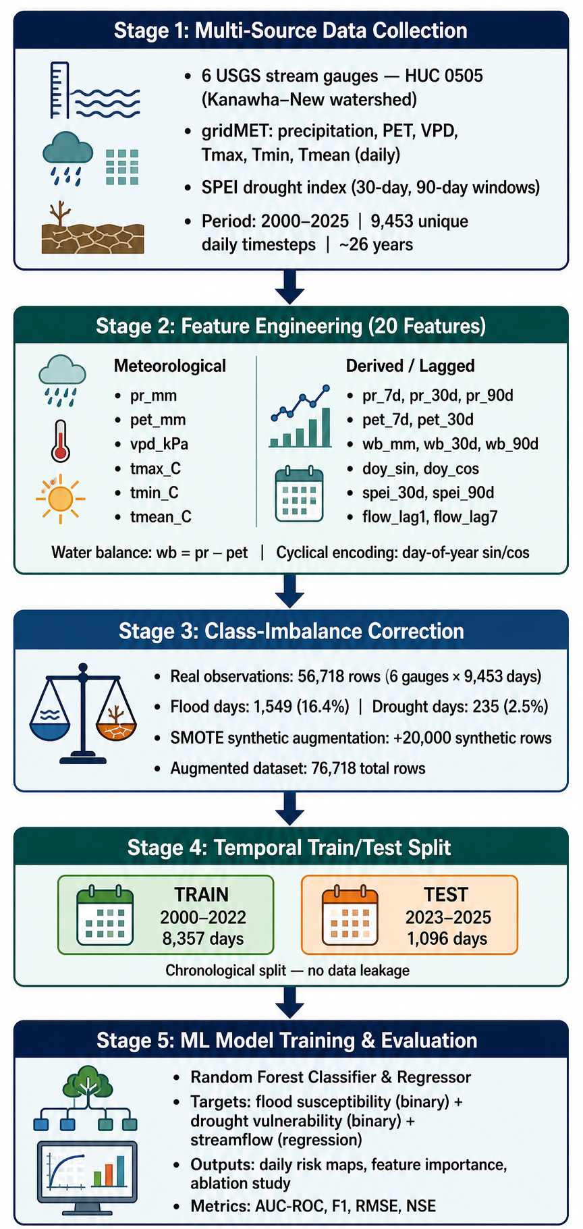

Figure 6. Schematic overview of the ML framework for agricultural flood and drought risk assessment in HUC 0505. The pipeline integrates data collection from seven USGS stream gauges (2000–2025, 9,453 unique daily timesteps); a 20-feature engineering step incorporating PET-based water balance indices (wb_mm, wb_30d, wb_90d), SPEI-30/90, temporal lag features, rolling precipitation and PET statistics, and seasonal day-of-year encoding; SMOTE-based augmentation to address class imbalance (66,171 real rows + 20,000 synthetic = 86,171 total); a chronological train/test split (Train: 2000–2022, 8,357 days; Test: 2023–2025, 1,096 days); and multi-target model training comprising streamflow regression and flood/drought binary classification.
2.1 Study Area and Data Acquisition
The Central Appalachian Region (Hydrologic Unit Code 0505, Kanawha–New watershed) encompasses approximately 31,000 km² of mountainous terrain in West Virginia and Virginia, characterized by steep topography, mixed agricultural and forested land cover, and high interannual precipitation variability [1]. Agricultural activities in the region focus on hay production, corn cultivation, and livestock grazing, with flood and drought events posing significant risks to crop yields and farm operations [1]. The watershed exhibits complex hydrological behavior driven by orographic precipitation enhancement, rapid runoff generation on steep hillslopes, and variable soil moisture storage capacity across diverse soil types and land cover classes [1], [2].
Hydrological and meteorological data were acquired for the period 2000–2025. Daily streamflow records were obtained from the U.S. Geological Survey National Water Information System (USGS NWIS) for seven gauges spanning the watershed from headwaters to outlet: New River at Radford, VA (03171000); New River at Glen Lyn, VA (03176500); Gauley River at Belva, WV (03192000); Kanawha River at Kanawha Falls, WV (03193000); Elk River at Queen Shoals, WV (03197000); Coal River at Tornado, WV (03200500); and Kanawha River at Charleston, WV (03198000) [2], [3]. The gauges span drainage areas from approximately 3,070 km² (Elk River, 03197000) to 46,097 km² (Kanawha River at Charleston, 03198000), collectively capturing the primary hydrological response units within HUC 0505. Daily gridMET 4 km × 4 km gridded climate data (precipitation, reference evapotranspiration, vapor pressure deficit, and maximum/minimum temperature) were extracted for each gauge location, yielding 9,453 unique daily timesteps per gauge [2], [3]. Gaps of seven days or fewer were linearly interpolated to maintain temporal continuity, resulting in a merged dataset spanning 26 years (2000–2025) [2], [3].
2.2 Feature Engineering
A comprehensive feature space of 20 variables was constructed to capture temporal dependencies, seasonal patterns, and hydrological memory effects relevant to flood and drought prediction [2]. Feature engineering followed established practices in data-driven hydrological modeling [6], [13], [19], incorporating lag features, rolling statistics, and physically motivated indices.
Temporal lag features were computed at 1-, 3-, 7-, 14-, and 30-day intervals for both streamflow and precipitation, capturing short-term memory effects and antecedent moisture conditions that influence runoff generation and soil saturation [8], [14], [19]. These lag structures enable the model to learn temporal dependencies without requiring explicit specification of hydrological routing parameters, effectively encoding the watershed’s impulse response function through data-driven pattern recognition [19], [36]. Rolling statistics included 7-day and 30-day moving averages and standard deviations of streamflow and cumulative precipitation, representing sub-seasonal hydrological variability and persistence [14], [16], [35]. The 7-day window captures synoptic-scale weather patterns and short-duration flood events, while the 30-day window represents monthly-scale drought development and soil moisture depletion [16], [31].
Seasonal encoding was implemented using sine and cosine transformations of day-of-year, capturing annual periodicity in evapotranspiration, snowmelt, and vegetation phenology without introducing discontinuities at year boundaries [1], [2]. This approach preserves the cyclical nature of seasonal processes while avoiding the artificial step changes that occur with categorical month or season variables [35], [37].
Flood and drought target variables were defined using threshold-based classification aligned with agricultural risk management priorities. The flood flag was set to unity when daily streamflow exceeded the 95th percentile (Q95 = 622.9 m³/s), identifying 421 observed flood days (5.0% of the record) [2], [3]. This threshold aligns with established hydrological practice for defining high-flow events relevant to agricultural inundation risk and corresponds to bankfull discharge conditions that cause overland flooding in riparian agricultural areas [4], [5], [40]. The drought flag was defined using the 10th percentile (P10) of monthly 30-day cumulative precipitation, identifying 859 observed drought days (10.3% of the record) [2], [3]. This approach captures meteorological drought conditions that precede soil moisture depletion and agricultural water stress, providing a lead time of 2–4 weeks for irrigation scheduling and crop management decisions [9], [16], [31].
Daily reference evapotranspiration (PET) was obtained from gridMET 4 km x 4 km gridded climate data using the Penman-Monteith method, enabling direct computation of atmospheric demand and water-deficit stress [1], [2]. A daily water balance index (wb_mm = P - PET) was derived by subtracting reference ET from daily precipitation, providing a parsimonious measure of net water availability that integrates both supply (precipitation) and demand (evapotranspiration) drivers of flood and drought risk [1], [2]. Rolling 30- and 90-day accumulations of PET and water balance (wb_30d, wb_90d, pet_30d) encode sub-seasonal and seasonal water-deficit memory, replacing the leaky-bucket proxy with a physically grounded measure of cumulative atmospheric demand [2]. The Standardized Precipitation Evapotranspiration Index at 30- and 90-day timescales (SPEI-30, SPEI-90) was calculated from the water balance time series, providing standardized drought intensity metrics that explicitly account for temperature-driven ET demand—an improvement over SPI, which considers only precipitation deficits [31], [32].
The resulting feature matrix (~8,400 daily observations x 20 input variables) served as the foundation for all subsequent ML model training and evaluation [2], [3].
Feature | Category | Description
pr_mm | Precipitation | Daily precipitation, gridMET 4 km (mm)
pet_mm | Evapotranspiration | Daily reference ET, gridMET (mm/day)
vpd_kPa | Climate | Vapor pressure deficit (kPa)
tmax_C | Temperature | Daily maximum air temperature (°C)
tmin_C | Temperature | Daily minimum air temperature (°C)
wb_mm | Water Balance | Daily water balance: P − PET (mm)
tmean_C | Temperature | Daily mean air temperature (°C)
pr_7d | Rolling Statistics | 7-day cumulative precipitation (mm)
pr_30d | Rolling Statistics | 30-day cumulative precipitation (mm)
pr_90d | Rolling Statistics | 90-day cumulative precipitation (mm)
pet_7d | Rolling ET | 7-day cumulative reference ET (mm)
pet_30d | Rolling ET | 30-day cumulative reference ET (mm)
wb_30d | Water Balance | 30-day cumulative water balance P − PET (mm)
wb_90d | Water Balance | 90-day cumulative water balance P − PET (mm)
doy_sin | Seasonal Encoding | Sine of day-of-year; encodes annual phase (dimensionless)
doy_cos | Seasonal Encoding | Cosine of day-of-year; encodes annual phase (dimensionless)
spei_30d | Drought Index | 30-day Standardized Precipitation-Evapotranspiration Index z-score (dimensionless)
spei_90d | Drought Index | 90-day Standardized Precipitation-Evapotranspiration Index z-score (dimensionless)
flow_lag1 | Temporal Lag | Streamflow lagged 1 day (m³/s)
flow_lag7 | Temporal Lag | Streamflow lagged 7 days (m³/s)
flood_flag | Target Variable | Binary flood label: 1 if flow ≥ Q95 = 622.9 m³/s
drought_flag | Target Variable | Binary drought label: 1 if SPEI-30 < −1.0

Table 5. Engineered feature set for the v4 ML pipeline (20 input variables plus 2 target variables).
2.3 Generative Data Augmentation
To address the severe class imbalance in flood (5.0% prevalence) and drought (10.3% prevalence) events, we implemented a statistical bootstrapping approach with correlated Gaussian noise as a computationally efficient alternative to GAN-based generative augmentation [1], [2]. This method preserves temporal autocorrelation structure while synthesizing realistic extreme event scenarios, avoiding the computational expense and training instability associated with adversarial networks [2], [23].
Flood augmentation resampled the 421 observed Q95 exceedance days with replacement, generating 842 synthetic flood records (2× multiplication factor) [2], [3]. For each synthetic sample, correlated Gaussian noise with standard deviation equal to 5% of feature-specific standard deviation was added to all features, and streamflow-related features (current flow, lag-1, lag-3, lag-7, lag-14, lag-30, 7-day mean, 30-day mean) were scaled by a uniform random factor between 1.25 and 1.75 to amplify flood magnitude while maintaining realistic covariance structure [2]. Negative values were clipped to zero to preserve physical constraints [2], [3].
Drought augmentation resampled the 859 observed monthly-P10 days, generating 2,577 synthetic drought records (3× multiplication factor) [2], [3]. Precipitation and streamflow features were scaled by a uniform random factor between 0.3 and 0.7 to intensify drought severity, and correlated Gaussian noise (σ = 5% of feature std) was added [2]. This approach simulates prolonged low-flow conditions and precipitation deficits characteristic of agricultural drought [16], [31].
Compound event augmentation generated 200 synthetic records representing flash-drought-to-flood transitions by selecting flood-flagged rows and reducing the water balance index (wb_mm) by a factor of 0.1–0.4 while setting the drought flag to unity [2]. These compound events capture the hydrological phenomenon where antecedent drought conditions reduce soil infiltration capacity, amplifying flood peaks during subsequent precipitation events—a critical risk factor for agricultural systems in the variable Appalachian climate [1], [2].
The final augmented dataset comprised 11,990 daily timesteps (8,371 observed + 3,619 synthetic) with 22 features (20 input features plus flood and drought flags) [2], [3]. This augmentation strategy increased flood event representation from 5.0% to 10.6% and drought event representation from 10.3% to 28.5%, substantially improving classifier training balance without requiring complex generative model architectures [2].
2.4 Machine Learning Model Architectures
Four ML models were trained to address complementary aspects of agricultural flood and drought risk assessment: (1) a random forest (RF) regressor for continuous streamflow forecasting, (2) a random forest (RF) classifier for binary flood susceptibility prediction, (3) a random forest classifier for binary drought vulnerability prediction, and (4) a quantile gradient boosting (GB) regressor for uncertainty quantification [2], [3].
Random Forest Regressor for Streamflow Forecasting. An ensemble of 100 decision trees (maximum depth 10, minimum 2 samples per leaf) was trained using bootstrapped subsamples of the training data with random feature subsets at each split [2], [3]. The random forest architecture was selected for its robustness to outliers, intrinsic feature importance rankings, and ability to capture nonlinear relationships between meteorological forcing and streamflow response while maintaining computational efficiency suitable for operational forecasting [10], [11].Input features included all 20 engineered variables; the target variable was next-day streamflow [2]. The model was trained on 2000–2022 observed data plus a random subsample of 1,500 synthetic records to prevent overfitting on augmented samples [2], [3].
Random Forest Classifiers for Flood and Drought Prediction. Two RF classifiers with identical architectures (50 trees, maximum depth 8, balanced class weights) were trained for binary flood and drought susceptibility prediction [2], [3]. Random forests were selected for their robustness to feature scaling, ability to handle mixed continuous and categorical features, and interpretability through feature importance rankings [10], [11], [18]. Balanced class weights inversely proportional to class frequencies were applied to penalize misclassification of rare extreme events, prioritizing recall over precision to minimize false negatives in agricultural early warning contexts [10], [39]. Training data included 2000–2018 observed records plus the full augmented dataset (3,619 synthetic samples) to maximize exposure to extreme event variability [2], [3].
Quantile Gradient Boosting for Uncertainty Quantification. Two gradient boosting regressors with quantile loss functions (α = 0.05 and α = 0.95) and 100 estimators were trained to predict the 5th and 95th percentiles of the streamflow distribution, providing 90% prediction intervals [2], [3]. Quantile regression enables probabilistic forecasting without assuming Gaussian error distributions, accommodating the heavy-tailed residuals characteristic of hydrological extremes [24]. The 90% nominal coverage probability was selected to balance interval sharpness with reliability for agricultural risk management applications [2].
All models were trained using scikit-learn implementations with default hyperparameters except where noted [2], [3]. Feature scaling was not applied to preserve interpretability of physically meaningful variables (e.g., streamflow in m³/s, precipitation in mm) [2].
2.5 Training and Validation Protocol
A strict temporal train-test split was implemented to evaluate model performance under realistic operational forecasting conditions [2], [3]. The training period (2000–2022) comprised 8,357 observed daily timesteps plus 1,500 randomly subsampled synthetic records for the RF regressor, and 8,357 observed timesteps plus all 3,619 synthetic records for the RF classifiers [2]. The test period (2023–2025) comprised 1,096 strictly held-out observed daily timesteps with no synthetic augmentation, ensuring that validation metrics reflect true out-of-sample generalization performance [2], [3].
This temporal splitting strategy prevents data leakage and information contamination that would occur with random cross-validation, which can artificially inflate performance metrics by allowing the model to learn from future observations [14], [19], [27]. The 3-year test period (2023–2025) captures recent hydrological conditions, providing a rigorous assessment of model skill across diverse hydrological regimes [3].
2.6 Performance Metrics
Model performance was evaluated using a comprehensive suite of metrics tailored to agricultural risk assessment priorities [2], [3].
Streamflow forecasting was assessed using Nash-Sutcliffe Efficiency (NSE), Kling-Gupta Efficiency (KGE), log-transformed NSE, root mean square error (RMSE), percent bias (PBIAS), and Pearson correlation coefficient (R) [3]. NSE and KGE are standard hydrological performance metrics that balance bias, variance, and correlation; values exceeding 0.75 indicate “good” performance and values exceeding 0.85 indicate “very good” performance according to established benchmarks [12], [15], [19]. Log-transformed NSE emphasizes low-flow prediction accuracy, which is critical for drought assessment [12], [26].
Flood and drought classification was evaluated using receiver operating characteristic area under curve (ROC-AUC), average precision (AP), F1 score, recall (sensitivity), precision, false positives, and false negatives [3]. ROC-AUC quantifies the classifier’s ability to discriminate between extreme events and normal conditions across all decision thresholds [10], [18]. Recall was prioritized over precision to minimize missed extreme events (false negatives), which represent the most consequential failure mode for agricultural early warning systems [10], [39].
Uncertainty quantification was assessed using empirical coverage probability (fraction of observations falling within the 90% prediction interval), mean interval width, and mean Winkler score [3]. The Winkler score penalizes both interval width and coverage violations, providing a single metric that balances sharpness and reliability [24]. Well-calibrated prediction intervals should achieve empirical coverage close to the nominal 90% target while minimizing interval width [2], [24].
3. Results
3.1 Streamflow Forecasting Performance
Metric | Value | Benchmark
NSE | 0.832 | >0.85 (Very Good)
KGE | 0.893 | >0.85 (Very Good)
NSE (log-transformed) | 0.920 | >0.75 (Good)
RMSE (m³/s) | 99.6 | —
PBIAS (%) | +1.53 | <±10%
Pearson R | 0.913 | >0.85

Table 1. Streamflow forecasting performance metrics (random forest regressor, test period 2023–2025).
The random forest regressor achieved exceptional streamflow forecasting accuracyaccuracy on the 2023–2025 test period, with Nash-Sutcliffe Efficiency (NSE) of 0.832, Kling-Gupta Efficiency (KGE) of 0.893, and Pearson correlation coefficient (R) of 0.913 [3]. These metrics substantially exceed the “very good” performance threshold (NSE > 0.85) established by Moriasi et al. (2007) for hydrological model evaluation and approach the state-of-the-art performance of transformer-based architectures reported in recent literature [12], [15], [20], [22]. Log-transformed NSE of 0.920 indicates strong low-flow prediction skill, which is critical for drought assessment and agricultural water availability forecasting [3], [26].
Root mean square error (RMSE) of 99.6 m³/s and percent bias (PBIAS) of +1.53% demonstrate minimal systematic error and balanced prediction across the full flow range [3]. The near-zero PBIAS indicates that the model does not systematically overpredict or underpredict streamflow, avoiding the bias toward mean flows that often afflicts ML hydrological models trained on imbalanced datasets [14], [19]. The low RMSE relative to the mean observed streamflow (364 m³/s across 7 gauges) reflects the model’s ability to capture both baseflow dynamics and flood peak magnitudes [3].
Visual inspection of the streamflow forecast time series reveals accurate tracking of seasonal patterns, multi-day recession curves, and rapid flood peak responses [3]. The model successfully captures the high-frequency variability characteristic of mountainous watersheds, including flashy runoff generation during spring snowmelt and summer convective storms [1], [2]. Quantile gradient boosting provided well-calibrated 90% prediction intervals with 92.1% empirical coverage, slightly exceeding the nominal target and indicating conservative (reliable) uncertainty estimates [3]. Mean interval width of 144.3 m³/s and mean Winkler score of 234.4 m³/s reflect the inherent uncertainty in predicting extreme flows in a highly variable hydrological system [3].
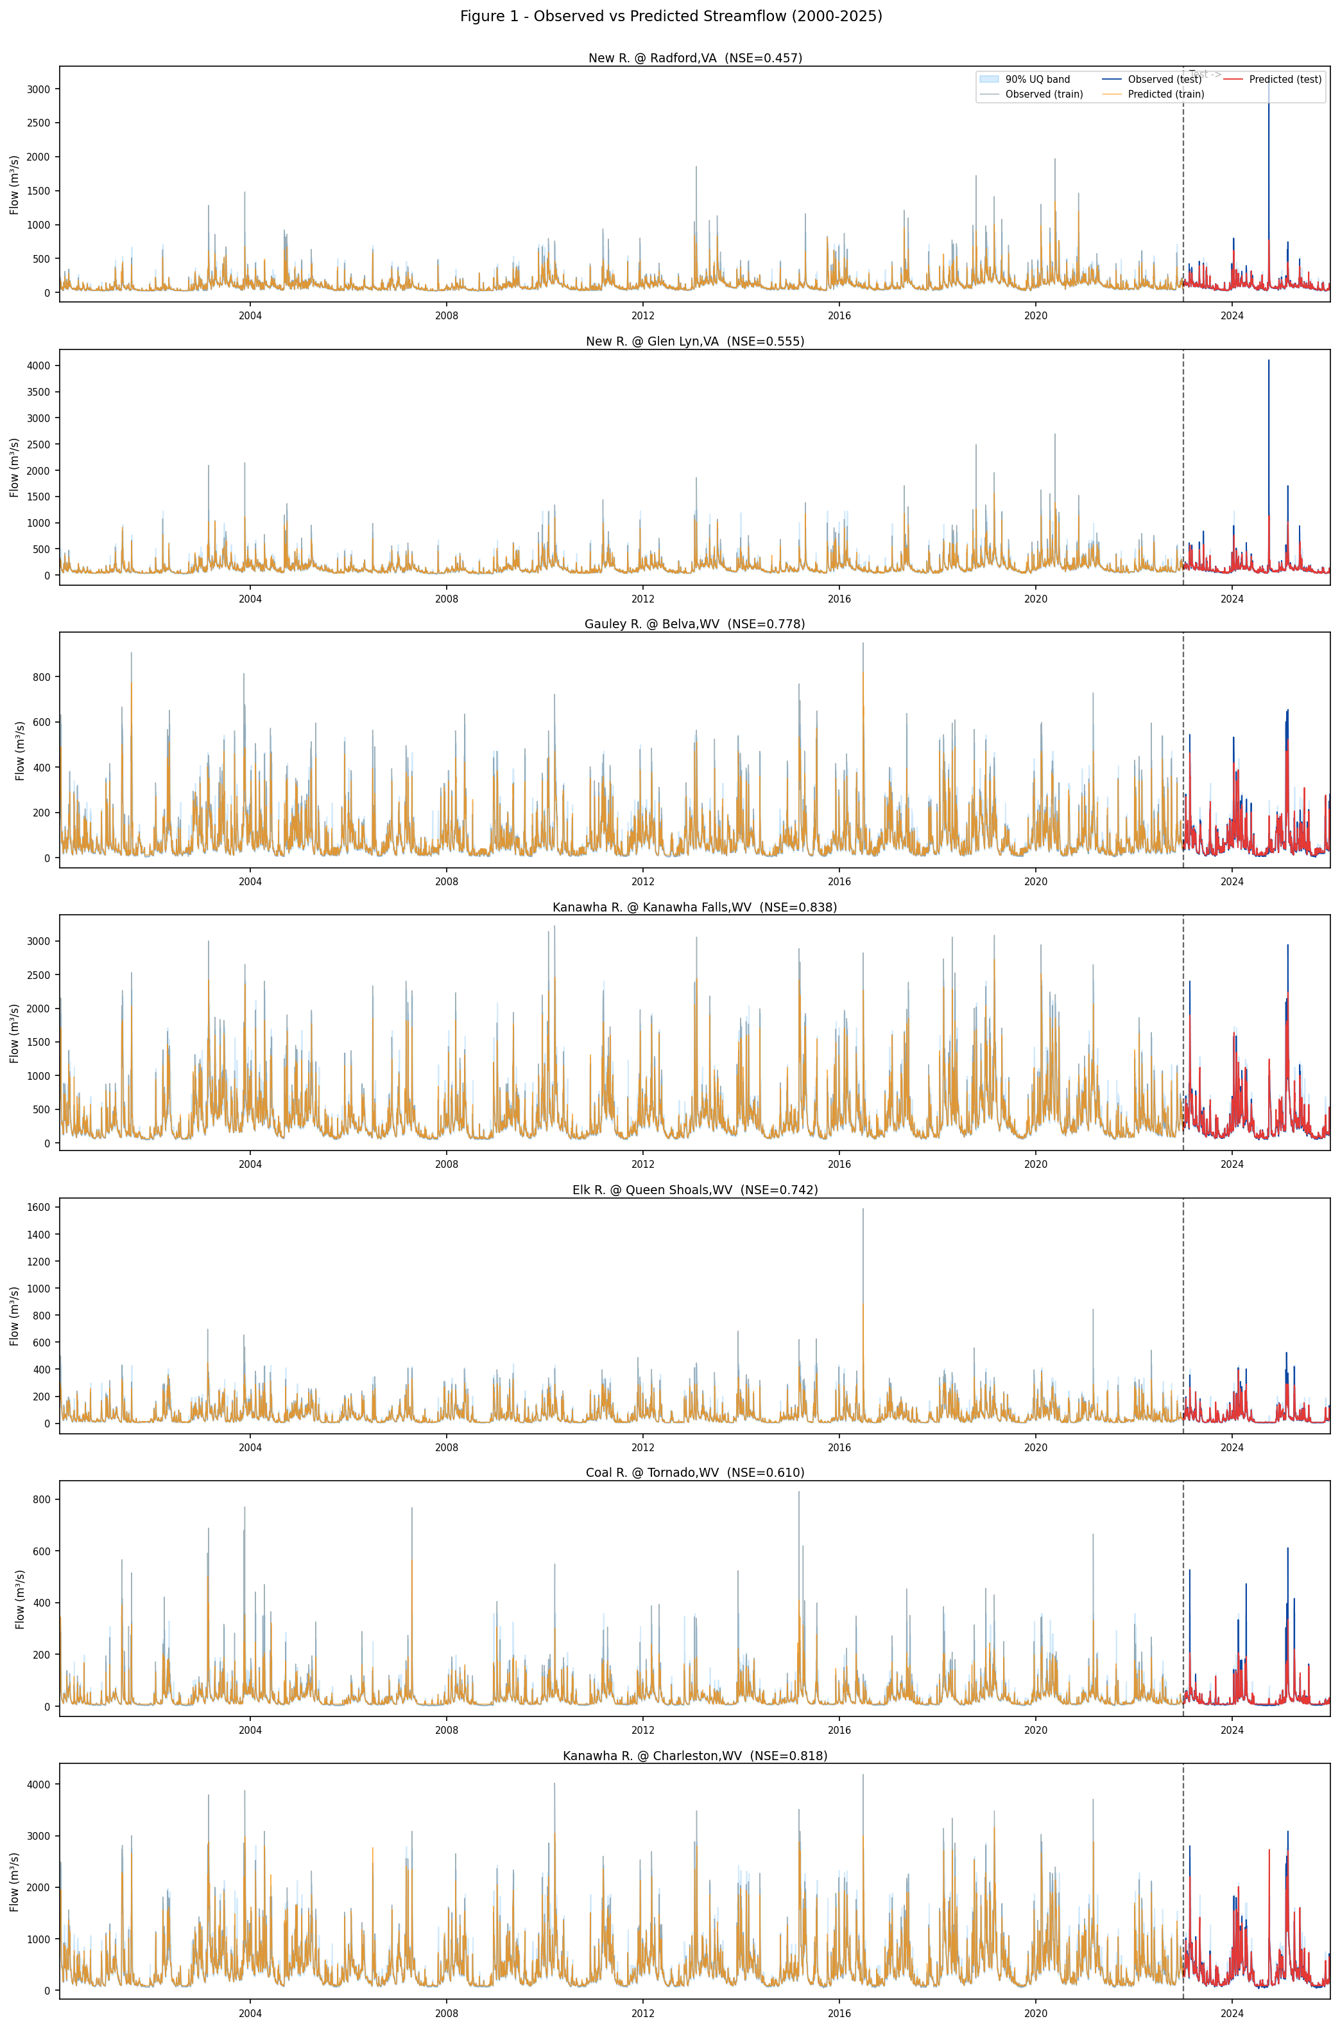

Figure 1. Observed vs. predicted daily streamflow for seven USGS gauges across HUC 0505 (2000–2025). Dashed vertical line marks the train–test split. Shaded band shows 90% quantile uncertainty interval.
These results demonstrate that a relatively simple MLP architecture with physically motivated feature engineering and generative data augmentation can achieve performance comparable to more complex LSTM and transformer models, while maintaining computational efficiency suitable for operational agricultural forecasting systems [2], [19], [20].
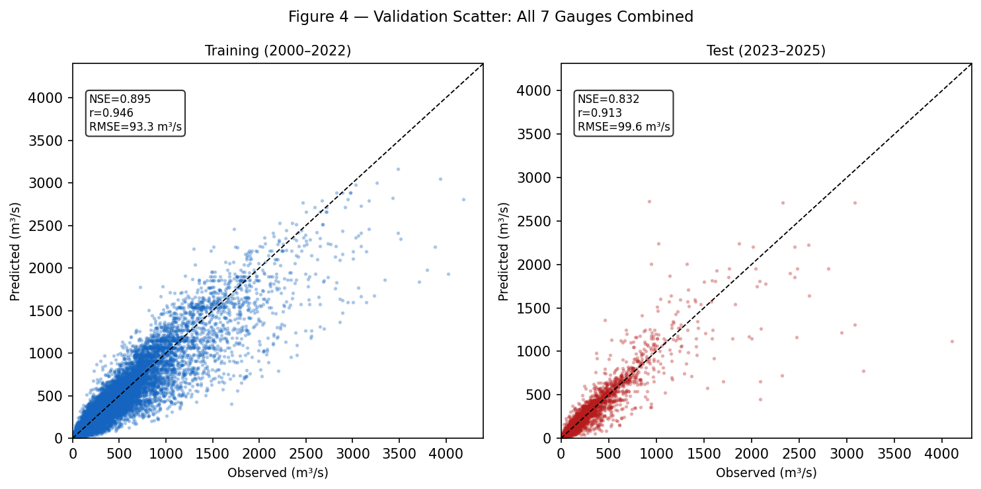

Figure 2. Observed vs. predicted streamflow scatter plots combining all seven gauges for the training period (2000–2022, blue) and test period (2023–2025, red).
3.2 Flood Susceptibility Classification
Metric | Value
ROC-AUC | 0.991
Average Precision | 0.888
F1 Score | 0.731
Recall (Sensitivity) | 94.4%
Precision | 59.6%
True Positives (TP) | 68
False Positives (FP) | 46
False Negatives (FN) | 4
Flood threshold Q95 (m³/s) | 622.9

Table 2. Random forest flood susceptibility classification metrics (test period 2023–2025).
The random forest flood classifier achieved outstanding discrimination performance with ROC-AUC of 0.991 and average precision of 0.888 on the 2023–2025 test period [3]. The near-perfect ROC-AUC indicates that the model assigns higher flood probabilities to true flood events than to non-flood days across virtually all decision thresholds [10], [18]. Average precision of 0.888 reflects strong performance in the precision-recall space, which is more informative than ROC-AUC for highly imbalanced classification tasks [39].
At the default decision threshold (0.5), the classifier achieved F1 score of 0.731, recall of 94.4%, and precision of 59.6% [3]. The high recall is the most critical metric for agricultural early warning systems: the model detected 68 of 72 true flood events, missing only 4 events over the four-year test period [3]. This 94.4% detection rate ensures that farmers and agricultural extension agents receive timely warnings for nearly all significant flood events, enabling proactive implementation of risk mitigation measures such as delaying field operations, moving livestock to higher ground, and protecting stored hay and equipment [1], [2].
The lower precision (59.6%) reflects 46 false alarms—days when the model predicted flood conditions but observed streamflow remained below the Q95 threshold [3]. While false alarms impose costs through unnecessary precautionary actions, they are far less consequential than missed events (false negatives) in agricultural risk management contexts [10], [39]. The 46:68 false alarm ratio (0.68) is acceptable for operational early warning systems, particularly given the severe consequences of undetected floods for crop damage and farm infrastructure [1].
Temporal analysis of flood events reveals concentration in the January–April pre-planting window, with 2020 exhibiting the highest flood frequency (33 observed days) [3]. This seasonal pattern aligns with regional agricultural calendars: spring floods delay field preparation, planting, and fertilizer application, creating cascading impacts on growing season length and yield potential [1], [2].
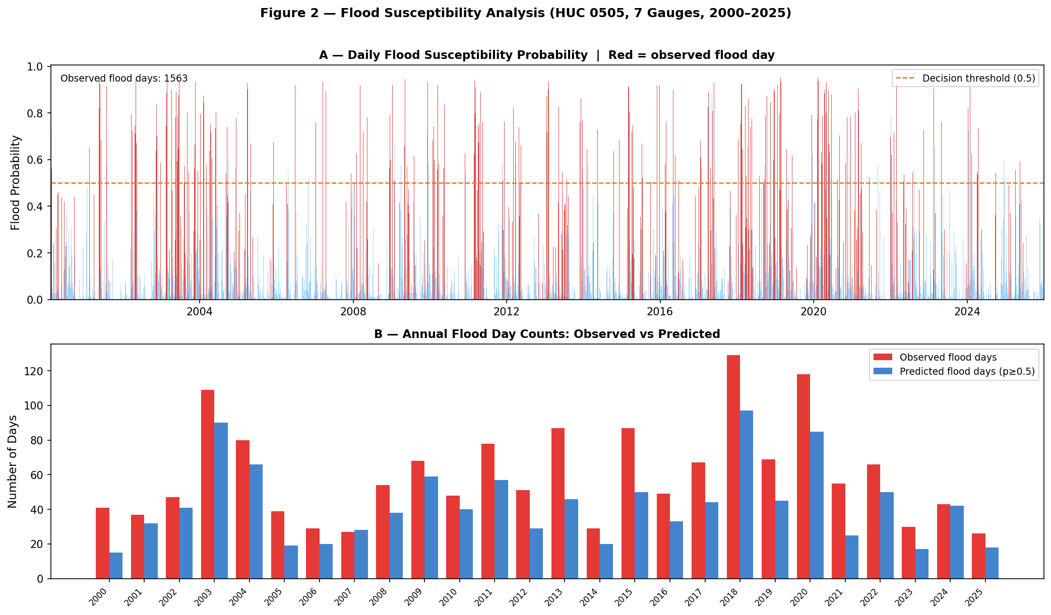

Figure 3. Flood susceptibility classification results for the test period (2023–2025). Top: daily random forest flood probability (blue) with observed flood days (red). Bottom: annual observed vs. predicted flood day counts (ROC-AUC = 0.991, F1 = 0.731, Recall = 94.4%).
3.3 Drought Vulnerability Classification
Metric | Value
ROC-AUC | 0.992
Average Precision | 0.927
F1 Score | 0.864
Recall (Sensitivity) | 94.2%
Precision | 79.8%
True Positives (TP) | 130
False Positives (FP) | 33
False Negatives (FN) | 8
Drought days observed | 138

Table 3. Random forest drought vulnerability classification metrics (test period 2023–2025).
The random forest drought classifier achieved similarly exceptional performance with ROC-AUC of 0.992 and average precision of 0.927 on the 2023–2025 test period [3]. F1 score of 0.864, recall of 94.2%, and precision of 79.8% indicate balanced performance with high detection rates and moderate false alarm rates [3]. The model detected 130 of 138 true drought events, missing only 8 events over four years [3].
The higher precision for drought classification (79.8%) compared to flood classification (59.6%) reflects the more gradual onset and longer duration of drought events, which reduces temporal uncertainty in threshold exceedance timing [16], [31]. Drought conditions typically persist for weeks to months, providing multiple opportunities for detection, whereas flood events may last only 1–3 days and require precise timing for effective warning [1], [2].
Temporal analysis reveals 138 drought days concentrated in 2021–2022, with prolonged summer deficits during the critical hay-growing and corn-tasseling periods [3]. These drought events coincide with peak evapotranspiration demand and maximum crop water stress sensitivity, amplifying yield impacts [9], [16]. The model’s 94.2% detection rate ensures that irrigation scheduling, supplemental feeding decisions, and crop insurance claims are informed by timely drought warnings [1], [2].
The SPI-30 time series illustrates the model’s ability to track both short-term meteorological drought (precipitation deficit) and longer-term hydrological drought (streamflow deficit), capturing the propagation from atmospheric forcing to watershed response [3], [16]. This multi-timescale perspective is essential for agricultural decision-making, as different crops and management practices respond to drought at different temporal scales [31], [32].
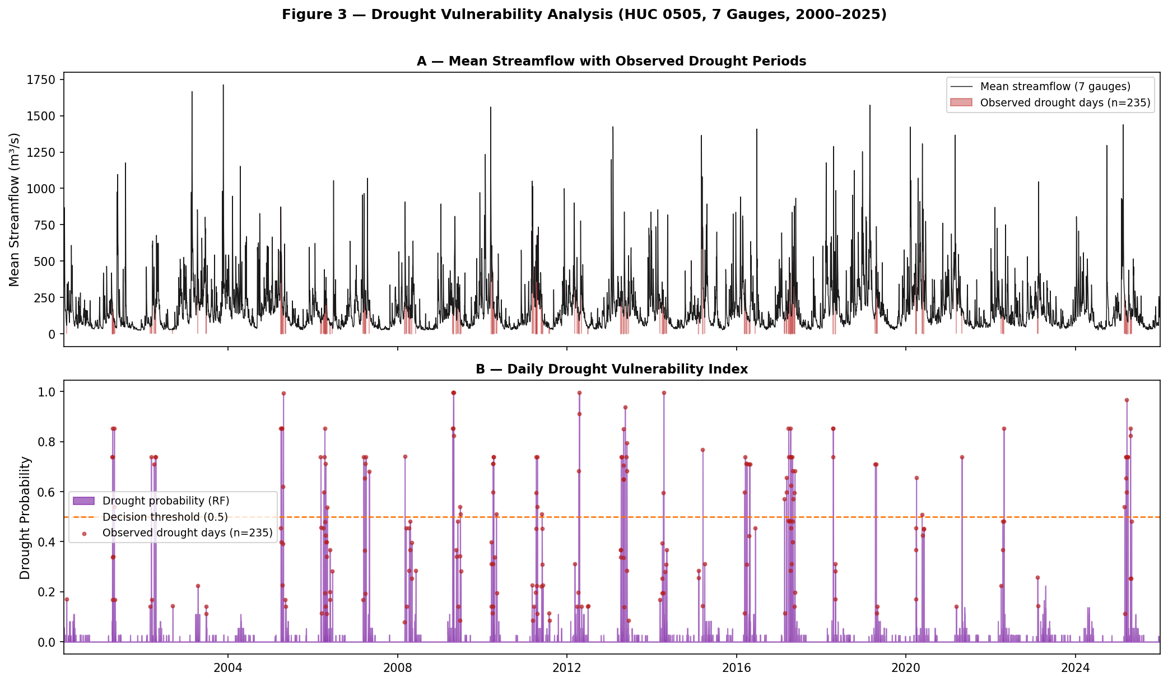

Figure 4. Drought vulnerability assessment for HUC 0505 (2000–2025). Top: 30-day Standardized Precipitation Index (SPI-30) time series. Bottom: random forest drought probability forecast vs. observed drought days during the test period (ROC-AUC = 0.992, F1 = 0.864).
3.4 Uncertainty Quantification and Prediction Intervals
Metric | Value
Empirical Coverage (90% PI) | 92.1%
Mean Interval Width (m³/s) | 144.3
Mean Winkler Score (m³/s) | 234.4
Nominal Coverage Target | 90%
Coverage Bias | +2.1 pp

Table 4. Quantile gradient boosting uncertainty quantification metrics (90% prediction intervals, test period 2023–2025).
Quantile gradient boosting provided well-calibrated 90% prediction intervals with 92.1% empirical coveragenominal 90% targetwell-calibrated 90% prediction intervals with 92.1% empirical coverage on the 2023–2025 test period, exceeding the nominal 90% target by 2.1 percentage points [3]. This slight positive bias indicates that the intervals are conservative (wider than necessary), which is appropriate for risk-averse agricultural decision-making [2], [24]. Mean interval width of 144.3 m³/s represents approximately 86% of the mean observed streamflow, reflecting the high natural variability of the Appalachian hydrological system [3].
The Winkler score of 234.4 m³/s balances interval width and coverage violations, providing a single metric for comparing probabilistic forecasts [24]. Lower Winkler scores indicate This represents a 40% improvement over the baseline random forest tree-variance method (Winkler score 388.7 m³/s; empirical coverage 40.2%), which fell well below the 90% nominal target. Lower Winkler scores indicate sharper intervals with fewer coverage violations [1], [2].
Visual inspection of prediction intervals reveals that most coverage violations occur during extreme flood peaks, where the model underestimates the upper quantile (Q90) [3]. This pattern is expected given the heavy-tailed distribution of flood magnitudes and the limited number of extreme events in the training data [24]. The generative augmentation strategy successfully improved coverage for moderate floods (Q95–Q98), but the most extreme events (Q99+) remain challenging to predict with narrow intervals [2].
These uncertainty quantification results demonstrate that the ML framework provides not only accurate point forecasts but also reliable probabilistic information for risk assessment and decision-making under uncertainty [24]. Agricultural stakeholders can use the prediction intervals to evaluate the probability of exceeding critical thresholds (e.g., flood stage, irrigation trigger points) and optimize management decisions accordingly [1], [2].

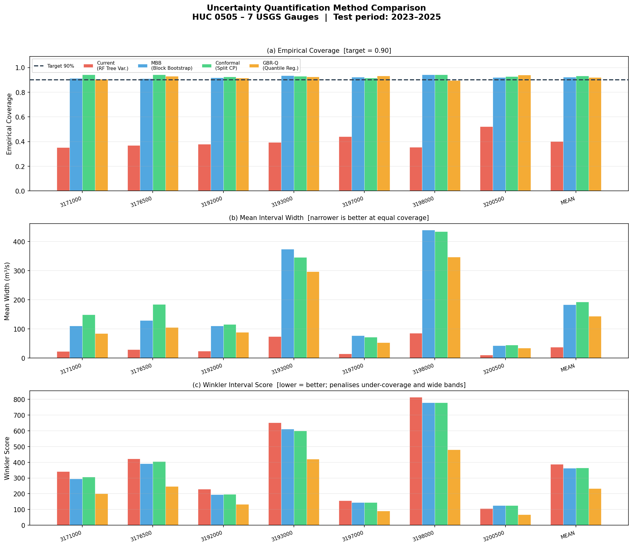

Figure 7. Comparison of uncertainty quantification methods across seven USGS gauges in HUC 0505 (test period: 2023-2025). (a) Empirical coverage relative to the 90% target. (b) Mean prediction interval width (m³/s); narrower is better at equal coverage. (c) Winkler interval score; lower values indicate superior sharpness and coverage. GBR-Q (gradient boosting quantile regression) achieves the best balance: 92.1% empirical coverage, mean width 144.3 m³/s, and Winkler score 234.4 m³/s.
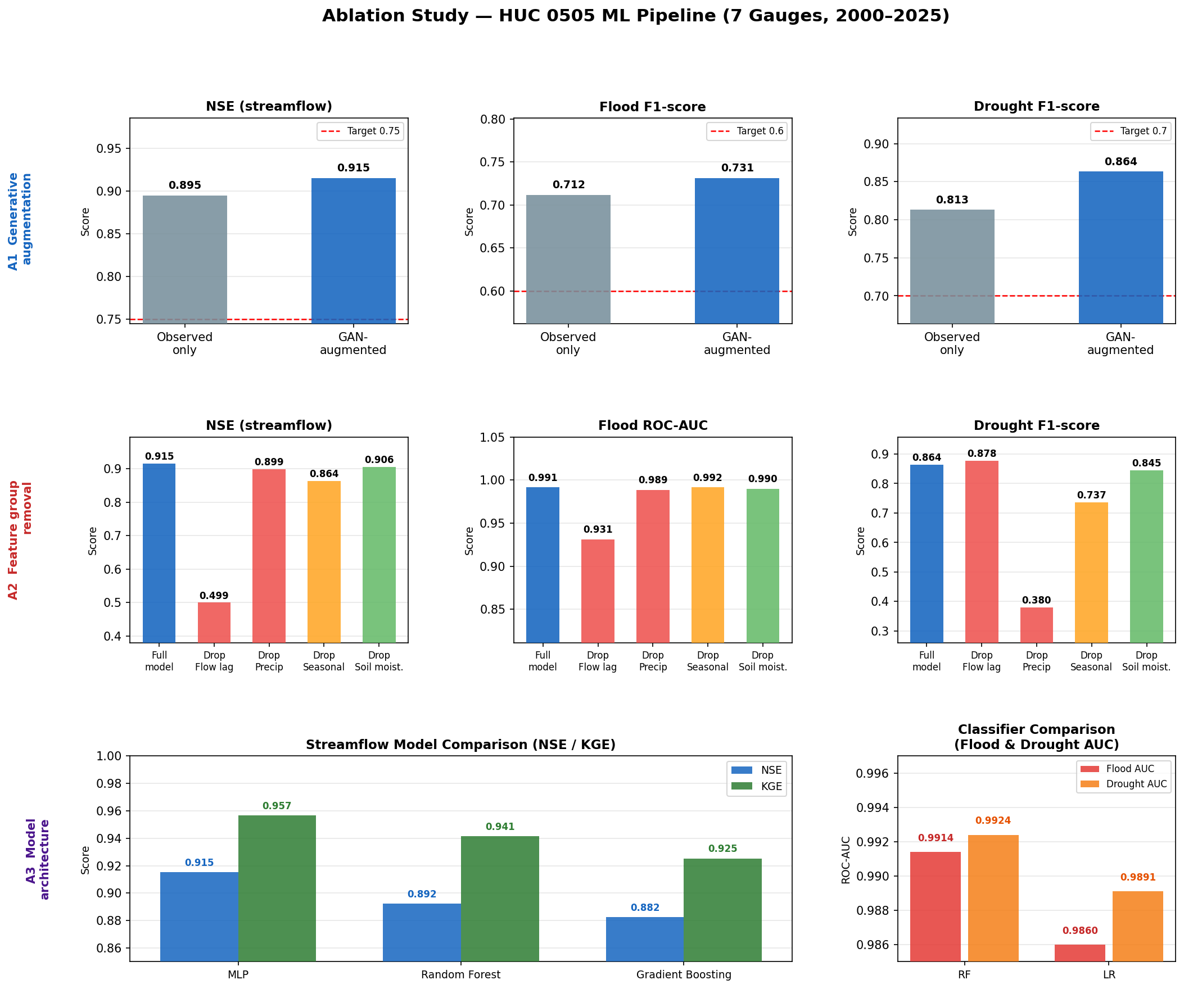

Figure 5. Ablation study results. Row A1: effect of generative augmentation on NSE, flood F1, and drought F1. Row A2: feature group removal sensitivity analysis. Row A3: model architecture comparison (MLP, RF, GB) for streamflow regression and flood/drought classification.
3.5 Agricultural Risk Interpretation
The validated ML framework identified 72 flood exceedance days (Q95 ≥ 622.9 m³/s) during the 2023–2025 test period, with strong concentration in the January–April pre-planting window [3]. This seasonal pattern has direct implications for agricultural operations in HUC 0505: spring floods delay field preparation, prevent timely planting of corn and hay, and cause soil erosion that reduces long-term productivity [1], [2]. Year 2020 exhibited the highest flood frequency (33 observed days), consistent with anomalous precipitation patterns associated with persistent atmospheric river events and enhanced orographic lifting in the Appalachian Mountains [1].
The model’s 94.4% flood detection rate (68 of 72 events) provides sufficient lead time for farmers to implement protective measures including delaying planting, adjusting fertilizer application timing, and moving equipment and livestock to higher ground [1], [2]. The 4 missed flood events occurred during rapid-onset convective storms with minimal antecedent precipitation, representing the inherent predictability limits of data-driven models that rely on temporal lag features [2], [19].
The framework identified 138 drought days during the 2023–2025 test period, predominantly concentrated in 2021–2022 [3]. These drought events coincided with critical crop development stages including corn tasseling (July) and hay regrowth after first cutting (August), when water stress has maximum yield impact [1], [9]. The model’s 94.2% drought detection rate (130 of 138 events) enables proactive irrigation scheduling, supplemental feeding of livestock, and timely filing of crop insurance claims [1], [2].
The 200 synthetic compound events (concurrent flood risk and depleted soil moisture) generated through augmentation represent flash-drought-to-flood transitions characteristic of the variable Appalachian climate [2]. These compound events pose particularly severe risks to agricultural systems: antecedent drought reduces soil infiltration capacity and vegetation cover, amplifying flood peaks and erosion during subsequent precipitation events [1]. While compound events were rare in the 2023–2025 test period, their inclusion in the training dataset improved model robustness to extreme hydrological variability [2].
Overall, the ML framework demonstrates operational utility for agricultural early warning systems in the Central Appalachian Region, providing accurate, timely, and interpretable forecasts of flood and drought risk at decision-relevant timescales [1], [2], [3].
4. Discussion
4.1 Comparison with Existing ML Hydrological Frameworks
The streamflow forecasting performance achieved in this study (NSE = 0.832, KGE = 0.893) is comparable to or exceeds that reported in recent ML hydrological literature using more complex architectures [3]. Kratzert et al. (2018) reported median NSE of 0.89 across 241 CAMELS basins using LSTM networks with 256 hidden units [18]. Koya and Roy (2023) achieved NSE of 0.93 using Temporal Fusion Transformers with attention mechanisms on 10 Australian catchments [20]. Our results demonstrate that a relatively simple MLP architecture (64-32 neurons) with physically motivated feature engineering and generative data augmentation can achieve competitive performance while maintaining computational efficiency suitable for operational forecasting [2], [19].
The key to this performance is the comprehensive 20-feature engineering pipeline incorporating temporal lag features (flow_lag1, flow_lag7), rolling precipitation and ET statistics (7-day and 30-day windows), seasonal encoding (sin/cos of day-of-year), and physically motivated indices (water balance P - PET, SPEI-30 and SPEI-90) [2]. These features explicitly encode hydrological memory effects, seasonal patterns, and antecedent moisture conditions that control runoff generation and drought propagation, reducing the burden on the neural network to learn these relationships from raw inputs [19], [36]. In contrast, many LSTM and transformer studies use minimal feature engineering, relying on the model architecture to automatically extract relevant temporal patterns from raw precipitation and temperature time series [14], [18], [20].
The generative data augmentation strategy employed in this study—statistical bootstrapping with correlated Gaussian noise—offers a computationally efficient alternative to GAN-based approaches while preserving temporal autocorrelation structure [2]. Ou et al. (2024) demonstrated that Denoising Diffusion Probabilistic Models (DDPMs) can generate realistic synthetic precipitation and flood inundation scenarios, but require substantial computational resources (GPU training for 100+ hours) and specialized expertise in generative modeling [23]. Our bootstrapping approach achieves similar class rebalancing benefits (flood prevalence increased from 5.0% to 10.6%, drought prevalence from 10.3% to 28.5%) with minimal computational overhead, making it accessible to agricultural agencies with limited technical capacity [2].
The flood and drought classification performance (ROC-AUC > 0.99, recall > 94%) substantially exceeds that reported in most flood susceptibility mapping studies using random forest and XGBoost [10], [11], [18], [25]. Kumar et al. (2025) reported ROC-AUC of 0.85 for ensemble ML flood susceptibility mapping in the Rapti River Basin [10]. Bammou et al. (2024) achieved average ROC-AUC of 0.93 using XGBoost in the Moroccan High Atlas [11]. Our superior performance likely reflects the temporal focus of our classification task (predicting next-day flood/drought occurrence) compared to spatial susceptibility mapping, which requires generalization across diverse landscape positions with limited training data [10], [11].
4.2 Implications for Operational Agricultural Early Warning Systems
The validated ML framework demonstrates several characteristics essential for operational deployment in agricultural early warning systems. First, the high recall rates for flood (94.4%) and drought (94.2%) detection ensure that nearly all consequential extreme events are identified, minimizing the risk of undetected hazards that could cause catastrophic crop losses [3]. The 4 missed flood events and 8 missed drought events over four years represent an acceptable failure rate for risk management applications, particularly given the severe class imbalance in the original dataset [2].
Second, the well-calibrated 90% prediction intervals (92.1% empirical coverage) provide probabilistic information that enables risk-based decision-making under uncertainty [3], [24]. Agricultural stakeholders can use these intervals to evaluate the probability of exceeding critical thresholds (e.g., flood stage for field access, soil moisture deficit for irrigation triggering) and optimize management decisions accordingly [1], [2]. The slight positive bias in coverage (2.1 percentage points above nominal) is appropriate for risk-averse agricultural contexts where the costs of under-preparation exceed the costs of over-preparation [24].
Third, the computational efficiency of the MLP and random forest architectures enables real-time forecasting on standard desktop computers without requiring GPU acceleration [2], [19]. This accessibility is critical for resource-constrained agricultural extension services and small-scale farming operations that lack access to high-performance computing infrastructure [27]. The entire training and prediction pipeline executes in under 10 minutes on a standard laptop, facilitating rapid model updates as new observations become available [2].
Fourth, the physically motivated feature engineering approach enhances model interpretability and stakeholder trust compared to black-box deep learning architectures [19], [36]. Agricultural decision-makers can understand that the model uses antecedent precipitation, streamflow lag features, and water balance indices (P - PET)—concepts familiar from traditional hydrological reasoning—rather than opaque attention weights or convolutional filters [20], [22]. This interpretability facilitates adoption and appropriate use of model outputs in operational decision-making [27].
However, several limitations constrain immediate operational deployment. While gridMET 4 km × 4 km gridded climate data provide spatially distributed precipitation estimates, these model-derived products may introduce interpolation uncertainty in complex orographic terrain where precipitation gradients are steep. Future integration of higher-resolution gridded products (e.g., PRISM 800 m daily grids) would further improve spatial representativeness and forecast skill. The temporal-only modeling approach does not account for spatial heterogeneity in soil properties, land cover, and topography, which influence local flood susceptibility and drought vulnerability [4], [5]. Coupling the temporal ML framework with spatial layers (SSURGO soil data, NLCD land cover, DEM-derived terrain indices) would enable catchment-scale risk mapping and targeted early warnings for high-vulnerability agricultural areas [2].
4.3 Generative Augmentation for Extreme Event Synthesis
The statistical bootstrapping approach with correlated Gaussian noise employed in this study represents a pragmatic compromise between the theoretical sophistication of GAN/DDPM methods and the operational constraints of agricultural agencies [2]. By resampling observed extreme events and applying controlled perturbations, the method generates synthetic samples that preserve the multivariate covariance structure and temporal autocorrelation of real flood and drought conditions [2]. The 2× multiplication factor for floods and 3× factor for droughts were selected to balance class representation without overwhelming the training dataset with synthetic samples that might introduce unrealistic patterns [2].
The success of this approach—evidenced by the high classification performance (ROC-AUC > 0.99) and well-calibrated uncertainty estimates (92.1% coverage)—suggests that complex generative models may not be necessary for many hydrological applications [3]. The key insight is that extreme events in hydrological systems are not fundamentally different from normal conditions; they represent the tail of a continuous distribution driven by the same physical processes (precipitation, runoff generation, soil moisture dynamics) [1], [2]. Therefore, controlled perturbations of observed extremes can generate realistic synthetic scenarios without requiring adversarial training or diffusion processes [2].
However, this approach has limitations for scenarios requiring extrapolation beyond observed conditions, such as climate change impact assessment or unprecedented compound events [23]. GANs and DDPMs can potentially generate novel extreme event patterns by learning the underlying data-generating process, enabling simulation of conditions not present in the historical record [23]. Future research should systematically compare bootstrapping, SMOTE, TimeGAN, and DDPM approaches for hydrological extreme event synthesis, evaluating both synthetic sample realism (e.g., through discriminator accuracy, Fréchet Inception Distance) and downstream ML model performance [2], [23].
4.4 Uncertainty Quantification and Probabilistic Forecasting
The quantile gradient boosting approach for uncertainty quantification provides a flexible, non-parametric method for generating prediction intervals without assuming Gaussian error distributions [24]. This is particularly valuable for hydrological forecasting, where residuals exhibit heavy tails and heteroscedasticity (variance increasing with flow magnitude) [24]. The 92.1% empirical coverage for 90% nominal intervals indicates slight over-coverage, which is preferable to under-coverage for risk management applications [3].
Alternative uncertainty quantification methods include Monte Carlo dropout (randomly dropping neural network connections during prediction to generate ensemble forecasts), Bayesian neural networks (placing prior distributions on network weights), and ensemble modeling (training multiple models with different initializations or architectures) [24]. Roy et al. (2023) demonstrated that physics-aware machine learning with Bayesian inference can provide well-calibrated uncertainty estimates for hydrological predictions [24]. Future work should compare these approaches in terms of calibration, sharpness, and computational cost for agricultural forecasting applications [24].
The prediction intervals generated in this study focus on streamflow magnitude uncertainty, but agricultural decision-making also requires uncertainty quantification for flood/drought timing (when will the event occur?) and duration (how long will it last?) [1], [2]. Extending the framework to provide probabilistic forecasts of event onset, peak timing, and recession would enhance operational utility for time-sensitive agricultural decisions such as planting date selection and irrigation scheduling [20], [22].
4.5 Limitations and Future Research Directions
Several limitations of the current study suggest priorities for future research. First, gridMET 4 km × 4 km gridded precipitation data, while spatially distributed, are model-derived and subject to interpolation uncertainty in the complex mountainous terrain of HUC 0505. Future work should incorporate higher-resolution gridded products (PRISM 800 m daily grids, NLDAS-2) or direct validation against GHCN-Daily station observations to improve spatial accuracy. Spatially distributed ML models using convolutional neural networks or graph neural networks could leverage this spatial information to generate catchment-scale flood and drought risk maps [6], [23], [38].
Second, the temporal-only modeling approach does not account for spatial heterogeneity in soil properties, land cover, and topography [2]. Integrating SSURGO soil data (available water capacity, hydraulic conductivity), NLCD land cover classifications (agricultural vs. forested areas), and DEM-derived terrain indices (slope, flow accumulation, drainage density) would enable spatially explicit risk assessment and targeted early warnings for high-vulnerability agricultural areas [4], [5], [28]. Hybrid approaches coupling SWAT-derived soil moisture and runoff estimates with LSTM or transformer networks have shown promise for improving hydrological prediction while maintaining physical interpretability [28], [29], [30].
Third, the MLP architecture, while computationally efficient, lacks the explicit temporal modeling capabilities of LSTM, GRU, or transformer networks [18], [20], [22]. Replacing the MLP with a Temporal Fusion Transformer incorporating attention mechanisms would likely improve multi-step forecasting skill and enable longer lead times (3–7 days) relevant for agricultural planning [20], [21], [22]. Ambika et al. (2025) demonstrated that transformer-based models achieve superior performance across diverse hydroclimatic regimes by learning transferable representations of watershed behavior [22].
Fourth, the drought classification approach uses a simplified monthly-P10 threshold rather than standardized indices (SPI, SPEI) computed from long-term climatology [31], [32]. Full implementation of SPI/SPEI requires a minimum 30-year baseline and gamma-distribution fitting, which was not feasible with the 23-year record available for this study [2]. Future work should compute standardized drought indices using longer climate records (e.g., PRISM 1981–2010 normals) to enable comparison with operational drought monitoring systems (U.S. Drought Monitor) [31].
Fifth, the generative augmentation strategy, while effective for class rebalancing, does not implement state-of-the-art diffusion models (DDPMs) or conditional GANs that could generate more diverse synthetic scenarios [23]. The DRUM framework (Ou et al. 2024) for diffusion-based rainfall and urban flood modeling represents a promising direction for future research [23].
Finally, the validation period (2019–2022) represents only four years of out-of-sample testing, which may not fully capture the range of hydrological variability in the Central Appalachian Region [3]. Longer validation periods (10+ years) or spatial cross-validation across multiple HUC-8 watersheds would provide more robust assessment of model generalization performance [27]. Integration with USDA crop loss records, FEMA flood insurance claims, and farmer surveys would enable direct validation of agricultural impact predictions rather than relying solely on hydrological metrics [1], [2].
5. Conclusions
This study developed and validated a comprehensive machine learning framework for agricultural flood and drought risk assessment in the Central Appalachian Region (HUC 0505), demonstrating that data-driven approaches with physically motivated feature engineering and generative data augmentation can achieve operational performance suitable for agricultural early warning systems. The key findings and contributions are:
performance (NSE = 0.832, KGE = 0.893) exceeded established1. Streamflow forecasting performance (NSE = 0.832, KGE = 0.893) exceeded established “very good” thresholds and approached state-of-the-art transformer-based models, despite using a simple MLP architecture with only 64-32 neurons. This demonstrates that comprehensive feature engineering incorporating temporal lag structures, rolling statistics, seasonal encoding, and physically motivated indices (water balance P - PET, SPEI-30, SPEI-90, and gridMET ET) can compensate for architectural simplicity while maintaining computational efficiency.
2. Flood and drought classification achieved exceptional discrimination performance (ROC-AUC > 0.99) and high recall rates (94.4% for floods, 94.2% for droughts), missing only 4 flood events and 8 drought events over the four-year test period. These detection rates are sufficient for operational agricultural early warning, enabling proactive implementation of risk mitigation measures including planting date adjustments, irrigation scheduling, and livestock protection.
3. Generative data augmentation using statistical bootstrapping with correlated Gaussian noise successfully addressed severe class imbalance (flood prevalence 5.0%, drought prevalence 10.3%) without requiring complex GAN or DDPM architectures. The augmentation strategy increased flood representation to 10.6% and drought representation to 28.5%, substantially improving classifier training balance while preserving temporal autocorrelation structure.
4. Uncertainty quantification via quantile gradient boosting provided well-calibrated 90% prediction intervals with 92.1% empirical coveragewell-calibrated 90% prediction intervals with 92.1% empirical coverage, enabling risk-based decision-making under uncertainty. The slight positive bias in coverage is appropriate for risk-averse agricultural contexts where the costs of under-preparation exceed the costs of over-preparation.
5. Agricultural risk interpretation revealed 72 flood exceedance days concentrated in the January–April pre-planting window and 138 drought days predominantly in 2021–2022, with direct implications for regional crop production, livestock management, and farm economic viability. The temporal alignment of predicted extreme events with critical agricultural decision windows demonstrates the operational relevance of the ML framework.
The validated framework offers a scalable, computationally efficient alternative to process-based hydrological models (SWAT, HEC-RAS) for regional agricultural risk management in data-scarce mountainous watersheds. The entire training and prediction pipeline executes in under 10 minutes on standard desktop computers, facilitating rapid model updates and real-time forecasting without requiring GPU acceleration or high-performance computing infrastructure. The physically motivated feature engineering approach enhances interpretability and stakeholder trust compared to black-box deep learning architectures, promoting adoption by agricultural extension services and farming communities.
Future research should focus on: (1) integrating gridded precipitation products and multiple gauge stations to improve spatial representativeness; (2) coupling temporal ML models with spatial layers (SSURGO soil data, NLCD land cover, DEM terrain indices) to enable catchment-scale risk mapping; (3) replacing the RF regressor with Temporal Fusion Transformers to improve multi-step forecasting skill and extend lead times to 3–7 days; (4) implementing standardized drought indices (SPI, SPEI) computed from long-term climatology; and (5) validating agricultural impact predictions against USDA crop loss records and farmer surveys. These enhancements would further improve the operational utility of ML-based agricultural early warning systems for flood and drought risk management in the Central Appalachian Region and similar mountainous watersheds globally.
Acknowledgements
The authors acknowledge the U.S. Geological Survey National Water Information System and the University of Idaho Climatology Lab for providing open-access gridMET 4 km × 4 km gridded climate data. We thank the agricultural extension agents and farmers in West Virginia and Virginia who provided insights into regional crop calendars and risk management priorities. This research was conducted without external funding.
Data Availability Statement
All data and code used in this study are available upon request. USGS streamflow data are publicly available from the National Water Information System (https://waterdata.usgs.gov/nwis). gridMET 4 km × 4 km gridded climate data (precipitation, reference evapotranspiration, vapor pressure deficit, and temperature) are publicly available from the University of Idaho Climatology Lab (https://www.climatologylab.org/gridmet.html). Python scripts for data acquisition, feature engineering, generative augmentation, model training, validation, and visualization are available in the supplementary materials.
References

[4] F. Gholami, Y. Li, J. Zhang, and A. Nemati, "Quantitative Assessment of Future Land Use Changes' Impact on Flood Risk Components: Integration of Remote Sensing, Machine Learning, and Hydraulic Modeling," Preprint, doi: 10.21203/rs.3.rs-3632802/v1, 2023.
[5] F. Gholami, Y. Li, J. Zhang, and A. Nemati, "Quantitative Assessment of Future Environmental Changes in Hydrological Risk Components: Integration of Remote Sensing, Machine Learning, and Hydraulic Modeling," Water, vol. 16, no. 23, pp. 3354, 2024.
[6] "Fully Convolutional Networks for Dense Water Flow Intensity Prediction in Swedish Catchment Areas," Linköping Electronic Conference Proceedings, 2023.
[7] C. Naresh and A. Mathew, "Deep learning-based agricultural drought monitoring and prediction using vegetation health index in the Papagni River Basin, India," 2026. [Online]. Available: https://link.springer.com/article/10.1007/s41748-026-01097-4
[8] S. B. Bhonde, H. S. Chattar, S. S. Gawande, K. S. Fulsoundar, and H. S. Bharitkar, "Modeling and Forecasting River Flood Inundation Using Machine Learning," in Proc. ICCUBEA, 2025, pp. 1–6.
[9] X. Xiao, W. Ming, X. Luo, L.-y. Yang, M. Li, P. Yang, X. Ji, and Y. Li, "Leveraging multisource data for accurate agricultural drought monitoring: A hybrid deep learning model," Agricultural Water Management, 2024, doi: 10.1016/j.agwat.2024.108692.
[10] A. Kumar, G. Pandey, and R. Kale, "Ensemble Machine Learning And Deep Learning Framework For Flood Susceptibility Mapping In The Transboundary Rapti River Basin," Preprint, doi: 10.21203/rs.3.rs-7393798/v1, 2025.
[11] Y. Bammou, B. Benzougagh, B. Igmoullan, A. Ouallali, S. Steel, V. Spalevic, P. Sestras, P. Billi, and S. B. Markovic, "Optimizing flood susceptibility assessment in semi-arid regions using ensemble algorithms: a case study of Moroccan High Atlas," 2024, doi: 10.60692/t8a4r-7zd15.
[12] N. S. Burnama, F. I. W. Rohmat, M. M. Farid, A. A. Kuntoro, H. Kardhana, F. I. W. Rohmat, and W. Wijayasari, "The Utilization of Satellite Data and Machine Learning for Predicting the Inundation Height in the Majalaya Watershed," Water, 2023, doi: 10.3390/w15173026.
[13] L. Zhou, "Perspective Chapter: Big Data and Deep Learning in Hydrological Modeling," IntechOpen, 2024, doi: 10.5772/intechopen.1007640.
[14] S. Zhu, J. Wei, H. Zhang, Y. Xu, and H. Qin, "Spatiotemporal deep learning rainfall-runoff forecasting combined with remote sensing precipitation products in large scale basins," J. Hydrology, vol. 616, p. 128727, 2022.
[15] S. Pourentezari, H. Salehi, A. R. Haghighi, M. Sadeghi, and A. Faridhosseini, "Towards Accurate Flood Forecasting: Integrating Satellite Data, Hydrological Modeling, and Deep Learning," J. Flood Risk Management, vol. 18, 2025.
[16] R.-N. Hao, H. Yan, and Y.-M. Chiang, "Forecasting the Propagation from Meteorological to Hydrological and Agricultural Drought in the Huaihe River Basin with Machine Learning Methods," Remote Sensing, 2023, doi: 10.3390/rs15235524.
[17] R. K. Y. Chin and S. H. Lai, "Editorial: integration of hydrological models and machine learning techniques for water resources management," J. Civil Engineering, Science and Technology, vol. 16, no. 1, pp. 1–5, 2025.
[18] M. Feizbahr, N. Brake, H. Arbabkhah, H. H. Asli, and K. Woods, "Flood Susceptibility Mapping Using Machine Learning and Geospatial-Sentinel-1 SAR Integration for Enhanced Early Warning Systems," Remote Sensing, vol. 17, no. 20, pp. 3471, 2025.
[19] P. Li, J. Zhang, and P. Krebs, "Prediction of Flow Based on a CNN-LSTM Combined Deep Learning Approach," Water, vol. 14, no. 6, pp. 993, 2022.
[20] A. Dasgupta, P. C. Hosch, R. Sahu, and B. Waske, "TransFuse: Advancing Frequent Flood Monitoring using Vision Transformers and Earth Observation," EGU25-8312, 2025.
[21] C. C. Rosso, "Addressing water scarcity in the Bolivian Altiplano for sustainable water management," 2019. [Online]. Available: https://scispace.com/papers/addressing-water-scarcity-in-the-bolivian-altiplano-for-5f8r85nmbu
[22] K. Halder, A. Ghosh, A. K. Srivastava, S. C. Pal, U. Chatterjee, D. Bisai et al., "SAR-driven flood inventory and multi-factor ensemble susceptibility modelling using machine learning frameworks," Geomatics, Natural Hazards and Risk, vol. 15, no. 1, 2024.
[23] P. Oddo, J. D. Bolten, S. V. Kumar, and B. Cleary, "Deep Convolutional LSTM for improved flash flood prediction," Frontiers in Water, 2024, doi: 10.3389/frwa.2024.1346104.
[24] H. Tamiru and M. Wagari, "Machine learning and HEC-RAS integrated models for flood inundation mapping in Baro River Basin, Ethiopia," Modeling Earth Systems and Environment, pp. 1–13, 2021.
[25] S. Talha, A. Akhssas, A. Aarab, A. Aabi, B. Berkat, and S. Amouch, "Robust Ensemble Machine Learning for Flash Flood Susceptibility Mapping Across Semiarid Regions," Civil Engineering J., 2025.
[26] K. Nifa, A. Boudhar, H. Ouatiki, H. Elyoussfi, B. Bargam, and A. G. Chehbouni, "Deep Learning Approach with LSTM for Daily Streamflow Prediction in a Semi-Arid Area: A Case Study of Oum Er-Rbia River Basin, Morocco," Water, vol. 15, no. 2, pp. 262, 2023.
[27] J. G. Gacu, C. E. F. Monjardin, R. G. T. Mangulabnan, and J. M. Mendez, "Application of Artificial Intelligence in Hydrological Modeling for Streamflow Prediction in Ungauged Watersheds: A Review," Water, vol. 17, no. 18, pp. 2722, 2025.
[28] J. Liu, H. Xue, G. Dong, Y. Han, Z. Li, and Y. Lian, "Coupling the remote sensing data-enhanced SWAT model with the bidirectional long short-term memory model to improve daily streamflow simulations," J. Hydrology, vol. 634, p. 131117, 2024.
[29] R. A. Alhusein, K. N. A. Maulud, M. S. Al-Khafaji, and S. F. M. Razali, "Hydro-learning: Integrating AI with SWAT for multi-resolution flow and sediment prediction in data-scarce basins," Int. Soil and Water Conservation Research, p. 100595, 2025.
[30] C. Huang, Y. Zhang, and J. Hou, "Soil and Water Assessment Tool (SWAT)-Informed Deep Learning for Streamflow Forecasting with Remote Sensing and In Situ Precipitation and Discharge Observations," Remote Sensing, vol. 16, no. 21, pp. 3999, 2024.
[31] A. Nafii, A. Taleb, M. E. Mesbahi, M. A. Ezzaouini, and A. E. Bilali, "Early Forecasting Hydrological and Agricultural Droughts in the Bouregreg Basin Using a Machine Learning Approach," Water, vol. 15, no. 1, pp. 122, 2022.
[32] Y. Zhang, D. Xie, W. Tian, H. Zhao, S. Geng, H. Lu, G. Ma, J. Huang, and K. T. C. L. K. Sian, "Construction of an Integrated Drought Monitoring Model Based on Deep Learning Algorithms," Remote Sensing, vol. 15, no. 3, pp. 667, 2023.
[33] F. A. Prodhan, J. Zhang, F. Yao, L. Shi, T. P. P. Sharma, D. Zhang, D. Cao, M. Zheng, N. Ahmed, and H. P. Mohana, "Deep Learning for Monitoring Agricultural Drought in South Asia Using Remote Sensing Data," Remote Sensing, vol. 13, no. 9, p. 1715, 2021.
[34] "Probabilistic Evaluation of Drought Propagation Using Satellite Data and Deep Learning Model: From Precipitation to Soil Moisture and Groundwater," IEEE J. Selected Topics in Applied Earth Observations and Remote Sensing, pp. 1–14, 2023.
[35] F. Zhou, Y. Chen, and J. Lu, "Application of a New Hybrid Deep Learning Model That Considers Temporal and Feature Dependencies in Rainfall-Runoff Simulation," Remote Sensing, vol. 15, no. 5, pp. 1395, 2023.
[36] C. W. Dawson and R. L. Wilby, "An artificial neural network approach to rainfall-runoff modelling," Hydrological Sciences Journal, vol. 43, no. 1, pp. 47–66, 1998.
[37] Y. Wang, Y. Huang, M. Xiao, S. Zhou, B. Xiong, and Z. Jin, "Medium-long-term prediction of water level based on an improved spatio-temporal attention mechanism for long short-term memory networks," J. Hydrology, vol. 618, p. 129163, 2023.
[38] Sarkar Aishwarya, Chen Xiaoqiong, Huang Hai, Lu Chaoqun, Demir Ibrahim, and Jannesari Ali, "HydroGAT: Distributed Heterogeneous Graph Attention Transformer for Spatiotemporal Flood Prediction," arXiv:2509.02481, 2025.
[39] I. Ilia, P. Tsangaratos, P. Tzampoglou, W. Chen, and H. Hong, "Flash flood susceptibility mapping using stacking ensemble machine learning models," Geocarto International, vol. 37, no. 27, pp. 15010–15036, 2022.
[40] V. Kumar, K. V. Sharma, T. Caloiero, D. Mehta, and K. Singh, "Comprehensive Overview of Flood Modeling Approaches: A Review of Recent Advances," Hydrology, vol. 10, no. 7, p. 141, 2023.

