**DEVELOPMENT OF A MULTIGRID OPERATIONAL FORECAST SYSTEM FOR THE OCEANIC REGION OFF RIO DE JANEIRO STATE**

**ABSTRACT**

In this work we propose the development of a multigrid open source operational forecast system, with the oceanic region off Rio de Janeiro state as our first case study. The system is composed by three nested ROMS domains with resolutions 1/12°, 1/36°, and 1/72°, employing Mercator Ocean to force the lateral open boundaries of the outermost grid, and GFS to force the surface open boundary of all grids. Two schemes were built for the operational forecast workflow, free (without resolving Data Assimilation) and assimilated (resolving Data Assimilation), in order to account for limited computational resources, as most Data Assimilation (DA) schemes requires a cluster or cloud computing. To validate the open source codes developed in the project, we performed hindcast simulations using Mercator and Era5 as input data for different parts of the Southeastern Brazilian oceanic region, covering various regimes of the unique Brazil Current system. The modelled data was compared against velocity components from three buoys of the Brazilian National Buoy Programme, SST from MUR, and SSH from AVISO. The results from the Buoys showed a good representation of the velocity field by ROMS, performing better than Mercator for some scenarios. ROMS also presented good performances for SST and SSH, with the spatial average of RMSE and MAE lower than 0.5 °C for SST, and lower than 0.1 m for SSH. For the three-nested forecast system, the velocity fields presented comparable magnitudes against Mercator, without the presence of jet-like instabilities, indicating a stable system. To test the scheme with DA, we implemented the 4DVAR method in a two day analysis, finding smaller errors when comparing to the free scheme.

**1) INTRODUCTION**

The development of an operational ocean forecast system and its important role for human activities, including search and rescue at sea, oil spill modelling, and plankton transport, have been described in a variety of studies, as in Breivik *et al*. (2013), Strand *et al*. (2017), and Röhrs *et al*. (2018a). Robust systems are successfully implemented for oceanic and coastal regions of the United States, Europe, Australia, and Japan. In Brazil, most operational efforts were executed associated with a research and development consortium called Oceanographic Modelling and Observation Network (with the Portuguese acronym REMO) (Marta-Almeida *et al*., 2011). REMO currently delivers for the oceanic region off Brazil hindcasts with Data Assimilation (DA) and forecast products with HYCOM in the resolutions of 1/4°, 1/12°, and 1/24°.

So far, Brazil still lacks an operational forecast system covering regional and shelf regions, as the ones implemented for California (<https://www.cencoos.org/observations/models-forecasts/>, Moore *et al.,* 2013), Delaware Bay (<https://tidesandcurrents.noaa.gov/ofs/dbofs/dbofs.html>), New Jersey and New York shelf (<http://www.myroms.org/espresso/>), the Mediterranean (<https://www.socib.es/?seccion=modelling&facility=forecast>, SOCIB; Tintoré *et al.* 2013), among others. In common, all these systems employ the ROMS model nested, for the outermost grid for multigrid systems, in a global circulation model. In this context, following the best practices in the ocean forecast field, we propose the development of a multigrid high-resolution operational ocean forecast system off Rio de Janeiro State (RJ), as part of a bigger project to be extended for other Brazilian regions. The coastal and oceanic region off RJ is paramount for Brazil’s economy, as it boasts major port structures and oil/gas reserves.

The system is composed by three nested ROMS domains with resolutions 1/12°, 1/36°, and 1/72°, employing Mercator Ocean to force the lateral open boundaries of the outermost grid, and GFS to force the surface open boundary of all grids. Tides are not being resolved. Two schemes were built for the operational forecast workflow, free (without resolving DA) and assimilated (resolving the DA method 4D-var, as in Moore *et al*., 2011), in order to account for limited computational resources, as most DA schemes requires a cluster or cloud computing.

This project aims at modelling the ocean circulation by means of an open source operational forecast system, taking into account limited computation resources to allow a wide range application of the system.

The codes for interpolation of input data, grid configuration, ingestion of oceanic and atmospheric data, workflow of the forecast system, and creation of the observation file for DA were developed with open source languages, including Python, Shell Script, GrADS, and Octave. They are freely available for the scientific community through the following Github page https://github.com/fernandotcbarreto/ROMS.

A quantitative comparison of the model results with observations is necessary to evaluate the performance of the new codes. To this end, we performed hindcast simulations using on the lateral open boundaries data from Mercator reanalysis and on the surface from Era5. The results were compared against *u* and *v* velocity components from the Brazilian National Buoy Programme (with the Portuguese acronym PNBOIA), Sea Surface Temperature (SST) from Ultra-high Resolution Sea Surface Temperature (TSM-MUR), and Sea Surface Height (SSH) from Aviso. Different domains were established to test the modelled velocity field along three regions of the Brazilian coast, off Vitória (19°55' S and 39°41' W), Cabo Frio (23°37’ S and 42°12’ W), and Itajaí (27°24’ S and 47°15' W), encompassing different regimes of the Brazil Current system.

At last, results from the multigrid operational system are evaluated against the Mercator output, in order to check the stability of the ROMS solution inside the domain and close to the boundaries.

This paper describes the operational forecast system and presents a validation for the implemented codes. The paper is organized as follows. The description of the validation set-up and the development of the forecast system are presented in section 2. The results of the validation are presented and discussed in section 3. In this section we also present results from the forecast system. Conclusions and future developments are given in section 4.

**2) METHODOLOGY**

2.1) THE OCEAN MODEL

The numerical model implemented in the operational system was the Regional Ocean Modeling System (ROMS), a free-surface, terrain-following, primitive equation ocean model, which is advantageous for regional applications (Shchepetkin and McWilliams 2005; Haidvogel *et al.* 2008). The ROMS prognostic variables are potential temperature (), salinity (), horizontal velocity (,), and sea surface displacement (). When the primitive equations are discretized and arranged in a ROMS grid, the individual grid point values at the time define the components of a state vector , where superscript denotes the vector transpose. The state vector is propagated forward in time through the discretized nonlinear ocean model and is subject to surface boundary conditions (denoted ), for momentum, heat and freshwater fluxes, and lateral open boundary conditions (denoted ). A complete description of ROMS and the extensive set of numerical algorithms available can be found in Shchepetkin and McWilliams (2005). **(copiei de fragoso et al 2016)**

ROMS was chosen due to its advanced and robust rapidly evolving community-code model, being employed in a great number of forecast systems, as in Powell *et al*., (2009), Röhrs *et. al.* (2018), Mourre *et al.* (2018), and Hirose *et al.* (2019).

2.2) OPERATIONAL MODELLING SET-UP

A system composed by three nested grids was established with the innermost grid centered in the Rio de Janeiro state (Figure 990). The outermost grid is initialized and forced at the lateral open boundaries by the assimilated global model results of the Mercator analysis (Global Ocean 1/12° Physics Analysis and Forecast updated daily), and at the surface from results of NCEP-GFS (3-hourly average Global Forecast System at a base horizontal resolution of 28 kilometers).

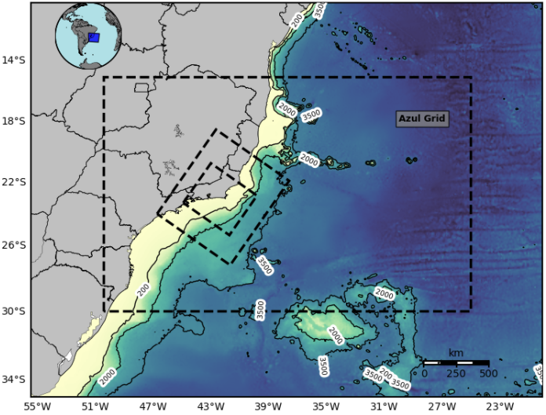

Figure 990 - Three nested grids (Parent, Nest 1, Nest 2) implemented for the operational forecast system, with resolutions 1/12°, 1/36°, 1/72°.

For the outermost grid we employed the Azul grid from Fragoso *et al.* (2016), as it was successfully applied to a regional ocean observing system in the southeastern Brazilian coast with the strong constraint 4D-variational (I4D-Var) method (Moore *et al*., 2011). This grid covers the domain from 50° W to 25° W and from 15° S to 30° S with a horizontal grid resolution of 1/12° and 40 vertical levels. The numerical grid presents three open boundaries in the model domain: northern, southern, and eastern boundaries, while the western is bounded by the coast.

The two inner grids, Nest 1 and Nest 2, were rotated to maximize the sea/land proportion, and present the resolutions of 1/36° and 1/72°, and 40 vertical levels. Nest 1 covers the domain from 46.72° W to 37.58° W and from 18.53° S to 27.16° S, and Nest 2 from 44.91° W to 39.80° W and from 20.73° S to 25.30° S. The nesting method used in the system was based on the one-way nesting technique described in Marchesiello *et al.* (2001) and Mason *et al.* (2010).

To avoid model instability and/or spurious deep currents the final masked bathymetry of all three grids was smoothed to fulfill a requirement on the ROMS slope or rx0-factor (Beckmann and Haidvogel, 1993). The two child’s grid bathymetry was modified so that it becomes exactly equal to the parent one at the open boundaries, linearly converging to the original high resolution bathymetry, as in Mason *et al.* (2010).

The simulation is configured to conserve volume with a free-surface condition (Chapman, 1985), a condition for the 2D momentum (Flather, 1976), and radiation boundary condition with nudging for the 3D momentum and tracers (Marchesiello *et al*., 2001), with nudging timescales of 1 and 30 days for the inflow and outflow, respectively.

The interpolation and extrapolation of data from Mercator to the ROMS grid, and between ROMS grids for nesting, were performed following the works of Mason *et al.* (2010) and Marta-Almeida *et al*. (2019). To ensure the conservation of volume the input data are initially horizontally interpolated for the ROMS grid, with the vertical interpolation resolved for each node in the next step. The extrapolation, consisting of replicating the data closest to the missing node (NaN), is applied in the two interpolation steps (horizontally and vertically) to the following three regions: above the uppermost input data layer, below the bottommost input data layer, and on the coast, within the landmask of the input data.

The codes for interpolation and extrapolation are available at the following Github page <https://github.com/fernandotcbarreto/ROMS/tree/master/bou> ndary_ini.

Tides are not being resolved, and are expected to be implemented in the next development of the system.

Two schemes were built for the operational forecast workflow, free (without Data Assimilation, Fig. 993) and assimilated (with the Data Assimilation method I4D-var, Fig. 9078). This strategy was used in order to account for limited computational resources, as most DA schemes requires a Cluster or Cloud computing.

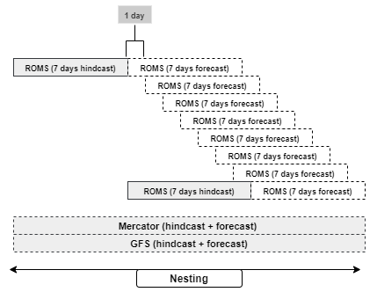

Fig. 993 - Operational forecast workflow for the free scheme, without Data Assimilation.

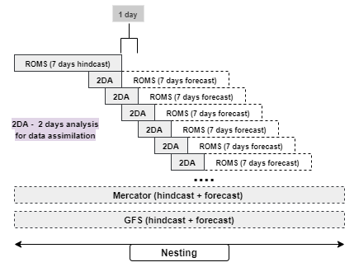

Fig. 9078 - Operational forecast workflow for the assimilated scheme, with Data Assimilation.

The free scheme was based in the works of Costa *et al*. (2012) and Juza *et al.* (2016), and involves resolving two systems: a hindcast that runs at a specified frequency (weekly in the figure) and a forecast system that runs daily. The hindcast system (7 days) is forced on the surface by the GFS and uses Mercator as initial and lateral boundary conditions. The forecast system (7 days) uses the Mercator to build the boundary conditions and the ROMS data from the previous run to build the initial conditions. If the previous run is the hindcast system, the last available time step is used. In case of the forecast system, it uses the time step corresponding to the start day of the new run (1 day after the start day of the previous run).This workflow is repeated for all nested grids. This restart strategy was used to ensure that the ROMS solution stays close to the real evolution of the ocean in scenarios where DA is not resolved (Costa *et al*., 2012). The frequency to perform the restart depends on the quality of input data and on the stability of the model (bathymetry smoothing playing an important role).

The codes for implementing this scheme are available at the following Github

https://github.com/fernandotcbarreto/ROMS/tree/master/operational.

Based on the works of Mourre *et al* (2018) and Hirose *et al.* (2019), we developed the assimilated system presented in Fig. 9078. The main difference between the two schemes is an analysis run (a two-day analysis in the figure), where the Data Assimilation is performed. The forecast is then initialized using the last time step of this analysis as the initial condition, simulating 7 days in the future. The analysis starts from the midpoint of the running time in the previous analysis, leading to an overlap of 50%.

The codes for implementing this scheme are available at the following Github page <https://github.com/fernandotcbarreto/ROMS/tree/master/operational_assi> milation.

2.3) VALIDATION SET-UP

In order to evaluate the developed codes of the system we established different domains for three regions along the Eastern Brazilian coast. These domains aim to cover the variable aspects of the Brazilian Current System (BC) as it flows poleward.

The first domain (Figure 656.a) is composed by the single Azul grid, and was run for the year long period of 2016, using at boundaries data from Mercator and Era5. The *u* and *v* velocity components were compared against the near surface and bottom available current data from the Vitória buoy, located at 19°55' S e 39°41' W (part of Brazilian National Buoy Programme – PNBOIA). The velocity comparison was performed between 15-04-2016 and 15-06-2016, based on the [availability](https://www.google.com/search?sxsrf=ALeKk01p7XybMtjjIIvyVrYIf-jxK4gjtg:1606008758586&q=availability&spell=1&sa=X&ved=2ahUKEwjcz77sgJXtAhUWMbkGHcR-CfYQkeECKAB6BAgEEDU) of the Vitória buoy data. PNBOIA velocity data extends from the depth of 5.5 m to 75.5 m, with a cell of 3.5 m. Since this domain presented highly satisfactory results against this buoy (to be presented in next section) and is outside the region of interest, a nesting was not performed in this case.

As the Azul grid covers the entire Eastern Brazilian coast, its results were also compared against MUR and AVISO, in order to evaluate the fields of Sea Surface Temperature (SST) and Sea Surface Height (SSH), respectively. The MUR analysis (Chin *et al*., 2017) presents a 1 km resolution and is produced as a retrospective data set (four-day latency) and as a near-real-time data set (one-day latency) at the Jet Propulsion Laboratory (JPL) PODAAC using wavelets as basis functions in an optimal interpolation (OI) approach. Aviso is a 0.1° resolution gridded composite of the Advanced Very High Resolution Radiometer (AVHRR) from the Polar Operational Environmental Satellites (POES) project (AVISO, 1996).

A grid with resolution 1/36° was nested to the previous domain, creating a nested two-grid system (Figure 656.b) centered in the Rio de Janeiro State. This system was executed from 01-09-2017 to 01-11-2017, employing a two months spin-up (01-07-2017 to 01-09-2017), with the results compared against the *u* and *v* velocity components of the Cabo Frio Buoy (PNBOIA), located at 23°37’ S and 42°12’ W. This date was selected based on the [availability](https://www.google.com/search?sxsrf=ALeKk01p7XybMtjjIIvyVrYIf-jxK4gjtg:1606008758586&q=availability&spell=1&sa=X&ved=2ahUKEwjcz77sgJXtAhUWMbkGHcR-CfYQkeECKAB6BAgEEDU) of Cabo Frio buoy.

A second domain composed by a nested two-grid system with resolutions 1/12° and 1/36° was implemented for the southern region of Brazil. This system was executed from 01-11-2017 to 01-01-2018, employing a two months spin-up (01-09-2017 to 01-11-2017), with results compared against the *u* and *v* velocity components of the Itajaí Buoy (PNBOIA), located at 27°24’ S and 47°15' W. This date was selected based on the [availability](https://www.google.com/search?sxsrf=ALeKk01p7XybMtjjIIvyVrYIf-jxK4gjtg:1606008758586&q=availability&spell=1&sa=X&ved=2ahUKEwjcz77sgJXtAhUWMbkGHcR-CfYQkeECKAB6BAgEEDU) of Itajaí buoy.

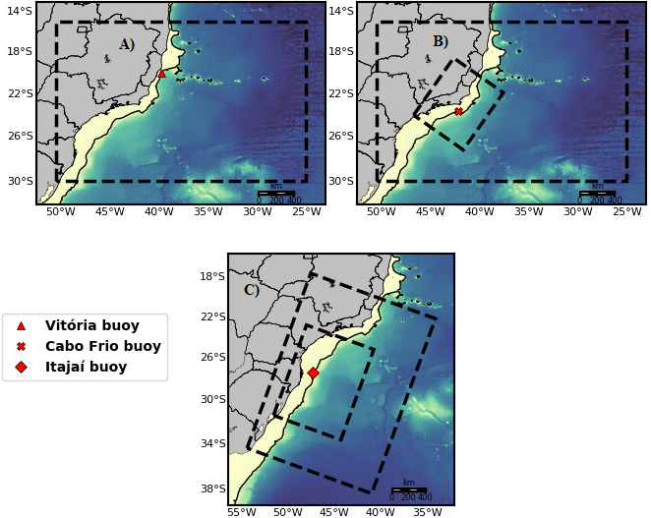

Figure 656 - Depiction of the three domains used in the validation. Dashed lines represent the ROMS grid.

The quality of the model simulations relative to the observations were assessed by means of basic statistic, such as The Pearson’s correlation coefficient, the mean absolute error (MAE, the average of the absolute value of the difference between the model and observations) and the root mean square error (RMSE, the quadratic scoring rule which measures the root average quadratic distance between the model and observations). The three scores complement each other and give different statistical information about the errors. While the Pearson coefficient measures the linear [correlation](https://en.wikipedia.org/wiki/Correlation) between two time series, the MAE measures the average magnitude of the errors, and the RMSE the spread of the distribution of the differences between the model and observations, thus giving information about how wide is its.

For the operational forecast system results, the velocity fields of the free scheme were compared against the Mercator output to evaluate the stability of the solution inside the domain and close to the boarders for the three nested grids. To evaluate the correct inclusion of the DA method into the assimilated system, the modelled SSH and SST fields were compared against ocean measurements from MUR and AVISO.

**3) RESULTS AND DISCUSSION**

3.1) EVALUATING THE VELOCITY COMPONENTS

The Brazil Current (BC) is unique among subtropical western boundary currents, with increasing vertical extension from its origin site (around 15°S) towards the confluence region with the Malvinas Current. It goes from 200 m to 400-500 m at 20°S with the addition of the South Atlantic Central Water (SACW), and to about 1200 m at 25°S with the addition of the Antarctic Intermediate Water (AAIW) (Silveira *et al*., 2004, Schmid *et al.*, 2000, Soutelino *et al*., 2013). This modification of the BC as it flows poleward motivated the tests of the modelling system for the buoys Vitória, Cabo Frio, and Itajaí, as they cover different regimes of the BC.

The Vitória buoy was moored at a depth of 200 m, in a region with baroclinic mesoscale activity resultant from the strong vertical shear of the BC with its immediate adjacent western boundary current (NBUC) (Soutelino *et al*., 2013).

In the region of the Cabo Frio buoy (moored at 200 m), besides the baroclinic mesoscale activity from the strong vertical shear of BC-NBUC system (Silveira *et al*., 2008; Mano *et al*., 2009), the dynamics are also modified by a change in coastal direction from north-south to east-west around 23 °S, which also promotes upwelling of deep South Atlantic central water (Valentin, 2001), resulting a highly complex region.

The site of the Itajaí buoy (moored at 200 m) is much less studied compared to other two due to the distance from the pre-salt oil reserves of the Campos and Santos Basin. In this region the BC is composed by the Tropical Water (TW), South Atlantic Central Water (SACW), Antarctic Intermediate Water (AAIW), and North Atlantic Deep Water (NADW) flowing towards the Malvinas Confluence.

The *u* and *v* velocity components from ROMS were compared against the *in situ* data for two months at the depths of 5.5 m and 75.5 m (top and bottom depths of PNBOIA data). The modelled data are initially linear interpolated to the in *situ* higher frequency data to avoid losing information. A low-pass filter in then applied to the time series to remove the high frequencies. The Mercator output was also included in the analysis. Since Mercator assimilates real-time ocean measurements from satellite and in situ observation systems, it is a great dataset to use as quality control.

The Pearson’s correlation coefficient and the RMSE were the chosen parameters to evaluate the modelled data and are presented in Table 324 for the three buoys.

**Table 324 - Pearson (r) and RMSE for buoys Vitória, Itajaí, and Cabo Frio**

|  |  |  |  |  |  |  |
| --- | --- | --- | --- | --- | --- | --- |
| Buoy | Depth | Source | Pearson (r) * | | RMSE (m/s) | |
|  |  |  | **u** | **v** | **u** | **v** |
| Vitória | 5.5 m | ***MERCATOR*** | 0.8775 | 0.8683 | 0.1304 | 0.1612 |
| ***ROMS*** | 0.9104 | 0.8908 | 0.1017 | 0.1637 |
| 75.5 m | ***MERCATOR*** | 0.8790 | 0.8730 | 0.1091 | 0.090 |
| ***ROMS*** | 0.8946 | 0.8901 | 0.0781 | 0.1169 |
| Cabo Frio | 5.5 m | ***MERCATOR*** | 0.1123 | 0.4096 | 0.1981 | 0.098 |
| ***ROMS PARENT*** | 0.03(0.45) | 0.3887 | 0.2418 | 0.1285 |
| ***ROMS NEST*** | 0.5506 | 0.0162 | 0.1294 | 0.1238 |
| 75.5 m | ***MERCATOR*** | 0.2981 | 0.5877 | 0.2078 | 0.077 |
| ***ROMS PARENT*** | 0.1720 | 0.2659 | 0.2629 | 0.1425 |
| ***ROMS NEST*** | 0.7206 | 0.1004 | 0.1191 | 0.1066 |
| Itajaí | 5.5 m | ***MERCATOR*** | 0.2583 | 0.5314 | 0.1000 | 0.1182 |
| ***ROMS PARENT*** | 0.02 (0.42) | 0.3896 | 0.0979 | 0.1358 |
| ***ROMS NEST*** | 0.2061 | 0.8528 | 0.0926 | 0.0852 |
| 75.5 m | ***MERCATOR*** | 0.3358 | 0.1887 | 0.1314 | 0.1703 |
| ***ROMS PARENT*** | 0.2564 | 0.1624 | 0.1162 | 0.1934 |
| ***ROMS NEST*** | 0.4875 | 0.8309 | 0.1073 | 0.1331 |

* P-values for the correlation coefficient are zero, unless noted otherwise in brackets.

**Vitória Buoy**

The modelled data from ROMS grid 1/12° (Azul grid, Figure 656.a) and Mercator are plotted against Vitoria Buoy in Figure 512 and Figure 513. ROMS and Mercator presented high correlations for both depths and velocity components (> 0.85), with ROMS performing slightest better. This can be confirmed in the plots, with the models reproducing the main peaks. It was not observed a significant difference between surface and bottom values for correlation coefficients. For RMSE, the worst value was observed for Mercator *v* component at depth 5.5 m (0.1612 m/s), and the best for ROMS *u* component at depth 75.5 m (0.0781). Both ROMS and Mercator improved their RMSE values at 75.5 m. ROMS improved around 23% for *u*, and 28% for *v*.

Since ROMS performed very well for Vitória buoy, and this region is outside the region of interest for the operational system (RJ state), it was not implemented a nested grid for this case.

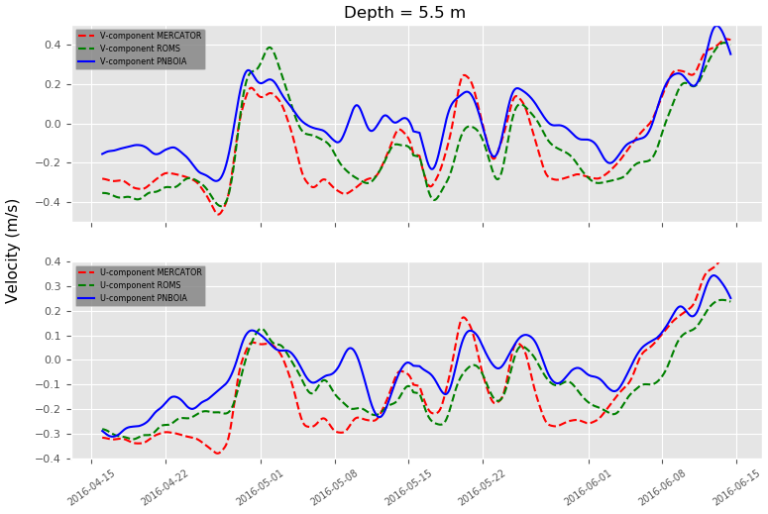

Figure 512 - Comparison of filtered *v* (upper) and *u* (bottom) velocity components between ROMS, Mercator, and Vitória Buoy at depth 12.5 m.

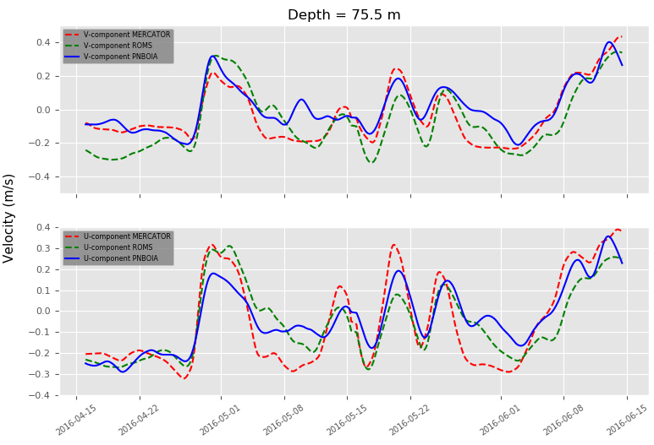

Figure 513 - Comparison of filtered *v* (upper) and *u* (bottom) velocity components between ROMS, Mercator, and Vitória Buoy at depth 75.5 m.

**Cabo Frio Buoy**

The modelled data from ROMS 1/12° (Azul grid), ROMS 1/36° (Figure 656.b) and Mercator are plotted against Cabo Frio Buoy in Figure 516 and Figure 517. At 5.5 m Mercator (0.41) and ROMS Parent (0.39) presented better correlation coefficients for *v*, and ROMS Nest for *u* (0.55). However, as seen in the plots, none of the models seem to represents the main peaks in *v* component, while in *u* componentROMS Nest represented fairly well, with exception of the feature between 2016/10/08 and 2016/10/13. For RMSE, ROMS Nest performed well for both *u* and *v*, with values smaller than 0.13 m/s, while Mercator and ROMS Parent presented values close to 0.2 m/s for *u* component. For comparison, in their work for Santos Basin, Fragoso *et al.* (2016) calculated RMSE with minimum value around 0.2 m/s for both free and assimilated run. At 75.5 m Mercator improved the correlation for *v* in 43% (to 0.58), and ROMS Nest for *u* in 30% (to 0.72). ROMS Parent performed worse for this depth. Again, no clear correlation can be observed from the plots of *v* component for neither models. For RMSE the nested ROMS improved slightly for both *u* and *v*.

In overall, Mercator presented a better correlation for *u* component, and ROMS Nest for *v*. When calculating a depth average of these correlations, however, we find a greater value for ROMS (0.63), against 0.5 for Mercator. Besides, the depth average of RMSE for *u* and *v* are0.20 and 0.08 m/s, respectively, for Mercator, and 0.12 and 0.11 m/s, respectively, for ROMS, indicating a better representation of the *in situ* data by the ROMS Nest.

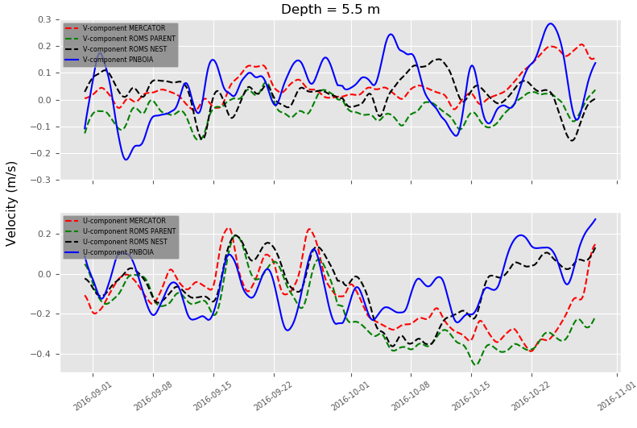

Figure 516 - Comparison of filtered *v* (upper) and *u* (bottom) velocity components between ROMS Parent (1/12°), ROMS Nest (1/36°), Mercator, and Cabo Frio Buoy at depth 12.5 m.

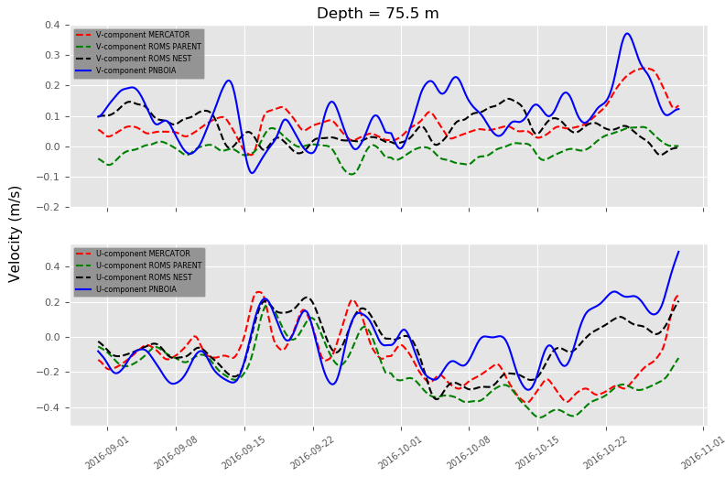

Figure 517 - Comparison of filtered *v* (upper) and *u* (bottom) velocity components between ROMS Parent (1/12°), ROMS Nest (1/36°), Mercator, and Cabo Frio Buoy at depth 75.5 m.

**Itajaí Buoy**

The modelled data from ROMS 1/12°, ROMS 1/36° (Figure 656.c) and Mercator are plotted against Itajaí Buoy in Figure 514 and Figure 515. At 5.5 m both ROMS and Mercator presented greater correlations for *v*, with the nested domain performing 60% better than Mercator (0.85 against 0.53), and the parent performing 26% worse (0.38 against 0.53). For *u* component all domains presented low correlations, as can be confirmed in the plots, with most of the peaks not represented in the simulations. Regarding RMSE, all cases presented values around 0.1, indicating a stable solution, with ROMS Nest performing best for both *u* (0.0926 m/s) and *v* (0.0852 m/s).

At 75.5 m Mercator and ROMS Parent presented low correlations, with the nested domain performing well for *v* (0.83) and regular for *u* (0.49). In the work of Costal *et al.* (2018) for the northwestern Iberian coast, correlations around 50% were deemed as decent. In spite of the high correlation value for the nested domain, in Figure 515 we can observe a significant dampening in all modelled results. For RMSE, ROMS Nest again performed better for both *u* and *v*.

Therefore, ROMS Nest performed better than Mercator and Parent domain for both depths.

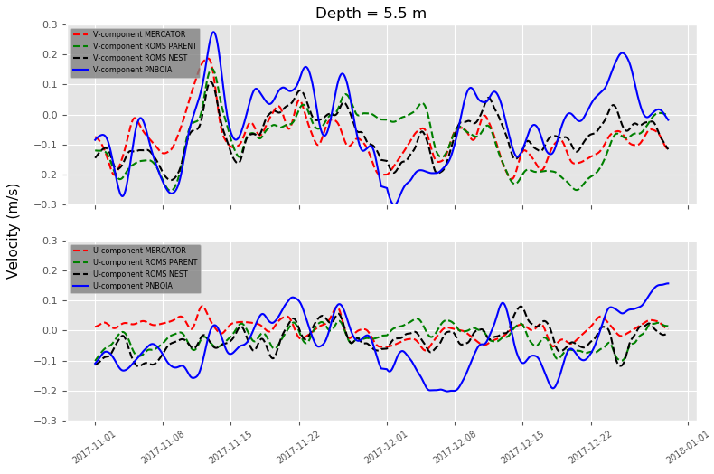

Figure 514 - Comparison of filtered *v* (upper) and *u* (bottom) velocity components between ROMS Parent (1/36°), ROMS Nest (1/36°), Mercator, and Itajaí Buoy at depth 12.5 m.

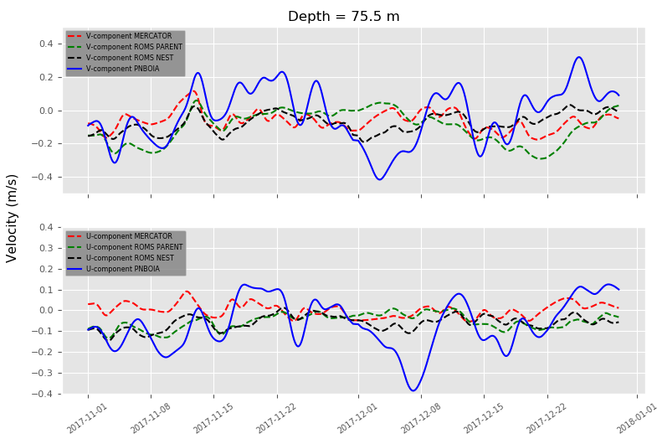

Figure 515 - Comparison of filtered *v* (upper) and *u* (bottom) velocity components between ROMS Parent (1/36°), ROMS Nest (1/36°), Mercator, and Itajaí Buoy at depth 75.5 m.

3.2) SEA SURFACE TEMPERATURE AND ALTIMETRY

From January 2016 to December 2016 (excluding the two first months of spin-up) it was calculated maps of RMSE and MAE for the Sea Surface Temperature (SST, Figure 465) and the Sea Surface Height (SSH, Figure 998) to be employed as skill scores in the evaluation of model performance. These parameters were resolved for each grid node after the linear interpolation between the time series from ROMS, MUR (SST), and Aviso (SSH).

Most of the RMSE and MAE values for SST remained below 1, as observed in Costal *et al* (2012) for the Iberian coast, with greater values in the oceanic region below 25°S, and next to the coastal region of Rio de Janeiro (around 23°S). The discrepancies in the coastal region 23°S was expected, and is probably a result of the wind-driven coastal upwelling off Cabo Frio. After comparison with *in situ* measurements, Pereira *et al.* (2020) reported strong biases in L4 SST products (like MUR) for this region, particularly during upwelling days. According to the author these discrepancies result mainly from the spatio-temporal interpolation in L4 SST analyses and the use of microwave SST.

The spatial average of RMSE and MAE presented values of 0.45°C and 0.39°C, respectively, indicating a good representation of the surface temperature field, as can be compared against the works of Al Azhar *et al.* (2006) for the Arabian Gulf and the Sea of Oman, and of Chakraborty *et al.* (2019) for the Indian Ocean.

For the SSH, most of the area presents values of RMSE and MAE below 0.1, indicating a better representation of SSH field when comparing to the work of Pereira *et al.* (2013) for the same region, which is probability related to the climatological open boundary conditions used in their simulation.

The spatial average of RMSE and MAE presented values of 0.026 and 0.024 m, respectively, indicating a good representation of the SSH field.

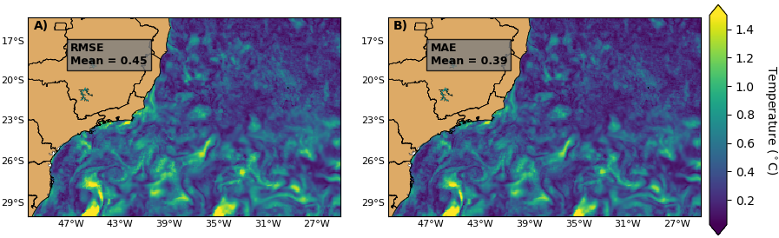

Figure 465 - Distribution of the statistical parameters RMSE (left) and MAE (right) for the Sea Surface Temperature simulated by ROMS from January 2016 to December 2016 compared against MUR SST. In the figures are also calculated the spatial average over the domain.

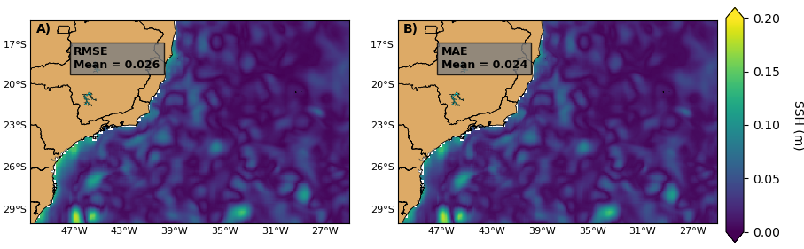

Figure 998: Distribution of the statistical parameters RMSE (left) and MAE (right) for the Sea Surface Height simulated by ROMS from January 2016 to December 2016 compared against Aviso. In the figures are also calculated the spatial average over the domain..

3.3) OPERATIONAL SYSTEM RESULTS

After validation we implemented the free multigrid operational forecast system (Fig. 993) in an i7-5500 CPU 2.40GHz with 12 Gb RAM laptop. The system was executed for two months, without restart during this period, performing daily 7 days forecast, with each forecast taking approximately 4 h for conclusion. As the first day included both a 7 day hindcast and forecast, it took approximately 8 h for conclusion. In order to evaluate the stability of the ROMS solution inside the domain and close to the boundaries, we plotted in Figure 988 the surface velocity for the forecast system, and in Figure 999 the surface velocity from Mercator for the date 26/11/2020. The velocity fields in the two nested grids were plotted in a lower resolution to facilitate the visualization.

The velocity fields presented comparable magnitudes for the three ROMS grids against Mercator. The Brazil current is well formed in the region off RJ state, with magnitudes around 0.8 m/s. It is also observed a southward current adjacent to the coastline in all domains, with higher velocities next to Cabo frio (23 °S). The models also presented the same overall features, like the cyclonic gyre centered at 24.80 °S and 40.80 °W, and the anticyclonic gyre centered at 25.87 °S and 44.51 °W. The cyclonic gyre was outside the domain of the smallest grid. The boundaries kept stable for all ROMS domains, without the presence of jet-like instabilities. Deeper layers also presented comparable magnitudes and features between ROMS and Mercator, and were not show for sake of repeatability.

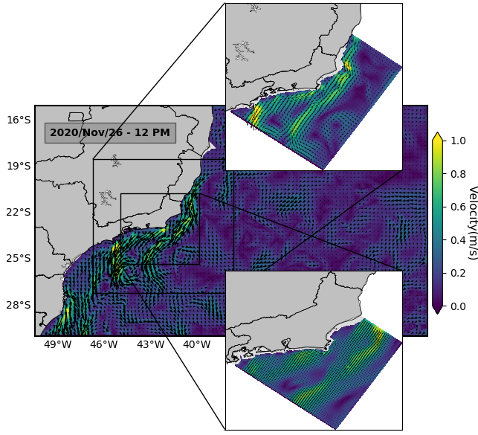

Figure 988 - Surface velocity for the three-nested grids of the free operational system for the date 26/11/2020.

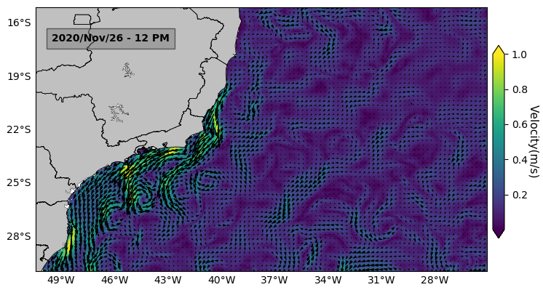

Figure 999 - Surface velocity from Mercator for the date 26/11/2020

Due to computational constraints we were not able to perform the past operational simulation employing 4D-var. However, to test the developed open source routines used to build the observation file for DA we executed a 2 day analysis with 4D-var. For the observation file we employed SST data from MUR and altimetry data from AVISO. Following the work of Fragoso *et al.* (2016), the number of outer and inner loops was set as 1 and 10, respectively. At the end of the analysis, in order to check the correct implementation of 4D-var, the modelled SST was subtracted by MUR, and the SSH by aviso, with the residuals values plotted in Figure 7798 - top. The same analysis was run without assimilation, with the residuals calculated for comparison (Figure 7798 - bottom).

The figures show that the inclusion of DA reduced greatly the error between modelled and measured data, indicating the correct implementation of the assimilated analysis.

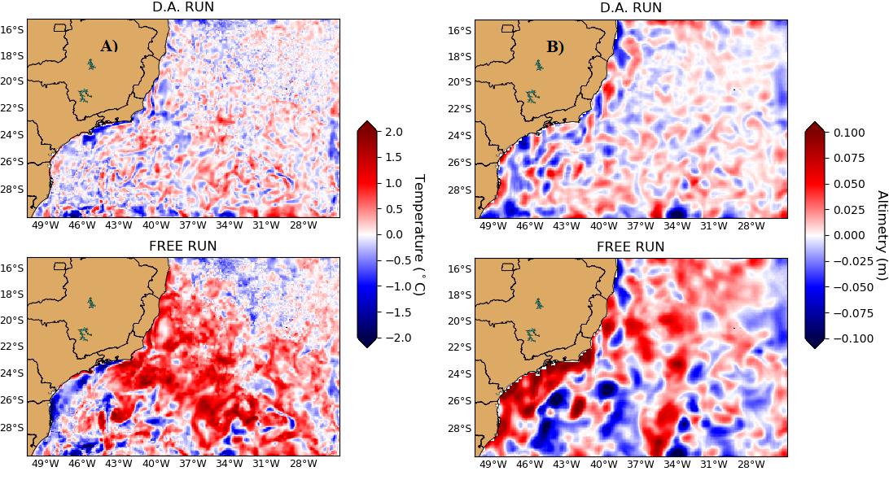

Figure 7798 - Residuals between modelled and measured SST (A) and SSH (B) for assimilated (top) and free (bottom) analysis. The measurements for SST and SSH are from MUR and AVISO, respectively.

**4) CONCLUSION AND FUTURE DEVELOPMENTS**

In this work we proposed to build a multigrid ocean forecast operational system for the region off Rio de Janeiro state, based on regional systems implemented for places like California, Japan, and Mediterranean. For that we developed a set of open source codes to create boundary and initial conditions, grid, data ingestion, atmospheric forcing, nesting, and observation file for Data Assimilation. Two operational schemes were developed, a free (without Data Assimilation), and an assimilated (employing the data assimilation method 4D-var), with the main difference being an analysis run performed in the assimilated scheme to resolve DA. In order to validate the new codes, we performed hindcast simulations using Mercator and Era5 as input data for different parts of the Southeastern Brazilian oceanic region, covering various regimes of the unique Brazil Current system. The modelled velocity components, including Mercator, were compared against two months of data from the following buoys of the PNBOIA program, Vitória, Itajaí, and Cabo frio. Mercator and ROMS (1/12°) performed very well for Vitória buoy for both *u* and *v* components. In Itajaí buoy, ROMS Nested (1/36°) performed better than Mercator and ROMS Parent (1/12°), with better correlations for *v* component. For Cabo Frio buoy, Mercator performed better for *v* component, and ROMS nest for *u*, with ROMS Parent performing poorly overall. The Cabo Frio buoy presented the lowest correlation values among the three, which is not a surprise when considering the complexity of the region, with baroclinic instability associated to the BC/NBUC system, change in the coast orientation, and strong upwelling. Therefore, ROMS performed better than Mercator in most of the cases, even with Mercator assimilating real-time ocean measurements from satellite and in situ observation systems

From a one year simulation with the Azul grid we performed calculations of the statistical parameters RMSE and MAE for the Sea Surface Temperature and Sea Surface Height, comparing against MUR and AVISO, respectively. ROMS performed very well for both variables, with space average values for RMSE and MAE of 0.45°C and 0.39° for SST, respectively, and 0.026 and 0.024 m for SSH, respectively.

After validation we implemented the free operational forecast system in serial model in a laptop. The system was executed for two months, performing daily 7 days forecast, with each forecast taking 4 h for conclusion. At the end of these two months, we compared the velocity field against Mercator data, showing the stability of the ROMS solution inside the domain and close to the boundaries for all grids. Considering the relative small time for running three nested grids operationally, we conclude that this free scheme is viable to be employed by researchers lacking cluster structure or cloud computing, allowing the execution of operational studies with few resources.

For future developments we aim to continue the validation of the system, including transects and vertical profiles of temperature, salinity, and currents collected with gliders, ARGO floats, and ADCPs. We also aim to implement the operational system with DA in a cloud environment assimilating real-time ocean measurements from satellite and in situ observation systems.

Acknowledgments: the first author was supported by the Rio de Janeiro Research Foundation (FAPERJ), grant ***.

**5) REFERENCES**

Al Azhar, M.; Temimi, M.; Zhao, J.; Ghedira, H. **Modeling of circulation in the Arabian Gulf and the Sea of Oman: Skill assessment and seasonal thermohaline structure**. J. Geophys. Res. Oceans, 121, doi:10.1002/ 2015JC011038. 2016.

AVISO (1996) Merged TOPEX-Poseidon products (GDR-Ms). **AVISO User Handbook. 3rd ed**. http://www.aviso.altimetry.fr/fileadmin/ documents/data/tools/hdbk_tp_gdrm.pdf. Accessed November 2020.

Beckmann, A.; D. B. Haidvogel. **Numerical simulation of flow around a tall isolated seamount. Part I: Problem formulation and model accuracy**, J. Phys. Oceanogr., 23, 1736–1753, doi:10.1175/1520-0485(1993)0232.0.CO;2. 1993.

Breivik, O., Allen, A.; Maisondieu, C.; Olagnon, M. **Advances in Search and Rescue at Sea**. Ocean Dynam., 63, 83–88, doi:10.1007/s10236-012-0581-1. 2013.

Chapman, D.C. **Numerical treatment of cross-shelf open boundaries in a barotropic coastal ocean model**. J Phys Oceanogr 15:1060– 1075. doi:10.1175/1520-0485.1985.

Chakraborty, K.; Maity, S.; Lotliker, A. A.; Samanta, A.; Ghosh, J.; Masuluri, N. K.; Swetha, N.; Bright, R. P. **Modelling of marine ecosystem in regional scale for short term prediction of satellite-aided operational fishery advisories**. Journal of Operational Oceanography. 2019

Chin, T. M.; Vazquez-Cuervo, J.; Armstrong, E. M.. **A Multi-scale High-resolution Analysis of Global Sea Surface Temperature**. Remote Sensing of Environment 200: 154–169. doi:10.1016/j. rse.2017.07.029. 2017.

Costa, P.; Gomez, B.; Venancio, A.; Perez, E.; Perez-Munuzuri, V**. Using the Regional Ocean Modelling System (ROMS) to improve the sea surfasse temperature predictions of the MERCATOR Ocean System**. Advances in Spanish Physical Oceanography. 2012.

Costa, T.; Pereira, L.; Marta-Almeida, M.; Guedes Soares, C**. Mapping of currents off the northwestern Iberian coast with the Regional Ocean Modelling System**. Journal of Operational Oceanography. 13. 1-13. 10.1080/1755876X.2018.1522717. 2018.

Flather, RA. **A tidal model of the North-West European continental shelf**. Mem Soc R Sci Liege 6:141–164. 1976.

Hirose, N.; Usui, N.; Sakamoto, K.; Tsujino, H.; Yamanaka, G.; Nakano, H.; Urakawa, S.; Toyoda, T.; Yosuke, F.; Kohno, N. **Development of a new operational system for monitoring and forecasting coastal and open-ocean states around Japan**. Ocean Dynamics. 69. 10.1007/s10236-019-01306-x. 2019.

Mason, E.; Molemaker, J.; Shchepetkin, A. F.; Colas, F.; McWilliams, J. C.; Sangra, P. **Procedures for off-line grid nesting in regional ocean models**. Ocean Modelling. Vol. 35. 2010.

Mano, M.; Paiva, A.; Rebelo, A.; Coutinho, A. **Energy Flux to a Cyclonic Eddy off Cabo Frio, Brazil**. Journal of Physical Oceanography. J. Phy Oceano. 39. 10.1175/2009JPO4026.1. 2009.

Marchesiello, P., J. C. McWilliams, and A. F. Shchepetkin. **Open boundary conditions for long-term integration of regional ocean models**, Ocean Modell., 3, 1–20, doi:10.1016/S1463-5003(00)00013-5. 2001.

Moore, A. M.; Arango, H. G.; Broquet, G.; Edwards, C; Veneziani, M.; Powell, B. S.; Foley, D.; Doyle, J. D.; Costa, D.; Robinson, P. **The Regional Ocean Modeling System (ROMS) 4-dimensional variational data assimilation systems: Part III – Observation impact and observation sensitivity in the California Current System**. Progress in Oceanography, 91(1), 74–94, doi:10.1016/j.pocean.2011.05.005. 2011

Moore, A.; Edwards, C.; Fiechter, J.; Drake, P.; Neveu, E.; Arango, H.; Gürol, S.; Weaver, A. **A 4D-Var Analysis System for the California Current: A Prototype for an Operational Regional Ocean Data Assimilation System**. S.K. Park and L. Xu, eds. Data Assimilation for Atmospheric, Oceanic and Hydrologic Applications (Vol. II), DOI 10.1007/978-3-642-35088-7 14. 2013.

Mourre, B.; Aguiar, E.; Juza, M.; Hernandez-Lasheras, J.; Reyes, E.; , Heslop, E.; Escudier, R.; Cutolo, E.; Ruiz, S.; Mason, E.; Pascual, A.; Tintoré, J.. **Assessment of high-resolution regional ocean prediction systems using multi-platform observations: Illustrations in the Western Mediterranean Sea**. In "New Frontiers in Operational Oceanography", E. Chassignet, A. Pascual, J. Tintoré, and J. Verron, Eds., GODAE OceanView, 663-694, doi:10.17125/gov2018.ch24. 2018.

Pereira, F.; Bouali, M.; Polito, P.; Silveira, I. C. A.; Candella, R. **Discrepancies between satellite-derived and in situ SST data in the Cape Frio Upwelling System, Southeastern Brazil (23˚S)**. Remote Sensing Letters. 11. 555-562. 10.1080/2150704X.2020.1742941. 2020.

Pereira, J.; Cirano, M.; Marta-Almeida, M.; Amorim, F. **A regional study of the Brazilian shelf/slope circulation (13°-31°s) using climatological open boundaries**. Brazilian Journal of Geophysics. 31. 289-305. 10.22564/rbgf.v31i2.295. 2013.

Powell, B. S.; Moore, A. M.; Arango, H. G.; Di Lorenzo, E.; Milliff, R. F.; Leben, R. R. **Near real-time ocean circulation assimilation and prediction in the Intra-Americas Sea with ROMS**. Dynamics of Atmosphere and Oceans. 2009. doi:10.1016/j.dynatmoce.2009.04.001. 2009.

Shchepetkin, A.; McWilliams, J. **The regional oceanic modeling system (ROMS): a split-explicit, free-surface, topography-following-coordinate oceanic model**. Ocean Model., 9(4), 347–404, doi:10.1029/2008JC005135. 2015.

Schmid, C.; Siedler, G.; Zenk, W. **Dynamics of Intermediate Water Circulation in the Subtropical South Atlantic. Journal of Physical Oceanography**. J Phys Oceano. 30. 3191-3211. 10.1175/1520-0485(2000)030<3191:DOIWCI>2.0.CO;2. 2000.

Soutelino, R.; Gangopadhyay, A.; Silveira, I. **The roles of vertical shear and topography on the eddy formation near the site of origin of the Brazil Current**. Continental Shelf Research. 70. 10.1016/j.csr.2013.10.001. 2013.

Tintoré, J.; Vizoso, G.; Casas, B.; Heslop, E.; Pascual, A.; Orfila, A.; Ruiz, S.; Martínez-Ledesma, M.; Torner, M.; Cusi, S.; Diedrich, A.; Balaguer Huguet, P.; Gómez-Pujol, L.; Álvarez-Ellacuria, A.; Gómara, S.; Sebastian, K.; Lora, S.; Beltrán, J.; Renault, L.; Manriquez, M. **SOCIB: The Balearic Islands Coastal Ocean Observing and Forecasting System Responding to Science**, Technology and Society Needs. Marine Technology Society Journal. 47. 101-117. 10.4031/MTSJ.47.1.10. 2013.

Silveira, I. C. A.; Schimidt, A. C. K.; Campos, E. J. D.; Godoi, S. S.; Ikeda, Y. **The Brazil Current off the Eastern Brazilian Coast**. Brazilian Journal of Oceanography. 2000.

Silveira, I. C. A.; Calado, L.; Castro, B.; Cirano, M.; Lima, J.; Mascarenhas, A. **On the baroclinic structure of the Brazil Current-Intermediate Western Boundary Current system at 22°-23°S**. Geophysical Research Letters. 31. 14308-. 10.1029/2004GL020036. 2004.

Silveira, I. C. A.; Lima, J.; Schmidt, A.; Belo, W.; Sartori Neto, A.; Francisco, C.; Fontes, R. **Is the meander growth in the Brazil Current system off Southeast Brazil due to baroclinic instability?** Dynamics of Atmospheres and Oceans. 45. 187-207. 10.1016/j.dynatmoce.2008.01.002. 2008.

Strand, K. O.; Sundby, S.; Albretsen, J.; Vikebø, F. B. **The Northeast Greenland Shelf as a Potential Habitat for the Northeast Arctic Cod**, Frontiers in Marine Science, 4, doi:10.3389/fmars.2017.00304. 2017.

Röhrs, J., Dagestad K. F.; Asbjørnsen, H.; Nordam, T.; Skancke J.; Jones, C. E.; Brekke , C**. The effect of vertical mixing on the horizontal drift of oil spills**. Ocean Science Discussions, pp. 1–32, doi:https://doi.org/10.5194/os-2018-100. 2018a

Rohrs, J.; Sperrevik, A. K.; Christensen, K. H. **NorShelf: A reanalysis and data-assimilative forecast model for the Norwegian Shelf Sea**. Documentation of ocean model setup, No. 04/2018, ISSN 2387-4201. 2018b.

Valentin, J.L. **The Cabo Frio Upwelling System, Brazil**. In: Seeliger U., Kjerfve B. (eds) Coastal Marine Ecosystems of Latin America. Ecological Studies (Analysis and Synthesis), vol 144. Springer, Berlin, Heidelberg. <https://doi.org/10.1007/978-3-662-04482-7_8>. 2001.