Image Processing Project 3

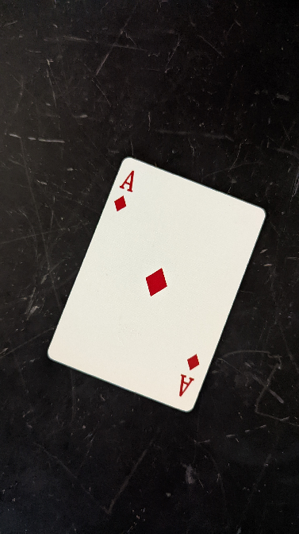Fernando Koiti Tsurukawa

# C:\Users\fetsuruk\Desktop\suit.pngCard rank and suit detection

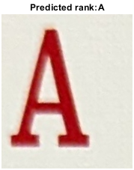

# Objective

Determine the rank and suit of an image of a playing card.

### Assumptions

The image must be captured with nearly optimal lighting conditions, meaning it should be taken in a well-lit room with no overhead illumination, which causes glare and could compromise the image processing.

The card must be resting in a flat, black surface and the camera is to be positioned at an angle directly above the card. Any changes to the angle of the shot will cause unaccounted distortions.

At last, there must be no objects in the frame other than the card itself, each card is to be captured and identified separately.

### Algorithm

1. Blur the image using a moving average of size 10x10.
2. Sweep the blurred image with a fixed threshold of 0.8 in all four directions: downwards, upwards, left-to-right and right-to-left to find the card corners and store their coordinates.
3. Calculate the angle of rotation using the top-left and top-right corners of the playing card.
4. Using *imwarp()*, undo the rotation on the original non-blurred image.
5. Crop the image by using *imcrop()* such that all pixels above the threshold are maintained.
6. Automatically select the pixels containing the rank and the suit by assuming they’re always in the same spot at the top-left corner.
7. Use a precomputed convolutional neural network to classify the rank and suit separately.

### Subset of results

