**SympMeds**

**Specifications Document**

**Ver. 1.0**

**Application Name:** SympMeds

System Metaphor: Pharmacist

Authors: Milena Fernandez & Randall Rosing

**Use Case Diagram:**

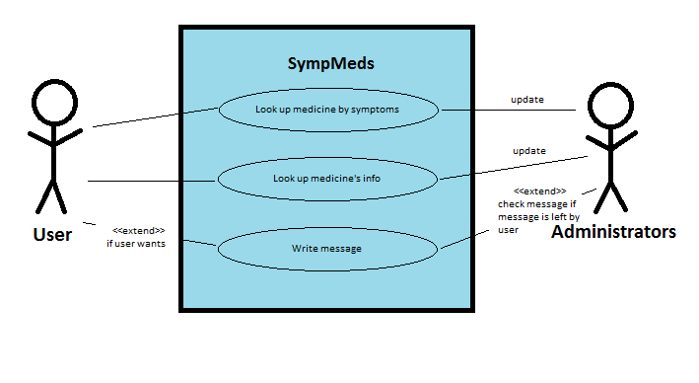

**User Stories:**

Pre-alpha Release 0.1:

* What I am looking for as the customer is for an app that allows me to look up information on a non-prescription drug, such as the symptoms it treats and any side-effects or other warnings it has. Also, if I am not sure of which drug I want, I can get a list of a lot of drugs by searching for a symptom that I or a loved one has.

Pre-alpha Release 0.2:

* <filler text>
* <filler text>