Return to iCARDEA User Guides
iCARDEA PHR User Manual
“An Intelligent Platform for Personalized Remote Monitoring of the Cardiac Patients with Electronic Implant Devices”
1 Introduction 2
1.1 Overview 2
1.2 Definitions, acronyms and abbreviations 2
2 Please Read – No monitoring by Doctors 3
3 PHR Portal Functionalities 3
3.1 Logging in to the Personal Health System (PHR) Portal 3
3.2 Navigation Menu Sidebar 4
3.3 Home 5
3.4 Import Electronic Health Information from the hospital 6
3.5 Monitoring 6
3.5.1 Health Reports 6
3.5.2 Monitoring Vital signs over time 7
3.6 Patient Information 8
3.6.1 Health Observations 9
3.6.2 Action Plan 16
3.6.3 Health Profile 18
3.6.4 Monitoring Vital Signs 23
3.7 Information and People 24
3.7.1 Health Topics 24
3.7.2 Community related topics 27
3.7.3 Contacts 28
3.8 Privacy – Patient Consent Editor 29
3.9 Sharing of personal health information and interoperability 29
4 Communication with patients sharing similar situations 30
4.1 Forums for patients and health experts 30
4.2 Wiki-based resources for patient communities and forums 33

Introduction

Overview
This document describes the software supporting the Patient Empowerment Framework developed in Task 5.1.

The Patient Empowerment Framework (PEF) is a term used to describe the software and tools that are used to create a system called a PHR system (PHRS). The PHRS system includes functionalities to add, import or update health related information. Information saved is also sent to the hospital system; however, access to this health information by doctors and nurses requires permission from the patient. The patient uses the Consent Manager User Interface to authorize who may access their health information.

Definitions, acronyms and abbreviations

Abbreviation/Acronym | DEFINITION
CMS | Content management system. The use of the term is meant to include social and collaborative software e.g. Wikis, Blogs, Forums
JSF | Java Server Faces (User Interfaces)
HIS | Hospital information System
OpenID | A framework and standard that describes how to authenticate users in a decentralized manner
PEF | Patient Empowerment Framework
PHR Portal | The PHR portal is where a user interacts with the PHR system (PHRS)
PHR or PHRS | Personal Health System based on the PEF for example.
UI | User Interface
WP | Work Package
Table 1 List of Abbreviations and Acronyms

Please Read – No monitoring by Doctors
Please note that a doctor does not monitor the Personal Health information (PHR - Personal Health Records) that you add to this PHR software. Please contact your doctor directly and perhaps print out the reports to bring to your doctor.

This software is a prototype, it is not a medical product – users should sign a consent form. Use this software at your own risk, no one can be held liable.

PHR Portal Functionalities

This chapter describes the main functionalities of the PHR web portal; the portal is split into three high level sections that are accessible in the portal’s navigation menu:
- Patient Information – comprising the management of the patient’s health data
- Information and People – offering information and health material for CIED patients, access to CIED communities and contact to care takers
- Feedback mechanism
  - If you are connected to a hospital system via your CIED implant identifier, then your data is shared with hospital using the iCARDEA clinical software. Your privacy settings (Consent Manager) control authorized access to your health information.
  - If configured, you might use a web-based forum to discuss issues with other patients or healthcare professionals
- Privacy and Administration – offering services for organising the patient’s privacy

Logging in to the Personal Health System (PHR) Portal

Login with a user identifier created by the iCARDEA Identity provider as shown in Figure 1. Otherwise if you have another OpenID, choose “Other Open ID”. For testing and demonstration, please choose a local login name, Figure 2 that begins with ‘phr’ e.g. phrhans123. There is no password for this local login, please use sample health data. We will enable the use of Google mail account if the hospital security requirements allow this.

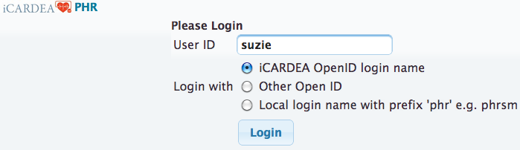
Figure 1 - Login with iCARDEA Identity Provider

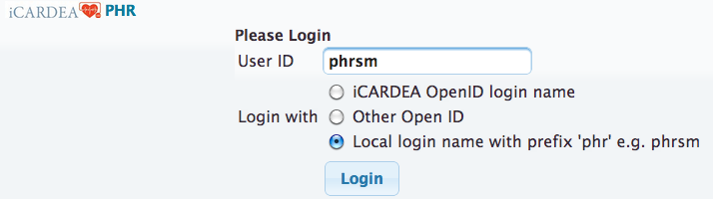
Figure 2 - Login by local user name ('phr' prefix), no password

Navigation Menu Sidebar

Physicians or nurses will be provided with a limited navigation menu displaying only the Health reports options. Patients must authorize who can access using the Consent Manager Editor.

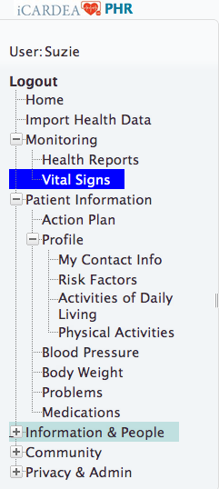
Figure 3 - Menu options for Patient information and monitoring your patient information

Home

Under the home page, the patient is first presented with their contact information and either a CIED web form or a web form (dashboard) to collecting latest health data.

The CIED form asks the patient for their CIED implant device serial number so that the PHR can connect to the Hospital health system and retrieve health data from the hospital health data. After submitting the CIED form, the patient identity is determined.

If the doctor role is detected, a simpler interface provided that only allows health reports to be viewed

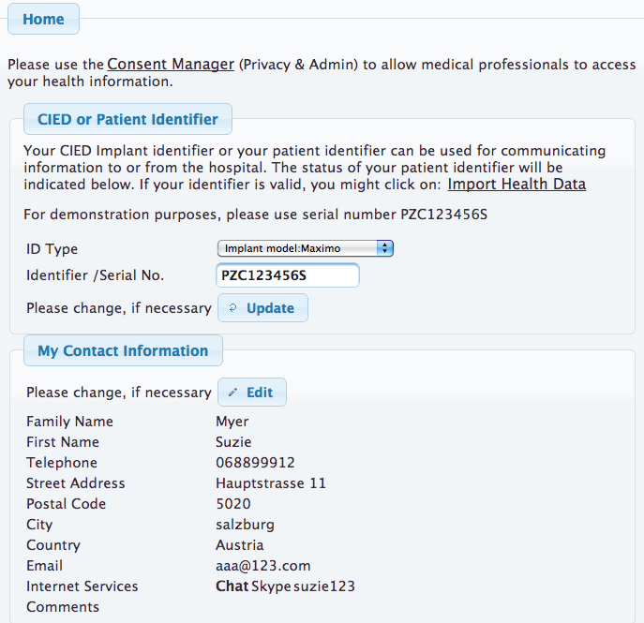
Figure 4 - Home with contact info and form for collecting the CIED Implant serial number

Import Electronic Health Information from the hospital

If you successfully connected to the hospital system, the import button will be displayed in the User Interface. If there is information to import, an overview list will be displayed. Press the import button and data will be imported. If, for example, medications were imported, please check the Patient information section to update your medications. It is important to report the status of the medications, whether you are taking the medication or not. Once you have saved the medication, it will be reported to the iCARDEA clinical related tools that might be used by doctors. Please not that there might be no doctor monitoring your information. Please contact your doctor directly.

Monitoring

Health Reports
Health reports can be displayed from a variety of Observations of Daily Living (blood pressure, heart rate, body weight, medications, problems), profile information (contact info, activities of daily living)

The following figures show a Body weight history report, Figure 5, and a Medications report, Figure 6.

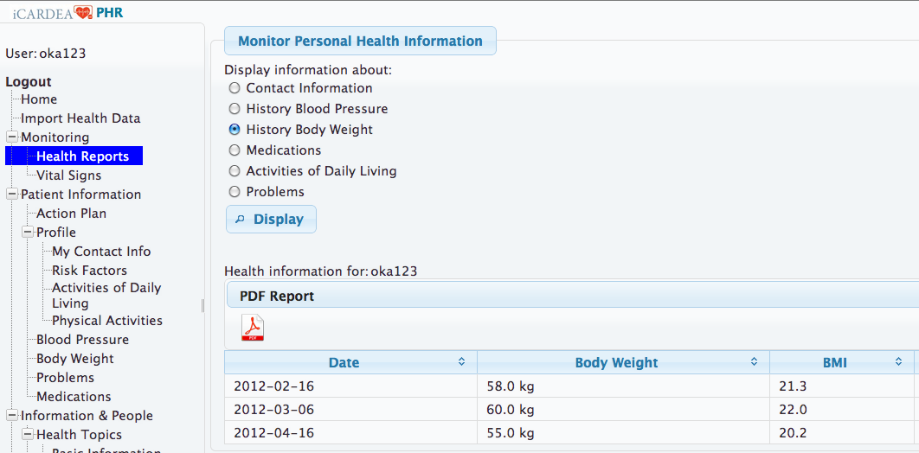
Figure 5 - Personal Health Reports – Body Weight History

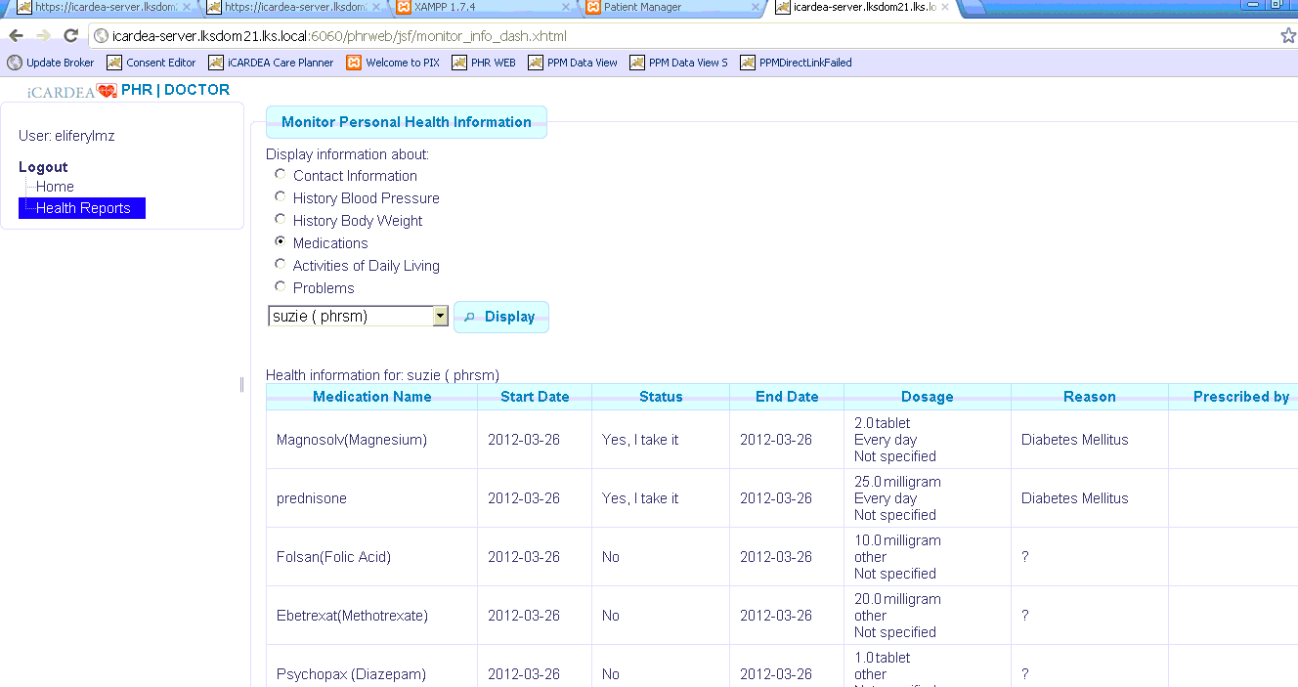
Figure 6 - Personal Health Reports - Medication Report

Monitoring Vital signs over time

The vital signs can be displayed over time on a graph.

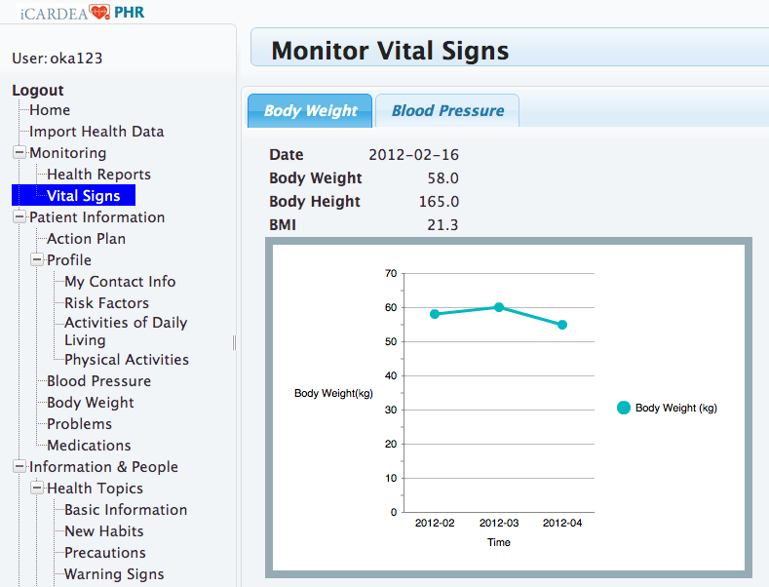
Figure 7 - Monitoring Vital signs over time

Patient Information

Patient Information comprises an overview of the patient’s health data from different perspectives:
- Health observations – includes periodically or occasionally recorded patient data such as blood pressure or current symptoms or problems.
- Action Plan - includes an Action Plan allowing the patient to organize such observations of daily living or other health-related event such as an appointment with his/her cardiologist.
- Profile – describes the patient’s profile from different categories such as risk factors, sport activities and activities of daily living
- Monitoring – refers to an overview for vital signs (e.g. blood pressure, weight) as graphics.

The following sections presents examples of UIs for gathering patient information.

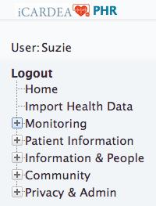
Figure 8 – Menu: Patient Information

Health Observations

The menu item “Health Observations” comprises patient data collected and recorded by the patients themselves. This includes in the current version of the PEF portal blood pressure, body weight, problems and medication compliance.

Recording Blood Pressure

Figure 9 shows the form for inserting blood pressure and heart rate on a daily basis. An overview form (see Figure 10) lists all recorded values. An historical overview of blood pressure and heart rate data can also be presented as a graphical view depicted in Figure 11.

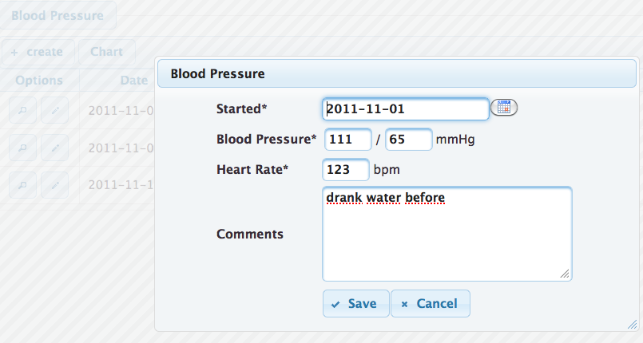
Figure 9 – Dialog view: Blood Pressure

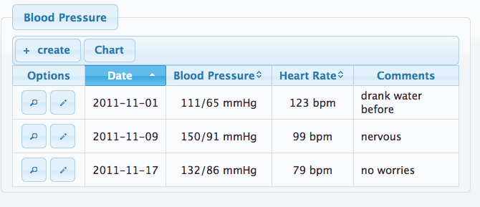
Figure 10 - List view: Blood Pressure

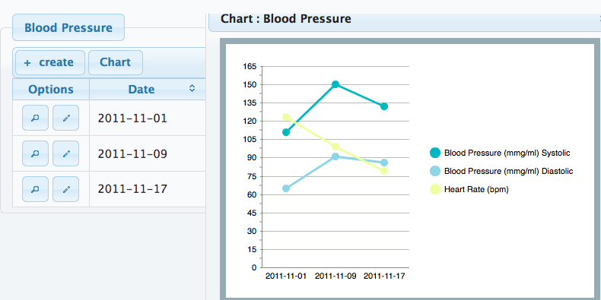
Figure 11 - Chart and List View: Blood Pressure

Recording Body Weight

Figure 12 shows the form for inserting body weight and height; the height is inserted from the known height and available here for modification. An overview form (see Figure 13) lists all recorded values and additionally calculates the body mass index (BMI) based on weight and height. An historical overview of body weight data can also be presented as a graphical view depicted in Figure 14.

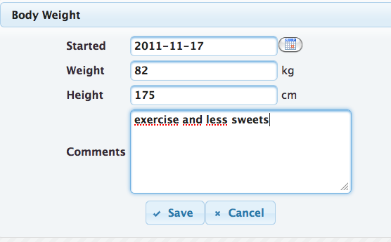
Figure 12 – Dialog view: Body Weight

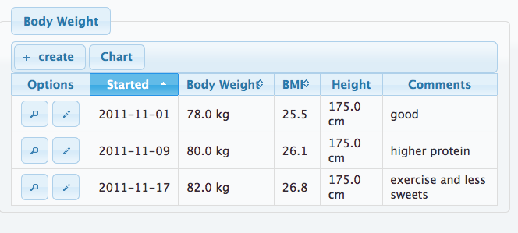
Figure 13 - List view: Body Weight

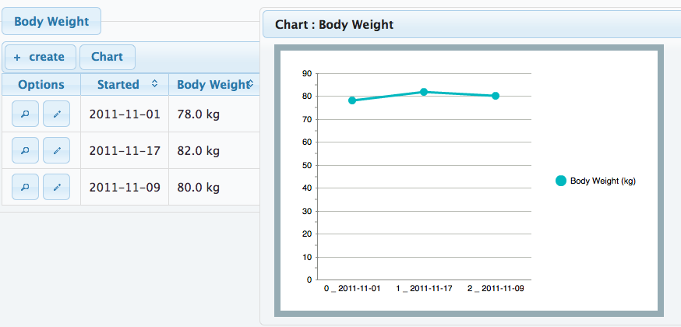
Figure 14 - Chart and List View: Body Weight

Reporting Health Problems (Symptoms)

The patients can provide a list of their health problems to share with their doctor either directly during consultation or by sharing via the interoperability services.

Figure 15 presents the dialog form for inserting an observed problem or symptom on a daily basis. The patient can indicate whether s/he has currently a problem or whether the problem disappeared. The list of problems comprises typical symptoms related to CIED patients (see Figure 16). An overview of recorded problems and their status are presented in a chronological order in Figure 17.

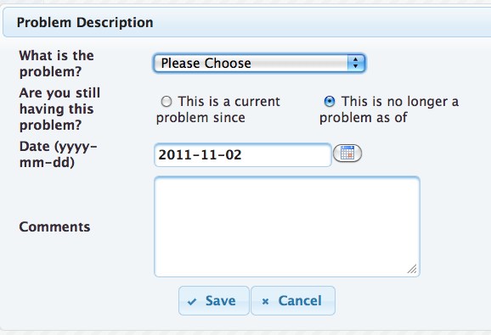
Figure 15 – Dialog view: Problems (Symptoms)

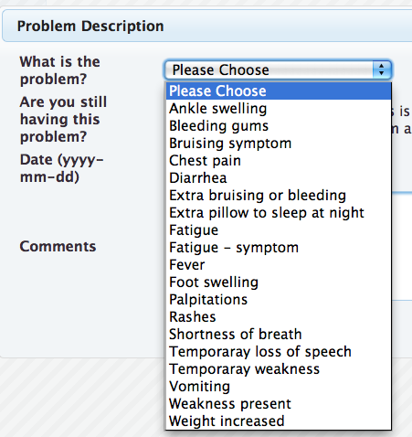
Figure 16 - Controlled vocabulary for UI and PHRS interoperability services

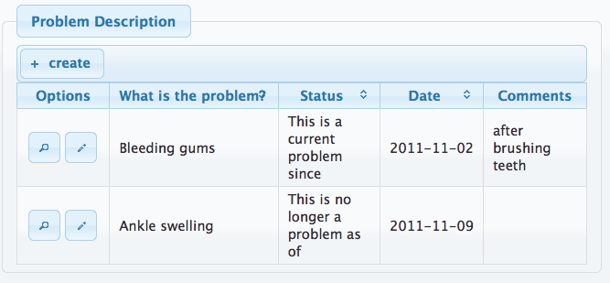
Figure 17 - List view: Health Problems (Symptoms)

Medication Compliance

The medications sections display three views: active and inactive medications and a history of updates to the medication items by the patient. The patient might manually enter their own medications, both prescription and over the counter. In iCARDEA medication data are also imported from the Hospital Information System (HIS). Figure 18 presents the dialog form for inserting a medication. The patient can indicate dosage, frequency and whether s/he is currently taking this medication or whether s/he stopped the intake. Figure 19 depicts an overview for medication compliance.

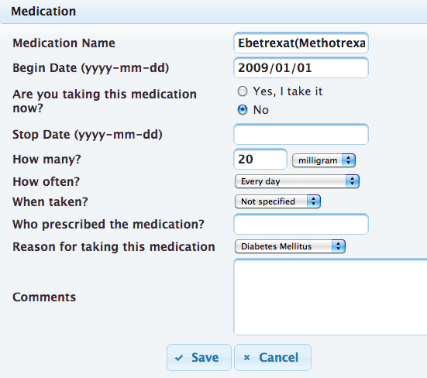
Figure 18 – Dialog view: Medications

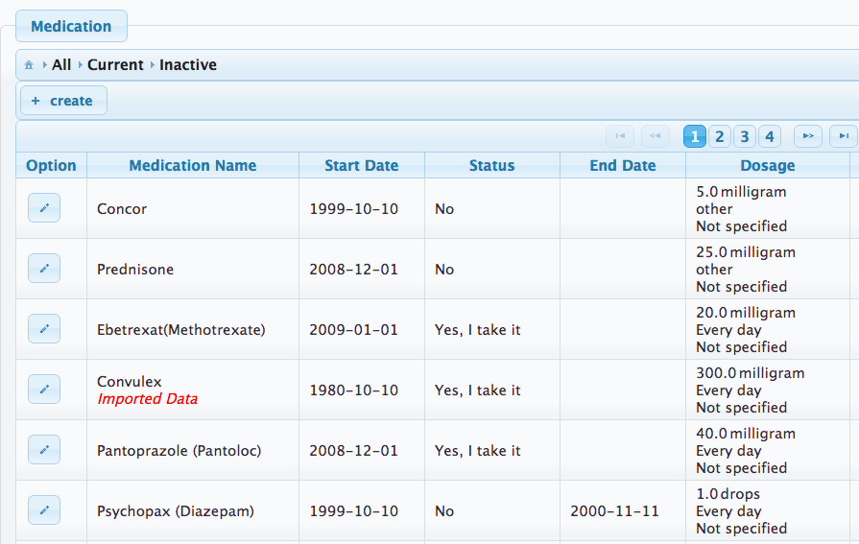
Figure 19 - List view: Medications. Note the medication imported from a Hospital

Action Plan

The action plan tool provides a simplified means of recording actions or diary entries and viewing these entries from either a table list or calendar view. Optimally, actions should be planned over a two-week period or diaries (physical activities, medication diary) might be recorded on a daily basis. Figure 20 depicts the dialog view for inserting or updating actions and Figure 21 presents the inserted actions as a table.

It is possible to enter new actions directly using the calendar view (see Figure 22), however, this feature is not activated by default because not all users are accustom to this interacting with electronic calendars.

Basically, the information about actions in the Action Plan is not shared with other persons (such as physicians). But the patient can grant access and e.g. share the status of physical actions as feedback to clinicians via the PHRS interoperability services.
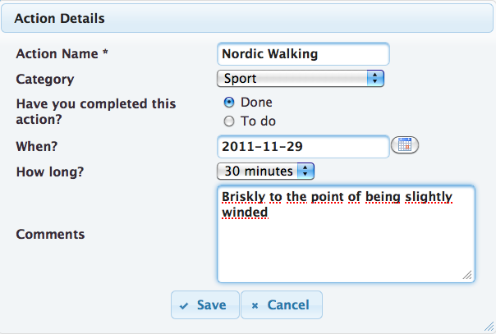
Figure 20 – Dialog view: Actions

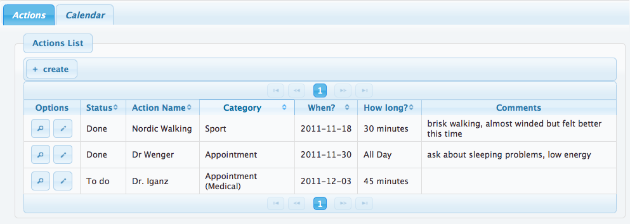
Figure 21 - List view: Actions

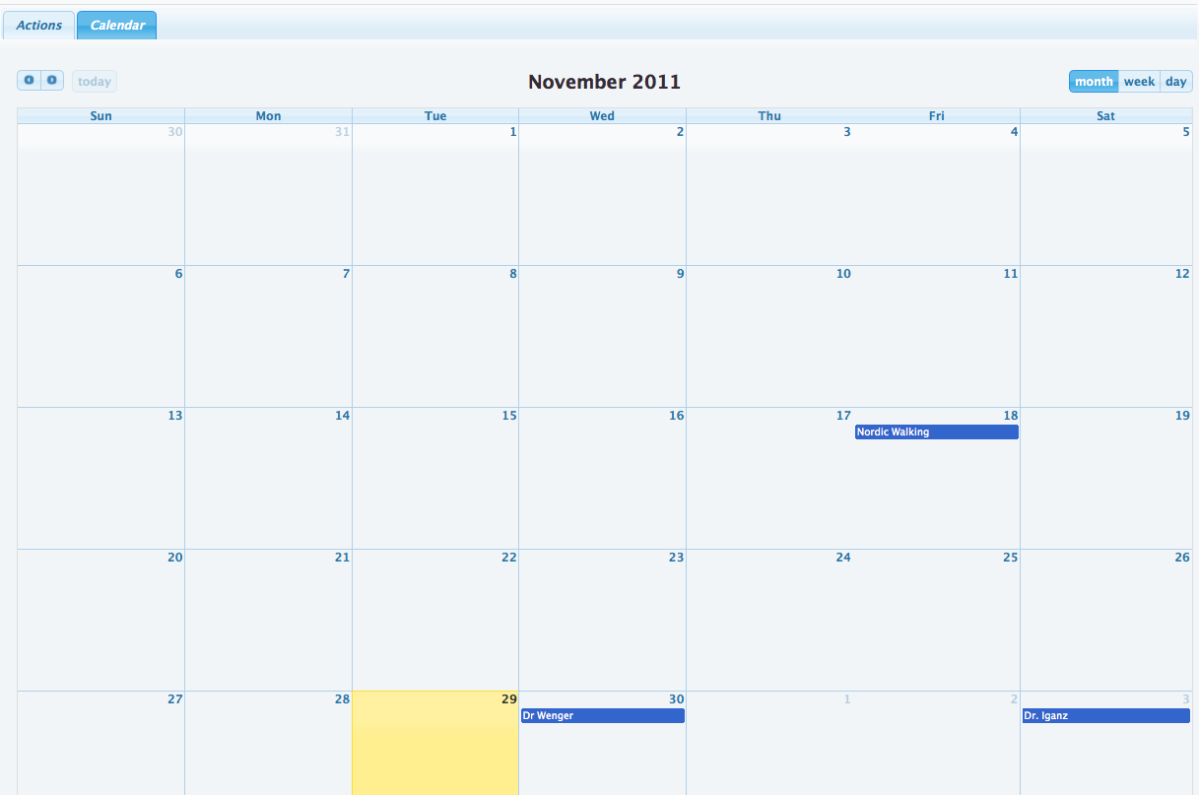
Figure 22 – Calendar view: Actions

Health Profile

Maintaining Contact Information

This menu item allows the patient to insert and update his/her contact information. Figure 23 presents the dialog form for managing the contact data.
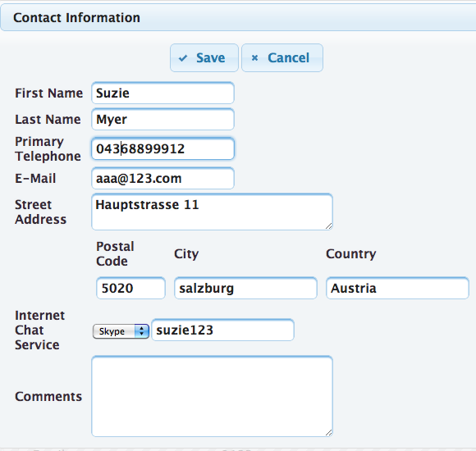
Figure 23 – Dialog view: Contact Information

Indicating Risk Factors

The patient can provide basic information about their risk factors. This might be additional information for physicians. Important risk factors related to CIED patients are cholesterol, smoking, diabetes and hypertension (see Figure 24). Figure 25 and Figure 26 presents examples how to describe the profiles for smoking and for diabetes.
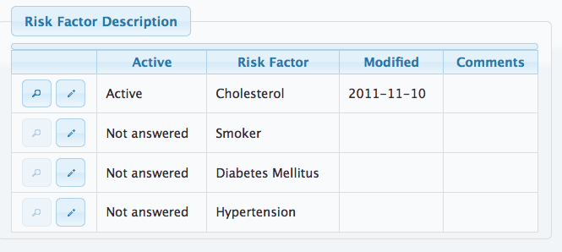
Figure 24 - List view: Risk Factors

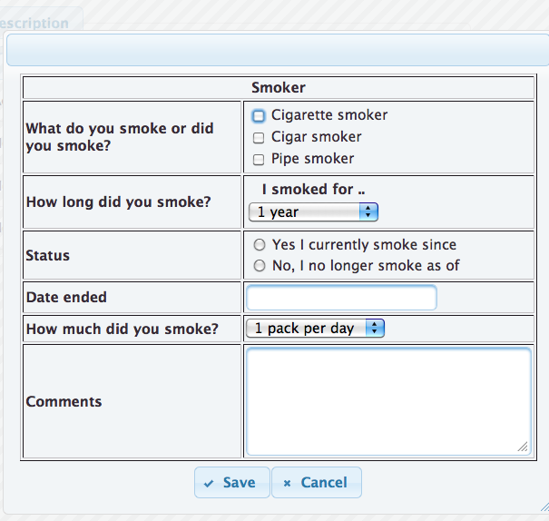

Figure 25 – Dialog view: Risk Factors – Smoking

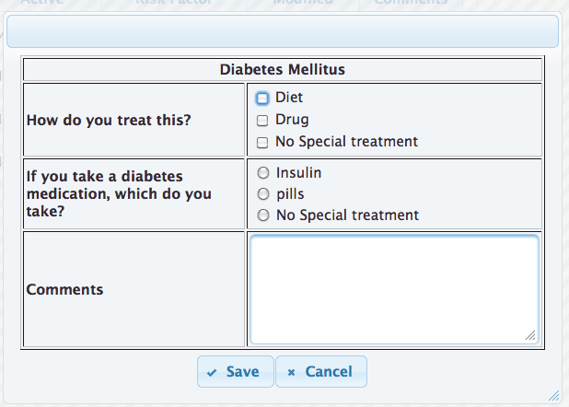
Figure 26 – Dialog view: Risk Factors - Diabetes

Activities of Daily Living

Activities of Daily Living concern the patient profile and deliver insight how a patient is able managing his/her daily routine. This menu item provides a list of activities patient can either do or requires assistance (see Figure 27). Figure 28 presents the dialog view for climbing stairs and represents one example for indicating such activities.

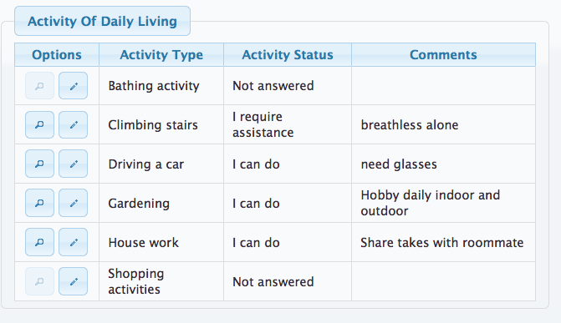
Figure 27 - List view: Activities of Daily Living

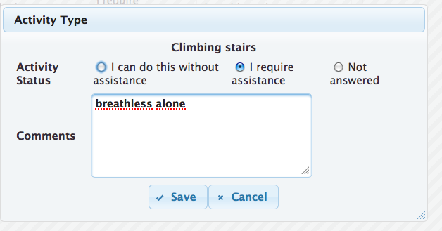
Figure 28 – Dialog view: Activities of Daily Living, climbing stairs

Physical Activities

Physical activity data concerns the patient profile, although these are not actions for organizing in the action plan. These are more similar to Activities of Daily Living as another means to access what physical activities, such as sports or exercise, the patient can do or has done. Figure 29 presents an example for indicating jogging as a physical activity that a patient performs on a regular basis several times per week. The overview form summarizes all current physical activities of the patient (see Figure 30).

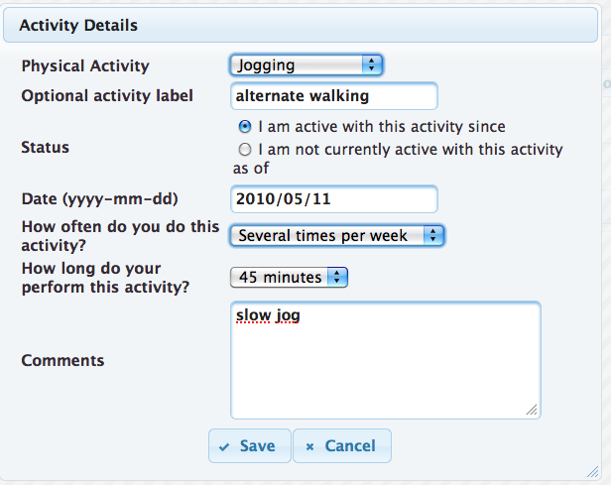
Figure 29 – Dialog view: Physical Activities

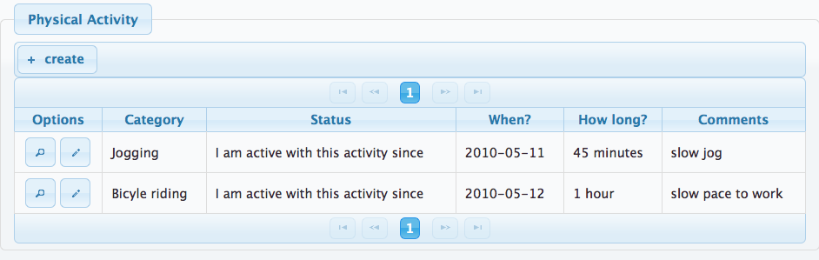
Figure 30 - List view: Physical Activities

Monitoring Vital Signs

The monitoring section provides an overview of current health information and charts of historical information. Additional information and charts can be added as needed. The following are examples for date (body weight and blood pressure) that the patient might wish to follow and perhaps share with their physician:

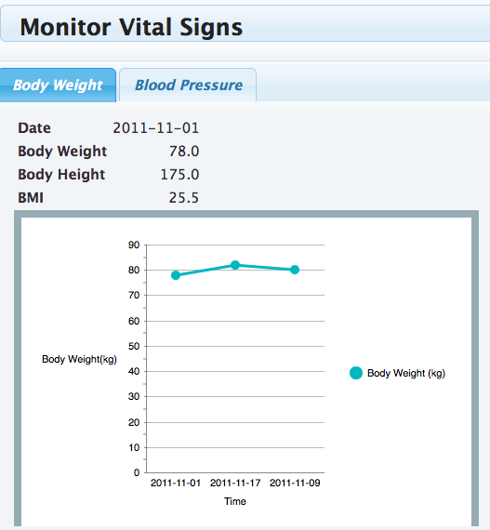
Figure 31 – Monitoring Body Weight

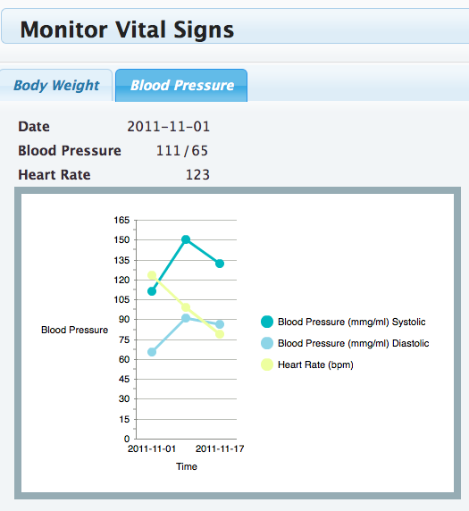
Figure 32 – Monitoring Blood pressure

Information and People

This menu item is dedicated to health information customized for CIED patients and comprises the following topics:
- Health Topics – includes information and education material and decision aids for CIED patients
- Community – allows patients to share information and experiences with other patients in similar situations by using social software tools
- Contacts – allows patients to insert contact data about medical persons such as the treating cardiologist or other persons.

Health Topics

The PEF provides light integration to a Content Management portal (CMS) where patient education materials can be created and managed for CIED patients. A detailed description about information and education material can be found in D521 “Patient Education Mechanisms for the PHR”. The main topics are listed in Error: Reference source not found:

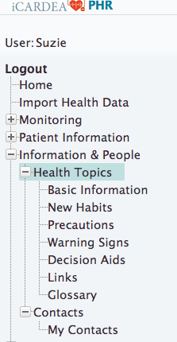
Figure 33 - Menu Options for Patient Education

An example for the sub menu items New Habits is presented in Figure 34.
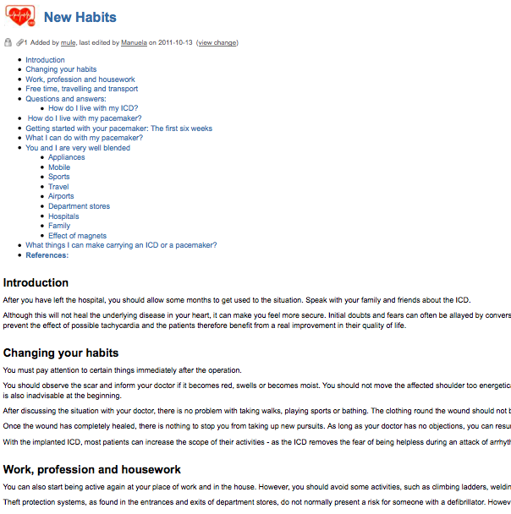
Figure 34 - Patient Education Example: New Habits

In the following Figure 35 is an example for a Decision aid for Telemonitoring Y/N. Commonly, decision aids describe different aspects of a decision situation such as advantages and disadvantages, risks and possible alternatives.

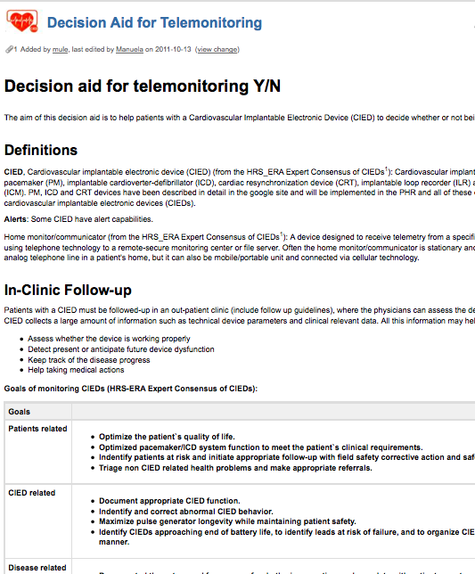
Figure 35 – Patient Education Example: Decision Aids

Community related topics

The community related topics include a list of community links, forums for patients and healthcare providers, blogs, and information discovery via community bookmarks and by browsing content by keyword.
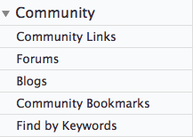
Figure 36 - Menu view: Community

Contacts

Contact information of a patient’s healthcare providers can be viewed and managed. The telephone or email might be sufficient to facilitate feedback to patients, however, chat and VoIP (Voice over IP) will depend on how the healthcare professional wishes to communication.

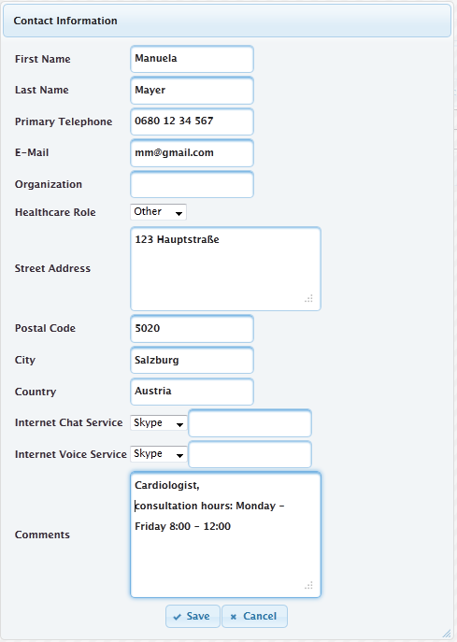
Figure 37 – Dialog view: Contacts

Privacy – Patient Consent Editor

The PHRS system includes functionalities to add, import or update health related information. Information saved is also sent to the hospital system; however, access to this health information by doctors and nurses requires permission from the patient. The patient uses the Consent Manager User Interface to authorize who may access their health information.

Privacy settings primarily affect the sharing of information with clinical systems via the PHRS interoperability services. A patient can manage privacy settings using the patient Consent Editor that is based on roles (e.g. physicians, nurses or family member) and can be granted for different categories of patient data such as medication.
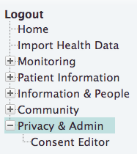
Figure 38 - Consent Editor for authorizing access to personal health information

Sharing of personal health information and interoperability

The patient consent editor and PHRS interoperability services regulate the sharing of personal health information with clinical systems. The PHRS creates a unique PHRS user health profile identifier that can be mapped to patient identifiers shared by clinical systems seeking access to PHRS patient data. When the patient saves or updates their PHR information, this information is persisted and then enriched and forwarded to the PHRS interoperability service repository.

The transformed data must conform to the standard coding understood by the interoperability services. The interoperability services use the IHE CM Profile and utilize standardized vocabularies, such as UMLS, LOINC, and SNOMED. The interoperability client software includes a SKOs based RDFS ontology (Simple Knowledge Organization) contains relevant standard vocabularies, simple labels, and organized with relevant query tags for use by User Interfaces. The PHR portal sends messages containing new or updated patient health information to the PHRS interoperability component and are persisted separately by that component.

The PEF framework includes tools to filter, enrich and transform PHRS patient data. Content enrichment steps include transforming any local codes to standard medical codes and filtering data that should not be shared, such as private notes or comments. The interoperability client is used to exchange information with the PHRS interoperability component.

Communication with patients sharing similar situations

Patients and healthcare professionals might share their experiences or provide other information to other patients by using social media for patients.

Forums for patients and health experts

Web-based forums (Figure 39) provide common features for users to create a threaded discussion of forum posts by using a web-form editor (Figure 41). Users have the ability to also freely tag their posts or to categorize their post using a simple vocabulary created by the users. Example categories might include: Anxiety, defibrillator technology, depression, medication, sport, using electronic devices. Users might then select a category or subscribe to particular categories to follow posts in the forum.

Threaded discussions contain one or more posts submitted by users. An overview of all threaded discussions are shown in (Figure 39 and Figure 42).

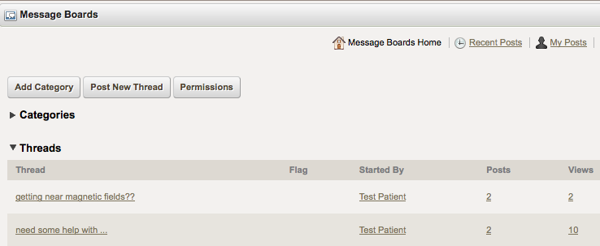
Figure 39 - Forum overview

Figure 40 shows a list of posts within a discussion thread that are created using editor shown in Figure 41.

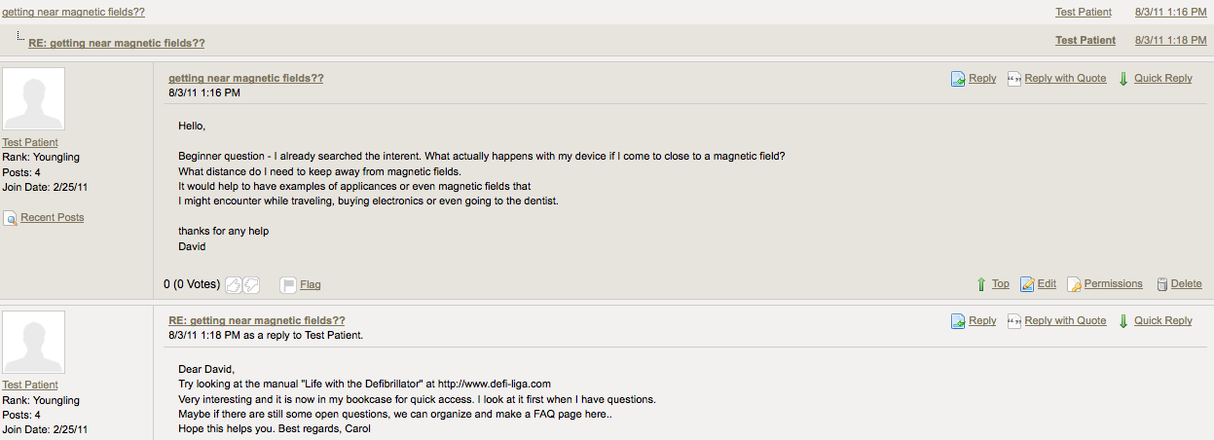
Figure 40 - Overview of forum “posts” from users in a threaded discussion

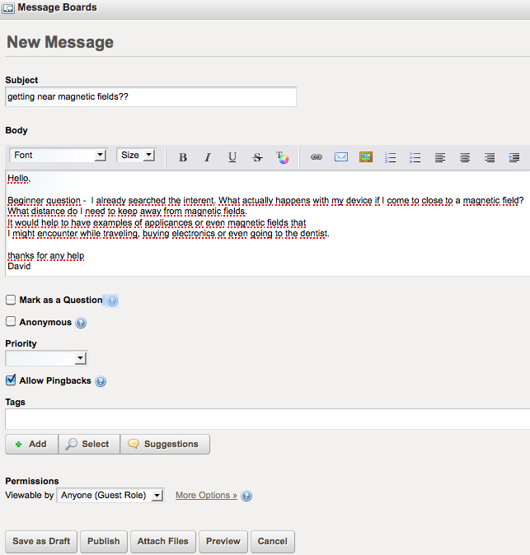
Figure 41 - Editor for creating a post in the forum

Categories can be used to help filter and organize posts from users (Figure 42). Categories can be added, such as: Anxiety, Medication, Using electronic devices, and Defibrillator technology.

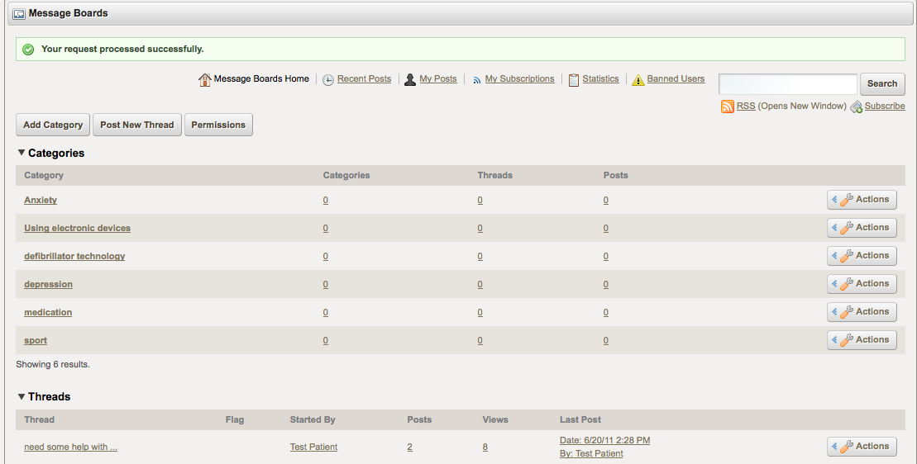
Figure 42 - Category subscription

Existing online patient forums can be accessed via the portal’s Wiki pages (Section 4.2) for patient communities and forums (section 4.2). An example for an existing forum is Defibrillator-Forum, a German forum for patients with a defibrillator. Defibrillator-Forum also includes information and contacts about self-help groups and related associations. These patient forums pages can be edited and assembled by users.

Wiki-based resources for patient communities and forums

Wiki-based content management in the PHR portal will enable authors to create web pages identifying resources for both online and offline communities supporting patients. These references and others might also be collected by recommendations from healthcare professionals that are shared their patients. This enables patients to contact and communicate with other patient communities and forums. With feedback from other forums as well as from the PHRS forum, the patient might bring more understanding and further questions to his/her physician, or the PHRS forum, for feedback. The portal content management supports the creation and updates to community pages by designated authors.

OpenID http://openid.net/,
SKOS Single Knowledge Organization http://www.w3.org/2009/08/skos-reference/skos.html
RDFS http://www.w3.org/TR/rdf-schema/
Defibrillator-Forum http://www.defi-forum.de/

