Return to iCARDEA User Guides
iCARDEA Learning Unit for Core Activities
“An Intelligent Platform for Personalized Remote Monitoring of the Cardiac Patients with Electronic Implant Devices”

Introduction 3
1.1 Overview 3
1.2 Definitions, acronyms and abbreviations 3
2 Activities for you, the Patient 3
3 PHR Portal Functionalities 5
3.1 Logging in to the Personal Health System (PHR) Portal 5
3.2 Navigation Menu Sidebar 6
3.3 Home 7
3.4 Import Electronic Health Information from the hospital 7
3.5 Patient Information 8
3.5.1 Health Observations 8
3.5.2 Action Plan 15
3.5.3 Health Profile 17
3.6 Monitoring 22
3.6.1 Health Reports 22
3.6.2 Monitoring Vital signs over time 23
3.7 Information and People 25
3.7.1 Health Topics 25
3.7.2 Community related topics 27
3.7.3 Contacts 28
3.8 Privacy – Patient Consent Editor 29

Introduction

Overview
The objective of this learning unit is to introduce the user to the core functionalities of the Person Health Record (PHR) system. The learning unit introduces the main concepts, the learning activities and

The PHR system includes core functionalities to add, import or update health-related observations, action plan, and health profile information. Information saved can also be sent to the hospital system; however, access to this health information by doctors and nurses requires permission from the patient. The patient uses the Consent Manager User Interface to authorize who may access their health information.

Definitions, acronyms and abbreviations

Abbreviation/Acronym | DEFINITION
HIS | Hospital information System
OpenID | A login identifier that can be used with many internet systems
PHR Portal | The PHR portal is where a user interacts with the PHR system (PHRS)
PHR or PHRS | Personal Health Record System
UI | User Interface
Table 1 List of Abbreviations and Acronyms

Activities for you, the Patient

The following activities, listed in Figure 1 - Personal Health Activities table, can be followed in the following order so that you can become familiar with the PHR application. The
No. | Activity to try in this learning unit | Activity reference in this document
1 | Login using an iCARDEA Login identifier, an OpenID URL or a demonstration login identifier | Login  3.1 Logging in to the Personal Health System (PHR) Portal
2 | Click on any plus-sign (+) to open a menu item. | 3.2 Navigation Menu Sidebar
3 | Select Home in the menu sidebar.  You can:  Update the patient implant device serial number  or  Update the Contact information | 3.3 Home Under the home page, the patient is first presented with their contact information and either a CIED web form or a web form (dashboard) to collecting latest health data.
4 | Set your CIED implant identifier | 3.3 Home
5 | Edit your contact information | 3.3 Home
 | Manage Health Information
6 | Add a new Blood Pressure Observation | 3.5.1.1 Recording Blood Pressure
7 | Add a new Body Weight Observation | 3.5.1.2 Recording Body Weight
8 | Add new Problem Observation  Update existing problem | 3.5.1.3 Reporting Health Problems (Symptoms)
9 | Add or update a medication | 3.5.1.4 Medication Compliance
 | Manage your Action Plan
10 | Add an Action | 3.5.2 Action Plan
11 | View the Calendar | 3.5.2 Action Plan
 | Manage your Profile Information
12 | Indicate your Risk Factors | 3.5.3.2 Indicating Risk Factors
13 | Indicate Activities of Daily Living | 3.5.3.3 Activities of Daily Living
14 | Indicate your physical activities | 3.5.3.4 Physical Activities
 | Monitor your health information
15 | Make health reports | 3.6.1 Health Reports
16 | Monitor charts for your vital signs | 3.6.2 Monitoring Vital signs over time (display charts)
 | Privacy
17 | View Consent Editor (separate Help manual) | 3.8 Privacy – Patient Consent Editor
 | Patient Education
18 | View Health topics | 3.7.1 Health Topics
19 | Select health topic and view the material
Figure 1 - Personal Health Activities table

PHR Portal Functionalities

This chapter describes the main functionalities of the PHR web portal; the portal is split into three high level sections that are accessible in the portal’s navigation menu:
- Patient Information – comprising the management of the patient’s health data
- Information and People – offering information and health material for CIED patients, access to CIED communities and contact to care takers
- Feedback mechanism
  - If you are connected to a hospital system via your CIED implant identifier, then your data is shared with hospital using the iCARDEA clinical software. Your privacy settings (Consent Manager) control authorized access to your health information.
  - If configured, you might use a web-based forum to discuss issues with other patients or healthcare professionals
- Privacy and Administration – offering services for organising the patient’s privacy

Logging in to the Personal Health System (PHR) Portal

Login with a user identifier created by the iCARDEA Identity provider as shown in Figure 2. Otherwise if you have another OpenID, choose “Other Open ID”. For testing and demonstration, please choose a local login name, Figure 3 that begins with ‘phr’ e.g. phrhans123. There is no password for this local login, please use sample health data. We will enable the use of Google mail account if the hospital security requirements allow this.

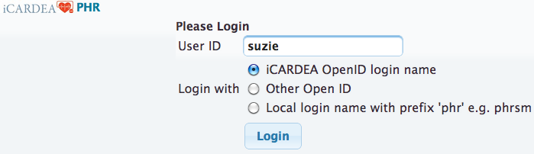
Figure 2 - Login with iCARDEA Identity Provider

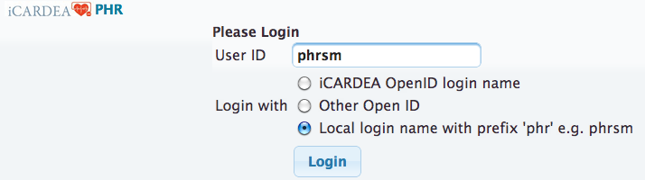
Figure 3 - Login by local user name ('phr' prefix), no password

Navigation Menu Sidebar

Health reports options. Patients must authorize who can access using the Consent Manager Editor.

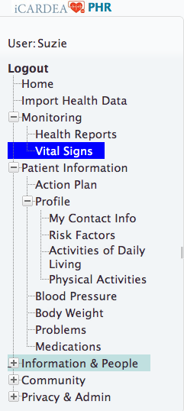
Figure 4 - Menu options for Patient information and monitoring your patient information

Home

Under the home page, the patient is first presented with their contact information and either a CIED web form or a web form (dashboard) to collecting latest health data.

The CIED form asks the patient for their CIED implant device serial number so that the PHR can connect to the Hospital health system and retrieve health data from the hospital health data. After submitting the CIED form, the patient identity is determined.

If the doctor role is detected, a simpler interface provided that only allows health reports to be viewed

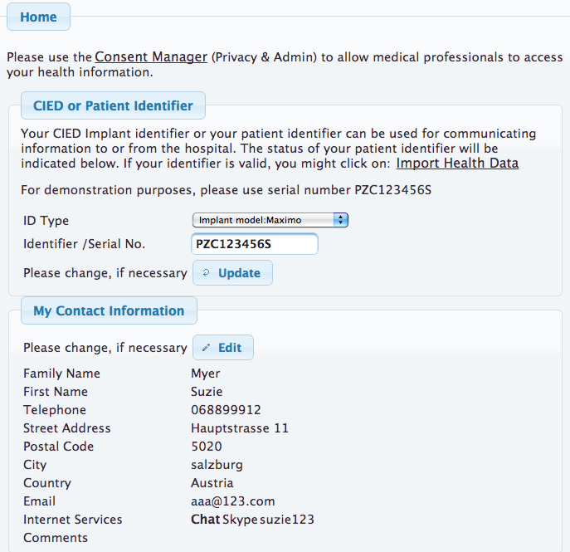
Figure 5 - Home with contact info and form for collecting the CIED Implant serial number

Import Electronic Health Information from the hospital

If you successfully connected to the hospital system, the import button will be displayed in the User Interface. If there is information to import, an overview list will be displayed. Press the import button and data will be imported. If, for example, medications were imported, please check the Patient information section to update your medications. It is important to report the status of the medications, whether you are taking the medication or not. Once you have saved the medication, it will be reported to the iCARDEA clinical related tools that might be used by doctors. Please not that there might be no doctor monitoring your information. Please contact your doctor directly.

Patient Information

Patient Information comprises an overview of the patient’s health data from different perspectives:
- Health observations – includes periodically or occasionally recorded patient data such as blood pressure or current symptoms or problems.
- Action Plan - includes an Action Plan allowing the patient to organize such observations of daily living or other health-related event such as an appointment with his/her cardiologist.
- Profile – describes the patient’s profile from different categories such as risk factors, sport activities and activities of daily living
- Monitoring – refers to an overview for vital signs (e.g. blood pressure, weight) as graphics.

The following sections presents examples of UIs for gathering patient information.

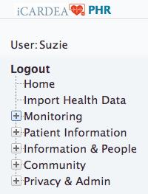
Figure 6 – Menu: Patient Information

Health Observations

The menu item “Health Observations” comprises patient data collected and recorded by the patients themselves. This includes in the current version of the PEF portal blood pressure, body weight, problems and medication compliance.

Recording Blood Pressure

Figure 7 shows the form for inserting blood pressure and heart rate on a daily basis. An overview form (see Figure 8) lists all recorded values. An historical overview of blood pressure and heart rate data can also be presented as a graphical view depicted in Figure 9.

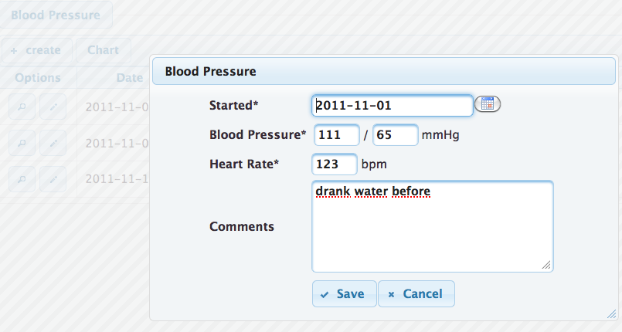
Figure 7 – Dialog view: Blood Pressure

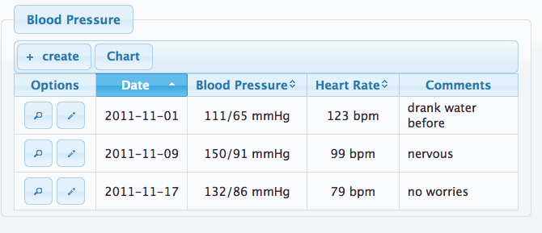
Figure 8 - List view: Blood Pressure

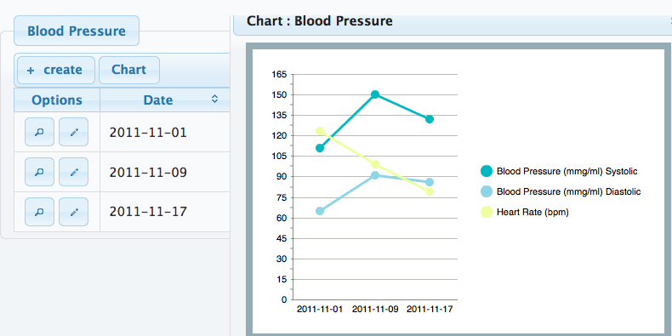
Figure 9 - Chart and List View: Blood Pressure

Recording Body Weight

Figure 10 shows the form for inserting body weight and height; the height is inserted from the known height and available here for modification. An overview form (see Figure 11) lists all recorded values and additionally calculates the body mass index (BMI) based on weight and height. An historical overview of body weight data can also be presented as a graphical view depicted in Figure 12.

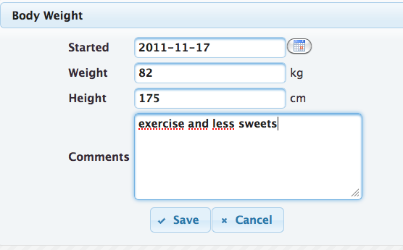
Figure 10 – Dialog view: Body Weight

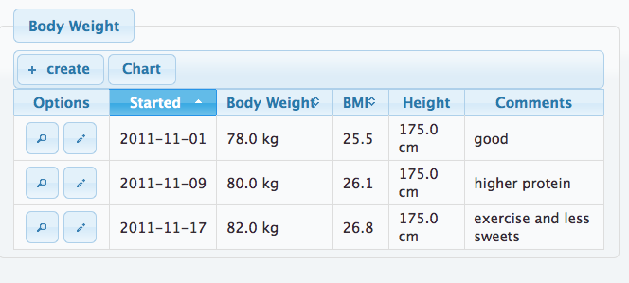
Figure 11 - List view: Body Weight

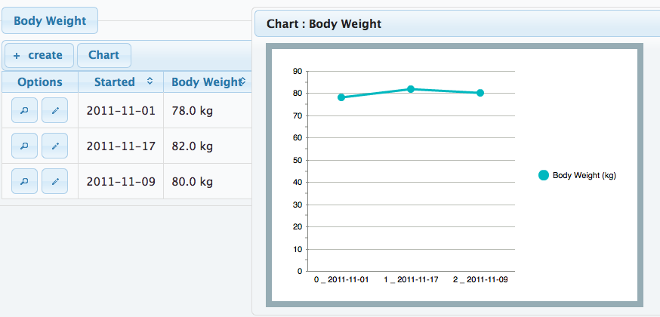
Figure 12 - Chart and List View: Body Weight

Reporting Health Problems (Symptoms)

The patients can provide a list of their health problems to share with their doctor either directly during consultation or by sharing via the interoperability services.

Figure 13 presents the dialog form for inserting an observed problem or symptom on a daily basis. The patient can indicate whether s/he has currently a problem or whether the problem disappeared. The list of problems comprises typical symptoms related to CIED patients (see Figure 14). An overview of recorded problems and their status are presented in a chronological order in Figure 15.

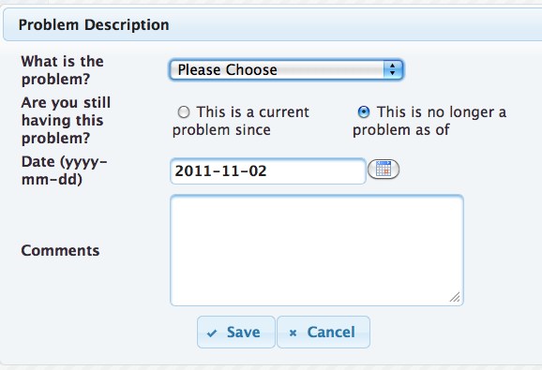
Figure 13 – Dialog view: Problems (Symptoms)

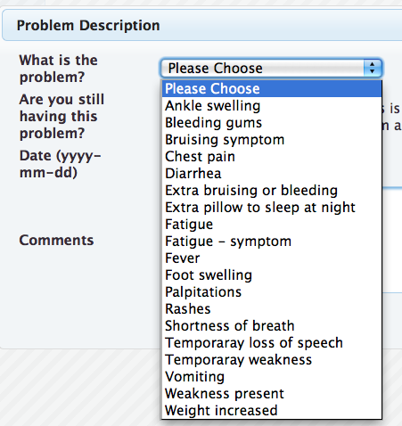
Figure 14 - Controlled vocabulary for UI and PHRS interoperability services

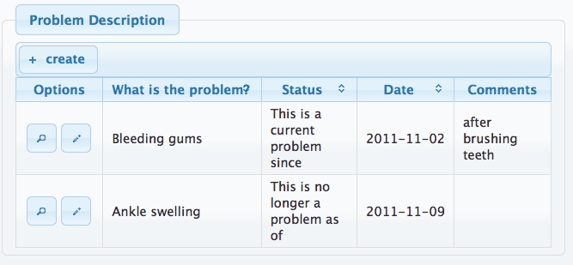
Figure 15 - List view: Health Problems (Symptoms)

Medication Compliance

The medications sections display three views: active and inactive medications and a history of updates to the medication items by the patient. The patient might manually enter their own medications, both prescription and over the counter. In iCARDEA medication data are also imported from the Hospital Information System (HIS). Figure 16 presents the dialog form for inserting a medication. The patient can indicate dosage, frequency and whether s/he is currently taking this medication or whether s/he stopped the intake. Figure 17 depicts an overview for medication compliance.

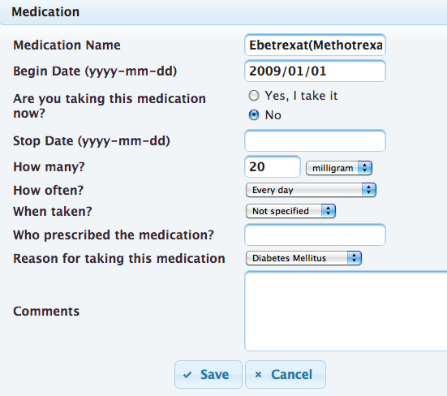
Figure 16 – Dialog view: Medications

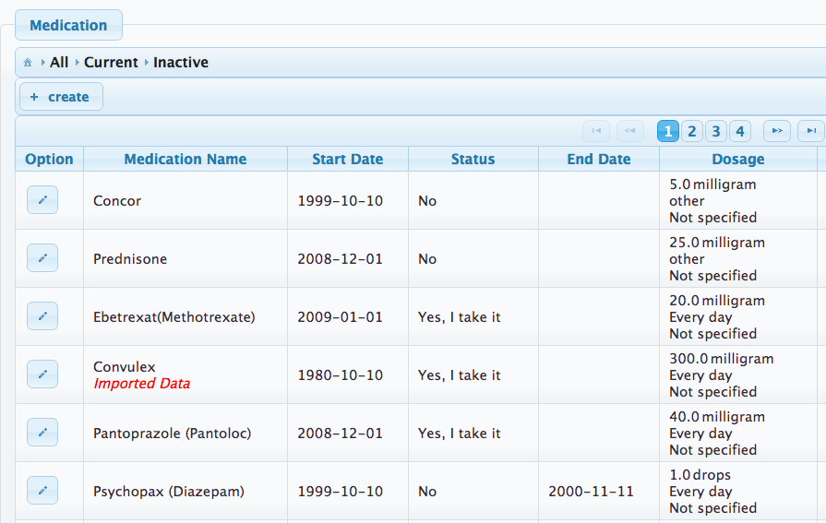
Figure 17 - List view: Medications. Note the medication imported from a Hospital

Action Plan

The action plan tool provides a simplified means of recording actions or diary entries and viewing these entries from either a table list or calendar view. Optimally, actions should be planned over a two-week period or diaries (physical activities, medication diary) might be recorded on a daily basis. Figure 18 depicts the dialog view for inserting or updating actions and Figure 19 presents the inserted actions as a table.

It is possible to enter new actions directly using the calendar view (see Figure 20), however, this feature is not activated by default because not all users are accustom to this interacting with electronic calendars.

Basically, the information about actions in the Action Plan is not shared with other persons (such as physicians). But the patient can grant access and e.g. share the status of physical actions as feedback to clinicians via the PHRS interoperability services.
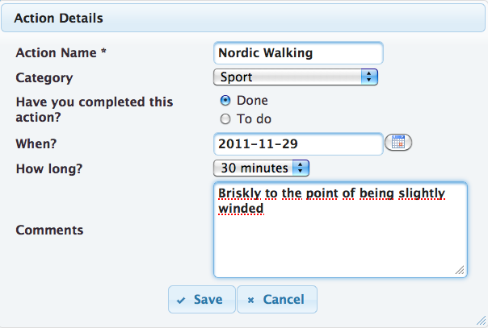
Figure 18 – Dialog view: Actions

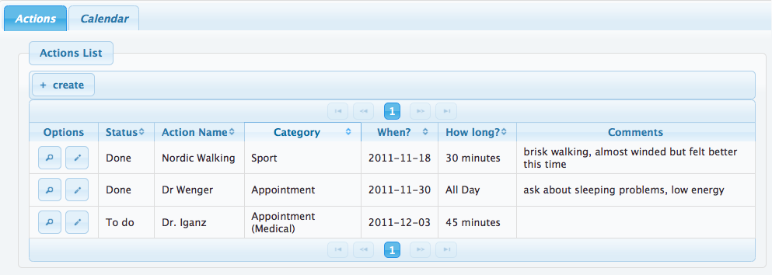
Figure 19 - List view: Actions

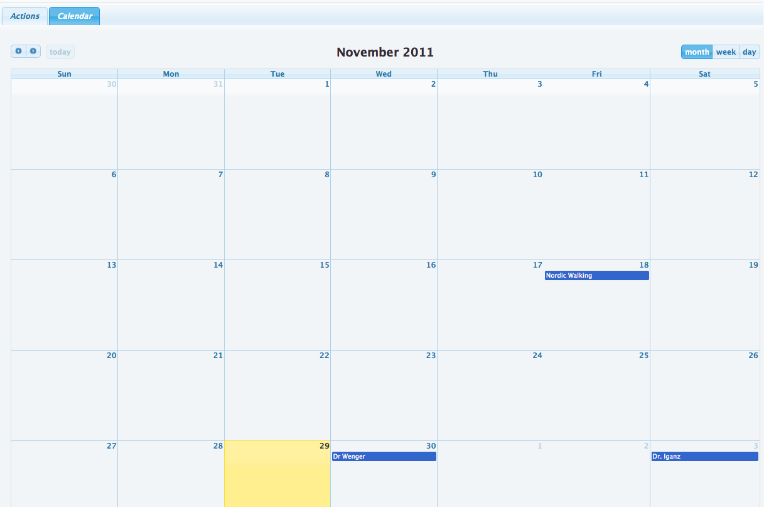
Figure 20 – Calendar view: Actions

Health Profile

Maintaining Contact Information

This menu item allows the patient to insert and update his/her contact information. Figure 21 presents the dialog form for managing the contact data.
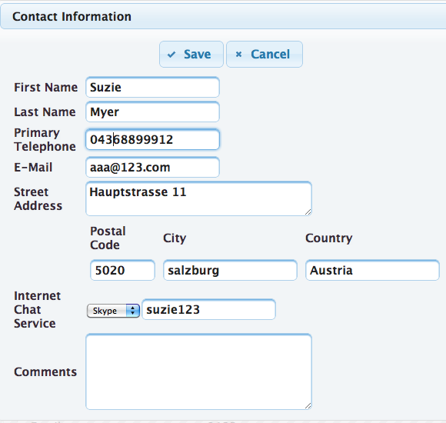
Figure 21 – Dialog view: Contact Information

Indicating Risk Factors

The patient can provide basic information about their risk factors. This might be additional information for physicians. Important risk factors related to CIED patients are cholesterol, smoking, diabetes and hypertension (see Figure 22). Figure 23 and Figure 24 presents examples how to describe the profiles for smoking and for diabetes.
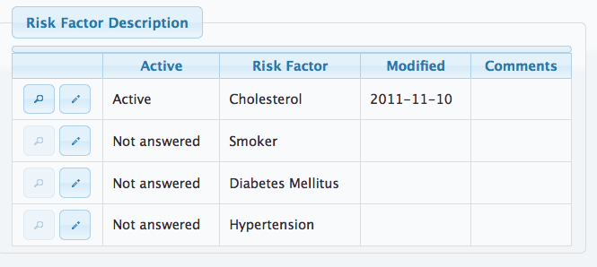
Figure 22 - List view: Risk Factors

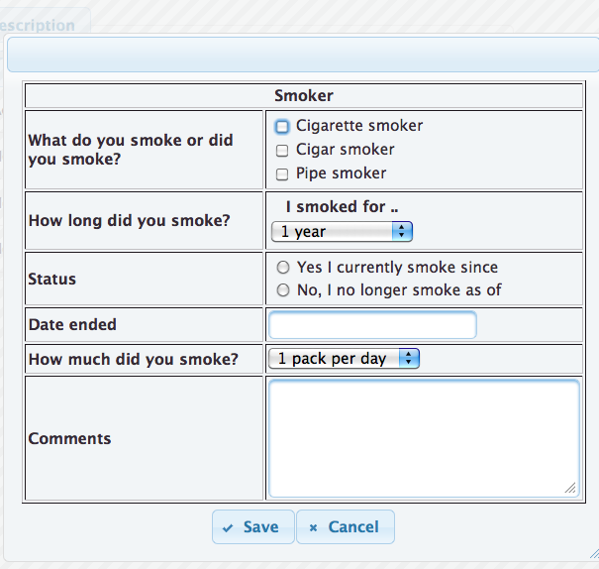

Figure 23 – Dialog view: Risk Factors – Smoking

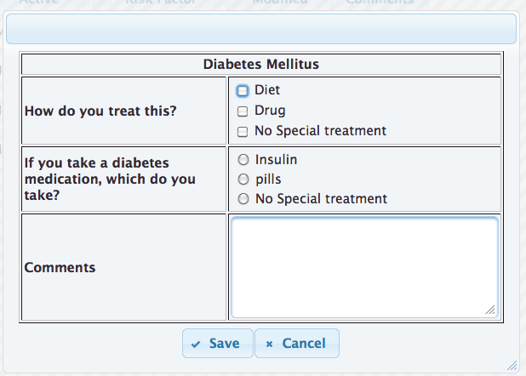
Figure 24 – Dialog view: Risk Factors - Diabetes

Activities of Daily Living

Activities of Daily Living concern the patient profile and deliver insight how a patient is able managing his/her daily routine. This menu item provides a list of activities patient can either do or requires assistance (see Figure 25). Figure 26 presents the dialog view for climbing stairs and represents one example for indicating such activities.

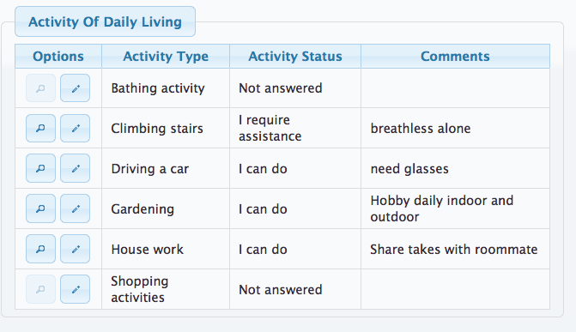
Figure 25 - List view: Activities of Daily Living

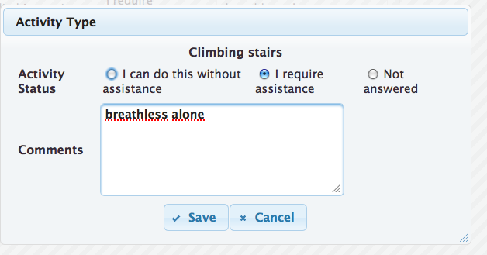
Figure 26 – Dialog view: Activities of Daily Living, climbing stairs

Physical Activities

Physical activity data concerns the patient profile, although these are not actions for organizing in the action plan. These are more similar to Activities of Daily Living as another means to access what physical activities, such as sports or exercise, the patient can do or has done. Figure 27 presents an example for indicating jogging as a physical activity that a patient performs on a regular basis several times per week. The overview form summarizes all current physical activities of the patient (see Figure 28).

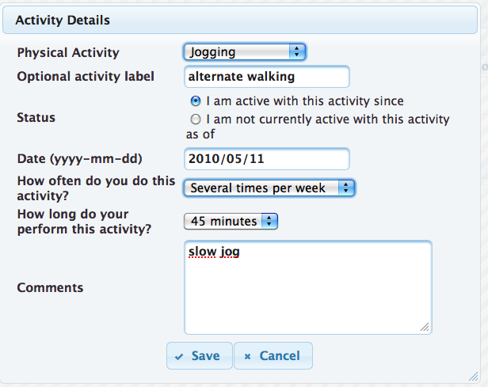
Figure 27 – Dialog view: Physical Activities

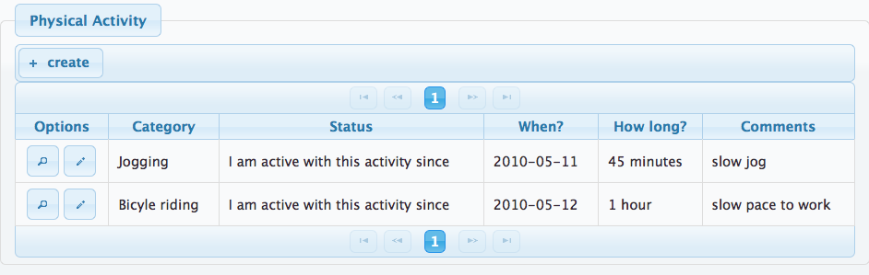
Figure 28 - List view: Physical Activities

Monitoring

Health Reports

Health reports can be displayed from a variety of Observations of Daily Living (blood pressure, heart rate, body weight, medications, problems), profile information (contact info, activities of daily living)
Health reports can be displayed from a variety of Observations of Daily Living or even contact information. The following figures show a Body weight history report, Figure 29, and a Medications report,.

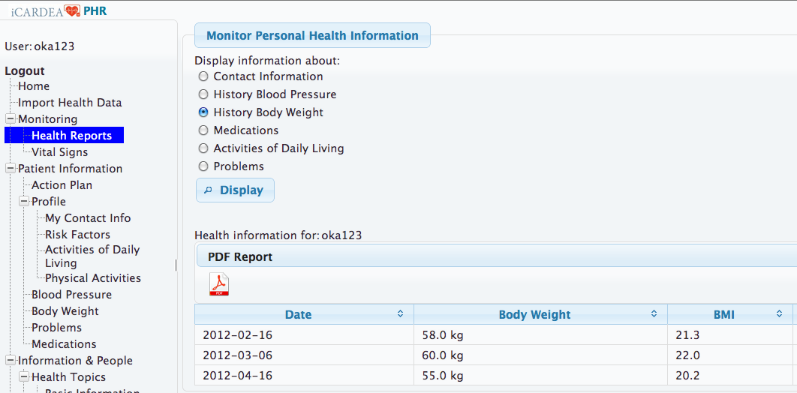
Figure 29 - Personal Health Reports - Body Weight history

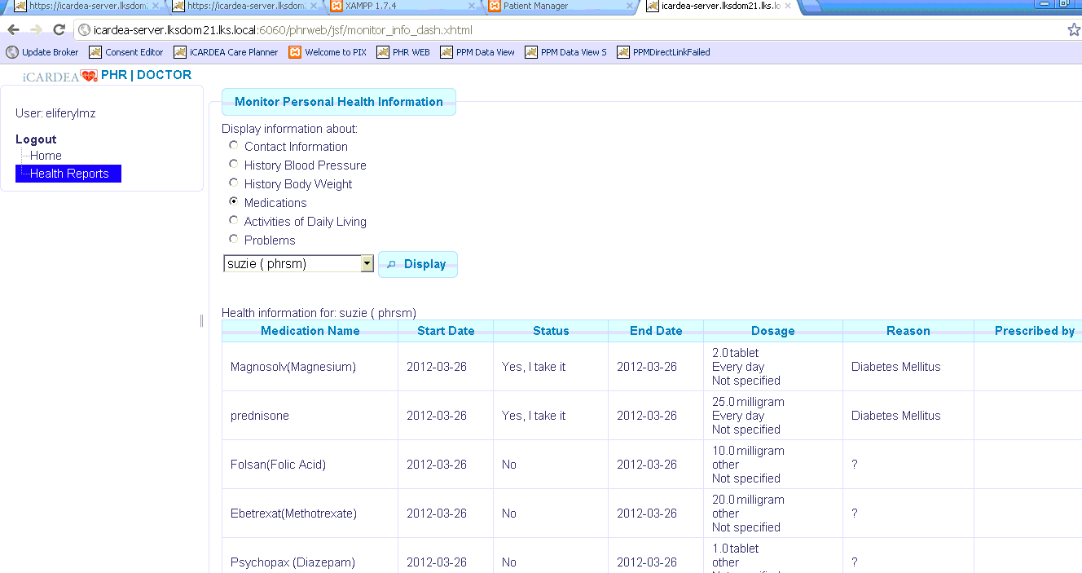
Figure 30- Personal Health Reports - Medication Report

Monitoring Vital signs over time

Monitoring vital signs provides an overview of current health information and charts of historical information. Additional information and charts can be added as needed. The following are examples for date (body weight and blood pressure) that the patient might wish to follow and perhaps share with their physician:

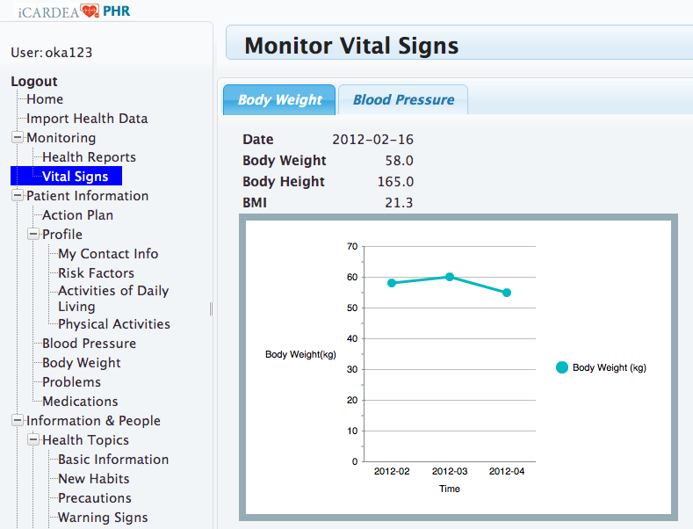
Figure 31 - Monitoring Body Weight chart

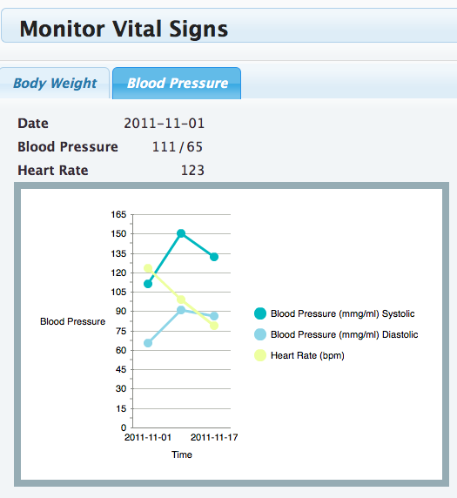
Figure 32 – Monitoring Blood pressure chart

Information and People

This menu item is dedicated to health information customized for CIED patients and comprises the following topics:
- Health Topics – includes information and education material and decision aids for CIED patients
- Community – allows patients to share information and experiences with other patients in similar situations by using social software tools
- Contacts – allows patients to insert contact data about medical persons such as the treating cardiologist or other persons.

Health Topics

The PEF provides light integration to a Content Management portal (CMS) where patient education materials can be created and managed for CIED patients. A detailed description about information and education material can be found in D521 “Patient Education Mechanisms for the PHR”. The main topics are listed in Error: Reference source not found:

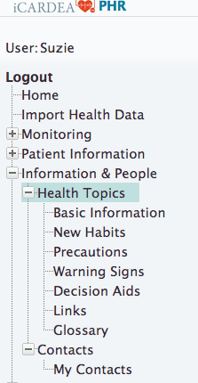
Figure 33 - Menu Options for Patient Education

An example for the sub menu items New Habits is presented in Figure 34.
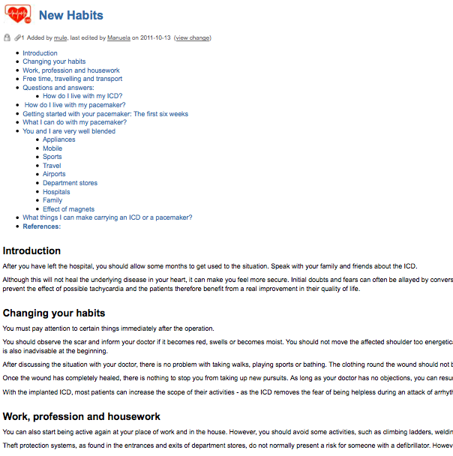
Figure 34 - Patient Education Example: New Habits

In the following Figure 35 is an example for a Decision aid for Telemonitoring Y/N. Commonly, decision aids describe different aspects of a decision situation such as advantages and disadvantages, risks and possible alternatives.

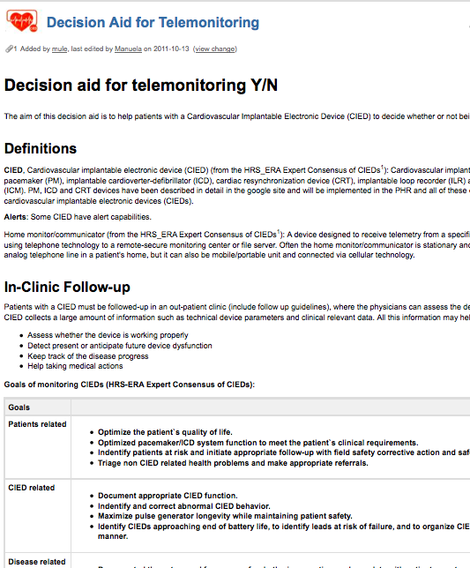
Figure 35 – Patient Education Example: Decision Aids

Community related topics

The community related topics include a list of community links, forums for patients and healthcare providers, blogs, and information discovery via community bookmarks and by browsing content by keyword.
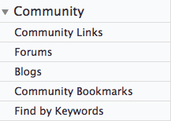
Figure 36 - Menu view: Community

Contacts

Contact information of a patient’s healthcare providers can be viewed and managed. The telephone or email might be sufficient to facilitate feedback to patients, however, chat and VoIP (Voice over IP) will depend on how the healthcare professional wishes to communication.

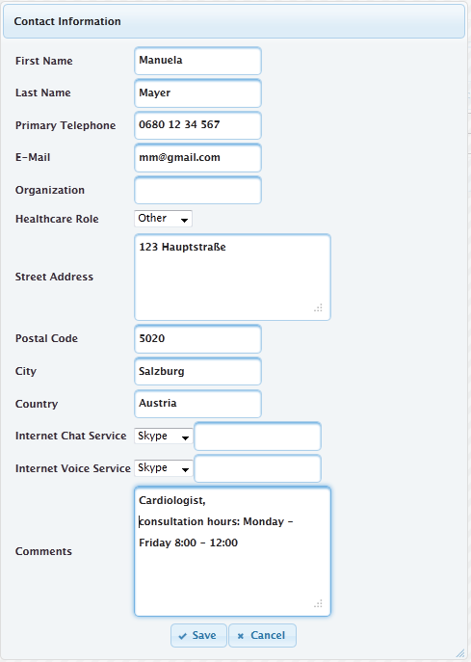
Figure 37 – Dialog view: Contact Information

Privacy – Patient Consent Editor

The PHR system includes functionalities to add, import or update health related information. Information saved is also sent to the hospital system; however, access to this health information by doctors and nurses requires permission from the patient. The patient uses the Consent Manager User Interface to authorize who may access their health information.

Privacy settings primarily affect the sharing of information with clinical systems via the PHRS interoperability services. A patient can manage privacy settings using the patient Consent Editor that is based on roles (e.g. physicians, nurses or family member) and can be granted for different categories of patient data such as medication.

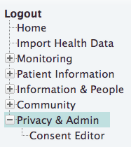
Figure 38 - Consent Editor for authorizing access to personal health information

OpenID http://openid.net/,

