**Read multiple json files into a working directory for further converting into a dataset.**

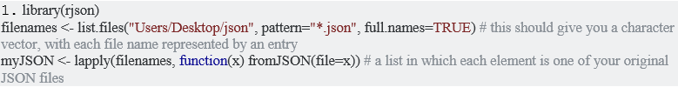

**Parse the following JSON into a data frame**

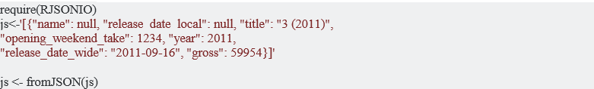

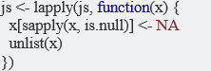



**Write a script for variable binning using R.**

# example of 1-d use

x <- rnorm(1000)

xb <- binning(x)

xb <- binning(x, breaks=seq(-4,4,by=0.5))

# example of 2-d use

x <- rnorm(1000)

y <- 2*x + 0.5*rnorm(1000)

x <- cbind(x, y)

xb<- binning(x, nbins=12)