This dashboard is available at

<https://app.powerbi.com/groups/me/dashboards/400eaf30-e47c-4caf-b9e6-093db4ba225b>

From our Sankey Chart, we find that two developers only post on Thursdays.

These developers, Dave and Murari, should be reviewed, either they work only on Thursdays or they are saving their commits too long and bringing in unnecessary risk.

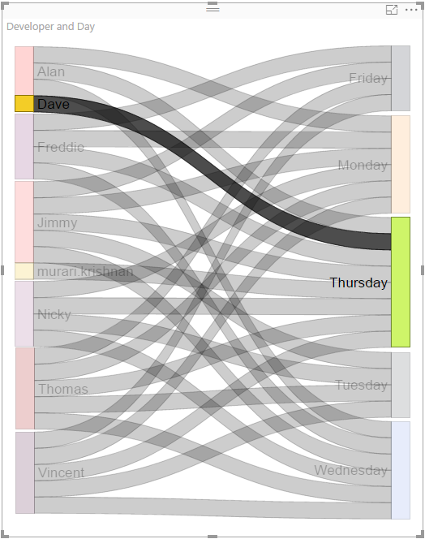 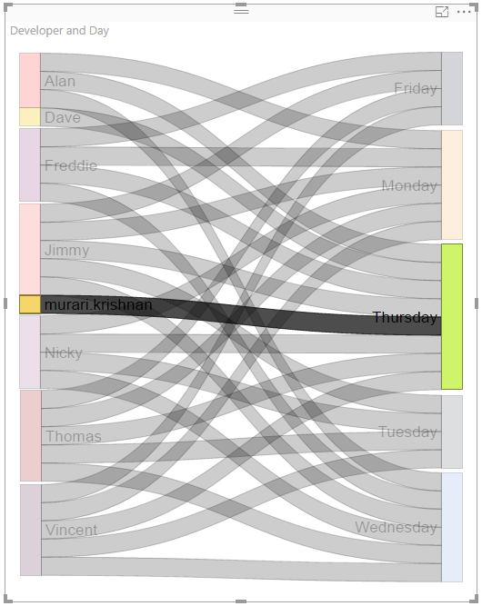

Possibly due to the developers above, Thursday is the most common day for committing updates, as can be seen in the barchart.

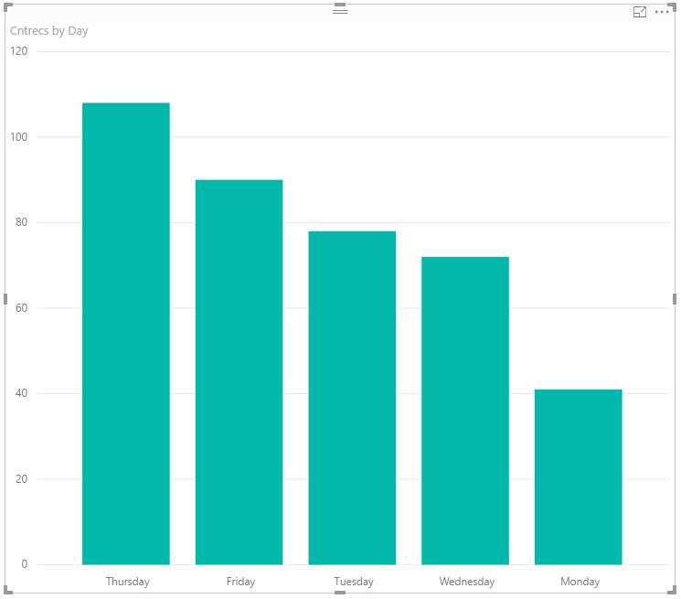

It would generally be expected that most commits would be done towards the end of the day, and this is supported by the graphic showing the Morning / Afternoon / Evening submissions.

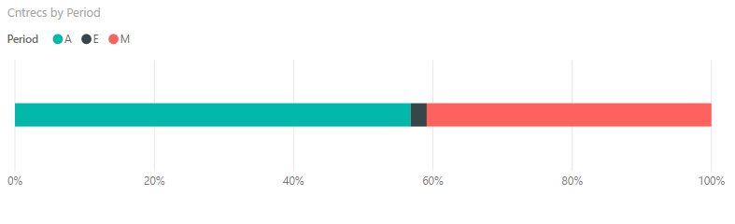

It may be of concern, however, that the morning commits are above 40%.