Pumpkin Kathy: 🡪 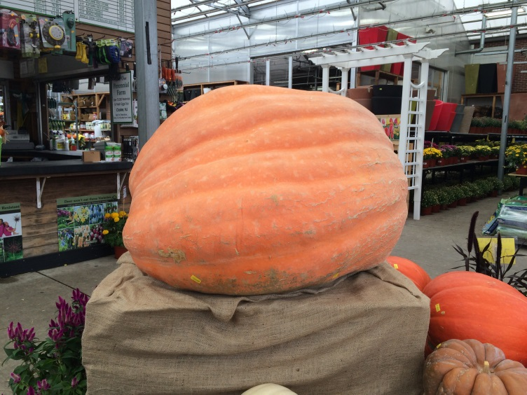 by Elena Butuzova, Pictures by Elena Butuzova

This quaint little store area in New Jersey, Fort Lee named Garden Center sits on the side of a highway this year holds an 889 Lb. pumpkin named Kathy. This year she has been chosen as the attraction for the store, Garden Center. A new pumpkin comes every year as a showcase and also as a product to buy at $2000.00. Garden Center holds different plants from flowers, little pumpkins and haystacks for the fall season, as well as little Christmas trees for the upcoming winter. I met a girl there named Kathrin Panchenko, a teenaged girl from Fort Lee High school and interviewed her about her experience and thoughts about the attraction, Kathy.

Interview

Elena (interviewer)- Why do they bring this pumpkin every year?

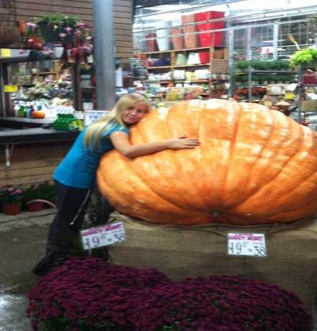Kathrin- Perennials, a farm in Closter, New Jersey every year finds the biggest pumpkin and choses the main winner as its candidate to bring to Garden Center, this is just an attraction for the store, as a way for people to come in and take pictures with the very large pumpkin. Picture-2012

E-How long have you been visiting this attraction?

K- For the last four years.

*2013 (down) 2012 (up)*

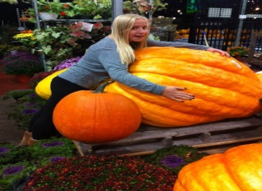

E- Is there a different pumpkin each year?

K- Yes, Last year there was a nameless pumpkin which I named Pumpkin Paul who was at 1400 lb.

E-Why have you been coming and seeing the pumpkins each year?

k- Well I live right by the store and every time I see the signs showing that the “big pumpkin” is back, it attracts me to go and see it once again. I’ve taken pictures of these encounters for the last four years *(Pictures in 1st page*)

E-what were your initial thoughts when first seeing the pumpkin four years ago?

k- I was like damn…that’s a big pumpkin.

E-how does it make you feel once you see these signs if you’re so attracted to go back every year?

k- Its brings me into the fall spirit and I always make my friends excited to take the pictures of me with the pumpkin.

e- any type of message you want to say to the New Yorkers in A.Philp.Randolph High School for the upcoming Halloween from the new jersey-ians in Fort Lee High School?

k-if you want to buy a big a\*\* (ass) pumpkin to throw on people this year, Garden Center will always have Kathy available! Have a happy Halloween everyone!

PICTURES ON NEXT PAGE

*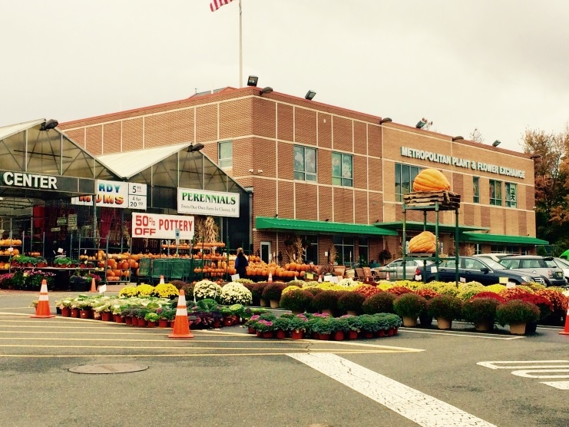 (Entrance) 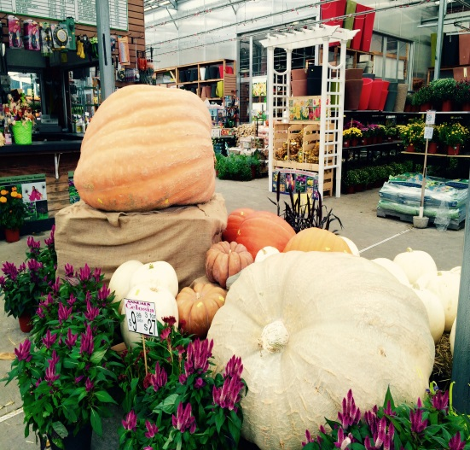(Pumpkin Kathy)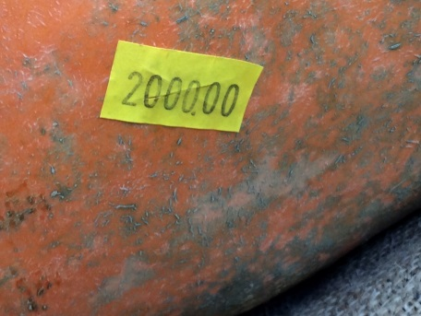 price tag)*

*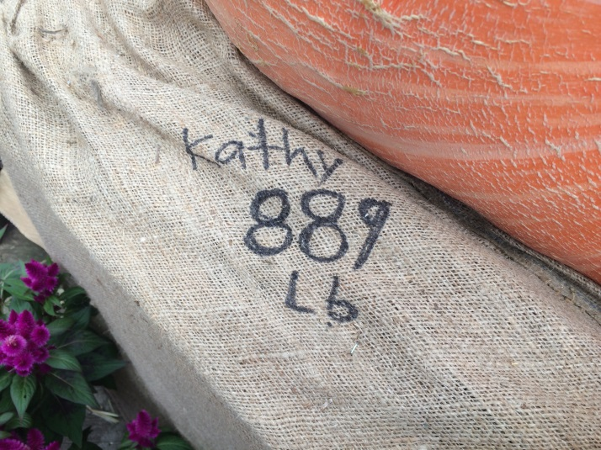 Name and pounds*

*Next Page Down*

*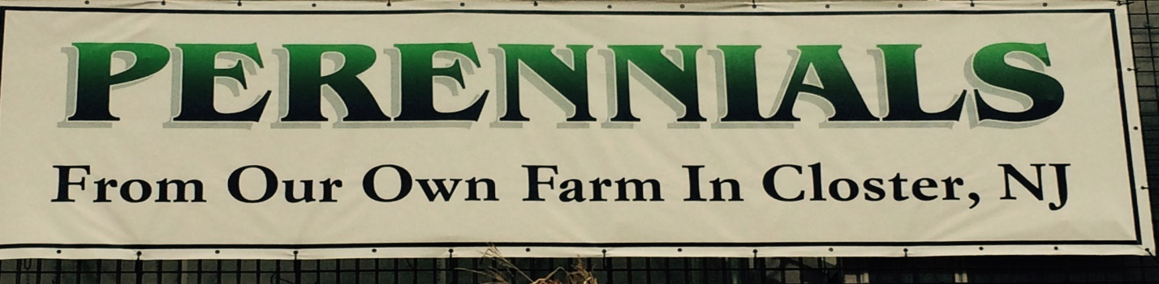*

*Name of farm*

*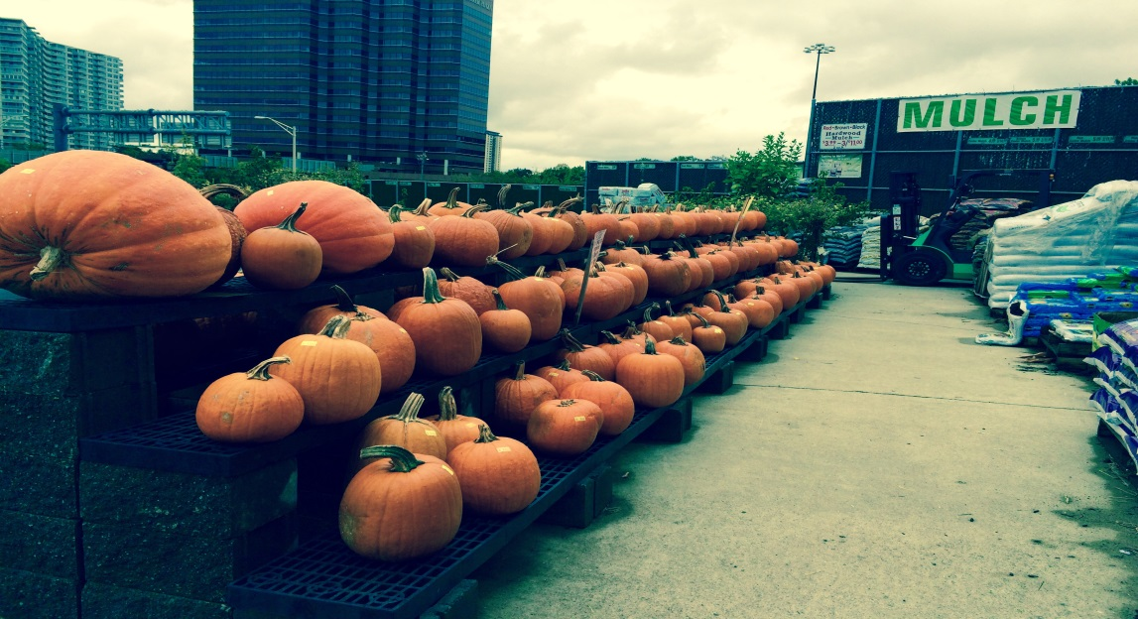 More pumpkins*

*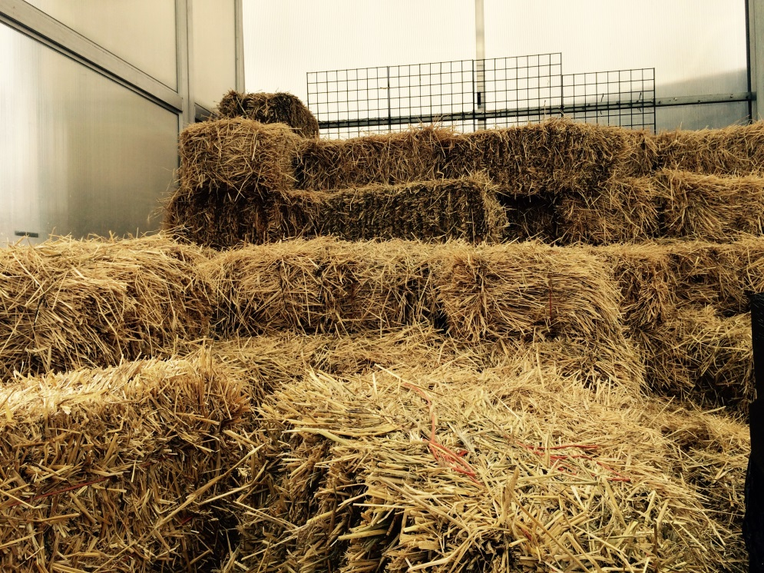haystacks*

*NEXT PAGE*

*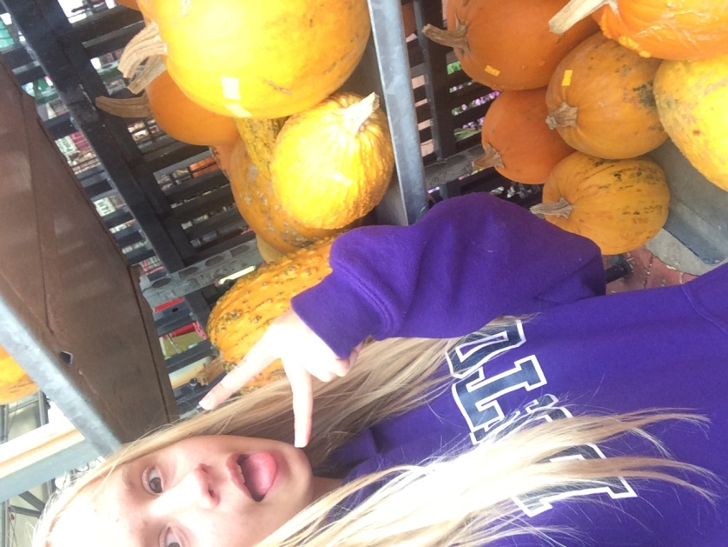 PICTURE TAKEN 2014: KATHIN PANCHENKO AGE-15*