Fernglen Native Plant Gardens
Winter Newsletter 2014

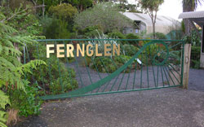

Contents:

- Fernglen-Curator report
- New rare additions to our plant collection
- Book Review “Handbook of the New Zealand Flora” by Joseph Hooker
- A look at Native Lizards
- Rediscovering Celmisia major at Anawhata
- 2014 “A mast event” for South Island Beech Trees
- Why our native flowers are predominantly white

- Winter at Fernglen – Curator report June 2014
“Education for Sustainability” coordinates the successful “Learning through Experience” programmes at the Botanic Gardens, Ambury Park, Arataki, and Long Bay. A trial outreach program at Fernglen has seen about 10 classes held at Fernglen over the past 6 weeks. The hope is that these will resume in spring. Fernglen is endeavouring improve accessibility for EfS with improved areas designated for groups to congregate.

Subsequent to attending the Kaipatiki restoration network meeting I was impressed with the other reserve group’s use of voluntary help in planting, removing weed species and pest control. Following this example, Fernglen would like to establish a local action group to deal with animal pests in this area. We will arrange to use council provided bait stations and bait to deal with troublesome rodents and possums.

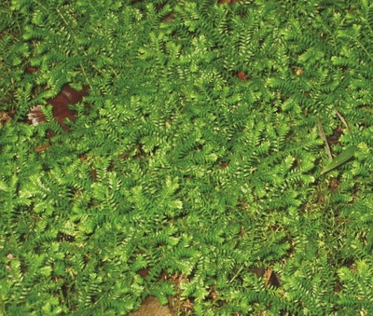
Fernglen was spared any major damage in the recent storm. The milder temperatures however, encourage spring like weed growth. Heterosporous club moss (Selaginella) is particularly troublesome. It hides out of sight spreading and reproducing quickly. Friends of Fernglen visiting the gardens are encouraged to eliminate on sight!

African club moss (Selaginella kraussiana) (Photo: DOC)

The council commissioned an appraisal of Muriel’s house. As the house is not in original condition and lacks architectural integrity, it does not warrant listed building protection as a Historic Place. The report notes Muriel as a key New Zealand botanist, and the Fisher family as significant early Birkenhead settlers and that any plans for the site should acknowledge this.

Fernglen Gardens had a visit from some of the councillors of the Kaipatiki Board and council parks officers. This preceded a meeting with the Kaipatiki Board to discuss future planning and the challenges Fernglen faces. The three committee member attending the meeting felt it was both encouraging and constructive. Parks adviser, Adi James is now in the process of applying for funding to commission a project to develop a plan particularly for the area around the house, improve access and facilities for public use.

- New Rare Additions to our Plant Collection at Fernglen

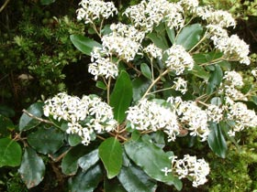
Olearia townsonii
This rare Olearia has a limited distribution. It naturally grows on cliffs and scrub land in the Coromandel ranges, but extends south in isolated locations as far as Wanganui. The common name is Coromandel tree daisy. It grows up to five metres it and is best described as a large shrub or small tree. Typically it flowers with clusters of small white flowers. We hope that our specimen will thrive on Ben’s Ridge. Olearia can be difficult to cultivate. They have a preference for free draining soils and will die quickly if the roots become too wet.
Olearia townsonii Many thanks to Photographer the late John Dodson-Smith NZNPCN

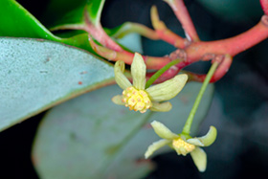
Pseudowintera insperata
This plant was only recently discovered on the northern side of the Whangarei Harbour at Mt Manaia and Bream Head. The total population is estimated at around 50 plants. It is therefore labelled a “threatened species” with the status of “nationally critical”. A large shrub or small tree it grows to up to seven metres. The common name is Northland horopito.The Pseudowintera species include: Pseudowintera axillaris, Pseudowintera colorata, and the lesser known Pseudowintera traversii found in the mountain forest of the South Island .
Pseudowintera insperata Many thanks to Photographer Andrew Townsend NZ NPCN

Davallia tasmanii ( subsp tasmanii)
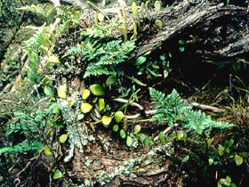
Not the first of this rare species at Fernglen, however, this worthy addition has been grown by a friend over time, and is the size of a full horticultural tray. There are around 40 Davallia species, sometimes known as Rabbit Foot Fern. They are found in Fiji,South Africa, and East Asia. Critically endangered D.tasmanii subsp cristata is found in Puketi Forest. D. tasmanii (subsp tasmanii) is from the Three Kings Islands and was discovered by eminent botanist TF Cheeseman in 1887. Successfully cultivated, this attractive fern has creeping rhizomes which can create a clump a metre across. Slow growing, they prefer open or dappled light and free draining soil.
Davallia tasmanii many thanks to photographer Anthony Wright NZNPCN

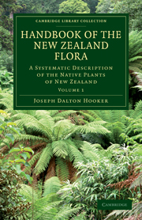
- Book Review: Handbook of the New Zealand Flora – A systematic description of the native plants of New Zealand by Joseph Dalton Hooker

This digital reprint by Cambridge University press, from a book first published in 1864 , shows a commitment to re-issuing out of print titles that have considerable importance to researchers, professionals and enthusiastic amateurs.

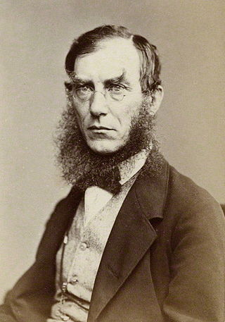
The author Joseph Dalton Hooker came from a family of eminent scientists. His paternal grandfather had a considerable collection of rare plants and maternal grandfather, Dawson Turner, published works on the mosses and ferns of England and Ireland. His father, William Hooker, was professor of Botany at Glasgow University and later director of Kew gardens (a post later held by Joseph in 1865). Hooker completed a medical degree and was appointed naturalist and assistant surgeon for the 1839 Ross Antarctic expedition on the HMS Erebus. Similar to his best friend, Charles Darwin’s earlier Beagle trip, Hooker botanised throughout the voyage, including in the Falkland Islands and Tasmania. Wintering for eleven weeks in New Zealand and guided by William Colenso, he collected over 700 species in Northland botanical expeditions. Upon return to England he systematically collated his samples. With an additional 306 species from Jardin des Plantes, donated by French botanist Roaul, and regular contributions from Colenso in New Zealand, there was sufficient material for two volumes of New Zealand flora. He listed plants from New Zealand, the Chathams, Auckland, Campbell, and Kermadec Islands. This first major study of New Zealand flora remained the foremost authority on the subject for over 50 years. Hooker dedicated his New Zealand handbook to Governor George Grey, commending his long and distinguished career in the colonies, and exhorting that he “has been the liberal encourager of every scientific undertaking”.
There have been numerous changes in the taxonomy of plants since Hooker published in 1864, yet the handbook remains a remarkable publication. The quantity and quality of information concerning individual plants is incredible and makes for fascinating reading. In the preface to this book Hooker acknowledged the contribution of fellow botanists Banks, Solander, Fraser, Cunningham, Bidwell and Dieffenbach. All contemporary botanists in New Zealand acknowledge the contribution of Joseph Hooker to their pursuit of knowledge.
Sir Joseph Dalton Hooker
Cambridge University Press should be commended for reproducing this gem.

- A look at our Native Lizards

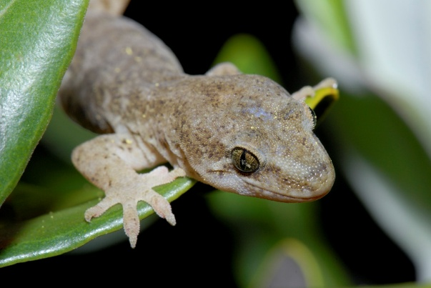
There appears to be a recent increase in the lizard population in backyards and at the beach. New Zealand has approximately 40 indigenous lizards comprised of geckos and skinks. As with many of New Zealand’s natural phenomena New Zealand geckos are quite distinctive. Overseas geckos lay eggs whilst our geckos and many skinks are live born.

Geckos and skinks have the following shared characteristics:
Hoplodactylus maculates common gecko
Photo: © Simon Fordham/Naturepix

-Their camouflaged skin makes them indistinguishable even in small zoo enclosure
-The tail that breaks off in an attack then grows back
-They make a range of sounds whereas most reptiles are silent
-Although they prefer insects, they also eat berries and nectar and help propagate native plants

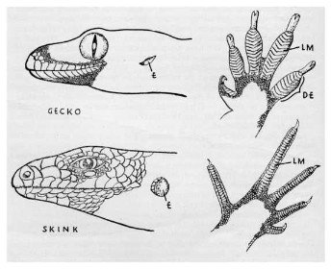
Fundamental differences between geckos and skinks:

-Gecko’s baggy skin so it looks dull and bumpy whereas skinks have tight skin overlaid like fish scales
-Gecko’s have adapted toes for climbing smooth surfaces. Skinks have exceptionally thin toes
-Gecko eyes have vertical slit pupils whereas skinks have round pupils
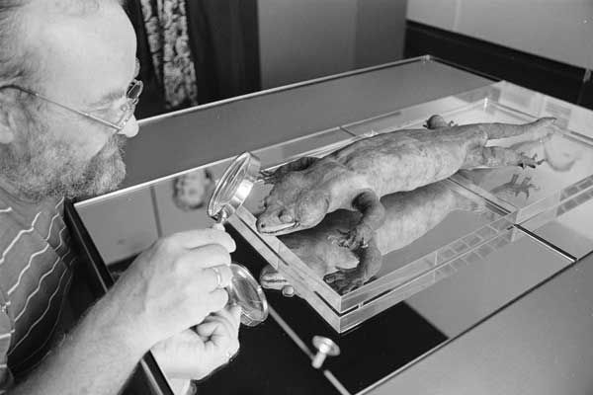
-
http://nzetc.victoria.ac.nz/tm/scholarly/tei-Bio06Tuat02-t1-body-d2.html

Geckos usually shed skin in one piece but skinks shed theirs in small pieces.

New Zealand was once home to the largest gecko the extinct Hoplodactylus delcourti Which grew to half a metre long. The only known taxidermy specimen was unearthed in a French museum in 1984 and reported to have been there for 150 years.
Hoplodactylus delcourti Ray Pigney / Dominion Post / Alexander Turnbul Library, Wellington, New Zealand, ID: EP / 1990 / 0968 / 4

- Rediscovering Celmisia major at Anawhata

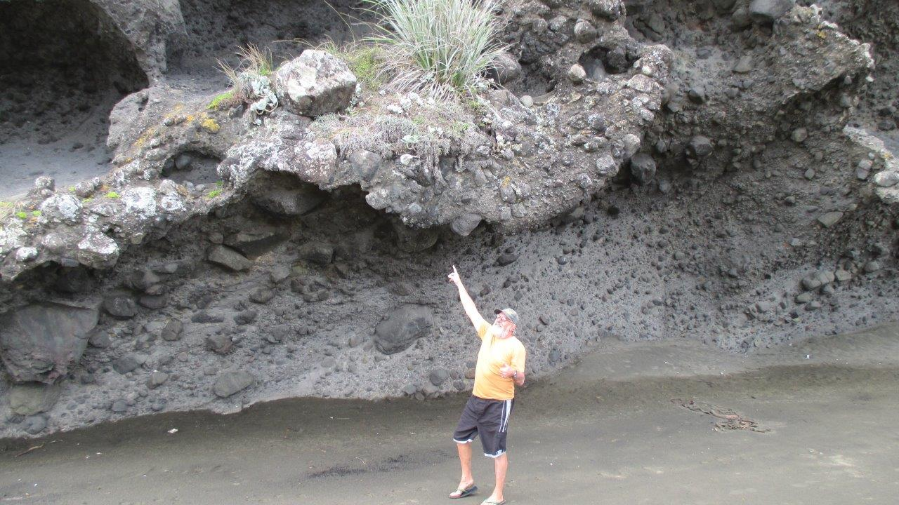
Once comparatively easy to locate growing on large rocks from Anawhata to Whatipu .This is the first population I have located in the past 9 months. It is a mystery why this Celmisia spp or “mountain daisy” made the evolutionary decision to settle on the west coast beaches. I hope this is not an indication that climate change is endangering this species- or that my plant hunting skills are diminishing. There was evidence of flowering, but the seeds had long dispersed. I will return to this site in March/ April next year for the normal seed ripening time to see if I can harvest viable seed. Note the Celmisia major is not to be confused with Celmisia adamsii that grows on rocky outcrops of the Coromandel Peninsula and Whangarei Heads.
Nev and Celmisia major at Anawhata 2014

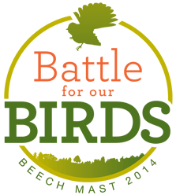
- 2014 A mast event for South Island Beech Trees

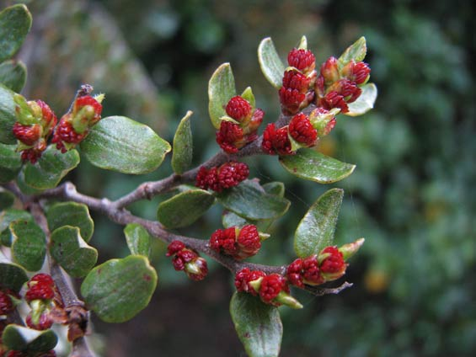
About every 10-20 years the South Island beech trees have a bumper harvest of seed that drop in autumn. This is known as a mast event. Such events are critical to the spring germination of beech forests. Unfortunately, the downside is a simultaneous rise in the rodent population feeding off the beech seeds, and in turn the stoats that feed on rodents. As the rat population declines vast areas of the South island have a stoat population explosion. Stoats then feed off native birds such as yellowheads, kiwi, whio, kea, kaka, and rock wren. The Department of Conservation predicted a mast event and subsequently ramped up pest control measures in January.

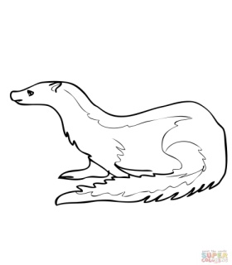

Beech flowering DOC 2014
- Why are our native flowers predominantly white?

Among the un-initiated, the complaint that New Zealand native bush is an “unbroken cloak of dark green foliage and insignificant dull small white flowers” is sometimes heard. The absence of brilliantly coloured flowers has attracted the interest of botanists . Explanations for this phenomena have been suggested. Fossil records indicate that New Zealand was significantly warmer in past epochs . As the country cooled between Eocene and Pleistocene era ,at least fifteen flowering plant families and forty genera became extinct. A few of the more spectacular plants remained “huddled” on off- shore islands such as Xeronema callistemon and Tecomanthe speciosa. The majority of brilliantly coloured flowers were retained on the islands north of New Zealand that remained tropical or sub- tropical . The hypothesis is that smaller white flowers are more tolerant to the cold because inconspicuous flowers are available to a range of pollinators. This is what is termed “adaptive to generalist visiors.” The trend in other parts of the world to flower complexity means that plants are dependant on specific pollinators. In New Zealand the simplification of flowers such as Hebes and Pimelea make them more available to polliators, by massing their flowers together and making pollen and nectar more available. White, whether a simple or a specialized colour, usually belongs to short-tubed flowers adapted to short-tongued bees.In New Zealand it has been found that white is the colour most attractive to the majority of New Zealand insects. It attracts a large number of native bees, more Lepidoptera than any other colour, besides a large number of beetles and flies.In Darwinian terms flower colour and character reflect the local conditions and are a result of intense selection pressure

