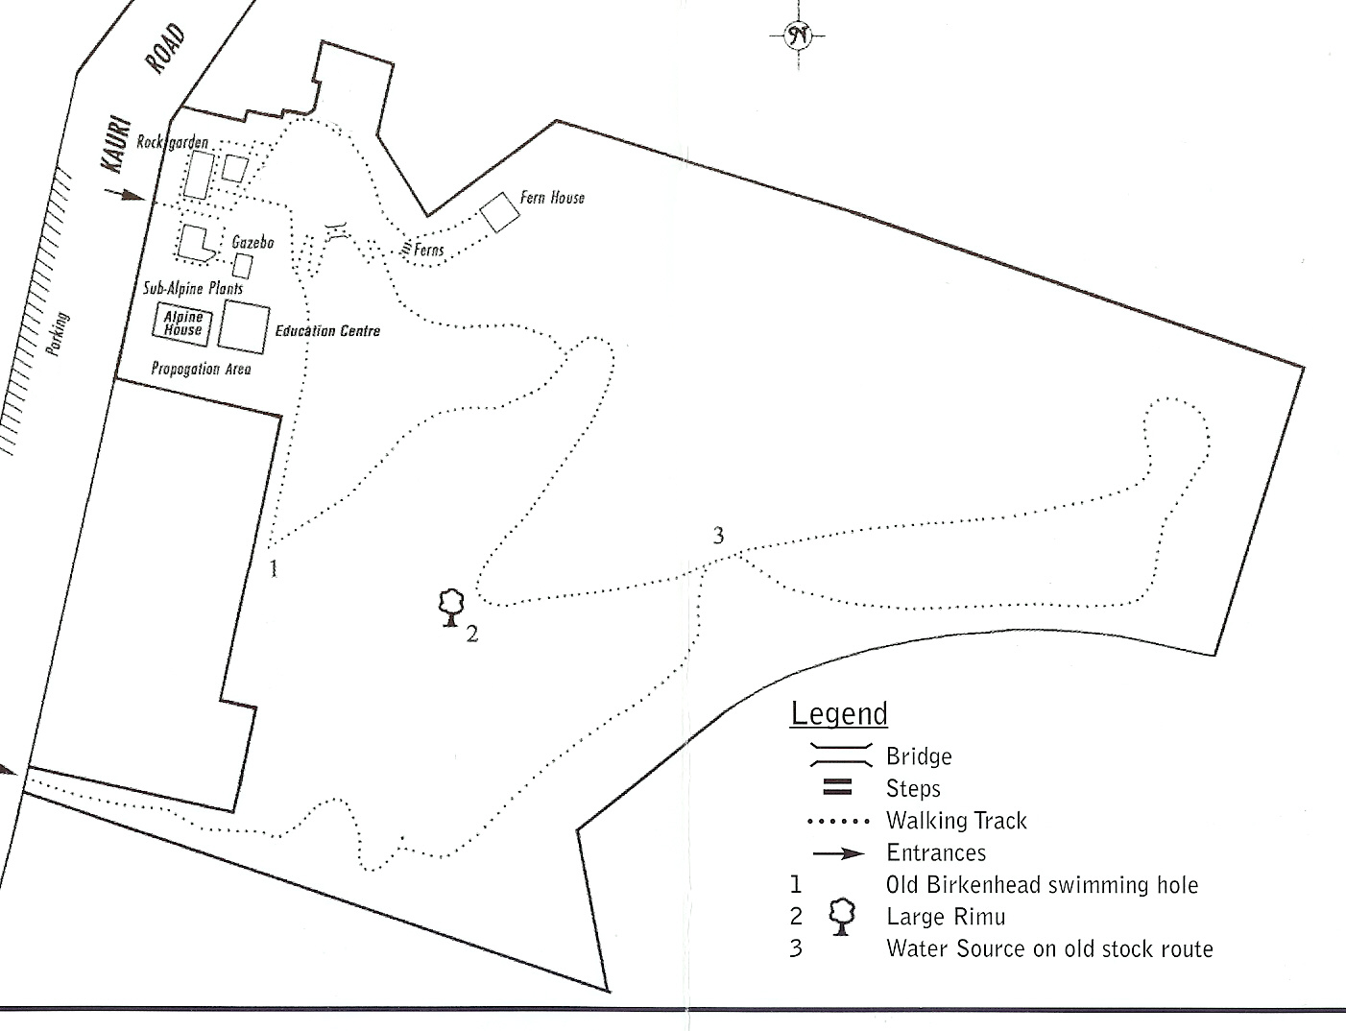
Ben’s Ridge
Dracophyllum Collection
Offshore Islands Collection

