**Fernglen Native Plant Gardens**

**Autumn Newsletter 2014**

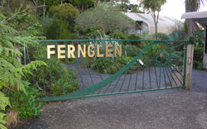

**Contents:**

1. Fernglen-Curator report
2. Discovering the “Stairway to *Blechnum fraseri* heaven
3. Book Review “Rat Island” by William Stolzenburg
4. A novel approach to plant propagation-shotgun blast
5. A look back in history Professor Arnold Wall
6. Assessment of pohutukawa flowering Christmas 2013
7. Coastal landscaping fifteen years after planting commenced
8. **Summer at Fernglen – Curator report February**

There was a useful meeting with the council parks officers, Paul and Adie, in January looking at the options for developing the area around Muriel’s house. We now await further reports before approaching the Kaipataki Board to instigate a development plan. It is hoped that improving bus access and additional toilet and class facilities will help support further education at Fernglen. The council staff arranged for a delivery of much needed mulch and discussed the possibility of improved safety on steep sections of path. The owner of 14/12 kindly allowed us to have mulch tipped on to his driveway. A “Working Bee” held in early February spread the mulch to Ben’s Ridge and the plants look happy with their circles of mulch around them. The new Jackie Arbury Memorial Coprosma collection is looking healthy.

In mid December the Kaipatiki summer walk programme included Fernglen but this was not well supported. In February a walk through Muriel Fisher reserve in the same programme attracted a large crowd. Pre-Christmas is thought to be a less attractive time and so we hope to have a further walk closer to Easter. Some local children’s nature parties have been held over the summer holidays and it has been wonderful to see the young children delight in their natural environment.

This year the Hort Training Arborist course has been cancelled. We have enjoyed hosting this class of about 8 students for the past 5 years.

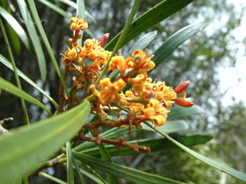

The Protea family is well represented in Australia but only two species, *Knightia excelsa* (Rewarewa) and *Toronia toru* (Toru) grow in New Zealand. Toru is less well known that the taller and more spectacular flowering Rewarewa, but can be an eye-catching small tree with its glossy long narrow leaves turning red as they age. A Toru was planted near the Gazebo about 25 years ago and has been making quite a show in recent years. However its neighbour *Planchonella novo-zelandica* (Tawapou) has been expanding into Toru’s territory, reducing its impact on the scene. Tawapou has now been trimmed and we hope Toru will reassert itself. There is also a fine looking metre-high specimen at Ben’s Ridge and one is growing naturally amongst the Kauri on the way to Ben’s Ridge.

*Toronia Toru*

*c*ourtesy NPCN

**Photographer:** John Smith-Dodsworth

Presently in flower are the *Metrosideros fulgens* (Rata), *Hoheria pulnea* (lacebark), the, *Earina autumnalis* (Easter orchid), *Olearia avicenniaefolia*, *Tecomanthe speciosa* and *Pernettya macrostigma*, a South Island snowberry.

Lots of fruit can be seen on *Vitex lucens* (Puriri), *Elingamita johnsonii*, of the Three Kings Islands, the local *Coprosma rhamnoides* and *Fuchsia procumbens*. Kereru are visiting Fernglen’s Cabbage trees to feast on the seeds, the product of prolific spring flowering.

Earlier in summer the pale yellow flowering Pohutukawa and its rare relative *Metrosideros bartlettii* had quite a lot of blossom.

**2**. **Discovering the stairway to *Blechnam fraseri* heaven**

During the summer break I was invited by a fellow “fern nut” to tramp in the Tangihua Forest south west of Whangarei. I was assured that I would see *Blechnum fraseri* (miniature tree fern or maukurangi) growing in profusion. We followed the track uphill for a few hours through nikau, kiekie and ground ferns, all thriving under a canopy of massive *Beilschmiedia tarairi* (taraire). After a long hike, the expectation of locating the mass of *Blechnum fraseri* previously discovered by my friend was fading. Just as we contemplated the possibility of being on the wrong track and turning back, we came across “*Blechnum fraseri* heaven”. On both sides of the track for over 100m and 10m wide, extended a mass of this unique miniature tree fern. Like kids in a lolly factory we explored this population and lost count in the thousands of specimens.

The question of why the population was so large at this juncture of the track did not have an obvious answer. One potential explanation is that the environment may be less hospitable since the dominant kauri, tanekaha and mahoe trees were not as healthy. Perhaps, unlike other ferns, this difficult to cultivate fern prefers an open site with filtered light and impoverished soil.

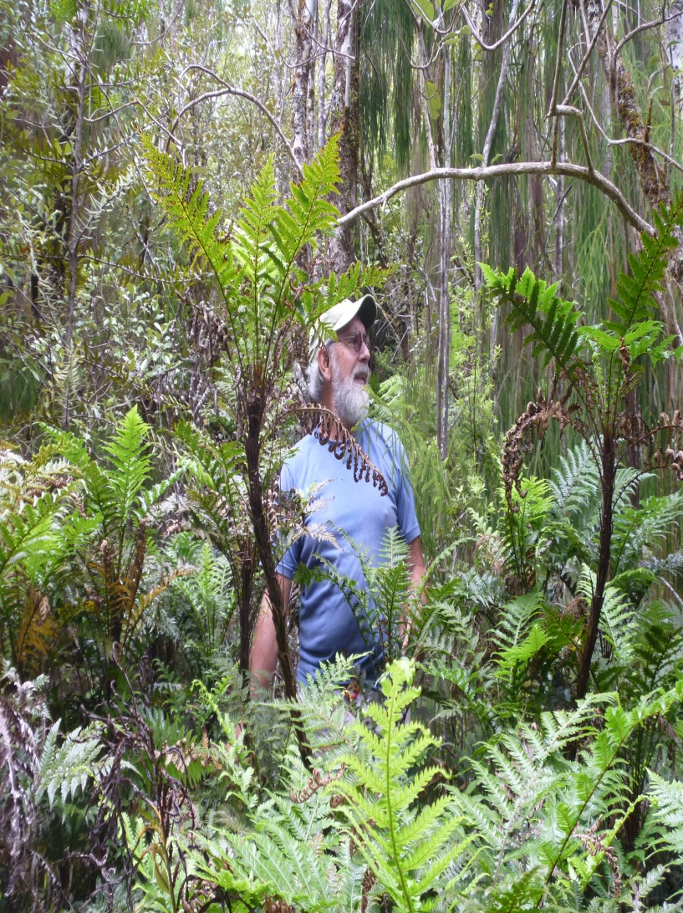*Blechnum fraseri* interesting facts:

* naturally located in lowland forest from North Cape to Tauranga, King Country, and northwest Nelson to Westport.
* it has a slender trunk that grows to 1.5m with 25-60cm fronds
* it grows on the forest floor in dry bush areas
* the first documented collection was by Charles Fraser in 1825 then superintendant of the Sydney Botanic Gardens
* specimens sent by William Colenso were successfully grown at Kew Gardens in the 19th century
* five of the six *Blechnum fraseri* planted in the Fernglen fernery last year are thriving.

*Nev in Blechnum fraseri heaven*

1. **Book Review: Rat Island: Predators in Paradise and the World’s Greatest Wildlife Rescue by William Stolzenburg**

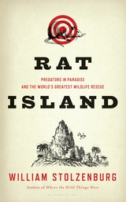

This is a fascinating Bloomsbury 2011 publication and worth tracking down – it is also available from Amazon and Kindle. The first sentence speaks volumes...

“*A massive wildlife reserve is underway, a rescue that may rank as the most pressing ever waged in the defence of so many creatures on the brink of extinction”.* Stolzenburg notes that islands totalling just 5 % of the earth’s land mass are home to more than half of endangered species."*Unique and naive fauna that evolved in blissful isolation have been shattered by mainland predators rats ,cats, goats, pigs and a host of fellow predators ferried around the globe by humans*.”

Considerable attention is paid to the New Zealand experience, especially the ongoing arrival of various pests starting with the introduction of the kiore by Maori, followed by brown and black rats with European settlement. Rabbits introduced as game in1864, rapidly overpopulated, and their solution in the form of mustelids (ferrets, weasels, and stoats) promptly ignored the rabbits in favour of easily available native fauna. One particular heartbreaking saga was of Richard Henry’s 1870’s solo heroic effort to preserve kakapo on Resolution Island. The channel separating Resolution Island from the South Island was not sufficient to stop the weasels from migrating. To quote Stolzenburg, Henry’s kakapo “became sacrificial lambs to professional killers.”

[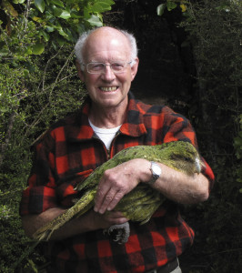](http://kakaporecovery.org.nz/wp-content/uploads/2012/12/Don-Merton-and-Richard-henry-big.jpg)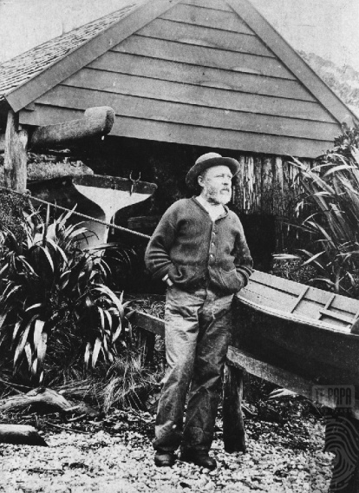There are also heartening success stories, both in New Zealand and the Aleutian Islands (in the Bering Strait between Russia and Alaska). Don Merton is credited with large scale pest control and the re-colonising and breeding of kakapo on Codfish Island. The appropriately named “Rat Island” in the Aleutians has been the site of the largest successful island rat eradication operation in the world.

This is a great read and a significant conservation text relevant to New Zealand’s ongoing battle with introduced predators.

Richard Henry

Kakapo Recovery pioneer Don Merton holds Richard Henry, November 2010

1. **A novel approach to plant propagation- shotgun blast.**



The critically endangered kaka beak *Clianthus maximus,* has for many years been decimated by goat, deer and other browsing animals. Commonly cultivated in home gardens by native plant enthusiasts, nursery plants have been derived from a limited number of wild plants. In Hawkes Bay the Forest Lifeforce Restoration Trust has endeavoured to reverse the decline of the kaka beak. They have five seed nurseries with four in Hawke’s Bay and one in the Bay of Islands

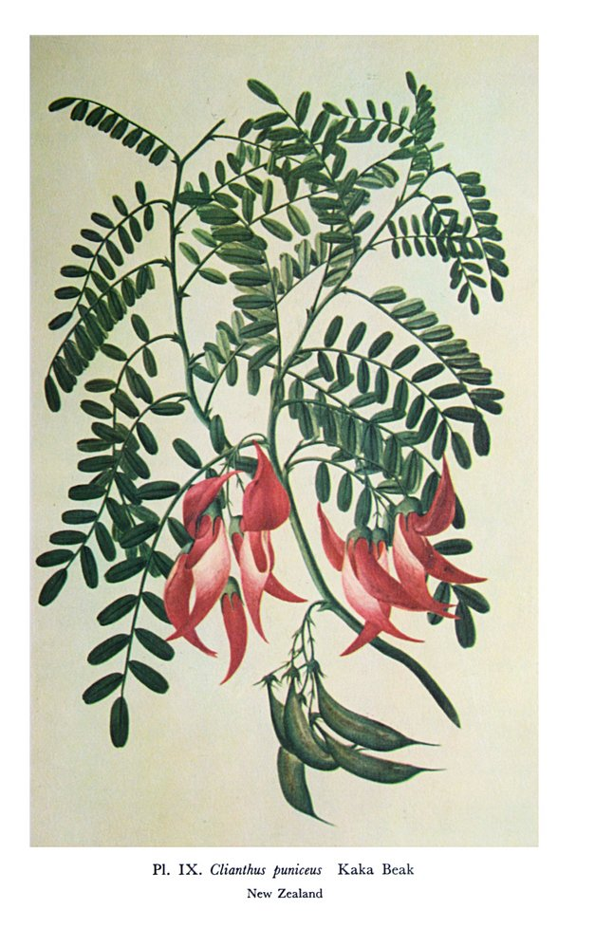They have successfully grown hundreds of young kaka beak and planted these on conservation land. Trust staff experimented to develop a successful propagation technique for kaka beak by blasting seeds from a shotgun into likely nursery sites. Re-loaded shotgun pellets packed with a pulp medium and kaka beak seed. They are discharged at a range of about 20m, which is the approximate range from a helicopter, for aerial propagation of wild inaccessible spaces such as bluffs and cliff faces. View on <http://www.forestlifeforce.org.nz/kakabeak.html>.

Endeavour Journal Joseph Banks 1768-1771 http://nzetc.victoria.ac.nz/

1. **A look back in History Prof Arnold Wall 1869-1966**

*This article was inspired by meeting Mattie Wall -grandaughter*.

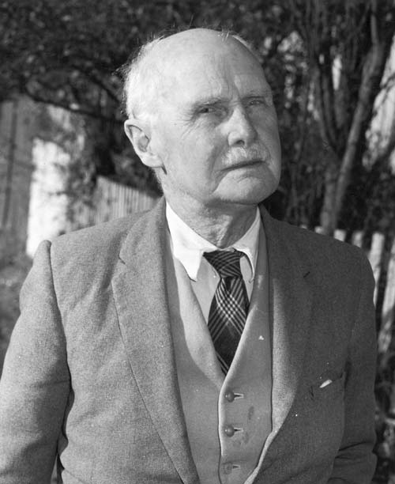Arnold Wall was born in Ceylon(Sri Lanka) in 1869 . He was the sixth of nine children of a British colonial coffee planter and merchant. Following the social norms of the time, he was sent back to England for his education. Upon leaving school, he supported himself with lowly paid teaching and tutoring jobs whilst studying part-time for an MA in English and French at the University of London. In 1893, while teaching at Cambridge University correspondence school, he submitted a thesis on Scandinavian elements in the English language gaining a Cambridge degree. His appointment to chair of English, Literature, and History at Canterbury University, Christchurch resulted in his emigration in1899. He maintained the English Chair until retirement in 1932. Wall became a strong advocate of reforms to improve the academic standing of New Zealand's tertiary institutions, including having New Zealand qualifications independent from the British.

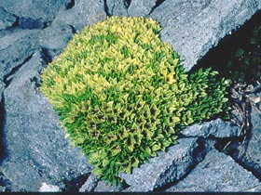He was also a keen mountaineer and fly fisherman. It was not until 1915, after collecting alpine specimens with his friend, the eminent Wellington botanist Leonard Cockayne, that he became passionate about New Zealand native plants. With his intellectual and physical vigour his expertise developed rapidly. By the 1920’s he was the honorary keeper of the herbarium at Canterbury museum. In this role he collected and catalogued many New Zealand alpine species aquired on his extensive exploration of mountainous regions throughout the country. As a result of his identification of a number of new species and varieties, seven plants bear his name. He published numerous articles and books on the native flora, in addition to his prolific authorship of material on English philology and his original poetry. Amongst his botanical publications were: ‘The Botany of Christchurch’, 1922; ‘The Southern Alps,’ 1924; ‘The Flora of Mount Cook’, 1925; ‘The Botany of Auckland,’ 1937, with Lucy Cranwell; and ‘The Botanical Names of the Flora of New Zealand,’1950, with HH Allen. Like all botanists and plant enthusiasts he had his special areas of interest, which were chiefly grasses and sedges. A seed exporting business with friend Mary Poulton, whilst not a commercial success, introduced a variety of New Zealand native plants to Britain, Europe, and the United States. His energy and physical stamina saw him continue to write , broadcast,climb, and botanise throughout his long retirement. He was heralded at the age of 84 for the ascent of Mt Isobel near Hamner. He was conferred a CBE in 1956 and an honorary Doctorate in Literature in 1960, and died at the age of 96.

***Clobanthus walli***

**Kind permission NZPCN**

**Photographer:** **John Smith-Dodsworth**

1. **Assessment of Pohutukawa Flowering Christmas 2013.**

The summer edition of the newsletter commented on the early flowering of pohutukawa in November . Nev now remarks that this was “possibly the most dismal flowering I have ever experienced in Auckland since I began monitoring”. What followed the early flowering by some trees was followed by resplendant new growth but failed to provide the expected magnificent cloth of red we associate with Christmas. The odd tree for example in Okahu Bay and at the Northern entrance to the Harbour Bridge, were prolific enough to save the season from complete disaster. Interestingly, cloned trees (cutting grown) planted as specimen street trees in Auckland, such as Maori Princess and Lighthouse, all flowered prolifically but for a short period. While it is impossible for pohutukawa to be covered in masses of flowers every year,hopefully, Christmas 2014 will be more spectacular. Regardless- admire the pohutukawa for its fascinating habit, difficult sites, and longevity. Very old pohutukawa that grow on the beach south of Lang’s Cove were dislodged in cyclone Bola. They toppled onto their sides down a steep hill, then re-established themselves, with large branches on the sandy beach and roots still largely above ground. Amazingly, one of these hardy trees was resplendent with flowers in January. Does any other plant species diplay such fortitude?

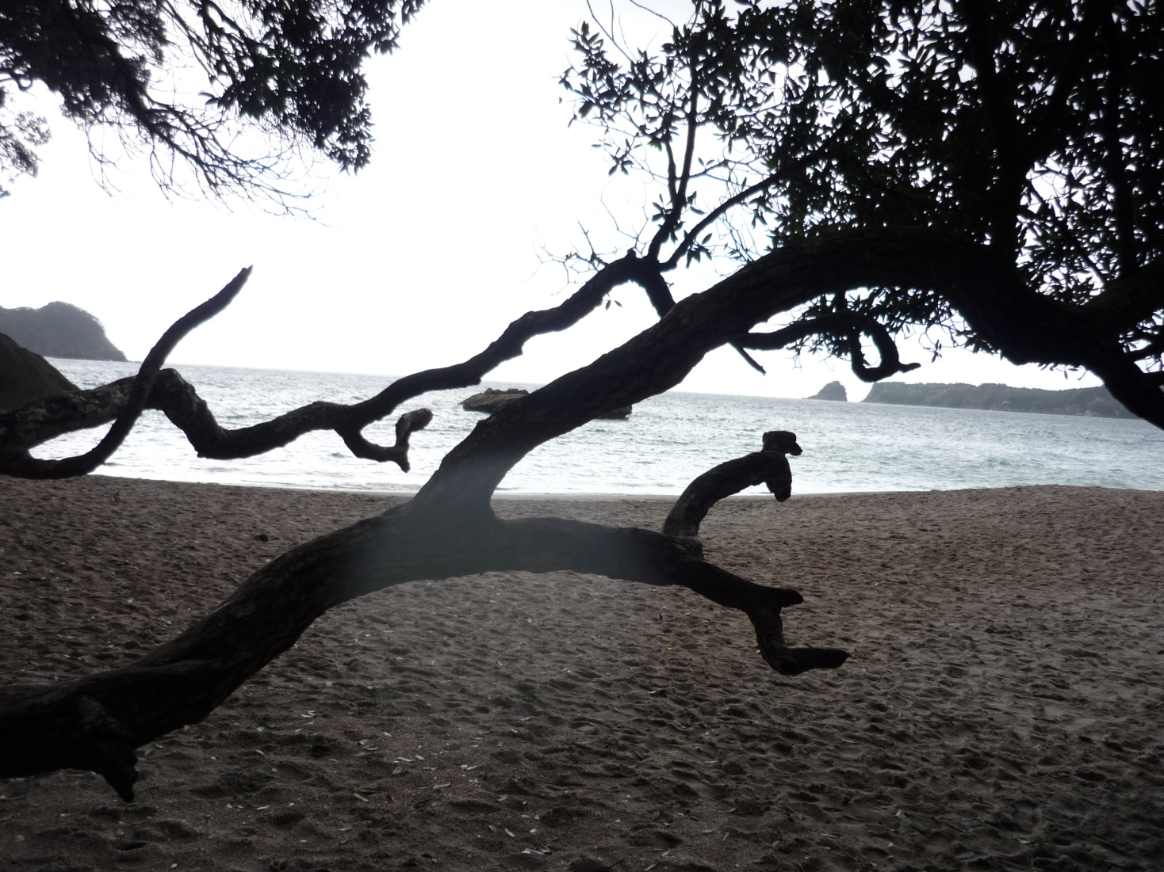

1. **Coastal Landscaping: Fifteen years after planting commenced (Nev Arbury)**

It seems like only yesterday that I started planting my own coastal forest at Mangawhai Heads. Overall the results have been pleasing. Despite some failures it has been fun and a great learning experience. Some advice on the successes and challenges that might help others wanting to plant a coastal block:

Outstanding performance thriving and successful plants

*Coprosma –*: C*. areolata, C crassifolia, C.lucida, C.macrocarpa, C neglecta, C picturata, C.propinqua, C repens,C.rigida,C virescens*

*Pseudopanax – P. arboreus,P.discolour,P.lessonii,*

*Nestegis-* N*. cunninghamii, N apetala, N.lanceolata, N, montana*

*Pittosporum- P. crassifolum,P.fairchildii, P. stephens island*

*Geniostoma rupestre -* now the predominant understory under the tree canopy

*Metrosideros SPP.* *M excelsa,M bartletti*,*M.robusta,*await Northern rata to tower over them

*Griselinia lucida -* may have over planted this beauty and they are now over 5m

*Pomaderris hamiltonii –*Now self seeding throughout

*Pomaderris kumarahou -.*pop up on paths and clay banks and can be transplanted in winter

More challenging plants

*Myrsine australis* slow to establish but now self seeding

*Meryta sinclairii* struggle in heavy soil

*Hedycarya arborea* Just surviving perhaps planted too early

*Elingamita johnsonii –* struggled to estalish now thriving but no berries

*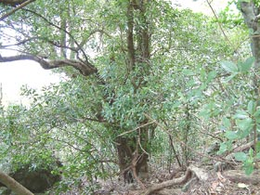Dysoxylum spectabile -* replanted as possibly too windy

*Agathis Australis (kauri) –* A struggle eight survive ranging from 1.5m -4m

*Corynocarpus laevigatus (Karaka)-* Initial disaster but now sheltered later plantings improved

*Planchonella costata (tawapou) –C*rucial plants- alive but barely grown in 15yrs

*Phyllocladus trichomanoides (tanekaha)* Alive but stunted

*Olearia species-* struggle in heavy clay soil exceptions *O angulata,O furfuracea,O solandri.*

*Carex species(sedges)* Whilst providing an interesting entrance- hard work! Only last 2-3years.Bestsuccess with *C. buchananii,C.* *flagellifera,C.*te*stacea C. trifida*

*Planconella costata* Tawapou

Photo John Smith Dodson courtesy NPN

I look forward to the next 15 years of ongong planting and maturing mini-botanic gardens!