Mahesh Prasath J.R

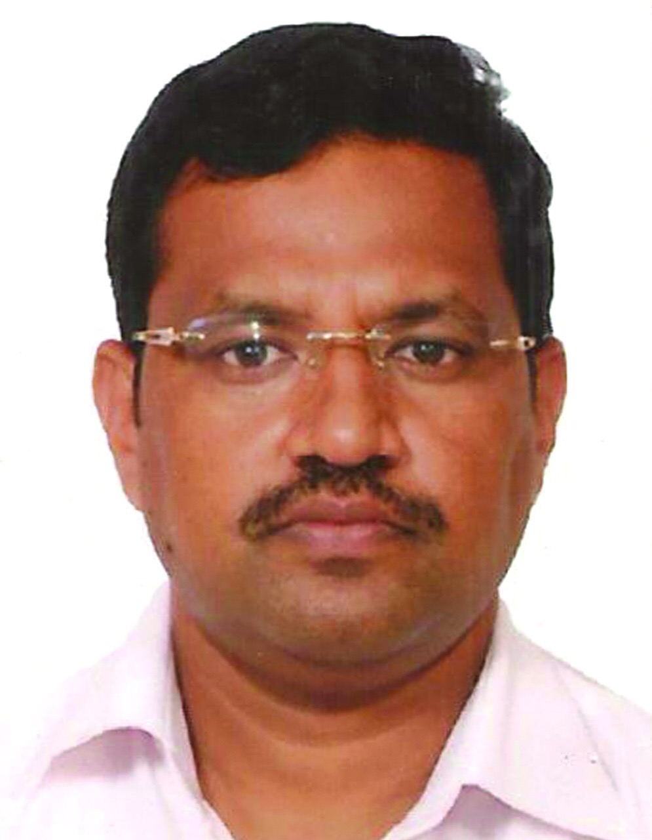

CEO, has around 20 years of Experience in the field of Electronics Design, Embedded Systems, Internet of things, Machine Learning, Artificial Intelligence, Industrial automation. Worked with various MNCs Involved and worked on various Research development product executed various projects. Heads the R&D department for Industrial Automation, AI, ML, IoT 4.0 and day to day company operations.

Shashanka,

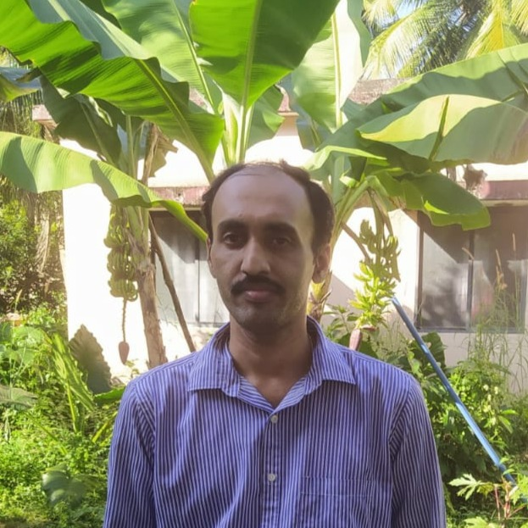

VP Software, has around 20 years of experience in the field of software development, has worked on projects based on web application, cloud front, UI/UX, mobile application, ERP projects, Machine learning and Artificial Intelligence. Heads the software development department at Fernhill.

Santhosh,

VP Electronics Design, Has around 18 years of experience in the field of Electronics design worked on designs that involve microprocessor, microcontrollers, digital and analogy circuits. Has knowledge on various hardware design standards and delivered project in all most all the domain from consumer, industrial, Power electronics and Medical Electronics. Heads the Electronics design service department at Fernhill.