Este documento es básicamente una transcripción de distintas charlas de Robert C. Martin (que es como el padre de los principios SOLID) que hice como para tener más a mano los conceptos que emanan de esos videos. Véanlos porque no tienen desperdicio, son mejores que cualquier apunte que encontré y da placer escuchar al tipo:
https://www.youtube.com/watch?v=t86v3N4OshQ&t=3080s
https://www.youtube.com/watch?v=TMuno5RZNeE&t=3241s
Lamentablemente en sus conferencias solo llega hasta el principio de sustitción de Liskov. De modo tal que el Interface Segregation Principle y el Dependency Inversion Principle que están acá no son de los videos. El ISP lo saqué de una página en castellano y lo copypasteé y el DIP es un resumen del artículo de la página de Robert Martin que trata al principio mismo.
Por Darius Maitia.

The single responsibility principle:

A class should have one, and only one, reason to change.
It should have a single responsibility to change. Responsibility means CHANGE. It has one reason to CHANGE.
How many sources of change are in a class? It shows an example with a class with 3 different responsibilities all
at the same time. It finally says: "I'm not going to put those three methods in my class, because those three methods have different reasons to change. They change at different times, for different reasons, they change based on the interest of different people in the organization. So I'm going to separate those 3 methods and keep them out of a single class. How to do that?

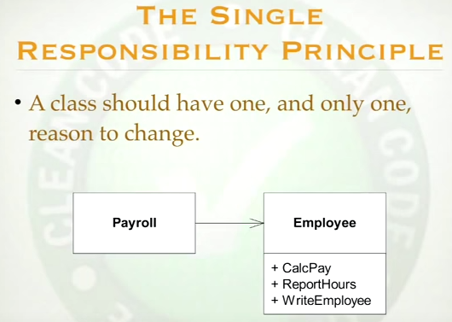

How many reasons has this class to be changed. How many changes could be requested? How many sources of change are there?
If the CalcPay method were to break and cost the company a million dollars, which C level executive would find about it first? Would it be the CFO, the COO or the CTO?
It would be the CFO. Because he would be the one looking at the problem in the books, in the accounts, and he would go to the programmers and fire them. If there were a bug in the report hours function and it would cost the company a million dollars, which C level executive would find it first? The CFO, the COO ot the CTO?
The COO because he controls the auditors who check the reports of what got work done and work spent, and he would go to the developers and fire them.
And if the database crashed destroying a million dollars of data assets because some programmer screwed up that WriteEmployee method, which C level executive would discover it first? It's the CTO.

So I have 3 level executives interested in these 3 functions. If they don't work right, each of them would be upset for different reasons and if they want changes, those changes will come from beneath those particular C levels. And so this class has 3 different responsibilities. It has responsibilities to 3 different actors, 3 different people or 3 different organizations all at the same time.
Is it posisble for me to add a new feature to the ReportHours function and accidentally break the calcPay function?
It is. But I'm not going to do that, I'm not going to put those 3 methods in my class. Because those 3 methods have different reasons to change. They come at different times, for different reasons, they change based on the interest of different people in the organization. So I'm going to separate those 3 methods and keep them out of the single class.
And you say "Wait a minute, I thought this was objects, I thought objects were supposed to have the methods that make them work" and yes sure, that is true but you should also better protect yourself from those C level guys who are going to come and fire you. So how do we do? How do we get those 3 methods in 3 different classes because I don't want them there.

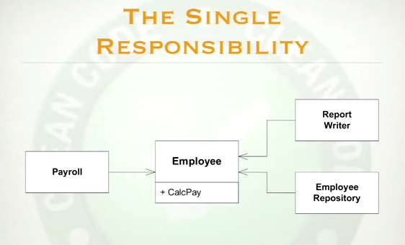

There is a whole bunch of ways to do that. We could do what's in the image. Although I do not much like that because these guys now depend on that and if there were a change in CalcPay these guys would have to be changed, they would have to be recompiled and redeployed... So maybe what we would do is this: we would create an interface named Employee that has at least one of these methods and then we will derive from that interface another one of these classes that implements calcPay. Maybe we could do that. Or maybe we could have a single class that implements all 3 methods but has 3 different base classes, one with each of the methods. That would be interesting although I don't know if it solves the problem. Or maybe what we could do is create 3 classes, one with each method and put a facade object here that delegates to them. There is a million ways to address this problem. The importan part is "don't put functions that change for different reasons in the same class". What reason is the report hours function going to change?
Change of the format for example. You would change and maybe break the CalcPay method. You don't want methods in a class, in the same class, if they change for widely different reasons. I don't want to expose these calcpay to the vagueries of the auditors who would like to change the formatting of a report. Formatting should go in one place, calculation should go on another, database in another, and if you have got another concern, put it in another. Don't mix concerns in your classes.

Open/Closed Principle : Modules should be open for extension, but closed for modification
It means you should be able to change what a module does without
changing the module, you should be able to change the behaviour
of the module without changing the module. It should be open for extension
so it's behaviour could be extended but closed for modification.
This sounds impossible. But we do it all the time.
If you can conform to this principle, then when you add a new feature to
an application you should be able to do that by writing new code
and not changing any old code. You are not going to modify, you will
extend it. So all your modules are closed for modification but they can
be extended so you can extend your application with a new feature
without changing any of the existing modules.

Example:
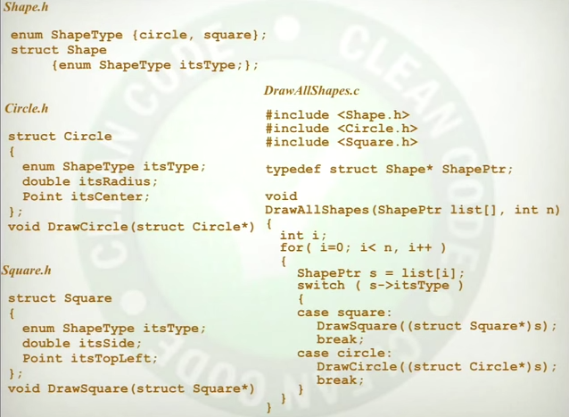

This is the failing version, that doesn't hold to the OCP. What bad thing happens because I wrote the code this way?
- If I add an oval, I must add another case to the switch statement
- I change enum, and that's located in Shape.h and everybody includes 'shape.h'. Who recompiles? - Everybody
Circle recompiles because I added an oval.
Square recompiles because I added an oval.
That's fundamentally sick. Square and Circle don't give a damn about oval but they have to recompile because I added an oval.
That's rigid. That is the symptom of rigidity, you have to compile too much because of a change. You have to compile things that should not have had to be recompiled because of a change.
But it's worse than that, because I do have to modify the switch statement. There is more than one switch statement, switch statements duplicate and replicate and spread through the system. Some programmers don't like switch statements and they use “if's” and “else's “ instead, but they are switch statements. And now what I have to do is to find them all, and I have to modify them all, I have to put "oval" to them all.

But that it's not the worst of the problem: a boss comes to us and says "you know... we have got a lot of trouble
with this startup company and we are about to run out of funding, the sales model we have just isn't working, but we got a new idea: we hired a consultant, payed him a lot of money and he told us what we had to do. What we have to do is this: we have to give away DrawAllShapes for free, we are going to put that, to put it on a .jar file or a .dll, we are going to put that on our website, give it for free and then take all the squares, circles and ovals and we are going to put them in separate jar files or dll's and we will sell them for five dollars each on our website". And we have to tell our boss that we can't do that because the switch statement has a dependency on square, and circle and oval, and triangle. We cannot separate them. We must deploy Circle, Triangle, Square... with DrawAllShapes. There is no way to independently deploy them! And we tell our boss "our architecture does not support what you want to do". And we go out of business and go out looking for other jobs." That is immobility: the reusable part is not properly decoupled from the GUP. A design is immobile when the desirable parts of the design are highly dependent upon other details that are not desired.
How do we fix that?
Fixed version (but he says it's a lie):

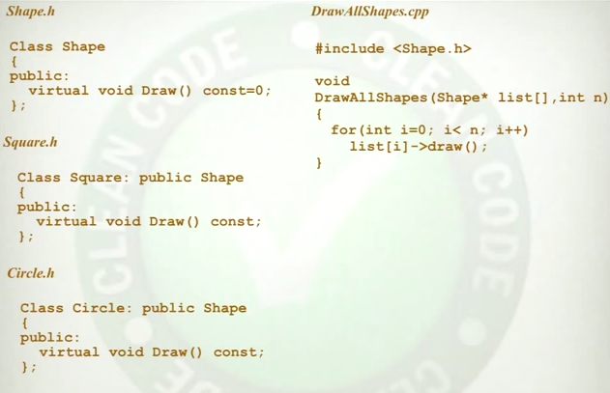

What happens when we add the oval? What here must recompile? Nothing.
I can add the oval, nothing here recompiles: open/close principle.
It's not rigid now because nothing has to recompile.
Is it fragile? Can't be fragile because everything I can do to a shape I must implement in that shape. There is no way for me to forget to implement a method, it's not fragile, I don't have to hunt for switch statements. There is no funny local optimizations. But the best part is that we can do what the boss asked for before.
Because DrawAllShapes doesn't have any idea that squares and circles exist. The High level policy does not know about the low level details. The flow of control still works the same way. This loop calls these draw functions but at compile time.
He says it's a lie because that implementation protects us from the change of adding a shape. But it says “What if the customer wants the shapes to be printed ordered”. And then he speaks about how to prevent changes.

Liskov substitution principle:

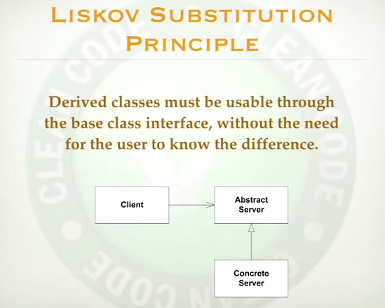

Derived classes must be usable through the base class interface,
without the need of the user to know the difference.
That makes perfect sense. Simple polymorphism.

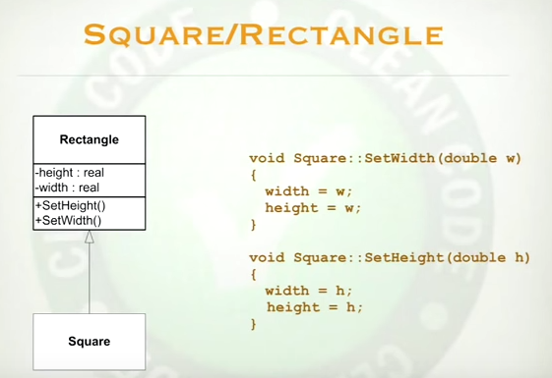

A new requirement has come along. It's for a square. Now clearly square is a rectangle. So clearly square inherits from
rectangle. Makes perfect sense.
But wait a minute. How many fields does a rectangle have? Two: height and width .
How many fields does a square need? One. And how many would he inherit? Two.
Something is wrong.
Square cannot inherit from rectangle and only have one field. Now that means we are going to waste memory. Memory is cheap, let's just waste the memory and do this. Let's override SetWidth and
SetHeight in square so they sets both the height and the width (watch image).
Imagine some user of rectangle, that user calls set height. Does the user that calls SetHeight on rectangle have the right to expect that the width won't change? Yes. But if I pass him a square he will call setHeight and the width will change and that would corrupt his internal final statement machine and he would then corrupt the heap and he would
discover this a billion instructions later when he get a null pointer exception. What happened? By the way you are the guy right on the code that's called setWidth on a rectangle and you get your logic analyzer out and walk through the backtrace through a billion instructions and you find after weeks of analysis that the reason you blew up
is that somebody passed you a square. So what code are you going to write in your module that will protect
you from the possibility that the rectangle you are holding may actually be a square?: If the rectangle is a square... And by doing so you will hang a dependency on a square, something you never wanted to know about. But your module which was supposed to know about rectangles will suddenly have a dependency upon the square, violating the open closed principle and making you rigid and fragile. What went wrong? Isn't a square a rectangle? A square is a rectangle, so that has to be the right relationship.
No.
Because that's not a square, that's a piece of code ! that's not a rectangle, it's a piece of code!
It is true that a square is a rectangle but the class square
is not a square. The class rectangle is not a rectangle. The class square represents a square, the class rectangle represents a rectangle but the representatives of things do not share the relationships
of the things they represent.
Example of divorcement: there are two lawayers representing the husband and the spouse and those two lawayers were not probably getting divorced.
The things they represent do not share the relationships of the things they represent. You cannot simply say "well that class has the name of something and therefor I'm going to use and inheritance relationship”.
We call that relationship "is a", and that's the wrong name for that. It's not "is a". It got inherited from the artificial intelligence people in the 80's who then turned object oriented programmers taking they interesting abbreviation with them, naming these relationships that way like "is a" but these are lies, it's not correct.
The inheritance relationship is not the "is a" relationship. Inheritance relationship really is just the redeclaration of functions and variables in a subscope.
How can we fix this problem? What is the relationship between a square and a rectangle? I'm I going to have any relationship between these to classes at all?
This is a Liskov Substitutions principle violation, because rectangle is not substituable by rectangle, evenough it seems to fit the definition of "is a". It does not fit the substitution rule.
And whenever you violate the substitution rule you will eventually add and if statement that checks the type of the object to prevent you from crashing your system.

Interface segregation principle:
Fuente: https://www.adictosaltrabajo.com/tutoriales/solid-4/
Vamos a ver el cuarto principio del acrónimo SOLID. El principio de segregación de interfaz. Aunque algunos lo confunden con el principio de responsabilidad única tiene matices diferentes que estudiaremos a continuación. Fue propuesto originalmente por Robert C. Martin, también conocido como “tío Bob” (Uncle Bob).
Para referirse a este principio se suelen usar las frases:
“Muchas interfaces específicas son mejores que una única más general”
“Los clientes no deberían verse forzados a depender de interfaces que no usan”
Interfaces diferentes para clientes diferentes.
Cuando los clientes son forzados a utilizar interfaces que no usan por completo, están sujetos a cambios de esa interfaz. Esto al final resulta en un acoplamiento innecesario entre los clientes.
Dicho de otra manera, cuando un cliente depende de una clase que implementa una interfaz cuya funcionalidad este cliente no usa, pero que otros clientes si usan, este cliente estará siendo afectado por los cambios que fuercen otros clientes en la clase en cuestión.
Debemos intentar evitar este tipo de acoplamiento cuando sea posible, y esto se consigue separando las interfaces en otras más pequeñas y específicas.

Ejemplos:
Hay casos de proyectos que se han vuelto inmantenibles debido a la violación de este principio al crearse una clase en la que se va metiendo casi toda la funcionalidad en lugar de ir extrayéndola en diferentes clases. En ocasiones esta clase suele ser un singleton que está accesible siempre para el resto del programa.
Esto va provocando que casi todos los cambios y bugs se encuentren siempre en la misma clase, y normalmente arreglar o modificar algo en ella conlleva consecuencias inesperadas en el resto de esta.
Por si fuera poco, normalmente este tipo de proyectos tienen un testing con muy poca cobertura o ni siquiera cuentan con él, por lo que encontrar los fallos provocados por arreglar otra parte de nuestra clase se vuelve muy costoso.
Vamos a ver un ejemplo de violación de este principio:
Estamos implementando un zoo, y queremos crear una interfaz que sirva para todas las aves.
Pensamos en loros, flamencos, gaviotas, aves rapaces y gorriones, por lo que implementamos los métodos de comer y volar. Posteriormente el zoo consigue presupuesto extra y compra una pareja de avestruces, por lo que definimos también el método correr. No nos podemos olvidar tampoco de los pingüinos, necesitamos un método para nadar.
Como no hemos ido refactorizando entre estos pasos, ahora nuestro sistema tiene esta pinta.
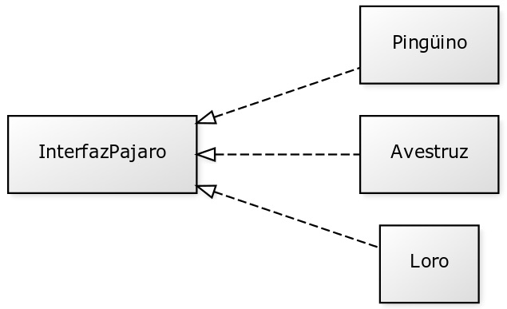
El problema viene con que, por ejemplo, el avestruz tiene que implementar métodos que no usa, y con la llegada del pingüino tuvo que cambiar innecesariamente para implementar el método de nadar.
Una forma correcta de haber modelizado el problema seria haber dividido la interfaz en otras mas pequeñas de esta manera:
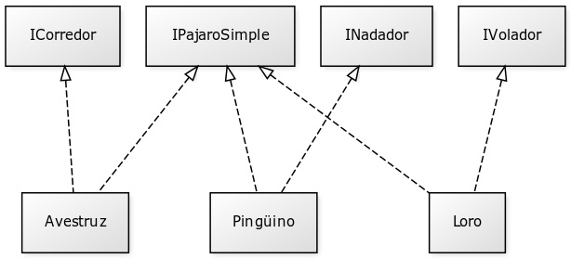
De esta manera cada pájaro concreto solo tiene lo que realmente necesita y se pueden añadir nuevas clases sin modificar otras zonas que no estén afectadas.

Dependency Inversion Principle
A. High level modules should not depend upon low level modules. Both should depend upon abstractions.
B. Abstractions should not depend upon details. Details should depend upon abstractions.
Why the word “inversion” : Frankly, it is because more traditional software development methods, such as Structured Analysis and Design, tend to create software structures in which high level modules depend upon low level modules, and in which abstractions depend upon details.
It is the high level modules that contain the important policy decisions and business models of application. It is these models that contain the identity of the application. Yet, when these modules depend upon the lower level modules, then changes in the lower level modules can have direct effects upon them; and can force them to change. → THIS IS ABSURD. IT SHOULD BE INVERSE. IT IS THE HIGH LEVEL MODULES THAT OUGHT TO BE FORCING THE LOW LEVEL MODULES TO CHANGE. IT IS THE HIGH LEVEL MODULES THAT SHOULD TAKE PRECEDENCE OVER THE LOWER LEVEL MODULES. HIGH LEVEL MODULES SIMPLY SHOULD NOT DEPEND UPON LOWER LEVEL MODULES IN ANYWAY.
Además, nos interesa mas que nada reutilizar modulos de alto nivel. Los de bajo nivel ya los usamos bastante bajo la forma de subrutinas de librerías.
A simple exampe:
Dependency Inversion can be applied wherever one class sends a message to another. Consider the case of the button object and the lamp object.
The button object senses the external environment. The button object detects that a user has activated or deactivated it. The lamp object affects the external environment. Upon receiving a TurnOn message, it illuminates a light of some kind. Y acá está más traducido:
Consideremos un objeto botón y un objeto lámpara. El objeto botón reacciona a un estímulo cambiando su estado entre encendido y apagado. Puede ser un botón físico, uno de una interfaz gráfica en nuestro teléfono, o incluso algún tipo de sensor.
La lámpara si recibe la orden de encenderse o de apagarse actuará en consecuencia, no importa qué tipo de lámpara sea. Una modelización clásica de este sistema sería una clase botón que contiene una instancia de la clase lámpara, a la que cambia su estado entre encendida y apagada.
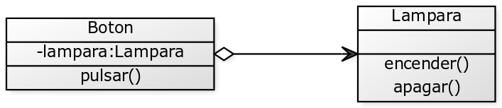
El problema de este modelo es que el botón está demasiado acoplado a la lámpara innecesariamente, a este botón le costaría encender y apagar un motor por ejemplo, porque ya tiene la lampara dentro de su estructura.
La solución propuesta es la siguiente para respetar el principio de inversión de dependencias:
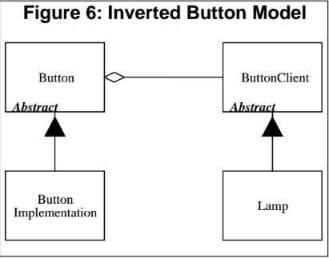

What is the high level policy? It's the abstractions that underlie the application, the truth that do not vary when the details are changed. In the Button/Lamp example, the underlying abstraction is to detect an on/off gesture from a user and relay that gesture to a target object. What mechanism is used to detect the user gesture? Irrelevant! What is the target object? Irrelevant! These are details that do not impact the abstraction.
To conform to the principle of dependency inversion, we must isolate this abstraction from the details of the problem. Then we must direct the dependencies of the design such that the details depend upon the abstractions.
The button class know nothing of the physical mechanism for detecting the user's gestures; and it know nothing at all about the lamp. Those details are isolated withing the concrete derivatives: ButtonImplementation and Lamp.

