UAV Intelligence and Traffic Management Systems
— Intelligence, Issues, Needs, and an Agentic Roadmap
Ameya Mathew and Jerry Gao
Department of Computer Engineering, San José State University, San José, CA, USA
ameya.mathew@sjsu.edu · jerry.gao@sjsu.edu
Corresponding author: Jerry Gao

Abstract
The low-altitude economy is projected to grow from $33.9 billion in 2024 to $61.2 billion in 2029, a compound annual growth rate of 12.6%, and three of the six application segments industry roadmaps name for it are emergency-response services. As unmanned aerial vehicles are tasked with managing and monitoring traffic across roads, airspace, and water, the intelligence of those systems becomes decisive — both the intelligence carried on the aircraft and the intelligence of the traffic management system it reports to. However, despite this growth, few existing works treat those two together, span all three settings, compare research against the commercial landscape, and identify what remains unbuilt. This paper fulfils that gap. We screen 15,825 unique records down to a curated corpus of 128 highly-cited papers, augmented with 30 representative 2024-2026 works, and classify them against a twelve-capability taxonomy that instantiates in each setting. Extending this, a fourteen-platform commercial audit draws out a finding the literature alone cannot support: perception is commercially mature under favourable conditions and duplicated across vendors, capability sets are almost disjoint between hardware and airspace-software suppliers, and emergency response is the only capability in the taxonomy that no audited platform implements at all. We then specify an agentic design in which twenty-one agents divide across two tiers — front-end agents on the aircraft and back-end agents in the traffic management system — and give its architecture, its seven-step emergency-response workflow, and the governance that would permit it to run. Lastly, this work states the issues and needs that remain and orders them into a three-phase agentic roadmap, each phase ending at a gate that produces the evidence the next phase requires.
Index Terms— UAV traffic intelligence, traffic management systems, low-altitude economy, agentic AI, agentic roadmap, capability taxonomy, unmanned traffic management, emergency response, edge AI.
I. INTRODUCTION
Unmanned aerial vehicle usage has evolved over the previous decade from isolated survey flights to standing roles in traffic operations, and it has done so in three settings at once. Over road networks, UAVs count vehicles, track them, and map congestion from a vantage that fixed roadside sensors cannot reach. In the airspace above those roads the aircraft are themselves the traffic, and keeping them separated has become a regulated engineering problem under EASA U-space and FAA UTM. Over coastal and open water they extend vessel surveillance and search-and-rescue. These three literatures rarely cite one another, yet they share a platform, a common set of methods, and a single unsolved problem.
These advancements are enabled by a market large enough to shape research priorities. The global drone market is forecast to grow from $33.9 billion in 2024 to $61.2 billion in 2029, a compound annual growth rate of 12.6%, with China's low-altitude economy alone projected at 3.5 trillion yuan by 2035, and manufacturing concentrated in a single vendor holding over 70% of it [160]. The airspace at issue is the band below 1,000 m, extending to 3,000 m in some jurisdictions, which is where UAV traffic must be actively managed rather than merely permitted. The vehicles are arriving ahead of the systems meant to manage them: AutoFlight's Prosperity eVTOL flew the first inter-city air-taxi demonstration between Shenzhen and Zhuhai, 50 km in about 20 minutes against three hours by road, through airspace bordering three international airports [160].
The application mix matters more than the headline figure. Industry roadmaps name six segments — logistics and last-mile delivery, public security, emergency medical services, firefighting, tourism, and urban air mobility [160] — and three of the six are emergency response. That is where the systems stop. A UAV detects a stalled vehicle, a converging pair of aircraft, or a drifting boat, and passes the finding to a human operator.
Overhead sensing is most valuable when time is shortest: a blocked corridor delays an ambulance, a loss of separation plays out in seconds, a person in the water has minutes. Yet in almost every system reviewed here the move from detection to response is manual. The field has built good eyes and left the acting part unbuilt, underneath a substantial share of projected demand.
This paper treats UAV intelligence and traffic management systems as one subject with three strands: the intelligence of the aircraft (perception, flight autonomy and on-board inference within its power budget); the UAV as a sensing platform for traffic on the ground or water; and the UAV as traffic in its own right, which is what UTM and U-space address. The three are usually surveyed apart, and separating them is what hides the gap reported here — the first strand runs on the aircraft, the third runs in the traffic-management system, and the missing capability sits at the handover between them. Only conventional fixed-infrastructure transportation intelligence is out of scope, and Section II.A uses it as a reference point.
Existing reviews generally focus on one domain, one method family, or one application. Kanistras et al. catalogue UAV applications to traffic monitoring and remain the foundational reference. Barmpounakis and Geroliminis [25] survey aerial trajectory data and released pNEUMA, the benchmark most ground perception work now rests on. Outay et al. review UAV applications to road safety and construction, and Sapkota et al. [161] survey agentic UAV autonomy, though for UAV applications in general rather than for traffic.
Each is strong within its scope, but none organises the field by capability rather than by application or method, none spans road, airspace, and maritime traffic together, none compares academic research against what commercial platforms implement, and none identifies where the perception-to-response loop breaks.
This paper addresses that gap through a capability-level analysis of both the literature and the commercial landscape. It contributes: (i) a domain-general taxonomy of twelve capabilities in two clusters, instantiated in road, airspace, and maritime settings, which forms the backbone of the review; (ii) a statistical literature review of a corpus screened from 15,825 unique records to 128 highly-cited papers augmented with 30 representative 2024–2026 works, with publication-trend, keyword, and capability-coverage analyses; (iii) a fourteen-platform commercial comparison spanning UAV hardware, UTM software, cloud AI, and maritime autonomy, mapped against the same twelve capabilities, with a research-to-product gap analysis; and (iv) an agentic design and roadmap that the analysis indicates is now the efficient path forward — what agentic means here, the twenty-one front-end and back-end agents required, the architecture, the seven-step workflow, the supporting governance, and a three-phase roadmap that orders the remaining issues and needs by the barrier each one retires.
Together these turn a literature split across three disconnected domains into one comparable picture, and tell a team entering the field which capabilities to buy and which one remains to be built.
Section II presents the statistical literature review: concepts and scope, the taxonomy, corpus and method, the per-domain review, and the trend, coverage, and keyword analyses. Section III covers the product comparison and research-to-product gap. Section IV sets out the agentic approach and the agent society it requires. Section V states the issues, challenges, and needs that remain, and Section VI concludes with a three-phase agentic roadmap.
II. UAV AND TRAFFIC MANAGEMENT INTELLIGENCE: A STATISTICAL LITERATURE REVIEW
A. Concepts and Scope
Before UAV traffic intelligence can be surveyed it helps to place it against the field it grew out of. Intelligent transportation systems have been developing traffic intelligence for decades over fixed infrastructure, and their capability structure is a useful reference point.
Conventional ITS intelligence divides broadly into four layers. Sensing covers loop detectors, roadside cameras, radar, and increasingly connected-vehicle telemetry. Analysis turns that into traffic state: flow, density, speed, queue length, incident presence. Prediction projects that state forward for signal timing, congestion warning, and travel-time estimation. Control and response acts on it, through signal control, ramp metering, variable message signs, and incident dispatch to emergency services.
Two properties of that stack matter here. First, its sensing is fixed: the infrastructure sees what it was installed to see, and coverage gaps are expensive to close. Second, and more importantly, conventional ITS does close its loop at the response layer. Computer-aided dispatch is a mature, deployed technology; a detected road incident results in a dispatched vehicle through an established institutional path. The loop closure that this paper finds missing in UAV traffic systems is not missing from transportation systems generally.
UAV traffic systems differ from conventional ITS in four ways. The sensing platform moves, which removes the coverage-gap problem but makes where to fly a first-class scheduling question. The platform is itself traffic, so a fleet must be separated from itself, from other operators and from manned aviation — what UTM and U-space exist for, and something ITS has no analogue of. Compute is split and constrained between an aircraft with a power budget and a cloud reached over an intermittent link, forcing a what-runs-where decision ITS never faces. And the institutional path is absent: conventional ITS grew up inside transport authorities that already owned the dispatch relationship, whereas UAV traffic systems were built by aerospace and technology vendors with no such relationship, so the interface to emergency dispatch was never inherited. The loop is open not because the technology is younger but because the institutional plumbing was never laid.
The platform itself shapes what intelligence is possible. UAV platforms divide by airframe [1], [2]. Fixed-wing and VTOL-hybrid designs give endurance and wide-area coverage but cannot hover, which suits corridor and flow monitoring; multi-rotors trade endurance for a stationary view over an incident and carry the edge processors (NVIDIA Jetson-class) that make on-board inference possible. Swarms extend coverage through distributed sensing under a coordination policy. On water the analogue is the unmanned surface vehicle, often paired with a UAV for an over-and-on-the-water team. Section IV returns to the reasoning and decision technologies that sit on top of these platforms.
B. UAV Traffic Intelligence Taxonomy
A survey needs a vocabulary precise enough to tell whether two papers solve the same problem and whether a gap is real or terminological. We define twelve capabilities in two clusters (Table I). Perception and sensing: object detection, multi-object tracking, congestion detection, flow analysis, hazard detection, and accident/incident detection. Decision, response, and infrastructure: emergency response, airspace/traffic management, fleet coordination, multi-modal fusion, edge processing, and communications/cloud. Each capability is defined by its output and the decision it enables, not by a sensor or algorithm, so the taxonomy survives method churn and (the point of this survey) instantiates in each domain.
Fig. 1 presents the taxonomy as a mind-map, with the twelve capabilities grouped into their two clusters and each expanded into its per-domain instantiation. The per-domain reading is direct: detection means a vehicle, an aircraft, or a vessel; emergency response means road dispatch, airspace diversion, or maritime search-and-rescue; airspace and traffic management means signal control, separation assurance, or vessel-traffic service.
Read left to right the two clusters also form a pipeline, from sensing through to action, and the break in that pipeline at autonomous emergency response is what the rest of this survey traces. The taxonomy does double duty, as the scheme that classifies the literature (Section II) and as the specification the proposed platform is measured against (Section IV). The capabilities are increasingly realized by AI (deep learning in perception, reinforcement and multi-agent learning in coordination) and Section II.F quantifies how far that penetration reaches.
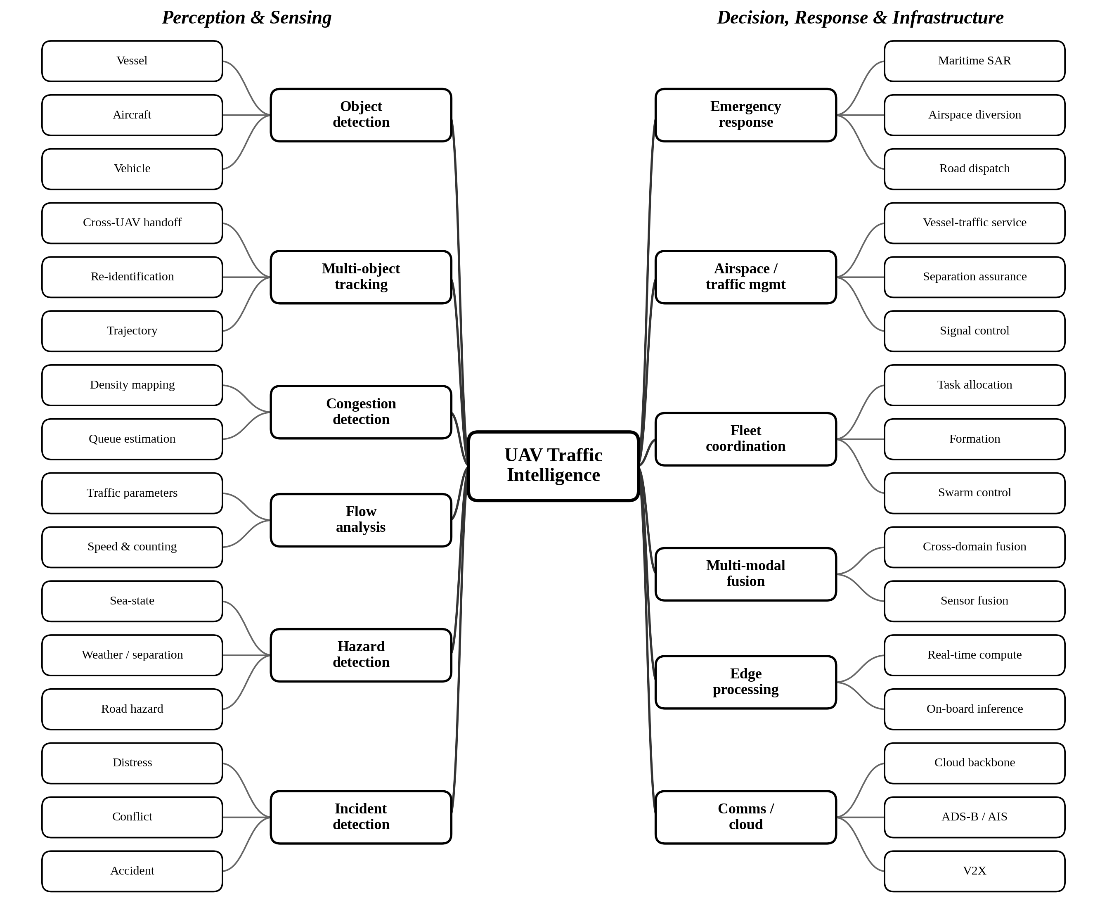
Fig. 1. Taxonomy of UAV traffic intelligence: twelve capabilities in two clusters, each expanded into its per-domain instantiation.
TABLE I. Capability Taxonomy: Definitions and Clusters
Capability | Definition | Cluster
Vehicle/object detection | Detect and classify traffic objects (vehicles, aircraft, vessels) in UAV imagery. | Perception & sensing
Multi-object tracking | Maintain persistent identities for detected objects across video frames. | Perception & sensing
Congestion detection | Identify and predict queue formation and traffic-density build-up. | Perception & sensing
Traffic flow analysis | Estimate microscopic flow parameters: speed, density, flow rate. | Perception & sensing
Hazard detection | Detect surface/environmental hazards and scene-level anomalies. | Perception & sensing
Accident/incident detection | Identify collisions, near-misses, and safety-critical incident events. | Perception & sensing
Emergency response | Autonomously classify an incident and dispatch emergency services with priority routing. | Decision, response & infrastructure
Airspace/traffic mgmt | Assure separation and deconfliction, or signal/waterway traffic control. | Decision, response & infrastructure
Fleet coordination | Allocate missions and re-task UAV/USV fleets and swarms. | Decision, response & infrastructure
Multi-modal fusion | Integrate aerial, ground, and other sensor streams into one traffic state. | Decision, response & infrastructure
Edge AI/on-board | Run inference on resource-constrained on-board hardware. | Decision, response & infrastructure
Comms & cloud | Provide the 5G/6G and cloud backbone for fleet-scale operation. | Decision, response & infrastructure

C. Corpus and Method
We assembled the corpus with a three-domain search and a staged screening protocol, reported here so the counts can be reproduced from the raw Scopus exports.
Search. Three Scopus queries were run in July 2026, one per domain, each combining UAV platform terms (UAV, drone, unmanned aerial vehicle, UAS, and, for the water domain, unmanned surface vehicle) with domain-specific traffic terms: road, vehicle, and congestion terms for ground; airspace, UTM, U-space, detect-and-avoid, and collision-avoidance terms for air; and vessel, maritime, waterway, and search-and-rescue terms for maritime. Results were limited to 2014 onward, English, and to articles, conference papers, and reviews. The queries returned 8,443 (air), 5,460 (ground), and 3,667 (maritime) records, 17,570 in total.
Screening. After removing duplicates within and across the three sets, 15,825 unique records remained. Each was screened against inclusion and exclusion criteria: a record was kept only if its primary subject was traffic intelligence in one of the three domains, and was removed if its main contribution lay in an out-of-scope area: precision agriculture, infrastructure or building inspection, package delivery, medical transport, physical-layer communications, or generic computer vision with no traffic application. Screening removed 7,221 records, leaving 8,604 eligible.
Curation. From the eligible pool we selected a core review corpus of 128 papers (the most-cited on-topic work in each domain plus the leading surveys) balanced as 45 ground, 47 air/UTM, and 36 maritime. The imbalance toward air and ground reflects the field: Fig. 2 shows airspace research as the largest domain in every year since 2017. The maritime literature is smaller, so the reviewed maritime set sits close to the top of what the search returned; we note this as a scope limitation rather than a sampling choice.
Because citation-based selection under-represents the newest work, we additionally include 30 representative 2024–2026 papers selected by topical relevance and early citation impact (cited by domain in Section II.D), bringing the full reviewed set to 158 (54 ground, 58 air/UTM, 46 maritime). These recent papers enter the temporal coverage analysis (Fig. 3); the capability-and-method classification reported below is performed on the 128-paper core, for which each paper was read and verified.
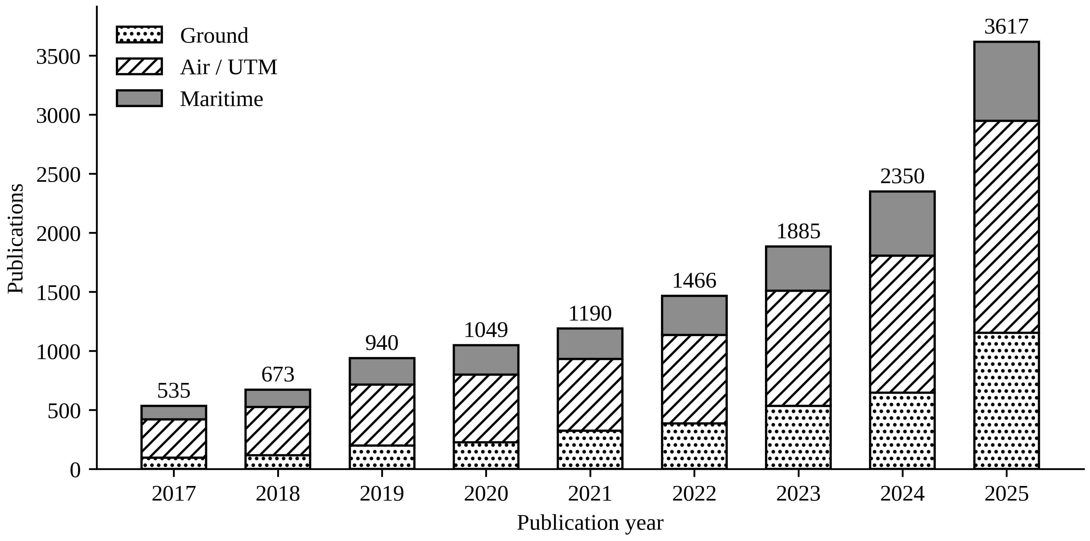
Fig. 2. UAV traffic research by domain and year (Scopus, 2017–2025).
Classification. Each paper was classified against the taxonomy by domain, and its method and (where determinable) its degree of autonomy recorded. Capability tags were derived from title, keywords, and abstract and then checked; the emergency-response capability was audited by hand because keyword matching conflates three distinct senses of "SAR" (search-and-rescue, synthetic-aperture radar, and specific absorption rate) and inflates the count. The classification underlies the coverage analysis (Section II.F) and the per-domain comparison tables.
D. Literature Review by Domain
Ground is the best-balanced domain and the one whose capabilities map most directly onto the taxonomy, but its balance masks a narrowing base. Detection is the richest single capability, with 24 papers, and progress has come from transfer: aerial vehicle detection is a mature engineering capability in favourable conditions, built largely by porting ground-level detectors such as YOLO and Faster R-CNN to the overhead view. What remains open is the hard case — small-object detection from altitude, where a vehicle seen from 150 m fills a few hundred pixels and recall collapses. The strongest responses attack it with architecture and data together, fusing RGB and infrared for poor light or benchmarking detector families against one another, yet most later work reuses that comparison rather than advancing the problem (Sun et al. [3]; Benjdira et al. [4]; also [5]–[24]).
Tracking inherits the pattern. The SORT and DeepSORT family is adapted to the aerial view and works within a single aircraft's field of view, but the operationally decisive case — holding a vehicle's identity as it passes between UAVs — is named as an open problem and solved by none (Elloumi et al. [6]; Yuan et al. [10]; Bakirci [11]). The clearest structural weakness is dataset dependence: congestion detection and flow analysis are effectively exclusive to ground and both rest on one corpus, pNEUMA, with over 100,000 trajectories from ten drones over Athens, which is the de facto benchmark across detection, tracking, congestion and flow (Barmpounakis and Geroliminis [25]; Ke et al. [27]; Outay et al. [26]; also [12], [14], [16], [28]–[32]). That is an achievement and a monoculture: results from one city, in good weather, at fixed altitude cannot be assumed to generalise, and the field has no way to test whether they do.
The gaps cluster on the decision side. Hazard detection has no dedicated ground paper, despite road-surface hazards being exactly what overhead sensing is placed to catch — a mismatch between operational value and research attention rather than a technical barrier. Accident detection exists but is thin and is evaluated on short curated clips rather than continuous streams, which hides the real difficulty: at the true collision base rate, precision rather than raw accuracy is the binding constraint (Khan et al. [33]; Orsino et al. [34]; also [35]). Infrastructure is the one well-covered non-perception area, anchored by the most-cited paper in the corpus and by recent 6G-V2X integration (Menouar et al. [36]; Noor-A-Rahim et al. [37]; also [38]–[46]). Across all of it the pipeline terminates the same way: analysis is delivered to a human operator, and no ground system turns a detection into an autonomous action. Recent work concentrates on the infrastructure cluster rather than the decision layer [47]–[55].
Air is the largest domain (Fig. 2) and its centre of gravity sits at the opposite end of the pipeline, for regulatory rather than technical reasons. The dominant capability is airspace and traffic management, with 46 of the 60 such papers, driven by a hard mandate under EASA U-space and FAA UTM that ground research has no equivalent of. That mandate is why the air literature is unusually system-level and standards-aware: it treats the UAVs themselves as the traffic, through urban-air-mobility concepts, airspace integration, and separation assurance by detect-and-avoid (Cohen et al. [56]; Thipphavong et al. [57]; Sun et al. [58]; also [59]–[97]). Air research keeps aircraft apart better than any other domain and covers almost nothing downstream of that.
Perception in air is inverted relative to ground and correspondingly harder, because detection and tracking mean finding and following other aircraft, often from a moving camera against sky or cluttered terrain (Rozantsev et al. [63]; Li et al. [70]; also [69], [74]–[78], [83], [85], [93], [96], [98], [99]). The deeper limitation is methodological: air decision-making, both path planning and target tracking, is validated almost entirely in simulation (Section V.B), so reinforcement-learning results that look strong on paper carry no evidence of safe transfer to real airspace. Hazard becomes weather and loss-of-separation prediction, and fleet coordination is mature through multi-UAV trajectory and swarm work (Seo et al. [72]; Bijjahalli et al. [88]; Yanmaz et al. [100]; Lin et al. [60]; also [61], [62], [64]–[68], [71], [73], [79]–[82], [84], [87], [89]–[92], [94], [97], [101], [102]). Congestion and flow are absent, as the taxonomy predicts.
What air lacks is the bridge to the ground. Deconfliction is automated within the airspace, but a UAV that detects a ground or surface emergency must coordinate simultaneously with air-traffic authorities, a fleet controller and emergency services — a three-way integration no air paper treats as one problem. Emergency response appears in four air papers, none closing the loop. Recent work stays centred on separation and coordination, and the decision-to-dispatch step remains outside its scope [103]–[113].
Maritime is the smallest domain, at 38 papers, and the most methodologically distinct — which is what makes it disproportionately important here. Detection is vessel and ship detection from UAV or coordinated UAV–USV platforms, facing the same small-object and cluttered-background problems as air with the added difficulty of sea-state variation, supported by dedicated airborne-maritime datasets (Li et al. [114]; Chen et al. [115]; also [116]–[126]). Perception is competent but is not the domain's contribution. Maritime is distinguished instead by a formal-safety tradition: several of its most-cited papers are systems-theoretic risk analyses of autonomous vessels using STPA and related methods, a style absent from the air and ground corpora and reflecting a safety-case regulatory culture the others lack (Wróbel et al. [127], [128]; Chaal et al. [129]).
Maritime is also where emergency response is most developed and where its limits are clearest. Search-and-rescue is a first-class topic, with UAV–USV teams locating and reaching casualties under group-computing coordination, which is why emergency response concentrates here — eight of the fourteen emergency-response papers are maritime (Yang et al. [130]; also [131]–[148]). But these systems coordinate rescue assets once a mission already exists rather than initiating one from perception, so the loop is open at exactly the joint it is open elsewhere. Fleet coordination is correspondingly strong, while infrastructure is thin and congestion and flow are absent, as in air.
Maritime therefore contributes what the other two lack: a formal treatment of autonomy risk and human oversight, directly relevant to the governance questions the emergency-response gap raises (Section V.A). It has done the intellectual groundwork for closing the loop and still does not close it. That a small, safety-literate literature stops at the same point as the large, engineering-driven air and ground literatures is the strongest single indication that the gap is structural rather than incidental. Recent work deepens the rescue-coordination tradition without closing the initiation loop [149]–[158].
E. Publication Trend Analysis
Read as a whole, the corpus shows one shape, and the temporal view in Fig. 3 makes it concrete. Perception capabilities such as detection and tracking, and infrastructure capabilities such as fleet coordination, airspace management, and communications, recur in volume across every year. The decision-layer capabilities appear late and stay small: multi-modal fusion not before 2020, and emergency response, though tagged at the topic level in 36 papers across the full reviewed set (26 of them in the 128-paper core), addressed as a genuine capability in only 14 (Section III.D).
The domain specialisations are logical — airspace management is an air capability (46 of 59), congestion and flow are ground capabilities, emergency response leans maritime — but the decision layer as a whole is underbuilt in all three. The 2024–2026 columns confirm the shape persists into the most recent work: fleet coordination, communications, and object detection continue in volume, and maritime search-and-rescue remains active, while flow analysis, congestion, and incident detection stay sparse or absent. Recency is not translating into decision-layer capability, so the loop-closure gap is not an artefact of any one domain's literature.
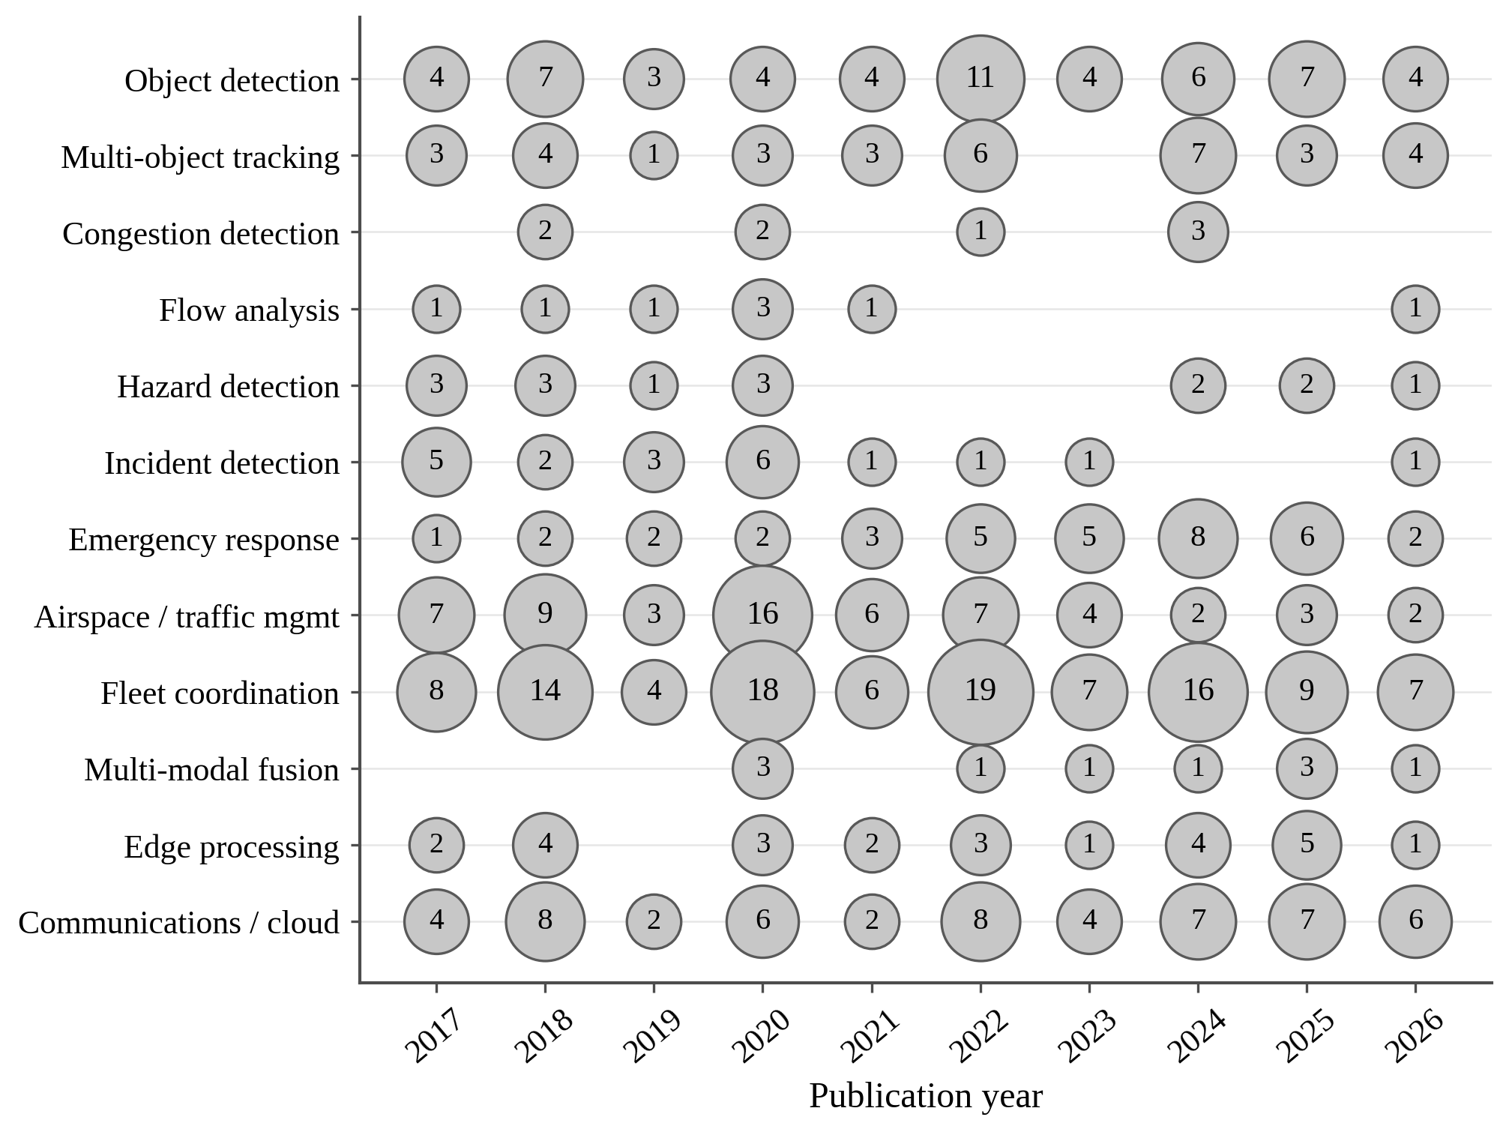
Fig. 3. Temporal coverage of the reviewed corpus: papers addressing each capability by publication year, including 30 representative 2024–2026 works (n = 158). Counts are topic-level capability tags over all 158 papers, so a paper contributes to every capability it addresses. The emergency-response row therefore totals 36, of which 26 fall in the 128-paper core; the narrower count of 14 reported in Sections II.E and III.D is the subset of those 26 that a hand audit confirmed as addressing emergency response as a capability rather than as a topic.
F. Capability Coverage Analysis
AI is the method behind most of these capabilities, but its reach is uneven. Fig. 4 shows the distribution of methods across air, ground, and maritime. Of the 128 core papers (the set read and classified by method), 79 use a learning-based method (38 built on deep learning or reinforcement learning, 41 on classical machine learning) while 49 remain analytical or rule-based. The divide follows the pipeline. Perception is AI-saturated: object detection, tracking, and congestion estimation are learning-based in roughly two-thirds of their papers. The decision and infrastructure capabilities are far thinner, typically under a third: hazard, incident, and flow analysis remain largely analytical or rule-based.
AI has matured where the loop is already closed and stayed thin where it breaks. Table II lists the data source, sensor type, and method of the representative high-impact studies in each domain, and Table III makes the divide concrete at the level of individual studies, showing which of the twelve capabilities a representative sample of high-impact papers actually implements: dense in the perception cluster, sparse in the decision-and-response cluster.
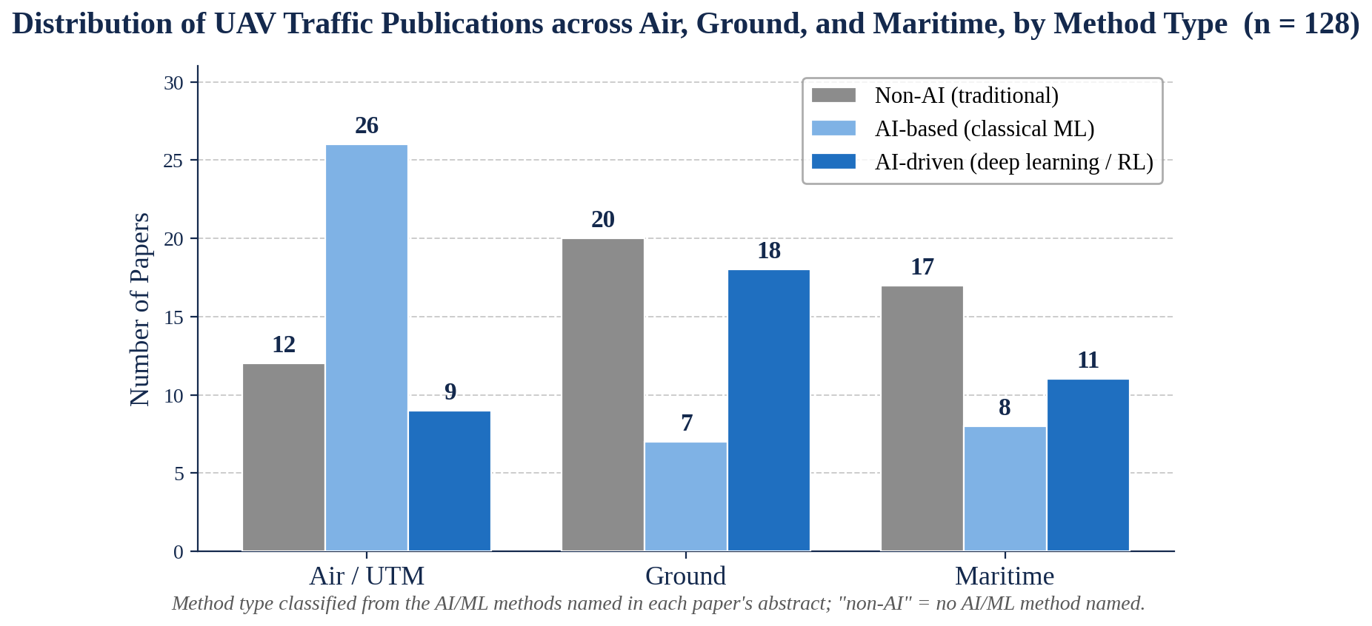
Fig. 4. Distribution of the 128 reviewed papers across air, ground, and maritime, by method type (non-AI, AI-based, AI-driven).
TABLE II. Data Sources and Methods of Representative High-Impact Studies
Study | Domain | Task | Data source & sensor | Method | RT
Benjdira [4] | Ground | Vehicle detection | UAV aerial RGB imagery | YOLOv3, Faster R-CNN | Y
Sun [5] | Ground | Small-object detection | UAV aerial RGB imagery | RSOD (CNN) | Y
Mou [8] | Ground | Vehicle segmentation | Aerial image + video (remote sensing) | CNN / deep learning | N
Xu [9] | Ground | Vehicle detection | Low-altitude UAV imagery | Faster R-CNN | P
Zhang [102] | Air | Navigation / path planning | Simulation (dynamic obstacles) | RL path planning | N
Li [70] | Air | Ground-target tracking | Simulation | Deep RL (DDPG) | P
Li [75] | Air | Maneuvering-target tracking | Simulation | Deep RL (MN-DDPG) | Y
Manesh [99] | Air | GPS-spoofing detection | GNSS / RF signals | ML classifier | P
Yang [130] | Maritime | Search-and-rescue coord. | UAV + USV, mobile computing | Group computing / coord. | P
Li [114] | Maritime | Ship detection | Multi-resolution remote sensing | Deep CNN (HSF-Net) | N
Chen [115] | Maritime | Small-ship detection | Shipborne camera (vs radar) | Deep-learning recognition | P
Wang [116] | Maritime | USV–UAV search-and-rescue | UAV camera + USV | DL visual navigation | P

RT = real-time emphasis reported by the study (Y yes, P partial, N not reported).
TABLE III. Capability Coverage of Representative Studies
Study | Domain | Perception & Sensing |  |  |  |  |  | Decision, Response & Infrastructure
Study | Domain | Object detection | Multi-object tracking | Congestion detection | Flow analysis | Hazard detection | Incident detection | Emergency response | Airspace / traffic mgmt | Fleet coordination | Multi-modal fusion | Edge processing | Communications / cloud
Benjdira [4] | Ground | Y | N | N | N | N | N | N | N | N | N | N | N
Sun [5] | Ground | Y | N | N | N | N | N | N | N | N | N | N | N
Mou [8] | Ground | Y | N | N | N | N | N | N | N | N | N | N | N
Xu [9] | Ground | Y | N | N | N | N | N | N | N | N | N | N | N
Zhang [102] | Air | N | N | N | N | N | N | Y | N | Y | N | N | N
Li [70] | Air | N | Y | N | N | N | N | N | N | Y | N | N | N
Li [75] | Air | N | Y | N | N | N | N | N | N | Y | N | N | N
Manesh [99] | Air | Y | N | N | N | N | N | N | N | N | N | N | N
Yang [130] | Maritime | N | N | N | N | N | Y | Y | N | Y | N | N | N
Li [114] | Maritime | Y | N | N | N | N | N | N | N | N | N | N | N
Chen [115] | Maritime | Y | N | N | N | N | N | N | N | N | N | N | N
Wang [116] | Maritime | Y | N | N | N | N | N | Y | N | N | N | N | N
Y capability addressed; N not addressed. Left band: perception & sensing; right band: decision, response & infrastructure.

G. Keyword Analysis
Read directly, the word cloud (Fig. 5) sorts the field's vocabulary into three groups. The AI-method group is the most prominent after the platform terms: reinforcement learning, deep learning, machine learning, and convolutional neural networks, together with the AI-driven behaviours they produce, namely collision avoidance, trajectory and path planning, and autonomous navigation. The traffic-perception group follows: object, vehicle, and aircraft detection, object recognition, and computer vision.
The third group is domain and infrastructure vocabulary: air traffic control and air navigation, intelligent transportation systems, communications and antennas, and swarm and multi-agent coordination.
The decision-side vocabulary needs a distinction the cloud makes visible. Terms for vehicle decision are prominent — collision and obstacle avoidance, trajectory, path and motion planning, autonomous navigation — because the field has invested heavily in how an aircraft decides where to fly. Terms for response decision are not: emergency services appears at the smallest size in the cloud, and the vocabulary of dispatch, first response and incident escalation is effectively absent. The corpus has a rich language for an aircraft deciding its own trajectory and almost none for a system deciding to act on what that aircraft sees, which is the coverage finding arriving from a second direction.
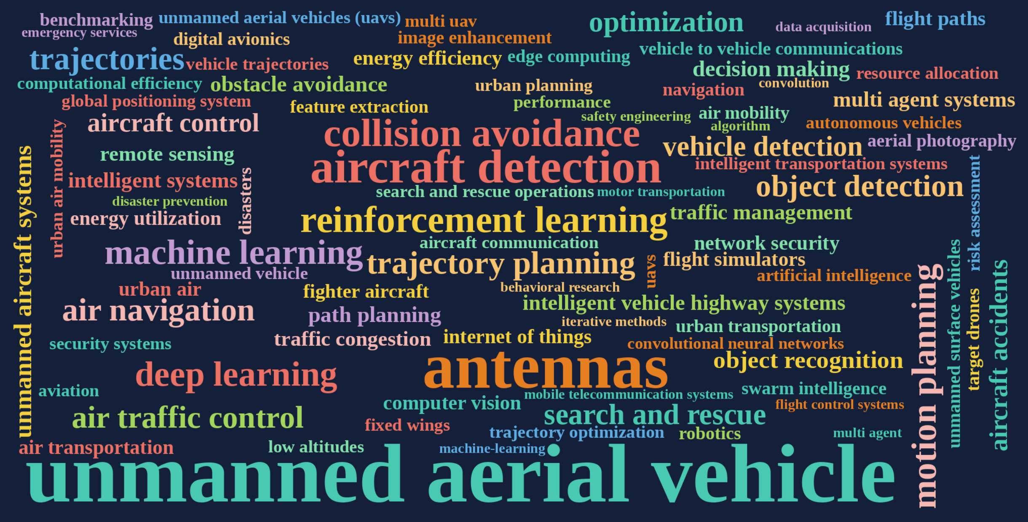
Fig. 5. Keyword word cloud of the UAV-traffic corpus; term size is proportional to occurrence across 15,825 records.
III. PRODUCT COMPARISON AND RESEARCH-TO-PRODUCT GAP ANALYSIS
A. Comparison with Prior Surveys
Table IV sets this survey against six prior UAV-traffic surveys across eight criteria; it differs on four axes at once. It is the only survey to organise the field by capability rather than by application or method, the only one to span air, ground, and maritime traffic together, the only one to evidence the emergency-response loop-closure gap, and the only one to audit commercial platforms against a capability framework. Each of the prior surveys introduced in Section I is strong within its own scope; the contribution here is the combination, not any single axis.
TABLE IV. Comparison of This Survey with Representative Prior UAV-Traffic Surveys
Criterion | Kanistras '13 | Barmp. & Gerol. '20 | Outay '20 | Zheng '24 | Soni '25 | Sapkota '25 | This survey
UAV traffic focus | Y | Y | Y | Y | Y | P | Y
AI methods reviewed | N | P | P | Y | Y | Y | Y
Multi-domain (air/ground/maritime) | N | N | N | N | N | P | Y
Capability taxonomy | N | N | N | N | N | N | Y
Agentic AI framing | N | N | N | N | N | Y | Y
LLM integration | N | N | N | N | N | Y | Y
Loop-closure gap | N | N | N | P | N | N | Y
Commercial platform audit | N | N | N | N | N | N | Y

B. Commercial Platform Comparison
Fourteen commercial platforms were assessed against the same twelve capabilities used for the literature, to test whether deployment has closed a loop the research has not. Table V gives the full scoring; the set spans four groups.
UAV hardware provides strong perception-layer sensing and no autonomous response. It covers multi-payload aircraft such as DJI's Matrice 350 RTK, autonomous platforms with on-board inference such as Skydio's X10, drone-in-a-box installations such as Percepto Air and AIM, tethered persistent systems such as Elistair's Safe-T 2, thermal traffic sensors such as Teledyne FLIR's ThermiCam AI and TrafiBot, the Beyond Vision VTOne, and LiDAR survey aircraft such as Leica's BLK2FLY.
UTM and airspace software provides airspace management, fleet coordination, and a cloud path, and implements no perception at all. Thales TopSky-UAS, Airbus U-Space UTM, and Altitude Angel GuardianUTM are representative, and all three are built to the deconfliction, geofencing, and remote-identification standards their regulatory setting requires.
Cloud AI supplies the infrastructure substrate rather than the application. AWS Rekognition with IoT Greengrass and Microsoft Azure Digital Twins with IoT Hub both offer video analytics and device management, but neither implements the traffic-specific decision capabilities.
Maritime autonomy extends the audit to water. Saildrone's Surveyor and Sea Machines' SM300 and AI-ris provide vessel detection, AIS fusion, and autonomous navigation, and classification-society approval marks real operational maturity. Neither integrates autonomous emergency dispatch.
Three readings follow from Table V, and the third explains the other two.
Perception is commercially mature, in narrow bands. Object detection is fully implemented by seven of the fourteen platforms and partially by two more, and edge processing is the most widely implemented capability of the twelve, at eight full and five partial. A team building overhead vehicle or vessel detection today is rebuilding something several vendors already ship.
The capability sets are almost disjoint. No platform in the audit scores a full implementation on any perception capability and on airspace management and cloud together. Hardware vendors implement the perception band and stop; UTM vendors implement airspace, fleet, and cloud and implement none of the perception band; cloud vendors supply the substrate and little else.
Emergency response is the only capability with no implementation at all. Every other capability in the taxonomy is scored Y or P by at least one platform. Emergency response is scored N by all fourteen, which is a stronger result than the literature alone supports, because a commercial absence cannot be explained by publication bias.
The disjointness explains the blank. Closing the emergency loop requires perception, fleet control, and a cloud path to an external dispatch system at once, and no vendor currently occupies more than one of those bands. The capability is not hard; it falls between three industries.
TABLE V. Capability Coverage of Fourteen Commercial UAV, UTM, Cloud, and Maritime Platforms
Platform | Group | Perception & Sensing |  |  |  |  |  | Decision, Response & Infrastructure
Platform | Group | Object detection | Multi-object tracking | Congestion detection | Flow analysis | Hazard detection | Incident detection | Emergency response | Airspace / traffic mgmt | Fleet coordination | Multi-modal fusion | Edge processing | Communications / cloud
Matrice 350 RTK (DJI) | UAV hardware | P | P | N | N | P | N | N | N | Y | Y | P | P
X10 (Skydio) | UAV hardware | Y | Y | N | N | N | N | N | N | Y | N | Y | P
Air / AIM (Percepto) | UAV hardware | P | N | N | N | P | N | N | N | Y | N | P | P
VTOne (BVT516) (Beyond Vision) | UAV hardware | Y | Y | Y | N | Y | Y | N | N | N | P | P | N
Safe-T 2 / Ligh-T (Elistair) | UAV hardware | Y | Y | Y | Y | N | N | N | N | N | N | P | N
ThermiCam AI / TrafiBot (Teledyne FLIR) | UAV hardware | Y | Y | Y | Y | N | N | N | P | N | N | P | N
BLK2FLY (Leica Geosystems) | UAV hardware | N | N | N | N | N | N | N | N | N | Y | N | N
TopSky-UAS (AstraUTM) (Thales) | UTM / airspace | N | N | N | N | N | N | N | Y | Y | N | Y | Y
U-Space UTM (Airbus) | UTM / airspace | N | N | N | N | N | N | N | Y | Y | N | Y | Y
GuardianUTM (Altitude Angel) | UTM / airspace | N | N | N | N | N | N | N | Y | Y | N | Y | Y
Rekognition + Greengrass (AWS) | Cloud AI | Y | N | Y | Y | N | N | N | N | P | Y | Y | Y
Digital Twins + IoT Hub (Microsoft Azure) | Cloud AI(web/cloud based) | N | N | N | N | N | N | N | N | P | Y | Y | Y
Surveyor (Saildrone) | Maritime autonomy | Y | Y | N | N | P | N | N | P | P | Y | Y | P
SM300 / AI-ris (Sea Machines) | Maritime autonomy | Y | Y | N | N | P | N | N | P | P | Y | Y | P

Y fully implemented, P partial, N not implemented. Emergency response is scored against the definition used in this paper: the autonomous transition from a detected incident to structured emergency-service dispatch. UTM platforms provide aircraft contingency management (emergency landing, return-to-home), which a looser definition would score differently. Assessed from public documentation, not direct testing.
C. Development of UAV Traffic Systems
A snapshot is only half of what a developer needs; the trajectory matters as much as the position. Three lines of development are visible across the audited platforms and the corpus.
Airframes gave way to autonomous systems. The earliest commercial traffic UAVs were piloted multi-payload aircraft whose intelligence sat in the ground station. The current generation is structurally different: drone-in-a-box installations that launch, inspect, and return without an operator, and tethered systems that trade mobility for persistence over a fixed point. The unit of deployment has shifted from an aircraft to a system that happens to include one.
Computation moved onto the aircraft. This is the clearest trend in the audit. Thirteen of the fourteen platforms implement edge processing fully or partially, and the recent hardware ships named on-board inference stacks rather than generic compute. The consequence for traffic intelligence is that the aircraft now transmits events rather than video, which changes the bandwidth budget and makes fleet-scale operation feasible.
Airspace management professionalised separately. Over the same period UTM matured from research prototype to a regulated service class under EASA U-space and FAA UTM, and the vendors serving it built deconfliction, geofencing, and remote identification to a standard the perception vendors never had to meet. This was an advance, but it happened in a different industry from the one building the sensors.
Set against those three lines, the decision layer has not developed at all. It was absent from the earliest systems and it is absent from the current ones, and the corpus shows the same pattern: the temporal analysis in Section II.E finds decision-layer capabilities appearing late and staying small while perception and infrastructure recur in volume every year. Growth in this field has been growth in sensing quality, autonomy of flight, and airspace governance. None of those three is the capability that closes the loop.
D. The Research-to-Product Gap
Across the twelve capabilities, one stands out not because it is unstudied but because it is never completed. Emergency response is the autonomous transition from a UAV-detected incident (a road collision, an airspace conflict, a vessel in distress) to a structured dispatch of the appropriate emergency service, with a priority routing corridor, and without a human required on the critical path. This is where perception is supposed to become action.
What the corpus contains. Twenty-six of the 128 core papers carry an emergency-response tag, but a hand audit against the definition above reduces this to fourteen that treat it as a capability rather than as a topic: eight in the maritime domain, four in air, two in ground. The maritime concentration is real and reflects a mature search-and-rescue literature in which UAVs and unmanned surface vehicles cooperate to locate and reach casualties [116], [130], [134]. The ground and air entries are thinner: a 5G/IoT accident-detection system that reports to first responders [35] and urban-air-mobility and drone-network studies that treat emergency operation as one use case among many.
Why none closes the loop. Read against the emergency-response definition, none of the 14 demonstrates autonomous detection-to-dispatch. The maritime work coordinates rescue assets once a mission is underway; it does not autonomously initiate that mission from perception. The closest ground system detects an accident and transmits an alert to responders, but the dispatch decision remains with a human operator. We found no paper (and, in Section III.B, no commercial platform) in which detection automatically triggers structured emergency-service dispatch. The claim here is narrow, and it survives the counterexamples: emergency response is studied; the loop is not closed.
Why the gap persists. The missing capability is not a missing technology: detection, incident classification, route computation and edge-to-cloud messaging are each mature within the corpus. Three barriers external to the sensing stack hold the loop open. Liability: no aviation or maritime authority yet defines accountability for an AI-issued dispatch, so a deployable system cannot be validated in the field. Integration: emergency dispatch runs on proprietary, jurisdiction-specific computer-aided-dispatch systems that academic groups cannot access, unlike the public datasets behind the perception capabilities. False-positive cost: an erroneous autonomous dispatch consumes scarce emergency resources, raising the accountability threshold far above that of a missed detection. The three reinforce each other — no prototypes means no evidence base, which means no regulatory movement — which is why the gap is structural rather than incidental.
Consequence. Because emergency response requires the full sensing pipeline to feed a decision-layer action, it is the most demanding test of whether a UAV traffic system is an agent or an instrumented sensor. On this test, across three domains and 128 papers, the field does not yet pass.
IV. MOVING TO AN AGENTIC APPROACH
A. What We Mean by Agentic
The word agentic is used loosely across this literature, so we fix a definition and then apply it consistently.
A system is agentic, for our purposes, when it has four properties that an automated system lacks. It holds a persistent goal rather than executing a request. It performs contextual reasoning over heterogeneous inputs rather than applying a fixed rule to a single stream. It follows a policy that adapts from outcomes rather than a static configuration. And it acts without a human confirming each step, within a defined authority.
The fourth property is the one that matters here and the one most systems calling themselves agentic do not have. A pipeline that detects an incident, classifies it, and raises an alert is automated, however sophisticated its models. Such a pipeline becomes agentic only when it is permitted to act on the classification.
Two technologies make the reasoning and decision layers practical. Large language models supply zero-shot reasoning over heterogeneous context and, as importantly, a natural-language audit trail, which matters where a regulator will ask why a dispatch was issued. Multi-agent reinforcement learning supplies fleet-level coordination, with centralised training and decentralised execution keeping deployment communication-light. Both are established. The finding of this survey is that the composition, not the components, is what has not been built.
B. Why an Agentic Approach Is Efficient Now
The roadmap in this section rests on a claim that an agentic approach is the efficient path now. Both halves of that claim need support: why it is efficient, and why now rather than three years ago. The evidence assembled in Sections II and III answers both.
The field has already paid for perception, repeatedly. Seven of the fourteen audited platforms implement object detection fully and two more partially, each built independently by a different vendor. In the literature the same duplication appears: of the 128 papers classified by method, 79 use a learning-based approach, and perception capabilities are learning-based in roughly two-thirds of their papers. Overhead detection of a vehicle, an aircraft, or a vessel has been built and shipped many times over, at least under favourable conditions. A team entering this field today and starting with a detector is buying something that already exists in a dozen forms.
The enabling layers matured recently, and can now be procured rather than researched. Thirteen of the fourteen platforms implement edge processing fully or partially, and current hardware ships named on-board inference stacks; this was not true of the generation before it. Large language models made contextual reasoning over heterogeneous traffic state practical, and supply the natural-language audit trail a regulator will require. Multi-agent reinforcement learning made fleet-level coordination tractable. UTM moved from research prototype to a regulated service class under EASA U-space and FAA UTM. Each of those four is recent, and each was a precondition. The composition proposed here was not available to be built earlier, which is the answer to why now.
The remaining work is therefore composition, not construction. Of the seven steps in the emergency-response loop set out below, five already exist in the reviewed literature: confirmation from fused perception, incident classification, corridor computation, fleet re-tasking, and outcome logging. Only two do not — the decision to dispatch and the dispatch itself. A team that recognises this builds two steps and integrates five. A team that does not recognise it rebuilds the whole stack, and the audit suggests that is what most have done.
This is where the practical value of the survey lies, and much of it is negative. Table V says which capabilities are already commercially available and should be bought or integrated. The corpus statistics say which research problems are saturated. The loop-closure analysis says where the remaining gap is. Read together, they tell a team to spend nothing on overhead detection, nothing on airspace deconfliction, and everything on the decide-to-dispatch transition and the governance that permits it.
C. What Kinds of Agents
The agent set is derived, not invented. Section II.A described conventional traffic management as four layers staffed by people, and the most reliable way to enumerate the agents a UAV traffic system needs is to ask what those people do and then divide that work. A control room today has an operator watching a radar screen continuously: they notice when an aircraft drops off the display, when one drifts off its filed track, when two are converging, when weather is closing in, and when a situation has become an emergency other services must be told about. Each is a standing, bounded task with its own trigger and its own required authority — the shape of an agent. We take each task and ask whether it can be performed with what the aircraft alone knows or only with the fleet-wide picture, and assign it accordingly. That question, not a preference for edge or cloud, is what places an agent.
Two distinctions keep the design honest. The first is between models and agents: traffic vision, sensor and language models are machine-learning components that produce an output, while an agent consumes that output, decides, and acts under a stated authority — which is why Fig. 8 keeps them in separate blocks. The second is between where a model runs and where a decision is taken: computer vision runs on the aircraft, and the back end never receives pixels, only the events those models produce.
Agents divide, then, by where they run, because location determines what an agent can be trusted to do and on what latency budget. That division is also the division named in this paper's title: the front-end agents are UAV intelligence, running on the aircraft, and the back-end agents are the traffic management system, running in the cloud. The two strands of the subject are two tiers of one agent society, and the loop-closure gap the survey reports is a gap in the handover between them.
The front-end is everything on board, and it is where all perception lives. It operates within the aircraft's power and compute budget, must function through an intermittent link, and is responsible for the aircraft's own safety. Its agents are fully autonomous by necessity: a collision-avoidance decision cannot wait for a cloud round-trip, which is why on-board autonomy is a design constraint rather than a convenience. The vision agent checks every direction around the airframe — ahead, behind, above and below — for an approaching aircraft, a bird, or a structure at close range, and what it passes onward is an event, not a video stream. Fig. 6 gives the front-end subtree and Table VI specifies each agent.
The back-end owns everything outside the individual aircraft: the fleet, the airspace, the traffic picture, and the interface to external services. It sees what no single aircraft can, so collision safety across converging UAVs, path selection over a region, and emergency dispatch all belong here. It holds no computer vision of its own: its event-classification agent classifies the alerts arriving from the aircraft by type, severity and context, so its input is a feature summary rather than an image. Fig. 7 gives the back-end subtree and Table VII specifies each agent.
Three properties make this a society rather than a pipeline. Authority follows latency: an agent that must act inside a control loop is granted autonomy, and one whose error is expensive but recoverable by humans is not, which is why the front end is uniformly autonomous and the emergency-assistance agent is not. Agents own capabilities, not components, each defined by what it produces from the taxonomy, so the design is auditable against the same scheme used to survey the field. Coordination is through shared traffic state: an agent publishes what it observes or decides and the agents that need it subscribe, which lets the same society instantiate over road, airspace and maritime bindings without rewiring.
Three relations in Fig. 7 do not appear in a layered architecture diagram and are stated explicitly here. The first is the trigger path: six agents can raise a candidate emergency — collision safety, safety, geofence/violation, weather, security, and traffic monitoring on a confirmed loss of contact — and each hands its candidate to the emergency-assistance agent, which classifies it and owns the response. Raising a candidate is not the same as dispatching: most candidates are logged and monitored. Detection and response are separate agents because the authority required differs.
The second is the interaction protocol. A conventional system works because a human pilot and a controller talk under an agreed protocol; with a robot pilot that channel does not disappear, it changes ends. The traffic control and coordination agent carries it — clearances, advisories, a flag-and-acknowledge exchange when an aircraft must be challenged, and hand-back to human control — and it is the only real-time conversational path between the two tiers. The third is the endpoint: the emergency-assistance agent terminates at a computer-aided-dispatch interface, which is the step no reviewed system or audited platform reaches.
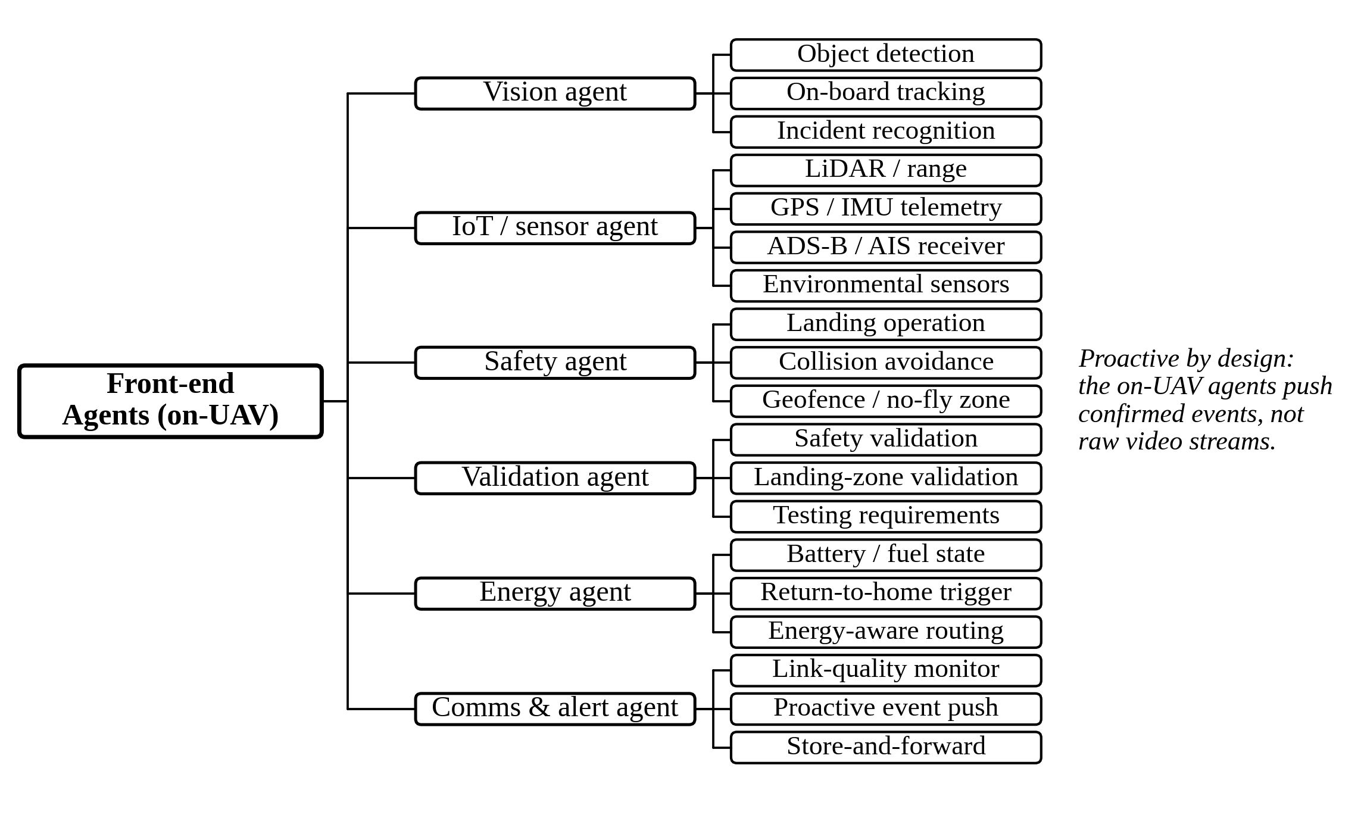
Fig. 6. Frontend agent subtree: the six agents running on-board the UAV with their sensor and function nodes; the edge tier pushes confirmed events rather than raw video.
TABLE VI. Front-End (On-UAV) Agent Definitions
Agent | Function | Data / sensor input | Trigger condition | Autonomy
Vision | On-board detection, tracking and incident recognition (camera-related) | RGB / thermal imagery | Continuous, frame-rate gated | Autonomous
IoT / sensor | Acquires and time-syncs range, position and environmental streams (sensor-related) | LiDAR / radar, GPS / IMU, ADS-B / AIS, environmental sensors | Continuous in flight | Autonomous
Safety | Safety decision-making and operation: landing operation, collision avoidance, geofence enforcement | Fused vision and sensor input, airspace DB | Threshold breach or descent phase | Autonomous
Validation | Validates safety and landing decisions against testing requirements before they are acted on | Safety-agent output, terrain map, test criteria | Safety or landing decision proposed | Autonomous
Energy | Battery and fuel state estimation; return-to-home triggering | Power telemetry | Reserve threshold crossed | Autonomous
Comms & alert | Link monitoring; proactive event push; store-and-forward | Link telemetry, event queue | Event confirmed or link degraded | Autonomous

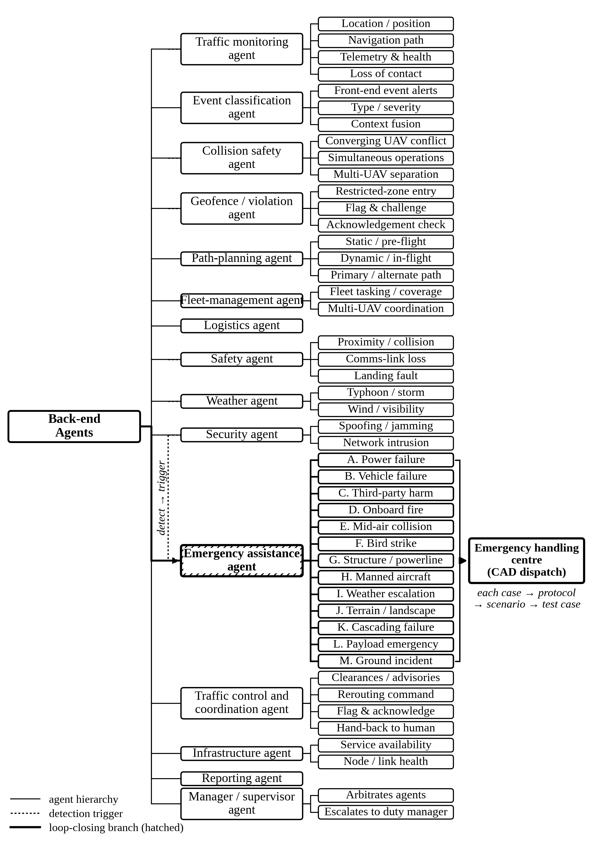
Fig. 7. Back-end agent subtree: the fifteen cloud-UTM agents. Candidate emergencies may be raised by the collision-safety, safety, geofence/violation, weather, security and traffic-monitoring agents; the emergency-assistance agent (hatched) owns the response, with thirteen cases terminating at the computer-aided-dispatch interface.
TABLE VII. Back-End (Cloud) Agent Definitions
Agent | Function | Data / sensor input | Trigger condition | Autonomy
Traffic monitoring | Tracks location and position, navigation path, telemetry and health, and operator check-in | Telemetry, Remote ID, flight plans, position feed | Continuous | Autonomous
Event classification | Classifies the events reported by front-end agents by type, severity and context; holds no computer vision of its own | Event alerts and feature summaries pushed from the aircraft; fleet and airspace state | Alert received from a front-end agent | Autonomous
Collision safety | Predicts converging-UAV conflicts across the fleet and resolves them by deconfliction; the traffic-safety function a human radar monitor performs today | Fleet position feed, flight intents, Remote ID | Predicted conflict between aircraft | Supervised
Path-planning | Selects which path to fly; static pre-flight and dynamic in-flight routing with primary and alternate paths | Airspace map, weather, region suitability, traffic state | Pre-flight; in-flight deviation | Supervised
Fleet-management | Fleet tasking and area coverage; coordination across more than one UAV | Fleet state, coverage map, mission queue | Coverage gap or new mission | Supervised
Logistics | Mission and payload scheduling | Task queue, fleet state | New mission request | Supervised
Safety | Geofence and no-fly zone, proximity and collision safety, comms-loss and landing-fault monitoring | Telemetry, airspace DB, link state | Threshold breach | Supervised
Geofence / violation | Holds geofence and no-fly definitions; detects restricted-zone entry, flags it and requires acknowledgement | Airspace DB, position feed, clearance state | Aircraft enters airspace it is not cleared for | Supervised
Weather | Weather and context hazard forecasting and alerting | METAR and forecast feeds, on-board sensors | Forecast threshold breach | Autonomous
Security | Spoofing, jamming and network-intrusion detection | GNSS / RF signals, network logs | Anomaly detected | Supervised
Emergency assistance | Confirms, classifies and dispatches emergency response (cases A-M) | Candidate emergencies from six agents; fused event context | Candidate raised by collision safety, safety, geofence/violation, weather, security, or traffic monitoring (confirmed loss of contact) | Human-in-the-loop
Traffic control / coordination | Runs the real-time traffic interaction protocol between the traffic-management system and each robot pilot: clearances, advisories, flag-and-acknowledge, and hand-back to human control | Protocol message queue, fleet state, airspace constraints | Continuous while any aircraft is airborne | Autonomous
Infrastructure | Monitors system and service availability across the platform | Service health, link state, node status | Degradation or outage | Autonomous
Reporting | Public interface, incident reporting, dashboard push | Incident log, fleet state | Incident closed or scheduled | Autonomous
Manager / supervisor | Orchestration and arbitration across agents; escalates to the duty manager | All agent states | Conflict between agent actions | Supervised

D. Architecture
The survey's finding is narrow and specific: perception is comparatively mature and commercially available under favourable operating conditions, the decision layer is substantially less developed, and the loop breaks at emergency response. A proposal that answers that finding does not need new detectors or new sensing hardware: it needs an agentic control layer that turns a confirmed detection into an authorised action, and a governance design that lets that layer run.
We specify such a layer by mapping an existing agentic smart-city traffic cloud platform [159] onto the capability taxonomy and extending it across the three domains. This is a design synthesis, not an implemented system; its value is that it is stated against the same taxonomy used to survey the field, so it can be audited claim by claim.
Fig. 8 shows the platform, structured after the agent-oriented traffic cloud platform of [160] and extended to the three domains: a physical sensing layer (instantiated per domain), a data layer, a backend traffic-management system layer, an AI layer that pairs a society of agentic traffic agents with an AI/ML framework (vision/CV, language/LLM, sensing, UAV, decision-making, and reporting models) over an agent-oriented cloud platform, a network layer, and a user-interaction layer, with edge AI running vision inference on-board the UAV.
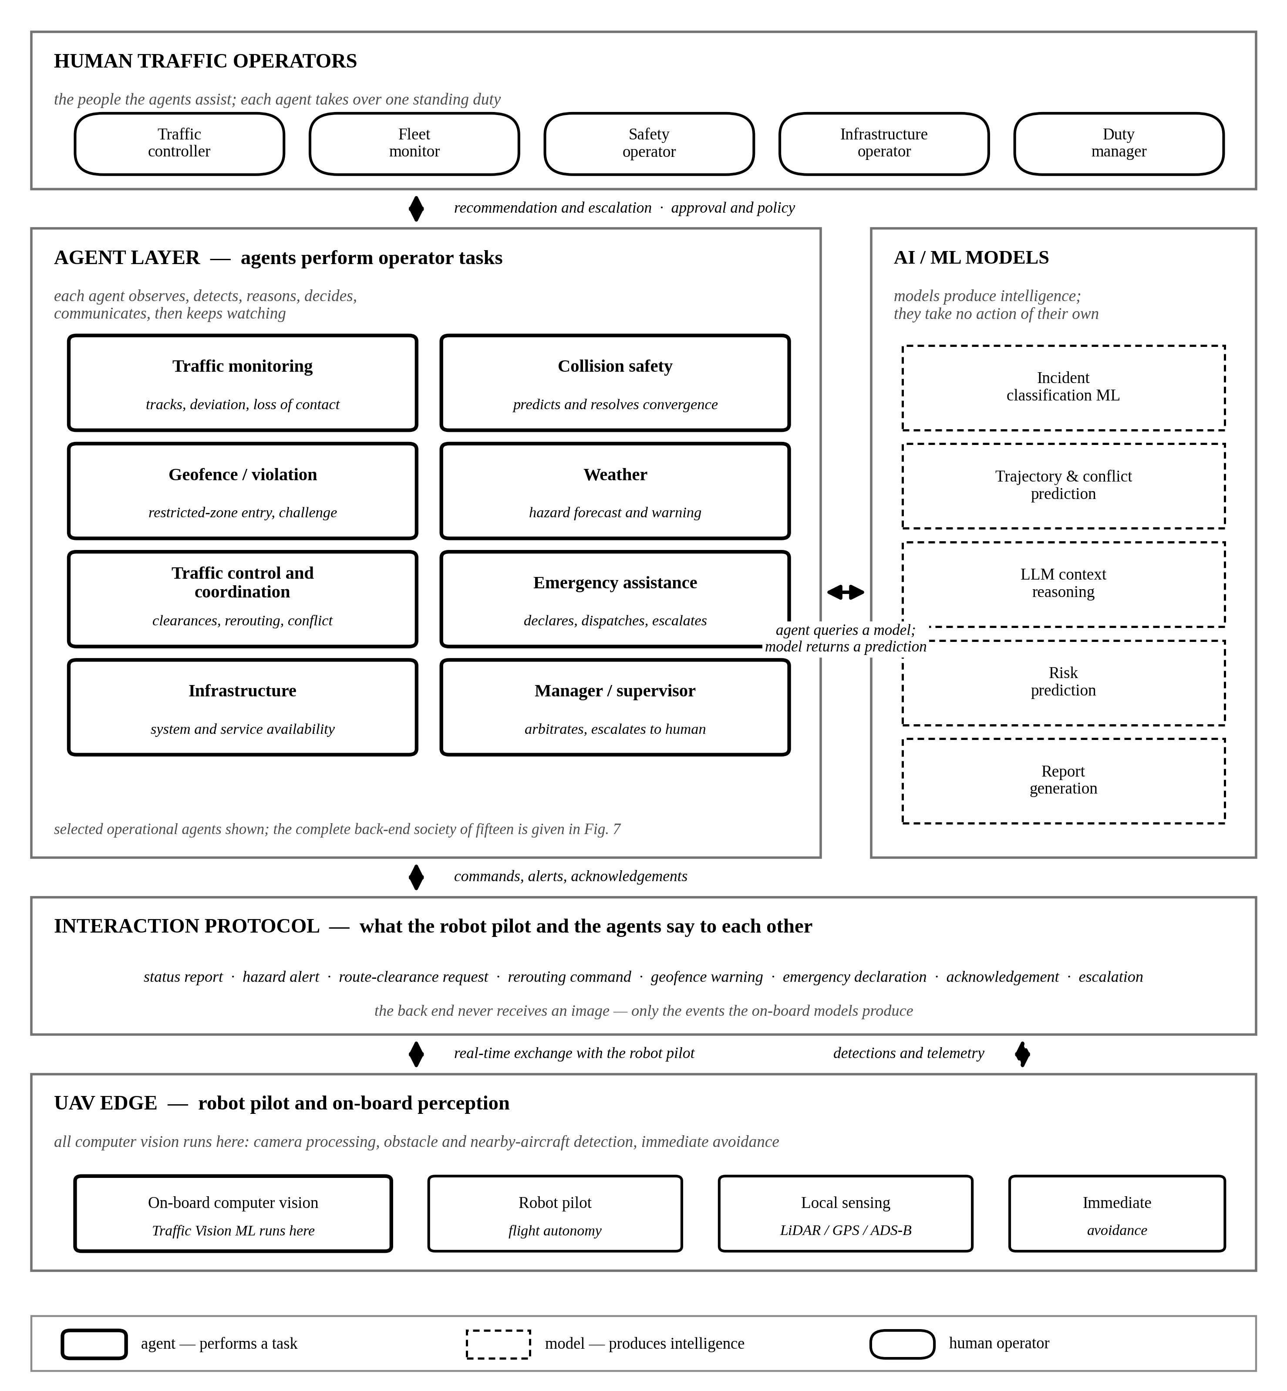
Fig. 8. Proposed agentic UAV traffic platform, structured after the agent-oriented traffic cloud platform of [160] and extended to air, ground, and maritime. Models produce intelligence and agents use it to perform tasks a human traffic operator performs today; each agent observes, detects, reasons, decides, communicates, and continues to monitor. Agents query models sideways and speak to the aircraft directly through the interaction protocol. All computer vision runs on the aircraft, so the back end reasons over reported events rather than imagery.
The distinguishing layer is the agentic one: a society of specialised agents that each own one or more capabilities and coordinate through a shared traffic state. At the platform level [160] this society is generic — sensing, vision, decision, control, emergency, safety-and-security, planning, infrastructure, service, and management roles, the last arbitrating among the rest. The twenty-one front-end and back-end agents of Figs. 6 and 7 are that society instantiated for UAV traffic: the generic roles are the reference, and the twenty-one agents are what this paper specifies and what Tables VI to VIII describe.
A language-model reasoning model sits beside the perception models and supplies the contextual step the survey found missing. It is a model, not an agent: it is invoked by the event-classification, emergency-assistance and manager/supervisor agents, which own the decisions taken on its output: not "a queue is forming" but "a queue is forming because of a collision two hundred metres upstream, so dispatch and reroute." Each layer instantiates by domain: UAV imagery fuses with IoT and V2X on the ground, with ADS-B and airspace radar in the air, and with USV and AIS at sea.
E. The Agentic Workflow
The contribution of the proposal is the loop the literature leaves open. We specify it as a seven-step cycle owned by the emergency-assistance agent, using the same agent names as Tables VI and VII. Fig. 9 instantiates that cycle on a representative proximity event, showing immediate on-board action, event-only reporting, back-end classification, conditional escalation, human-authorised dispatch, and outcome feedback; the four remaining scenarios of Section IV.F traverse the same structure. First, the vision and IoT/sensor agents confirm a candidate incident from fused perception, suppressing single-frame false positives by cross-sensor agreement. Second, the event-classification agent, invoking the language-model reasoning model, classifies the incident's type, severity, and context. Third, the emergency-assistance agent decides whether the case warrants dispatch, against a severity threshold tuned to the false-positive cost the survey identified.
Fourth, on a positive decision it dispatches a structured request to the appropriate service through a computer-aided-dispatch interface. Fifth, the path-planning agent computes a priority route and the traffic control and coordination agent reserves, authorises and communicates it. Sixth, the fleet-management agent re-tasks the fleet: one UAV holds station over the incident while others cover the vacated area. Seventh, the reporting and manager/supervisor agents log and feed back the outcome as a training signal, closing perception → decision → action → learning. Every step except the third and fourth (the decision-to-dispatch transition) already exists in the reviewed literature; the proposal's job is to supply that one transition and the authority to run it.
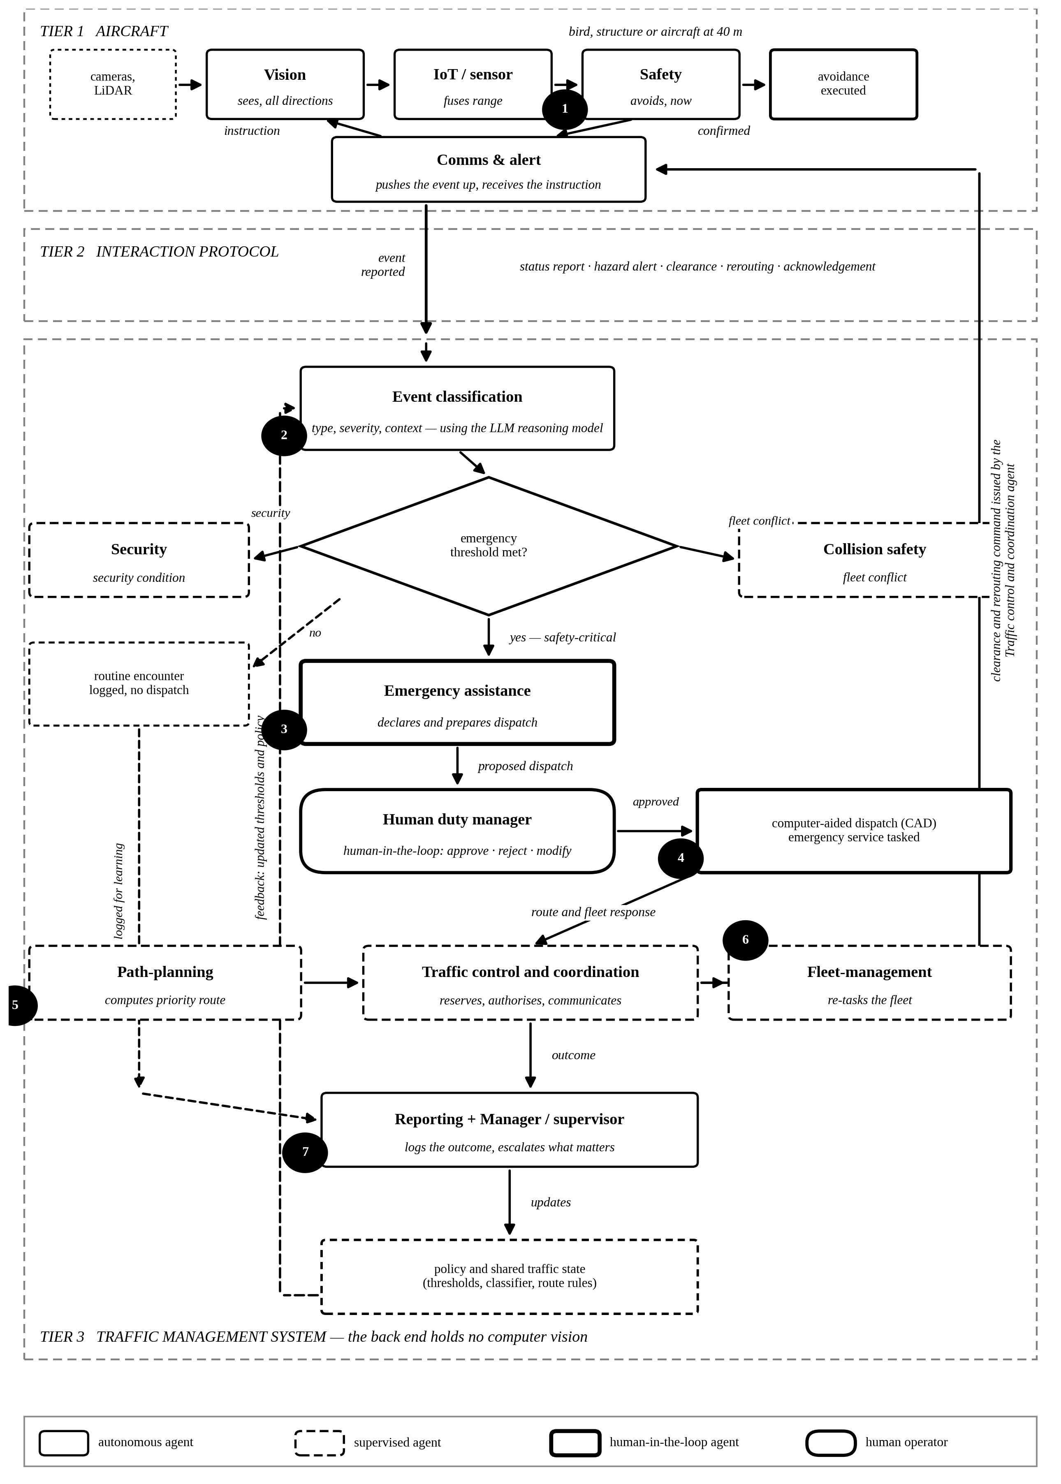
Fig. 9. The agentic workflow instantiated on a representative proximity event: immediate on-board action, event-only reporting, back-end classification, conditional escalation against an emergency threshold, human-authorised dispatch, route reservation and fleet re-tasking, and outcome feedback into policy. Numbered badges mark the seven steps of Section IV.E; the other four scenarios of Section IV.F traverse the same structure.
F. Operational Scenarios
The emergency loop is the hardest case, but it is not the common one. Five everyday scenarios exercise the rest of the society, and each is written here as the trigger, the tier that owns it, and the agents involved. They are drawn from what a control-room operator actually watches for, and they are what the design must handle before the emergency case is worth attempting.
Proximity encounter (front-end). The vision agent sees a bird, a structure, or another aircraft closing at short range in any direction around the airframe. The safety agent commands the avoidance manoeuvre on board, without consulting the cloud, because the time available is shorter than a round-trip. The comms-and-alert agent then pushes the event upward. The back end learns that an encounter happened; it never sees the image that produced it.
Converging pair (back-end). No single aircraft can see this. The collision-safety agent, holding every aircraft's position and intent, forecasts a loss of separation and resolves it, and the traffic control and coordination agent issues the resulting instruction to both aircraft. This is the task the radar operator performs today.
Loss of contact (back-end). An aircraft stops reporting. The traffic-monitoring agent detects the gap in telemetry — the operator's "it disappeared from the screen" — and the distinction that matters is whether the aircraft is lost or merely the link is. The traffic control and coordination agent attempts contact under the protocol; failure to re-establish escalates to the safety agent, and a confirmed loss over a populated area escalates further to the emergency-assistance agent.
Off-track deviation (back-end). The traffic-monitoring agent compares the flown path against the filed one and flags the divergence. The traffic control and coordination agent queries the aircraft, and the answer determines the response: a weather deviation is acknowledged and re-planned by the path-planning agent, while an unexplained one is treated as a possible fault or intrusion and handed to the security agent.
Restricted-zone violation (back-end). An aircraft enters airspace it is not cleared for. The geofence/violation agent holds the no-fly definitions and raises the violation; the geofence/violation agent flags it to the aircraft and requires acknowledgement. Intent is what separates the two cases: an aircraft that acknowledges and withdraws is a fault to be logged, while one that does not is a security event, and the security agent owns it from there. The system needs both readings because the same observation supports either, and only the exchange distinguishes them.
Fig. 10 puts two of these scenarios on a time axis, using the two cases raised in review: a bird at close range and a converging drone. Reading downward shows what a block diagram cannot. In the first, the aircraft is clear at t = 0.4 s while the back end is still classifying, so the on-board action and the back-end record are concurrent rather than sequential. In the second, detection happens only in the back end because no single aircraft sees the whole fleet, approval costs three seconds of human time, and the reserved routes are confirmed a further 1.4 s later when both aircraft acknowledge. Planning and confirmation are asynchronous throughout.
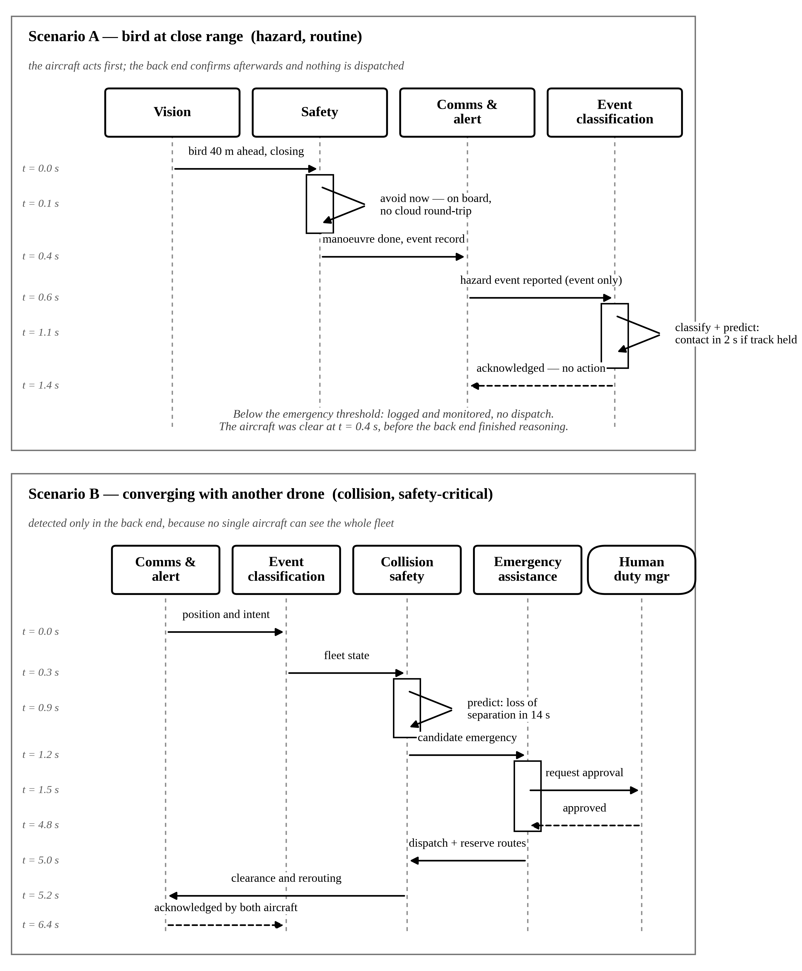
Fig. 10. Scenario diagram for the two cases named in review: a bird at close range (hazard, routine) and a converging drone (collision, safety-critical). Time runs downward, so the asynchrony is visible — in A the aircraft is clear at t = 0.4 s while the back end is still reasoning, and in B the routes are reserved at t = 5.0 s but confirmed only when both aircraft acknowledge at t = 6.4 s.
Three further artefacts make the structure concrete. Table VIII sets the three case classes side by side, and for each gives the condition the system observes, the condition it predicts, how the back end reacts, what is planned, and how confirmation arrives. Confirmation is asynchronous throughout: the aircraft acts when it must and the back end closes the record afterwards, which is why the table separates the reaction from the confirmation rather than treating them as one step.
TABLE VIII. Case Classes: Condition, Predicted Condition, and the Asynchronous Server Response
Case class | Condition observed | Predicted condition | Back-end (server) reaction | Planning | Confirmation (asynchronous)
Hazard — bird | Bird detected 40 m ahead, closing on the flown track | Contact within about 2 s if the track is held | Logs the event; no dispatch; raises a hazard advisory to aircraft nearby | Path-planning agent offers a deviation leg | Aircraft acknowledges; the back end confirms after the manoeuvre, flight continues
Hazard — structure | Fixed obstacle or powerline ~15 m from the planned path | Clearance lost within about 4 s | Logs the event and updates the obstacle layer | Path-planning agent recomputes the leg | Acknowledgement logged; the map update is published later
Hazard — weather | Wind or visibility beyond limits on the corridor | Corridor unflyable within about 10 min | Weather agent raises a corridor advisory | Path-planning agent proposes an alternate corridor | Each affected aircraft acknowledges independently
Collision — another drone | Two aircraft converging; closing rate above threshold | Loss of separation in about 14 s | Collision-safety agent predicts the conflict and resolves it | Traffic control and coordination agent reserves separated routes | Both aircraft acknowledge; resolution confirmed once both comply
Collision — manned aircraft | Manned traffic on ADS-B inside the operating block | Conflict in about 20 s | Collision-safety agent resolves and prepares an advisory to air traffic control | Immediate descent or hold issued to the UAV | Advisory sent; controller acknowledgement is asynchronous
Emergency — vehicle or power failure | Power reserve below the return threshold | Forced landing within about 40 s | Emergency-assistance agent declares a candidate emergency | Path-planning agent computes the nearest safe landing site | Human duty manager approves; dispatch confirmed after approval
Emergency — third-party harm | Person or vehicle at risk beneath the aircraft | Injury unless the situation is managed | Emergency-assistance agent declares and prepares a dispatch request | Corridor reserved for the responding service | Human approves; the dispatch system acknowledges asynchronously
Violation — restricted zone | Aircraft inside a no-fly polygon it is not cleared for | Continued incursion unless challenged | Geofence/violation agent flags the breach and challenges the aircraft | Traffic control and coordination agent issues an exit route | Acknowledged, a fault is logged; unacknowledged, the security agent takes over

Fig. 11 gives the same cycle as a state machine. The back end holds one state per event — monitoring, detected, classifying, predicting, deciding, awaiting approval, acting, logging — and each transition carries a guard. Two properties matter. Every path returns to monitoring, so a routine encounter and a dispatched emergency end in the same place. And only an approved decision reaches the acting state, which is where the human-in-the-loop gate sits.
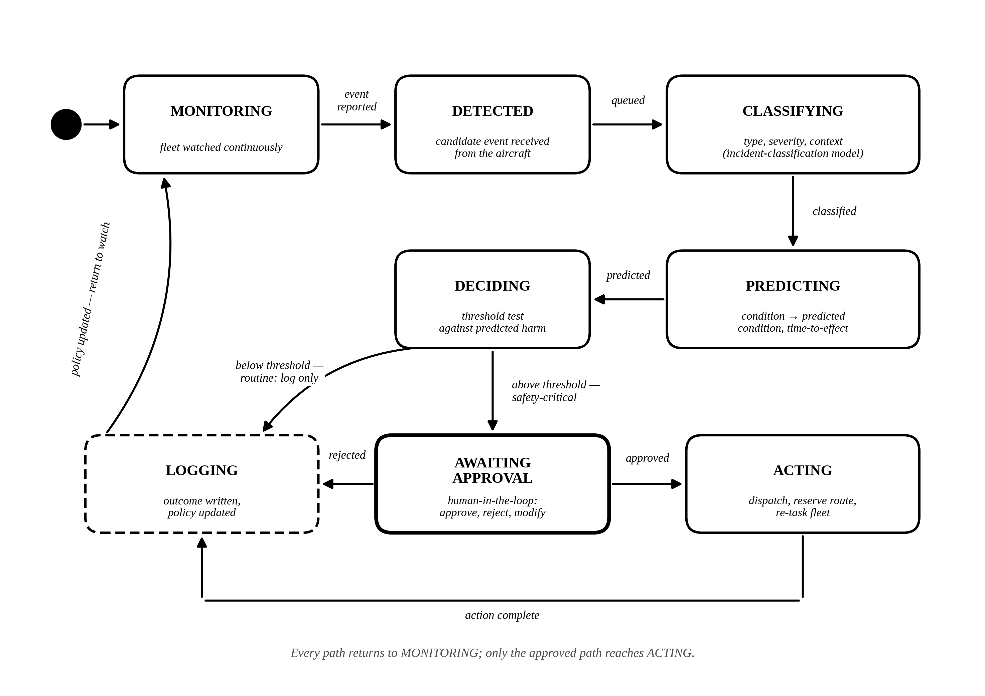
Fig. 11. State diagram of the agentic response cycle: the states the back end holds for one event and the guard on each transition. Every path returns to monitoring; only an approved decision reaches the acting state.
Fig. 12 shows the three case classes as parallel pipelines. Each runs the same three stages — Stage 1 detects and classifies on the aircraft, Stage 2 decides, Stage 3 produces the response and the record — and the classes inside each pipeline are the concrete ones the operator cares about: a bird or a structure for hazard, another drone or a manned aircraft for collision, a vehicle failure or third-party harm for emergency. The prediction step is explicit: a bird at 40 m becomes contact in about two seconds if the track is held, a converging pair becomes loss of separation in about fourteen, a power reserve below threshold becomes a forced landing in about forty.
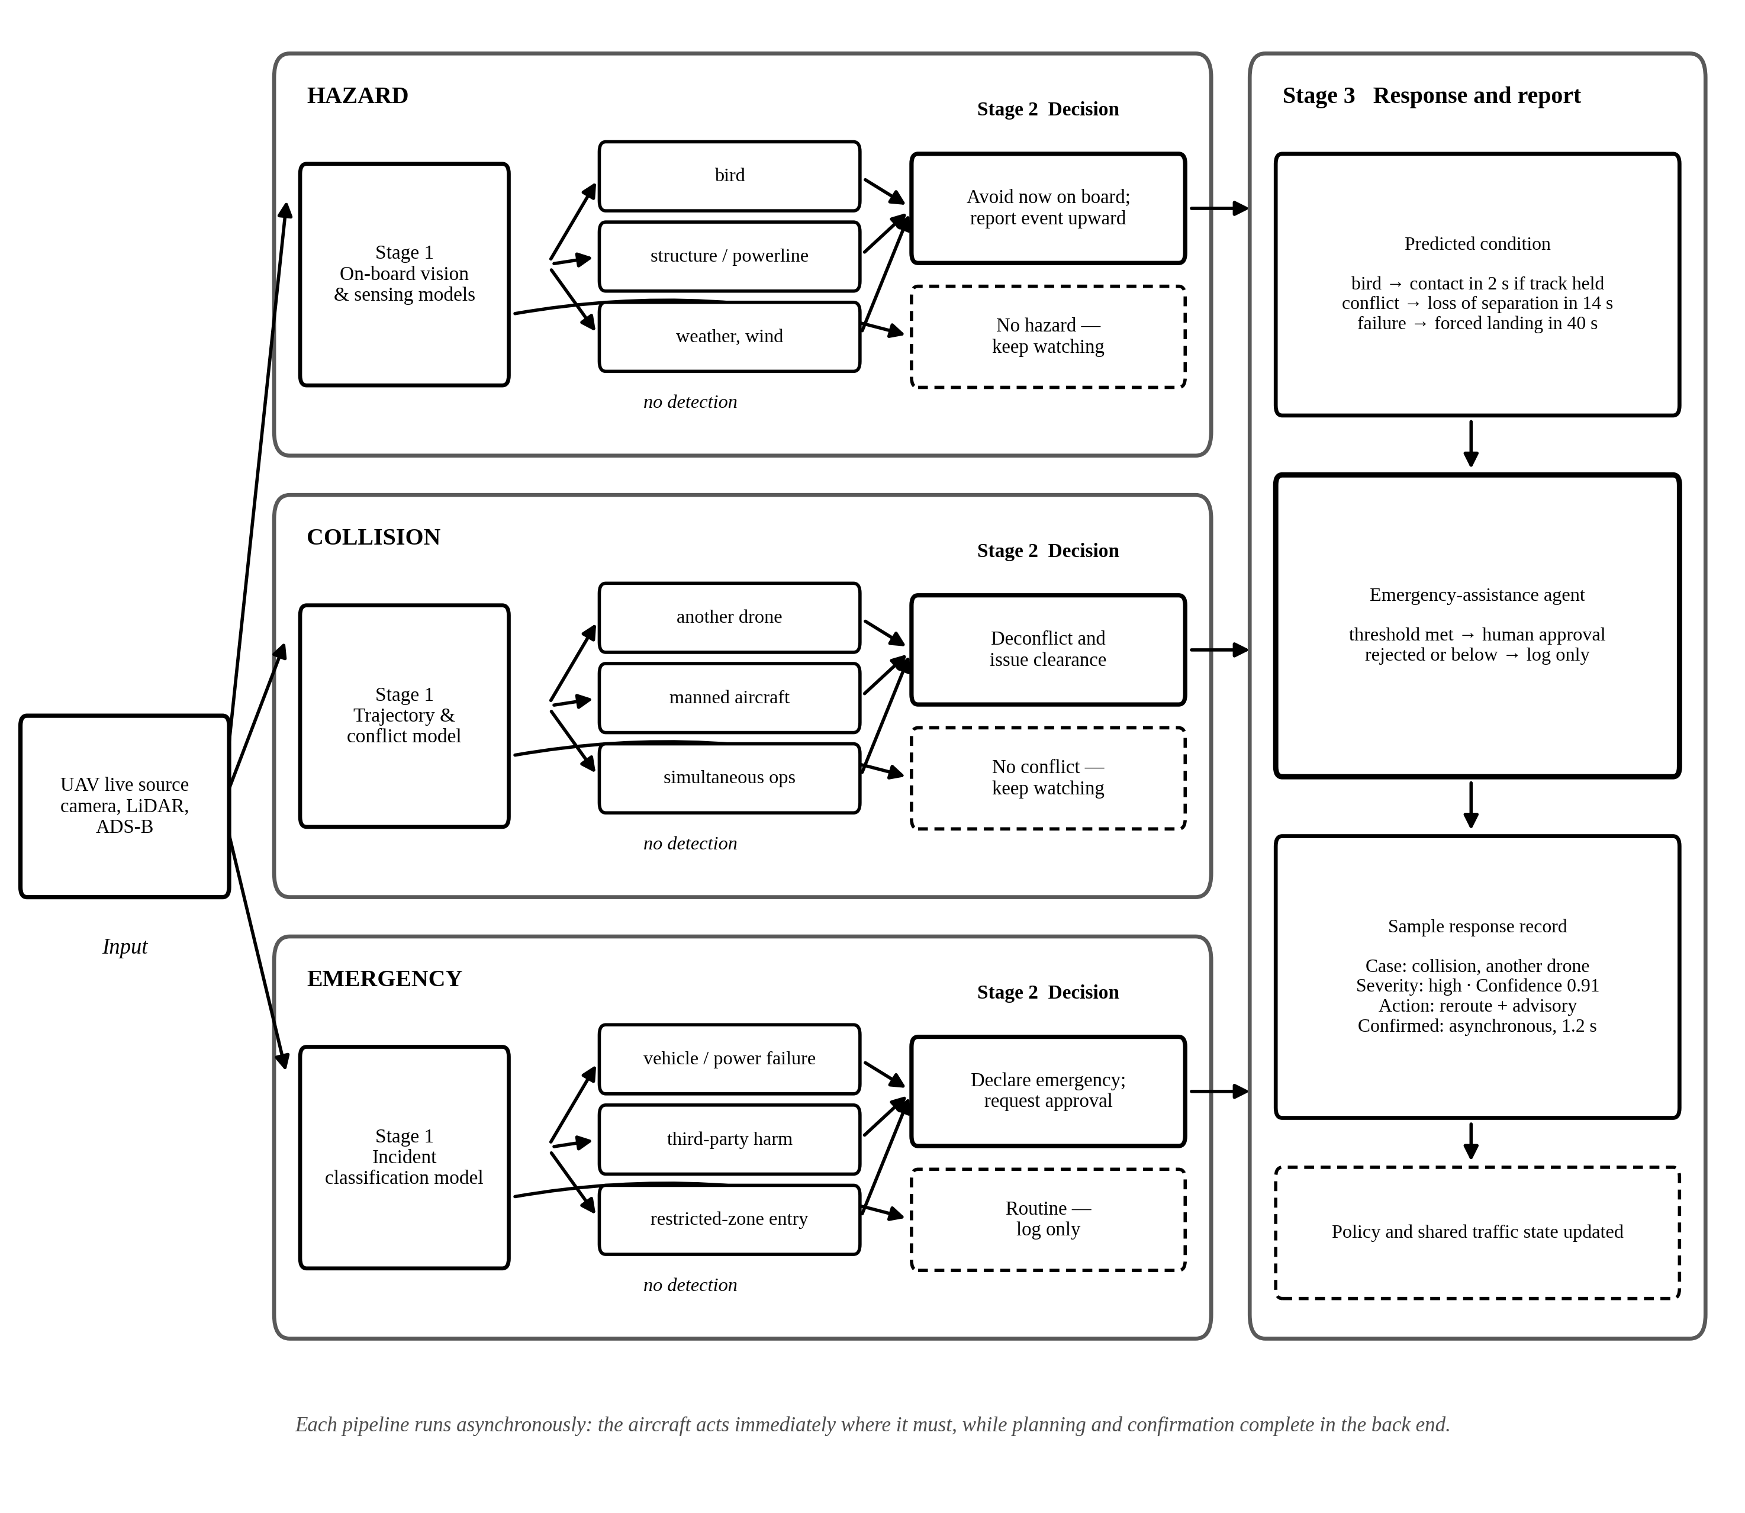
Fig. 12. Workflow for the three case classes. Stage 1 detects and classifies on the aircraft, Stage 2 decides, and Stage 3 produces the response and record. The pipelines run asynchronously: the aircraft acts immediately where it must, while planning and confirmation complete in the back end.
The scenarios share a shape worth naming. Perception is always on the aircraft; the judgement of what an observation means is always in the back end; and the two are joined by the interaction protocol rather than by a video link. Where a scenario ends in dispatch it enters the loop of Section IV.E, and where it ends in an exchange with the aircraft it terminates in the traffic control and coordination agent.
G. Agents and Capabilities
Because each agent owns capabilities drawn from the taxonomy, the design is auditable against the same scheme used to classify the field. Tables VI and VII specify the twenty-one agents in operational terms: each agent's function, the sensor or data input it consumes, the condition that triggers it, and the autonomy it is granted. Table IX then maps those same twenty-one agents onto the twelve capabilities. Every capability in the taxonomy is claimed by at least one agent, and two agents (validation and management) realise none directly, which is the point: they exist to assure and arbitrate the others rather than to sense or act.
The pattern is intentional: perception agents inherit mature methods and run fully autonomously, whereas the emergency-assistance agent (the capability the field leaves open) is the least autonomous by design, gated human-in-the-loop, requiring approval, until the evidence base the survey calls for exists.
TABLE IX. Agent-to-Capability Mapping for the Front-End and Back-End Agents of Tables VI and VII
Agent | Tier | Capabilities realised
Vision | Front-end | Object detection; multi-object tracking; incident detection; edge processing
IoT / sensor | Front-end | Multi-modal fusion; edge processing
Safety | Front-end | Hazard detection; airspace / traffic management (on-board separation)
Validation | Front-end | None directly; assures the safety and landing decisions of the safety agent
Energy | Front-end | Fleet coordination (aircraft availability state)
Comms & alert | Front-end | Communications / cloud; edge processing
Traffic monitoring | Back-end | Airspace / traffic management; multi-object tracking at fleet level
Event classification | Back-end | Incident detection; congestion detection; multi-modal fusion
Collision safety | Back-end | Airspace / traffic management (separation and conflict resolution)
Path-planning | Back-end | Airspace / traffic management; flow analysis
Fleet-management | Back-end | Fleet coordination
Logistics | Back-end | Fleet coordination (mission and payload scheduling)
Safety | Back-end | Hazard detection
Geofence / violation | Back-end | Hazard detection (restricted-zone entry)
Weather | Back-end | Hazard detection (weather and context)
Security | Back-end | Hazard detection (security); communications / cloud
Emergency assistance | Back-end | Emergency response (loop closure)
Traffic control / coordination | Back-end | Communications / cloud (real-time protocol with the aircraft)
Infrastructure | Back-end | Communications / cloud (service availability)
Reporting | Back-end | Communications / cloud
Manager / supervisor | Back-end | None directly; orchestration and arbitration across agents

H. Infrastructure and Governance
The three barriers identified in Section III.D are none of them a missing algorithm, and the design addresses each directly. Liability is handled by graduated autonomy: the emergency-assistance agent begins human-in-the-loop, where a human must approve every dispatch, advances to human-on-the-loop with a bounded veto window, and only later, in constrained settings, to conditional autonomy. Integration is handled by treating the computer-aided-dispatch connector as a first-class, standardised interface rather than an afterthought. False-positive cost is handled by the cross-sensor confirmation step and a tunable severity threshold, which makes the precision-versus-latency trade-off an explicit design parameter instead of an emergent accident.
The same loop instantiates in each domain with different perception inputs and dispatch endpoints. A road collision seen from an overhead UAV dispatches emergency-medical and traffic services and opens a green corridor; an airspace conflict triggers a deconfliction manoeuvre and an advisory to air-traffic control; a vessel in distress launches UAV–USV search-and-rescue coordination and alerts the coastguard. The agent roles and the loop are identical across the three; only their bindings change. That invariance is why the capability taxonomy, not a domain-specific pipeline, is the right specification for the proposal.
V. ISSUES, CHALLENGES, AND NEEDS
A. Safety, Security, and Assurance
UAV traffic intelligence is safety-critical, yet safety enters the reviewed literature unevenly and mostly implicitly, in three strands. The first is regulatory: EASA U-space and FAA UTM require separation assurance, detect-and-avoid, and remote identification before deployment, which is why the air corpus concentrates where it does; ground and maritime research faces no equivalent mandate and treats safety more thinly. The second is formal analysis, the systems-theoretic hazard work on autonomous vessels [127]–[129] described in Section II.D. The third is security: a small body of work treats the UAV itself as an attack surface, through GPS spoofing (Manesh et al. [99]), jamming, and network intrusion, recognising that a system acting on perception can be manipulated through it.
Assurance is the common thread. A perception error in a monitoring system produces a wrong number on a dashboard; the same error in a system that dispatches an emergency service produces a misallocated ambulance or an unnecessary airspace closure. A credible agentic system therefore needs an assurance case, not merely accuracy: bounded false-positive rates, a verifiable and explicitly staged human authority, and a certification pathway. Graduated autonomy (Fig. 13) is how the proposal in Section IV builds that case incrementally, and the maritime safety-case tradition is the one place in the corpus already reasoning in these terms.
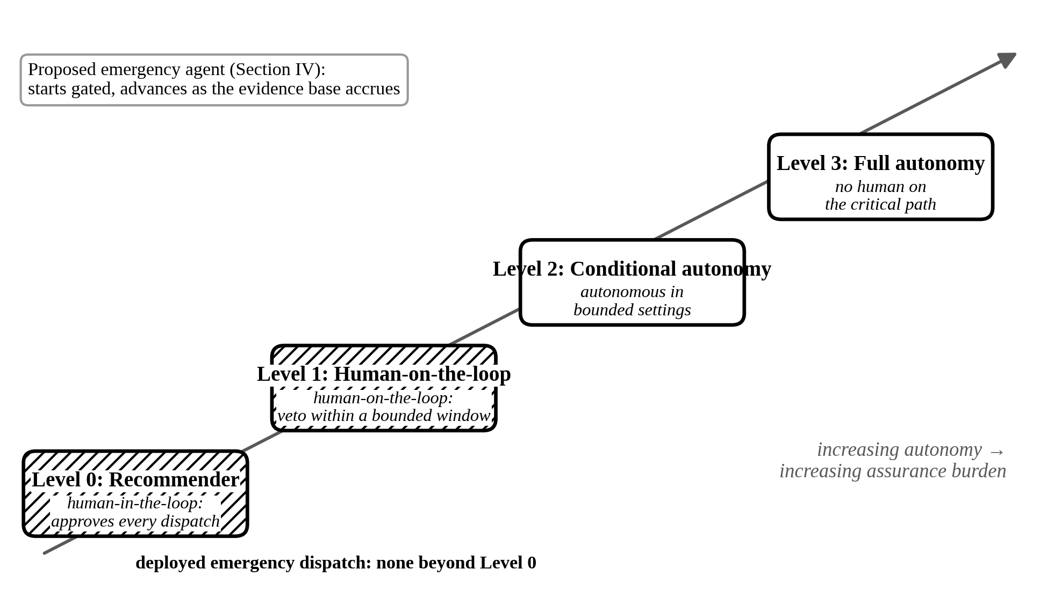
Fig. 13. Graduated autonomy for the emergency agent: deployed dispatch systems sit at Level 0, and the proposed agent advances from gated recommendation toward conditional autonomy as the assurance evidence base accrues.
B. Key Issues and the Needs They Create
The survey exposes issues that are structural rather than incidental. Table X maps each to its root cause and to the research that would address it. Five stand out, and each is stated below as the problem observed, the challenge it poses, and the need it creates.
Issue #1: Ground perception rests almost entirely on a single dataset, pNEUMA [25]. Reported gains may therefore reflect adaptation to one city, in good weather, at a fixed altitude, rather than generalisation.
Challenge #1: How can aerial traffic perception be evaluated when only one open trajectory corpus exists, and collecting another is expensive and legally constrained by privacy and airspace access?
Need #1: An open, multi-condition, multi-domain corpus of UAV-observed traffic incidents is required, covering varied weather, altitude, and geography. This is the aerial analogue of the accident datasets that drove ground CCTV research. Such a corpus would also enable the hazard and incident capabilities that the coverage analysis found sparse.
Issue #2: Air decision-making, both path planning and target tracking, is studied almost entirely in simulation (Table II). Policies validated this way carry no guarantee of safe transfer to real airspace.
Challenge #2: Real airspace experimentation is regulated and hazardous, so learning agents are trained where failure is free, and the corpus contains almost no sim-to-real validation.
Need #2: Explicit sim-to-real transfer studies for air decision-making are required, paired with uncertainty estimation and out-of-distribution detection so that a policy can report when it is operating outside its training envelope. Staged validation through digital twins and hardware-in-the-loop pipelines should precede any flight trial.
Issue #3: Multi-UAV and UAV-USV systems cannot hold a target's identity as it passes between platforms. Fleet-scale coordination degrades into a set of independent sensors.
Challenge #3: Detection and tracking are trained per platform on per-platform data, with no shared representation of traffic state across a fleet.
Need #3: A shared, platform-agnostic traffic-state representation is required, so that identity persists across a UAV fleet and across UAV-USV teams. This turns a set of sensors into a single coordinated observer, and it is a precondition for the fleet re-tasking step of the agentic loop.
Issue #4: Multi-modal fusion (six papers) and autonomous emergency response (none closing the loop) are the least-studied capabilities in the taxonomy, and emergency response is the only capability no audited commercial platform implements.
Challenge #4: The root cause is external to the algorithms. The three barriers set out in Section III.D together remove both the incentive and the data to build the decision layer.
Need #4: A simulation-first emergency-response prototype is required, building and evaluating the decide-to-dispatch loop of Section IV in a digital-twin environment before any field deployment. Measuring detection-to-dispatch latency and false-positive dispatch rate under a graduated-autonomy policy produces the evidence base that the regulatory path requires, without waiting for the regulation itself.
Issue #5: Agentic operation requires on-board inference within a UAV's power and compute budget, yet most high-accuracy perception is validated offline on server GPUs.
Challenge #5: This is a hardware tension rather than a modelling one. The models that close the accuracy gap are often the ones that do not fit the platform.
Need #5: Edge-efficient architectures and fleet-scale federated learning are required, so that models improve from operational experience without moving raw video off the aircraft. On-board inference should be treated as a design constraint from the outset rather than an optimisation applied afterwards.
TABLE X. Challenges, Root Causes, and Research Directions
Challenge | Root cause | Research direction
Benchmark monoculture | Cost and privacy/airspace limits on aerial-traffic data collection | Open, multi-condition UAV incident corpus
Simulation-to-reality gap (air) | Real airspace experimentation is regulated and hazardous | Sim-to-real transfer studies; real-airspace validation
Cross-platform continuity | Per-platform training; no shared traffic-state representation | Platform-agnostic shared traffic-state model
Open decision loop (emergency response) | Liability, dispatch integration, false-positive accountability | Simulation-first prototype under graduated autonomy
Real-time under edge limits | High-accuracy models exceed on-board power and compute | Edge-efficient and federated fleet-scale learning
Assurance and certification | No certification path for an AI-issued dispatch | Assurance cases; graduated-autonomy regulation

VI. CONCLUSION AND AN AGENTIC ROADMAP
A. Conclusion
Seen across air, ground, and maritime traffic through one taxonomy, UAV traffic intelligence has a consistent shape. Perception is comparatively mature and commercially available under favourable conditions, autonomous decision is substantially less developed, and the loop never closes. Each domain has built strong sensing and, under whatever regulatory or commercial pressure it faces, one strong decision capability: deconfliction in air, fleet efficiency across all three, search-and-rescue coordination at sea. None has joined sensing to autonomous action end to end.
The clearest evidence is emergency response. Fourteen papers study it, most of them in maritime search-and-rescue, yet none implements an autonomous detection-to-dispatch loop, and no audited platform contains one. The coverage and keyword analyses (Figs 4 and 5) show the same shape from two angles: learning-based perception dominates both the volume and the vocabulary, while the decision layer is thin and arrives late.
The barrier is not a missing technology, but a missing arrangement of liability and dispatch integration around a single decision. Put that way, the sense that autonomy is simply coming becomes a governable engineering and policy problem. It also explains why the maritime literature matters out of proportion to its size, since its formal-safety tradition is the one place in the field that already reasons about the assurance questions the decision layer will raise.
The platform of Section IV is best read not as a new system but as a specification of what closing the loop demands. What that specification implies for sequencing — which barrier falls first, and what evidence retires it — is set out as a three-phase roadmap below.
B. An Agentic Roadmap
The survey determines not just what to build but in what order, because the three barriers of Section III.D fall away in sequence rather than together. We set the roadmap out as three phases along the autonomy ladder of Fig. 13, each ending at a gate that must be passed before the next begins. The five needs of Section V.B are the workstreams that feed them.
Phase 1 — build the transition, gated (Level 0 to Level 1). Because the barrier at the decide-to-dispatch transition is governance rather than capability, the first phase needs no new detectors, no new sensors and no fielded aircraft — only the decision layer and a way to exercise it. We propose a simulation-first prototype in two halves. The build half implements the agent society of Section IV over recorded incident data in a digital twin, with the emergency-assistance agent gated human-in-the-loop. The validation half, separated and ideally owned by a different person, constructs the scenario catalogue and measures detection-to-dispatch latency, dispatch precision and recall against logged ground truth, and the false-positive dispatch rate as the severity threshold varies. Separating build from validation is methodological, not organisational: the central claim is a claim about false-positive cost, and the team that builds the dispatch logic is not placed to test it adversarially. Workstream: Need #4. Gate: a measured false-positive dispatch rate — the evidence the false-positive barrier demands, and which no published system reports.
Phase 2 — connect to real dispatch in a bounded setting (Level 1 to Level 2). The second barrier is integration, and it cannot be retired in simulation. This phase pilots the loop in one jurisdiction with a live computer-aided-dispatch connector built as a standardised, first-class interface, still under human authority, now relaxed from approval-required to a bounded veto window. It is also where the perception foundation must broaden: the identity-handover problem of Need #3 is a precondition for the fleet re-tasking step, and the benchmark monoculture of Need #1 has to be broken before results from one city can be claimed to generalise. Workstreams: Needs #1 and #3. Gate: a dispatch interface that a jurisdiction's emergency service will accept, and perception validated outside a single benchmark.
Phase 3 — conditional autonomy under an assurance case (Level 2 to Level 3). The liability barrier is the last to fall and is not in the field's gift to remove; what the field can supply is the evidence a regulator needs to act. That evidence is an assurance case in the sense of Section V.A: bounded false-positive rates from Phase 1, a verifiable authority model, and policies that report when they are operating outside their training envelope. Sim-to-real transfer for air decision-making (Need #2) and edge-efficient on-board inference (Need #5) both become binding here, because conditional autonomy means the aircraft acts on its own judgement within its own power budget. Workstreams: Needs #2 and #5. Gate: a certification pathway, which is a regulatory outcome rather than an engineering one.
The ordering matters more than the timeline. Each phase produces the evidence the next phase's barrier requires, which is why the gap has stayed open: the field has repeatedly attempted the whole loop at once, found the liability barrier immovable, and retreated to perception. Phase 1 alone can be run today, by one group, without waiting for regulation, and it is the step this survey most concretely recommends.
C. Limitations
Benchmark concentration (ground rests heavily on pNEUMA); maritime is a smaller literature, so its 46 reviewed papers are near the top of what exists; the platform audit uses public documentation, not direct testing; and the classification, though hand-audited at emergency response, is corpus-bounded and time-bounded to mid-2026.
REFERENCES
[1] Gupta A.; Afrin T.; Scully E.; Yodo N., "Advances of UAVs toward Future Transportation: The State-of-the-Art, Challenges, and Opportunities," Future Transportation, vol. 1, no. 2, pp. 326–350, 2021. doi: 10.3390/futuretransp1020019.
[2] Askarzadeh T.; Bridgelall R.; Tolliver D., "Monitoring Nodal Transportation Assets with Uncrewed Aerial Vehicles: A Comprehensive Review," Drones, vol. 8, no. 6, Art. no. 233, 2024. doi: 10.3390/drones8060233.
[3] Sun Y.; Cao B.; Zhu P.; Hu Q., "Drone-Based RGB-Infrared Cross-Modality Vehicle Detection Via Uncertainty-Aware Learning," IEEE Transactions on Circuits and Systems for Video Technology, vol. 32, no. 10, pp. 6700–6713, 2022. doi: 10.1109/TCSVT.2022.3168279.
[4] Benjdira B.; Khursheed T.; Koubaa A.; Ammar A.; Ouni K., "Car Detection using Unmanned Aerial Vehicles: Comparison between Faster R-CNN and YOLOv3," 2019 1st International Conference on Unmanned Vehicle Systems-Oman, UVS 2019, Art. no. 8658300, 2019. doi: 10.1109/UVS.2019.8658300.
[5] Sun W.; Dai L.; Zhang X.; Chang P.; He X., "RSOD: Real-time small object detection algorithm in UAV-based traffic monitoring," Applied Intelligence, vol. 52, no. 8, pp. 8448–8463, 2022. doi: 10.1007/s10489-021-02893-3.
[6] Elloumi M.; Dhaou R.; Escrig B.; Idoudi H.; Saidane L.A., "Monitoring road traffic with a UAV-based system," IEEE Wireless Communications and Networking Conference, WCNC, vol. 2018-April, pp. 1–6, 2018. doi: 10.1109/WCNC.2018.8377077.
[7] Garg S.; Singh A.; Batra S.; Kumar N.; Yang L.T., "UAV-Empowered Edge Computing Environment for Cyber-Threat Detection in Smart Vehicles," IEEE Network, vol. 32, no. 3, pp. 42–51, 2018. doi: 10.1109/MNET.2018.1700286.
[8] Mou L.; Zhu X.X., "Vehicle Instance Segmentation from Aerial Image and Video Using a Multitask Learning Residual Fully Convolutional Network," IEEE Transactions on Geoscience and Remote Sensing, vol. 56, no. 11, pp. 6699–6711, 2018. doi: 10.1109/TGRS.2018.2841808.
[9] Xu Y.; Yu G.; Wang Y.; Wu X.; Ma Y., "Car detection from low-altitude UAV imagery with the faster R-CNN," Journal of Advanced Transportation, vol. 2017, Art. no. 2823617, 2017. doi: 10.1155/2017/2823617.
[10] Yuan D.; Chang X.; Li Z.; He Z., "Learning Adaptive Spatial-Temporal Context-Aware Correlation Filters for UAV Tracking," ACM Transactions on Multimedia Computing, Communications and Applications, vol. 18, no. 3, Art. no. 70, 2022. doi: 10.1145/3486678.
[11] Bakirci M., "Enhancing vehicle detection in intelligent transportation systems via autonomous UAV platform and YOLOv8 integration," Applied Soft Computing, vol. 164, Art. no. 112015, 2024. doi: 10.1016/j.asoc.2024.112015.
[12] Zhu J.; Sun K.; Jia S.; Li Q.; Hou X.; Lin W.; Liu B.; Qiu G., "Urban Traffic Density Estimation Based on Ultrahigh-Resolution UAV Video and Deep Neural Network," IEEE Journal of Selected Topics in Applied Earth Observations and Remote Sensing, vol. 11, no. 12, pp. 4968–4981, 2018. doi: 10.1109/JSTARS.2018.2879368.
[13] Yuan M.; Wang Y.; Wei X., "Translation, Scale and Rotation: Cross-Modal Alignment Meets RGB-Infrared Vehicle Detection," Lecture Notes in Computer Science (including subseries Lecture Notes in Artificial Intelligence and Lecture Notes in Bioinformatics), vol. 13669 LNCS, pp. 509–525, 2022. doi: 10.1007/978-3-031-20077-9_30.
[14] Tahir N.U.A.; Long Z.; Zhang Z.; Asim M.; ELAffendi M., "PVswin-YOLOv8s: UAV-Based Pedestrian and Vehicle Detection for Traffic Management in Smart Cities Using Improved YOLOv8," Drones, vol. 8, no. 3, Art. no. 84, 2024. doi: 10.3390/drones8030084.
[15] Asghar Khan M.; Ullah I.; Alkhalifah A.; Ur Rehman S.; Ali Shah J.; Ud, "A Provable and Privacy-Preserving Authentication Scheme for UAV-Enabled Intelligent Transportation Systems," IEEE Transactions on Industrial Informatics, vol. 18, no. 5, pp. 3416–3425, 2022. doi: 10.1109/TII.2021.3101651.
[16] Balamuralidhar N.; Tilon S.; Nex F., "MultEYE: Monitoring system for real-time vehicle detection, tracking and speed estimation from UAV imagery on edge-computing platforms," Remote Sensing, vol. 13, no. 4, pp. 1–24, 2021. doi: 10.3390/rs13040573.
[17] Hamzenejadi M.H.; Mohseni H., "Fine-tuned YOLOv5 for real-time vehicle detection in UAV imagery: Architectural improvements and performance boost," Expert Systems with Applications, vol. 231, Art. no. 120845, 2023. doi: 10.1016/j.eswa.2023.120845.
[18] Silva L.A.; Leithardt V.R.Q.; Batista V.F.L.; Villarrubia Gonzalez G.;, "Automated Road Damage Detection Using UAV Images and Deep Learning Techniques," IEEE Access, vol. 11, pp. 62918–62931, 2023. doi: 10.1109/ACCESS.2023.3287770.
[19] Byun S.; Shin I.-K.; Moon J.; Kang J.; Choi S.-I., "Road traffic monitoring from uav images using deep learning networks," Remote Sensing, vol. 13, no. 20, Art. no. 4027, 2021. doi: 10.3390/rs13204027.
[20] Bakirci M., "Utilizing YOLOv8 for enhanced traffic monitoring in intelligent transportation systems (ITS) applications," Digital Signal Processing: A Review Journal, vol. 152, Art. no. 104594, 2024. doi: 10.1016/j.dsp.2024.104594.
[21] Xu Y.; Yu G.; Wu X.; Wang Y.; Ma Y., "An Enhanced Viola-Jones Vehicle Detection Method from Unmanned Aerial Vehicles Imagery," IEEE Transactions on Intelligent Transportation Systems, vol. 18, no. 7, pp. 1845–1856, 2017. doi: 10.1109/TITS.2016.2617202.
[22] Qiu M.; Huang L.; Tang B.-H., "ASFF-YOLOv5: Multielement Detection Method for Road Traffic in UAV Images Based on Multiscale Feature Fusion," Remote Sensing, vol. 14, no. 14, Art. no. 3498, 2022. doi: 10.3390/rs14143498.
[23] Bouguettaya A.; Zarzour H.; Kechida A.; Taberkit A.M., "Vehicle Detection From UAV Imagery With Deep Learning: A Review," IEEE Transactions on Neural Networks and Learning Systems, vol. 33, no. 11, pp. 6047–6067, 2022. doi: 10.1109/TNNLS.2021.3080276.
[24] Srivastava S.; Narayan S.; Mittal S., "A survey of deep learning techniques for vehicle detection from UAV images," Journal of Systems Architecture, vol. 117, Art. no. 102152, 2021. doi: 10.1016/j.sysarc.2021.102152.
[25] Barmpounakis E.; Geroliminis N., "On the new era of urban traffic monitoring with massive drone data: The pNEUMA large-scale field experiment," Transportation Research Part C: Emerging Technologies, vol. 111, pp. 50–71, 2020. doi: 10.1016/j.trc.2019.11.023.
[26] Outay F.; Mengash H.A.; Adnan M., "Applications of unmanned aerial vehicle (UAV) in road safety, traffic and highway infrastructure management: Recent advances and challenges," Transportation Research Part A: Policy and Practice, vol. 141, pp. 116–129, 2020. doi: 10.1016/j.tra.2020.09.018.
[27] Ke R.; Li Z.; Kim S.; Ash J.; Cui Z.; Wang Y., "Real-Time Bidirectional Traffic Flow Parameter Estimation from Aerial Videos," IEEE Transactions on Intelligent Transportation Systems, vol. 18, no. 4, pp. 890–901, 2017. doi: 10.1109/TITS.2016.2595526.
[28] Gui G.; Zhou Z.; Wang J.; Liu F.; Sun J.S., "Machine Learning Aided Air Traffic Flow Analysis Based on Aviation Big Data," IEEE Transactions on Vehicular Technology, vol. 69, no. 5, pp. 4817–4826, 2020. doi: 10.1109/TVT.2020.2981959.
[29] Zhang Q.; Mozaffari M.; Saad W.; Bennis M.; Debbah M., "Machine Learning for Predictive On-Demand Deployment of Uavs for Wireless Communications," Proceedings - IEEE Global Communications Conference, GLOBECOM, Art. no. 8647209, 2018. doi: 10.1109/GLOCOM.2018.8647209.
[30] Jawhar I.; Mohamed N.; Al-Jaroodi J., "Networking architectures and protocols for smart city systems," Journal of Internet Services and Applications, vol. 9, no. 1, Art. no. 26, 2018. doi: 10.1186/s13174-018-0097-0.
[31] Wu Z.; Yang Z.; Yang C.; Lin J.; Liu Y.; Chen X., "Joint Deployment and Trajectory Optimization in UAV-Assisted Vehicular Edge Computing Networks," Journal of Communications and Networks, vol. 24, no. 1, pp. 47–58, 2022. doi: 10.23919/JCN.2021.000026.
[32] Khabbaz M.; Antoun J.; Assi C., "Modeling and Performance Analysis of UAV-Assisted Vehicular Networks," IEEE Transactions on Vehicular Technology, vol. 68, no. 9, pp. 8384–8396, 2019. doi: 10.1109/TVT.2019.2911986.
[33] Khan N.A.; Jhanjhi N.Z.; Brohi S.N.; Usmani R.S.A.; Nayyar A., "Smart traffic monitoring system using Unmanned Aerial Vehicles (UAVs)," Computer Communications, vol. 157, pp. 434–443, 2020. doi: 10.1016/j.comcom.2020.04.049.
[34] Orsino A.; Ometov A.; Fodor G.; Moltchanov D.; Militano L.; Andreev S., "Effects of Heterogeneous Mobility on D2D-and Drone-Assisted Mission-Critical MTC in 5G," IEEE Communications Magazine, vol. 55, no. 2, pp. 79–87, 2017. doi: 10.1109/MCOM.2017.1600443CM.
[35] Alkinani M.H.; Almazroi A.A.; Jhanjhi N.Z.; Khan N.A., "5g and iot based reporting and accident detection (Rad) system to deliver first aid box using unmanned aerial vehicle," Sensors, vol. 21, no. 20, Art. no. 6905, 2021. doi: 10.3390/s21206905.
[36] Menouar H.; Guvenc I.; Akkaya K.; Uluagac A.S.; Kadri A.; Tuncer A., "UAV-enabled intelligent transportation systems for the smart city: Applications and challenges," IEEE Communications Magazine, vol. 55, no. 3, pp. 22–28, 2017. doi: 10.1109/MCOM.2017.1600238CM.
[37] Noor-A-Rahim M.; Liu Z.; Lee H.; Khyam M.O.; He J.; Pesch D.; Moessner, "6G for Vehicle-to-Everything (V2X) Communications: Enabling Technologies, Challenges, and Opportunities," Proceedings of the IEEE, vol. 110, no. 6, pp. 712–734, 2022. doi: 10.1109/JPROC.2022.3173031.
[38] Mohamed N.; Al-Jaroodi J.; Jawhar I.; Idries A.; Mohammed F., "Unmanned aerial vehicles applications in future smart cities," Technological Forecasting and Social Change, vol. 153, Art. no. 119293, 2020. doi: 10.1016/j.techfore.2018.05.004.
[39] Yu S.; Das A.K.; Park Y.; Lorenz P., "SLAP-IoD: Secure and Lightweight Authentication Protocol Using Physical Unclonable Functions for Internet of Drones in Smart City Environments," IEEE Transactions on Vehicular Technology, vol. 71, no. 10, pp. 10374–10388, 2022. doi: 10.1109/TVT.2022.3188769.
[40] Fei B.; Bao W.; Zhu X.; Liu D.; Men T.; Xiao Z., "Autonomous Cooperative Search Model for Multi-UAV With Limited Communication Network," IEEE Internet of Things Journal, vol. 9, no. 19, pp. 19346–19361, 2022. doi: 10.1109/JIOT.2022.3165278.
[41] Sharma V.; You I.; Pau G.; Collotta M.; Lim J.D.; Kim J.N., "LoRaWAN-based energy-efficient surveillance by drones for intelligent transportation systems," Energies, vol. 11, no. 3, Art. no. en11030573, 2018. doi: 10.3390/en11030573.
[42] Huang H.; Savkin A.V.; Huang C., "Decentralized Autonomous Navigation of a UAV Network for Road Traffic Monitoring," IEEE Transactions on Aerospace and Electronic Systems, vol. 57, no. 4, pp. 2558–2564, 2021. doi: 10.1109/TAES.2021.3053115.
[43] Abdollahi A.; Pradhan B.; Shukla N.; Chakraborty S.; Alamri A., "Deep learning approaches applied to remote sensing datasets for road extraction: A state-of-the-art review," Remote Sensing, vol. 12, no. 9, Art. no. 1444, 2020. doi: 10.3390/RS12091444.
[44] Gong T.; Zhu L.; Yu F.R.; Tang T., "Edge Intelligence in Intelligent Transportation Systems: A Survey," IEEE Transactions on Intelligent Transportation Systems, vol. 24, no. 9, pp. 8919–8944, 2023. doi: 10.1109/TITS.2023.3275741.
[45] Lagkas T.; Argyriou V.; Bibi S.; Sarigiannidis P., "UAV IoT framework views and challenges: Towards protecting drones as “things”," Sensors (Switzerland), vol. 18, no. 11, Art. no. 4015, 2018. doi: 10.3390/s18114015.
[46] Baltaci A.; Dinc E.; Ozger M.; Alabbasi A.; Cavdar C.; Schupke D., "A Survey of Wireless Networks for Future Aerial Communications (FACOM)," IEEE Communications Surveys and Tutorials, vol. 23, no. 4, pp. 2833–2884, 2021. doi: 10.1109/COMST.2021.3103044.
[47] Qin P.; Fu Y.; Zhang J.; Geng S.; Liu J.; Zhao X, "DRL-Based Resource Allocation and Trajectory Planning for NOMA-Enabled Multi-UAV Collaborative Caching 6G Network," IEEE Transactions on Vehicular Technology, vol. 73, no. 6, 2024. doi: 10.1109/TVT.2024.3357086.
[48] Ameur A.I.; Oubbati O.S.; Lakas A.; Rachedi A.; Yagoubi M.B, "Efficient Vehicular Data Sharing Using Aerial P2P Backbone," IEEE Transactions on Intelligent Vehicles, vol. 10, no. 1, 2025. doi: 10.1109/TIV.2024.3414140.
[49] Bai Z.; Lin Y.; Cao Y.; Wang W, "Delay-Aware Cooperative Task Offloading for Multi-UAV Enabled Edge-Cloud Computing," IEEE Transactions on Mobile Computing, vol. 23, no. 2, 2024. doi: 10.1109/TMC.2022.3232375.
[50] Chen D.; Qi Q.; Fu Q.; Wang J.; Liao J.; Han Z, "Transformer-Based Reinforcement Learning for Scalable Multi-UAV Area Coverage," IEEE Transactions on Intelligent Transportation Systems, vol. 25, no. 8, 2024. doi: 10.1109/TITS.2024.3358010.
[51] Bakirci M, "Vehicular mobility monitoring using remote sensing and deep learning on a UAV-based mobile computing platform," Measurement: Journal of the International Measurement Confederation, vol. 244, Art. no. 116579, 2025. doi: 10.1016/j.measurement.2024.116579.
[52] Huang J.; Yu T.; Zhu X.; Yang F.; Lai X.; Alfarraj O.; Yu K, "Energy Efficiency Maximization in UAV-Assisted Intelligent Autonomous Transport System for 6G Networks With Energy Harvesting," IEEE Transactions on Intelligent Transportation Systems, vol. 26, no. 10, 2025. doi: 10.1109/TITS.2024.3445088.
[53] Wu Y.; Li Y.; Liu M.; Wang X.; Yang X.; Ye H.; Zeng D.; Zhao Q.; Li S, "Learning an Adaptive and View-Invariant Vision Transformer for Real-Time UAV Tracking," IEEE Transactions on Circuits and Systems for Video Technology, vol. 36, no. 2, 2026. doi: 10.1109/TCSVT.2025.3599856.
[54] Chen M.; Li Y.; Dai Z.; Zhang T.; Zhou Y.; Wang H, "A Robust Multi-Domain Adaptive Anti-Jamming Communication System for a UAV Swarm in Urban ITS Traffic Monitoring via Multi-Agent Deep Deterministic Policy Gradient," IEEE Transactions on Intelligent Transportation Systems, vol. 27, no. 2, 2026. doi: 10.1109/TITS.2025.3584216.
[55] Yang F.; Yu T.; Huang J.; Yang C.; Zhang S.; Tolba A.; Yu K.; Han Z, "Energy Efficient and AoI-Aware Resource Allocation for UAV-Assisted ITS Networks," IEEE Transactions on Vehicular Technology, vol. 75, no. 4, 2026. doi: 10.1109/TVT.2025.3621632.
[56] Cohen A.P.; Shaheen S.A.; Farrar E.M., "Urban Air Mobility: History, Ecosystem, Market Potential, and Challenges," IEEE Transactions on Intelligent Transportation Systems, vol. 22, no. 9, pp. 6074–6087, 2021. doi: 10.1109/TITS.2021.3082767.
[57] Thipphavong D.P.; Apaza R.D.; Barmore B.E.; Battiste V.; Belcastro C.M, "Urban air mobility airspace integration concepts and considerations," 2018 Aviation Technology, Integration, and Operations Conference, Art. no. AIAA 2018-3676, 2018. doi: 10.2514/6.2018-3676.
[58] Sun J.; Tang J.; Lao S., "Collision Avoidance for Cooperative UAVs with Optimized Artificial Potential Field Algorithm," IEEE Access, vol. 5, pp. 18382–18390, 2017. doi: 10.1109/ACCESS.2017.2746752.
[59] Yasin J.N.; Mohamed S.A.S.; Haghbayan M.-H.; Heikkonen J.; Tenhunen H., "Unmanned Aerial Vehicles (UAVs): Collision Avoidance Systems and Approaches," IEEE Access, vol. 8, pp. 105139–105155, 2020. doi: 10.1109/ACCESS.2020.3000064.
[60] Lin Y.; Saripalli S., "Sampling-Based Path Planning for UAV Collision Avoidance," IEEE Transactions on Intelligent Transportation Systems, vol. 18, no. 11, pp. 3179–3192, 2017. doi: 10.1109/TITS.2017.2673778.
[61] Honig W.; Preiss J.A.; Kumar T.K.S.; Sukhatme G.S.; Ayanian N., "Trajectory Planning for Quadrotor Swarms," IEEE Transactions on Robotics, vol. 34, no. 4, pp. 856–869, 2018. doi: 10.1109/TRO.2018.2853613.
[62] Luis C.E.; Vukosavljev M.; Schoellig A.P., "Online Trajectory Generation with Distributed Model Predictive Control for Multi-Robot Motion Planning," IEEE Robotics and Automation Letters, vol. 5, no. 2, pp. 604–611, 2020. doi: 10.1109/LRA.2020.2964159.
[63] Rozantsev A.; Lepetit V.; Fua P., "Detecting Flying Objects Using a Single Moving Camera," IEEE Transactions on Pattern Analysis and Machine Intelligence, vol. 39, no. 5, pp. 879–892, 2017. doi: 10.1109/TPAMI.2016.2564408.
[64] Zhen Z.; Chen Y.; Wen L.; Han B., "An intelligent cooperative mission planning scheme of UAV swarm in uncertain dynamic environment," Aerospace Science and Technology, vol. 100, Art. no. 105826, 2020. doi: 10.1016/j.ast.2020.105826.
[65] Radmanesh M.; Kumar M.; Guentert P.H.; Sarim M., "Overview of Path-Planning and Obstacle Avoidance Algorithms for UAVs: A Comparative Study," Unmanned Systems, vol. 6, no. 2, pp. 95–118, 2018. doi: 10.1142/S2301385018400022.
[66] Liao F.; Teo R.; Wang J.L.; Dong X.; Lin F.; Peng K., "Distributed Formation and Reconfiguration Control of VTOL UAVs," IEEE Transactions on Control Systems Technology, vol. 25, no. 1, pp. 270–277, 2017. doi: 10.1109/TCST.2016.2547952.
[67] Barrado C.; Boyero M.; Brucculeri L.; Ferrara G.; Hately A.; Hullah P., "U-space concept of operations: A key enabler for opening airspace to emerging low-altitude operations," Aerospace, vol. 7, no. 3, Art. no. 24, 2020. doi: 10.3390/aerospace7030024.
[68] GUO T.; JIANG N.; LI B.; ZHU X.; WANG Y.; DU W., "UAV navigation in high dynamic environments: A deep reinforcement learning approach," Chinese Journal of Aeronautics, vol. 34, no. 2, pp. 479–489, 2021. doi: 10.1016/j.cja.2020.05.011.
[69] Qiu H.; Duan H., "A multi-objective pigeon-inspired optimization approach to UAV distributed flocking among obstacles," Information Sciences, vol. 509, pp. 515–529, 2020. doi: 10.1016/j.ins.2018.06.061.
[70] Li B.; Wu Y., "Path Planning for UAV Ground Target Tracking via Deep Reinforcement Learning," IEEE Access, vol. 8, pp. 29064–29074, 2020. doi: 10.1109/ACCESS.2020.2971780.
[71] Saeed R.A.; Omri M.; Abdel-Khalek S.; Ali E.S.; Alotaibi M.F., "Optimal path planning for drones based on swarm intelligence algorithm," Neural Computing and Applications, vol. 34, no. 12, pp. 10133–10155, 2022. doi: 10.1007/s00521-022-06998-9.
[72] Seo J.; Kim Y.; Kim S.; Tsourdos A., "Collision Avoidance Strategies for Unmanned Aerial Vehicles in Formation Flight," IEEE Transactions on Aerospace and Electronic Systems, vol. 53, no. 6, pp. 2718–2734, 2017. doi: 10.1109/TAES.2017.2714898.
[73] Shen C.; Chang T.-H.; Gong J.; Zeng Y.; Zhang R., "Multi-UAV interference coordination via joint trajectory and power control," IEEE Transactions on Signal Processing, vol. 68, pp. 843–858, 2020. doi: 10.1109/TSP.2020.2967146.
[74] Zhou L.; Leng S.; Liu Q.; Wang Q., "Intelligent UAV Swarm Cooperation for Multiple Targets Tracking," IEEE Internet of Things Journal, vol. 9, no. 1, pp. 743–754, 2022. doi: 10.1109/JIOT.2021.3085673.
[75] Li B.; Yang Z.-P.; Chen D.-Q.; Liang S.-Y.; Ma H., "Maneuvering target tracking of UAV based on MN-DDPG and transfer learning," Defence Technology, vol. 17, no. 2, pp. 457–466, 2021. doi: 10.1016/j.dt.2020.11.014.
[76] Liu X.; Lai B.; Lin B.; Leung V.C.M., "Joint Communication and Trajectory Optimization for Multi-UAV Enabled Mobile Internet of Vehicles," IEEE Transactions on Intelligent Transportation Systems, vol. 23, no. 9, pp. 15354–15366, 2022. doi: 10.1109/TITS.2022.3140357.
[77] Xu H.; Zhang Y.; Zhou B.; Wang L.; Yao X.; Meng G.; Shen S., "Omni-Swarm: A Decentralized Omnidirectional Visual-Inertial-UWB State Estimation System for Aerial Swarms," IEEE Transactions on Robotics, vol. 38, no. 6, pp. 3374–3394, 2022. doi: 10.1109/TRO.2022.3182503.
[78] Meng W.; He Z.; Su R.; Yadav P.K.; Teo R.; Xie L., "Decentralized Multi-UAV Flight Autonomy for Moving Convoys Search and Track," IEEE Transactions on Control Systems Technology, vol. 25, no. 4, pp. 1480–1487, 2017. doi: 10.1109/TCST.2016.2601287.
[79] Chen J.; Li T.; Zhang Y.; You T.; Lu Y.; Tiwari P.; Kumar N., "Global-and-Local Attention-Based Reinforcement Learning for Cooperative Behaviour Control of Multiple UAVs," IEEE Transactions on Vehicular Technology, vol. 73, no. 3, pp. 4194–4206, 2024. doi: 10.1109/TVT.2023.3327571.
[80] Wu Y.; Gou J.; Hu X.; Huang Y., "A new consensus theory-based method for formation control and obstacle avoidance of UAVs," Aerospace Science and Technology, vol. 107, Art. no. 106332, 2020. doi: 10.1016/j.ast.2020.106332.
[81] Zhang G.; Yan H.; Zeng Y.; Cui M.; Liu Y., "Trajectory Optimization and Power Allocation for Multi-Hop UAV Relaying Communications," IEEE Access, vol. 6, pp. 48566–48576, 2018. doi: 10.1109/ACCESS.2018.2868117.
[82] Xu L.; Cao X.; Du W.; Li Y., "Cooperative path planning optimization for multiple UAVs with communication constraints," Knowledge-Based Systems, vol. 260, Art. no. 110164, 2023. doi: 10.1016/j.knosys.2022.110164.
[83] Yin C.; Xiao Z.; Cao X.; Xi X.; Yang P.; Wu D., "Offline and Online Search: UAV Multiobjective Path Planning Under Dynamic Urban Environment," IEEE Internet of Things Journal, vol. 5, no. 2, pp. 546–558, 2018. doi: 10.1109/JIOT.2017.2717078.
[84] Wu J.; Luo C.; Luo Y.; Li K., "Distributed UAV Swarm Formation and Collision Avoidance Strategies Over Fixed and Switching Topologies," IEEE Transactions on Cybernetics, vol. 52, no. 10, pp. 10969–10979, 2022. doi: 10.1109/TCYB.2021.3132587.
[85] Baca T.; Hert D.; Loianno G.; Saska M.; Kumar V., "Model Predictive Trajectory Tracking and Collision Avoidance for Reliable Outdoor Deployment of Unmanned Aerial Vehicles," IEEE International Conference on Intelligent Robots and Systems, pp. 6753–6760, 2018. doi: 10.1109/IROS.2018.8594266.
[86] Wang D.; Fan T.; Han T.; Pan J., "A Two-Stage Reinforcement Learning Approach for Multi-UAV Collision Avoidance under Imperfect Sensing," IEEE Robotics and Automation Letters, vol. 5, no. 2, pp. 3098–3105, 2020. doi: 10.1109/LRA.2020.2974648.
[87] Zheng J.; Ding M.; Sun L.; Liu H., "Distributed Stochastic Algorithm Based on Enhanced Genetic Algorithm for Path Planning of Multi-UAV Cooperative Area Search," IEEE Transactions on Intelligent Transportation Systems, vol. 24, no. 8, pp. 8290–8303, 2023. doi: 10.1109/TITS.2023.3258482.
[88] Bijjahalli S.; Sabatini R.; Gardi A., "Advances in intelligent and autonomous navigation systems for small UAS," Progress in Aerospace Sciences, vol. 115, Art. no. 100617, 2020. doi: 10.1016/j.paerosci.2020.100617.
[89] LIU Y.; ZHANG X.; ZHANG Y.; GUAN X., "Collision free 4D path planning for multiple UAVs based on spatial refined voting mechanism and PSO approach," Chinese Journal of Aeronautics, vol. 32, no. 6, pp. 1504–1519, 2019. doi: 10.1016/j.cja.2019.03.026.
[90] Aggarwal S.; Kumar N., "Path planning techniques for unmanned aerial vehicles: A review, solutions, and challenges," Computer Communications, vol. 149, pp. 270–299, 2020. doi: 10.1016/j.comcom.2019.10.014.
[91] Lu Y.; Xue Z.; Xia G.-S.; Zhang L., "A survey on vision-based UAV navigation," Geo-Spatial Information Science, vol. 21, no. 1, pp. 21–32, 2018. doi: 10.1080/10095020.2017.1420509.
[92] Lyu M.; Zhao Y.; Huang C.; Huang H., "Unmanned Aerial Vehicles for Search and Rescue: A Survey," Remote Sensing, vol. 15, no. 13, Art. no. 3266, 2023. doi: 10.3390/rs15133266.
[93] Kanellakis C.; Nikolakopoulos G., "Survey on Computer Vision for UAVs: Current Developments and Trends," Journal of Intelligent and Robotic Systems: Theory and Applications, vol. 87, no. 1, pp. 141–168, 2017. doi: 10.1007/s10846-017-0483-z.
[94] Tang J.; Duan H.; Lao S., "Swarm intelligence algorithms for multiple unmanned aerial vehicles collaboration: a comprehensive review," Artificial Intelligence Review, vol. 56, no. 5, pp. 4295–4327, 2023. doi: 10.1007/s10462-022-10281-7.
[95] Huang S.; Teo R.S.H.; Tan K.K., "Collision avoidance of multi unmanned aerial vehicles: A review," Annual Reviews in Control, vol. 48, pp. 147–164, 2019. doi: 10.1016/j.arcontrol.2019.10.001.
[96] Al-Kaff A.; Martín D.; García F.; Escalera A.D.L.; María Armingol J., "Survey of computer vision algorithms and applications for unmanned aerial vehicles," Expert Systems with Applications, vol. 92, pp. 447–463, 2018. doi: 10.1016/j.eswa.2017.09.033.
[97] YU Z.; ZHANG Y.; JIANG B.; FU J.; JIN Y., "A review on fault-tolerant cooperative control of multiple unmanned aerial vehicles," Chinese Journal of Aeronautics, vol. 35, no. 1, pp. 1–18, 2022. doi: 10.1016/j.cja.2021.04.022.
[98] Guo Y.; Wu M.; Tang K.; Tie J.; Li X., "Covert spoofing algorithm of UAV based on GPS/INS-integrated navigation," IEEE Transactions on Vehicular Technology, vol. 68, no. 7, pp. 6557–6564, 2019. doi: 10.1109/TVT.2019.2914477.
[99] Manesh M.R.; Kenney J.; Hu W.C.; Devabhaktuni V.K.; Kaabouch N., "Detection of GPS Spoofing Attacks on Unmanned Aerial Systems," 2019 16th IEEE Annual Consumer Communications and Networking Conference, CCNC 2019, Art. no. 8651804, 2019. doi: 10.1109/CCNC.2019.8651804.
[100] Yanmaz E.; Yahyanejad S.; Rinner B.; Hellwagner H.; Bettstetter C., "Drone networks: Communications, coordination, and sensing," Ad Hoc Networks, vol. 68, pp. 1–15, 2018. doi: 10.1016/j.adhoc.2017.09.001.
[101] Lin Y.; Wang M.; Zhou X.; Ding G.; Mao S., "Dynamic Spectrum Interaction of UAV Flight Formation Communication with Priority: A Deep Reinforcement Learning Approach," IEEE Transactions on Cognitive Communications and Networking, vol. 6, no. 3, pp. 892–903, 2020. doi: 10.1109/TCCN.2020.2973376.
[102] Zhang S.; Li Y.; Dong Q., "Autonomous navigation of UAV in multi-obstacle environments based on a Deep Reinforcement Learning approach," Applied Soft Computing, vol. 115, Art. no. 108194, 2022. doi: 10.1016/j.asoc.2021.108194.
[103] Rezaee M.R.; Hamid N.A.W.A.; Hussin M.; Zukarnain Z.A, "Comprehensive Review of Drones Collision Avoidance Schemes: Challenges and Open Issues," IEEE Transactions on Intelligent Transportation Systems, vol. 25, no. 7, 2024. doi: 10.1109/TITS.2024.3375893.
[104] Miao Q.; Zhang K.; Jiang B, "Fixed-Time Collision-Free Fault-Tolerant Formation Control of Multi-UAVs under Actuator Faults," IEEE Transactions on Cybernetics, vol. 54, no. 6, 2024. doi: 10.1109/TCYB.2024.3352251.
[105] Du Z.; Zhang H.; Wang Z.; Yan H, "Model Predictive Formation Tracking-Containment Control for Multi-UAVs With Obstacle Avoidance," IEEE Transactions on Systems, Man, and Cybernetics: Systems, vol. 54, no. 6, 2024. doi: 10.1109/TSMC.2024.3354893.
[106] Hashim H.A, "Advances in UAV avionics systems architecture, classification and integration: A comprehensive review and future perspectives," Results in Engineering, vol. 25, Art. no. 103786, 2025. doi: 10.1016/j.rineng.2024.103786.
[107] Chen J.; Wang Y.; Zhang Y.; Lu Y.; Shu Q.; Hu Y, "Extrinsic-and-Intrinsic Reward-Based Multi-Agent Reinforcement Learning for Multi-UAV Cooperative Target Encirclement," IEEE Transactions on Intelligent Transportation Systems, vol. 26, no. 10, 2025. doi: 10.1109/TITS.2024.3524562.
[108] Kumar P.; Pal K.; Govil M.C, "Comprehensive Review of Path Planning Techniques for Unmanned Aerial Vehicles (UAVs)," ACM Computing Surveys, vol. 58, no. 3, Art. no. 3737280, 2025. doi: 10.1145/3737280.
[109] Ariante G.; Del Core G, "Unmanned Aircraft Systems (UASs): Current State, Emerging Technologies, and Future Trends," Drones, vol. 9, no. 1, Art. no. 59, 2025. doi: 10.3390/drones9010059.
[110] DONG C.; ZHANG Y.; JIA Z.; LIAO Y.; ZHANG L.; WU Q, "Three-dimension collision-free trajectory planning of UAVs based on ADS-B information in low-altitude urban airspace," Chinese Journal of Aeronautics, vol. 38, no. 2, Art. no. 103170, 2025. doi: 10.1016/j.cja.2024.08.001.
[111] Ye X.; Mao Y.; Yu X.; Sun S.; Fu L.; Xu J, "Integrated Sensing and Communications for Low-Altitude Economy: A Deep Reinforcement Learning Approach," IEEE Transactions on Wireless Communications, vol. 25, 2026. doi: 10.1109/TWC.2025.3583950.
[112] Khargharia H.S.; Ouali A.; Shakya S.; Ahmad S, "Collision avoidance in UAV swarms: A learning-centric perspective on collaborative intelligence," Neurocomputing, vol. 663, Art. no. 132020, 2026. doi: 10.1016/j.neucom.2025.132020.
[113] Zheng Y.; Li L.; Lin W.; Liang W.; Du Q.; Han Z, "Optimal Transport Framework for ISAC in Low-Altitude Networks: Joint Resource Allocation for Cooperative Communication and Non-Cooperative Localization," IEEE Transactions on Communications, vol. 74, 2026. doi: 10.1109/TCOMM.2025.3642742.
[114] Li Q.; Mou L.; Liu Q.; Wang Y.; Zhu X.X., "HSF-Net: Multiscale deep feature embedding for ship detection in optical remote sensing imagery," IEEE Transactions on Geoscience and Remote Sensing, vol. 56, no. 12, pp. 7147–7161, 2018. doi: 10.1109/TGRS.2018.2848901.
[115] Chen Z.; Chen D.; Zhang Y.; Cheng X.; Zhang M.; Wu C., "Deep learning for autonomous ship-oriented small ship detection," Safety Science, vol. 130, Art. no. 104812, 2020. doi: 10.1016/j.ssci.2020.104812.
[116] Wang Y.; Liu W.; Liu J.; Sun C., "Cooperative USV–UAV marine search and rescue with visual navigation and reinforcement learning-based control," ISA Transactions, vol. 137, pp. 222–235, 2023. doi: 10.1016/j.isatra.2023.01.007.
[117] Han J.; Cho Y.; Kim J.; Kim J.; Son N.-S.; Kim S.Y., "Autonomous collision detection and avoidance for ARAGON USV: Development and field tests," Journal of Field Robotics, vol. 37, no. 6, pp. 987–1002, 2020. doi: 10.1002/rob.21935.
[118] Cheng S.; Zhu Y.; Wu S., "Deep learning based efficient ship detection from drone-captured images for maritime surveillance," Ocean Engineering, vol. 285, Art. no. 115440, 2023. doi: 10.1016/j.oceaneng.2023.115440.
[119] Yao S.; Guan R.; Wu Z.; Ni Y.; Huang Z.; Wen Liu R.; Yue Y.; Ding W.;, "WaterScenes: A Multi-Task 4D Radar-Camera Fusion Dataset and Benchmarks for Autonomous Driving on Water Surfaces," IEEE Transactions on Intelligent Transportation Systems, vol. 25, no. 11, pp. 16584–16598, 2024. doi: 10.1109/TITS.2024.3415772.
[120] Li J.; Zhang G.; Cabecinhas D.; Pascoal A.M.; Zhang W., "Prescribed Performance Path Following Control of USVs via an Output-Based Threshold Rule," IEEE Transactions on Vehicular Technology, vol. 73, no. 5, pp. 6171–6182, 2024. doi: 10.1109/TVT.2023.3338518.
[121] Li S.; Fu X.; Dong J., "Improved Ship Detection Algorithm Based on YOLOX for SAR Outline Enhancement Image," Remote Sensing, vol. 14, no. 16, Art. no. 4070, 2022. doi: 10.3390/rs14164070.
[122] Brown A.; Anderson D., "Trajectory optimization for high-altitude long-endurance UAV maritime radar surveillance," IEEE Transactions on Aerospace and Electronic Systems, vol. 56, no. 3, pp. 2406–2421, 2020. doi: 10.1109/TAES.2019.2949384.
[123] Li Y.; Yuan H.; Wang Y.; Xiao C., "GGT-YOLO: A Novel Object Detection Algorithm for Drone-Based Maritime Cruising," Drones, vol. 6, no. 11, Art. no. 335, 2022. doi: 10.3390/drones6110335.
[124] Chen L.; Hopman H.; Negenborn R.R., "Distributed Model Predictive Control for cooperative floating object transport with multi-vessel systems," Ocean Engineering, vol. 191, Art. no. 106515, 2019. doi: 10.1016/j.oceaneng.2019.106515.
[125] Zhao C.; Liu R.W.; Qu J.; Gao R., "Deep learning-based object detection in maritime unmanned aerial vehicle imagery: Review and experimental comparisons," Engineering Applications of Artificial Intelligence, vol. 128, Art. no. 107513, 2024. doi: 10.1016/j.engappai.2023.107513.
[126] Ribeiro R.; Cruz G.; Matos J.; Bernardino A., "A Data Set for Airborne Maritime Surveillance Environments," IEEE Transactions on Circuits and Systems for Video Technology, vol. 29, no. 9, pp. 2720–2732, 2019. doi: 10.1109/TCSVT.2017.2775524.
[127] Wróbel K.; Montewka J.; Kujala P., "Towards the assessment of potential impact of unmanned vessels on maritime transportation safety," Reliability Engineering and System Safety, vol. 165, pp. 155–169, 2017. doi: 10.1016/j.ress.2017.03.029.
[128] Wróbel K.; Montewka J.; Kujala P., "Towards the development of a system-theoretic model for safety assessment of autonomous merchant vessels," Reliability Engineering and System Safety, vol. 178, pp. 209–224, 2018. doi: 10.1016/j.ress.2018.05.019.
[129] Chaal M.; Valdez Banda O.A.; Glomsrud J.A.; Basnet S.; Hirdaris S.; Ku, "A framework to model the STPA hierarchical control structure of an autonomous ship," Safety Science, vol. 132, Art. no. 104939, 2020. doi: 10.1016/j.ssci.2020.104939.
[130] Yang T.; Jiang Z.; Sun R.; Cheng N.; Feng H., "Maritime Search and Rescue Based on Group Mobile Computing for Unmanned Aerial Vehicles and Unmanned Surface Vehicles," IEEE Transactions on Industrial Informatics, vol. 16, no. 12, pp. 7700–7708, 2020. doi: 10.1109/TII.2020.2974047.
[131] Bolbot V.; Theotokatos G.; Boulougouris E.; Vassalos D., "A novel cyber-risk assessment method for ship systems," Safety Science, vol. 131, Art. no. 104908, 2020. doi: 10.1016/j.ssci.2020.104908.
[132] Valdez Banda O.A.; Kannos S.; Goerlandt F.; van Gelder P.H.A.J.M.; Ber, "A systemic hazard analysis and management process for the concept design phase of an autonomous vessel," Reliability Engineering and System Safety, vol. 191, Art. no. 106584, 2019. doi: 10.1016/j.ress.2019.106584.
[133] Zhang G.; Liu S.; Zhang X.; Zhang W., "Event-Triggered Cooperative Formation Control for Autonomous Surface Vehicles under the Maritime Search Operation," IEEE Transactions on Intelligent Transportation Systems, vol. 23, no. 11, pp. 21392–21404, 2022. doi: 10.1109/TITS.2022.3181141.
[134] Xiao X.; Dufek J.; Woodbury T.; Murphy R., "UAV assisted USV visual navigation for marine mass casualty incident response," IEEE International Conference on Intelligent Robots and Systems, vol. 2017-September, pp. 6105–6110, 2017. doi: 10.1109/IROS.2017.8206510.
[135] Li J.; Zhang G.; Zhang W.; Shan Q.; Zhang W., "Cooperative Path Following Control of USV-UAVs Considering Low Design Complexity and Command Transmission Requirements," IEEE Transactions on Intelligent Vehicles, vol. 9, no. 1, pp. 715–724, 2024. doi: 10.1109/TIV.2023.3317336.
[136] Liu X.; Li Y.; Zhang J.; Zheng J.; Yang C., "Self-Adaptive Dynamic Obstacle Avoidance and Path Planning for USV under Complex Maritime Environment," IEEE Access, vol. 7, pp. 114945–114954, 2019. doi: 10.1109/ACCESS.2019.2935964.
[137] Ventikos N.P.; Chmurski A.; Louzis K., "A systems-based application for autonomous vessels safety: Hazard identification as a function of increasing autonomy levels," Safety Science, vol. 131, Art. no. 104919, 2020. doi: 10.1016/j.ssci.2020.104919.
[138] Pedersen T.A.; Glomsrud J.A.; Ruud E.-L.; Simonsen A.; Sandrib J.; Eri, "Towards simulation-based verification of autonomous navigation systems," Safety Science, vol. 129, Art. no. 104799, 2020. doi: 10.1016/j.ssci.2020.104799.
[139] Xue J.; Van Gelder P.H.A.J.M.; Reniers G.; Papadimitriou E.; Wu C., "Multi-attribute decision-making method for prioritizing maritime traffic safety influencing factors of autonomous ships’ maneuvering decisions using grey and fuzzy theories," Safety Science, vol. 120, pp. 323–340, 2019. doi: 10.1016/j.ssci.2019.07.019.
[140] Liu J.; Aydin M.; Akyuz E.; Arslan O.; Uflaz E.; Kurt R.E.; Turan O., "Prediction of human–machine interface (HMI) operational errors for maritime autonomous surface ships (MASS)," Journal of Marine Science and Technology (Japan), vol. 27, no. 1, pp. 293–306, 2022. doi: 10.1007/s00773-021-00834-w.
[141] Tan G.; Zou J.; Zhuang J.; Wan L.; Sun H.; Sun Z., "Fast marching square method based intelligent navigation of the unmanned surface vehicle swarm in restricted waters," Applied Ocean Research, vol. 95, Art. no. 102018, 2020. doi: 10.1016/j.apor.2019.102018.
[142] Yu K.; Liang X.-F.; Li M.-Z.; Chen Z.; Yao Y.-L.; Li X.; Zhao Z.-X.; T, "USV path planning method with velocity variation and global optimisation based on AIS service platform," Ocean Engineering, vol. 236, Art. no. 109560, 2021. doi: 10.1016/j.oceaneng.2021.109560.
[143] Ai Q.; Qiao X.; Liao Y.; Yu Q., "Joint Optimization of USVs Communication and Computation Resource in IRS-Aided Wireless Inland Ship MEC Networks," IEEE Transactions on Green Communications and Networking, vol. 6, no. 2, pp. 1023–1036, 2022. doi: 10.1109/TGCN.2021.3135530.
[144] Li J.; Zhang G.; Jiang C.; Zhang W., "A survey of maritime unmanned search system: Theory, applications and future directions," Ocean Engineering, vol. 285, Art. no. 115359, 2023. doi: 10.1016/j.oceaneng.2023.115359.
[145] Jorge V.A.M.; Granada R.; Maidana R.G.; Jurak D.A.; Heck G.; Negreiros, "A survey on unmanned surface vehicles for disaster robotics: Main challenges and directions," Sensors (Switzerland), vol. 19, no. 3, Art. no. 702, 2018. doi: 10.3390/s19030702.
[146] Qiao Y.; Yin J.; Wang W.; Duarte F.; Yang J.; Ratti C., "Survey of Deep Learning for Autonomous Surface Vehicles in Marine Environments," IEEE Transactions on Intelligent Transportation Systems, vol. 24, no. 4, pp. 3678–3701, 2023. doi: 10.1109/TITS.2023.3235911.
[147] Heng H.; Ghazali M.H.M.; Rahiman W., "Exploring the application of ant colony optimization in path planning for Unmanned Surface Vehicles," Ocean Engineering, vol. 311, Art. no. 118738, 2024. doi: 10.1016/j.oceaneng.2024.118738.
[148] Chu Y.; Gao Q.; Yue Y.; Lim E.G.; Paoletti P.; Ma J.; Zhu X., "Evolution of Unmanned Surface Vehicle Path Planning: A Comprehensive Review of Basic, Responsive, and Advanced Strategic Pathfinders," Drones, vol. 8, no. 10, Art. no. 540, 2024. doi: 10.3390/drones8100540.
[149] Wu K.; Hu J.; Ding Z.; Arvin F, "Finite-Time Fault-Tolerant Formation Control for Distributed Multi-Vehicle Networks with Bearing Measurements," IEEE Transactions on Automation Science and Engineering, vol. 21, no. 2, 2024. doi: 10.1109/TASE.2023.3239748.
[150] Qi S.; Lin B.; Deng Y.; Chen X.; Fang Y, "Minimizing Maximum Latency of Task Offloading for Multi-UAV-Assisted Maritime Search and Rescue," IEEE Transactions on Vehicular Technology, vol. 73, no. 9, 2024. doi: 10.1109/TVT.2024.3384570.
[151] Quero C.O.; Martinez-Carranza J, "Unmanned aerial systems in search and rescue: A global perspective on current challenges and future applications," International Journal of Disaster Risk Reduction, vol. 118, Art. no. 105199, 2025. doi: 10.1016/j.ijdrr.2025.105199.
[152] Ma S.; Zhang Y.; Peng L.; Sun C.; Ding B.; Zhu Y, "OWRT-DETR: A Novel Real-Time Transformer Network for Small-Object Detection in Open-Water Search and Rescue From UAV Aerial Imagery," IEEE Transactions on Geoscience and Remote Sensing, vol. 63, Art. no. 4205313, 2025. doi: 10.1109/TGRS.2025.3560928.
[153] Yang L.; Zhang X.; Li Z.; Li L.; Shi Y, "A LODBO algorithm for multi-UAV search and rescue path planning in disaster areas," Chinese Journal of Aeronautics, vol. 38, no. 2, Art. no. 103301, 2025. doi: 10.1016/j.cja.2024.11.011.
[154] Li T.; Fei L, "Exploring obstacles to the use of unmanned aerial vehicles in emergency rescue: A BWM-DEMATEL approach," Technology in Society, vol. 81, Art. no. 102863, 2025. doi: 10.1016/j.techsoc.2025.102863.
[155] Zhang X.; Feng Y.; Wang N.; Lu G.; Mei S, "Aerial Person Detection for Search and Rescue: Survey and Benchmarks," Journal of Remote Sensing (United States), vol. 5, Art. no. 0474, 2025. doi: 10.34133/remotesensing.0474.
[156] Gu Q.; Deng B.; He Y.; Zhang Y.; Cheng L.; Wang Y, "MarineSeg: A CNN–transformer hybrid architecture with feature voting decoder for robust semantic segmentation in USV-captured images," Neurocomputing, vol. 671, Art. no. 132597, 2026. doi: 10.1016/j.neucom.2025.132597.
[157] Abro G.E.M.; Abdallah A.M, "Swarm Coordination and Trajectory Tracking in Quadrotor UAVs Using Fractional-Order PID Control Strategy," IEEE Transactions on Automation Science and Engineering, vol. 23, 2026. doi: 10.1109/TASE.2025.3582119.
[158] Liu H.; Tsang Y.P.; Lee C.K.M.; Wu C.H.; Yung K.L, "Optimizing UAV Flocks for Emergency Response in Post-Disaster Industrial Zones," IEEE Transactions on Industrial Informatics, vol. 22, no. 1, 2026. doi: 10.1109/TII.2025.3608299.
[159] Zhao L.; Gao J.; Mehta Y.; Ashok A.; Desharaju D.; Cebolu Srinivasan P.; Manchikanti S., "AI Cloud Platform for Smart City Traffic Monitoring and Analysis Using Multi-Dimensional Big Data and Deep Learning Models," manuscript under review, 2025.
[160] Gao J., "Building to Agentic Smart City Traffic Platform," Keynote, San Jose State University / IEEE CISOSE, 2026.
[161] Sapkota R.; Roumeliotis K.I.; Karkee M., "UAVs Meet Agentic AI: A Multidomain Survey of Autonomous Aerial Intelligence and Agentic UAVs," arXiv:2506.08045, 2025.

