SOAL UJIAN AKHIR SEMESTER

GENAP TA 2020/2021

Mata Kuliah : Pembelajaran Mesin

Kelas : IF 6 Bilingual (Pilihan)

Dosen Pengampuh : Alvi Syahrini Utami, M.Kom/Annisa Darmawahyuni, M.Kom

Hari/Tanggal : Sabtu, 8 Mei 2021

Waktu : 13.00 WIB

Sifat Ujian : CLOSE

Soal:

1. Fuzzy Logic is defined as a many-valued logic form which may have truth values of variables in any real number between 0 and 1. Fuzzy Logic architecture has four main parts, please mention it!

2. Some examples of biomedical and clinical sensing devices that use Deep Learning include: Computed Tomography (CT), Magnetic Resonance Imaging (MRI), Ultrasound, Single Photon Emission Computed Tomography (SPECT), Positron Emission Tomography (PET), Magnetic Particle Imaging, etc. Could you describe of the benefit deep learning in biomedical applications?

3. What is the difference between machine learning and deep learning?

4. a. Convolutional neural networks consist of three main parts, please mention!

b. Please mention all hyperparameters in CNN’s architecture below!

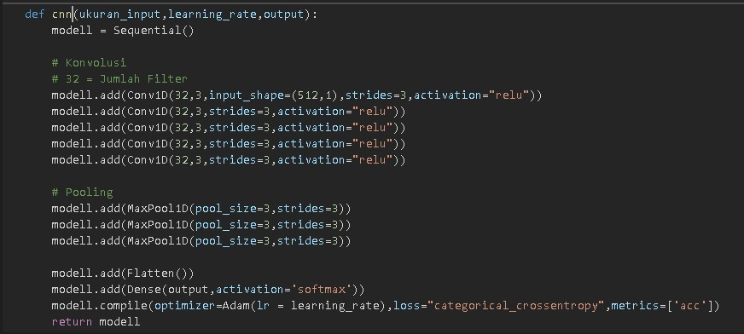

5. Total of test data = 300, A = normal, B = infected.

Actual

B

A

Predicted

|  |  |
| --- | --- |
| 75  A | ?  B |
| 80 | 75 |

a. Accuracy

b. Sensitivity

c. Specificity

d. Precision

e. F1-Score

**LEMBAR JAWABAN**

**NAMA : Feron Sadana**

**NIM : 09021381823085**

**KELAS : 6 TIBIL C**

**JAWABAN**

1. A. Aturan Dasar

B. Fuzzification

C. Inference Engine

D. Defuzzification

2. A. As computer-aided diagnosis to help the physicians for an efficient and early diagnosis, with a better harmonization and less contradictory diagnosis

B. To enhance the medical care of patients with better personalized therapies

C. To improve the human wellbeing, for example by analyzing the spread of disease and social behaviors in relation to environmental factors, or to implement a brain–machine interface for controlling a wheelchair

1. 1. machine learning = bagian dari Kecerdasan Buatan yang menggunakan algoritma pembelajaran statistik untuk membangun sistem yang memiliki kemampuan untuk belajar dan meningkatkannya secara otomatis
2. Deep Learning = menggali data dalam jumlah besar untuk secara otomatis mengidentifikasi pola dan mengekstrak fitur dari data kompleks tanpa pengawasan tanpa keterlibatan manusia, yang menjadikannya alat penting untuk analisis Big Data
3. A. 1. Feature Extraction Layer

2.Fully-Connected Layer (MLP).

3. Max Pulling

4.Convulision

B.

5. a. Accuracy = 0,5

b. Sensitivity = 0,48

c. Specificity = 0,51

d. Precision = 0,51

