Expected output through console application.

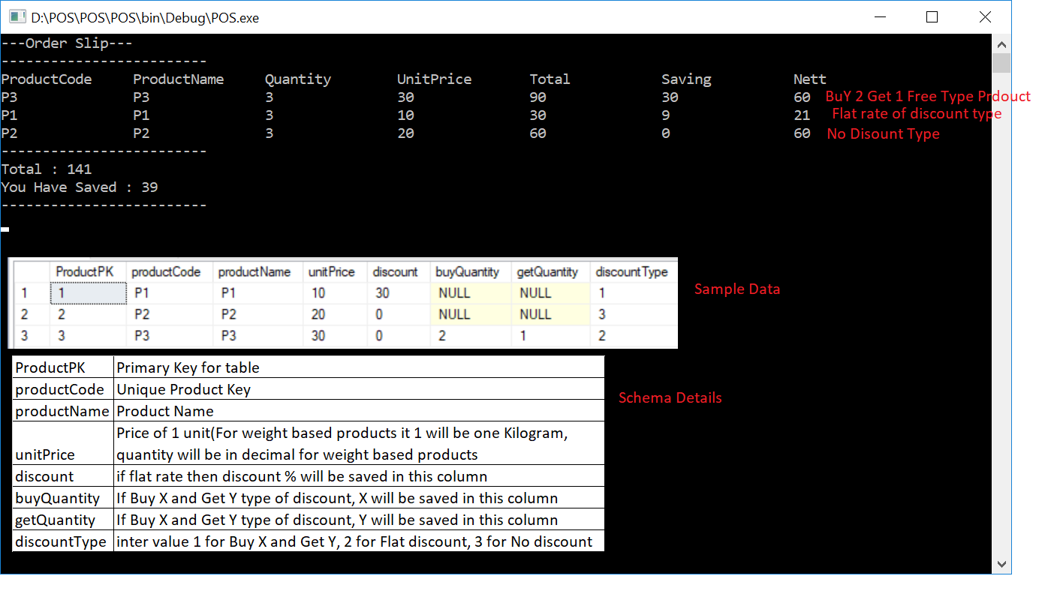

Flow Structure

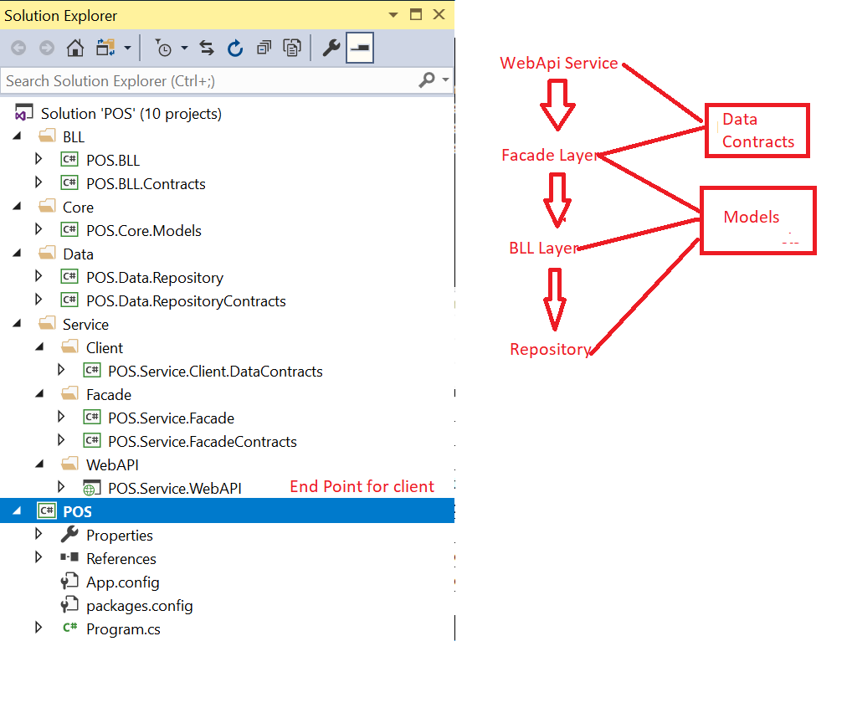

For automapping we can build separate mapping profile but as of now directly written in Façade itself.

All interfaces also can be resolved in a single method, as of now instantiated normally.

Please see sample data and sample output.

We can add any number of services to get data as response. Currently implemented below actions.

* GetProduct ( To read product based on product id)—It expects a product id as input.
* GenerateOrder ( To generate order slip) – It expects list of products added to the cart.
* Save & Update methods for product has implemented in ProductRepository.
* Used Entity Framework to get data. We can use SQL Database Proxy also.