Required Project 16.1: Build a Transit Data Application

- Task 1: Provide a screenshot to show that you have successfully created the MBTANetwork network.
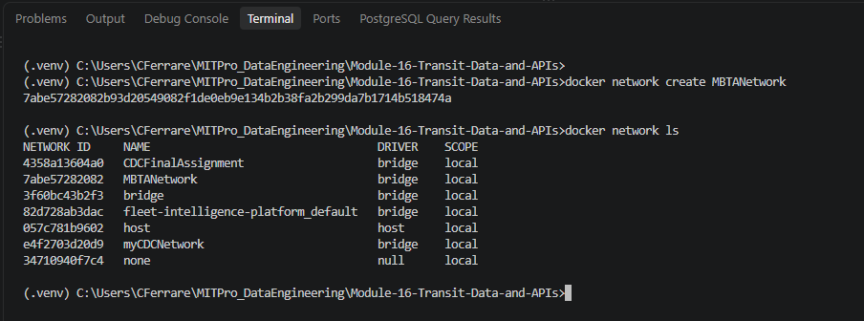

- Task 2: Provide a screenshot to show that you have successfully opened the mysqlDocker folder.
  - Provide a screenshot to show that you have successfully opened the MBTA.sql file.
Task02_01_mysqlDocker_Folder
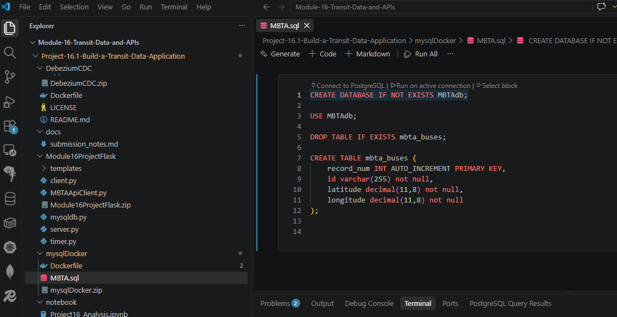

  - For this step, you will provide two screenshots. The first screenshot should show that you have successfully run the provided code in a Jupyter Notebook. The second screenshot should show that you have successfully added at least five additional fields to the mbta_buses table.

Task02_02_MBTA_API_Test
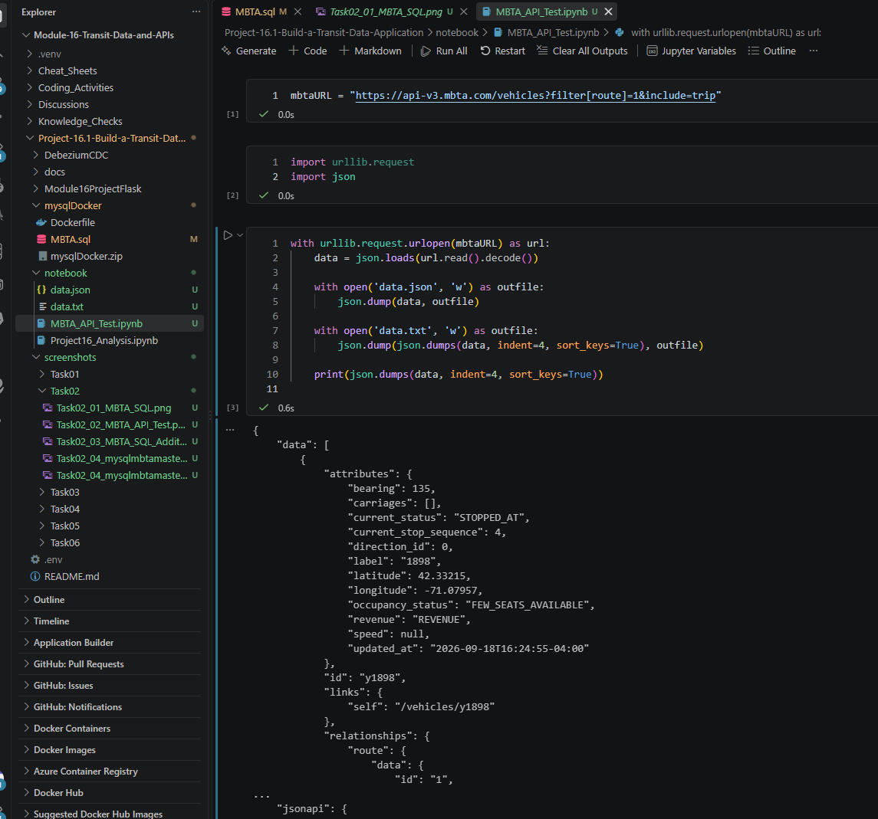

Task02_03_MBTA_SQL_Additional_Fields
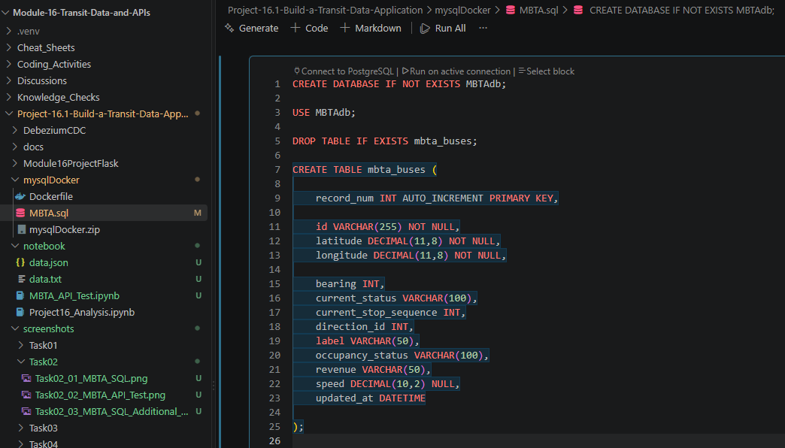

  - Provide a screenshot to show that you have successfully created the mysqlmbtamasterimg Docker image.

Task02_04_mysqlmbtamasterimg_Image
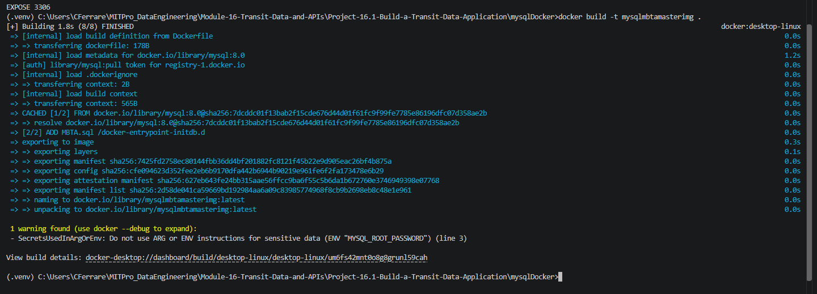

Task02_04_mysqlmbtamasterimg_desktop_Image
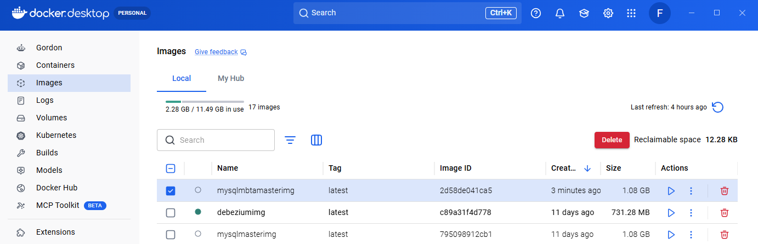

  - Provide a screenshot to show that you have successfully created the mysqlserver Docker container.

Task02_05_mysqlserver_Container
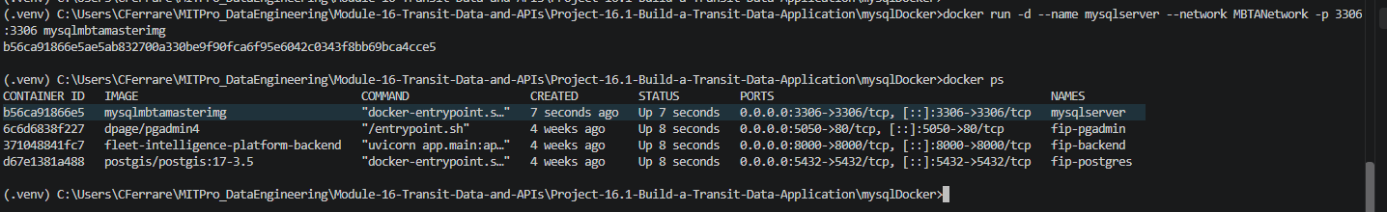

Task02_05_mysqlserver_Container_desktop
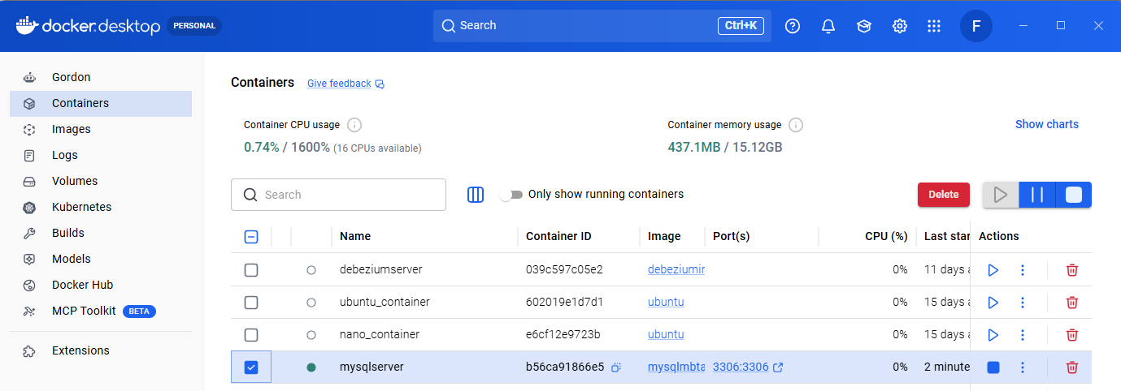

- Task 3: Provide a screenshot to show that you have successfully created the some-mongo Docker container.

Task03_01_some_mongo_Container
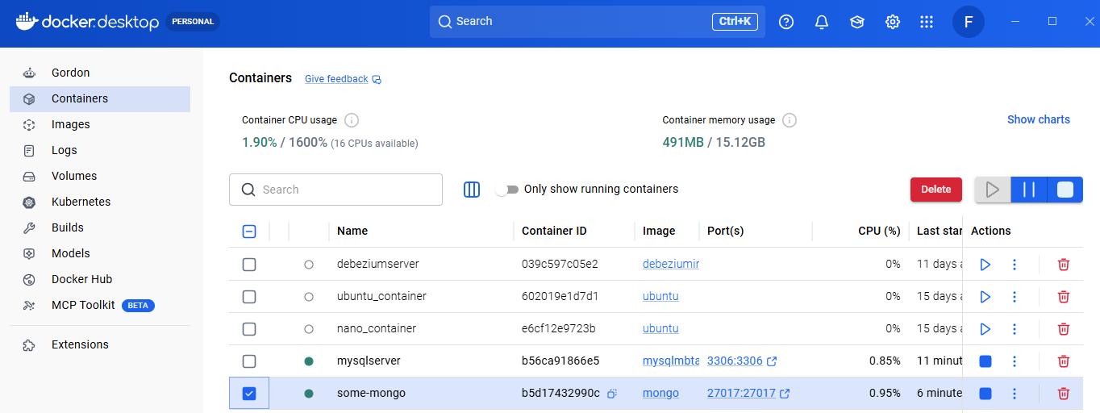

- Task 4:
  - Provide a screenshot to show that you have successfully opened the Module16ProjectFlask.zip folder in VS Code.

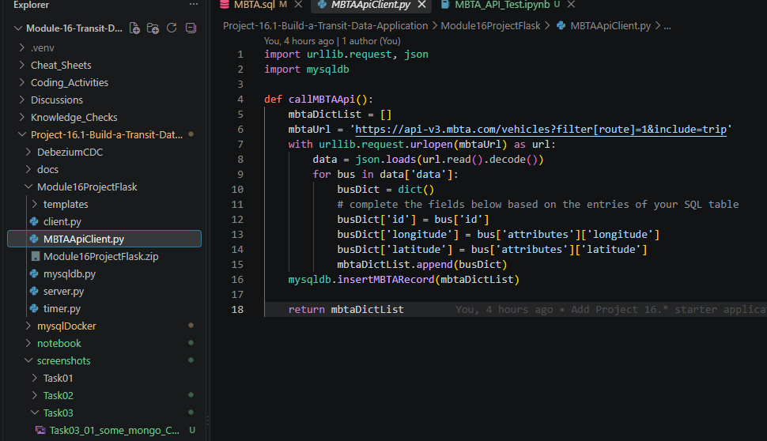

  - Provide a screenshot to show that you have successfully modified the mysqldb.py file.
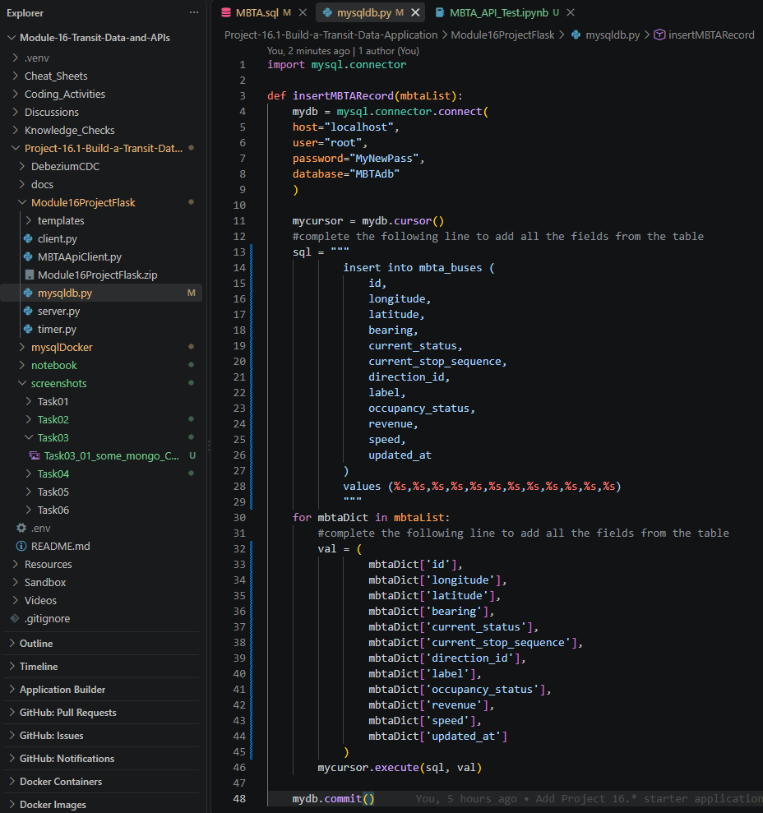

  - Provide a screenshot to show that you have successfully modified the MBTAApiClient.py file.

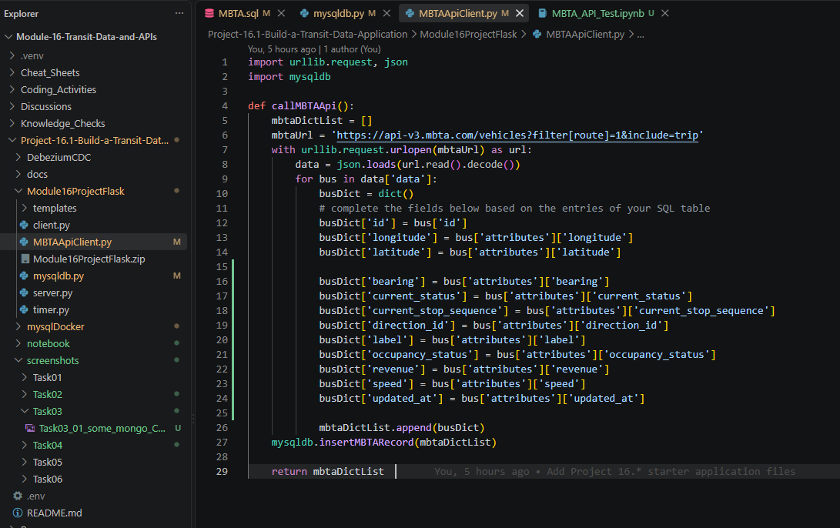

  - Provide a screenshot to show that you have successfully added your Mapbox access token in the index.html file.
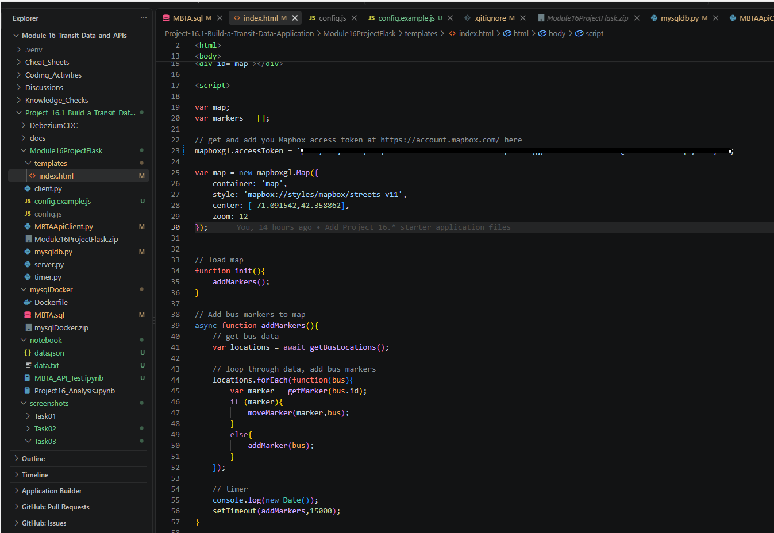
  - Provide a screenshot to show that you have successfully initialized the buses list in the server.py file.

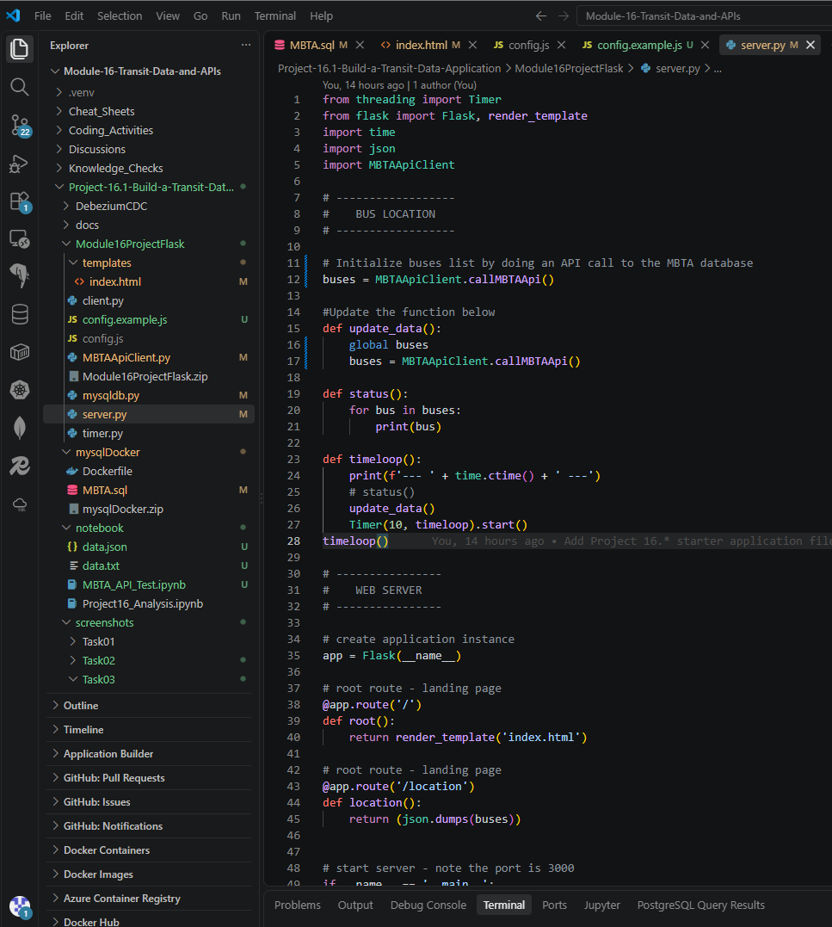

  - Provide a screenshot to show that you have successfully run the server.py file in VS Code.
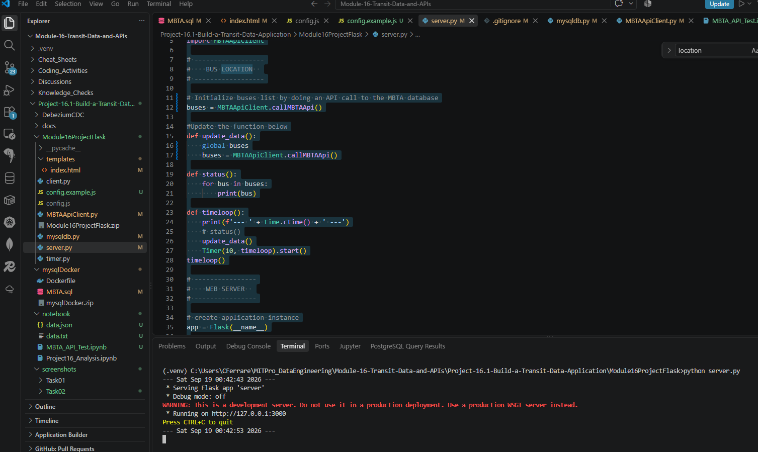

  - Provide a screenshot to show that you have successfully navigated to localhost:3000.

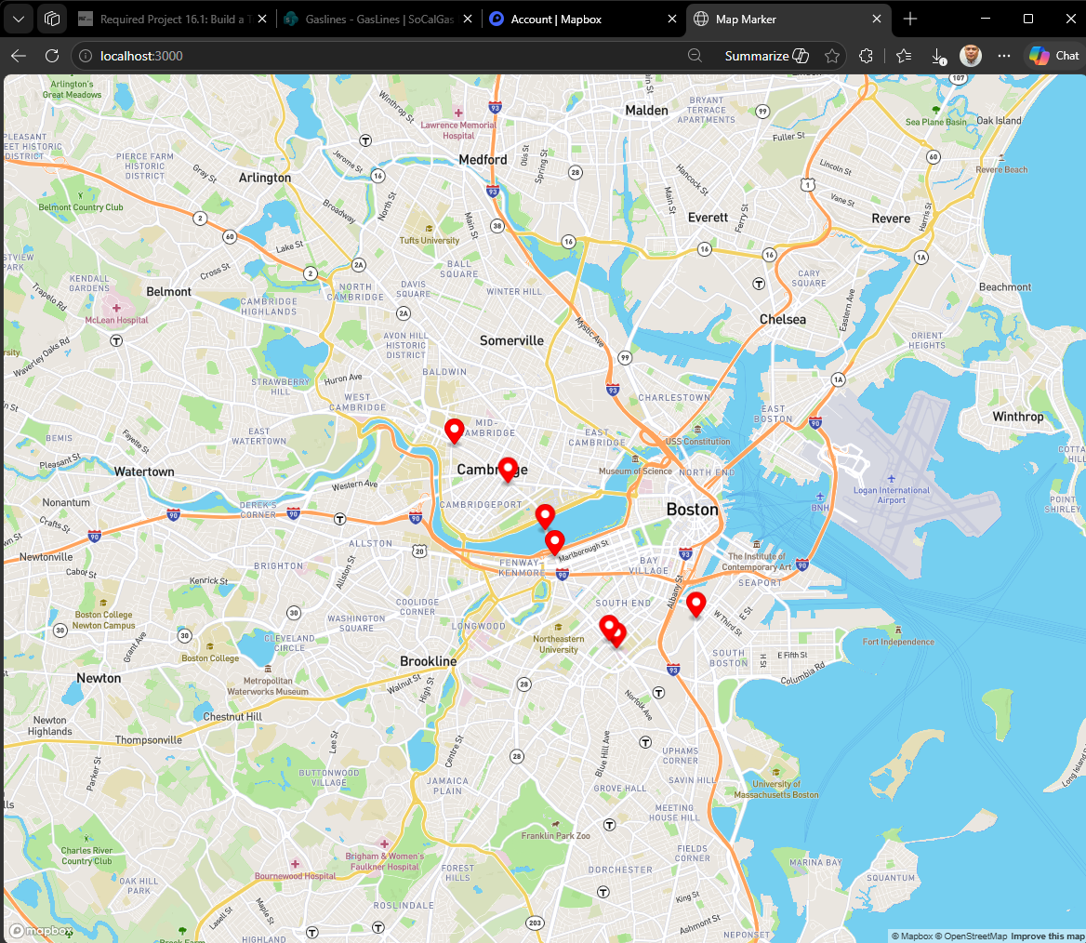

- Task 5:
  - Provide a screenshot to show that you have successfully opened the DebeziumCDC.zip folder in VS Code.
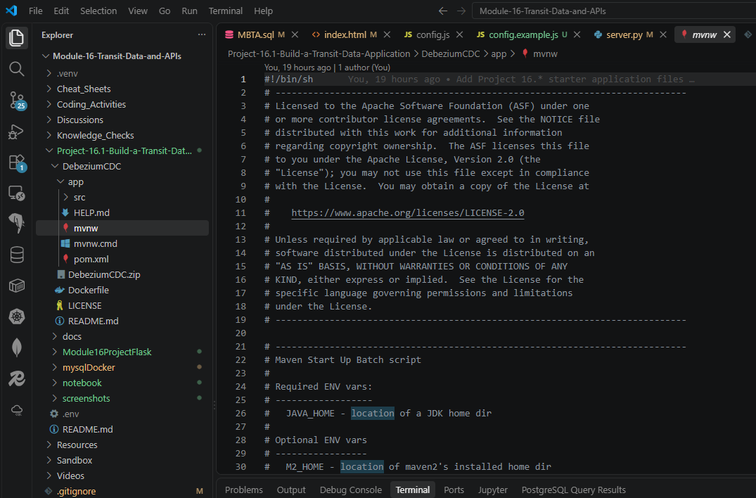

  - Provide a screenshot to show that you have successfully created the debeziummodule16 Docker image.

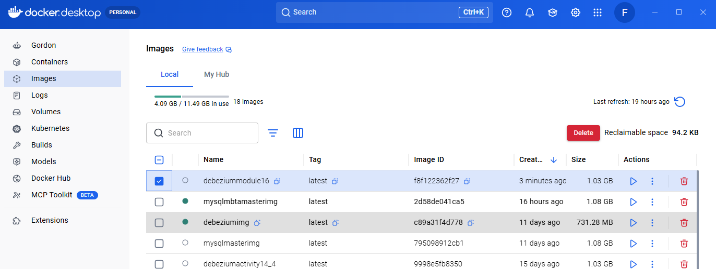

  - Provide a screenshot to show that you have successfully created the Docker container and associated it with the MBTANetwork network.
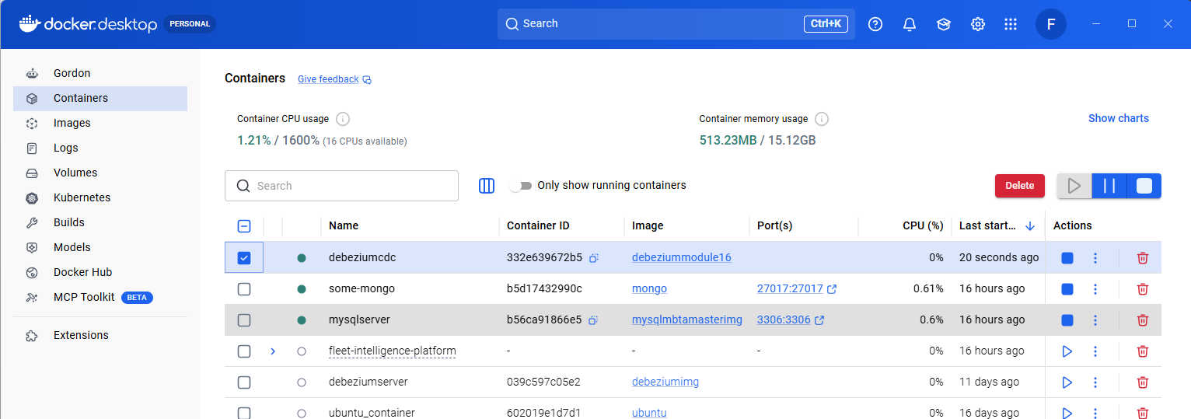

  - Provide a screenshot to show that you have successfully installed the nano text editor in your shell.
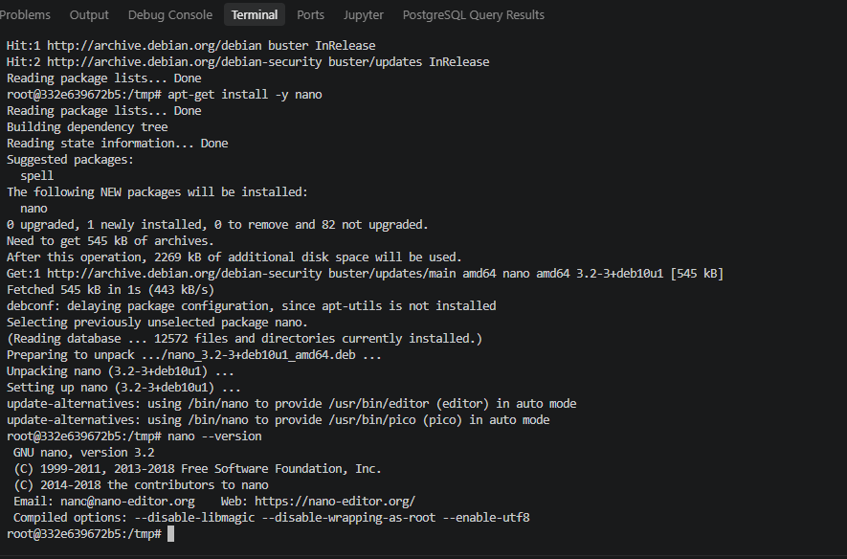

  - Provide a screenshot to show that you have successfully modified the MongoDB.java class.

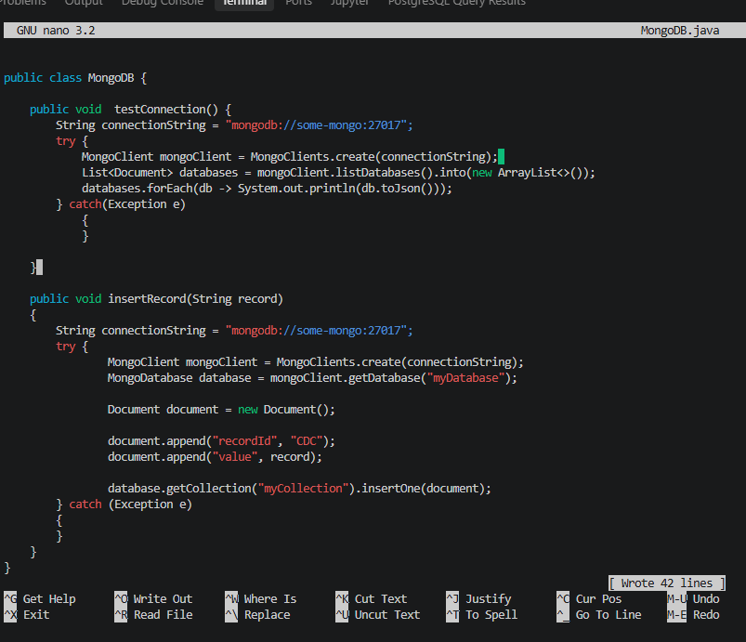

  - Provide a screenshot to show that you have successfully modified the handleChangeEvent method.

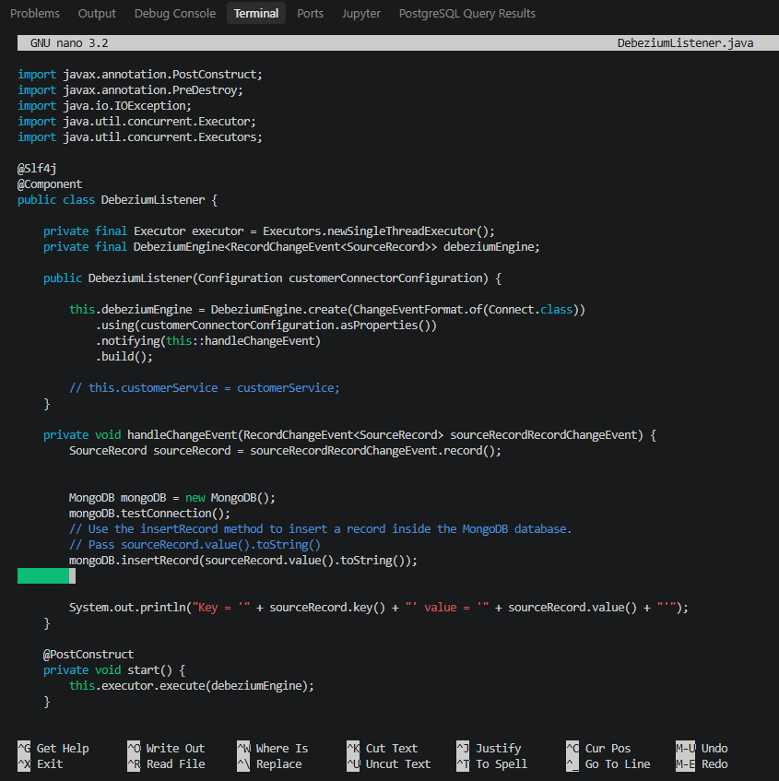

  - Provide a screenshot to show that you have successfully run the Maven SpringBoot application.

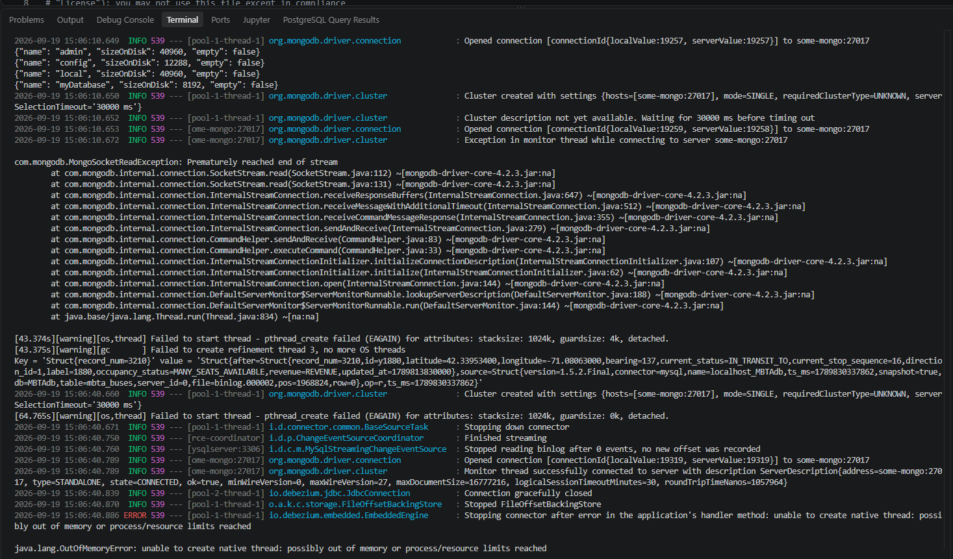

- Task 6:
  - Provide a screenshot of your Docker desktop to show the javamaven container running.
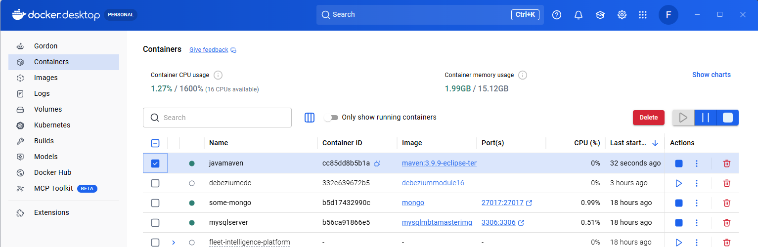

  - Provide a screenshot to show that you successfully navigated to the directory and listed the files.
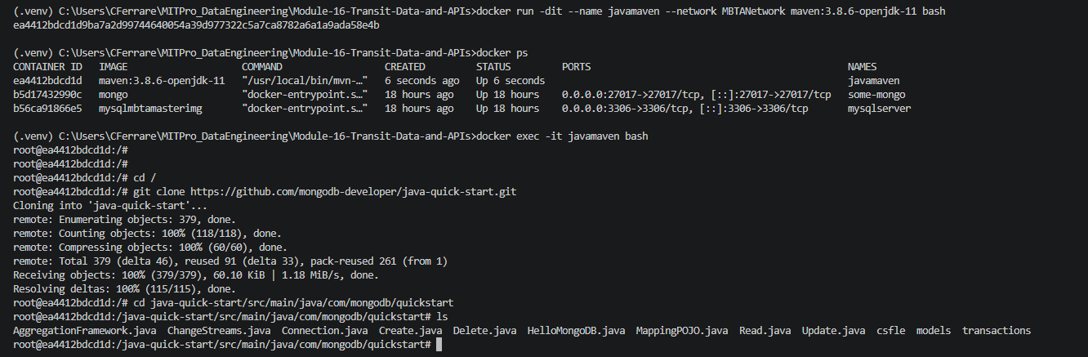
  - Provide a screenshot to show that you successfully created the ReadCDC.java file and copied the code.

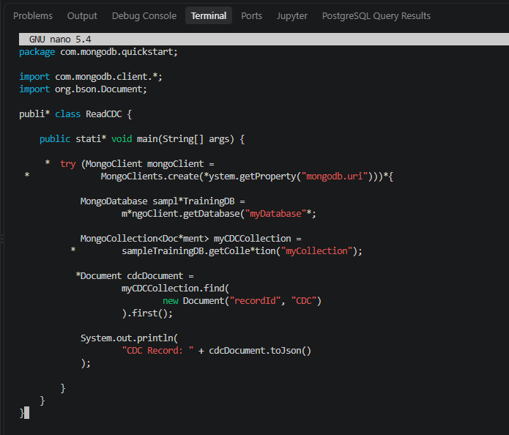

  - Provide a screenshot to show the results of the bash command to execute the ReadCDC.java class.

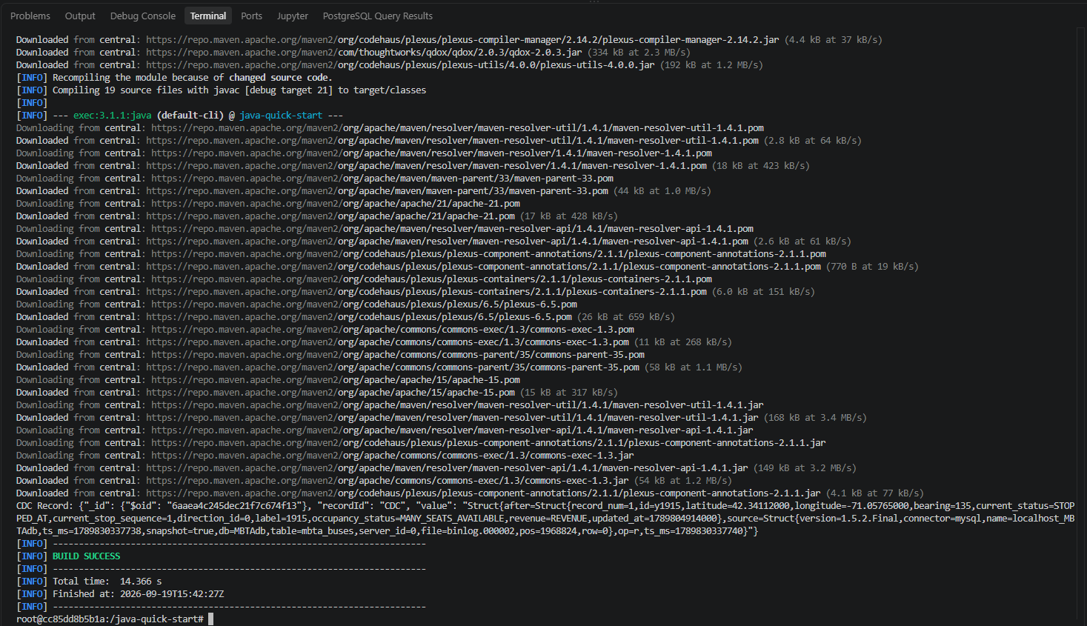

Your second file submission will be the Project 16.1 Jupyter Notebook template with your answers to the following three questions included:

- Task 7: Answer the following questions in your Jupyter Notebook submission:
  - What is the average time it takes for a bus to complete Route 1?
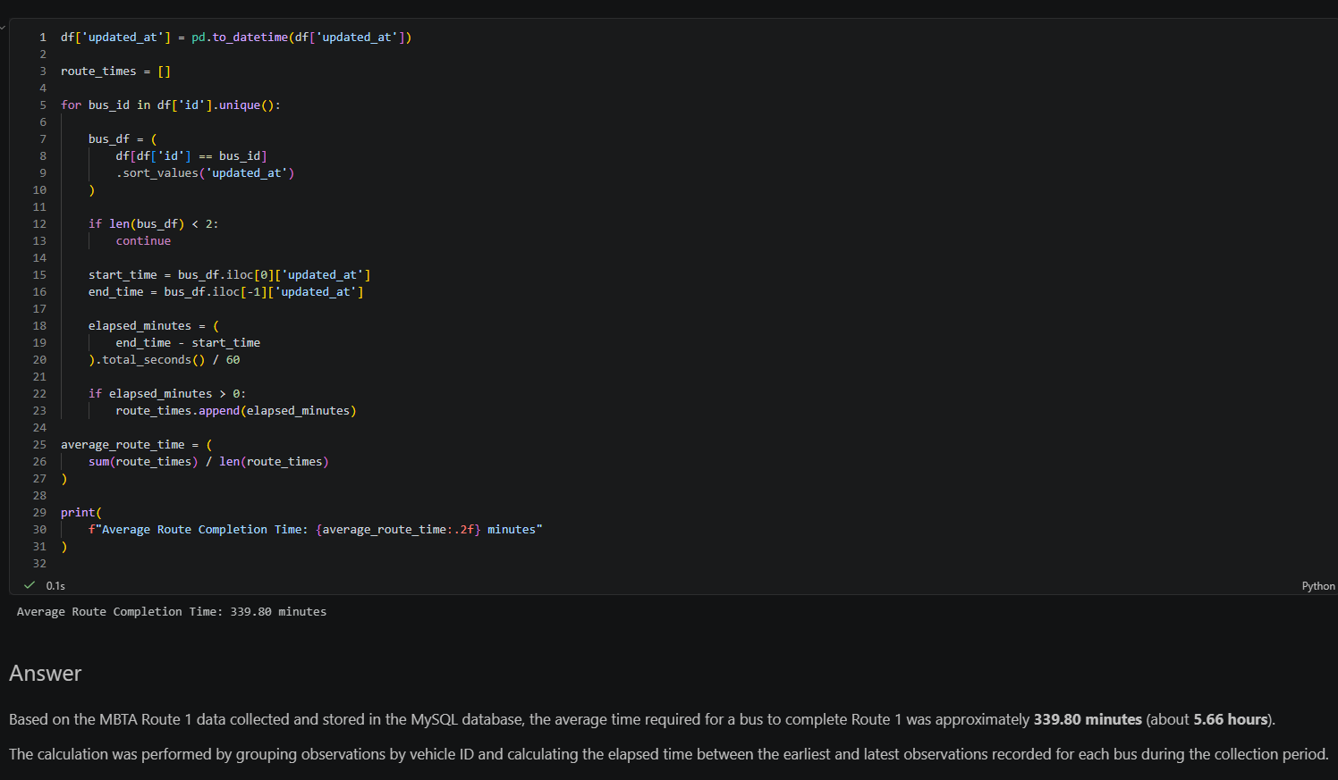

  - Include a plot-type visualization based on the data. The type of plot you choose to include is up to you.
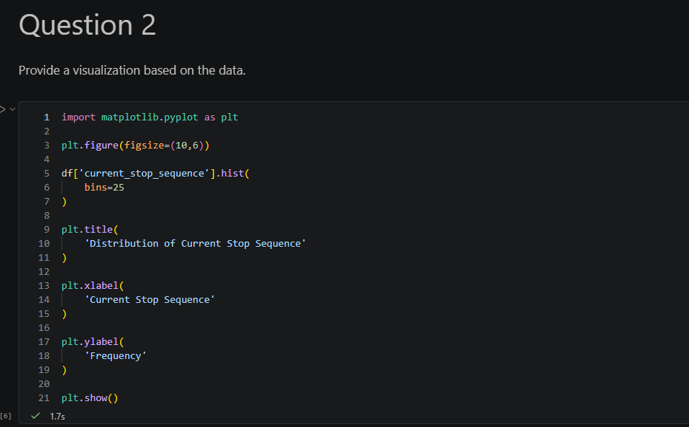

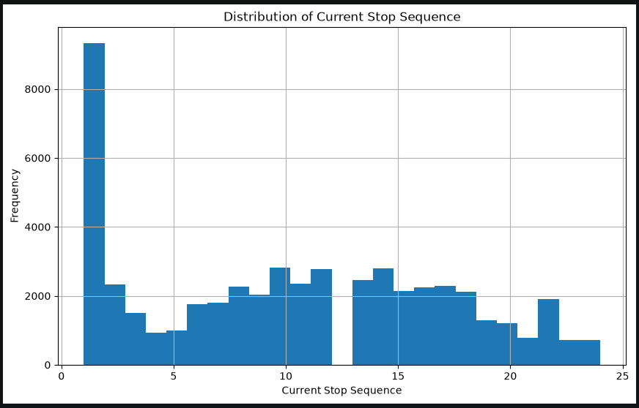

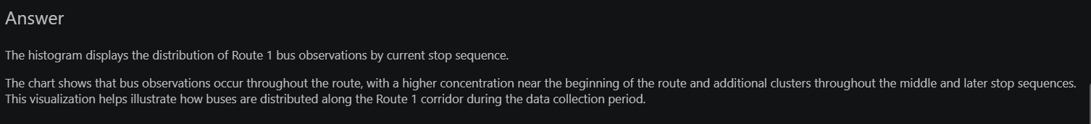

  - Give an estimate of the speed of the bus from current_stop_sequence = 1 to the last current_stop_sequence. Note: You can use the haversine Links to an external site.Python library to calculate the distance between two points given two longitude and latitude coordinates.
