Required Coding Activity 18.1: Setting Up Hadoop in a Docker Container

- Provide a screenshot to show that you successfully reviewed the list of Docker containers running on your machine using the docker ps command.

Step 1 - Review Existing Docker Containers Using docker ps
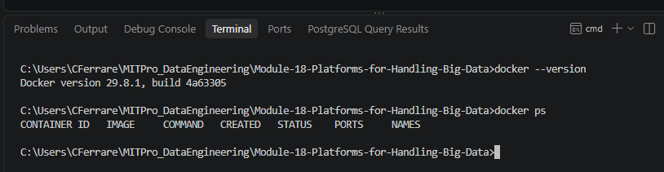

- Provide a screenshot to show that you successfully cloned the Big Data Europe Project GitHub repository.

Step 2: Clone the Big Data Europe Hadoop Repository
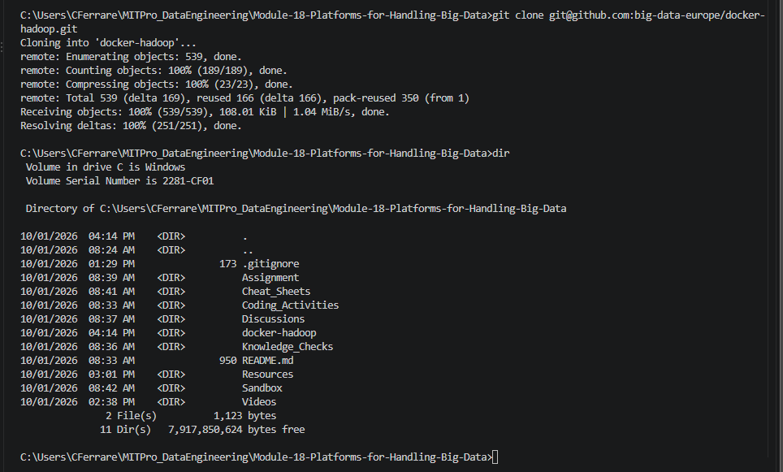

- Provide a screenshot to show you can find the docker-compose.yml file using the command line interface.

Step 3: Verify docker-compose.yml
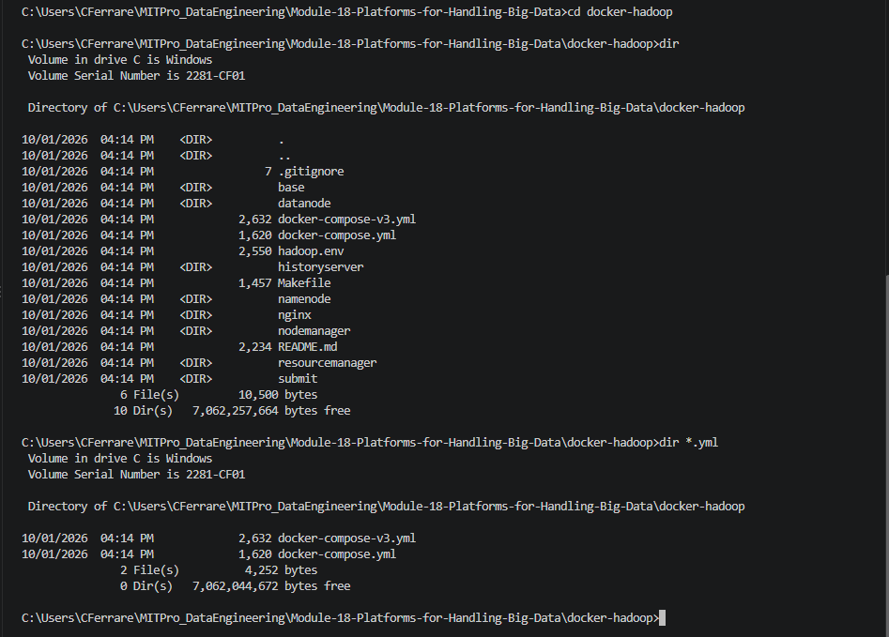

- Provide a screenshot to show that you successfully ran the Docker command to create the containers.

Step 4: Create the Hadoop Containers
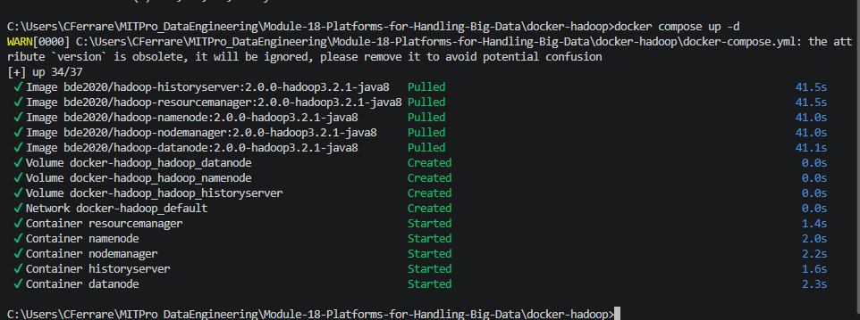

- Provide a screenshot to show that you have all of the Hadoop containers running in the (healthy) STATUS.

Step 5: Verify Container Health
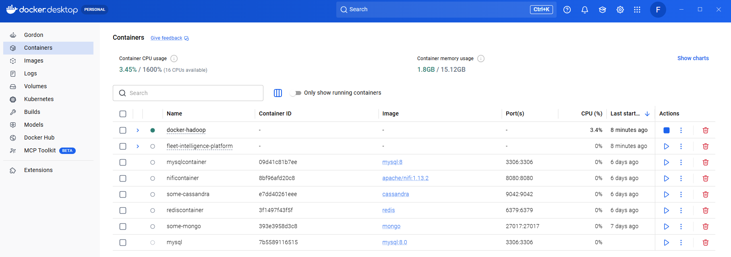
docker ps
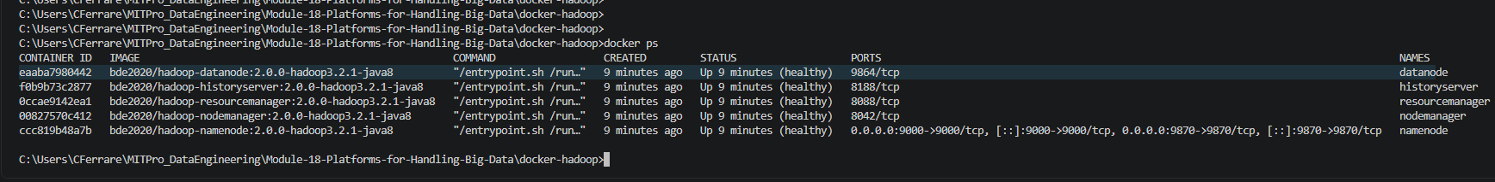

- Provide a screenshot to show you can open a Hadoop web browser link by navigating to http://localhost:9870.

Step 6 - Verify Hadoop Web Interface
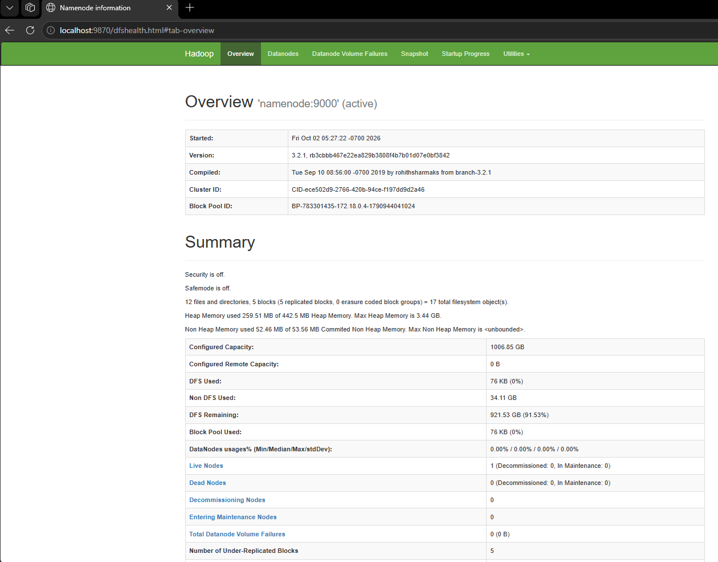

Conclusion

This activity demonstrated how to deploy Hadoop using Docker containers, verify the successful creation of Hadoop services, confirm healthy container status, and access the Hadoop HDFS NameNode web interface. The Hadoop environment is now operational and ready for future activities involving HDFS and MapReduce processing.

