Coding Activity 18.2: Executing the Word Count Program in Hadoop

- Provide a screenshot of your Docker desktop to show the Hadoop containers running.

Step 1 - Verify Hadoop Containers
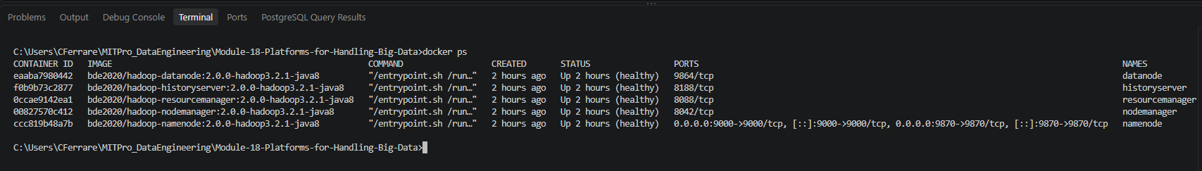

Docker desktop showing with the hadoop container highlighted: 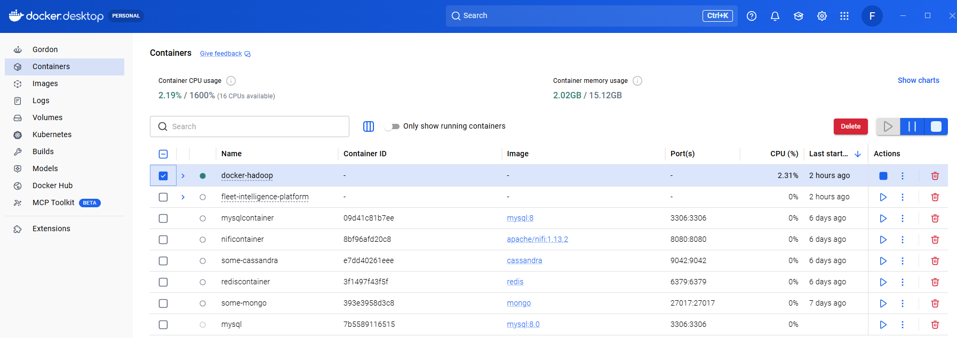

- Provide a screenshot of your local machine to show that you successfully downloaded the Moby Dick .zip file and unzipped its contents to your local machine.

Step 2 - Download Moby Dick Dataset
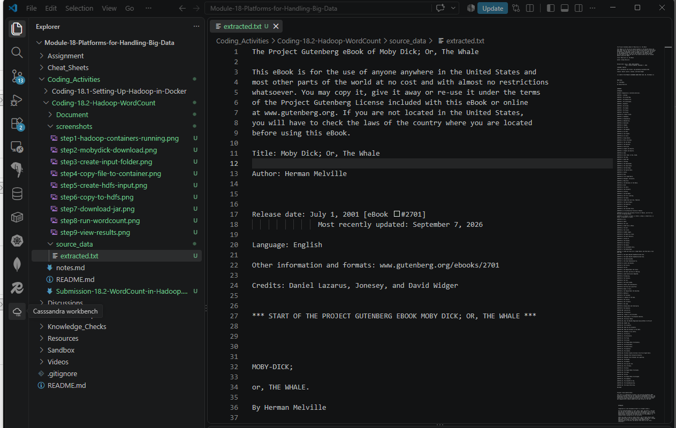

- Provide a screenshot to show that you successfully created the input folder in the namenode container.

Step 3 - Create Input Folder
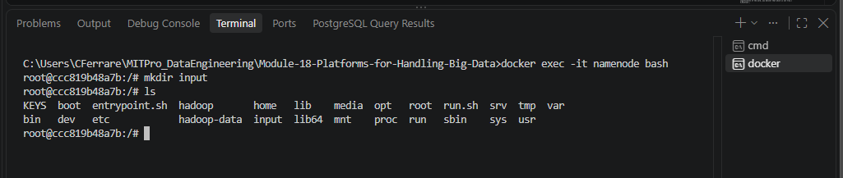

- Provide a screenshot to show that you successfully copied the .txt file to the namenode container.

Step 4 - Copy File to Container
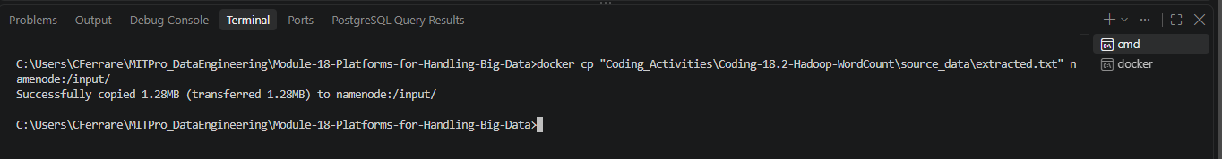
The file was successfully copied into the container.
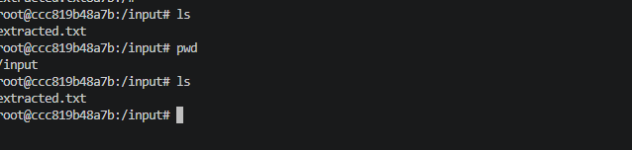

- Provide a screenshot to show that you successfully created an input folder.

Step 5 - Create HDFS Input Folder
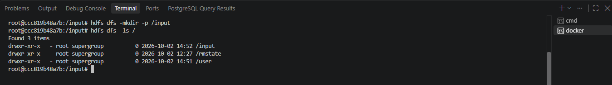

- Provide a screenshot to show that you successfully ran the HDFS command to copy the contents of the local input folder to the HDFS input folder.

Step 6 - Upload File to HDFS
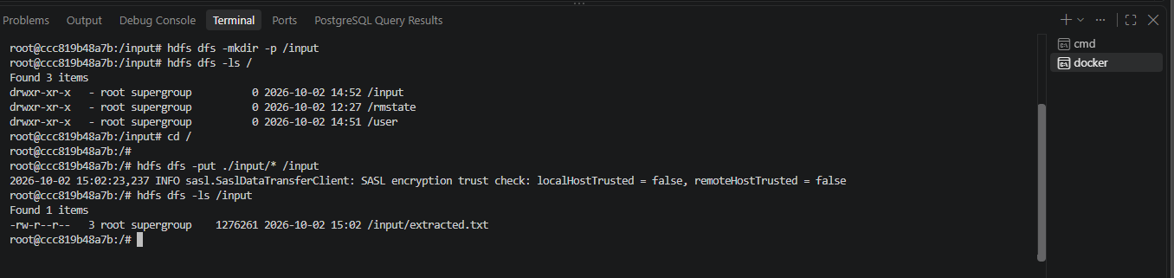

- Provide a screenshot to show that you successfully ran the curl command to download the jar file.

Step 7 - Download Word Count JAR
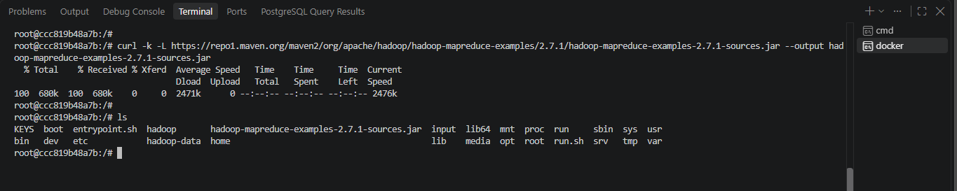

- Provide a screenshot to show that you successfully ran the word count program.

Step 8 - Execute Word Count Program
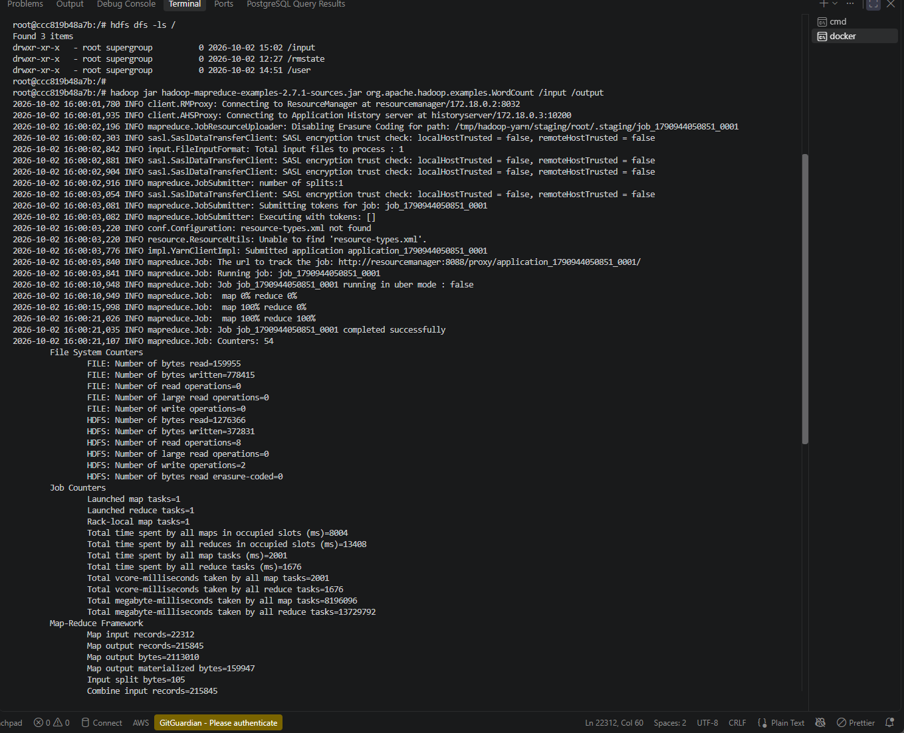
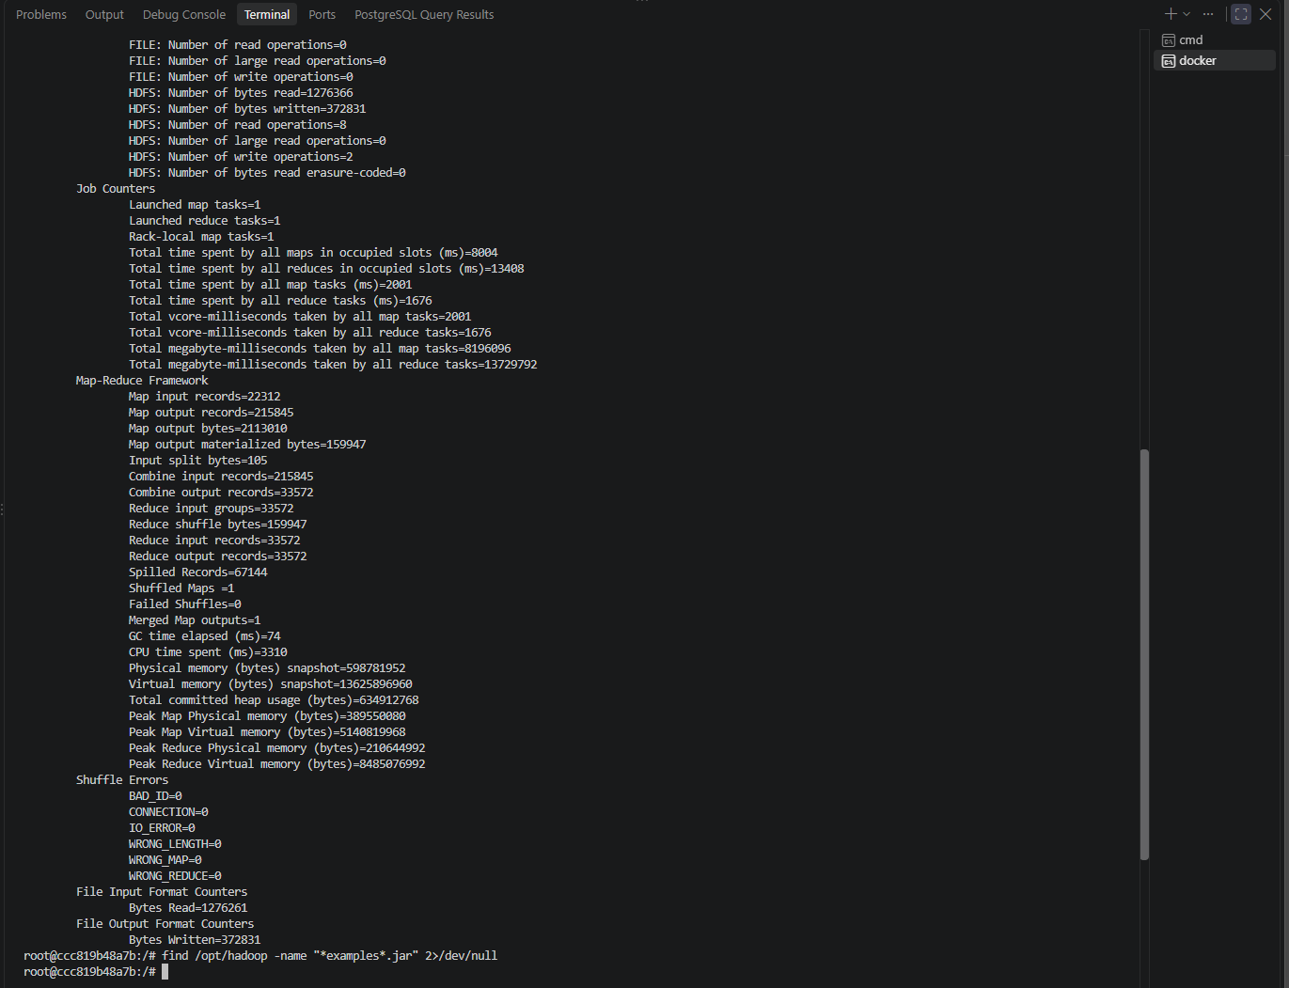

- Provide a screenshot to show that you successfully executed the cat command to display the contents of the file.

Step 9 - Display Output Results
