Required Final Assignment 18.1: Platforms for Handling Big Data

Part 1: Ingesting Data into the HDFS
- Provide a screenshot to show that you unzipped the testprogram.zip file.

Step 1 - Extract testprogram.zip
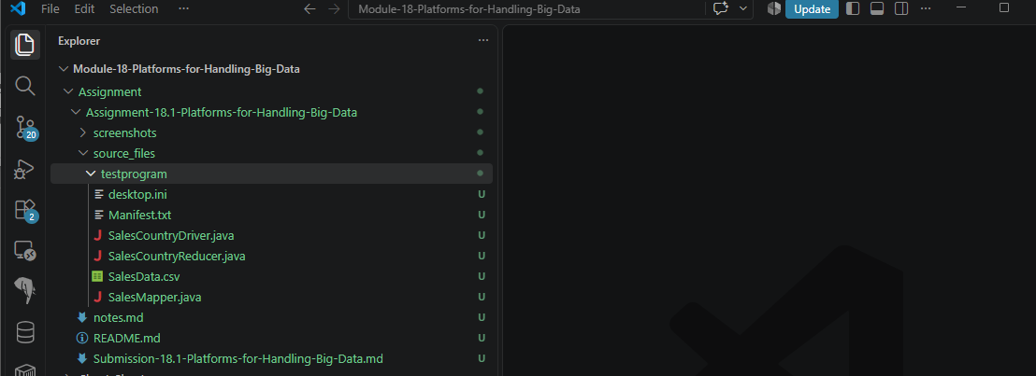

- Provide a screenshot to show that you copied the testprogram folder into the home directory of the Hadoop namenode.

Step 2 - Copy testprogram Folder to Hadoop NameNode
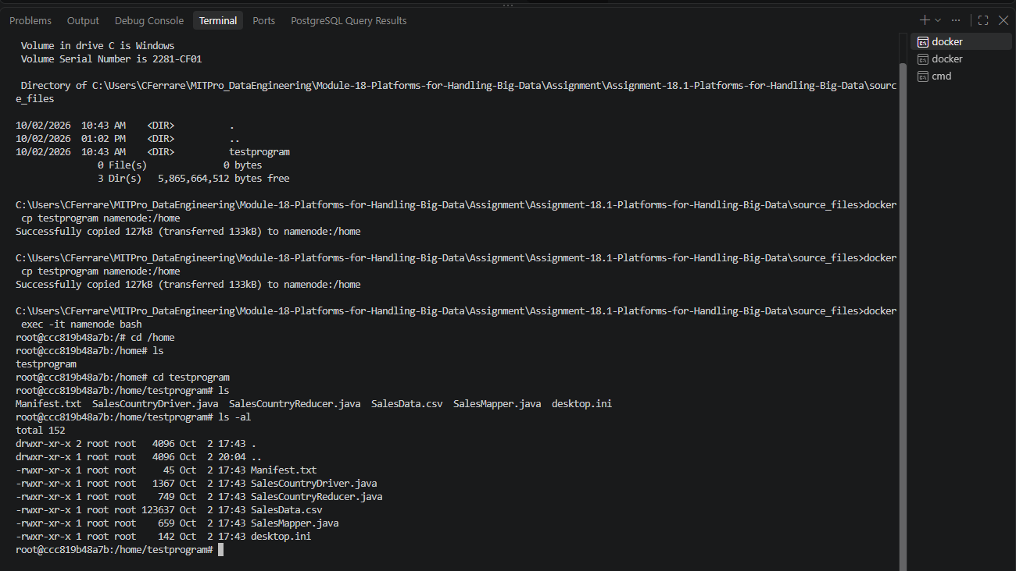

- Provide a screenshot to show that you successfully copied the SalesData.csv file into the inputMapReduce folder.

Step 3 Copy SalesData.csv into inputMapReduce
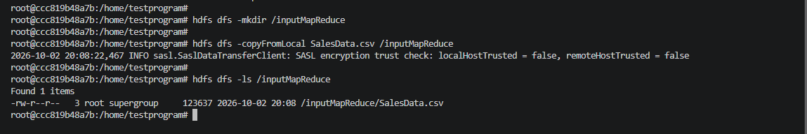

- Provide a screenshot to show that the file has been copied using the HDFS cat command.

Step 4 - Verify SalesData.csv Using HDFS Cat
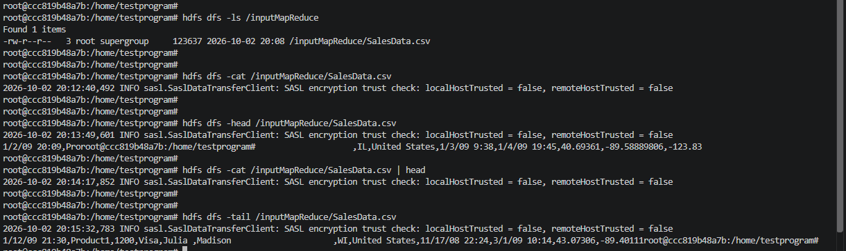

Part 2: Performing MapReduce — Aggregation Sales by Country
- Provide a description of the three Java files listed below that are used to apply the MapReduce framework on the Hadoop database:
- SalesCountryDriver.java
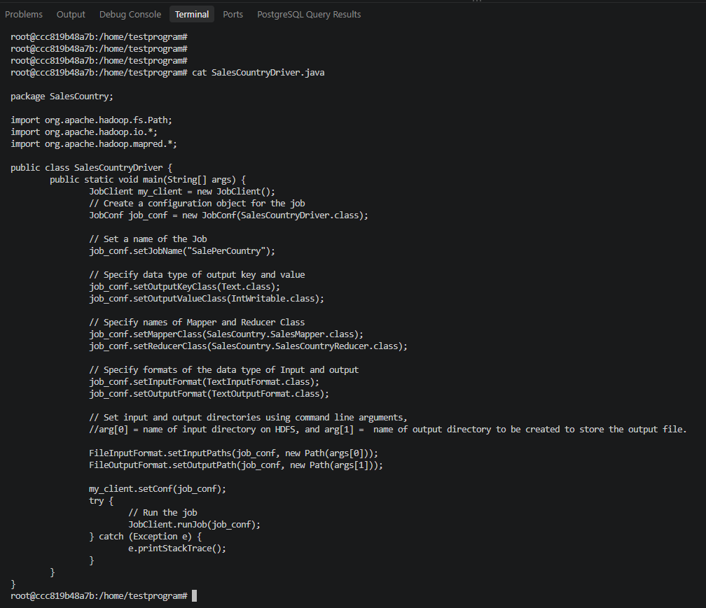

Description of SalesCountryDriver.java

SalesCountryDriver.java serves as the main driver class for the Hadoop MapReduce application. It is responsible for configuring and launching the MapReduce job. The driver creates a JobConf object that defines the job settings, assigns a job name, specifies the output key and value data types, and identifies the Mapper and Reducer classes that Hadoop should use during execution.

The driver also defines the input and output formats, accepts the HDFS input and output paths through command-line arguments, and submits the job for execution using JobClient.runJob(). In summary, SalesCountryDriver.java acts as the controller that coordinates the entire MapReduce process and connects all components of the application together.

Key Functions Identified
job_conf.setJobName("SalePerCountry");
Sets the Hadoop job name.
job_conf.setMapperClass(SalesCountry.SalesMapper.class);

Assigns the Mapper class.
FileInputFormat.setInputPaths(...)

Defines the HDFS input directory.
FileOutputFormat.setOutputPath(...)

Defines the HDFS output directory.
JobClient.runJob(job_conf);

- SalesMapper.java

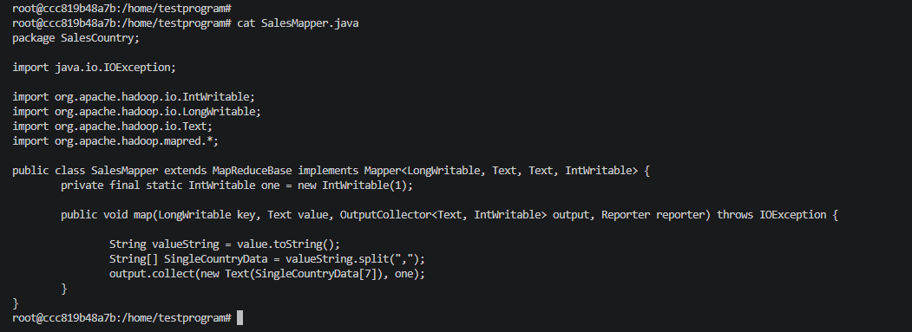

Description of SalesMapper.java

SalesMapper.java is the Mapper component of the Hadoop MapReduce application. Its responsibility is to read each sales record from SalesData.csv, extract the country field from the CSV record, and generate intermediate key-value pairs.

The mapper converts each input row into a string, splits the row into individual fields using a comma delimiter, and selects the country value located in the dataset. It then outputs the country as the key and assigns a value of 1 as the associated value.

The generated output takes the form:
<Country, 1>

These intermediate records are passed to Hadoop's Shuffle and Sort phase, which groups all records belonging to the same country together before sending them to the reducer.

Key Functions Identified
String valueString = value.toString();

Converts the input line into a string.
String[] SingleCountryData = valueString.split(",");

Splits the CSV record into fields.
output.collect(new Text(SingleCountryData[7]), one);

Outputs:
<Country, 1>

where:
SingleCountryData[7]

contains the Country field from the sales record.

Example:

Input Record:
United States

Mapper Output:
<United States,1>

- SalesCountryReducer.java

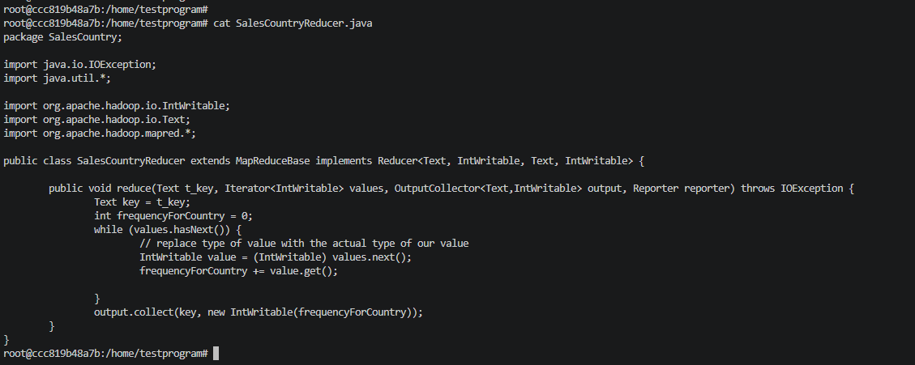

SalesCountryReducer.java

SalesCountryReducer.java is the Reducer component of the Hadoop MapReduce application. Its purpose is to aggregate all values associated with each country key produced by the mapper.

The reducer receives a country and an iterator containing multiple values of 1 generated from the sales records. It loops through the values, sums them together, and calculates the total frequency for that country. After aggregation, it outputs the country name along with the total count.

The final output takes the form:
<Country, Total Sales Records>

This process produces a summary showing the number of sales transactions associated with each country in the dataset.

Example:

Mapper Output:

<United States,1>
<United States,1>
<United States,1>

Reducer Output:

<United States,3>
Complete MapReduce Flow

SalesData.csv
↓
SalesMapper.java
↓
<Country,1>
↓
Shuffle and Sort
↓
Group by Country
↓
SalesCountryReducer.java
↓
<Country,Total Count>
↓
part-00000

- Provide a screenshot to show that you have successfully defined the environment variables in the namenode CLI.

Step 2 - Configure Hadoop Environment Variables
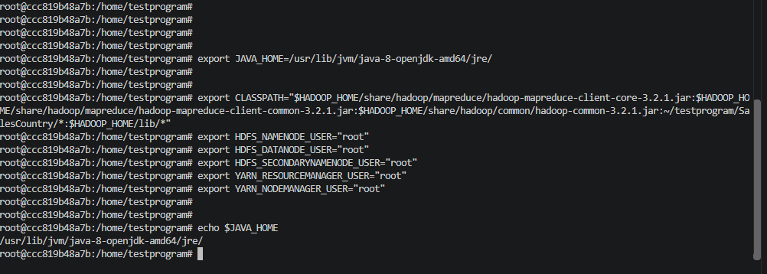

- Provide a screenshot to show that you successfully compiled the Java files in the SalesCountry folder.

Step 3 - Compile Java Files
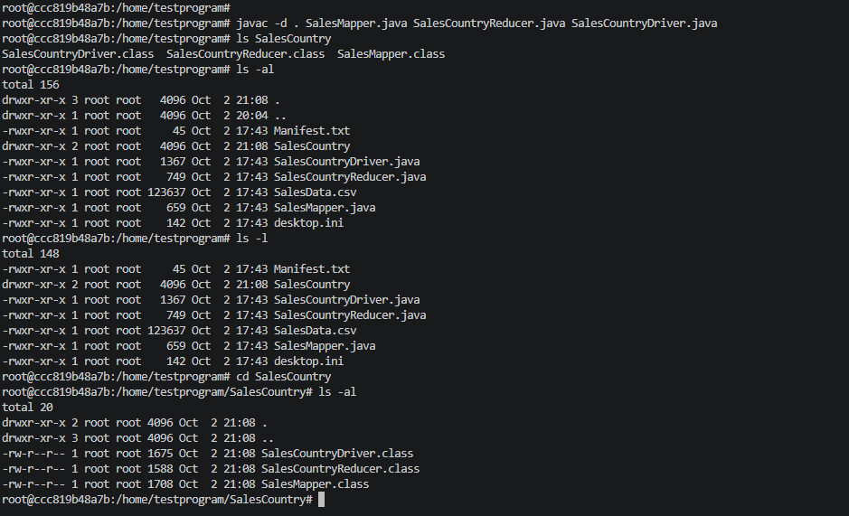

- Provide a screenshot to show that you successfully created a jar file from the compiled Java code.

Step 4 - Create ProductSalePerCountry.jar
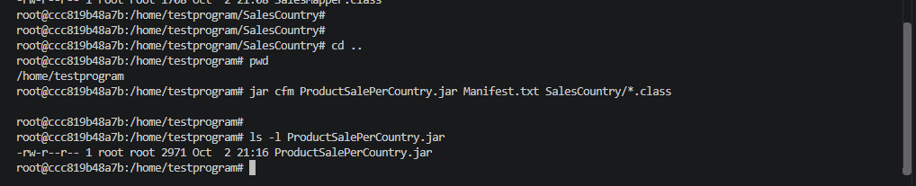

- Provide a screenshot to show that you successfully ran the MapReduce operation to distribute the analysis of the data.

Step 5 - Execute Sales Aggregation MapReduce Job 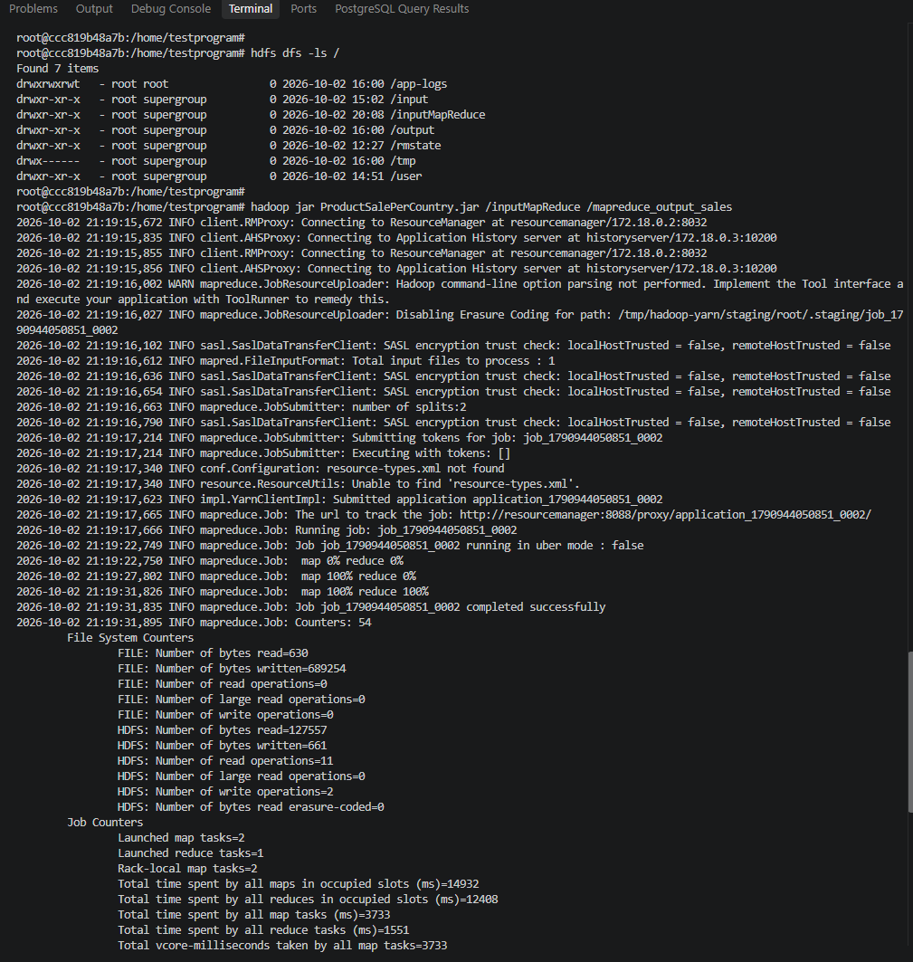
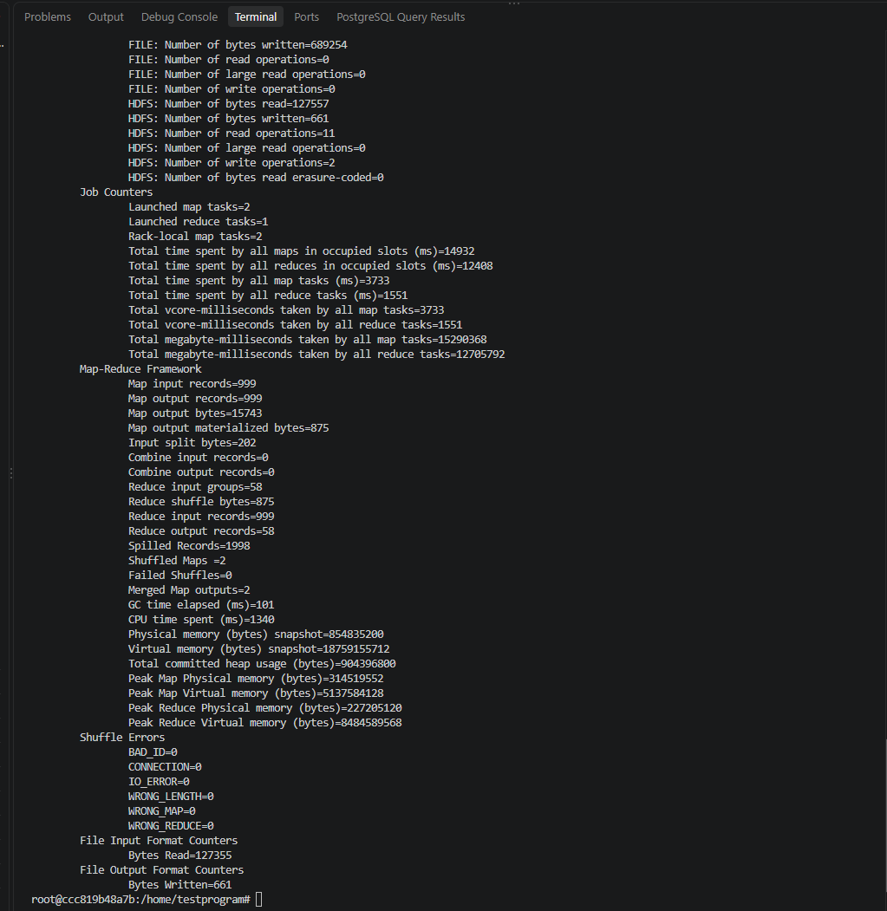

- Provide a screenshot to show that you successfully visualized the content of the part-00000 file inside the mapreduce_output_sales folder.

Step 6 - Display Sales Aggregation Results
