Required Coding Activity 19.2: Loading Data into a Spark Docker Container

- Provide a screenshot showing that you successfully created the data folder and downloaded the departuredelays.csv file.

Created the data folder and successfully downloaded the departuredelays.csv dataset required for loading into the Spark Docker container.
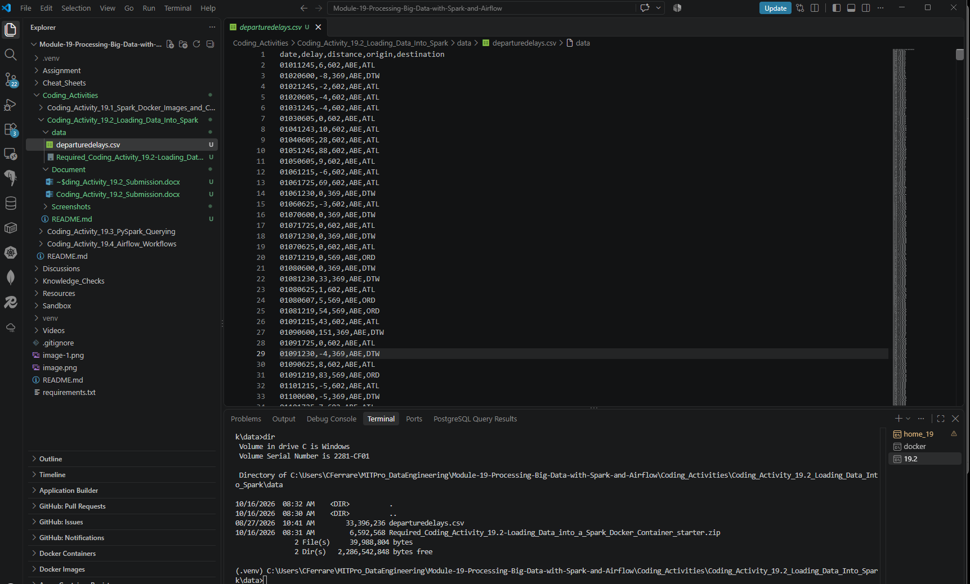

- Provide a screenshot showing that the Spark Docker containers that you created in Activity 19.1 are running.

Verified that the Spark Docker containers created in Activity 19.1 are running successfully. The Spark Master container (bitnami_spark_1) and Spark Worker container (bitnami_spark-worker-1) are both active and operational in Docker Desktop.
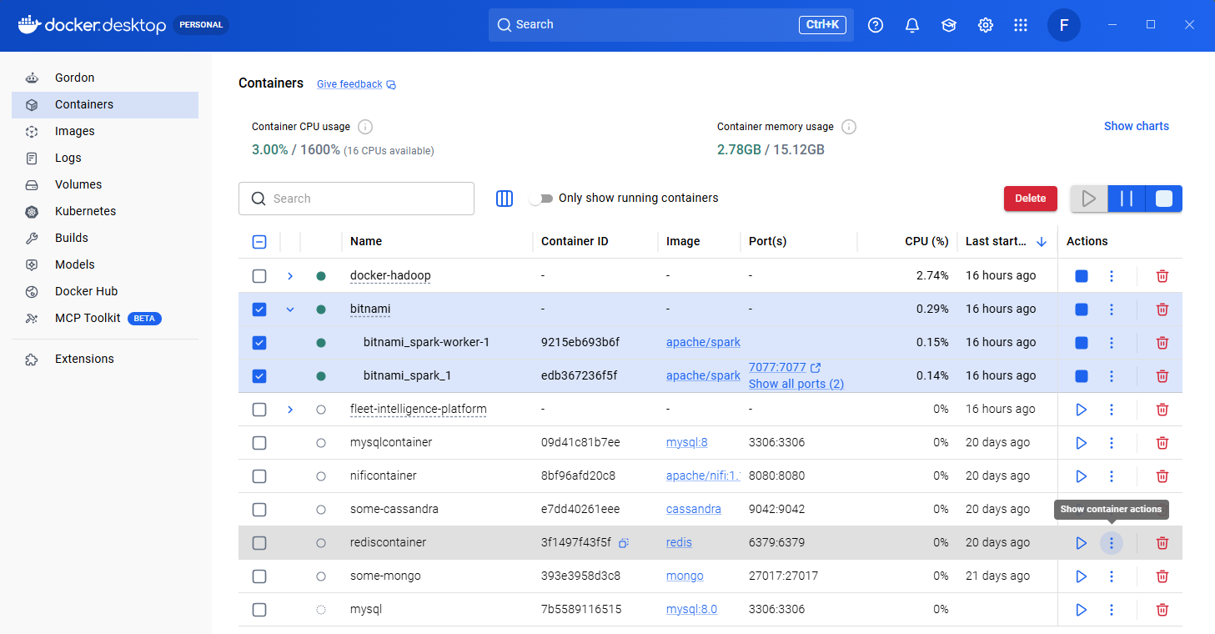

- Provide a screenshot showing that you successfully ran the docker cp command to copy the departuredelays.csv file to the Spark Docker container’s root folder.

Successfully copied the departuredelays.csv file from the local machine into the Spark Docker container using the Docker cp command.
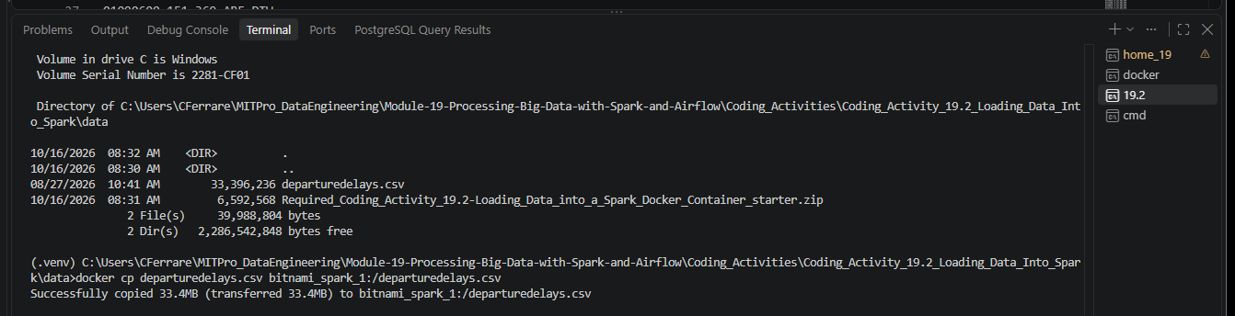

- Provide a screenshot showing that the departuredelays.csv file has been copied to the root folder.

Accessed the Spark Docker container and listed the contents of the root directory to verify that departuredelays.csv was successfully copied into the container.
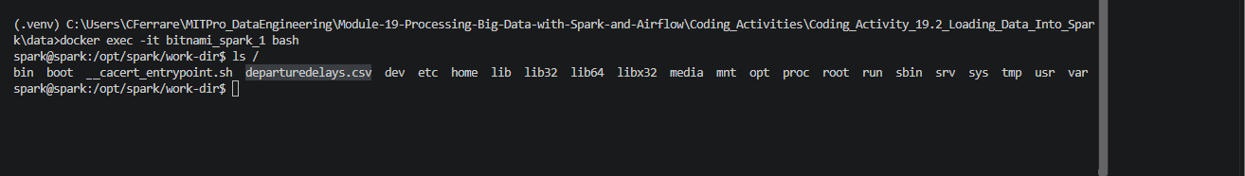

- Provide a screenshot showing that you successfully started the PySpark interface.

Successfully started the PySpark interactive shell and verified that the SparkSession was available for use.
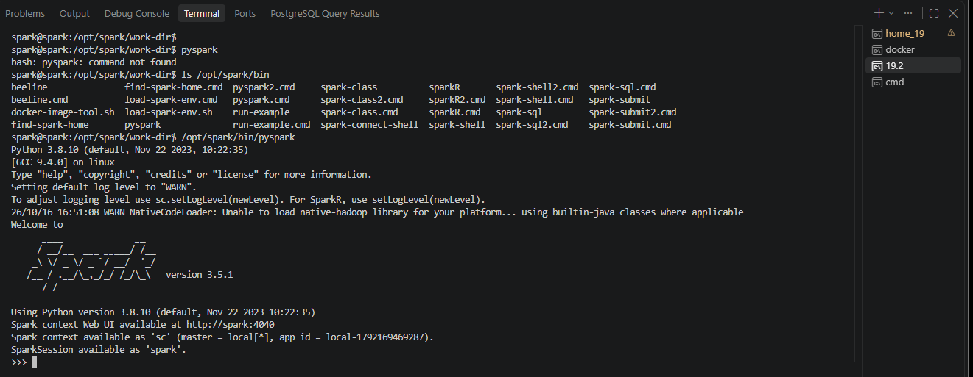

- Provide a screenshot showing that you successfully ran the command to create a Spark session.

Successfully created a SparkSession named DepartureDelays using the SparkSession builder. Spark confirmed that an existing session was available and would be reused.
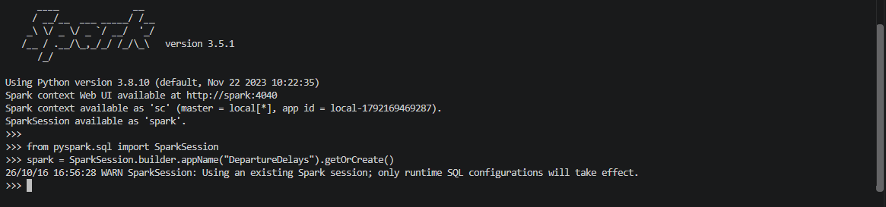

- Provide a screenshot showing that you successfully ran the command to load the departuredelays.csv file into a Python dataframe.

Successfully loaded the departuredelays.csv file into a Spark DataFrame and created a temporary SQL view named delays_table for SQL queries.
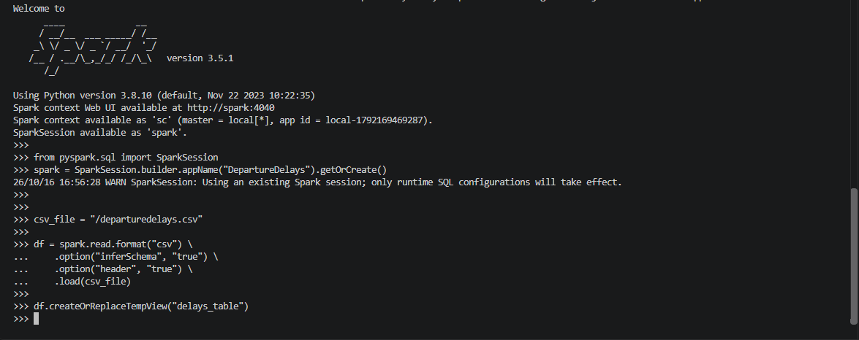

- Provide a screenshot showing that you successfully ran the SQL query and selected the correct columns (distance, origin, and destination).

Successfully executed a Spark SQL query to retrieve flights with a distance greater than 1,000 miles, displaying the distance, origin, and destination columns ordered by distance in descending order.
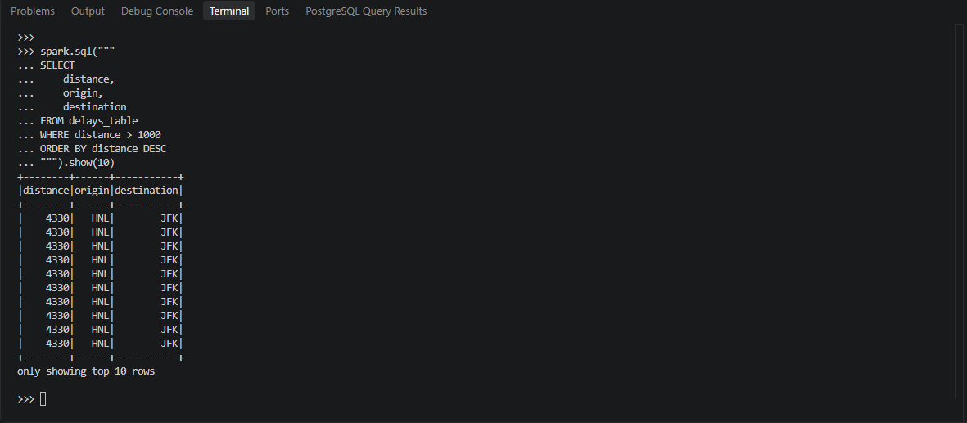

- Provide a screenshot showing that you successfully ran the SQL query with the correct rows.

Successfully executed a Spark SQL query to identify flights from SFO to ORD with delays greater than 120 minutes and displayed the top 10 results ordered by delay in descending order.
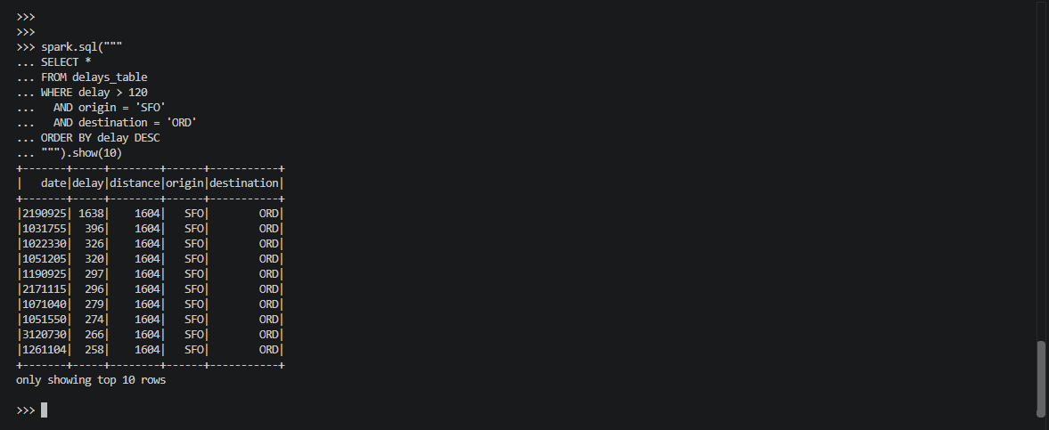

- Provide a screenshot showing that you successfully ran the SQL query, categorized the data correctly, selected the correct columns, and showed 10 rows of data.

Successfully executed a Spark SQL query using a CASE statement to categorize flight delays into delay length classifications and displayed the delay, origin, destination, and delay_length columns for the first 10 records.
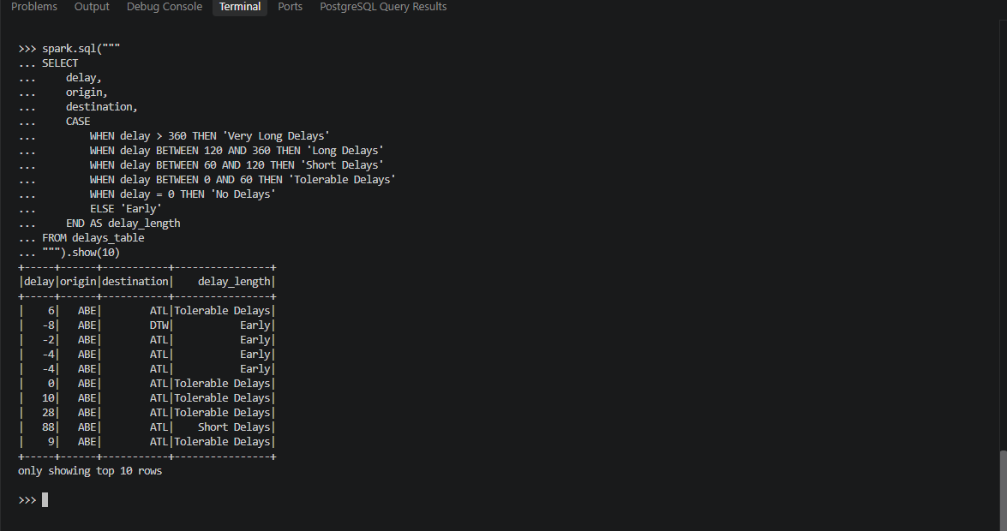

- Provide a screenshot showing that you successfully ran the query to determine the correct maximum delay for all of the flights in the dataset.

Successfully executed a Spark SQL query to determine the maximum flight delay in the dataset. The maximum delay identified was 1,642 minutes.
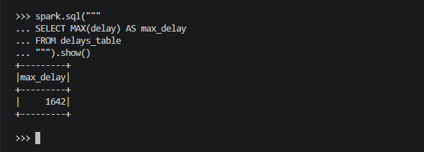

- Provide a screenshot showing that you successfully ran the query to determine the correct minimum delay for all of the flights in the dataset.

Successfully executed a Spark SQL query to determine the minimum flight delay in the dataset.
