Required Final Assignment 19.1: Processing Big Data with Spark and Airflow

Part 1: PySpark
- Provide a screenshot showing that you correctly pulled the image and the docker-compose.yaml file is present.

Created the bitnami directory, downloaded the Spark Docker Compose configuration file from the course repository, and verified that the docker-compose.yml file was successfully created.
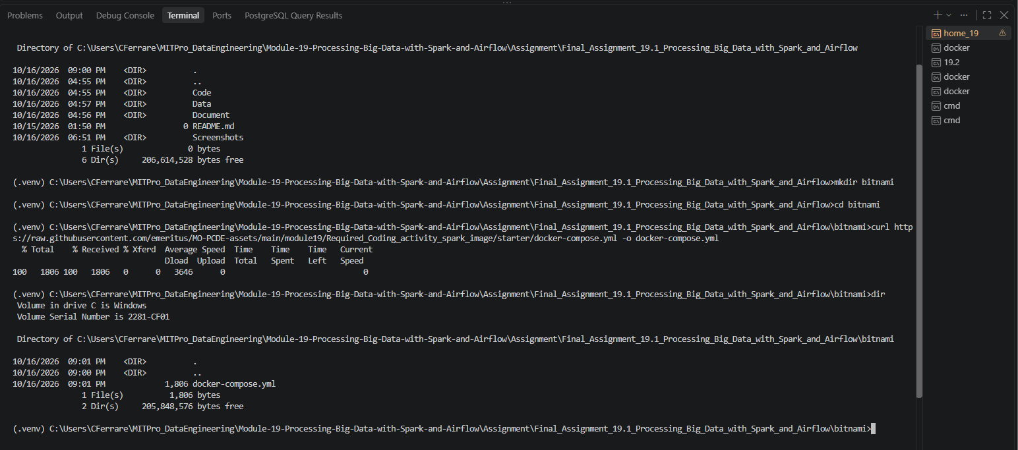

- Provide a screenshot of your Docker Desktop to show that you correctly pulled the containers.

Started the Spark environment using Docker Compose and verified that the Spark master (bitnami_spark_1) and Spark worker (bitnami_spark-worker-1) containers were running successfully.
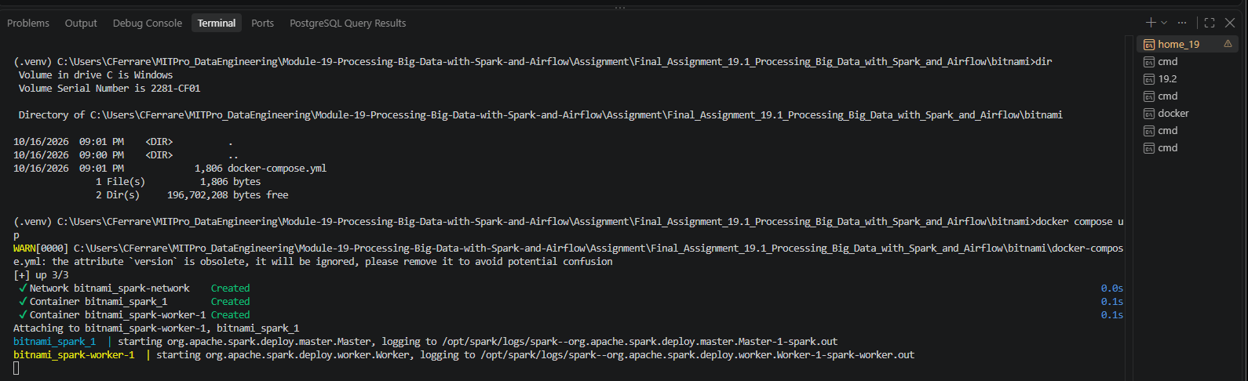

Successfully started the Spark environment using Docker Compose and verified in Docker Desktop that both the Spark master (bitnami_spark_1) and Spark worker (bitnami_spark-worker-1) containers were running.

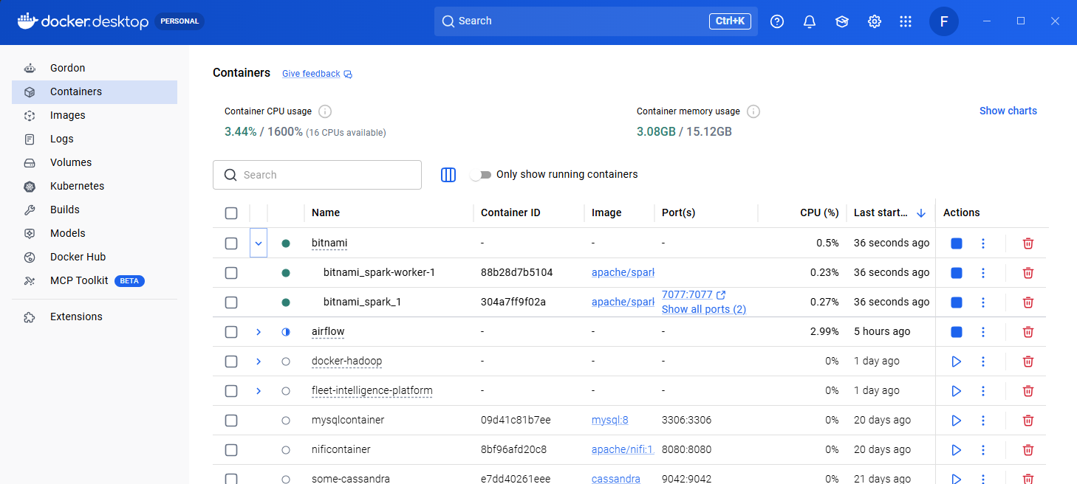

- Provide a screenshot to show that you successfully copied the departuredelays.csv file to the bitnami_spark_1 container.

Successfully copied the departuredelays.csv dataset into the bitnami_spark_1 container using the Docker copy command. The output confirmed the file transfer completed successfully.
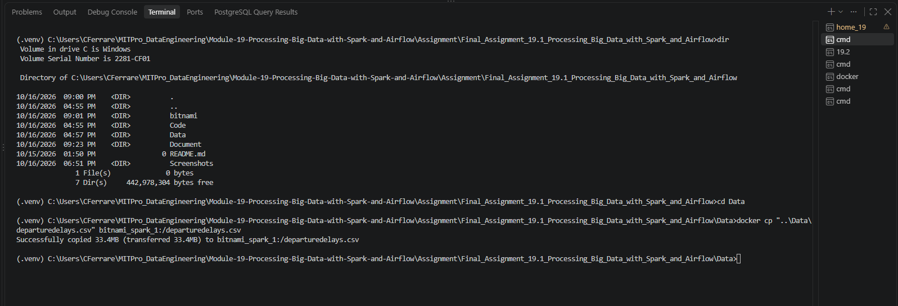

On Docker Desktop:

Successfully copied the departuredelays.csv file into the bitnami_spark_1 container and verified its presence using the Docker Desktop Exec terminal. The file is visible in the root directory of the container and is ready for use in PySpark.
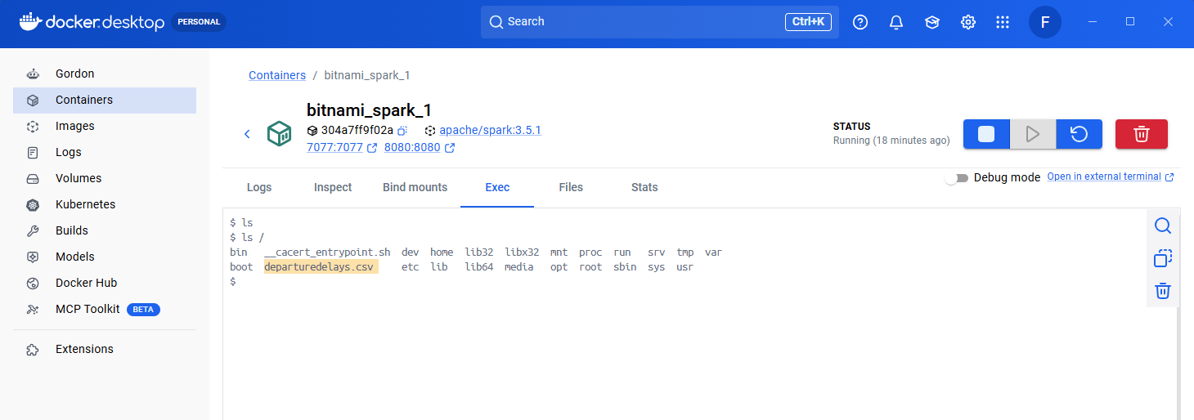

- Provide a screenshot to show that you successfully opened PySpark.

Accessed the Spark container and successfully launched the PySpark interactive shell. The Spark session initialized successfully and displayed the PySpark prompt.
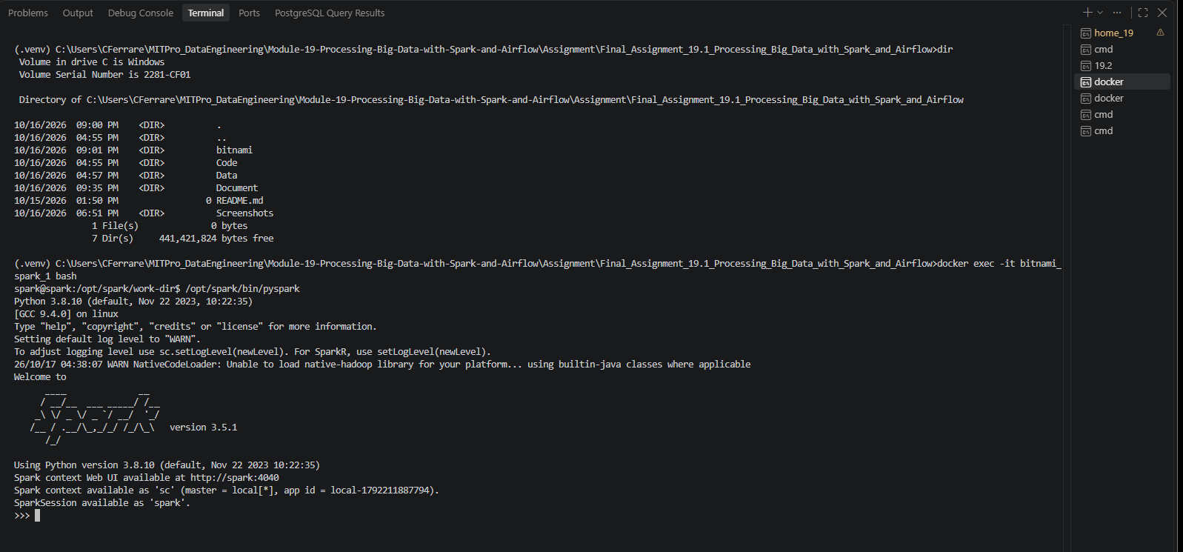

- Provide a screenshot to show that you successfully started a PySpark session.

Imported the SparkSession class from the PySpark SQL package to prepare for creating a custom Spark session for the assignment.
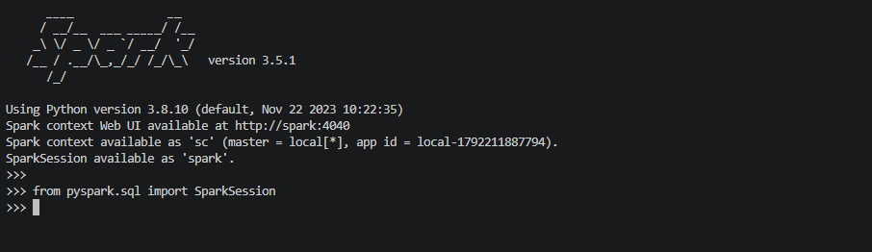

- Provide a screenshot to show that you successfully defined the spark PySpark session.

Created a Spark session named Assignment19.3 using the SparkSession builder and verified that the session object was successfully instantiated.
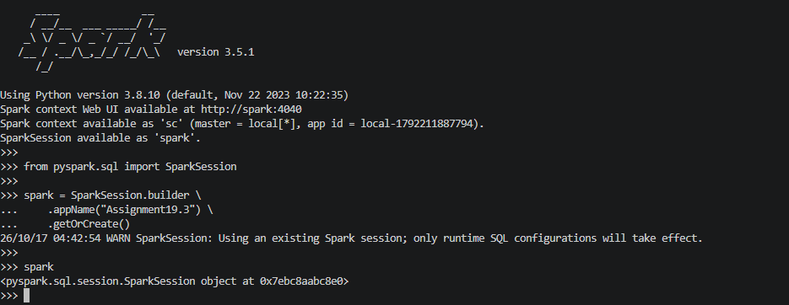

- Provide a screenshot to show that you successfully defined the assignment19_3_data variable.

Defined the variable assignment19_3_data and assigned it the path to the departuredelays.csv dataset stored inside the Spark container. Verified the variable value by displaying the assigned path.
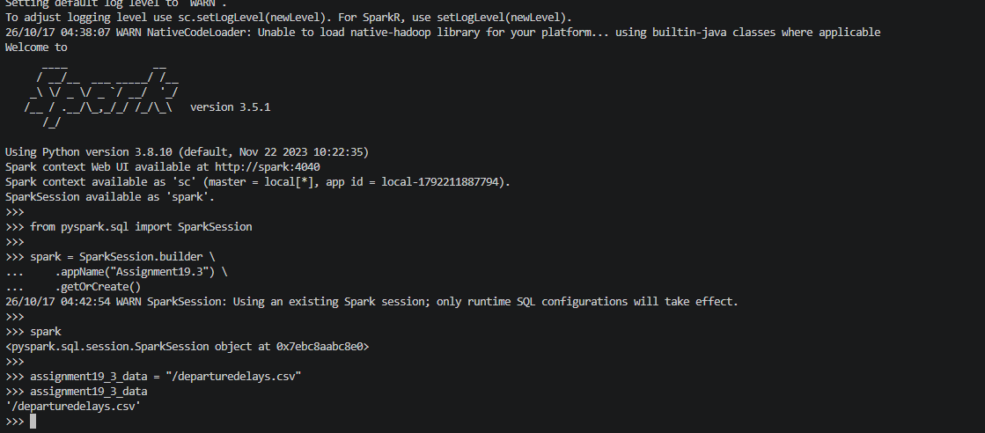

- Provide a screenshot to show that you successfully defined the df dataframe that contains all of the entries in the departuredelays.csv file.

Loaded the departuredelays.csv dataset into the Spark DataFrame df and displayed the first five records to verify that the data was successfully loaded.
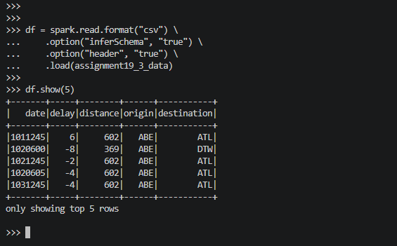

- Provide a screenshot to show that you successfully created a view of the assignment19_3_table dataframe.

Created a temporary SQL view named assignment19_3_table from the DataFrame and verified that the view was available for querying by returning the total record count.
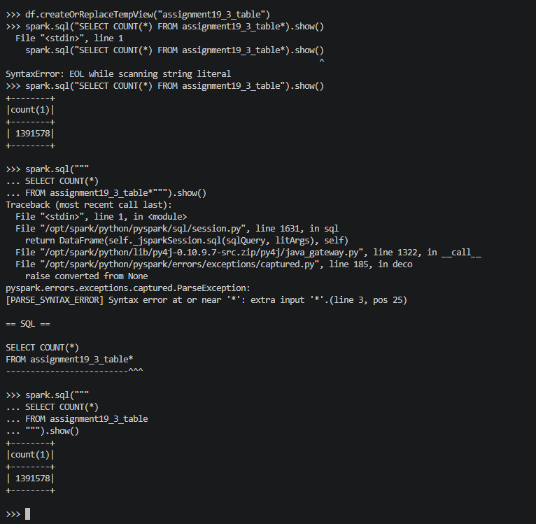

- Provide a screenshot to show that you selected the correct entries from your data. Your data should display the first 15 flights from PHL to DFW that had a delay of greater than 150 minutes.

Executed a Spark SQL query to retrieve the first 15 flights from Philadelphia International Airport (PHL) to Dallas/Fort Worth International Airport (DFW) with delays greater than 150 minutes.
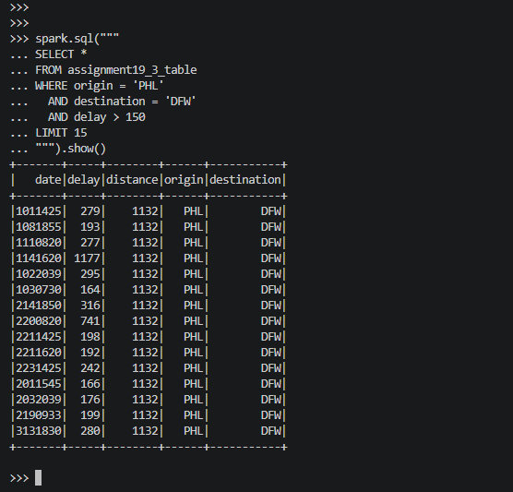

- Provide a screenshot to show that you selected the correct entries from your data. Your data should display the first 10 flights that have a distance of less than 200 miles and the resulting table should contain all of the columns in the original dataset.

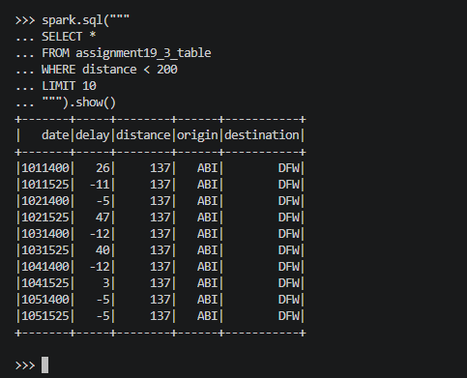

- Provide a screenshot to show that you selected the correct entries from your data. Your data should display the first 10 flights that have a distance greater than 600 miles and the resulting table should contain all of the columns in the original dataset.

Display the first 10 flights that have a distance greater than 600 miles and ensure that the resulting table contains all columns in the original dataset.
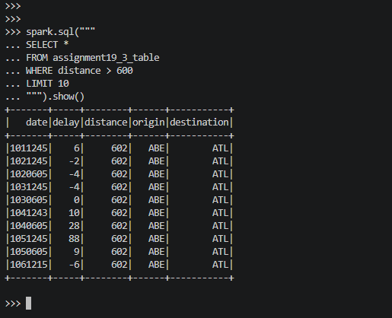

Part 2: Airflow
- Provide a screenshot of your Terminal window response to show that you correctly pulled the Airflow file.

Created the airflow_assignment directory, downloaded the Airflow Docker Compose configuration file, and verified that docker-compose.yaml was successfully created.
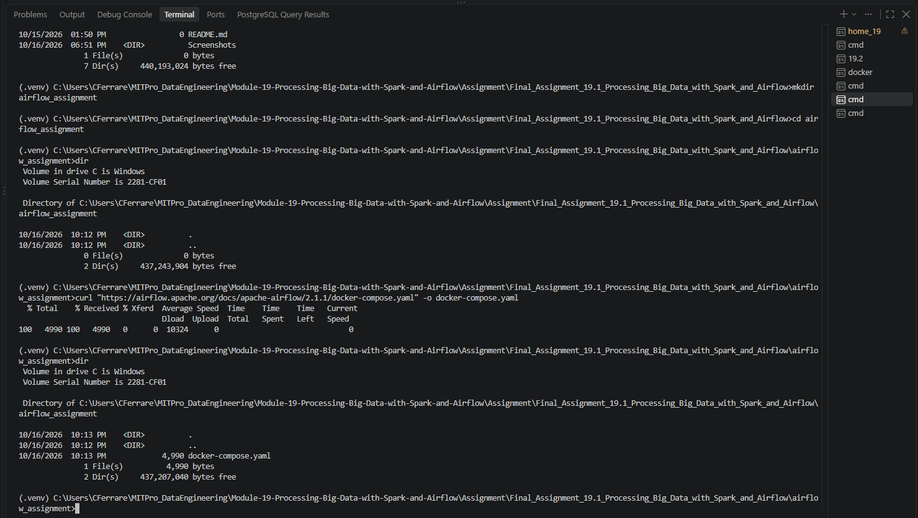

- Provide a screenshot to show the changed example value ( AIRFLOW__CORE__LOAD_EXAMPLES set to false).

Modified the Airflow Docker Compose configuration by setting AIRFLOW__CORE__LOAD_EXAMPLES to false and updating the webserver port mapping from 8080:8080 to 8081:8080 to avoid a local port conflict.
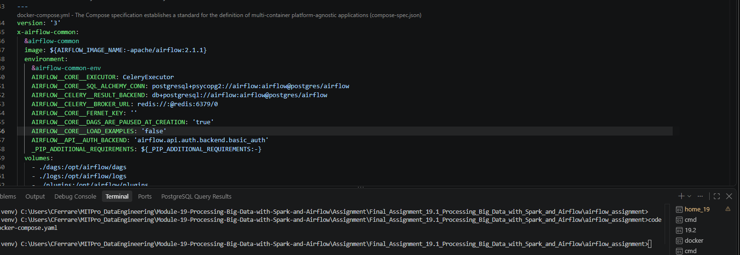

Modified the Airflow Docker Compose configuration by setting AIRFLOW__CORE__LOAD_EXAMPLES to false and updating the webserver port mapping to 8081:8080 to avoid a local port conflict.
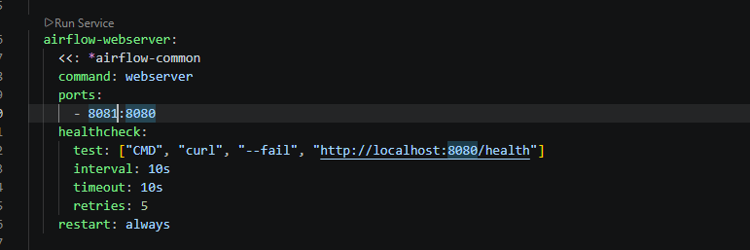

- Provide a screenshot to show that the Airflow Docker containers are running.

Started the Airflow environment using Docker Compose and verified that the Airflow webserver, scheduler, and supporting services initialized successfully.
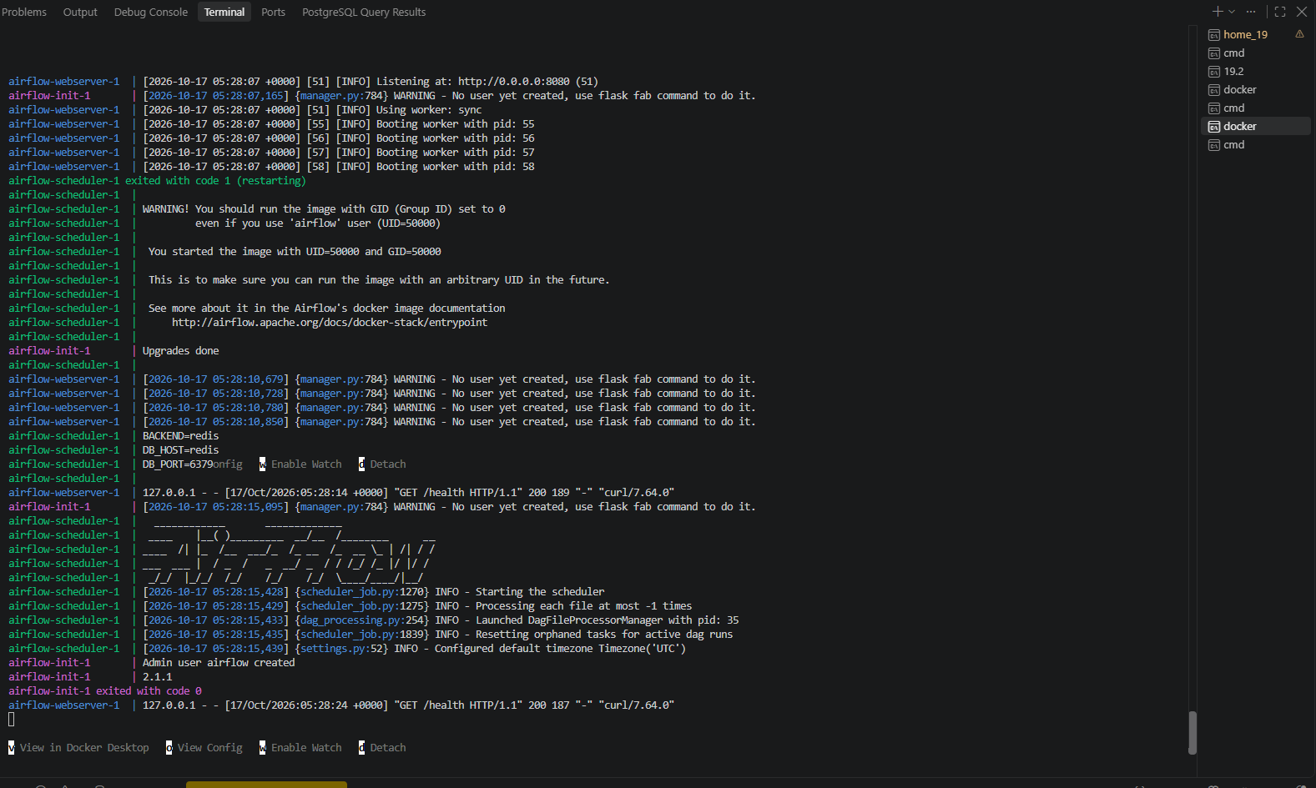

Successfully started the Airflow environment using Docker Compose and verified in Docker Desktop that all Airflow services, including the webserver, scheduler, worker, PostgreSQL, Redis, and Flower containers, were running successfully.
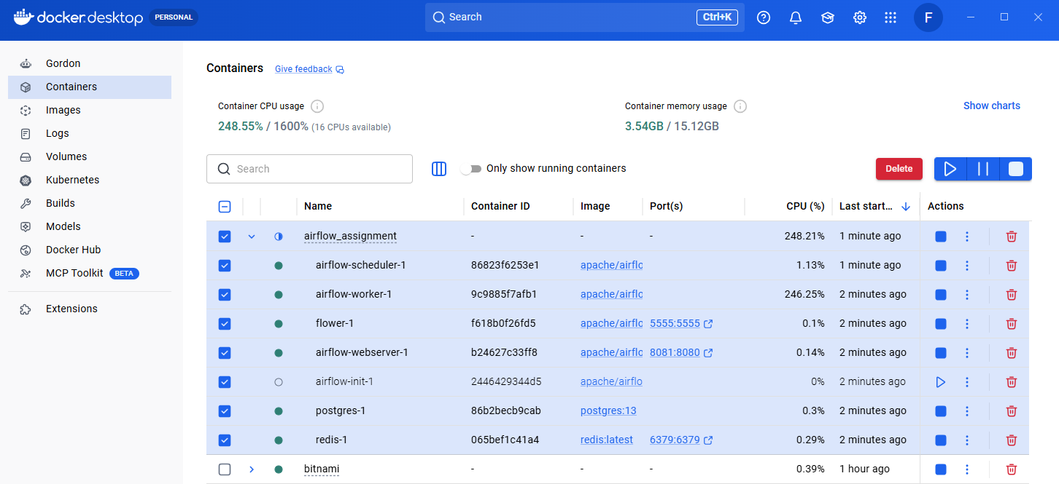

- Provide a screenshot of your browser window to show that you have successfully logged in to Airflow.

Successfully logged into the Apache Airflow web interface using the default Airflow credentials and verified access to the dashboard.
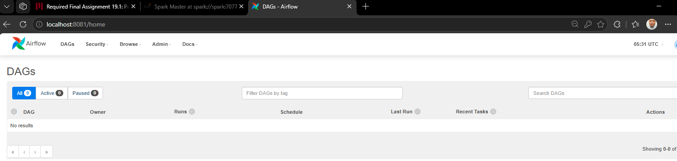

- Provide a screenshot to show that you created the module19_assignment.py file.

Created the module19_assignment.py file inside the Airflow dags directory to store the custom DAG definition required for the assignment.
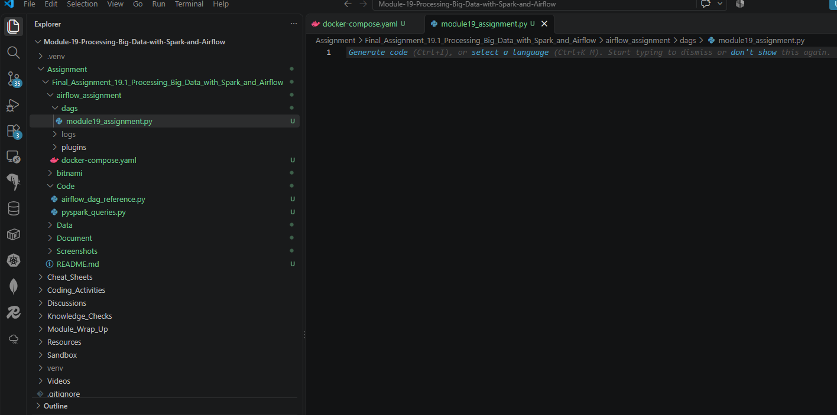

- Provide a screenshot to show that you correctly imported the required libraries.

Imported the required Airflow, datetime, and PythonOperator libraries needed to define and execute the custom workflow.
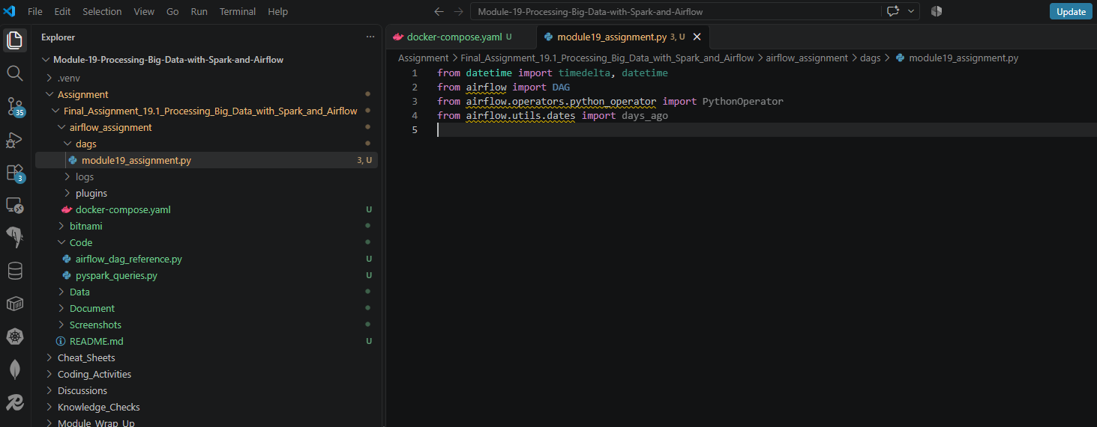

- Provide a screenshot to show that you set up your DAG correctly, including your last name and email address.

Configured the DAG default arguments, including the owner name, email address, retry settings, and workflow start date.
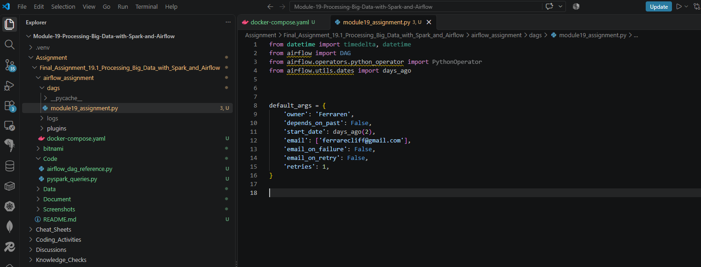

- Provide a screenshot to show that you defined the square() function correctly.

Defined the square() function, which accepts a numeric input and returns its squared value.
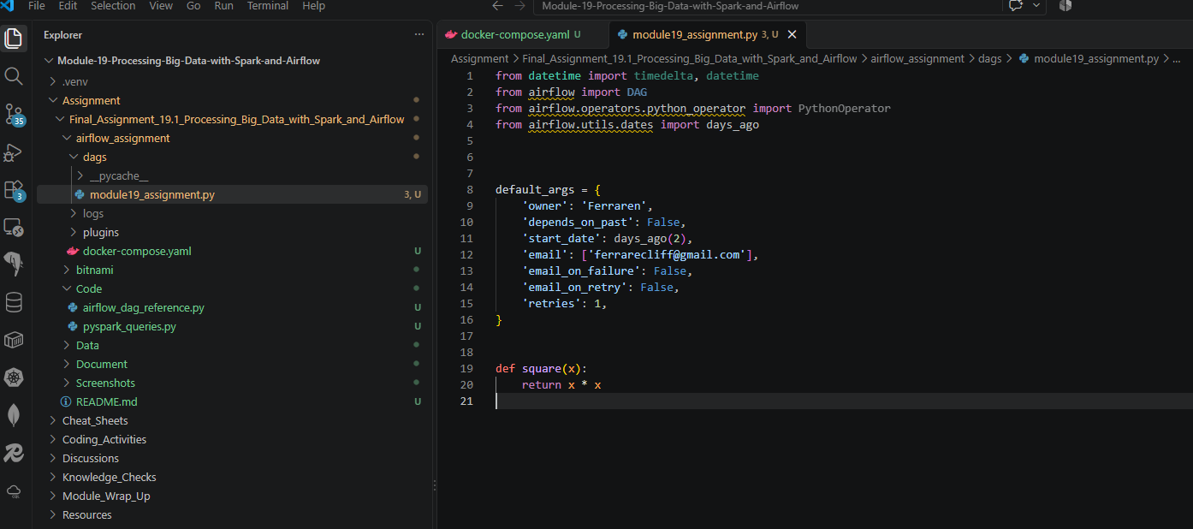

- Provide a screenshot to show that you correctly defined the DAG object.

Created the Airflow DAG named python_square_operator and configured its schedule and execution settings.
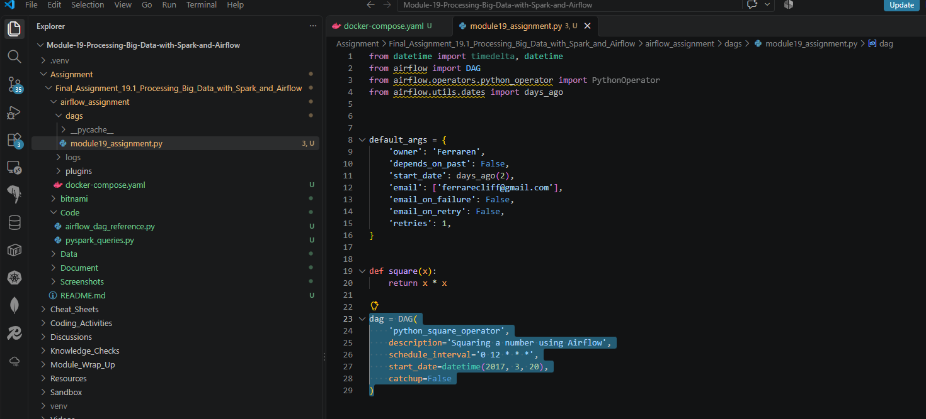

- Provide a screenshot to show that you defined the DAG Task correctly.

Defined a PythonOperator task named square that executes the square() function using the input value of 13.
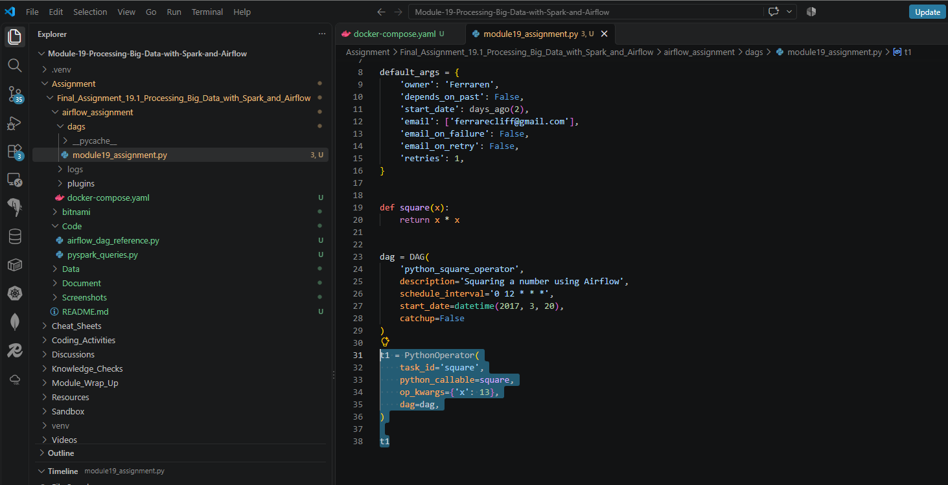

- Provide a screenshot of the Airflow UI to show that your DAG is configured correctly.

Verified that the python_square_operator DAG was successfully discovered and displayed in the Airflow UI after saving the workflow definition.
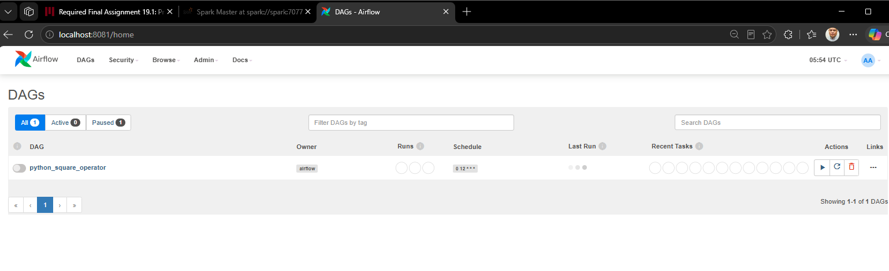

- Provide a screenshot of the log to show that the DAG ran successfully.

Executed the python_square_operator DAG and reviewed the Airflow task logs. The workflow completed successfully, returned the expected value of 169, and exited with a return code of 0.
