Required Coding Activity 19.3: Using PySpark to Query Data

- Provide a screenshot to show that you have the Bitnami containers up and running.

Verified that the Spark Docker environment is operational. Both the Spark Master (bitnami_spark_1) and Spark Worker (bitnami_spark-worker-1) containers are running successfully in Docker Desktop.
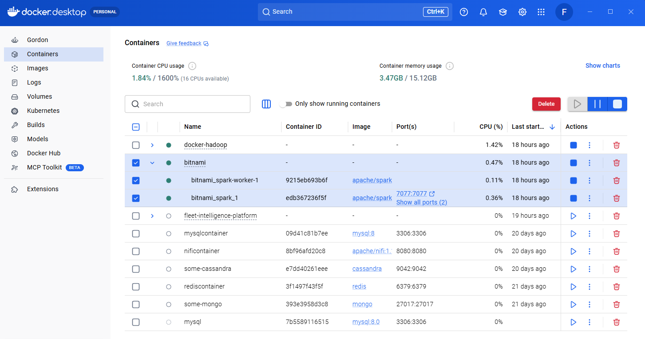

- Provide a screenshot to show that the departuredelays.csv file is in the root folder.

Accessed the Spark Docker container and verified that the departuredelays.csv file exists in the root directory of the container.
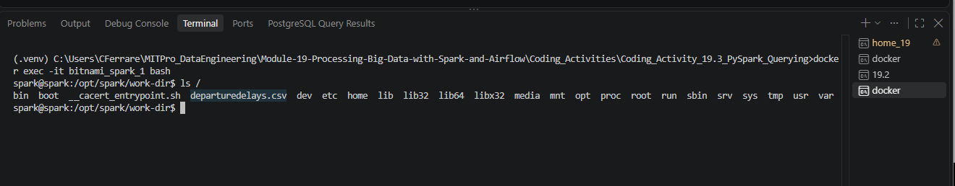

- Provide a screenshot to show that you successfully opened PySpark.

Successfully launched the PySpark interactive shell using /opt/spark/bin/pyspark and verified that Spark initialized correctly with an available SparkSession.
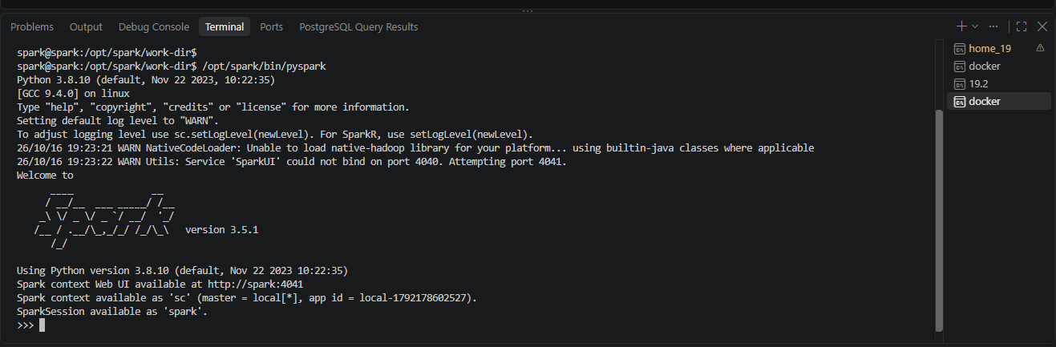

- Provide a screenshot to show that you successfully started a PySpark session.

Successfully imported the SparkSession package from PySpark, which is required to create and manage Spark sessions.
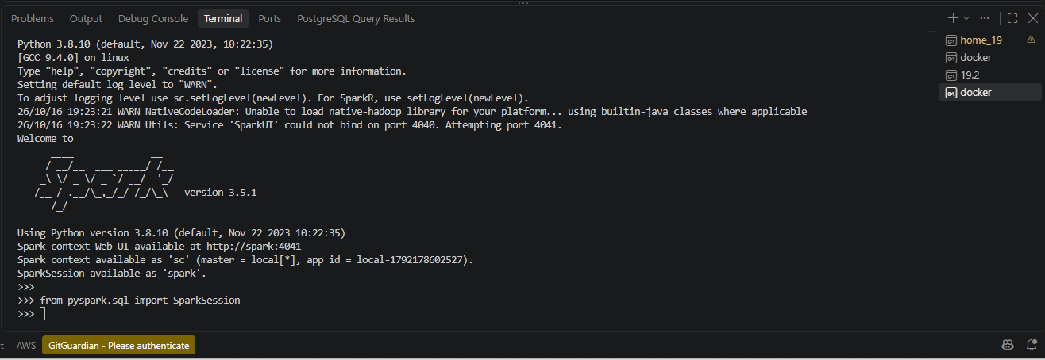

- Provide a screenshot to show that you successfully defined the spark PySpark session.

Successfully created a PySpark session named Activity19.3 using the SparkSession builder and verified that Spark reused the existing session.
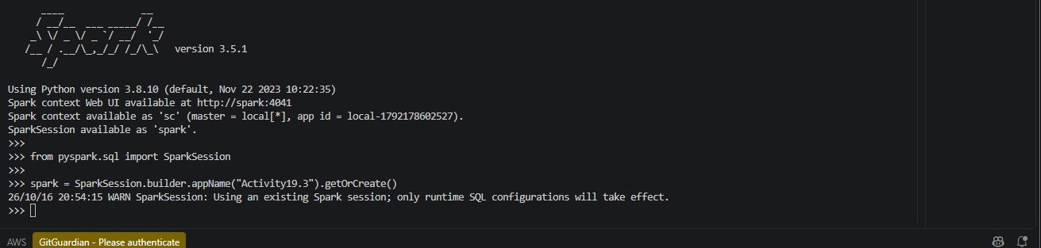

- Provide a screenshot to show that you successfully defined the activity19_3_data variable.

Successfully defined the activity19_3_data variable and assigned the path to the departuredelays.csv file stored in the Spark container.
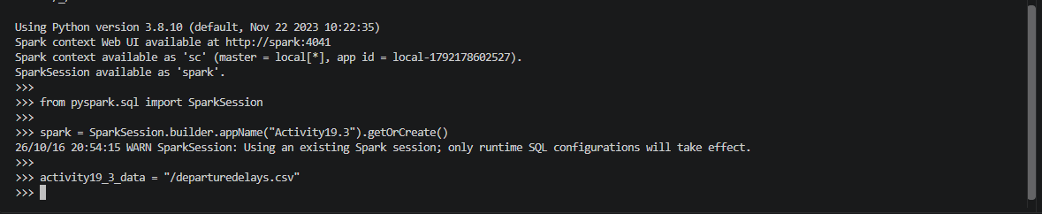

- Provide a screenshot to show that you successfully defined the df dataframe.

Successfully loaded the departuredelays.csv dataset into a Spark DataFrame named df using schema inference and header recognition.
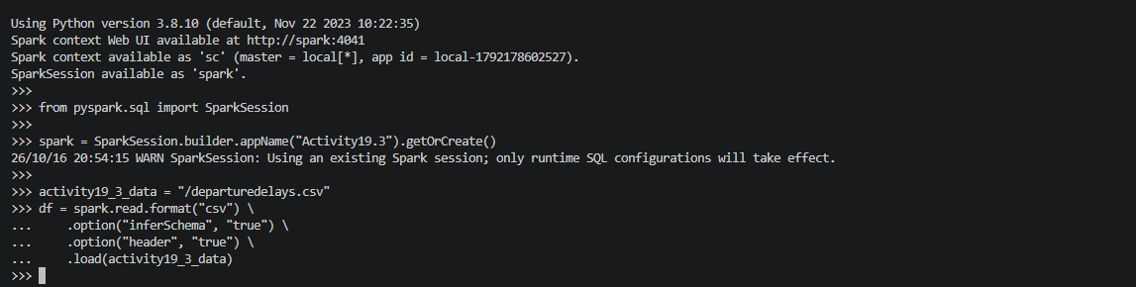

- Provide a screenshot to show that you successfully created a view of the dataframe that is named activity19_3_table.

Successfully created a temporary SQL view named activity19_3_table from the Spark DataFrame using the createOrReplaceTempView() method.
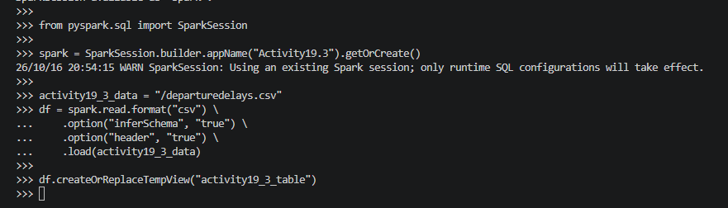

- Provide a screenshot to show that you selected the correct entries from your data. Your data should display the first 10 flights from JFK to SEA that had a delay of greater than 90 minutes.
Successfully queried the flight dataset and displayed the first 10 flights from JFK to SEA with delays greater than 90 minutes.
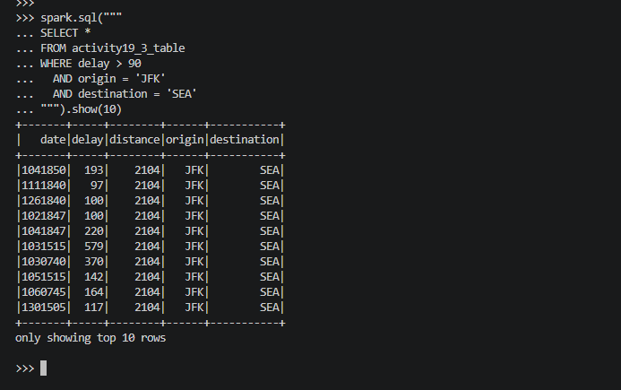

- Provide a screenshot to show that you selected the correct entries from your data. Your data should display the first five flights from SFO to MIA that had a delay of less than 60 minutes.
Successfully queried the flight dataset and displayed the first five flights from SFO to MIA with delays less than 60 minutes.
