Required Coding Activity 19.1: Creating Spark Docker Images and Containers

- Provide a screenshot to show that you have no containers running on your Docker Desktop.

Docker Desktop - No running containers displayed
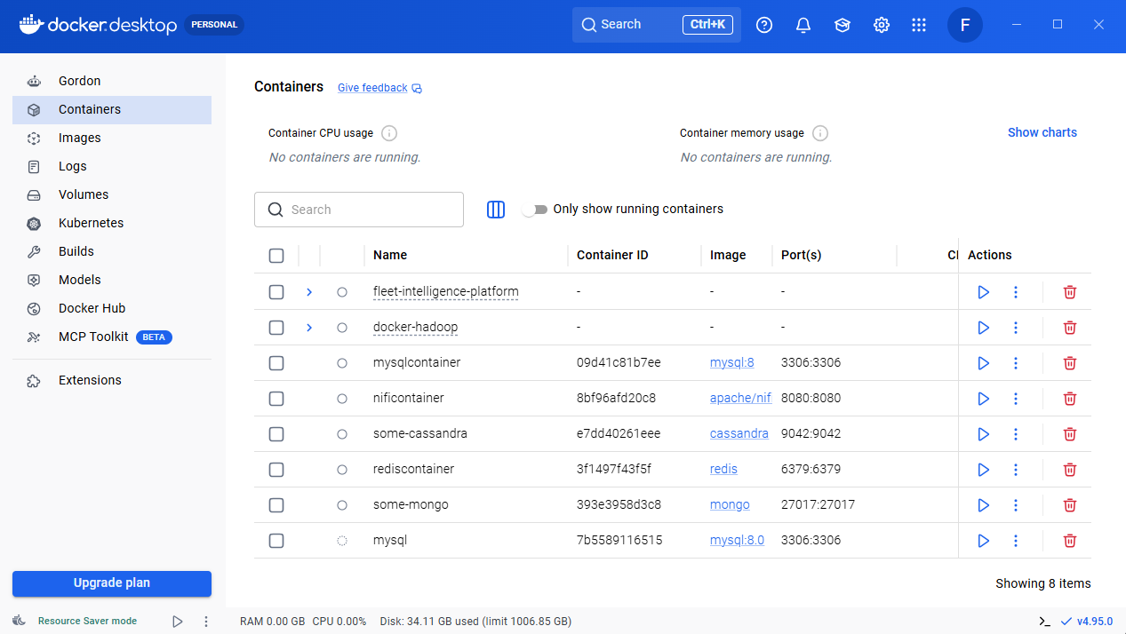

- Provide a screenshot to show that you successfully created the bitnami folder.

bitnami folder successfully created.
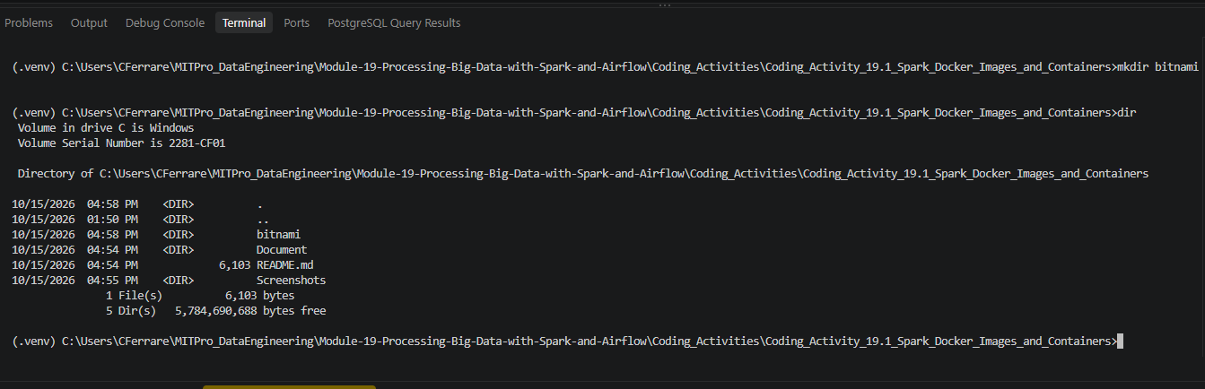

- Provide a screenshot to show that you successfully ran the curl command to download the docker-compose.yml file.
Successfully downloaded the docker-compose.yml file using the curl command and verified that the file exists in the bitnami directory.
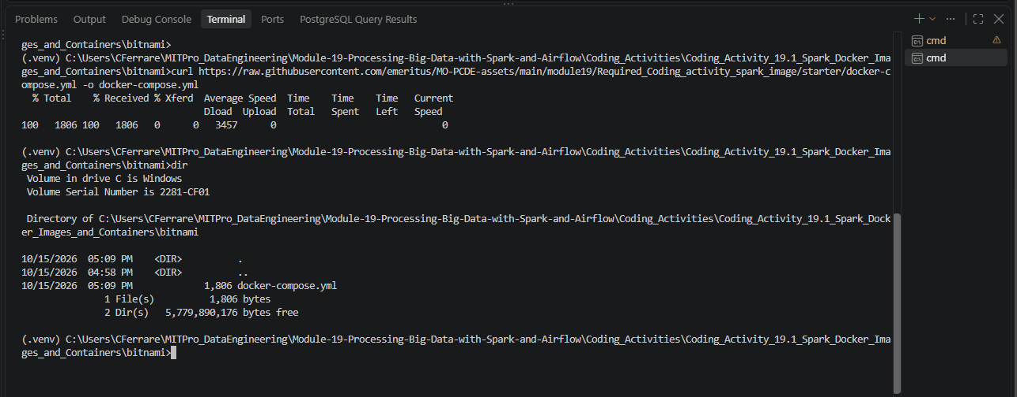

- Provide a screenshot to show the contents of the Spark folder within the docker-compose.yaml file.

Opened and reviewed the docker-compose.yml file to verify the Spark master and Spark worker service configurations used to create the Docker containers.
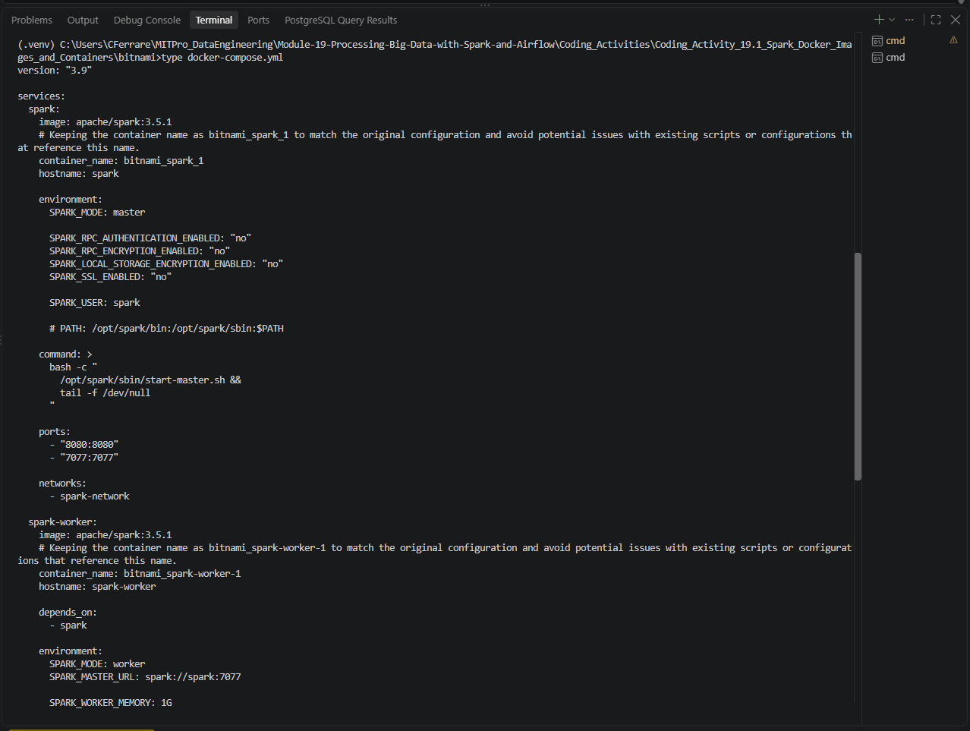
- Provide a screenshot to show that you successfully ran the docker-compose command.

Executed the docker compose up command successfully. Docker downloaded the Apache Spark image, created the Spark network, and started both the Spark Master and Spark Worker containers.
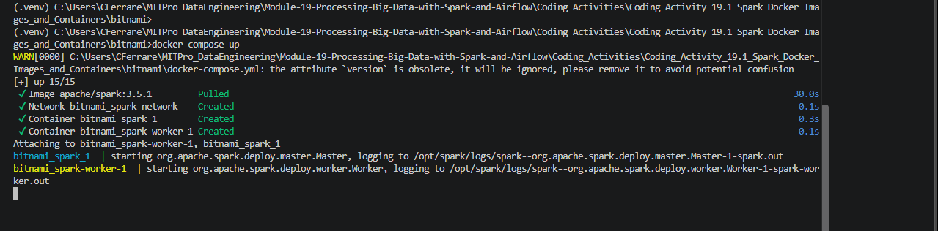

- Provide a screenshot of your Docker desktop to show that the Spark Docker containers are running.

Docker Desktop showing the Spark Master (bitnami_spark_1) and Spark Worker (bitnami_spark-worker-1) containers running successfully after executing the Docker Compose configuration.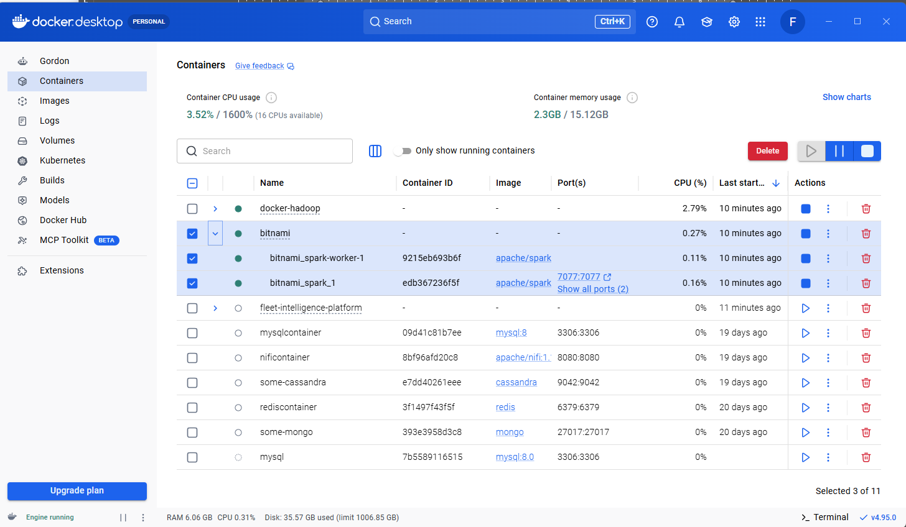

- Provide a screenshot to show that you successfully opened your browser to the Spark webpage.

Successfully accessed the Spark Master Web UI at http://localhost:8080 and verified that the Spark cluster is operational with one active worker connected to the Spark Master.
