Required Coding Activity 19.4: Creating a Workflow in Airflow

- Provide a screenshot of your Terminal window response to show that you correctly pulled the Airflow file.

Created the airflow directory, navigated into it, and successfully downloaded the Airflow docker-compose.yaml configuration file using the curl command.
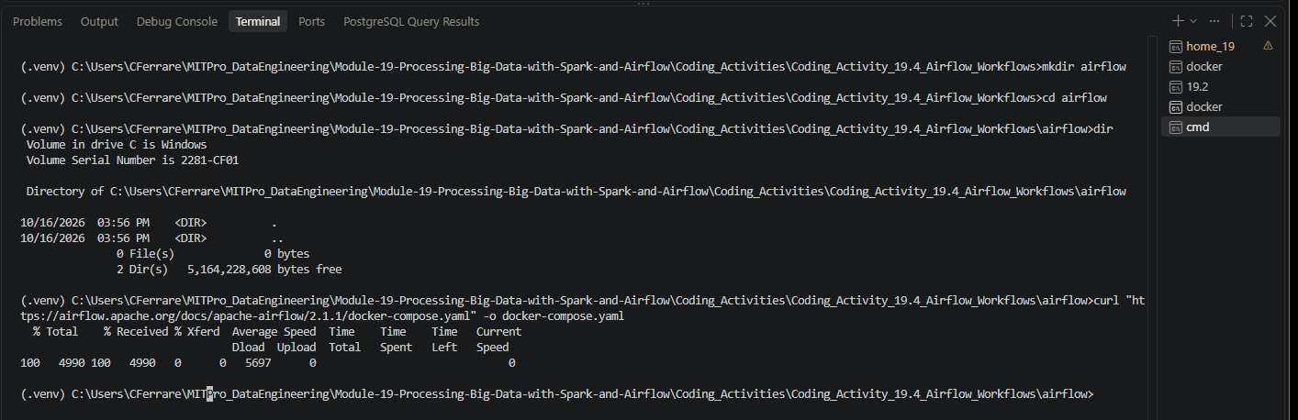

- Provide a screenshot to show the changed example value (AIRFLOW__CORE__LOAD_EXAMPLES set to false).

Modified the Airflow Docker Compose configuration file and changed AIRFLOW__CORE__LOAD_EXAMPLES from true to false to prevent loading the default example DAGs.
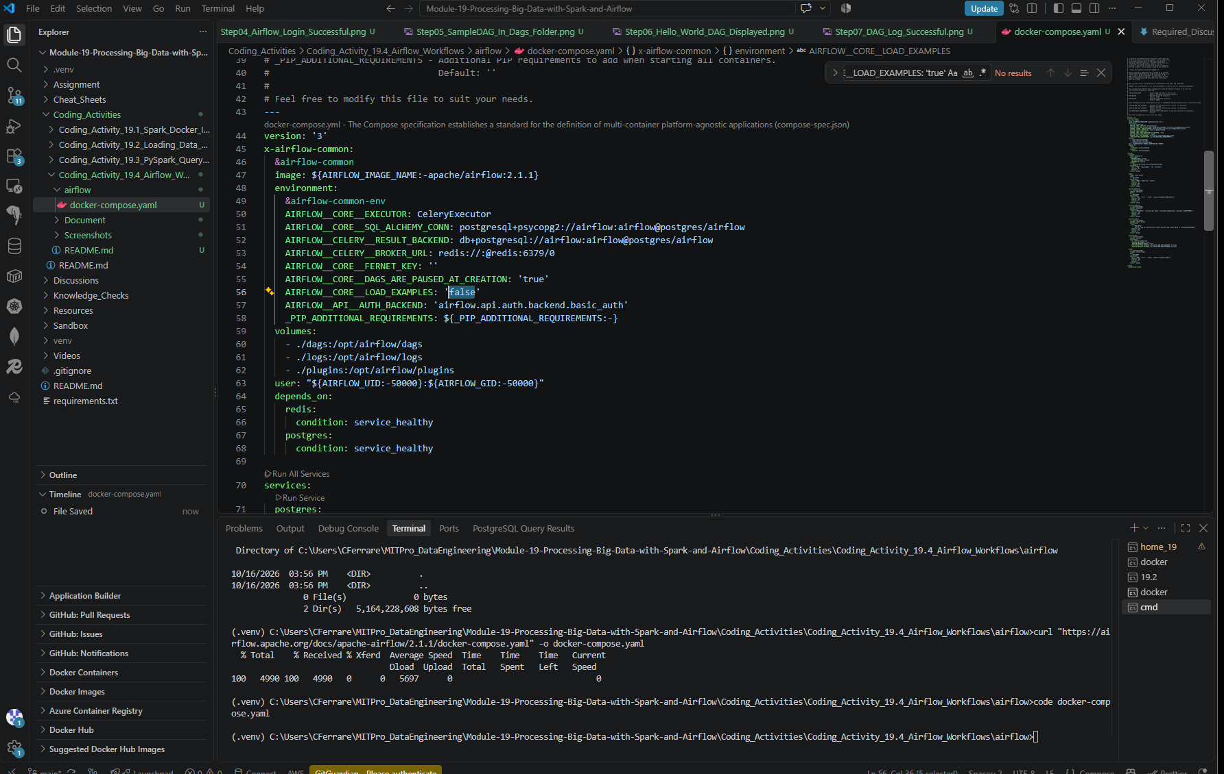

Need also to update the ports: - 8080:8080 to 8081:8080 to Fix webserver port conflict (8080 already in use by the docker desktop itself)
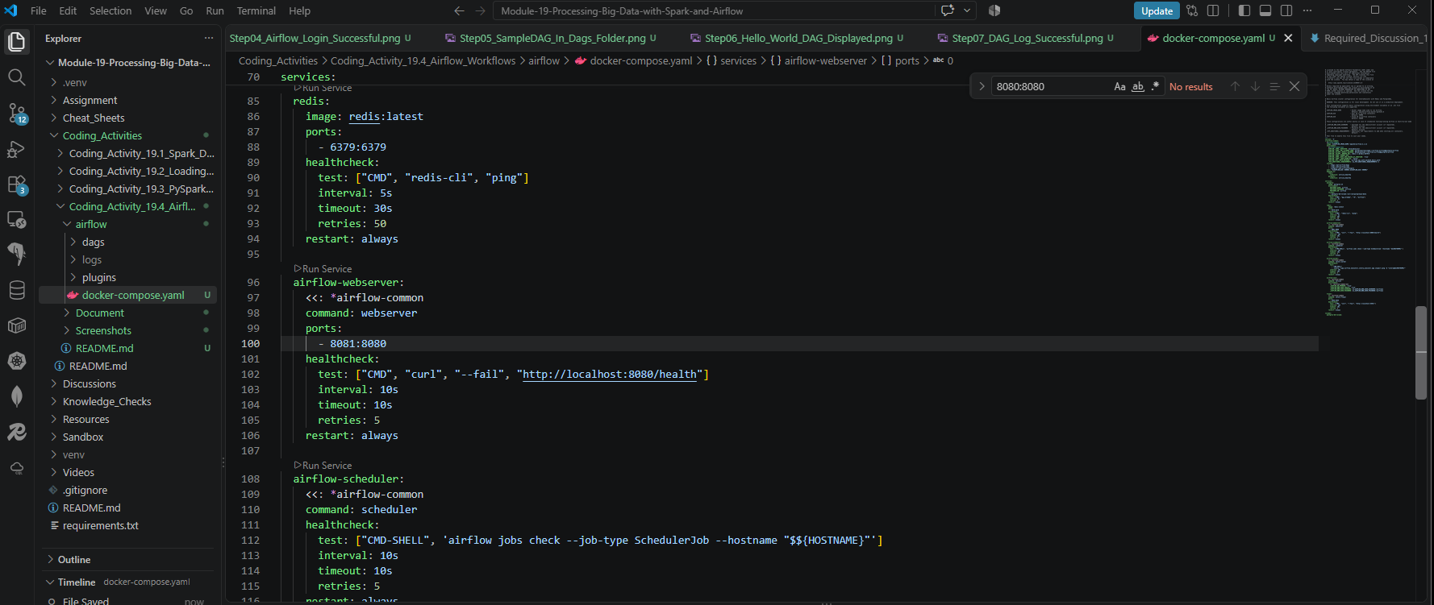

- Provide a screenshot of the Docker window to show that Airflow is running.

Airflow-webserver unable to start due to conflict on port: airflow-webserver-1 Ports: 8080:8080
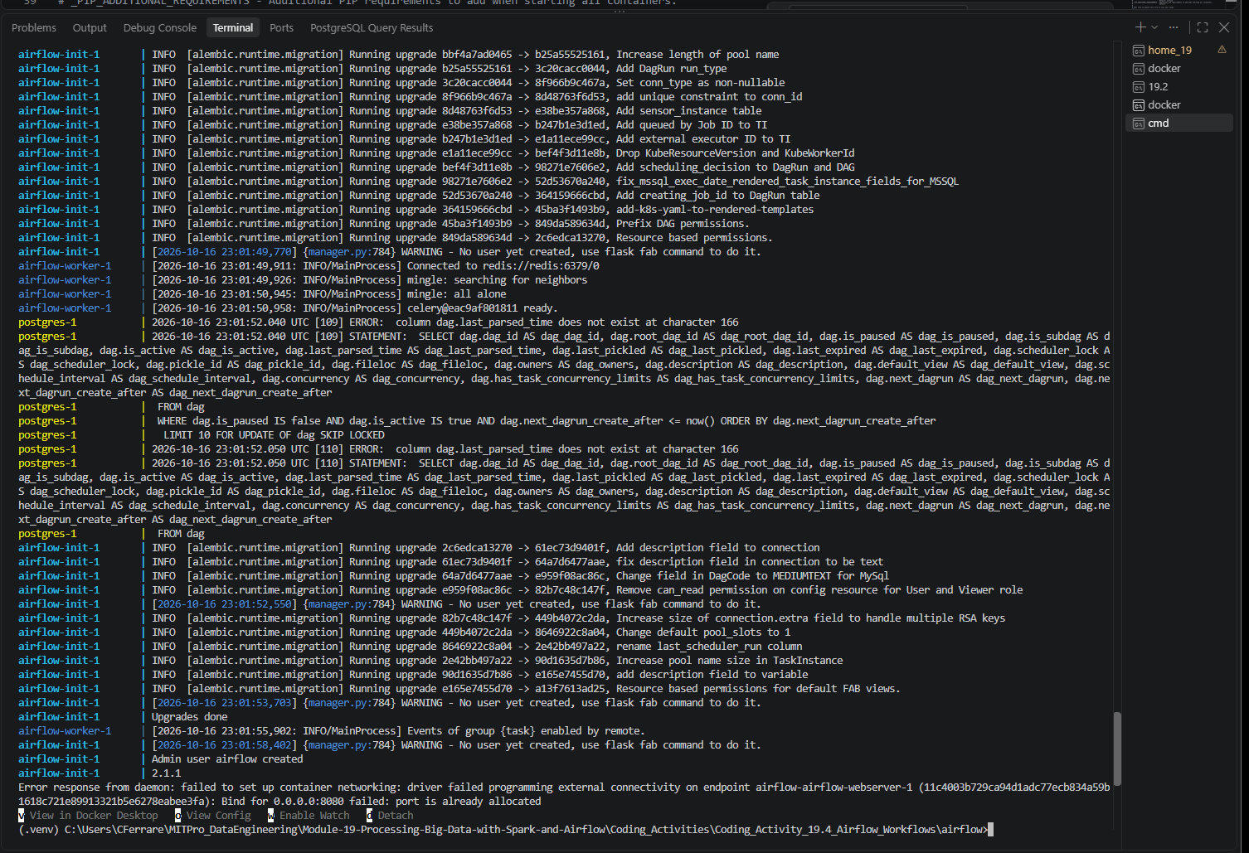

After updating the airflow webserver port: airflow-webserver-1 Ports: 8081:8080
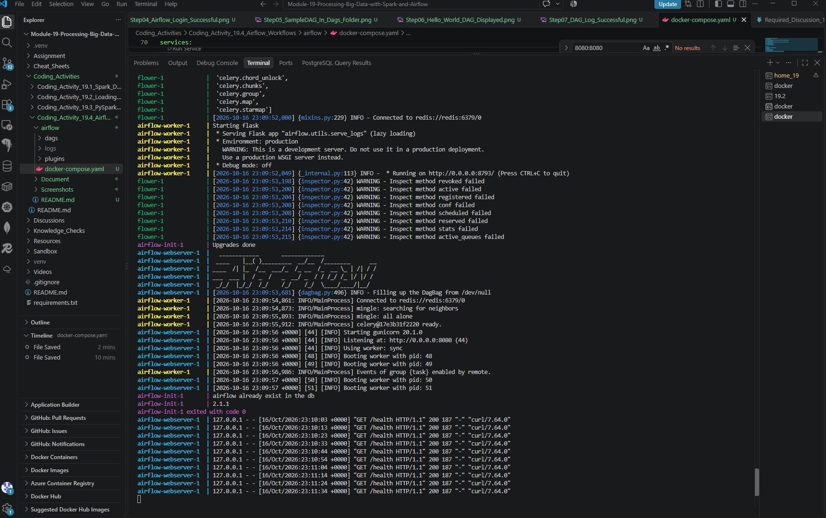
Successfully started the Airflow environment using Docker Compose. Verified that the Airflow webserver, scheduler, worker, Redis, PostgreSQL, and Flower services are running in Docker Desktop.
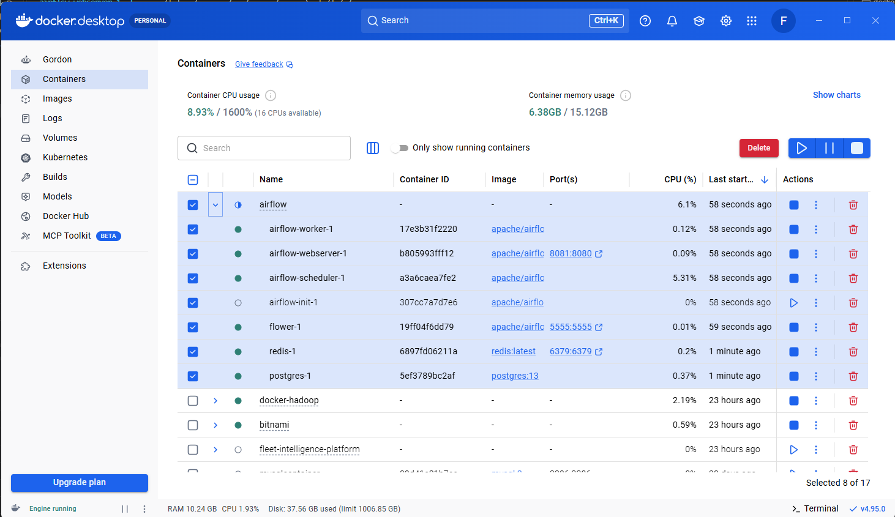

- Provide a screenshot of your browser window to show that you have successfully logged in to Airflow.
Successfully logged into the Apache Airflow web interface using the default credentials and verified access to the Airflow dashboard.
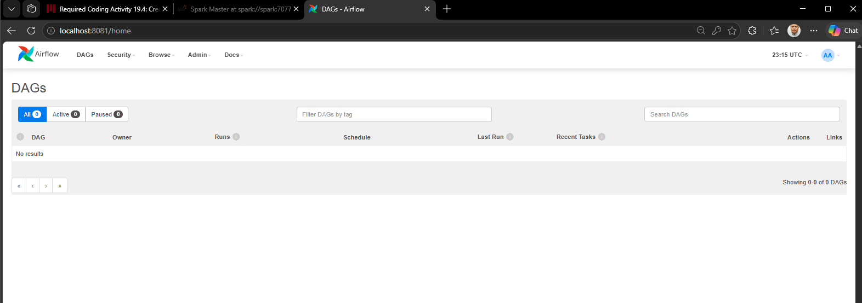

- Provide a screenshot of the dags folder to show the file is present.

Successfully copied SampleDAG.py into the Airflow dags directory and verified its presence. This allows Airflow to discover and load the workflow automatically.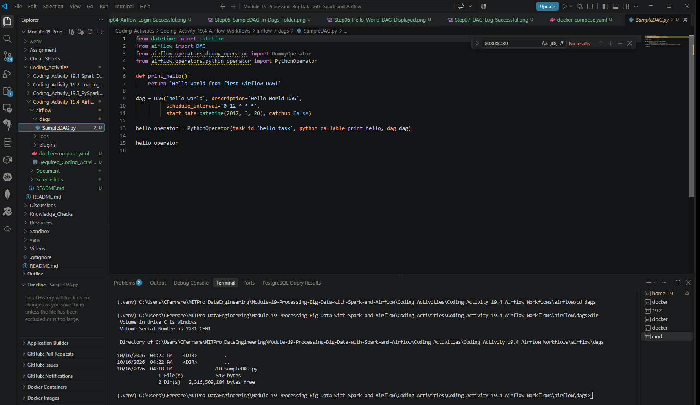

- Provide a screenshot to show that the hello_world DAG is successfully displayed in your Airflow window.

Verified that Airflow successfully discovered and loaded the hello_world DAG from the SampleDAG.py file and displayed it in the Airflow dashboard.
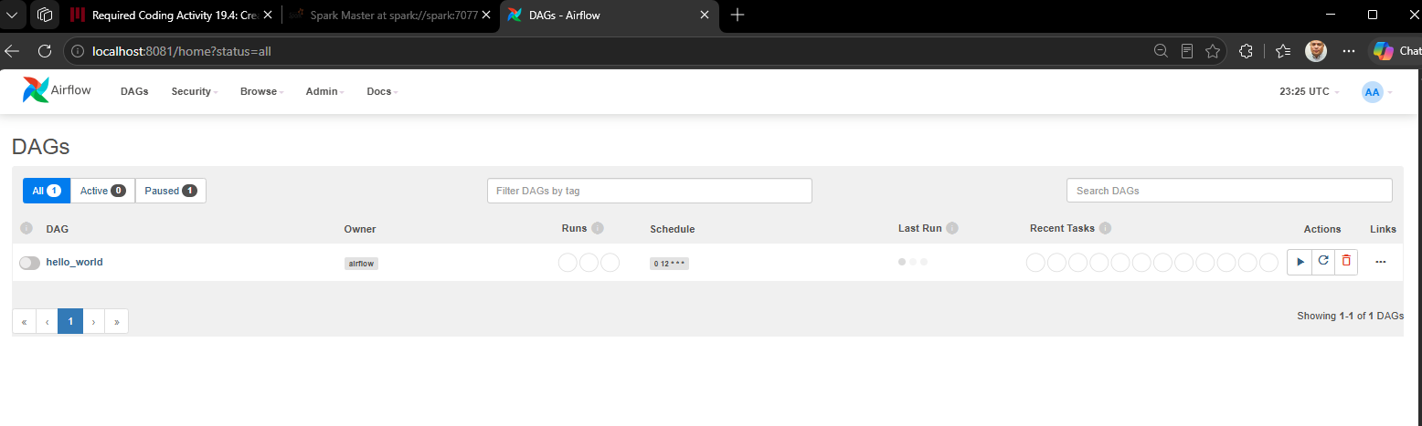

- Provide a screenshot of the log to show that the DAG ran successfully.

Executed the hello_world DAG and reviewed the task logs in Airflow. The log confirms successful execution of the Python function, including the output "Hello world from first Airflow DAG!", task success status, and return code 0.
