Required Coding Activity 22.1: Using DASK to Create Multiple Files in Parallel

- Provide a screenshot to show that you successfully installed DASK.

Figure 1. The terminal confirms that DASK and its required dependencies are installed in the active Python virtual environment.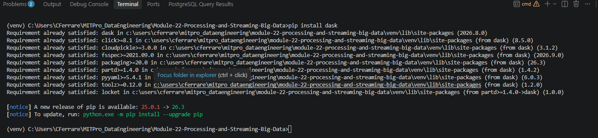

- Provide a screenshot to show that you opened the file correctly.

Figure 2. Activity_22_1.py opened successfully in Visual Studio Code.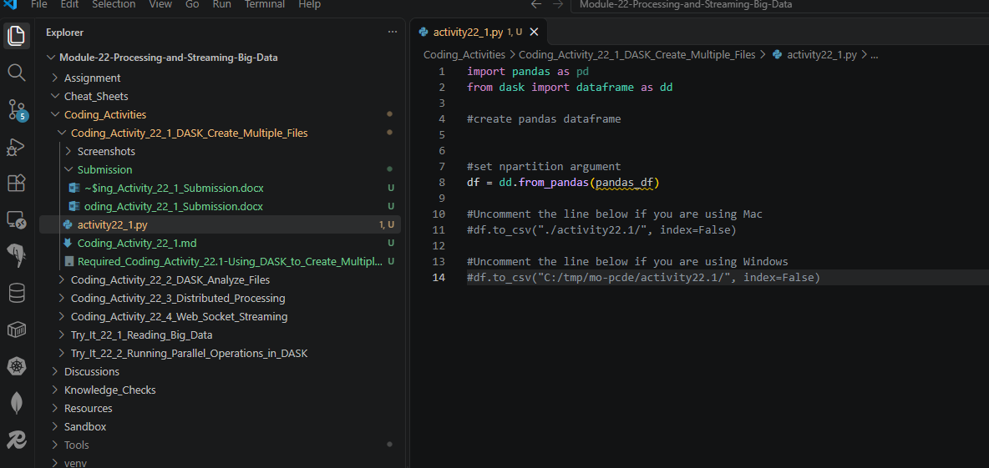
- Provide a screenshot to show that you created the pandas_df dataframe correctly.

Figure 3. Creation of the pandas_df DataFrame containing odd and even numbers.
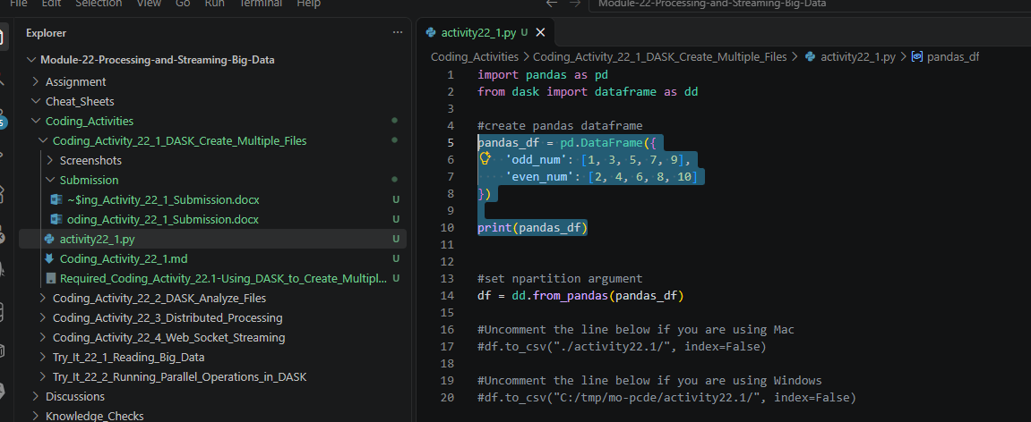

- Provide a screenshot to show that you set the npartitions argument equal to 2.

Figure 4. DASK DataFrame created using two partitions.
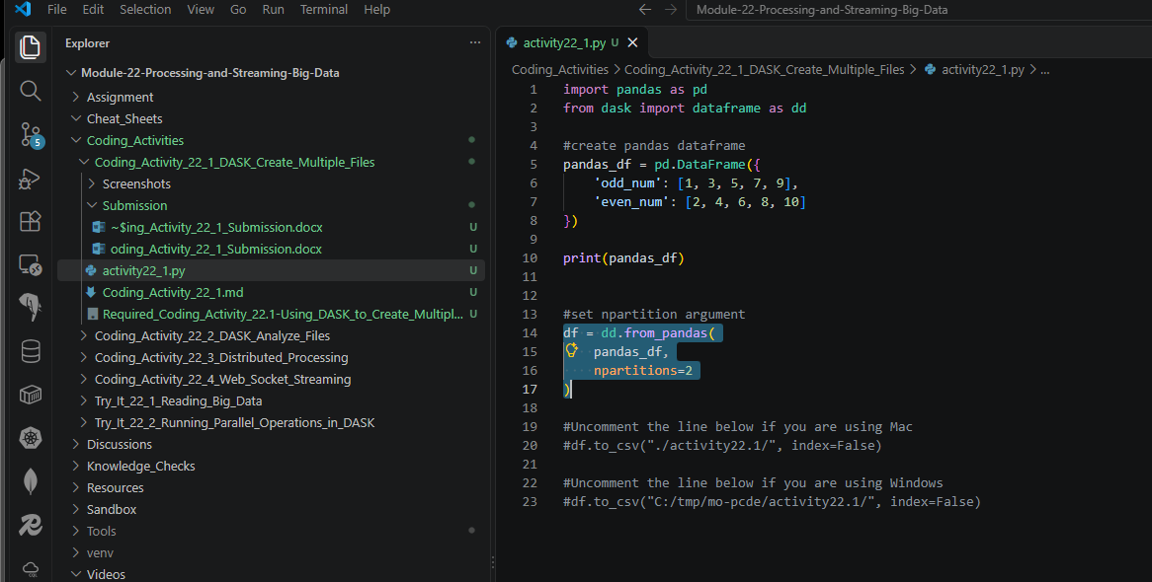
- Provide a screenshot to show that you ran the code without any errors.

Figure 5.1 Uncomment the Windows Line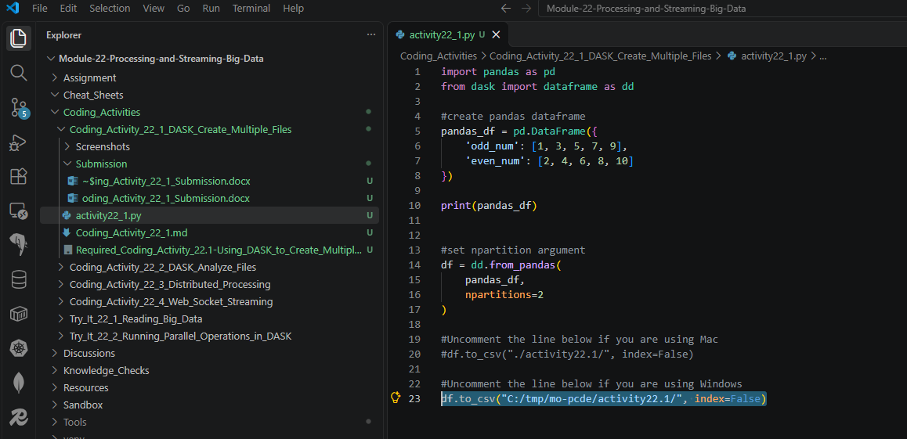

Figure 5.2 Create the Directory
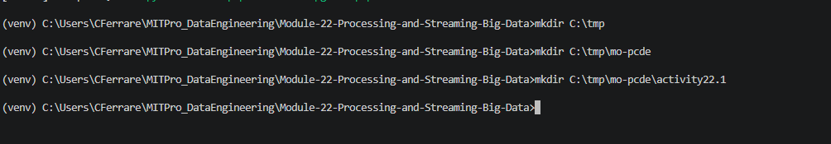

Figure 5.3. Successfully executed activity22_1.py without errors and displayed the DataFrame. 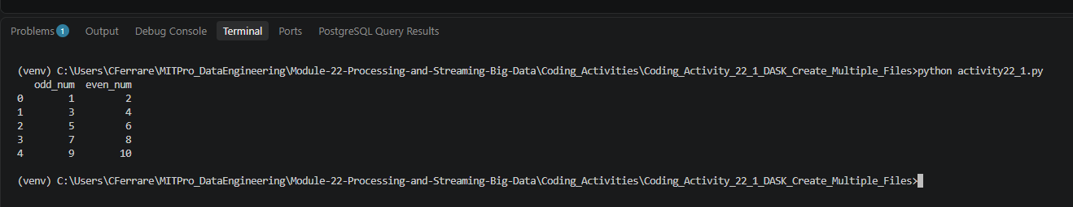

- Provide a screenshot to show that the 0.part and 1.part files are present inside of the activity22.1 folder.

Figure 6. Output directory containing the generated 0.part and 1.part files.
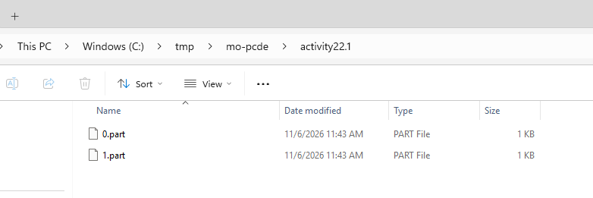

- Provide two screenshots. The first screenshot should show the contents of the 0.part file. The second screenshot should show the contents of the 1.part file.

Figure 7A. Contents of the 0.part output file generated by DASK.
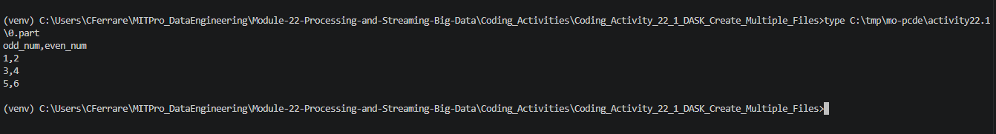

Figure 7B. Contents of the 1.part output file generated by DASK.


