Required Final Assignment 22.1 (Part 2): Processing and Streaming Big Data
- Provide a screenshot to show that you have successfully downloaded and extracted the Assignment22_2 folder on your local machine.

Figure 1. Successfully downloaded and extracted the Assignment22_2 folder containing the streamServer.py and streamClient.py files.
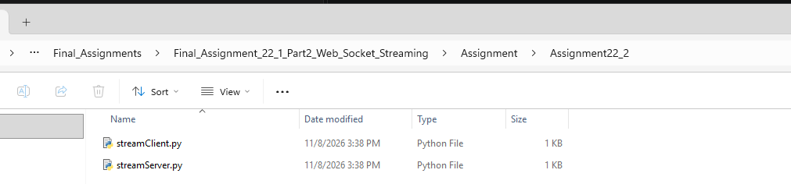

- Provide a screenshot to show that you successfully opened the streamServer.py file in VS Code and changed the port number to 7000.

Figure 2. Modified the streamServer.py file and updated the server port number to 7000.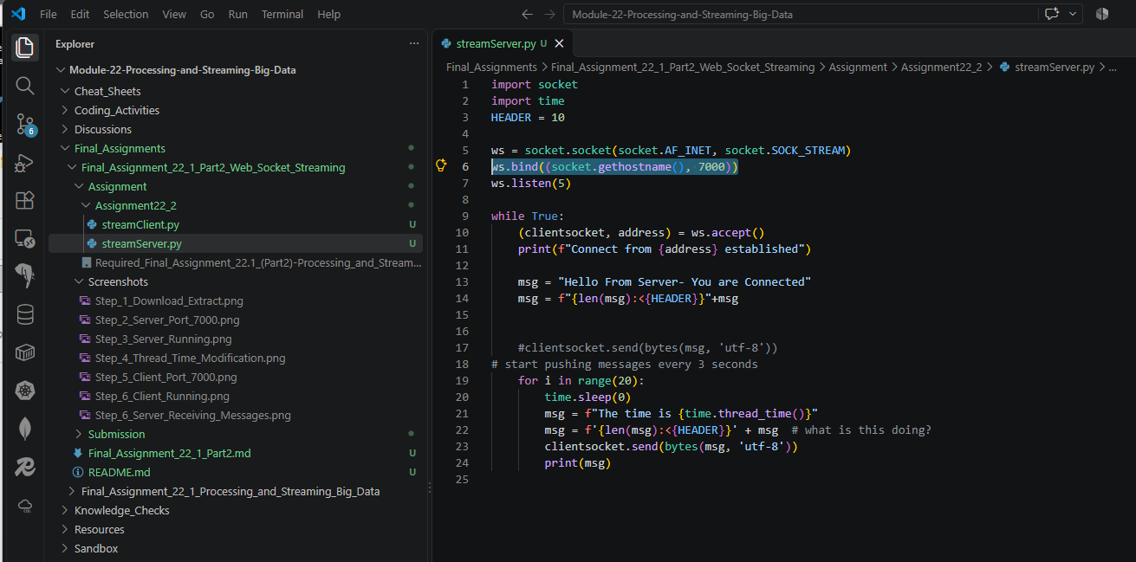
- Provide a screenshot to show that you successfully opened the command prompt in the streamServer.py folder and ran the python streamServer.py command without errors.

Figure 3. Successfully ran streamServer.py from the VS Code terminal. The server is running and waiting for a client connection on port 7000.
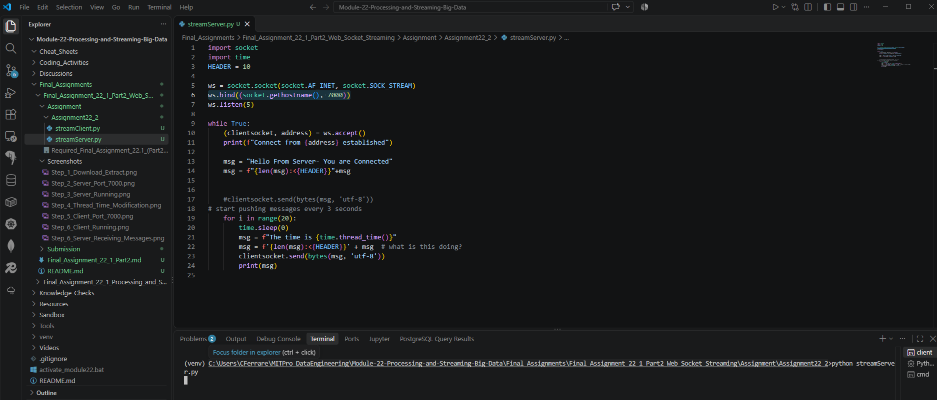

- Provide a screenshot to show that you correctly modified the code in the streamServer.py file to call the thread_time()function from the time library.

Figure 4. Modified streamServer.py to use the time.thread_time() function from the Python time library.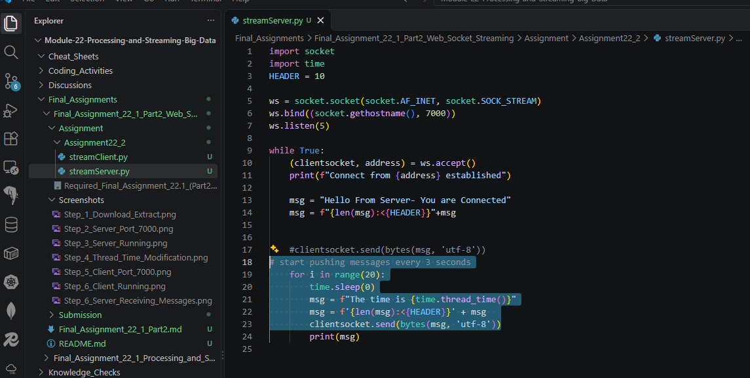

- Provide a screenshot to show that you successfully opened the streamClient.py file in VS Code and that you changed the port correctly.

Figure 5. Modified streamClient.py to connect to the server using port 7000.
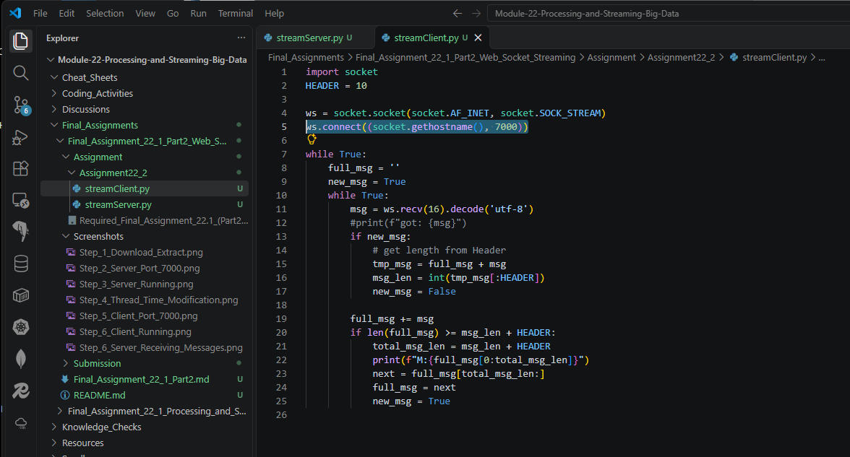

- Provide two screenshots. The first screenshot should show that you successfully ran the streamClient.py file. The second screenshot should show that the server is receiving messages from the client.

Figure 6. Successfully executed streamClient.py and received packets transmitted from the server.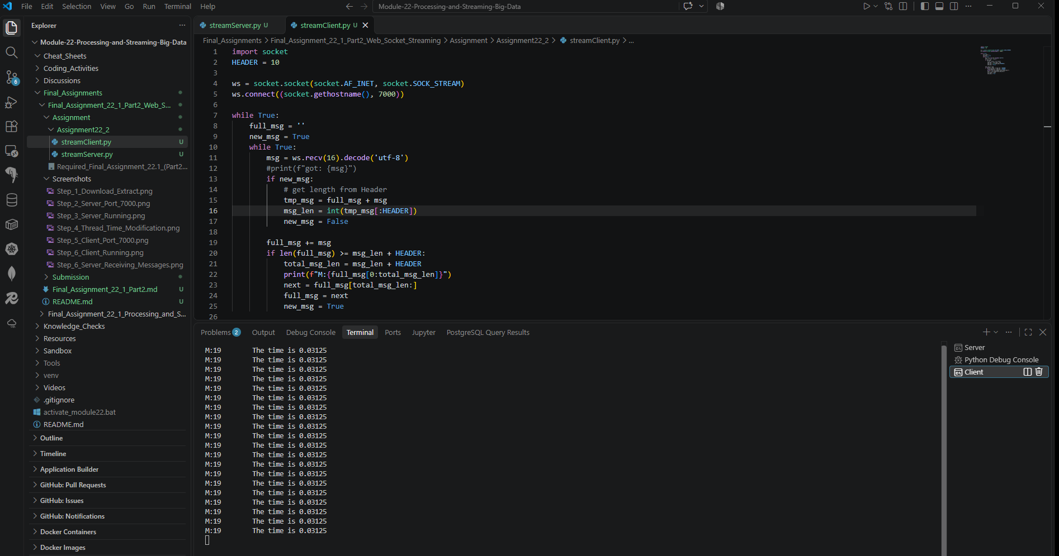

Figure 7. Server console showing a successful client connection and streamed messages being transmitted to the client.


