Required Coding Activity 22.2: Using DASK to Read and Analyze Multiple Files in Parallel

- Provide a screenshot to show the GenerateFilesWithDask.py file in the Activity_22.2 folder.

Figure 1. GenerateFilesWithDask.py successfully downloaded into the Activity_22.2 folder.
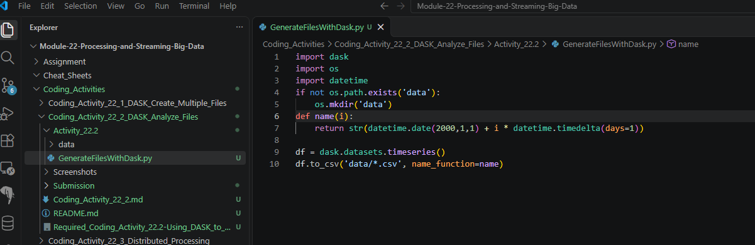
- Provide a screenshot to show that the /data folder has been successfully created.
Figure 2. Successful execution of GenerateFilesWithDask.py and creation of the data folder containing multiple CSV files.
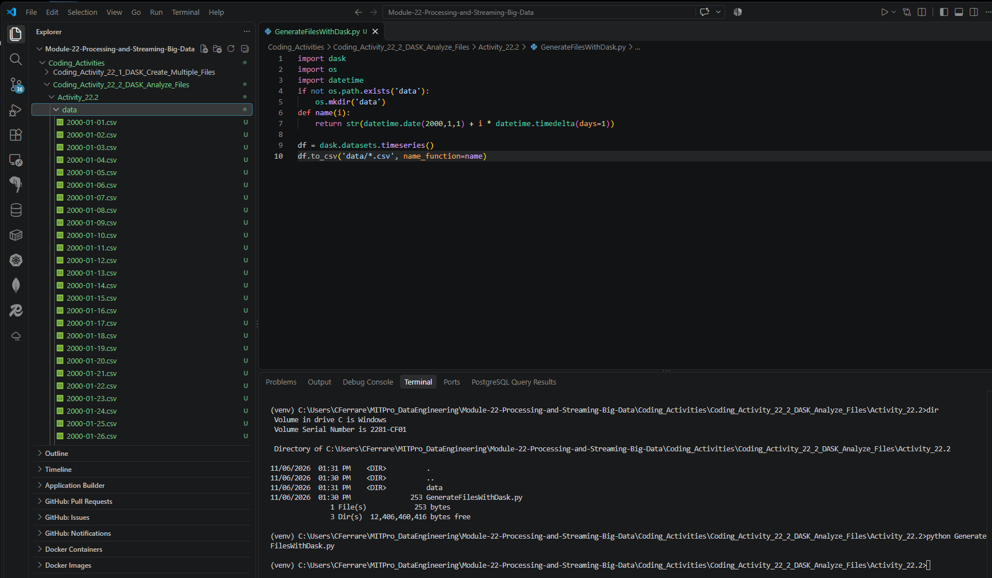

- Provide a screenshot to show the Activity22-2.py file is in the Activity_22.2 folder.

Figure 3. Activity22-2.py successfully created inside the Activity_22.2 folder.
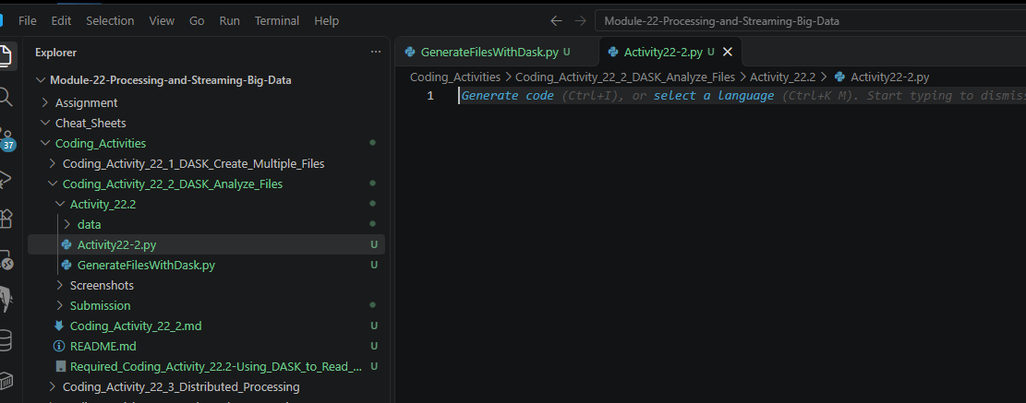

- Provide a screenshot to show that the correct DASK libraries have been imported into the Activity22-2.py file.

Figure 4. Imported the required DASK libraries into Activity22-2.py.
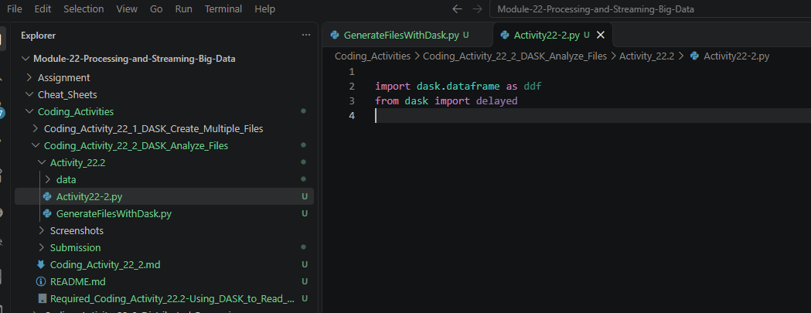

- Provide a screenshot to show the head of the DASK dataframe and display that the DASK dataframe correctly displays the first five rows.

Figure 5. DASK successfully read multiple CSV files and displayed the first five rows of the DataFrame.
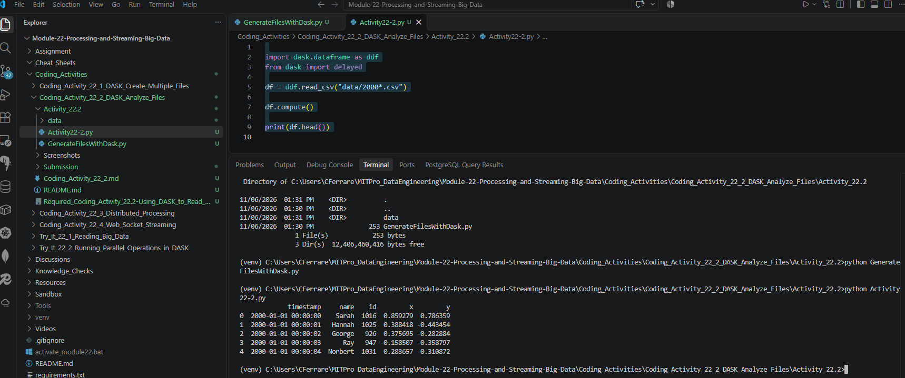

- Provide a screenshot of your Terminal window to show the output after you have printed the computed mean of the dataframe.

Figure 6. Computed and displayed the mean value of column x using DASK.
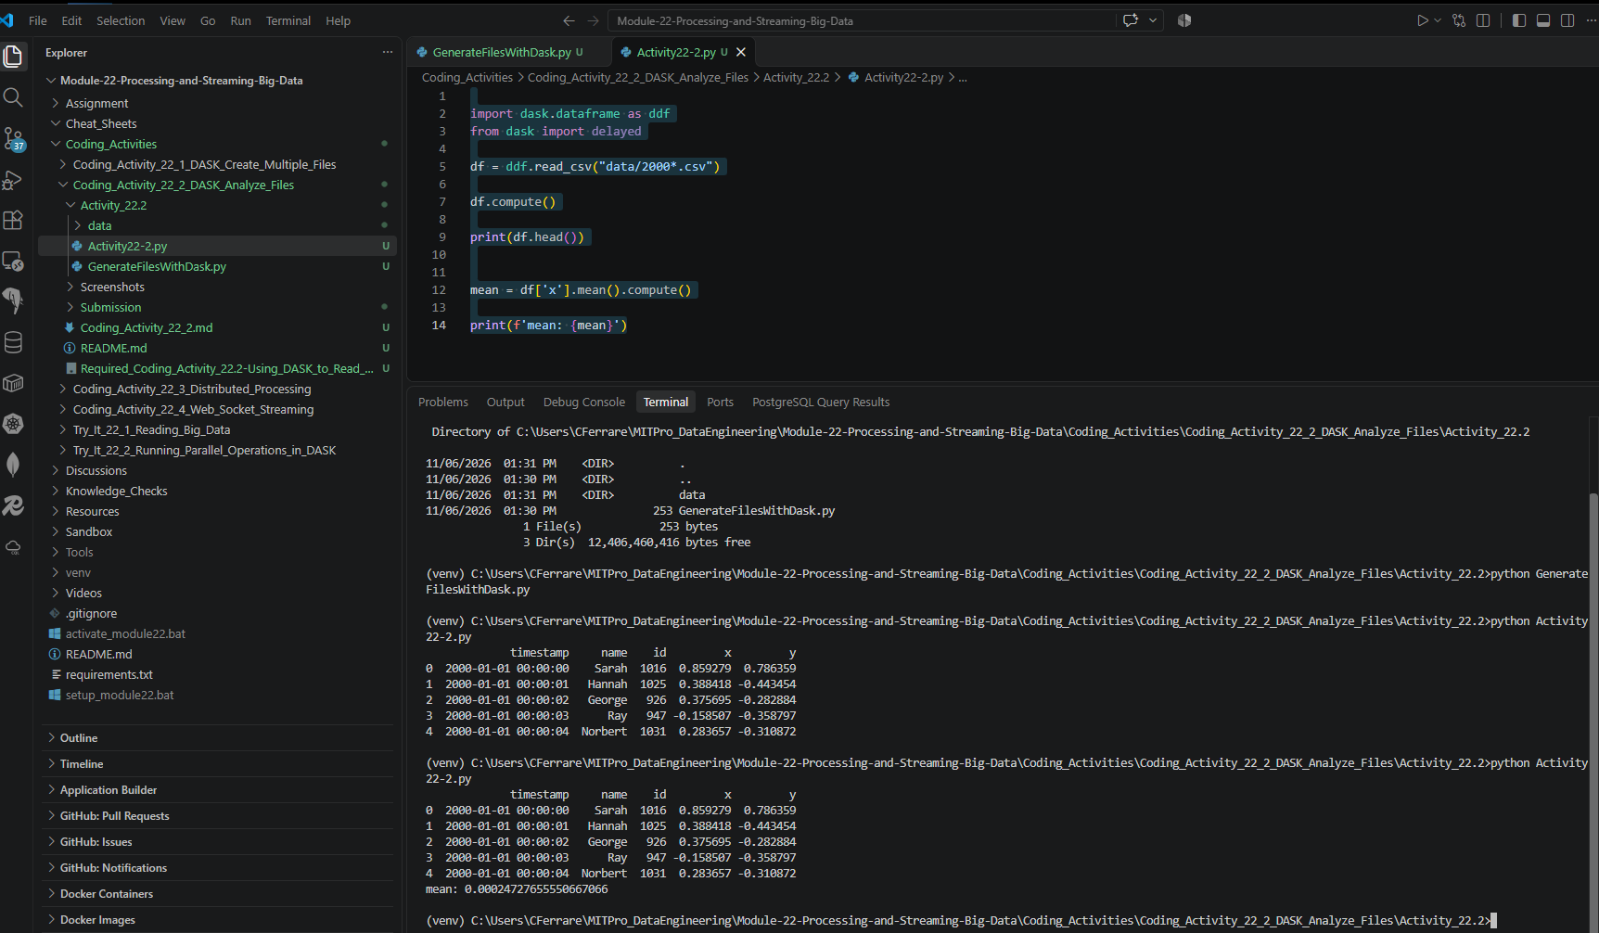

- Provide a screenshot of your Terminal window to show the number of columns in the dataframe.

Figure 7. Computed and displayed the number of columns in the DASK DataFrame.
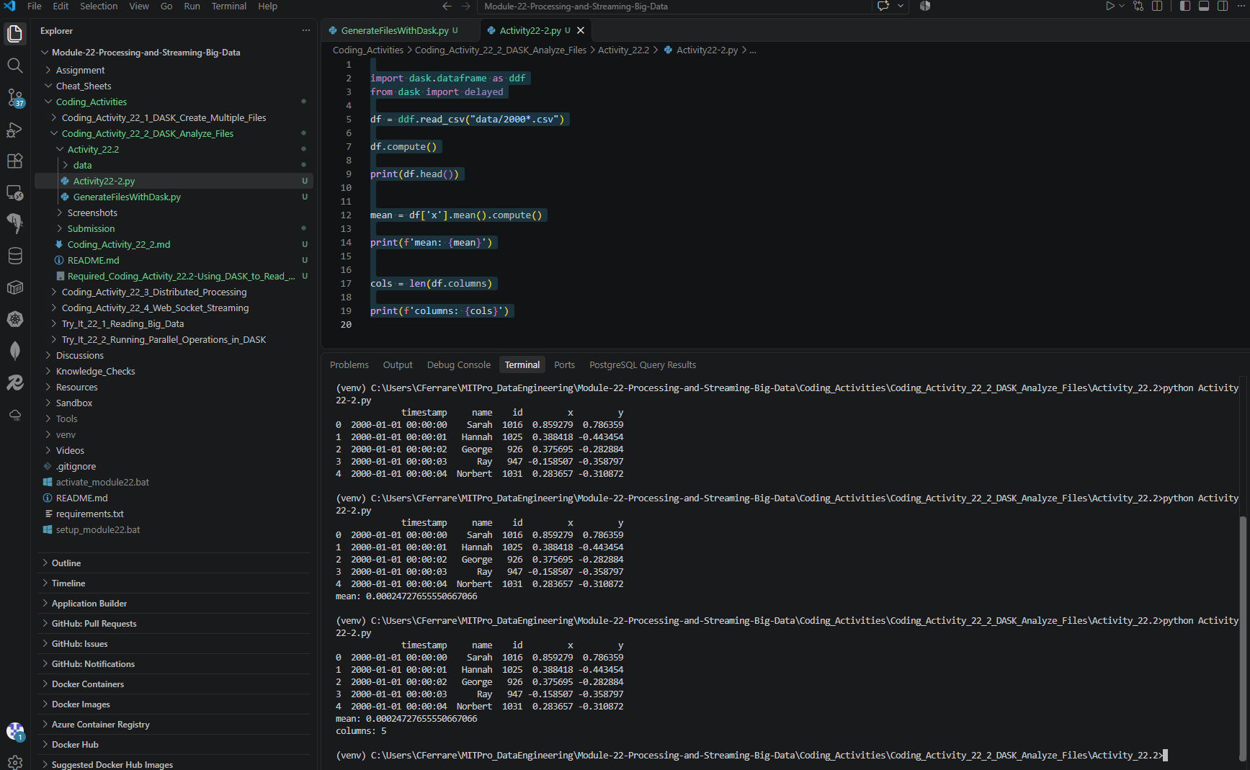

- Provide a screenshot of your Terminal window to show the number of rows in the dataframe.

Figure 8. Computed and displayed the total number of rows in the DASK DataFrame.


