Required Coding Activity 22.4: Streaming Web Sockets

- Provide a screenshot to show that you have successfully downloaded and extracted the johntango Streaming GitHub repository on your local machine.

Figure 1. Successfully downloaded and extracted the Streaming repository.
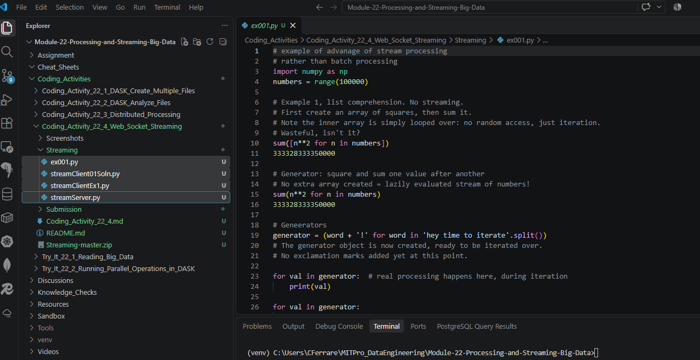
- Provide a screenshot to show that you successfully opened the streamServer.py file in VS Code.
Figure 2. streamServer.py opened successfully in Visual Studio Code.
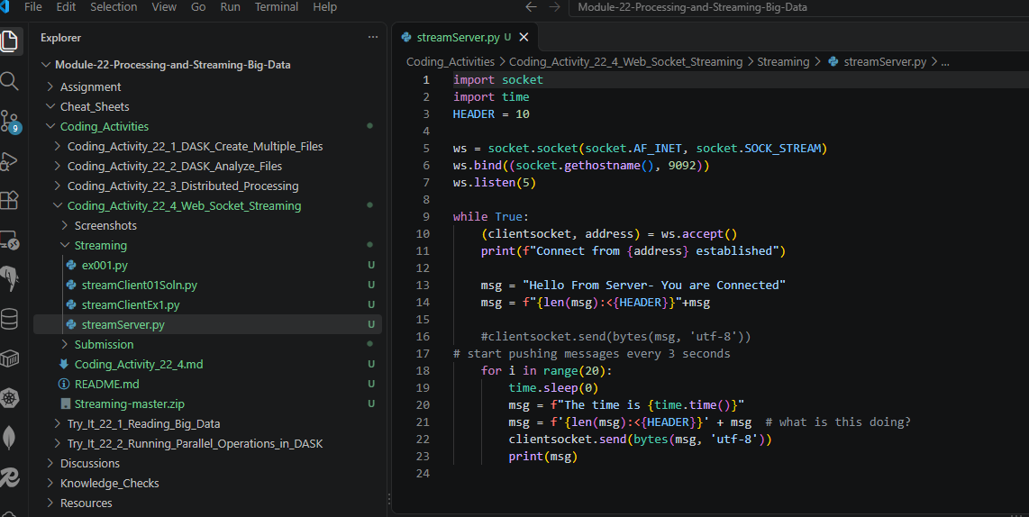
- Provide a screenshot to show that you successfully opened the command prompt in the streamServer.py folder and ran the python streamServer.py command without errors.

Figure 3. Successfully started the Web Socket server and placed it in listening mode awaiting client connections.
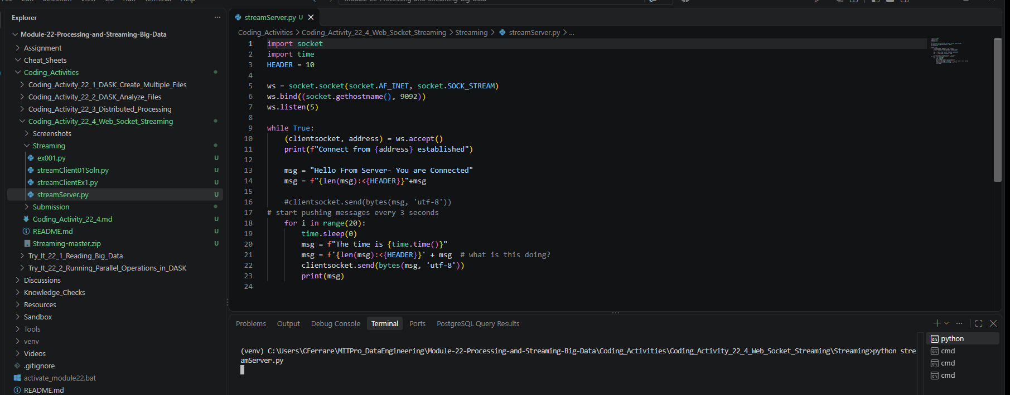

- Provide a screenshot to show that you successfully opened the command prompt in the streamClientEx1.py folder, ran the python streamClientEx1.py command, and received the message from the server.

Figure 4. streamClientEx1.py successfully connected to the server and received streamed messages from the server before encountering the packet-boundary parsing issue.
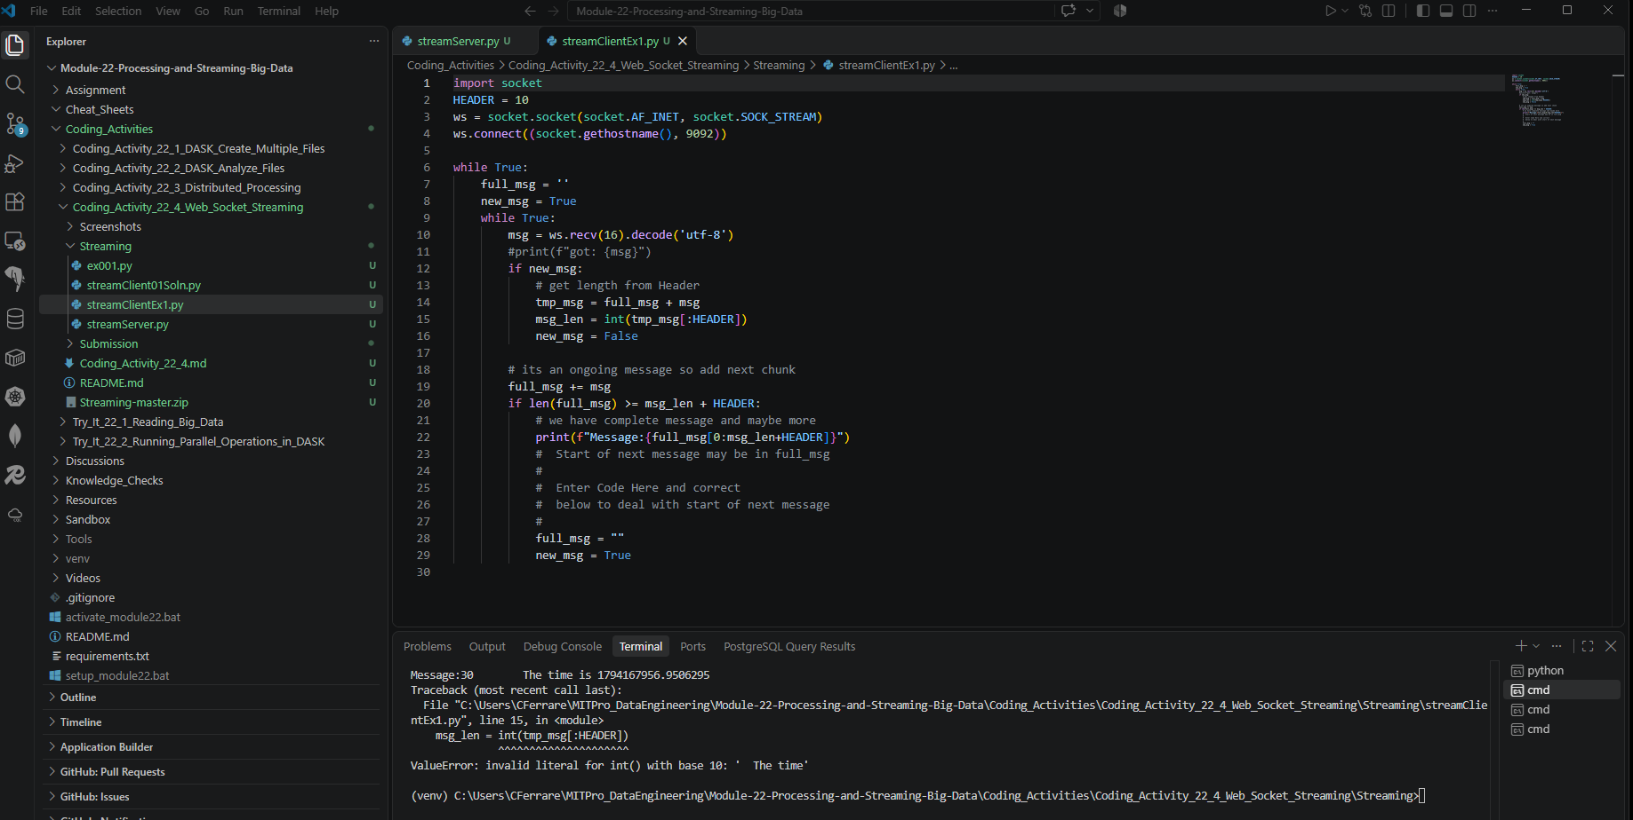

- Provide a screenshot to show that after running the client code, you can view the sent messages output over the server command line interface.
Figure 5. Server console showing a successful client connection and streaming packet transmissions.
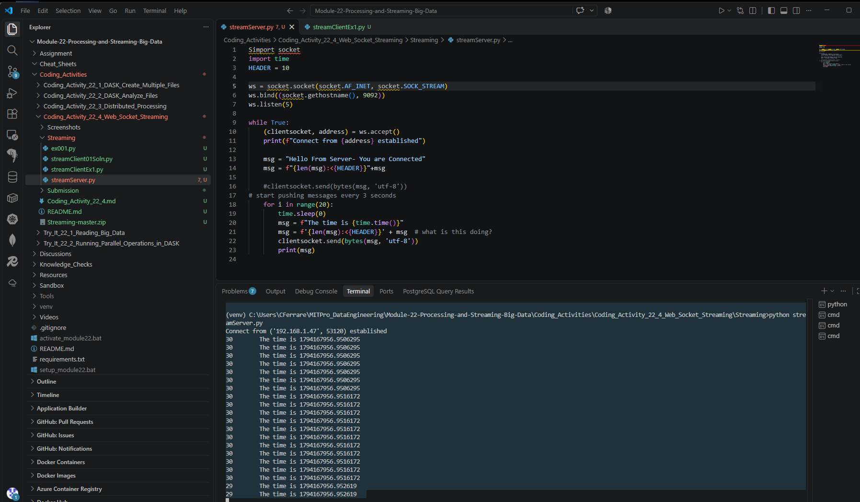

- Provide a screenshot to show that you successfully opened the command prompt in the streamClient01Soln.py file, ran the python streamClient01Soln.py command, and can view the received message from the server.

Figure 6. streamClient01Soln.py successfully connected to the server and continuously received streamed messages.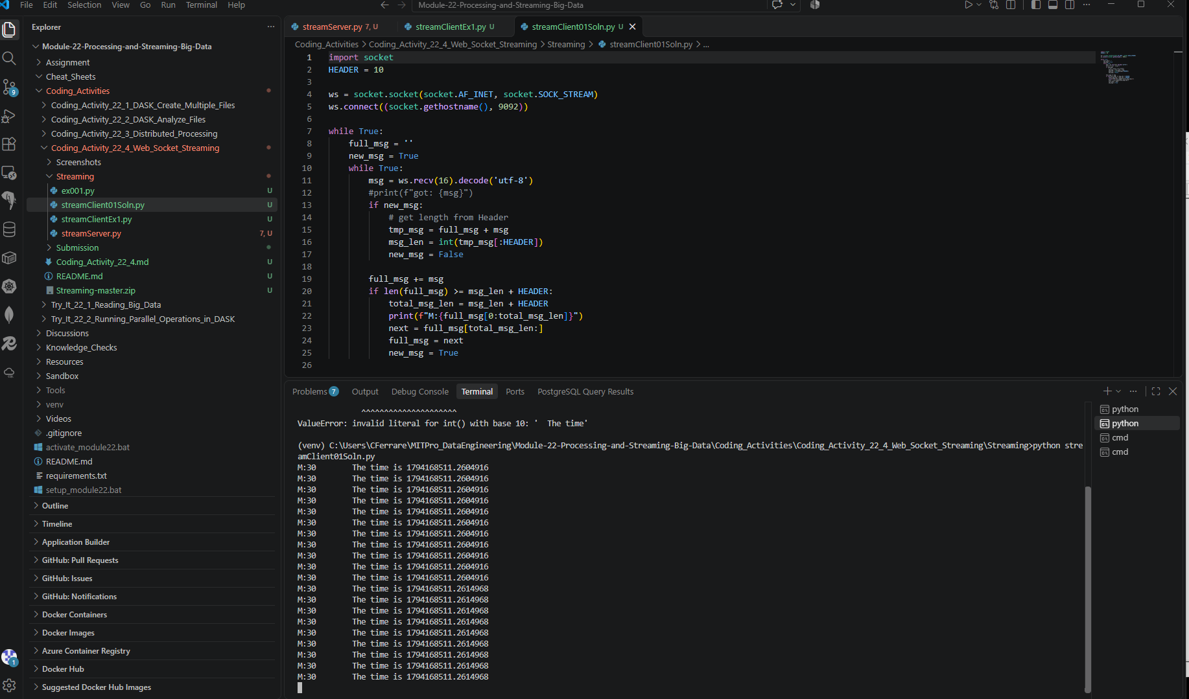

- Provide a screenshot to show that you successfully opened the client code in the streamClient01Soln.py folder and added a debugging checkpoint at line 13.

Figure 7. Added a debugging breakpoint at line 13 in streamClient01Soln.py.
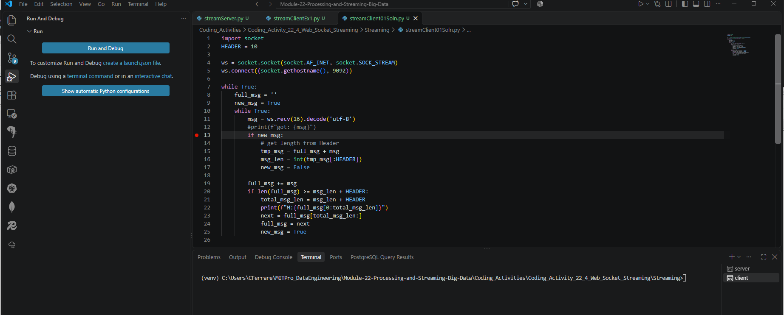

- Provide a screenshot to show that you were able to run the client code in debugging mode and see that the value of the Python msg variable is “'29 The ti'” in VS Code.



