Required Coding Activity 22.3: Simulating Parallel Processing

- Provide a screenshot to show that you successfully installed DASK.

Figure 1. Verification that DASK is installed and available in the active Python virtual environment.
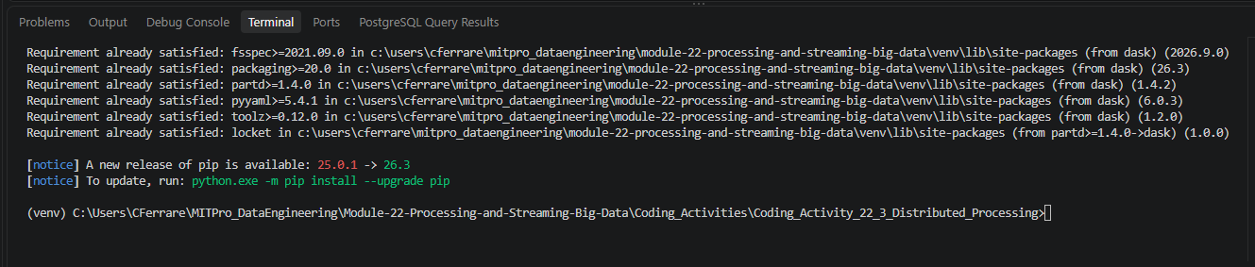

- Provide a screenshot to show that you successfully ran the dask scheduler.
Figure 2. Successfully launched the DASK scheduler and obtained the scheduler address.
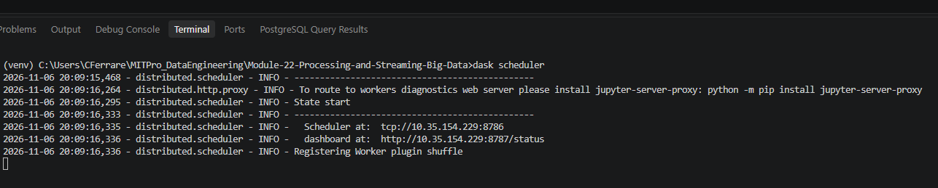

- Provide two screenshots to show that you successfully started both of the dask worker processes by passing the correct address to the dask scheduler.

Figure 3A. Successfully launched and connected DASK Worker 1 to the scheduler.
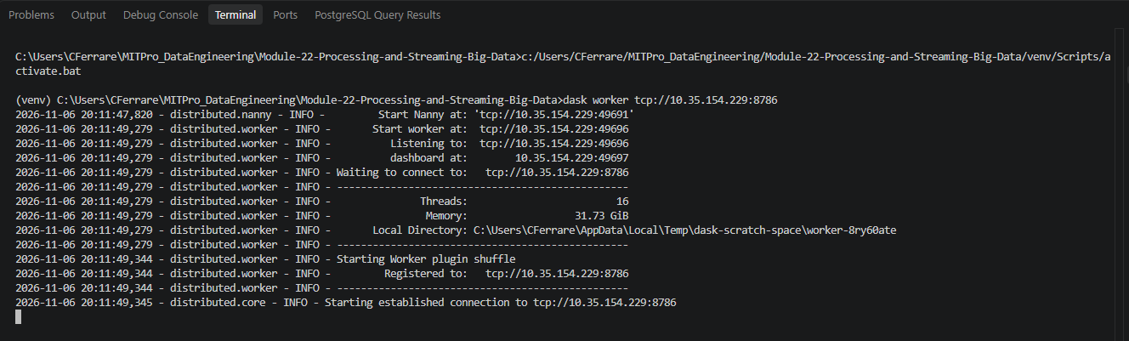

Figure 3B. Successfully launched and connected DASK Worker 2 to the scheduler.
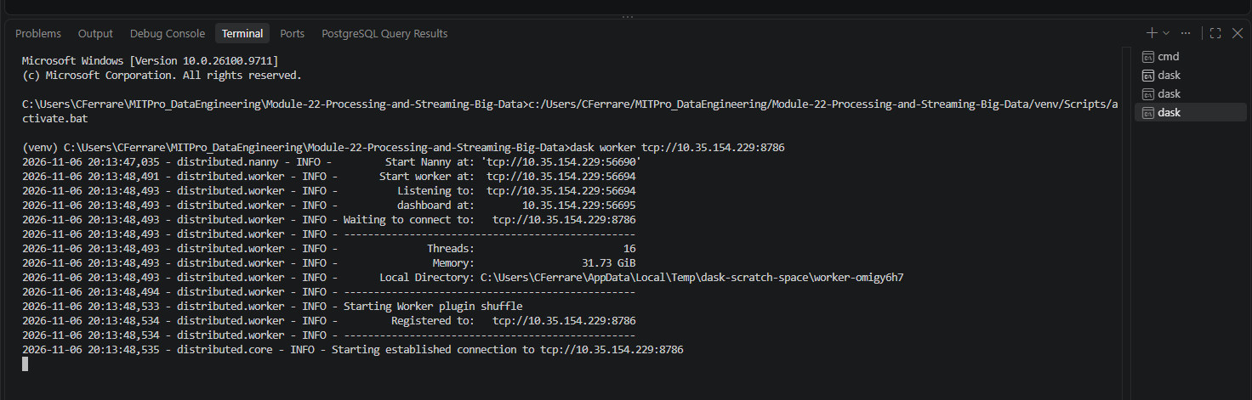

- Provide a screenshot to show that you created a Jupyter Notebook and successfully imported the DASK libraries.
Figure 4. Created a Jupyter Notebook and successfully imported the required DASK libraries.
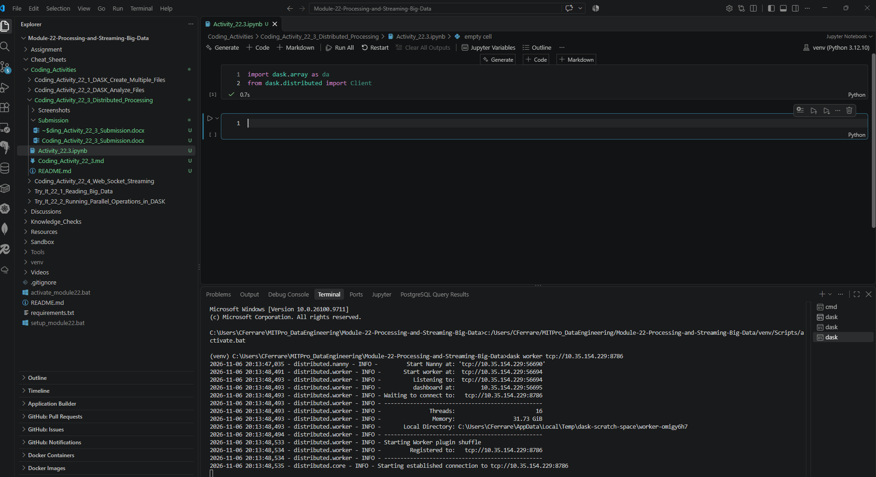

- Provide a screenshot to show that you successfully executed the command to create a matrix, compute the mean, and assign the value to the y variable.

Figure 5. Created a 50,000 by 50,000 DASK array and assigned the mean calculation to variable y.

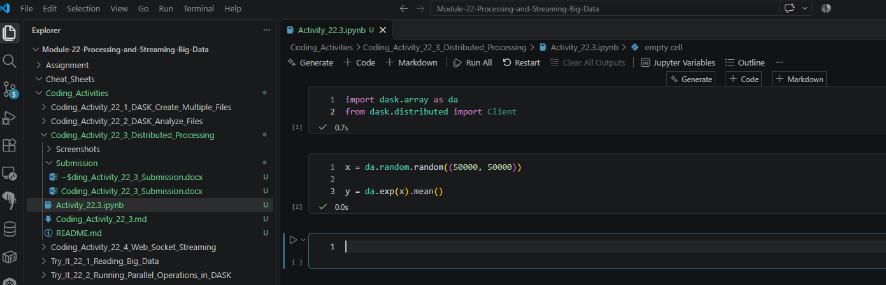

- Provide a screenshot to show that you successfully computed your calculations using DASK using the compute function.

Figure 6. Connected to the DASK scheduler and successfully executed a distributed computation using compute().


