Required Final Assignment 13.1: Change Data Capture (CDC)

Part 1
- Provide a screenshot of the “Assignment13” folder in VS Code to show that you added a file called my_sql_container.py and wrote the code to run a MySQL container named final_mysql_container in port 5600.
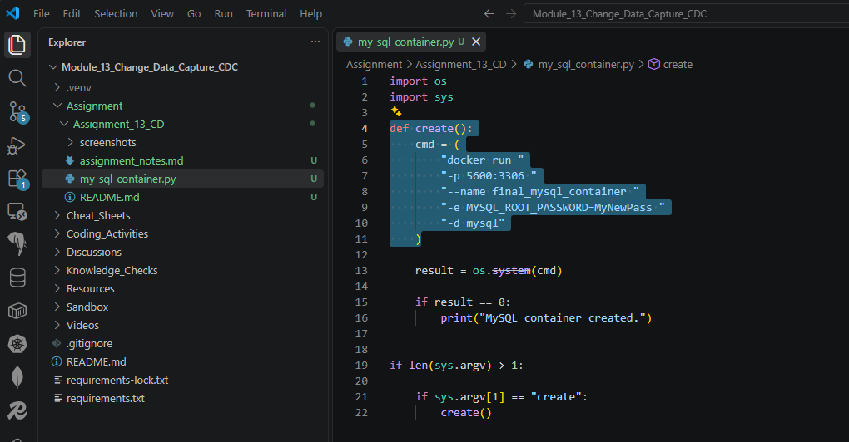

- Provide two screenshots to show that you ran the my_sql_container.py file using the create parameter to create a Docker container: one screenshot of your Terminal window and one screenshot of your Docker application to show that the container has been created.
2a. MySQL container created
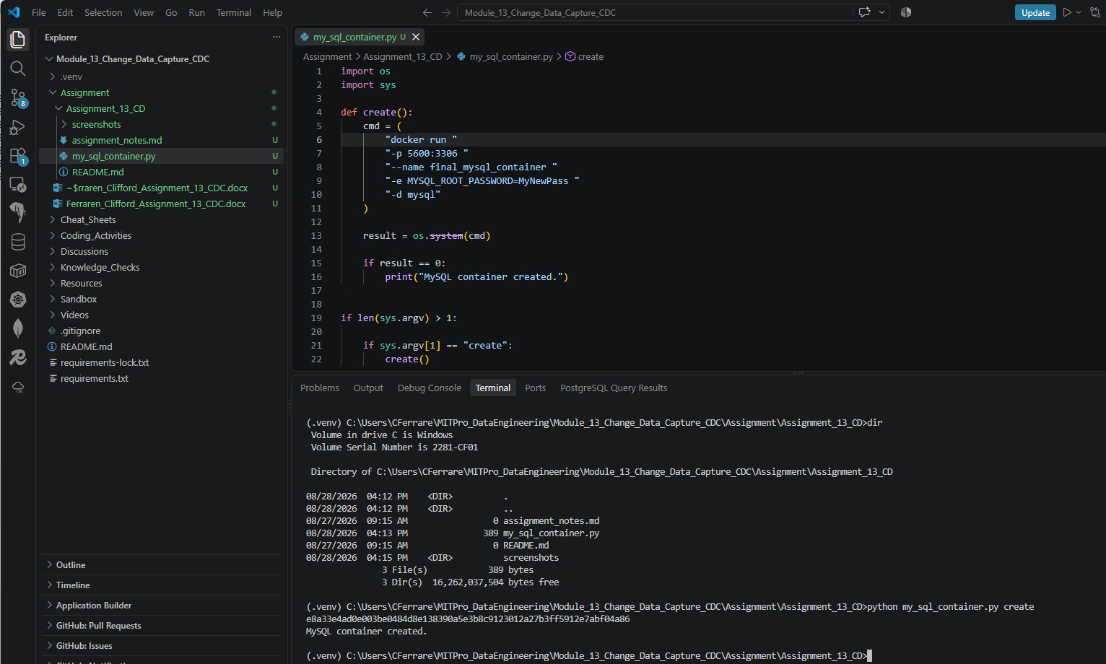
Open Docker Desktop and verify: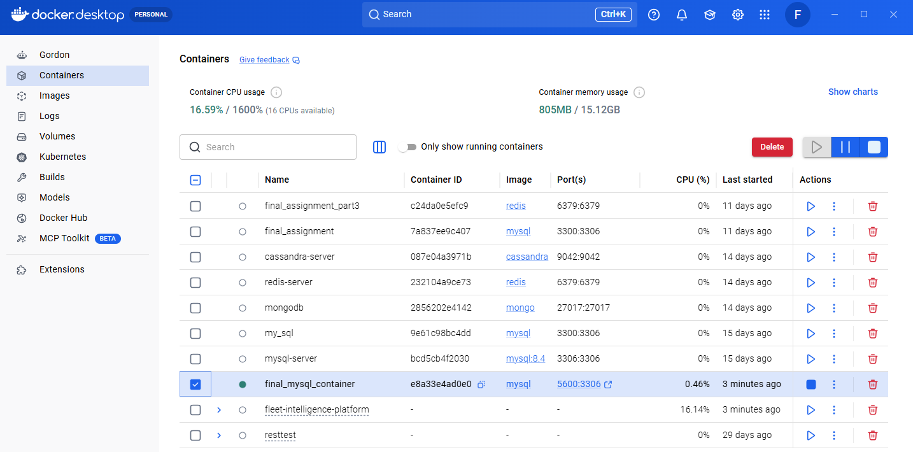

- Provide a screenshot to show that you created another file called my_mongo_container.py and wrote the code to run a MongoDB container named final_mongo_container in port 1800.
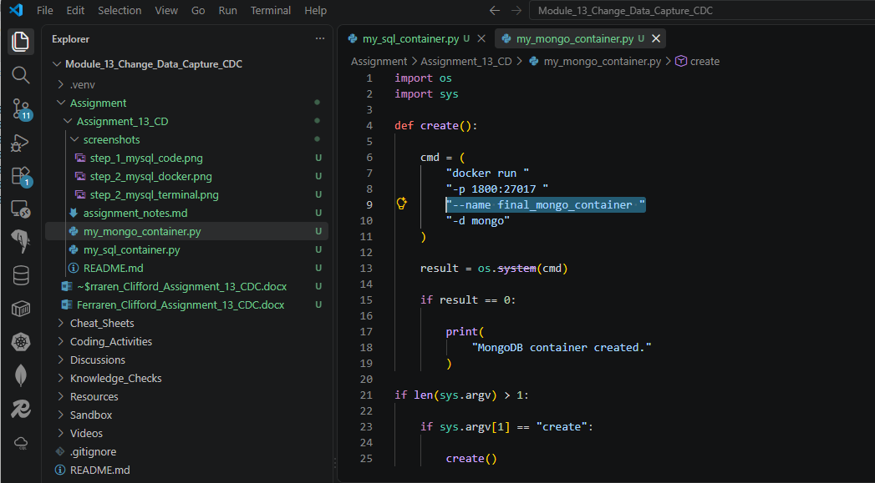

- Provide two screenshots to show that you ran the my_mongo_container.py file using the create parameter to create a Docker container: one screenshot of your Terminal window and one screenshot of your Docker application to show that the container has been created.

Terminal showing final_mongo_container created successfully.
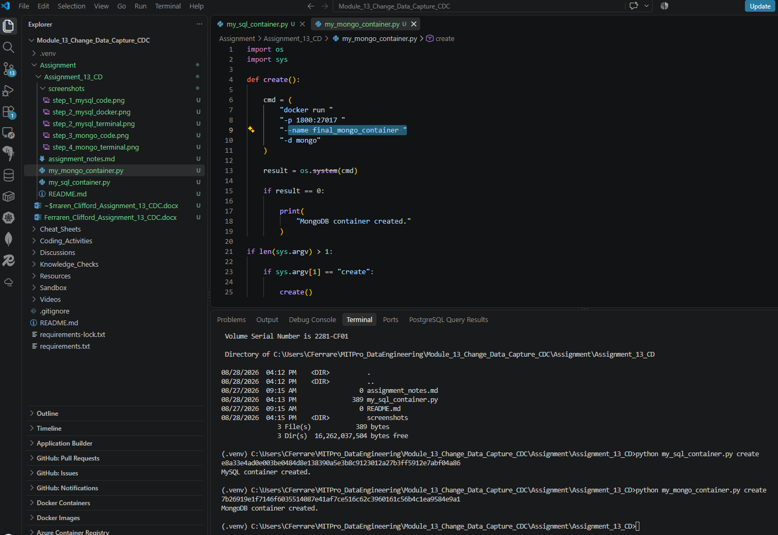

Open Docker Desktop and confirm:
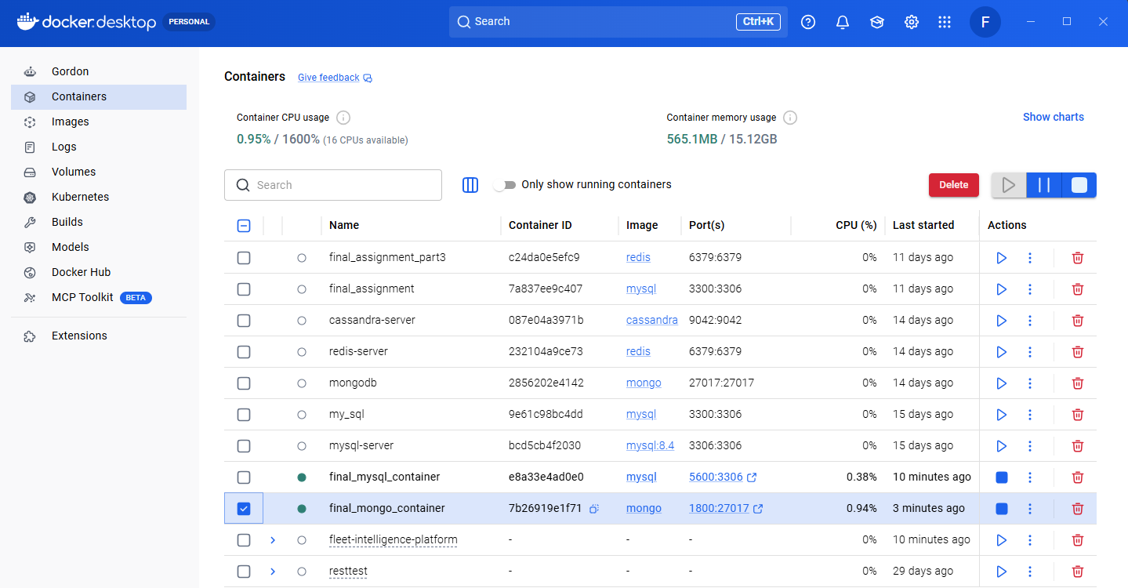

- Provide a screenshot to show that you created another file called my_redis_container.py and wrote the code to run a Redis container named final_redis_container using port 2400.
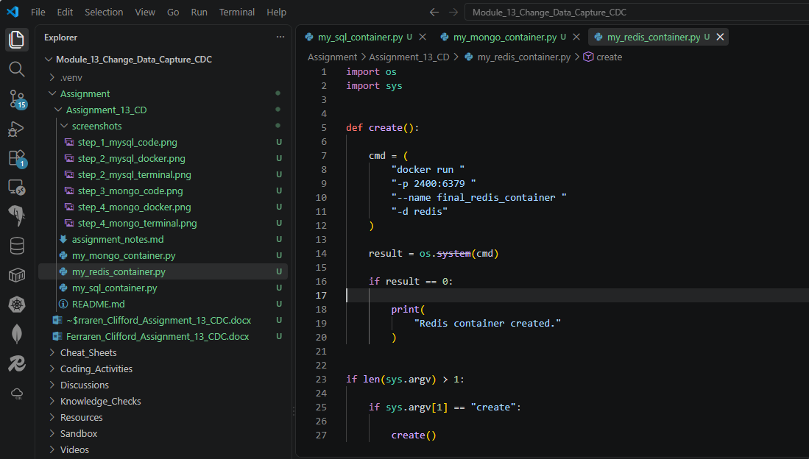

- Provide two screenshots to show that you ran the my_redis_container.py file using the create parameter to create a Docker container: one screenshot of your Terminal window and one screenshot of your Docker application to show that the container has been created.
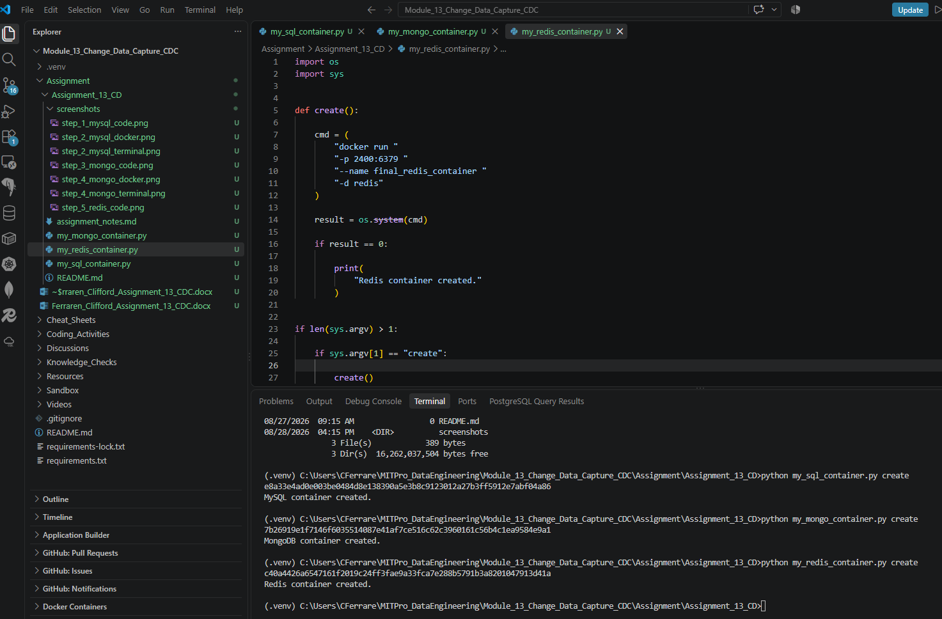

Created container viewed on docker desktop:
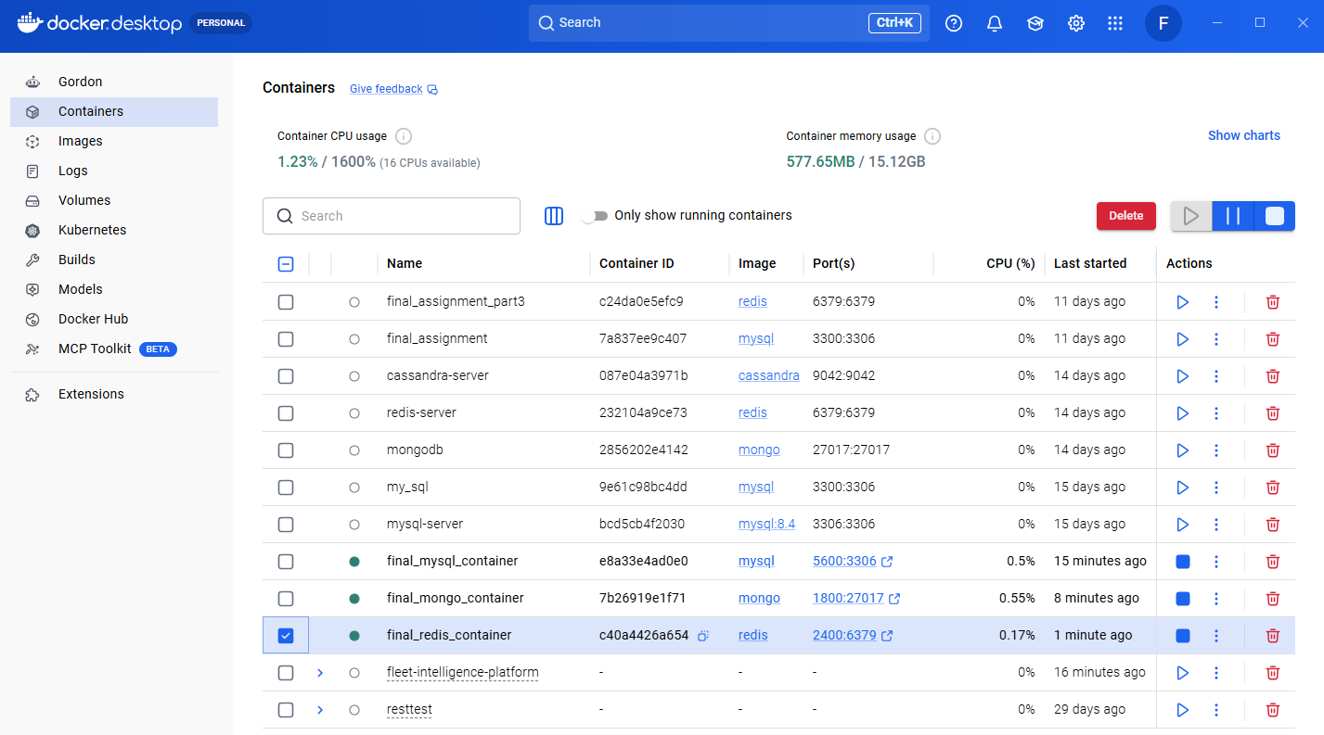

- Provide a screenshot to show that you created another file called my_cassandra_container.py and wrote the code to run a Cassandra container named final_cassandra_container using port 1000.
Created my_cassandra_container.py:
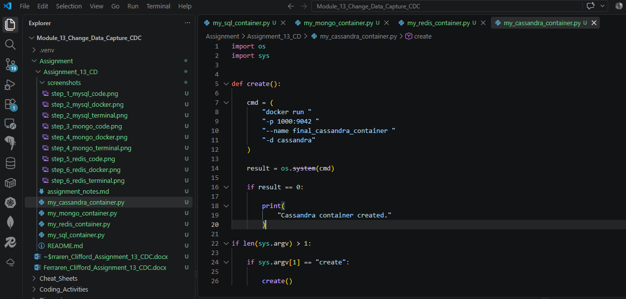
- Provide two screenshots to show that you ran the my_cassandra_container.py file using the create parameter to create a Docker container: one screenshot of your Terminal window and one screenshot of your Docker application to show that the container has been created.

Running the code on terminal successfully created the container.
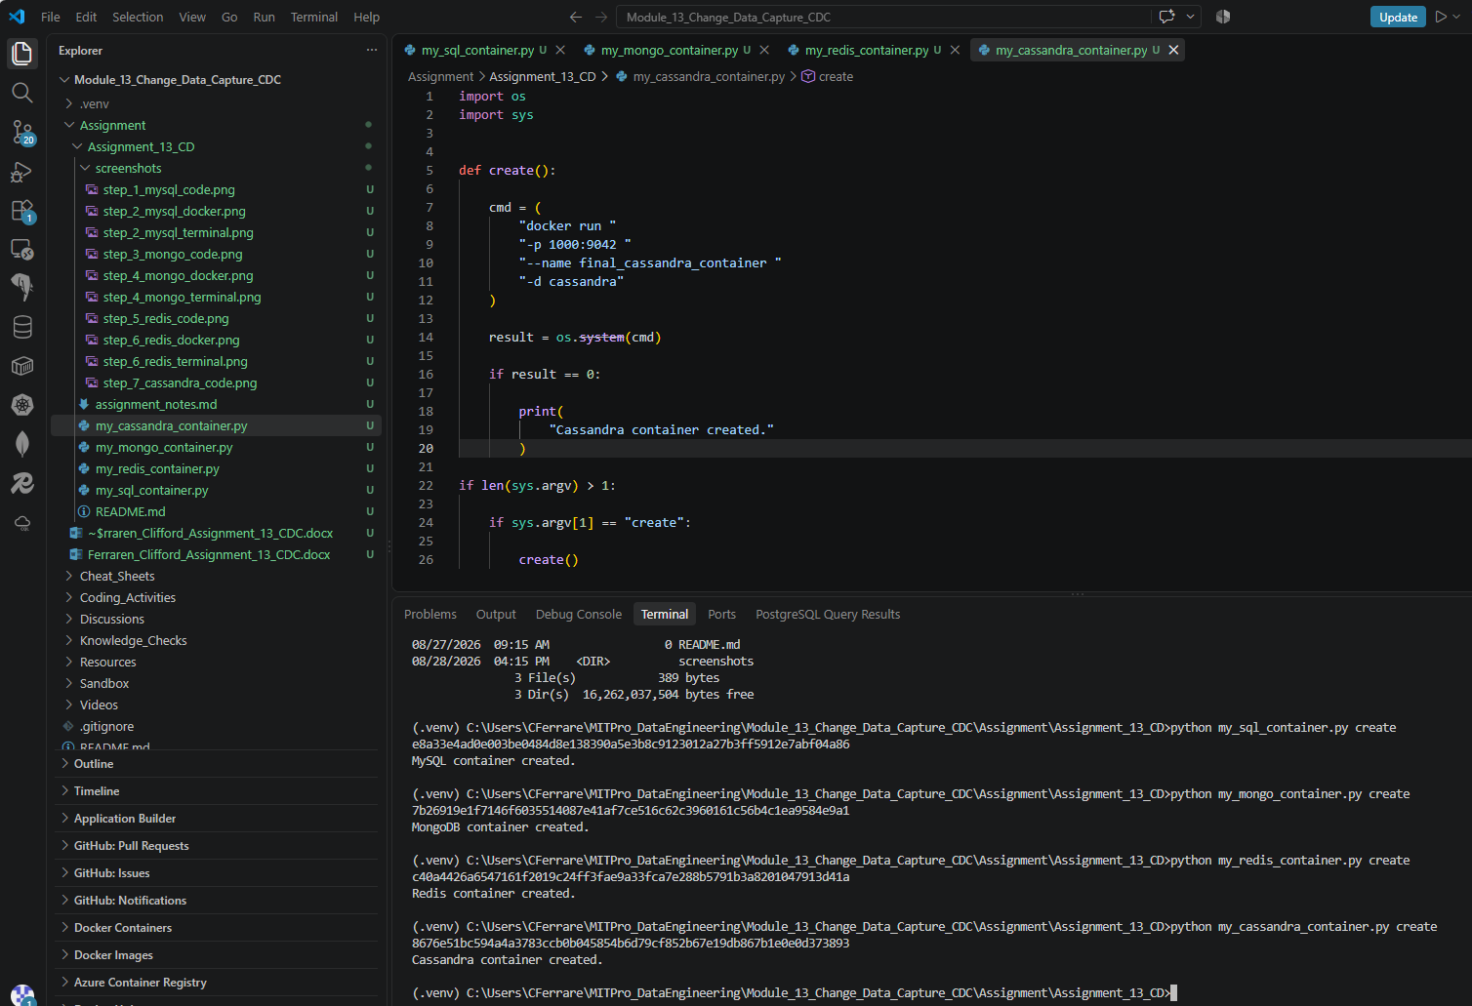

Dockers showing containers created.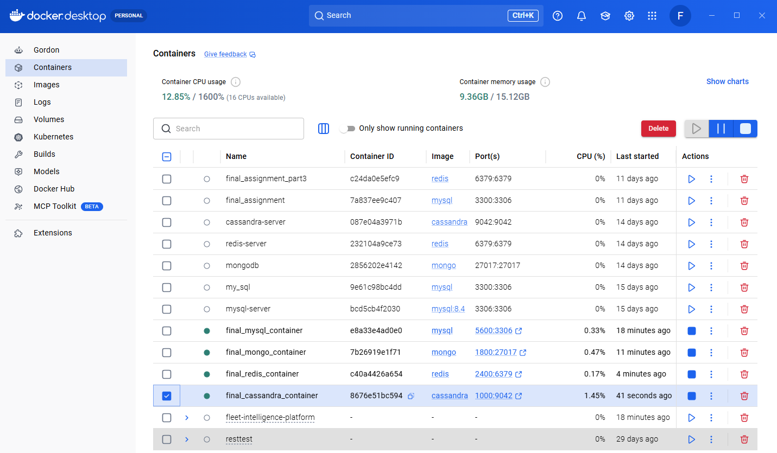
- Provide a screenshot that shows that all the Docker containers have been eliminated.
Create a code to delete created containers instead of deleting it manually and individually.
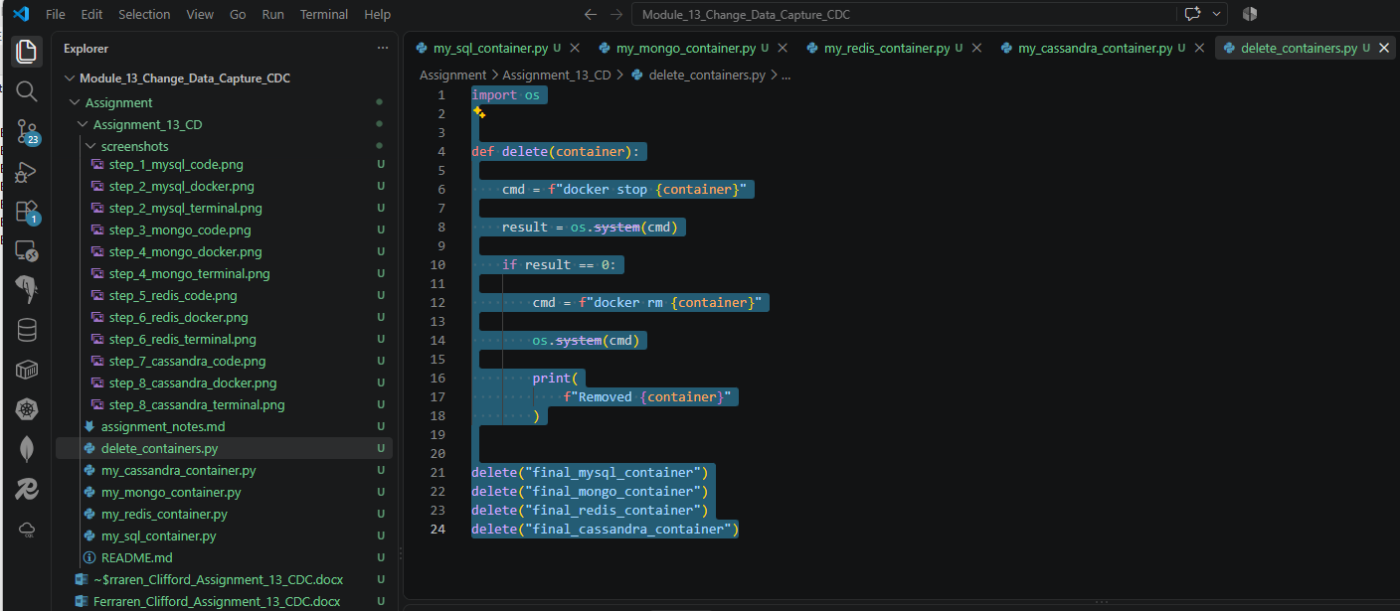

Terminal showing the containers are deleted using delete_containers.py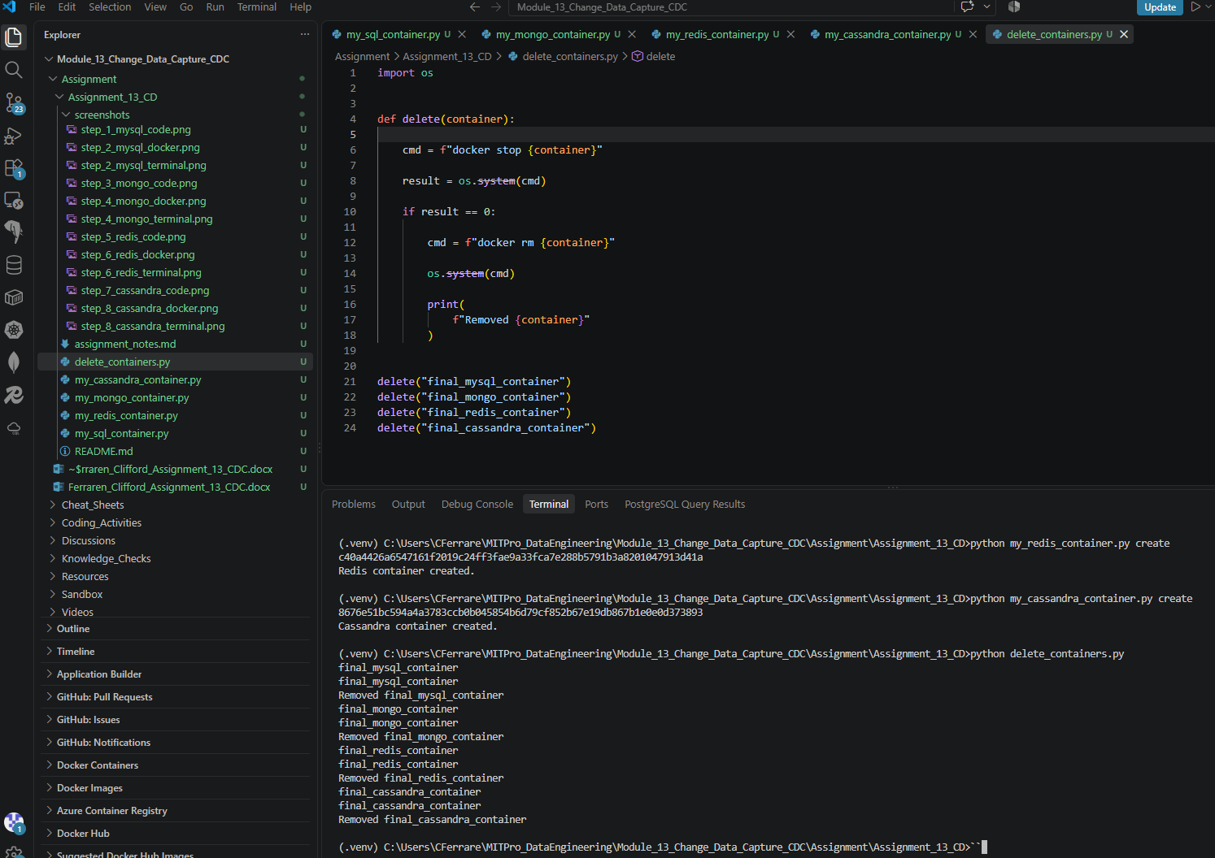

Docker showing all created running containers are deleted.
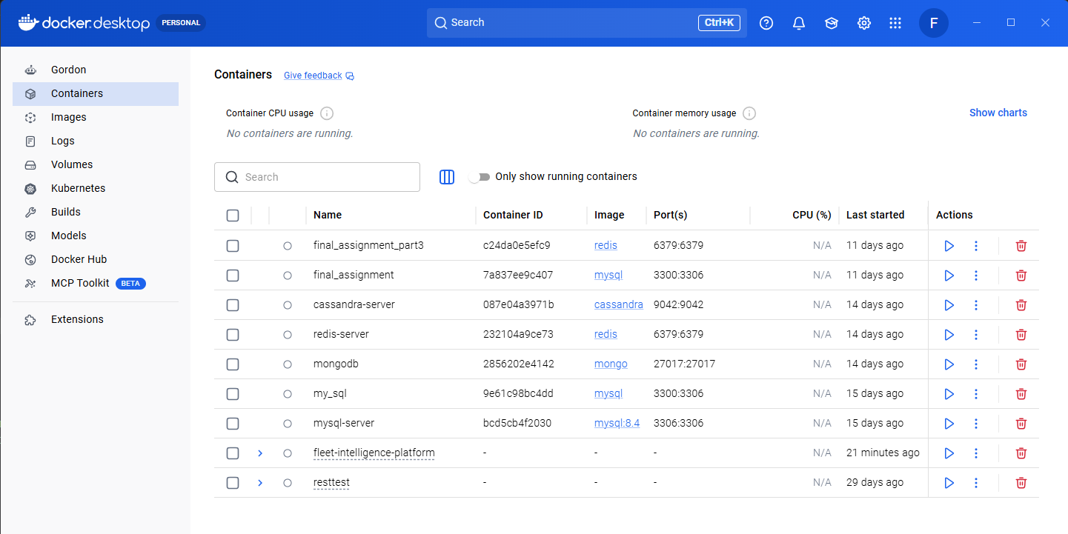

Part 2

- Provide a screenshot to show that you successfully created the container.py file and that it creates all the containers defined above using the same parameters as in Part 1.
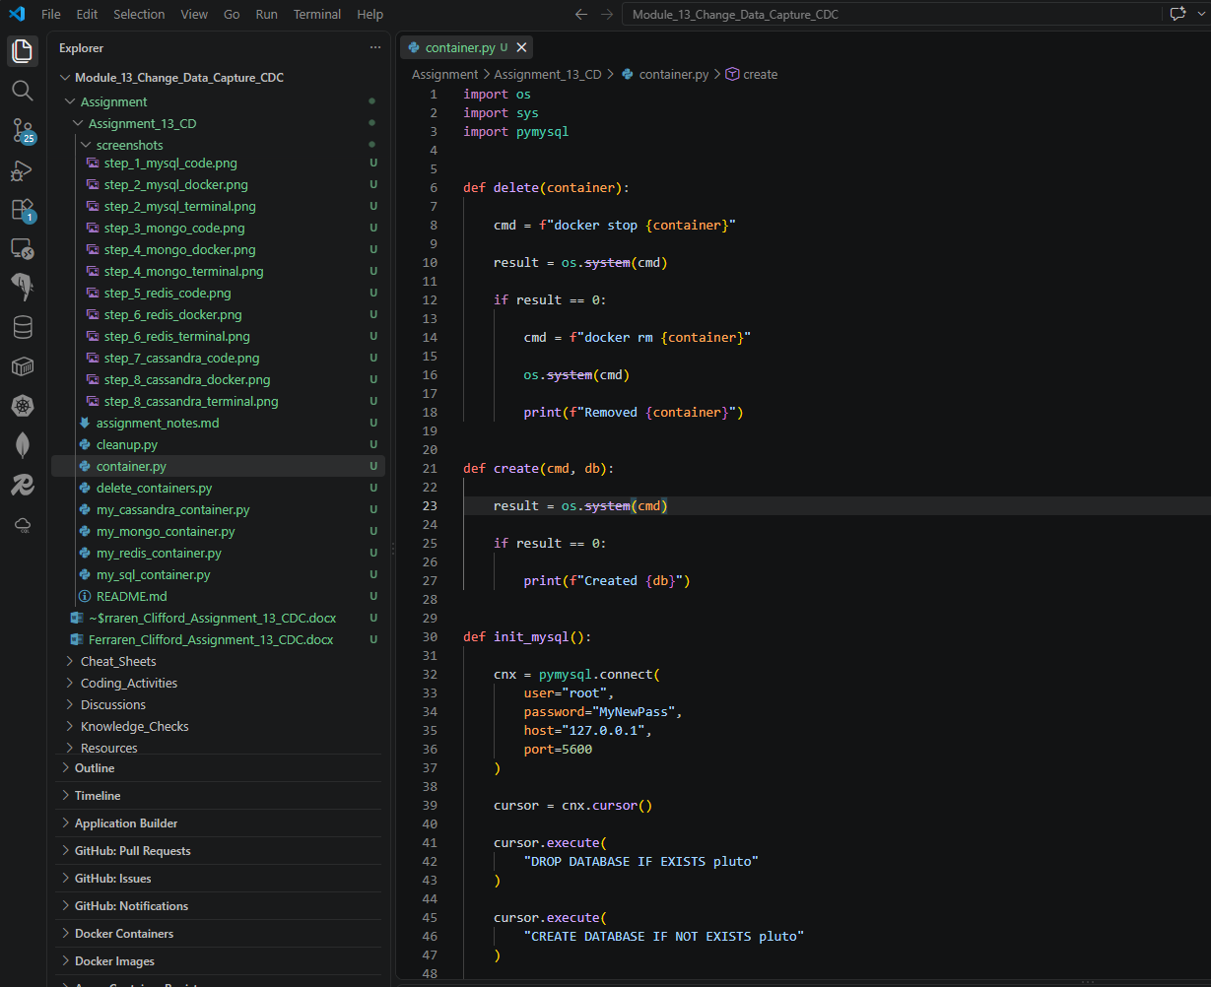

- Provide a screenshot running the container.py file in Docker to show that all the containers have been created successfully.
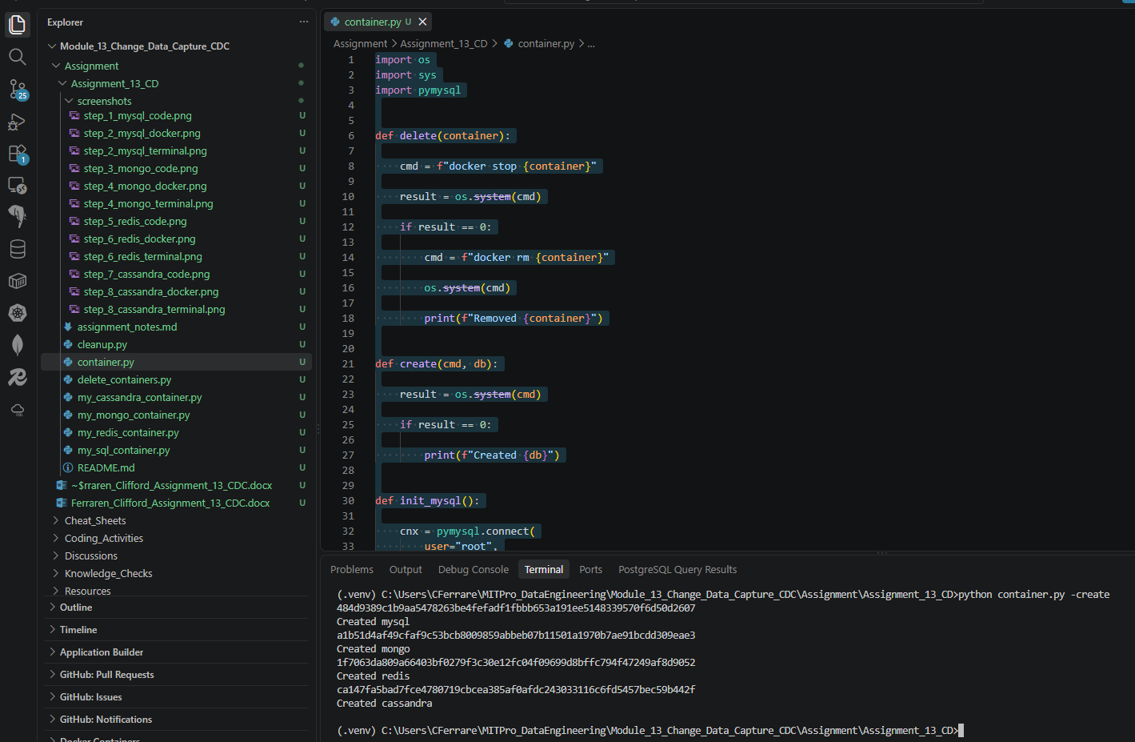

All the containers created thu python can be viewed on the desktop: 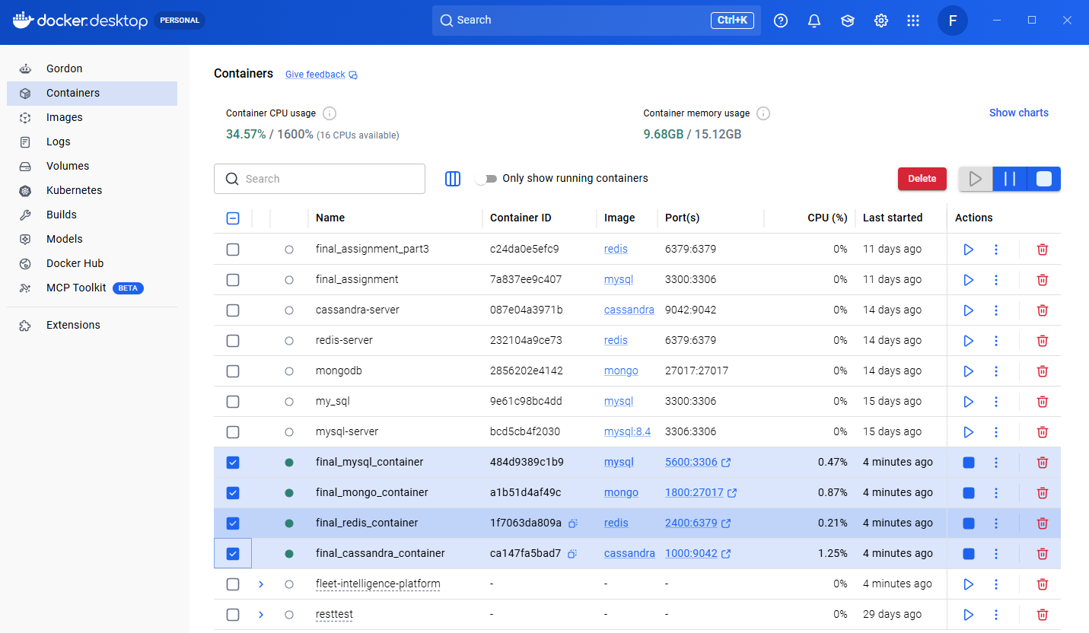

Showing the database and table was successfully created:
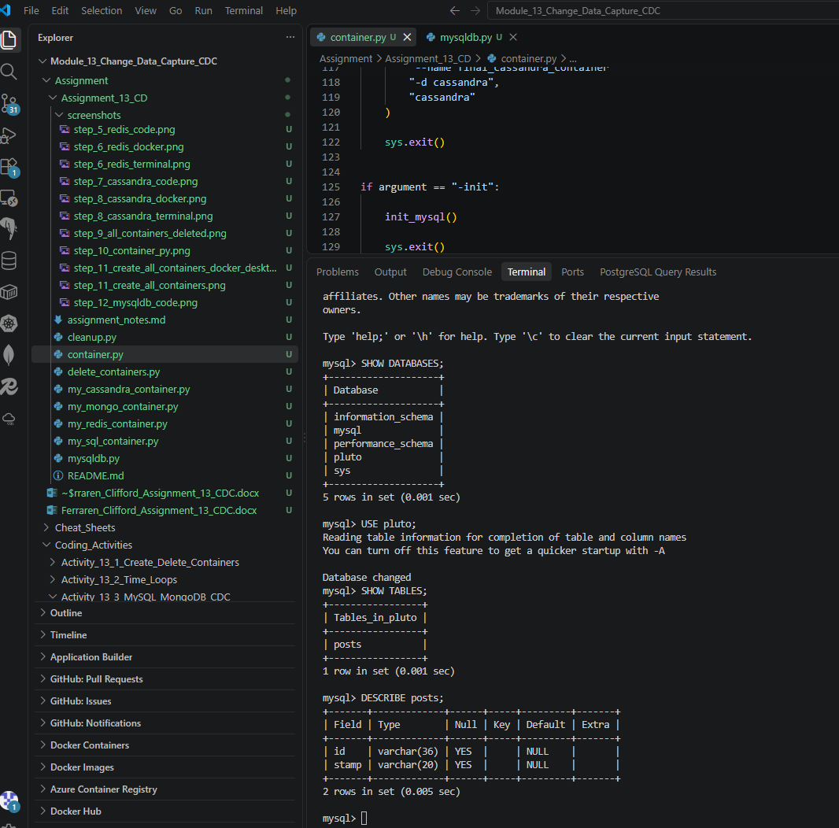

- Provide a screenshot to show that the mysqldb.py file has been created in the “Assignment13” folder.
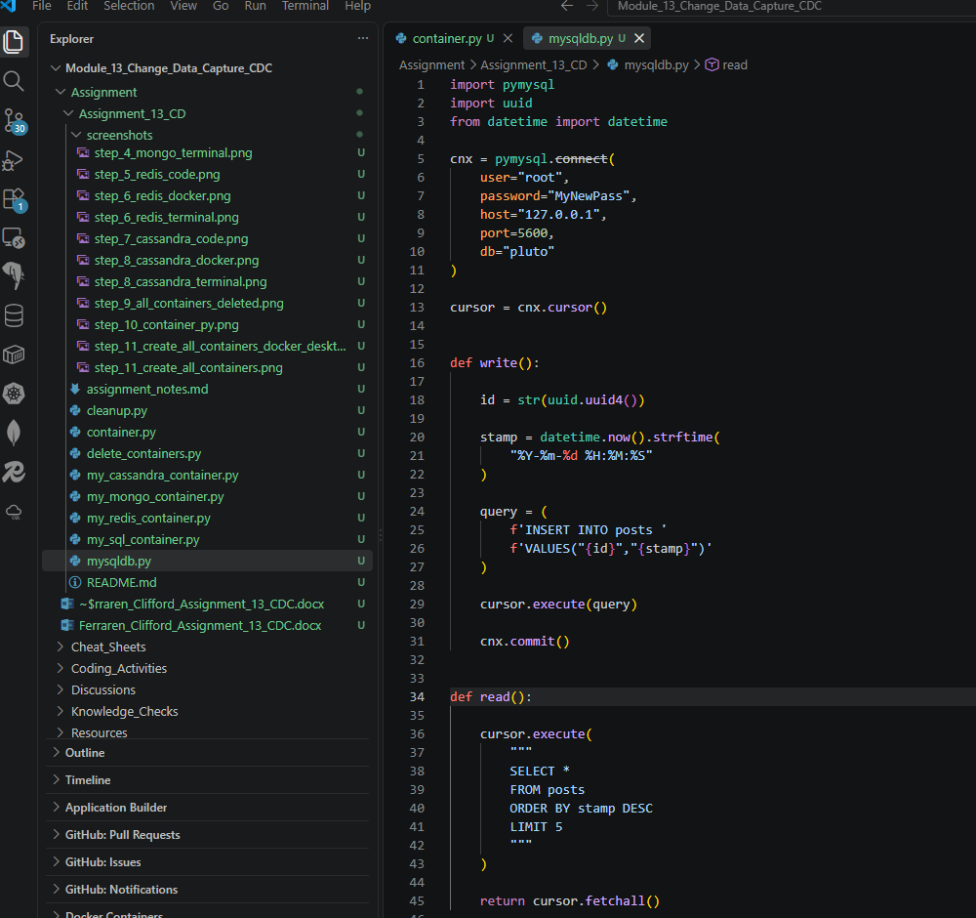

- Provide a screenshot of your Terminal window showing that the mysqldb.py file has run successfully.
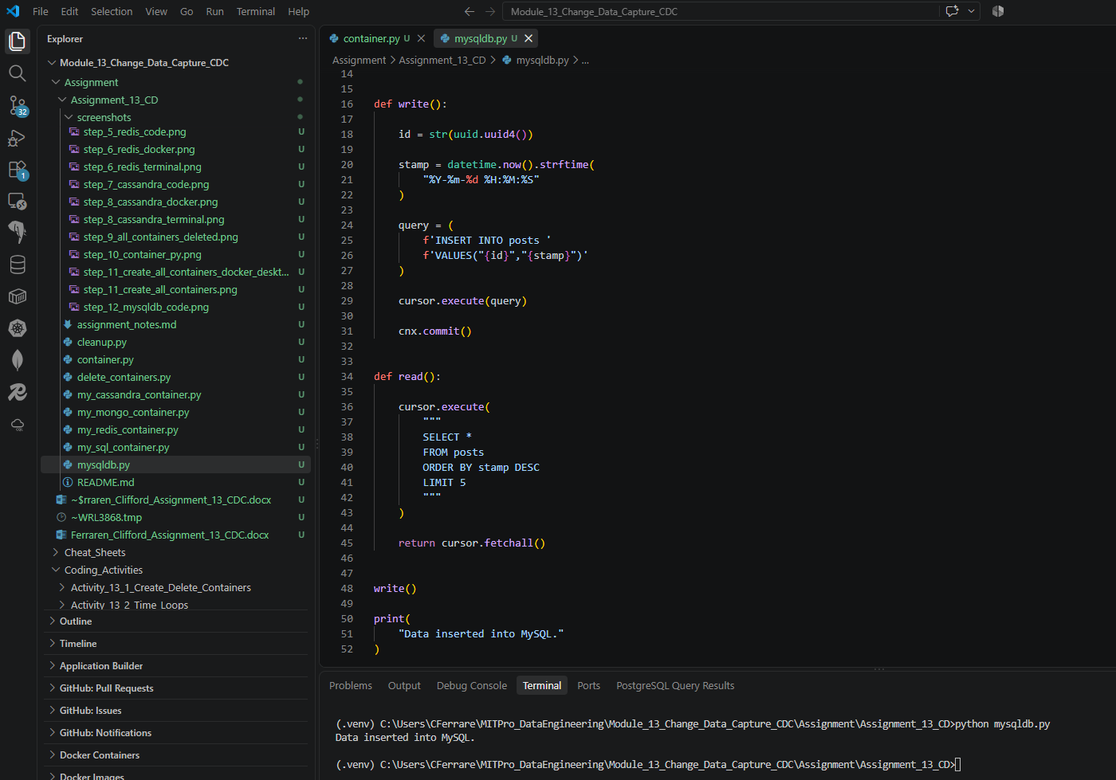
- Provide a screenshot to show that the mongodb.py file has been created in the “Assignment13” folder.
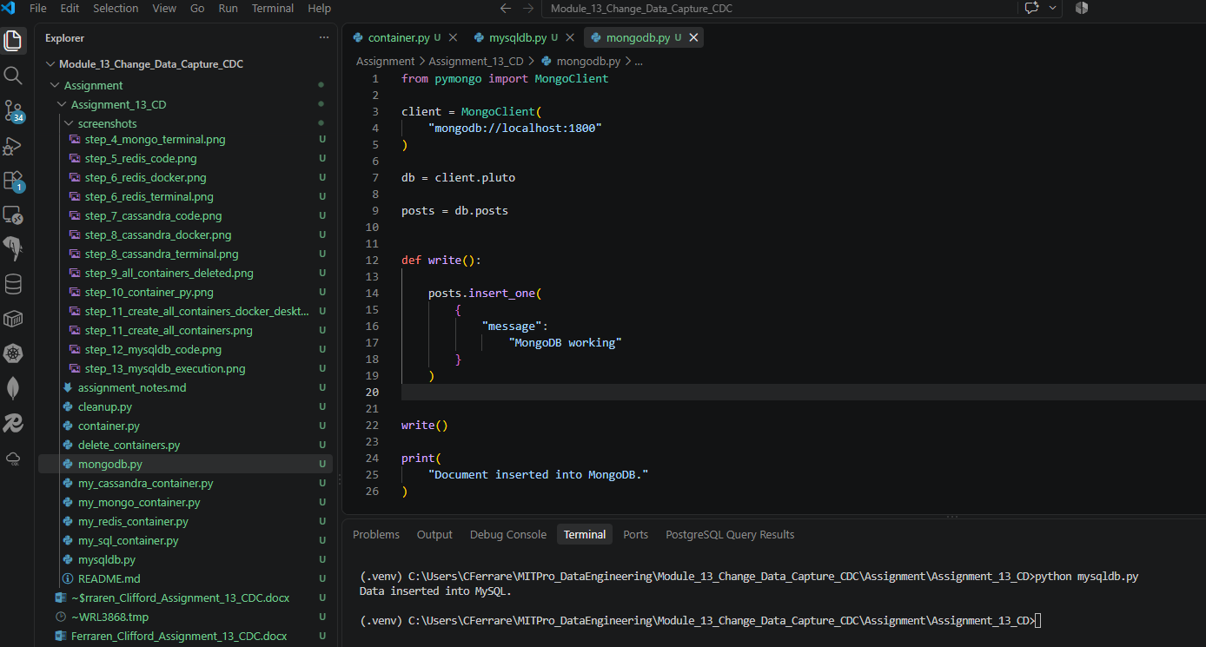

- Provide a screenshot of your Terminal window showing that the mongodb.py file has run successfully.
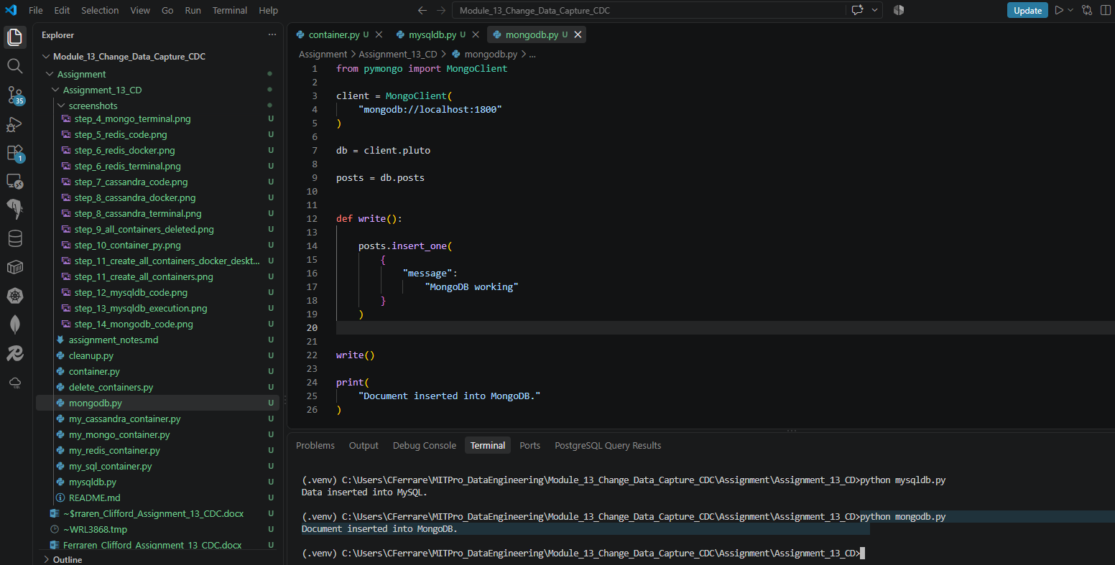

View collections:
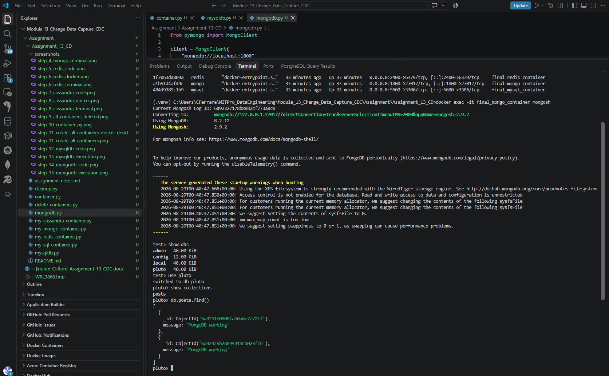

- Provide a screenshot to show that the scheduler.py file has been created.
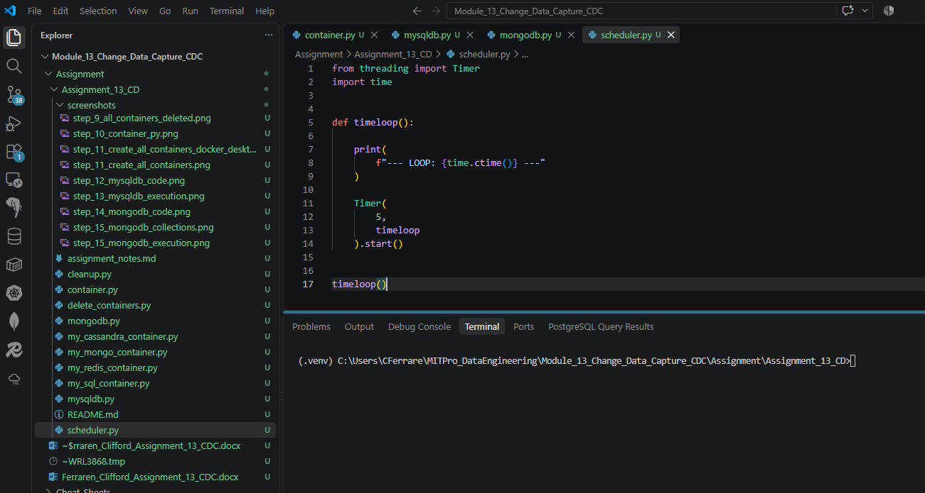

- Provide a screenshot of the command prompt showing that you successfully ran the container.py Python program from the command prompt passing -init as a parameter.
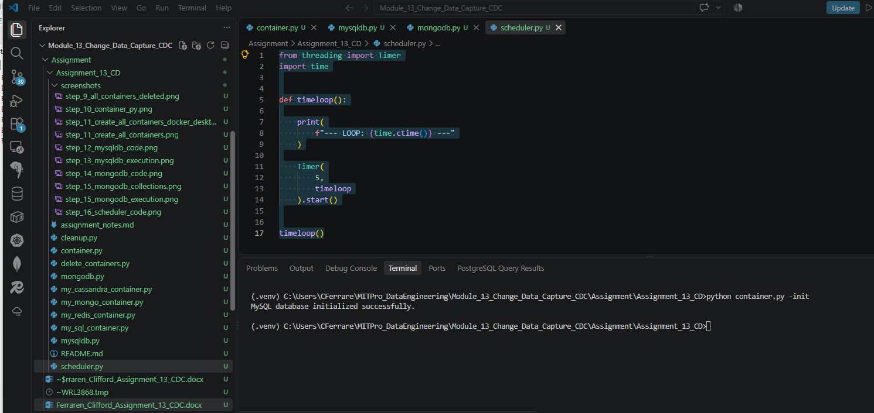

Verify MySQL: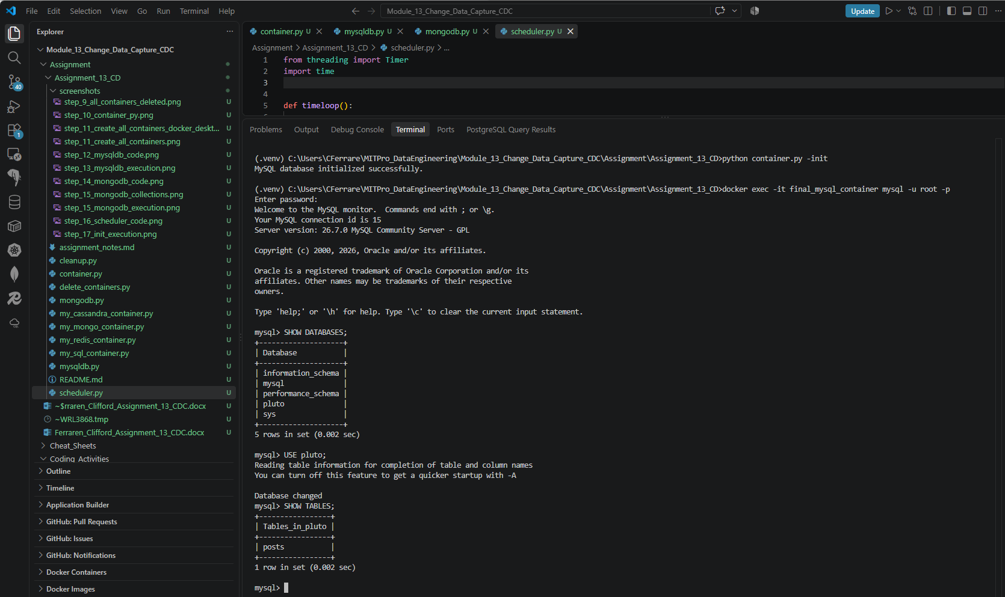

- Provide a screenshot of your Terminal window showing the scheduler.py program running.
